Stability, resilience, and productivity of horticultural agroforestry systems. A meta-analysis

Danielle Merrell, Cameron M Pittelkow, Amélie CM Gaudin
Corresponding author:
Amélie CM Gaudin
Email: agaudin@ucdavis.edu

Supplementary information and figures
After data collection and screening, we found that a paper included was redacted. The journal revealed that the experiment and data had been stolen from a student’s thesis and published without their knowledge. After careful consideration, we decided to continue to include this article, as the data was not falsified, and it was a valuable addition to the analysis.
Supplementary Figure 1. PRISMA selection criteria for horticultural agroforestry database. 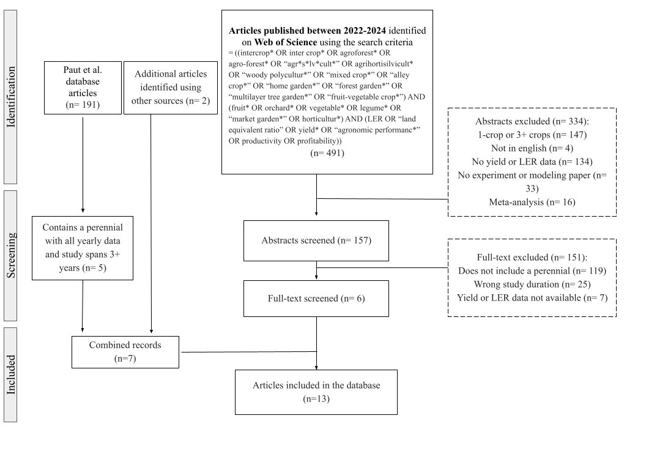
Supplementary Table 1. Moderators included in the database. All variables used as input into the model were divided by the square root of the number of observations to prevent false causation.
Categories | Moderating Variables
Article | - Title, DOI, Authors, year of publication, country, continent  - Experiment period, experiment years, study duration, number of replicates  - Study site location, Latitude, Longitude, climate zone
Site Characteristics | - Elevation  - Soil type, Soil texture, Soil pH
Management | - Fertilizer rate (N, P), fertilizer type (Organic, Mineral)  - Greenhouse or field experiment,  - Field applications (pesticide, herbicide), irrigation  - Experiment conducted  - Intercropping design, intercropping pattern, row and crop distance, crop planting density, mix proportion.
Crop | - Main Crop (MC): common name, species, family, age.  - Intercrop (IC): common name, species, family, age.  - Classification (perennial or annual).  - Yield measure and type (biomass, fruit yield, vegetative yield)
Climate | - Annual: mean temperature, mean minimum temperature of the coldest month, mean maximum temperature of the warmest month, total annual precipitation.  - Historical 20-year average: mean temperature, mean minimum temperature in the coldest month, mean maximum temperature of the warmest month, average annual precipitation

Supplementary Table 2. List of the 33 unique intercropping combinations within the database and associated mixture proportion across studies
Main Crop | Intercrop | Mix. proportion across studies
Olive | Saffron | 50:50
Olive | Oats | 50:50
Olive | Lavender | 50:50
Olive | Wild Asparagus | 50:50
Olive | Durum wheat | 45:55
Goji Berry | Wheat | 50:50
Goji Berry | Oats | 50:50
Goji Berry | Wheatgrass | 50:50
Goji Berry | Needle Grass | 50:50
Goji Berry | Ryegrass | 50:50
Goji Berry | Sweet Sorghum | 50:50
Goji Berry | Sophora alopecuroides | 50:50
Goji Berry | White clover | 50:50
Goji Berry | Beet | 50:50
Goji Berry | Alfalfa | 50:50
Cacao | Screwbean Mesquite | 90:10
Cacao | Peach Palm | 90:10
Cacao | Erythrina velutina | 75:25
Almond | Caper | 25:75
Almond | Winter Thyme | 25:75
Pigeon pea | Maize | 43:57
Gliricidia | Cassava | 66:34
White leadtree | Cassava | 66:34
Siamese cassia | Cassava | 66:34
Apple | Peanut | 50:50, 70:30
Apple | Maize | 50:50, 90:10
Apple | Millet | 50:50, 70:30
Apple | Watermelon | 50:50
Gmelina | Mango | 75:25
Gmelina | Pigeon pea | 60:40
Mango | Pigeon pea | 60:40
Coffee | Macadamia | 60:40
Coffee | Banana | 75:25, 66:34, 50:50, 80:20

Supplementary Figure 2. Funnel Plots showing the Cohen’s d effect size (log scale) of the mean pLER data for the (a) main crop (crop 1) and (b) intercrop (crop 2), and the bootstrapped data for the (c) main crop (crop 1) and (d) intercrop (crop 2). Egger’s regression is not significant for any of the plots (p > 0.05).
b
a
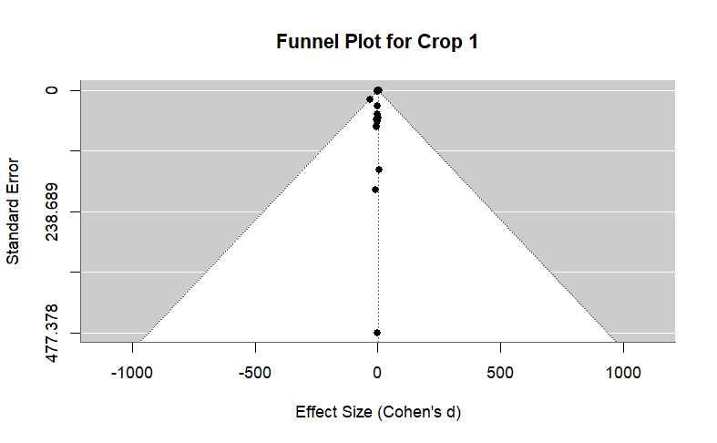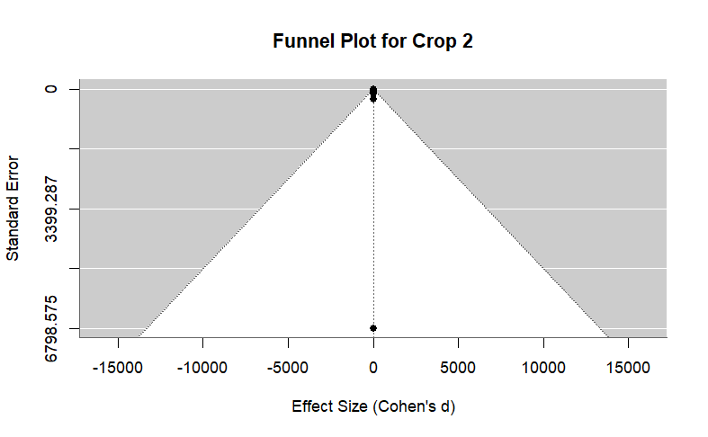
d
c
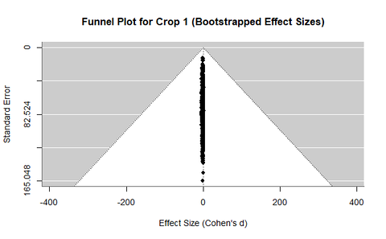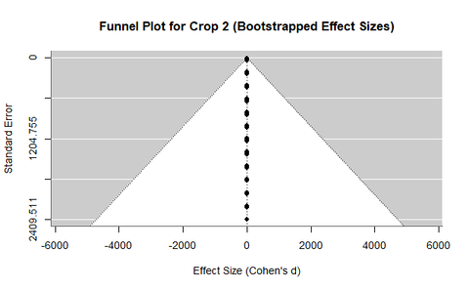

Supplementary Figure 3. The partial land use efficiency separated by crop. A value > 1 indicates that agroforestry has a net higher productivity compared to sole cropping. A value > 0.5 suggests that the combined crop productivity, assuming an even mixture, in agroforestry will exceed sole cropping. Values on the right show the number of observations with the number of studies in parentheses. The median is represented by vertical bars inside the box, edges indicate first and third quartiles, and whiskers indicate the minimum and maximum values.
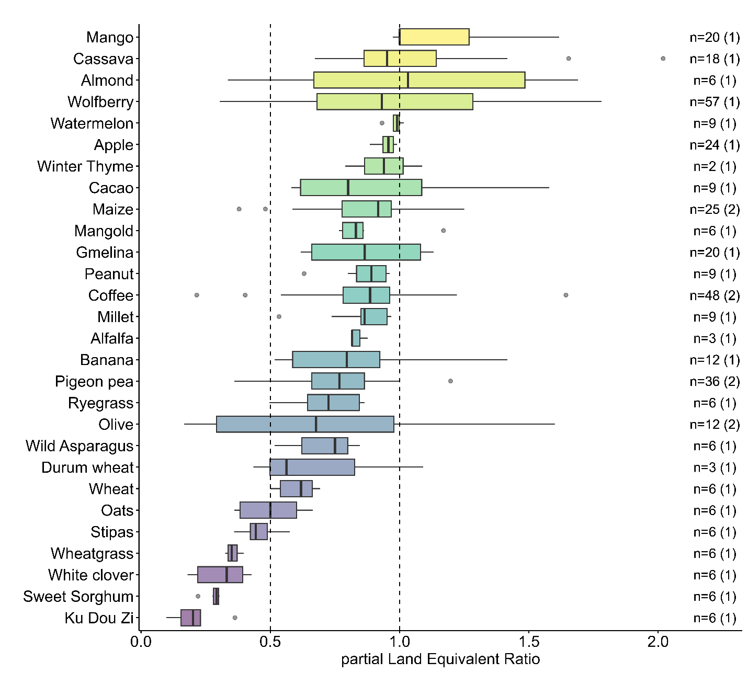

Supplementary Figure 4. Bootstrapped estimated effect size means and ± 95% confidence interval of individual crop performance for macronutrient provision evaluating the nutrient mean pLER (MC: n = 29, IC: n = 24), absolute stability (MC: n = 29, IC: n = 24), and relative stability (MC: n = 12, IC: n = 12). Values > 1 show that agroforestry had an advantage in yield or stability compared to sole cropping, while values < 1 show the reverse. The effect is significant if it does not cross one, represented by the open circle for non-significant and closed circle for significant. 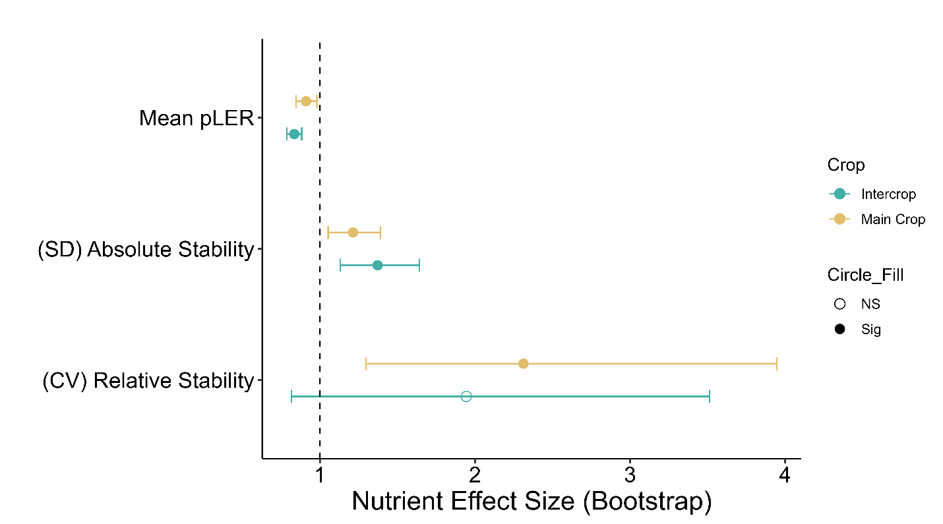

Supplementary Figure 5. Variable importance plot from a Random Forest analysis for relative stability of the (a) main crop and (b) intercrop.

Supplementary Figure 6. Crop absolute stability trends differently with the main crop and the intercrop when there is a dramatic change in the annual precipitation compared to the historic mean. The lines on the graph represent the trend of the perennial main crop (yellow) (n = 29) and the intercrop (green) (n = 24) for stability in a change of precipitation. A positive trend assumed to show that system stability favors sole cropping in high precipitation years, while a negative trend is assumed to show that the system stability favors agroforestry in high precipitation years (trends represented by τ; MC: τ = 0.05, p = 0.64; IC: τ = -0.19, p = 0.09).
