Supplementary information
- Estimation of the regional and global SOC benefits with compost
To address the comparatively limited data on compost production and compost use globally, we used a top-down approach to estimate the potential benefits with compost use on global region (Africa, Asia, Europe and North America) and global scales.
First, we explored the regional and global compost-C retention coefficient (%, CCRC)¹, which was defined as the percent of compost-C that sequestered (kg ha⁻¹ y⁻¹) into soil to compost-C input (kg ha⁻¹ y⁻¹), aiming to determine how much compost-C can be sequestrated in cropland soils if we use a given amount of compost-C.
The CCRC can be calculated with the regression coefficient of the relationship between compost-C input (kg ha⁻¹ y⁻¹) and soil SOC sequestration rate (kg ha⁻¹ y⁻¹, SOCSR) (Extended data Fig. 14).
The SOCSR was estimated by the following equation: SOCSR (kg C ha⁻¹ y⁻¹) = (SOCD_{t} - SOCD_{c})/T, where SOCD_{t} and SOCDc are the SOC density (kg C ha⁻¹) with CO/CM and MF, after the end of experiment, respectively. T refers to the number of years of compost use.
The SOCD was calculated by the following equation: SOCD (kg C ha⁻¹) = SOC (g kg⁻¹) × BD (g cm⁻³) × H (cm) × 10, where SOC was soil organic carbon content, BD was soil bulk density, H was soil sampling depth. If H was unavailable, we used an average value for a soil depth of 20 cm. If BD was unavailable, it was estimated using following equation: BD = 1.377 × e ^{(-0.0048 × SOC) 2}.
Second, we have estimated the global production of organic resource that can be used for composting. Organic resource includes crop straw and animal manure. The crop straw was produced from barley, cassava, groundnuts, maize, potatoes, rapeseed, rice, soybeans, sugar beet, sugarcane, sunflower seed, sweet potatoes, and wheat, which provides over 80% of crop straw. Then, using the ratio of crop straw to grain³⁻⁴, carbon content in straw and C/N ratio of straw⁵ (Supplementary Table 1), the organic carbon and nitrogen from crop straw was estimated. The animal manure N was obtained from the estimation from FAO⁶. whilst the carbon input from manure was calculated according to the C/N ratio of manure (20.0)⁷. In total, the global and regional annual production of organic carbon and nitrogen from crop and animal manure was estimated (Supplementary Table 2).
Third, we assumed 40% of organic carbon can be used for composting. A suitable C/N ratio (20.0) was selected for composting⁸. The organic nitrogen input for composting was estimated based on C/N ratio. Using the carbon (50%)⁸ and nitrogen (31.4%)⁹ loss factor (%) during the composting process, we obtained the amount of carbon and nitrogen in compost that can be used on global cropland. Using the CCRC outlined above, the soil carbon sequestration rate was estimated (Supplementary Table 3).

- Estimation of global and regional cereal productivity benefits with compost
We have calculated the potential total N input (CM-N) that includes the current global mineral fertilizer N use (MF-N)⁶ and potential compost N use (Compost-N). Then, using the relationships between the relative N supply compared to mineral fertilizer with mineral fertilizer-amended compost (CM) and SOC benefits at global and regional scale (Extended data Fig. 15), we obtained the global and regional yield benefit. Based on the yield benefits with compost use and the regional and global current cereal production, we estimated the potential cereal production benefits (Supplementary Table 4).

- The limitations and barriers for worldwide implementation of compost
While compost benefits are compelling, worldwide implementation faces challenges. Many smallholder farmers in Sub-Saharan Africa use their organic resources (e.g., crop residues, animal manure) for other uses (e.g., as animal feed, as cooking and building materials)¹⁰. Compost use in low-income regions is often constrained by lack of skilled labor, tools for compost production, collection, transportation and application¹¹. Although a modern compost industry is already established in Europe and North America, compost is rarely used in cropland. A large barrier to compost use is intensive liquid livestock manure, produced at surplus and applied to surrounding croplands^{12.} In Southeast Asia, such as Japan and China, compost use in crop cultivation has a long history¹³, but regions vary in science-based modern composting. Modern composting is more advanced and widely used in Japan compared than other Asia regions¹⁴. But compost use is declining with ageing Japanese farmers¹⁵. In China, modern composting has seen a recent surge driven by a nationwide project of recycling livestock manure¹⁶, but many composting plants are small-scale and have incomplete-infrastructure, which results in poor compost quality and negative environmental impacts. Another key factor for compost use in China and other regions is a lack of knowledge of the nutrient content and crop availability of nutrients in different composts, and a comprehensive system of recommendation for use is lacking (e.g., The UK’s MANNER-NPK system¹⁷).

Supplementary Data
Supplementary Table 1 The ratio of crop straw to grain, carbon content in straw and C/N ratio of straw.
Organic  resources | Ratio of crop straw to grain | Carbon content in straw (%) | C/N ratio of straw
Barley | 1.04 | 47.9 | 76.6
Cassava | 0.57 | 50.0 | 50.0
Groundnuts | 1.14 | 42.6 | 23.9
Maize | 1.04 | 44.4 | 49.9
Potatoes | 0.71 | 36.7 | 14.2
Rapeseed | 2.87 | 44.9 | 55.0
Rice | 1.00 | 41.8 | 48.0
Soybeans | 1.50 | 45.3 | 29.3
Sugar beet | 0.43 | 50.0 | 50.0
Sugarcane | 0.43 | 45.7 | 49.1
Sunflower seed | 2.63 | 40.0 | 41.0
Sweet potatoes | 0.45 | 36.7 | 14.2
Wheat | 1.17 | 39.9 | 66.5

Supplementary Table 2 Estimation of regional and global annual production of organic carbon and nitrogen from crop straw and animal manure.
 | Total organic N production (Tg) |  |  | Total organic C production (Tg)
Regions | Animal manure | Crop straw | Total | Animal manure | Crop straw | Total
Africa | 30.4 | 4.16 | 34.5 | 607.2 | 171.3 | 778.5
China | 12.4 | 9.1 | 21.5 | 248.7 | 369.0 | 617.8
Europe | 13.4 | 8.46 | 21.9 | 268.1 | 387.2 | 655.2
USA | 7.0 | 6.6 | 13.6 | 140.3 | 276.4 | 416.7
Global | 125.8 | 54.0 | 179.8 | 2516.3 | 2324.2 | 4840.5
Note: Other regions such as South America and Australia were excluded from the region-specific analysis as there is limited data with great uncertainties.

Supplementary Table 3 Estimation of regional and global SOC benefits with compost use.
Region | Total organic C  (Tg) | C used for composting  (Tg) | N used for composting  (Tg) | C in final compost  (Tg) | N in final compost  (Tg) | C sequestration rate (Tg y⁻¹)
Africa | 778.5 | 311.4 | 15.6 | 155.7 | 10.7 | 46.7
China | 617.8 | 247.1 | 12.4 | 123.6 | 8.5 | 27.9
Europe | 655.2 | 262.1 | 13.1 | 131.0 | 9.0 | 20.7
USA | 416.71 | 166.7 | 8.3 | 83.3 | 5.7 | 19.6
Global | 4840.5 | 1936.2 | 96.8 | 968.1 | 66.4 | 170.4
Note: Other regions such as South America and Australia were excluded from the region-specific analysis as there is limited data with great uncertainties.

Supplementary Table 4 Estimation of regional and global cereal production benefits with compost use.
Region | MF-N  (Tg) | Compost-N  (Tg) | CM-N  (Tg) | Ratio of CM to MF | Yield benefit (%) | Current cereal production  (Tg) | Yield increase  (Tg)
Africa | 4.3 | 10.7 | 15.0 | 3.5 | 40.4 | 204.2 | 82.5
China | 28.3 | 8.5 | 36.8 | 1.3 | 4.0 | 614.7 | 24.8
Europe | 14.8 | 9.0 | 23.8 | 1.6 | 8.7 | 543.1 | 47.0
USA | 11.6 | 5.7 | 17.4 | 1.5 | 14.4 | 421.5 | 60.6
Global | 108.7 | 66.4 | 175.1 | 1.6 | 11.9 | 2979.0 | 354.5
Note: Other regions such as South America and Australia were excluded from the region-specific analysis as there is limited data with great uncertainties.

Supplementary references
- Maillard E., & Angers, D. A. Animal manure application and soil organic carbon stocks: a meta-analysis. Glob. Chang Biol. 20, 666-679 (2014).
- Song, G. H., Li, L. Q., Pan, G. X., & Zhang, Q. Topsoil organic carbon storage of China and its loss by cultivation. Biogeochemistry 74, 47-62 (2005).
- Xie, G. H., Wang, X. Y., Han, D. Q., & Xue, S. Harvest index and residue factor of non-cereal crops in China. Journal of China Agricultural University (in Chinese) 16(1), 9-17 (2011).
- Xie, G. H., Han, D. Q., Wang, X. Y., & Lv, R. H. Harvest index and residue factor of cereal crops in China. Journal of China Agricultural University (in Chinese) 16(1), 1-8 (2011).
- Nutrient records of organic resources in China (1999).
https://ishare.iask.sina.com.cn/f/17503715.html.
- Food and Agriculture Organization of the United Nations. FAOSTAT Online Database (2018). http://faostat.fao.org/.
- Wang, G. C., Zhang, W., Sun, W. J., Li, T. T., & Han, P. F. Modeling soil organic carbon dynamics and their driving factors in the main global cereal cropping systems. Atmos. Chem. Phys. 17, 11849-11859 (2017).
- Bernal, M. P., Alburquerque, J. A., & Moral, R. Composting of animal manures and chemical criteria for compost maturity assessment. A review. Bioresour. Technol. 100, 5444-5453 (2009).
- Zhao, S. X., Schmidt S., Qin W., L, J., L, G. X., & Zhang, W. F. Towards the circular nitrogen economy - A global meta-analysis of composting technologies reveals much potential for mitigating nitrogen losses. Sci. Total Environ. 704, 135401.1-135401.10 (2020).
- Smith, J. U. et al. Sustainable use of organic resources for bioenergy, food and water provision in rural Sub-Saharan Africa. Renew. Sustain. Ener. Revie. 50, 903-917 (2015).
- Bougnom, B. P., Boyomo, O., Nwaga, D., Ngang, J. J. E., & Etoa, F. X. Compost: A Tool to Sustainable Urban and Peri-Urban Agriculture in Sub-Saharan Africa. Composting for Sustainable Agriculture (pp.269-283). (2014). DOI: 10.1007/978-3-319-08004-8_13.
- Viaene, J. et al. Opportunities and barriers to on-farm composting and compost application: A case study from northwestern Europe. Waste Manage. 48, 181-192 (2016).
- King. F. H. Farmers of Forty Centuries. (1911).
- Mishima, S. I., Leon, A., Eguchi, S., & Shirato, Y. Livestock Waste, Potential Manure Production and Its Use in Japan in 1980 and 2010. Compost Sci. Util. 25(S), S43-S52 (2017).
- Ohizumi, K. Land reform aims to eliminate farmers aging and abandoned farmland in Japan. The Japanese Journal of Real Estate Sciences (in Japanese), 23(4), 66-72 (2010).
- Ministry of Agriculture and Rural Affairs (MARA). Recycling of livestock manure’ policy the target for manure recycling is 75% by the end of 2020. (2017). Available at MARA of the People’s Republic of China website.
http://www.gov.cn/zhengce/content/2017-06/12/content_5201790.htm.
- Nicholson, F. A. et al. An enhanced software tool to support better use of manure nutrients: MANNER‐NPK. Soil Use Manage. 29, 473-484 (2013).

- Publications used in the meta-analysis
- Shan, N. et al. Emission of NH₃ and N₂O from Spinach Field Treated with Different Fertilizers. Environ. Sci. (in Chinese) 39, 4705-4716 (2018).
- Bi, Z. C., Zhang, H. X., Fang, G., Guo, S., & Xiong, Z. Q. Effects of combined organic and inorganic fertilizers on N₂O emissions in intensified vegetable field. Plant Nutr. Fert. Sci. (in Chinese) 23, 154-161 (2017).
- Xiao, Q. et al. Ammonia volatilization from fluvo-aquic clay soil and its influencing factors during wheat growing season under different fertilization. J. Agro-Environ. Sci. (in Chinese) 35, 2011-2018 (2016).
- Huang, T. et al. Effects of Different Organic Fertilization Modes on Yield, Quality, Fertilizer Nitrogen Utilization of Spring Maize and Nitrogen Loss from Field. Soil (in Chinese) 42, 915-919 (2010).
- Sheng, H., Pan, G. Y., Li, Y. Q., Dong, Z. R., & Song, H. Effect of different fertilizer treatments on yield and quality of wheat. J. Anhui Agric. Univ. (in Chinese) 41, 540-544 (2014).
- Zhang, Y. P., Liu, Q., Rong, X. M., Xie, G. X., & Li, B. Effects of Different Combinations of Organic and Chemical Fertilizers on Soil Microbial Activit. Chin. J. Soil Sci. (in Chinese) 44, 1434-1439 (2013).
- Li, B. et al. Effect of combined application with organic and inorganic fertilizers on methane emission in double-cropping paddy fields. Ecol. & Environ. (in Chinese) 22, 276-282 (2013).
- Wang, F., Zhang, J. S., Gao, P. C., & Tong, Y. A. Short term effect of applying organic materials in improving soil fertility of Weibei rainfed highland. Chin. J. Appl. Ecol. (in Chinese) 21, 930-936 (2010).
- Ren, X. L. et al. Effects of application of rapeseed cake compost combined with chemical fertilizer on the yield and quality of flue-cured tobacco and soil microorganism. J. Nanjing Agric. Univ. (in Chinese) 35, 92-98 (2012).
- Zhang, F. B. et al. Effects of Chemical Fertilizer and Composts Produced from Chicken, Swine and Cattle Manures on Yields and Quality of Leaf Vegetables. Chin. Agric. Sci. Bull. (in Chinese) 24, 283-286 (2008).
- Ni, Z. Y., Yao, Y. C., & Zhang, M. K. Soil Fertility and Heavy Metal Accumulation in Orchard System: Under Short-term Application of Compost with Different Manure Sources. Chin. Agric. Sci. Bull. (in Chinese) 33, 100-106 (2017).
- Li, M. M., Zhang, G. G., Yang, Z. B., & Yang, W. R. Effect of Different Amounts of Compost Fertilizer on Yields and Nutritive Values of Whole Corn Plant Silage. Sci. Agric. Sin. (in Chinese) 46, 2337-2344 (2013).
- Fan, M., Li, Q., Zhang, D., Jin, X. J., & Cao, A. N. Effects of compost replacement fertilizer on grain yield and water use efficiency of maize. Agric. Res. Arid Areas (in Chinese) 35, 143-146 (2017).
- Wang, H., Jin, X. J., Tang, W. W., Zhang, X. Y., & Xi, X. D. Effects of combination with compost and chemical fertilizer for maize growth and yield in Gansu inland irrigation area. China Soil Fert. (in Chinese) 2, 78-82 (2012).
- Xiao, Q. H., Wu, D. P., He, J. T. & Cao, Y. E. Effects of Functional Compost on Growth, Quality and Yield of Dioscorea opposita Thunb. cv. Tiegun. J. Changjiang Veg. (in Chinese) 18, 66-70 (2016).
- Zhou, H. et al. Effects of combined application of chemical and organic fertilizers on ammonia volatilization and maize yield in salinized soil. J. Agro-Environ. Sci. (in Chinese) 38, 1649-1656 (2019).
- Lu, Q. et al. Effect of straw returning and combined applications of organic fertilizer and inorganic fertilizer on grain yield and nitrogen utilization under rice-wheat rotation system. J. Nanjing Agric. Univ. (in Chinese) 37, 66-74 (2014).
- Sun, N., Shang, H. P., Ru, S. H., & Su, D. C. Effects of Continuous Application of Sewage Sludge Compost on Heavy Metals Accumulation and Mobility Characteristics in Soil Profile and on Heavy Metals Uptake of Wheat. Environ. Sci. (in Chinese) 38, 815-824 (2017).
- Qi, Z. Y. et al. Effects of continuous application of non-hazardous sewage sludge compost on fertility of sandy fluvo-aquic soil. Plant Nutr. Fert. Sci. (in Chinese) 24, 150-158 (2018).
- Guo, K. L. et al. Effects of consecutive application of composted sewage sludge on active organic nitrogen fractions in the sandy fluvo-aquic soil. Chin. J. Appl. Ecol. (in Chinese) 29, 1960-1968 (2018).
- Fan, X. S. et al. Effect of continuous application of pruning compost on the growth and distribution of pear roots. J. Fruit Sci. (in Chinese) 34, 1274-1285 (2017).
- Zeng, L. T. et al. Effect of vermicompost mixed with probiotics on watermelon growth and quality. China Soil Fert. (in Chinese) 1, 103-110 (2017).
- Luo, L. G., Jin, T. S. Y., & Yi, T. C. X. N₂O and CH₄ emission from Japan rice fields under different long-term fertilization patterns and its environmental impact. Chin. J. Appl. Ecol. (in Chinese) 21, 3200-3206 (2010).
- Shao, H. W. et al. Effect of Municipal Solid Waste (MSW) Compost Application on Heavy Metal Distribution in Maize Plant and Soil Nutrients. J. Agric. Res. Environ. (in Chinese) 30, 58-63 (2013).
- Ge. C. H., Yang, X. H., Sun, J. S. & Wang, X. Y. Influence of Living Garbage Compost Applied on Yield and Quality of Corn, and Physical-Chemical Character in Soil. Chin. Agric. Sci. Bull. (in Chinese) 29, 237-241 (2013).
- Yang, Y. H., Yi, J. T., Zhang, C., Chen, H., & Mu, Z. J. Effect of Application of Sewage Sludge Composts on Greenhouse Gas Emissions in Soil. Environ. Sci. (in Chinese) 38, 1647-1653 (2017).
- Shi, Y. P., Yu, H. Y., Song, K. F., Xu, H., & Ma, J. Effects of composted sludge application on greenhouse gases emissions from paddy soil and heavy metals accumulation in soil and plant. Ecol. & Environ. (in Chinese) 27, 178-185 (2018).
- Wang, H. F. et al. Emission of CH₄, N₂O and NH₃ from Vegetable Field Applied with Animal Manure Composts. Environ. Sci. (in Chinese) 35, 892-900 (2014).
- Wang, J. C. et al. Impact of applying straw compost on quality of lettuce and soil enzyme activity. Guangdong Agric. Sci. (in Chinese) 37, 97-99 (2010).
- Chen, X. et al. Effect of Sewage Sludge Compost Application on Heavy Metals Accumulation in Soil and Wheat Shoots. Chin. Agric. Sci. Bull. (in Chinese) 26, 278-283 (2010).
- Yang, L. J., Yang, Q. D., Zhou, C. J., & Chang, Q. Effect of vermicompost on Tomato Yield and Quality and soil Microorganisms Population in Greenhouse. Chin. J. Soil Sci. (in Chinese) 44, 1455-1459 (2013).
- Sun, X. P., Li, G. X., Xiao, A. P., Leng, J., & Liao, L. P. Impact of Pig Manure Compost on Maize Yield and Soil Properties. PLANT FIBER SCIENCES IN CHINA (in Chinese) 35, 258-264 (2013).
- Tao, Y. Y. et al. Partial nitrogen fertilizer substitution by aquatic plant compost to improve rice yield and paddy soil fertility. (in Chinese). 33, 196-202 (2017).
- Liang, L. N., Huang, Y. X., Yang, H. F., Xu, Z., & Li, J. Effects of farmland application of sewage sludge on crop yields and heavy metal accumulation in soil and crop. Trans. Chin. Soc. Agric. Eng. (in Chinese) 25, 81-86 (2009).
- Song, Y., Guo, S. J., Xie, M. M., Zhang, L., & Sun, H. J. Effect of different application ratios of inorganic and organic fertilizers on nitrogen and phosphorus contents of leaves, yield and quality of Castanea mollissima. J. Northeast Agric. Univ. (in Chinese) 48, 28-35 (2017).
- He, J. L. et al. Dynamic Change of Nitrogen in Early Rice Paddy Field on the Condition of Organic Fertilizer Instead of Part of the Inorganic Fertilizer. Chin. Agric. Sci. Bull. (in Chinese) 29, 24-28 (2013).
- Tian, C. et al. Effects of organic manure application combined with chemical fertilizers on absorption of nutrient, yield and quality of rapeseed. China Soil Fert. (in Chinese) 4, 70-74 (2012).
- Luo, J. et al. Effect of Combined Application of Chemical Fertilizer with Organic Manure on Cucumber Yield and Soil Microbial Diversity. J. Eco. Rur. Environ. (in Chinese) 32, 774-779 (2016).
- Zhang, Y. P. et al. Effects of Combination of Organic and Inorganic Fertilizer on Crop Nutrient Utilization Rate, Nitrogen and Phosphorus Loss in Dry Land. J. Soil Water Conserv. (in Chinese) 27, 44-48 (2013).
- Zhang, Y. P. et al. Effects of Combined Application of Organic Fertilizer and Chemical Fertilizer on Double Cropping Rice Nutrient Utilization and Leaching Loss from Paddy Soil. J. Soil Water Conserv. (in Chinese) 26, 22-27 (2012).
- Tong, X. J., Li, W. T., Li, J., & Ni, Y. Z. Ef fect of Effective Microorganisms Compost on Winter Wheat Growth. Res. Agric. Moder. (in Chinese) 24, 456-458, 463 (2003).
- Chen, Y. N. et al. Corn straw composting in the field and in situ fertilizer effect. Chin. J. Appl. Ecol. (in Chinese) 25, 3507-3513 (2014).
- Ma, Y. H. et al. Effects of the Organic Fertilizers Made from Maize Straw on Grain Yield of Rice and Emission of Greenhouse Gases from Paddy Fields. Chin. J. Rice Sci. (in Chinese) 27, 520-528 (2013).
- Meng, L., Cai, Z. C., & Ding, W. X. Effects of long-term fertilization on N distribution and N2O emission in fluvoaquci soil in North China. Acta Ecol. Sin. (in Chinese) 28, 6197-6203 (2008).
- Wang, Y., Li, J., Cao, Z. P., & Yang, H. F. Effects of long-term fertilization on soil fungi. Chin. J. Eco-Agrc. (in Chinese) 22, 1267-1273 (2014).
- Halihashi, Y. et al. Effects of different combined applications of pig manure compost and inorganic fertilizers on rice yield and nutrients accumulation. J. Nanjing Agric. Univ. (in Chinese) 36, 77-82 (2013).
- Meng, L. et al. Effects of Combined Application of Pig Manure Compost and Inorganic Fertilizers on Yield of Rice Grains and Nitrogen Use Efficiency. J. Eco. Rur. Environ. (in Chinese) 24, 68-71, 76 (2008).
- Illera-Vives, M., Labandeira, S. S., Loureiro, L. I., & López-Mosquera, M. E. Agronomic assessment of a compost consisting of seaweed and fish waste as an organic fertilizer for organic potato crops. J. Appl. Phycol. 29, 1663-1671 (2017).
- Sánchez-Monedero, M. A. et al. Agronomic Evaluation of Biochar, Compost and Biochar-Blended Compost across Different Cropping Systems: Perspective from the European Project FERTIPLUS. Agronomy 9, 225.1-225.19 (2019).
- Hojito, M., Hayashi, K., & Matsuura, S. Ammonia exchange on grasslands in an intensive dairying region in central Japan. Soil Sci. Plant Nutr. 56, 503-511 (2010).
- Shan, L. N., He, Y. F., Chen, J., Huang, Q., & Wang, H. C. Ammonia volatilization from a Chinese cabbage field under different nitrogen treatments in the Taihu Lake Basin, China. J. Environ. Sci. 38, 14-23 (2015).
- Suddick, E. C., & Six, J. An estimation of annual nitrous oxide emissions and soil quality following the amendment of high temperature walnut shell biochar and compost to a small-scale vegetable crop rotation. Sci. Total Environ. 465, 298-307 (2013).
- Montemurro, F., Ferri, D., Tittarelli, F., Canali, S., & Vitti, C. Anaerobic Digestate and On-Farm Compost Application: Effects on Lettuce (Lactuca sativa L.) Crop Production and Soil Properties. Compost science & utilization, 18, 184-193 (2013).
- Das, S. et al. Assessing C-N balance and soil rejuvenation capacity of vermicompost application in a degraded landscape: A study in an alluvial river basin with Cajanus cajan. Environmental research, 177, 108591.1-108591.10 (2019).
- Yanagi, Y., & Shindo, H. Assessment of Long-Term Compost Application on Physical, Chemical, and Biological Properties, as well as Fertility, of Soil in a Field Subjected to Double Cropping. Agricultural ences, 7, 30-43 (2016).
- Jeong, S. T. et al. Beneficial effect of compost utilization on reducing greenhouse gas emissions in a rice cultivation system through the overall management chain. Sci. Total Environ. 613-614, 115-122 (2018).
- Agegnehu, G., Bass, A. M., Nelson, P. N., & Bird, M. I. Benefits of biochar, compost and biochar–compost for soil quality, maize yield and greenhouse gas emissions in a tropical agricultural soil. Sci. Total Environ. 543, 295-306 (2016).
- Agegnehu, G. et al. Biochar and biochar-compost as soil amendments: Effects on peanut yield, soil properties and greenhouse gas emissions in tropical North Queensland, Australia. Agric. Ecosyst. Environ. 213, 72-85 (2015).
- Glaser, B., Wiedner, K., Seelig, S., Schmidt, H., & Gerber, H. Biochar organic fertilizers from natural resources as substitute for mineral fertilizers. Agron. Sustain. Dev. 35, 667-678 (2015).
- Žydelis, R., Lazauskas, S., & Povilaitis, V. Biomass accumulation and N status in grain maize as affected by mineral and organic fertilizers in cool climate. J. Plant Nutr. 41, 2626-2636 (2018).
- Meijide, A., Cárdenas, L. M., Sánchez-Martín, L., & Vallejo, A. Carbon dioxide and methane fluxes from a barley field amended with organic fertilizers under Mediterranean climatic conditions. Plant Soil 328, 353-367 (2010).
- Fan, J. L. et al. Carbon sequestration in an intensively cultivated sandy loam soil in the North China Plain as affected by compost and inorganic fertilizer application. Geoderma 230-231, 22-28 (2014).
- Zhang, L. L. et al. Changes in Soil Carbon and Enzyme Activity as a Result of Different Long-Term Fertilization Regimes in a Greenhouse Field. PLoS One 10, e0118371-e011837110 (2015).
- Mazzon, M. et al. Changes in soil phenol oxidase activities due to long-term application of compost and mineral N in a walnut orchard. Geofis. Int. 316, 70-77 (2018).
- Cheng, W. G. et al. Changes in the soil C and N contents, C decomposition and N mineralization potentials in a rice paddy after long-term application of inorganic fertilizers and organic matter. Soil Sci. Plant Nutr. 62, 212-219 (2016).
- Lee, S. B. et al. Changes of soil organic carbon and its fractions in relation to soil physical properties in a long-term fertilized paddy. Soil Tillage Res. 104, 227-232 (2009).
- Melero, S., Madejón, E., Ruiz, J. C., & Herencia, J. F. Chemical and biochemical properties of a clay soil under dryland agriculture system as affected by organic fertilization. Eur. J. Agron. 26, 327-334 (2007).
- Cao, Y., Ma, Y., Guo, D. J., Wang, Q. J., & Wang, G. F. Chemical properties and microbial responses to biochar and compost amendments in the soil under continuous watermelon cropping. Plant Soil Environ. 63, 1-7 (2017).
- Issoufa, B. B., Ibrahim, A., Abaidoo, R. C., & Ewusi-Mensah, N. Combined use of millet glume-derived compost and mineral fertilizer enhances soil microbial biomass and pearl millet yields in a low-input millet cropping system in Niger. Arch. Agron. Soil Sci. 65, 1107-1119 (2019).
- Kim, S. Y., Pramanik, P., Gutierrez, J., Hwang, H. Y., & Kim, P. J. Comparison of methane emission characteristics in air-dried and composted cattle manure amended paddy soil during rice cultivation. Agric. Ecosyst. Environ. 197, 60-67 (2014).
- Hayashi, S. Comparison of Two High-Yielding Rice Varieties, Kita-aoba and Tachijobu, for Hokkaido, Northern Japan, and Effects of Swine Compost Application on the Growth and Grain Yield of Tachijobu. Plant. Prod. Sci. 18, 481-490 (2015).
- Iqbal, S. et al. Compost Amended with N Enhances Maize Productivity and Soil Properties in Semi-Arid Agriculture. Agron. J. 111, 2536-2544 (2019).
- Maucieri, C., Barco, A., & Borin, M. Compost as a Substitute for Mineral N Fertilization? Effects on Crops, Soil and N Leaching. Agronomy 9, 193.1-193.16 (2019).
- Baldi, E. et al. Compost can successfully replace mineral fertilizers in the nutrient management of commercial peach orchard. Soil Use Manage. 26, 346-353 (2010).
- Montemurro, F., Maiorana, M., Convertini, G., & Ferri, D. Compost Organic Amendments in Fodder Crops: Effects on Yield, Nitrogen Utilization and Soil Characteristics. Compost Sci. Util. 14, 114-123 (2006).
- Das, A. et al. Compost Quality Prepared from Locally Available Plant Biomass and their Effect on Rice Productivity under Organic Production System. J. Sustain. Agric. 34, 466-482 (2010).
- Maharjan, B., & Hergert, G. W. Composted Cattle Manure as a Nitrogen Source for Sugar Beet Production. Agron. J. 111, 917-923 (2019).
- Das, S., Jeong, S. T., Das, S., & Kim, P. J. Composted Cattle Manure Increases Microbial Activity and Soil Fertility More Than Composted Swine Manure in a Submerged Rice Paddy. Front. Microbiol. 8, 1702.1-1702.10 (2017).
- Chattha, M. U. et al. Composted Sugarcane By-product Press Mud Cake Supports Wheat Growth and Improves Soil Properties. Int. J. Plant Prod. 13, 241-249 (2019).
- Jeong, S. T., Cho, S. R., Lee, J. G., Kim, J. P., & Kim, G. W. Composting and compost application: Trade-off between greenhouse gas emission and soil carbon sequestration in whole rice cropping system. J. Clean Prod. 212, 1132-1142 (2019).
- Hernandez, T., Chocano, C., Coll, M. D., & Garcia, C. Composts as alternative to inorganic fertilization for cereal crops. Environ. Sci. Pollut. Res. (2018). DOI: 10.1007/s11356-018-3898-6.
- Parker, D., Venhaus, D., Robinson, C., Marek, T., & Sweeten, J. Corn Yield and Soil Fertility with Combined Use of Raw or Composted Beef Manure and Inorganic Fertilizers on the Texas Northern High Plains. Compost Sci. Util. 26, 79-90 (2018).
- Demelash, N., Bayu, W., Tesfaye, S., Ziadat, F., & Sommer, R. Current and residual effects of compost and inorganic fertilizer on wheat and soil chemical properties. Nutr. Cycl. Agroecosyst. 100, 357-367 (2014).
- Muir, J. P., Butler, T., Helton, T. J., & McFarland, M. L. Dairy Manure Compost Application Rate and Timing Influence Bermudagrass Yield and Nutrient Concentration. Crop Sci. 50, 2133-2139 (2010).
- Butler, T. J., Weindorf, D. C., Han, K. J., & Muir, J. P. Dairy Manure Compost Quality Effects on Corn Silage and Soil Properties. Compost Sci. Util. 17, 18-24 (2009).
- Li, Z. Q., Zhao, B. Z., Wang, Q. Y., Cao, X. Y., & Zhang, J. B. Differences in Chemical Composition of Soil Organic Carbon Resulting from Long-Term Fertilization Strategies. PloS One 10, e0124359.1- e0124359.14 (2015).
- Kuppusamy, S. et al. Does long-term application of fertilizers enhance the micronutrient density in soil and crop-Evidence from a field trial conducted on a 47-year-old rice paddy. J. Soils Sediments 18, 49-62 (2017).
- Cai, Z. C., & Qin, S. W. Dynamics of crop yields and soil organic carbon in a long-term fertilization experiment in the Huang-Huai-Hai Plain of China. Geoderma 136, 708-715 (2006).
- Hu, C., Cao, Z. P., Chen, Y. F., & Dawson, R. Dynamics of Soil Microbial Biomass Carbon, Mineral Nitrogen and Nitrogen Mineralization in Long-Term Field Experiment, Northern China. J. Sustain. Agric. 32, 287-302 (2008).
- Tang, Q., et al. Ecosystem services of partial organic substitution for chemical fertilizer in a peri-urban zone in China. J. Clean Prod. 224, 779-788 (2019).
- Naseem, T. et al. Effect of city waste compost applied alone and in combination with chemical fertilizer on the yield and nutrient uptake of wheat and subsequent maize crop. Pure Appl. Biol. 4, 471-479 (2018).
- Sharma, A. R., & Mittra, B. N. Effect of combinations of organic materials and nitrogen fertilizer on growth, yield and nitrogen uptake of rice. J. Agric. Sci. 111, 495-501 (1988).
- Das, S., & Adhya, T. K. Effect of combine application of organic manure and inorganic fertilizer on methane and nitrous oxide emissions from a tropical flooded soil planted to rice. Geoderma 213, 185-192 (2014).
- Bautista-Cruz, A., Domínguez, G. C., Mendoza, M. N. R., Pacheco, R. P., & Robles, C. Effect of compost and slow-release fertilizers addition on soil biochemistry and yield of maize (Zea mays L.) in Oaxaca, Mexico. Rev. FCA UNCUYO 46, 181-193 (2014).
- Baldi, E., et al. Effect of compost application on the dynamics of carbon in a nectarine orchard ecosystem. Sci. Total Environ. 637-638, 918-925 (2018).
- Kavitha, R., & Subramanian, P. Effect of Enriched Municipal Solid Waste Compost Application on Growth, Plant Nutrient Uptake and Yield of Rice. J. Agro. 6, 586-592 (2007).
- Mi, W. H. et al. Effect of inorganic fertilizers with organic amendments on soil chemical properties and rice yield in a low-productivity paddy soil. Geoderma 320, 23-29 (2018).
- Sinha, S. K., Kumar, V., & Jha, C. K. Effect of Integrated use of Bio-Compost and Nitrogen on Productivity and Soil Properties of Sugarcane Plant–Ratoon System in Calcareous Soil. Sugar Tech. 19, 485-491 (2016).
- Ding, W. X. et al. Effect of long-term compost and inorganic fertilizer application on background N₂O and fertilizer-induced N₂O emissions from an intensively cultivated soil. Sci. Total Environ. 465, 115-124 (2013).
- Baldi, E., Toselli, M., Marcolini, G., Marangoni, B., & Arboree, D. C. Effect of Mineral and Organic Fertilization on Soil Chemical, Biological and Physical Fertility in a Commercial Peach Orchard. Acta Hort. 721, 55-62 (2006).
- Dar, S. R. et al. Effect of nitrogen fertilizer with mushroom compost of varied C:N ratio on nitrogen use efficiency, carbon sequestration and rice yield. Communications in Biometry & Crop Science, 4, 31-39 (2009).
- Abedi, T., Alemzadeh, A., & Kazemeini, S. A. Effect of organic and inorganic fertilizers on grain yield and protein banding pattern of wheat. Australian Journal of Crop Science, 4, 384-389 (2010).
- ŽYDELISY, R., LAZAUSKAS, S., VOLUNGEVIČIUS, J., & POVILAITIS, V. Effect of organic and mineral fertilisers on maize nitrogen nutrition indicators and grain yield. Zemdirbyste 106, 15-20 (2019).
- Rosa, D. D. et al. Effect of organic and mineral N fertilizers on N₂O emissions from an intensive vegetable rotation. Biol. Fertil. Soils 52, 895-908 (2015).
- Trinh, M. V. et al. Effect of organic, inorganic and slow-release urea fertilisers on CH₄ and N₂O emissions from rice paddy fields. Paddy Water Environ. 15, 317-330 (2016).
- Cooperband, L., Bollero, G., & Coale, F. Effect of poultry litter and composts on soil nitrogen and phosphorus availability and corn production. Nutr. Cycl. Agroecosyst. 62, 185-194 (2002).
- Sharma, S., & Dhaliwal, S. S. Effect of Sewage Sludge and Rice Straw Compost on Yield, Micronutrient Availability and Soil Quality under Rice–Wheat System. Commun. Soil Sci. Plant Anal. 50, 1943-1954 (2019).
- Lee, C. H. et al. Effect of long-term Fertilization on Soil Carbon and Nitrogen Pools in Paddy Soil. Korean J. Soil Sci. Fert. (in Korean) 46, 216-222 (2013).
- Guo, L. Y. et al. Effects of cattle manure compost combined with chemical fertilizer on topsoil organic matter, bulk density and earthworm activity in a wheat–maize rotation system in Eastern China. Soil Tillage Res. 156, 140-147 (2016).
- Srivastava, P. K. et al. Effects of combined application of vermicompost and mineral fertilizer on the growth of Allium cepa L. and soil fertility. J. Plant Nutr. Soil Sci. 175, 101-107 (2012).
- Zhang, N. W. et al. Effects of compost made from pruned pear trees on the fruit, soil nutrients and microorganisms in pear orchards. Acta Hortic. 1217, 39-44 (2018).
- Watanabe, T. et al. Effects of continuous rice straw compost application on rice yield and soil properties in the Mekong Delta. Soil Sci. Plant Nutr. 55, 754-763 (2009).
- Yuan, J., Yuan, Y. K., Zhu, Y. Z., & Cao, L. K. Effects of different fertilizers on methane emissions and methanogenic community structures in paddy rhizosphere soil. Sci. Total Environ. 627, 770-781 (2018).
- Wang, C. Effects of Different Organic Materials on Crop Production under a Rice–Corn Cropping Sequence. Commun. Soil Sci. Plant Anal. 44, 2987-3005 (2013).
- Guo, Z. B. et al. Effects of different regimes of fertilization on soil organic matter under conventional tillage. Span. J. Agric. Res. 12, 801-808 (2014).
- Moe, K., Moh, S. M., Htwe, A. Z., Kajihara, Y., & Yamakawa, T. Effects of Integrated Organic and Inorganic Fertilizers on Yield and Growth Parameters of Rice Varieties. Rice Sci. 26, 309-318 (2019).
- Lee, C. H., Lee, I. B., & Kim, P. J. Effects of long-term fertilization on organic phosphorus fraction in paddy soil. Soil Sci. Plant Nutr. 50, 485-491 (2004).
- Chang, E. H., Wang, C. H., Chen, C. L., & Chung, R. S. Effects of long-term treatments of different organic fertilizers complemented with chemical N fertilizer on the chemical and biological properties of soils. Soil Sci. Plant Nutr. 60, 499-511 (2014).
- Xin, X. L., Zhang, J. B., Zhu, A. N., & Zhang, C. Z. Effects of long-term (23 years) mineral fertilizer and compost application on physical properties of fluvo-aquic soil in the North China Plain. Soil Tillage Res. 156, 166-172 (2016).
- Yu, H. Y. et al. Effects of long-term compost and fertilizer application on stability of aggregate-associated organic carbon in an intensively cultivated sandy loam soil. Biol. Fertil. Soils 48, 325-336 (2012).
- Celik, I., Gunal, H., Budak, M., & Akpinar, C. Effects of long-term organic and mineral fertilizers on bulk density and penetration resistance in semi-arid Mediterranean soil conditions. Geoderma 160, 236-243 (2010).
- Zhen, Z. et al. Effects of Manure Compost Application on Soil Microbial Community Diversity and Soil Microenvironments in a Temperate Cropland in China. PloS One 9, e108555.1- e108555.12 (2014).
- Crecchio, C. et al. Effects of municipal solid waste compost amendments on soil enzyme activities and bacterial genetic diversity. Soil Biol. Biochem. 36, 1595-1605 (2004).
- Meena, M. D. et al. Effects of municipal solid waste compost, rice-straw compost and mineral fertilisers on biological and chemical properties of a saline soil and yields in a mustard–pearl millet cropping system. Soil Res. 54, 958-969 (2016).
- Mapanda, F., Wuta, M., Nyamangara, J., & Rees, R. M. Effects of organic and mineral fertilizer nitrogen on greenhouse gas emissions and plant-captured carbon under maize cropping in Zimbabwe. Plant Soil 343, 67-81 (2011).
- Yao, Z. S. et al. Effects of organic matter incorporation on nitrous oxide emissions from rice-wheat rotation ecosystems in China. Plant Soil 327, 315-330 (2009).
- Komiyama, T., Ito, T., & Saigusa, M. Effects of phosphorus-based application of animal manure compost on the yield of silage corn and on soil phosphorus accumulation in an upland Andosol in Japan. Soil Sci. Plant Nutr. 60, 863-873 (2014).
- Wang, F., Tong, Y. A., Zhang, J. S., Gao, P. C. & Cofe, J. N. Effects of various organic materials on soil aggregate stability and soil microbiological properties on the Loess Plateau of China. Plant Soil Environ. 59, 162-168 (2013).
- Sriramachandrasekharan, V., Manivannan, R., & Ravichandran, M. Enhancement of rice productivity and soil fertility through system integration of organic and mineral fertilizers in Vertisols. Arch. Agron. Soil Sci. 58, S158-S164 (2012).
- Illera-Vives, M., Labandeira, S. S., Brito, L. M., López-Fabal, A., & López-Mosquera, M. E. Evaluation of compost from seaweed and fish waste as a fertilizer for horticultural use. Sci. Hortic. 186, 101-107 (2015).
- Lee, J. Evaluation of Composted Cattle Manure Rate on Bulb Onion Grown with Reduced Rates of Chemical Fertilizer. HortTechnology 22, 798-803 (2012).
- Mcdonald, M. R., Bakker, C. J., & Motior, M. R. Evaluation of Wood Biochar and Compost Soil Amendment on Cabbage Yield and Quality. Can. J. Plant Sci. 99, 624-638 (2019).
- Warman, P. R., & Cooper, J. M. Fertilization of a mixed forage crop with fresh and composted chicken manure and NPK fertilizer: Effects on dry matter yield and soil and tissue N, P and K. Can. J. Soil Sci. 80, 377-344 (2000).
- Miao, S. J., Qiao, Y. F., Han, X. Z., Franco, R. B., & Burger, M. Frozen Cropland Soil in Northeast China as Source of N2O and CO2 Emissions. PLoS One 9, e115761.1- e115761.16 (2014).
- Dalal, R. C., Gibson, I., Allen, D. E., & Menzies, N. W. Green waste compost reduces nitrous oxide emissions from feedlot manure applied to soil. Agric. Ecosyst. Environ. 136, 273-281 (2010).
- Zhao, B. Z., Chen, J., Zhang, J. B., Xin, X. L., & Hao, X. Y. How different long-term fertilization strategies influence crop yield and soil properties in a maize field in the North China Plain. J. Plant Nutr. Soil Sci. 176, 99-109 (2013).
- Hafidi, M. et al. Impact of applying composted biosolids on wheat growth and yield parameters on a calcimagnesic soil in a semi-arid region. African Journal of Biotechnology 11, 9805-9815 (2012).
- Zafar, M., Abbasi, M. K., Arjumend, T., & Jabran, K. Impact of compost, inorganic phosphorus fertilizers and their combination on maize growth, yield, nutrient uptake and soil properties. J. Anim. Plant Sci. 22, 1036-1041 (2012).
- Ning, C. C. et al. Impacts of chemical fertilizer reduction and organic amendments supplementation on soil nutrient, enzyme activity and heavy metal content. J. Integr. Agric. 16, 1819-1831 (2017).
- Verma, S. et al. Improvement of antioxidant and defense properties of Tomato (var. Pusa Rohini) by application of bioaugmented compost. Journal of Biological Sciences 22, 256-264 (2015).
- Sarwar, G. et al. Improvement of soil physical and chemical properties with compost application in Rice-wheat cropping system. Pak. J. Bot. 40, 275-282 (2008).
- Drury, C. F. et al. Influence of compost source on corn grain yields, nitrous oxide and carbon dioxide emissions in southwestern Ontario. Can. J. Soil Sci. 94, 347-355 (2014).
- Mugnai, S., Masi, E., Azzarello, E., & Mancuso, S. Influence of Long-Term Application of Green Waste Compost on Soil Characteristics and Growth, Yield and Quality of Grape (Vitis vinifera L.). Compost Sci. Util. 20, 29-33 (2012).
- Sangeetha, S. P., Balakrishnan, A., & Devasenapathy, P. Influence of Organic Manures on Yield and Quality of Rice (Oryza sativa L.) and Blackgram (Vigna mungo L.) in Rice-Blackgram Cropping Sequence. American Journal of Plant Sciences 4, 1151-1157 (2013).
- Zhang, H. J., Ding, W. X., Yu, H. Y., & He, X. H. Linking organic carbon accumulation to microbial community dynamics in a sandy loam soil: result of 20 years compost and inorganic fertilizers repeated application experiment. Biol. Fertil. Soils 51, 137-150 (2015).
- Lehtinen, T. et al. Long-term amendment of four different compost types on a loamy silt Cambisol: impact on soil organic matter, nutrients and yields. Arch. Agron. Soil Sci. 63, 663-673 (2016).
- Bedada, W., Karltun, E., Lemenih, M., & Tolera, M. Long-term addition of compost and NP fertilizer increases crop yield and improves soil quality in experiments on smallholder farms. Agric. Ecosyst. Environ. 195, 193-201 (2014).
- Nayak, P., Patel, D., Ramakrishnan, B., Mishra, A. K., & Samantaray, R. N. Long-term application effects of chemical fertilizer and compost on soil carbon under intensive rice–rice cultivation. Nutr. Cycl. Agroecosyst. 83, 259-269 (2009).
- Nayak, D. R., Babu, Y. J., & Adhya, T. K. Long-term application of compost influences microbial biomass and enzyme activities in a tropical Aeric Endoaquept planted to rice under flooded condition. Soil Biol. Biochem. 39, 1897-1906 (2007).
- Meng, L., Ding, W. X., & Cai, Z. C. Long-term application of organic manure and nitrogen fertilizer on N2O emissions, soil quality and crop production in a sandy loam soil. Soil Biol. Biochem. 37, 2037-2045 (2005).
- Kwon, S. I. et al. Long-term assessment of the environmental fate of heavy metals in agricultural soil after cessation of organic waste treatments. Environ. Geochem. Health 36, 409-419. (2014).
- Ros, M., Klammer, S., Knapp, B., Aichberger, K., & Insam, H. Long-term effects of compost amendment of soil on functional and structural diversity and microbial activity. Soil Use Manage. 22, 209-218. (2010).
- Giusquiani, P. L., Gigliotti, G., & Businelli, D. Long-term effects of heavy metals from composted municipal waste on some enzyme activities in a cultivated soil. Biol. Fertil. Soils 17, 257-262 (1994).
- Hemmat, A., Aghilinategh, N., Rezainejad, Y., & Sadeghi, M. Long-term impacts of municipal solid waste compost, sewage sludge and farmyard manure application on organic carbon, bulk density and consistency limits of a calcareous soil in central Iran. Soil Tillage Res. 108, 43-50 (2010).
- Zhang, Y. L. et al. Maize yield and soil fertility with combined use of compost and inorganic fertilizers on a calcareous soil on the North China Plain. Soil Tillage Res. 155, 85-94 (2016).
- Halvorson, A. D., Del Grosso, S. J., & Stewart, C. E. Manure and Inorganic Nitrogen Aﬀect Trace Gas Emissions under Semi-Arid Irrigated Corn. J. Environ. Qual. 45, 906-914 (2016).
- Iqbal, S. et al. Maximizing maize quality, productivity and profitability through a combined use of compost and nitrogen fertilizer in a semi-arid environment in Pakistan. Nutr. Cycl. Agroecosyst. 107, 197-213 (2017).
- Wang, J. Y. et al. Methane and nitrous oxide emissions as affected by organic–inorganic mixed fertilizer from a rice paddy in southeast China. J. Soils Sediments 13, 1408-1417 (2013).
- MukumbutaI, I., Shimizu, M. & Hatano, R. Mitigating Global Warming Potential and Greenhouse Gas Intensities by Applying Composted Manure in Cornfield: A 3-Year Field Study in an Andosol Soil. Agriculture 7, 13.1-13.20 (2017).
- Yang, B., Xiong, Z., Wang, J., Xu, X., Huang, Q., & Shen, Q. Mitigating net global warming potential and greenhouse gas intensities by substituting chemical nitrogen fertilizers with organic fertilization strategies in rice–wheat annual rotation systems in China-A 3-year field experiment. Ecol. Eng. 81, 289-297 (2015).
- Ribas-Agustí, A. et al. Municipal solid waste composting: Application as a tomato fertilizer and its effect on crop yield, fruit quality and phenolic content. Renew. Agr. Food Syst. 32, 358-365 (2016).
- Rosa, D. D. et al. N₂O and CO₂ emissions following repeated application of organic and mineral N fertiliser from a vegetable crop rotation. Sci. Total Environ. 637-638, 813-824 (2018).
- Olson, B. M., Mckenzie, R. H., Larney, F. J., & Bremeret, E. Nitrogen- and phosphorus-based applications of cattle manure and compost for irrigated cereal silage. Can. J. Soil Sci. 90, 619-635 (2010).
- Zaman, M. et al. Nitrogen mineralization, N₂O production and soil microbiological properties as affected by long-term applications of sewage sludge composts. Biol. Fertil. Soils 40, 101-109 (2004).
- Meijide, A. et al. Nitrogen oxide emissions from an irrigated maize crop amended with treated pig slurries and composts in a Mediterranean climate. Agric. Ecosyst. Environ. 121, 383-394 (2007).
- Vallejo, A. et al. Nitrogen oxides emission from soils bearing a potato crop as influenced by fertilization with treated pig slurries and composts - ScienceDirect. Soil Biol. Biochem. 38, 2782-2793 (2006).
- Alluvione, F., Bertora, C., Zavattaro, L., & Grignani, C. Nitrous Oxide and Carbon Dioxide Emissions Following Green Manure and Compost Fertilization in Corn. Soil Sci. Soc. Am. J. 74, 384-395 (2010).
- Kim, S. U. et al. Nitrous oxide emission from upland soil amended with different animal manures. Applied Biological Chemistry 62, 1-8 (2019).
- Cai, Y. J., Ding, W. X., & Luo, J. F. Nitrous oxide emissions from Chinese maize–wheat rotation systems: A 3-year field measurement. Atmos. Environ. 65, 112-122 (2013).
- Yamane, T., Wakiyama, Y., & Kubotera, H. Nitrous oxide emissions from nitrogen-enriched cattle manure compost pellets applied to Andosols. World Congress of Soil Science: Soil Solutions for A Changing World. (2010).
- Abdou, G. et al. Nutrient release patterns of compost and its implication on crop yield under Sahelian conditions of Niger. Nutr. Cycl. Agroecosyst. 105, 117-128 (2016).
- Tejada, M., & Benitez, C. Organic amendment based on vermicompost and compost: differences on soil properties and maize yield. Waste Manage. Res. 29, 1185-1196 (2011).
- Tester, C. F. Organic Amendment Effects on Physical and Chemical Properties of a Sandy Soil. Soil Sci. Soc. Am. J. 54, 827-831 (1990).
- Lynch, D. H., Zheng, Z. M., Zebarth, B. J., & Martin, R. C. Organic amendment effects on tuber yield, plant N uptake and soil mineral N under organic potato production. Renew. Agr. Food Syst. 23, 250-259 (2008).
- Horta, C. et al. Organic amendments as a source of phosphorus: agronomic and environmental impact of different animal manures applied to an acid soil. Arch. Agron. Soil Sci. 64, 2, 257-271 (2017).
- Yang, X. M. et al. Organic carbon and nitrogen stocks in a clay loam soil 10 years after a single compost application. Can. J. Soil Sci. 94, 357-363 (2015).
- Pandey, A. et al. Organic matter and water management strategies to reduce methane and nitrous oxide emissions from rice paddies in Vietnam. Agric. Ecosyst. Environ. 196, 137-146 (2014).
- Eghball, B., & Power, J. F. Phosphorus- and Nitrogen-Based Manure and Compost Applications Corn Production and Soil Phosphorus. Soil Sci. Soc. Am. J. 63, 895-901 (1999).
- Domínguez, M., Núñez, R. P., Piñeiro, J., & Barral, M. T. Physicochemical and biochemical properties of an acid soil under potato culture amended with municipal solid waste compost. International Journal of Recycling of Organic Waste in Agriculture 8, 171-178 (2019).
- Hirzel, J., & Walter, I. Pig Compost Use on Zinc and Copper Concentrations in Soils and Corn Plants. American Journal of Plant Sciences 6, 524-536 (2015).
- Silva, A. N., Basso, C. J., Muraro, D. S., & Ortigara, C., & Pansera, E. Pig slurry composting as a nitrogen source in proso millet crop. Agropec. Trop. 46, 80-88 (2016).
- Singh, Y. P. et al. Plant and Soil Responses to the Combined Application of Organic Amendments and Inorganic Fertilizers in Degraded Sodic Soils of Indo-Gangetic Plains. Commun. Soil Sci. Plant Anal. 50, 20, 2640-2654 (2019).
- Forte, A., Fagnano, M., & Fierro, A. Potential role of compost and green manure amendment to mitigate soil GHGs emissions in Mediterranean drip irrigated maize production systems. J. Environ. Manage. 192, 68-78 (2017).
- Tian, W. et al. Responses of microbial activity, abundance, and community in wheat soil after three years of heavy fertilization with manure-based compost and inorganic nitrogen. Agric. Ecosyst. Environ. 213, 219-227 (2015).
- Wang, F., Wang, Z. H., Kou, C. L., Ma, Z. H., & Zhao, D. Responses of Wheat Yield, Macro- and Micro-Nutrients, and Heavy Metals in Soil and Wheat following the Application of Manure Compost on the North China Plain. PloS One 11, e0146453.1- e0146453.18 (2016).
- Lag-Brotons, A. J., Gómez, I., & Navarro-Pedreño, J. Sewage sludge use in bioenergy production. A case study of its effects on soil properties under Cynara cardunculus L. cultivation. Span. J. Agric. Res. 13, e11.1- e11.14 (2015).
- Crecchio, C., Curci, M., Mininni, R., Ricciuti, P., & Ruggiero, P. Short-term effects of municipal solid waste compost amendments on soil carbon and nitrogen content, some enzyme activities and genetic diversity. Biol. Fertil. Soils 34, 311-318 (2001).
- Mbau, S. K., Karanja, N., & Ayuke, F. Short-term influence of compost application on maize yield, soil macrofauna diversity and abundance in nutrient deficient soils of Kakamega County, Kenya. Plant Soil 387, 379-394 (2015).
- Sodhi, G. P. S., Beri, V., & Benbi, D. K. Soil aggregation and distribution of carbon and nitrogen in different fractions under long-term application of compost in rice–wheat system. Soil Tillage Res. 103, 412-418 (2009).
- Hu, C., Xia, X. G., Chen, Y. F., & Han, X. M. Soil carbon and nitrogen sequestration and crop growth as influenced by long-term application of effective microorganism compost. Chil. J. Agric. Res. 78, 13-22 (2018).
- Li, X. H. et al. Soil chemical and biological properties affected by 21-year application of composted manure with chemical fertilizers in a Chinese Mollisol. Can. J. Soil Sci. 92, 419-428 (2012).
- Paradelo, R., Eden, M., Martínez, I., Keller, T., & Houot, S. Soil physical properties of a Luvisol developed on loess after 15 years of amendment with compost. Soil Tillage Res.191, 207-215 (2019).
- Eghball, B. Soil Properties as Influenced by Phosphorus- and Nitrogen-Based Manure and Compost Applications. Agron. J. 94, 128-135 (2002).
- Sadeghpour, A., Ketterings, Q. M., Vermeylen, F., Godwin, G. S., & Czymmek, K. J. Erratum: Soil Properties under Nitrogen- vs. Phosphorus-Based Manure and Compost Management of Corn. Soil Sci. Soc. Am. J. 80, 1272-1282 (2016).
- Toselli, M. et al. Soil-plant nitrogen pools in nectarine orchard in response to long-term compost application. Sci. Total Environ. 671, 10-18 (2019).
- Liu, W. et al. Spatiotemporal differences in the arbuscular mycorrhizal fungi communities in soil and roots in response to long-term organic compost inputs in an intensive agricultural cropping system on the North China Plain. J. Soils Sediments 19, 2520-2533 (2019).
- Liu, X. Y. et al. Subsoil application of compost improved sugarcane yield through enhanced supply and cycling of soil labile organic carbon and nitrogen in an acidic soil at tropical Australia. Soil Tillage Res. 180, 73-81 (2018).
- Lehrsch, G. A., Brown, B., Lentz, R. D., Johnson-Maynard, J. L., & Leytem, A. B. Sugarbeet Yield and Quality When Substituting Compost or Manure for Conventional Nitrogen Fertilizer. Agron. J. 107, 221-231 (2015).
- Huang, X. L. et al. Ten-year long-term organic fertilization enhances carbon sequestration and calcium-mediated stabilization of aggregate-associated organic carbon in a reclaimed Cambisol. Geoderma 355, 113880.1-113880.11 (2019).
- Weber, J. et al. Kocowicz, Bekier, et al. The effect of a sandy soil amendment with municipal solid waste (MSW) compost on nitrogen uptake efficiency by plants. Eur. J. Agron. 54, 54-60 (2014).
- Dehkordi, E. A., Tadayon, M. R., & Tadayyon, A. The Effect of Different Fertilizers' Sources on Micronutrients' Content and Sugar Quality of Sugar Beet. Compost Sci. Util. 27, 161-168 (2019).
- Agegnehu, G., Nelson, P. N., & Bird, M. I. The effects of biochar, compost and their mixture and nitrogen fertilizer on yield and nitrogen use efficiency of barley grown on a Nitisol in the highlands of Ethiopia. Sci. Total Environ. 569-570, 869-879 (2016).
- Calleja-Cervantes, M. E. et al. Thirteen years of continued application of composted organic wastes in a vineyard modify soil quality characteristics. Soil Biol. Biochem. 90, 241-254 (2015).
- Paetsch, L., Mueller, C. W., Rumpel, C., Houot, S., & Kögel-Knabner, H. Urban waste composts enhance OC and N stocks after long-term amendment but do not alter organic matter composition. Agric. Ecosyst. Environ. 223, 211-222 (2016).
- Mcroberts, K. C. et al. Urea and composted cattle manure affect forage yield and nutritive value in sandy soils of south-central Vietnam. Grass Forage Sci. 73, 132-145 (2017).
- Stoffella, P. J., & Graetz, D. A. Utilization of Sugarcane Compost as a Soil Amendment In a Tomato Production System. Compost Sci. Util. 8, 210-214 (2000).
- Luo, J. et al. Effects of chemical fertilizer and different composts on growth of oilseed rape and soil nitrogen supply. Acta Pedol. Sin. (in Chinese) 47, 97-106 (2010).
- Hu, C., Cao, Z. P., Hu, C. J., & Wang, J. K. Effects of different manure management practices on soil carbon and basal respiration. Chin. J. Eco-Agrc. (in Chinese) 15, 63-66 (2007).
- Sheng, K., Pan, G. Y., Li, Y. Q., Dong, Z. R., & Song, H. Effect of different fertilizer treatments on yield and quality of wheat. J. Anhui Agric. Univ. (in Chinese) 41, 540-544 (2014).
- Xie, K., Song, X. H., Dong, C. X., Xu, Y. C. Effects of different organic fertilizers on tree growth and soil property in Huangguan pear orchard. Plant Nutr. Fert. Sci. (in Chinese) 19, 214-222 (2013).
- Zhang, L. X., Geng, Z. C., Zhang, C. Y., & Zhao, E. L. On Organic Fertilizer Application Pattern in Fuji Apple Orchard Under Different Water Supplies on Weibei Plateau. J. Northwest Fore. Univ. (in Chinese) 19, 68-71 (2004).
- Zhang, J. B. et al. Dynamics of soil water, salt and crop growth under farmyard manure and mulching in coastal tidal flat soil of northern Jiangsu Province. Trans. Chin. Soc. Agric. Eng. (in Chinese) 29, 116-125 (2013).
- Song, Y., Guo, S. J., Sun, H. J., Xie, M. M., & Zhang, L. Effect of deep application of organic materials on physical properties and yield of Chinese chestnut in cinnamon soil. Agric. Res. Arid Areas (in Chinese) 36, 137-144 (2018).
- Song, X. L., Liu, Q., Rong, X. M., Xie, G. X., & Zhang, Y. P. Effects of interated fertilization with pig compost and fertilizers on yield of rices grains and nitrogen use efficiency. J. Hunan Agric. Univ. (Natural Sciences) (in Chinese) 37, 440-445 (2011).
- Liu, Y. N. Effects of applying organic fertilizer and zinc fertilizers on wheat growth and utilization of water and fertilizer. Northwest A&F University (in Chinese) (2018).
- Lyimo, H. J. F., Pratt, R. C., & Mnyuku, R. S. O. W. Composted cattle and poultry manures provide excellent fertility and improved management of gray leaf spot in maize. Field Crop. Res. 126, 97-103 (2012).
- Lashari, M. S. et al. Effects of amendment of biochar-manure compost in conjunction with pyoligneous solution on soil quality and wheat yield of a salt-stressed cropland from Central China Great Plain. Field Crop. Res. 144, 113-118 (2013).
- Carrera, L. M. et al. Effects of cover crops, compost, and manure amendments on soil microbial community structure in tomato production systems. Appl. Soil Ecol. 37, 247-255 (2007).
- Castán, E., Satti, P., González-Polo, M., Iglesias, M. C., & Mazzarino, M. J. Managing the value of composts as organic amendments and fertilizers in sandy soils. Agric. Ecosyst. Environ. 224, 29-38 (2016).
- Thornton, F. C., Shurpali, N. J., Bock, B. R., & Reddy, K. C. N₂O and no emissions from poultry litter and urea applications to Bermuda grass. Atmos. Environ. 32, 1623-1630 (1998).
- Sato, A., Takeda, R., Oyanagi, R., Nishihara, E., & Murakami, M. Reduction of cadmium uptake in spinach (Spinacia oleracea L.) by soil amendment with animal waste compost. J. Hazard. Mater. 181, 298-304 (2010).
- Evanylo, G. et al. Soil and water environmental effects of fertilizer-, manure-, and compost-based fertility practices in an organic vegetable cropping system. Agric. Ecosyst. Environ. 127, 50-58 (2008).
- Wang, C. H. Farming Methods Effects on the Soil Fertility and Crop Production Under a Rice-Vegetables Cropping Sequences. J. Plant Nutr. 37, 1498-1513 (2014).
- Rudisill, M. A., Turco, R. F., & Hoagland, L. A. Fertility practices and rhizosphere effects alter ammonia oxidizer community structure and potential nitrification activity in pepper production soils. Appl. Soil Ecol. 99, 70-77 (2016).
- Zhou, X. L., Zhao, T. K., Li, H. J., & Shen, D. L. Effects of Different Fertilization Combinations on Photosynthetic Characters and Yield of Wheat. Shandong Agric. Sci. (in Chinese) 47, 58-60 (2015).
- Zhang, X. L. et al. Effects of organic-inorganic mixed fertilizers on rice yield and nitrogen use efficiency. Chin. J. Appl. Ecol. (in Chinese) 20, 624-630 (2009).
- Wang, Q. J. et al. Effects of organic-inorganic mixed fertilizations on yield of wheat, nitrogen use efficiency and soil microbial diversity. Plant Nutr. Fert. Sci. (in Chinese) 15, 1003-1009 (2009).
- Zhang, Z. X., Hua, L., Yi, X. X., & He, T. T. Influence of Urban Waste Compost and Compound Fertilizer on Emission of Nitrous Oxide from Agricultural Soils. J. Agro-Environ. Sci. (in Chinese) 25, 1371-1374 (2006).
- Guo, K. L. et al. Effects of Consecutive Application of Composted Sewage Sludge on Soil Organic Nitrogen Fractions and δ¹⁵ N in the Sandy Fluvo-aquic Soil. Journal of Isotopes (in Chinese) 31, 65-75 (2018).
- Zhang, Y. P. et al. Effects of combination of organic manure and inorganic fertilizer on yield, quality and metabolism of carbon and nitrogen of spring maize. J. Hunan Agric. Univ. (Natural Sciences) (in Chinese) 38, 319-324 (2012).
- Asada, K., Toyota, K., Nishimura, T., Ikeda, J. I, & Hori, K. Accumulation and mobility of zinc in soil amended with different levels of pig-manure compost. Journal of Environmental Science & Health Part B 45, 285-292 (2010).
- Asagi, N., Minamide, K., Uno, T., Saito, M., & Ito, T. Acidulocompost, a food waste compost with thermophilic lactic acid fermentation: Its effects on potato production and weed growth. Plant. Prod. Sci. 19, 132-144 (2015).
- Goswami, L. et al. Application of drum compost and vermicompost to improve soil health, growth, and yield parameters for tomato and cabbage plants. J. Environ. Manage. 200, 243-252 (2017).
- Tran, T. M., Bui, H. H., Luxhøi, J., & Jensen, L. S. Application rate and composting method affect the immediate and residual manure fertilizer value in a maize–rice–rice–maize cropping sequence on a degraded soil in northern Vietnam. Soil Sci. Plant Nutr. 58, 206-223 (2012).
- Erhart, E., Hartl, W., & Putz, B. Biowaste compost affects yield, nitrogen supply during the vegetation period and crop quality of agricultural crops. Eur. J. Agron. 23, 305-314 (2005).
- Fecondo, G. et al. Biowaste compost effects on productive and qualitative characteristics of some field crops and on soil fertility. Ital. J. Agron. 10, 85-89 (2015).
- Calleja-Cervantes, M. E. et al. Changes in soil nutrient content and bacterial community after 12 years of organic amendment application to a vineyard. Eur. J. Soil Sci. 66, 802-812 (2015).
- Mi, W. H. et al. Changes in soil organic carbon fractions under integrated management systems in a low-productivity paddy soil given different organic amendments and chemical fertilizers. Soil Tillage Res. 163, 64-70 (2016).
- Kim, M. S. et al. Changes of Chemical Characteristics of Soil Solution In Paddy Field from Fifty-Eight Years Fertilization Experiments. Korean J. Soil Sci. Fert. (in Korean) 48, 22-29 (2015).
- Mamo, M., Rosen, C. J., Halbach, T. R., & Moncrief, J. F. Corn Yield and Nitrogen Uptake in Sandy Soils Amended with Municipal Solid Waste Compost. J. Prod. Agric. 11, 469-475 (1998).
- Cheng, H., & Qi, Y. C. Effect of compost and chemical fertilizer on soil nematode community in a Chinese maize field. Eur. J. Soil Biol. 46, 230-236 (2010).
- Yousefzadeh, S., Sanavy, S. A. M. M., Govahi, M., & Oskooie, O. S. K. Effect of Organic and Chemical Fertilizer on Soil Characteristics and Essential Oil Yield in Dragonhead. J. Plant Nutr. 38, 12, 1862-1876, (2015).
- Ding, W. X., Meng, L., Cai, Z. C., & Han, F. X. Effects of long-term amendment of organic manure and nitrogen fertilizer on nitrous oxide emission in a sandy loam soil. J. Environ. Sci. 19, 185-193 (2007).
- Bouzaiane, O., Cherif, H., Saidi, N., & Hassen, A. Effects of municipal solid waste compost application on the microbial biomass of cultivated and non-cultivated soil in a semi-arid zone. Waste Manage. Res. 25, 334-342 (2007).
- Zhao, H. T. et al. Effects of vermicompost amendment as a basal fertilizer on soil properties and cucumber yield and quality under continuous cropping conditions in a greenhouse. J. Soils Sediments 17, 2718-2730 (2017).
- Smiciklas, K. D., Walker, P. M., & Kelley, T. R. Evaluation of Compost for Use as a Soil Amendment in Corn and Soybean Production. Compost Sci. Util. 16, 183-191 (2008).
- Gil, M. V., Carballo, M. T. & Calvo, L. F. Fertilization of maize with compost from cattle manure supplemented with additional mineral nutrients. Waste Manage. 28, 1432-1440 (2008).
- Martí, E. et al. Long-term amendment of soils with compost and pig manure: effects on soil function, production and health risk assessment. Acta Hort. 1146, 199-212 (2016).
- Yu, H. Y., Ding, W. X., Luo, J. F., Geng, R. L., & Cai, Z. C. Long-term application of organic manure and mineral fertilizers on aggregation and aggregate-associated carbon in a sandy loam soil. Soil Tillage Res. 124, 170-177 (2012).
- Marshall, K., Erich, S., Hutton, M., Hutchinson, M., & Mallory, E. Nitrogen Availability from Compost in High Tunnel Tomato Production. Compost Sci. Util. 24, 147-158 (2016).
- Peltre, C., Gregorich, E. G., Bruun, S., Jensen, L. S., & Magid, J. Repeated application of organic waste affects soil organic matter composition: Evidence from thermal analysis, FTIR-PAS, amino sugars and lignin biomarkers. Soil Biol. Biochem. 104, 117-127 (2017).
- Leogrande, R., Vitti, C., Lopedota, O., Ventrella, D., & Montemurro, F. Saline water and MSW compost: Effects on yield of maize crop and soil responses. J. Plant Nutr. 39, 1863-1873 (2016).
- Ball, B. C. et al. Seasonal nitrous oxide emissions from field soils under reduced tillage, compost application or organic farming. Agric. Ecosyst. Environ. 189, 171-180 (2014).
- Baldi, E. et al. Ten years of organic fertilization in peach: effect on soil fertility, tree nutritional status and fruit quality. Acta Hort. 1018, 237-244 (2014).
- Rady, M. M., Semida, W. M., Hemida, K. A., & Abdelhamid, M. T. The effect of compost on growth and yield of Phaseolus vulgaris plants grown under saline soil. International Journal of Recycling of Organic Waste in Agriculture 5, 1-11 (2016).
- Staugaitis, G. et al. The influence of composts on potato tuber, spring oilseed rape seed and threshing residue yields and concentrations of chemical elements in them. Zemdirbyste 104, 329-336 (2017).
- Staugaitis, G. et al. The influence of composts on yield and chemical elements of winter wheat and spring barley. Zemdirbyste 103, 355-362 (2016).

Extended Data
Extended Data Fig. 1 The geographical distributions of compost studies in this meta-analysis with the three response variables yield, SOC and N₂O emissions. CO (compost only) and CM (compost+mineral fertilizer).

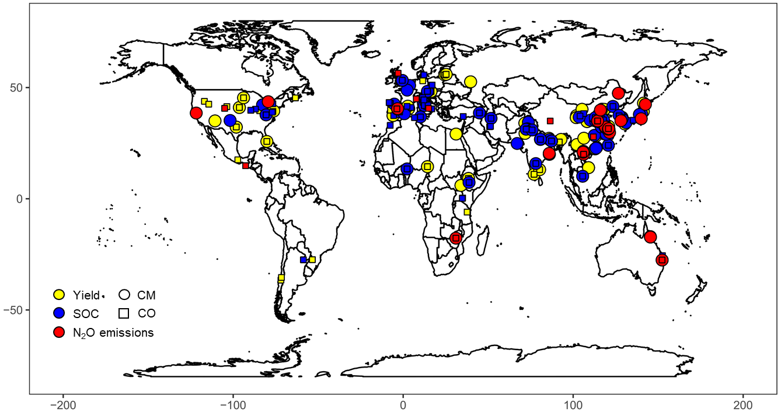

Extended Data Fig. 2 Frequency distribution of the effects of compost (CO) or compost+mineral fertilizer (CM) relative to mineral fertilization (MF) on crop yield (a), soil organic carbon (b) and N₂O emissions (c).

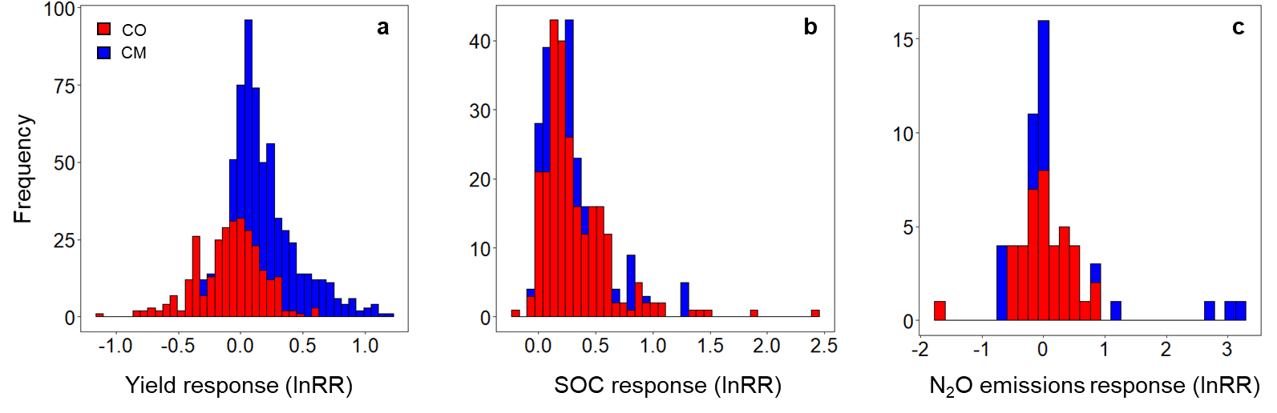

Extended Data Fig. 3 The comprehensive benefits with compost only (CO, a) and compost+ mineral fertilizer (CM, b) on yield and SOC response (lnRR).

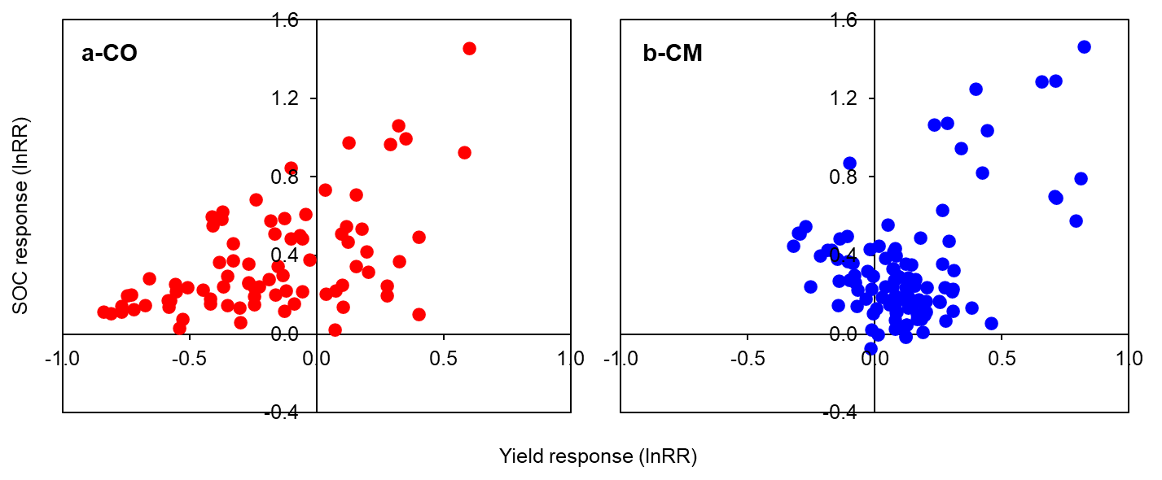

Extended Data Fig. 4 Effect of compost (CO) and compost+mineral fertilizer (CM) relative to mineral fertilization (MF) on crop yield (a), soil organic carbon (SOC) (b) and N₂O emissions (c) in relation to fertilization duration. Fertilization duration is the number of years under continuous CO or CM. lnRR is the response ratio with the natural logarithm of the ratio between the effect of CO or CM with MF. Dashed line at zero indicates similar yield, SOC or N₂O emissions with CO or CM and with MF.

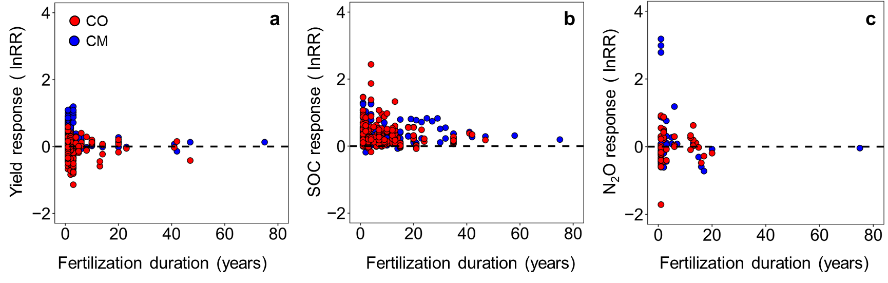

Extended Data Fig. 5 Effect of N supply in compost treatments with CO (compost) and CM (compost+mineral fertilizer) with lower N supply (≥50% reduced (-) and <50% reduced (-), similar N supply, or higher N supply (<50% increased (+) and ≥50% increased (+) than MF (mineral fertilizer) on crop yield (a), SOC (b) and N₂O emissions (c). Values are mean effect sizes with 95% confidence intervals (Cl). Number of observations are shown above bars. Mean effect sizes (i.e., relative change in N₂O emissions compared to MF) are considered significant if the 95% CI does not include 0. A ratio of 0 (dotted line) indicates no difference between CO or CM and MF. Values larger or smaller than zero indicate higher (>0) or lower (<0) values with CO or CM than with MF. *P<0.05, **P<0.01 and ***P<0.001 indicate significant differences between N supply classes.

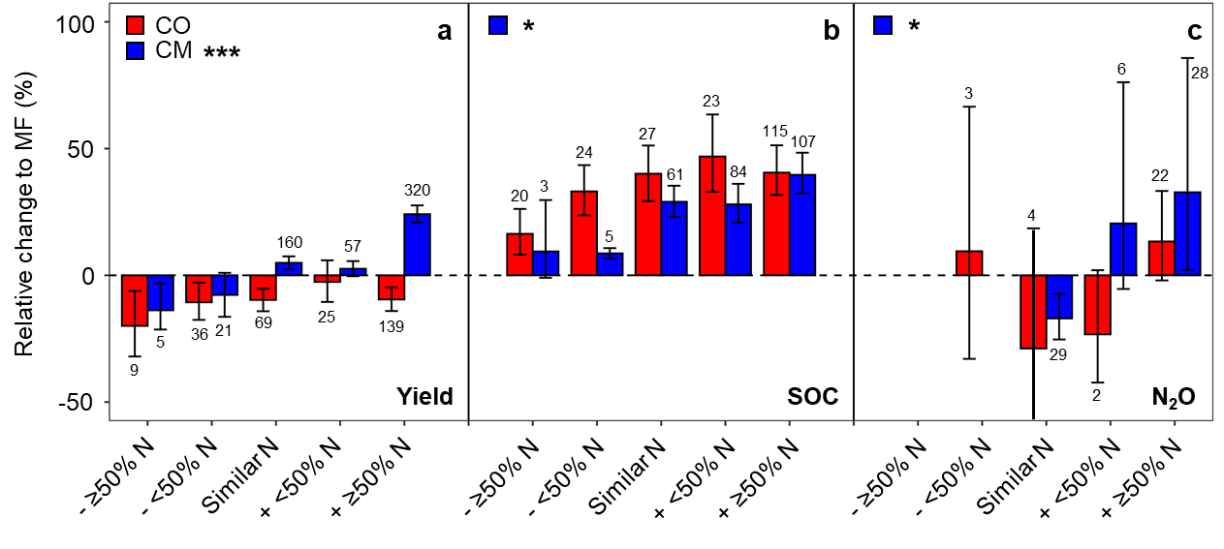

Extended Data Fig. 6 Effects of compost (CO) and compost+mineral fertilizer (CM) relative to mineral fertilizer (MF) on nitrogen use efficiency (NUE), soil bulk density, soil water, soil pH on acidic soils, soil pH on neutral soils and soil pH on alkaline soils. Values are mean effect sizes with 95% confidence intervals (Cl) and number of observations above bars. Mean effect sizes are considered significant if the 95% CI does not include 0. A ratio of 0 (dotted line) indicates no difference between CO or CM and MF. Values larger or smaller than zero indicate higher (>0) or lower (<0) values with CO or CM than with MF. *P<0.05, **P<0.01 and ***P<0.001.

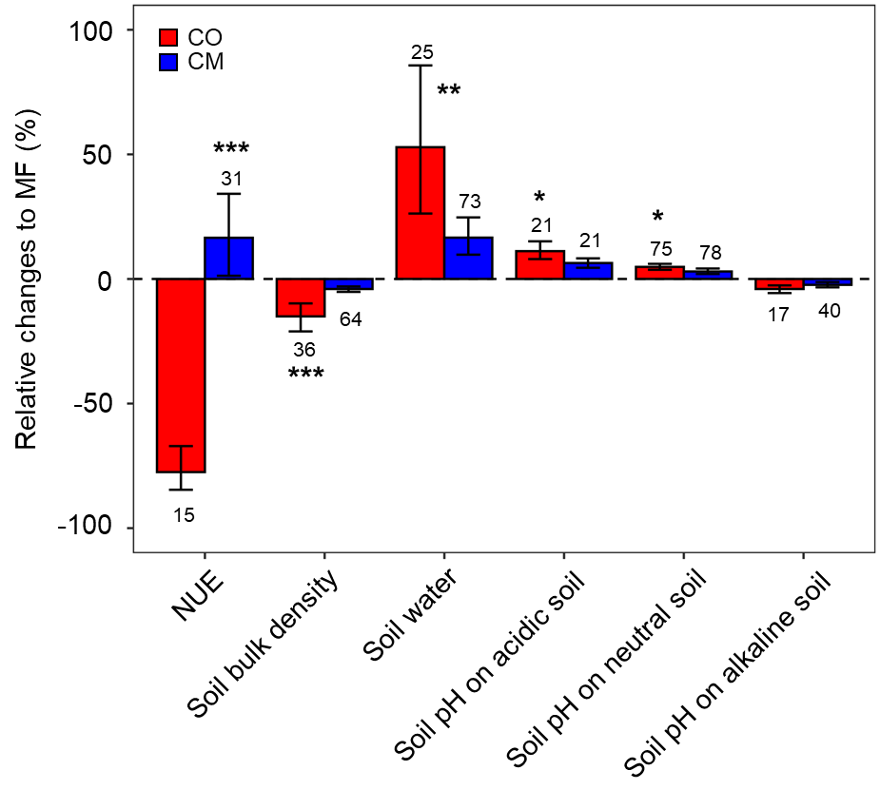

Extended Data Fig. 7 The relationships between proportion of compost N to total N supply (%) and yield response (lnRR). Relationship of overall (a), with very low SOC soil (b), low SOC soil (c), moderate SOC soil (d) and high SOC soil (e). This analysis was conducted on similar N supply of CO and CM than MF. *P<0.05, **P<0.01 and ***P<0.001 indicate significant relationships.

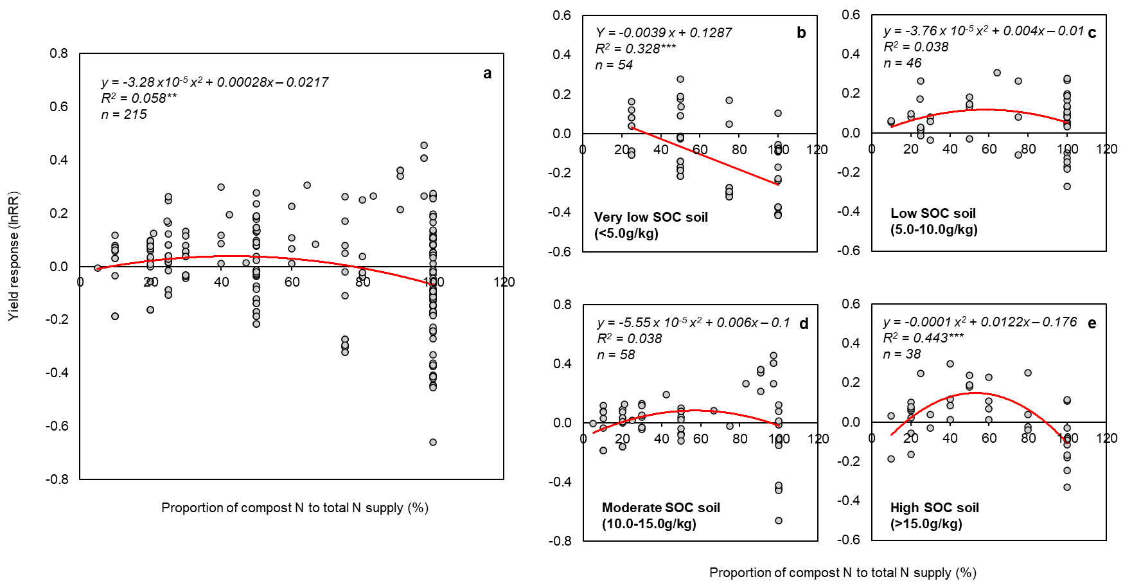

Extended Data Fig. 8 Influence of N supply on compost effects. a-c Relationship between the relative N supply compared to mineral fertilizer with compost (CO) or mineral fertilizer-amended compost (CM) and yield (a), SOC (b) and N₂O emissions (c). a Relationship with CO: Response of yield (lnRR) = 0.008 × relative N supply - 0.109, R²=0.02, P=0.016, n=278; Relationship with CM: Response of yield (lnRR) = 0.022 × relative N supply + 0.077, R²=0.16, P<0.001, n=573. b Relationship with CO: Response of SOC (lnRR) = 0.036 × relative N supply + 0.218, R²=0.14, P<0.001, n=206; Relationship with CM: Response of SOC (lnRR) = -0.004 × relative N supply² + 0.049 × relative N supply + 0.211, R²=0.02, P=0.050, n=260. c Relationship with CO: N₂O emissions (lnRR) = 0.073 × relative N supply - 0.211, R²=0.33, P<0.001, n=31; Relationship with CM: Response of N₂O emissions (lnRR) = 0.120 × relative N supply - 0.143, R²=0.07, P=0.038, n=63. The relative N supply represents the ratio of total N input with compost application (CO, CM) to the total N input with mineral fertilizer (MF). lnRR is the response ratio with the natural logarithm of the ratio between the effect of CO or CM with MF. Dashed line indicates similar yield, SOC or N₂O emissions with CO or CM and with MF. *P<0.05, **P<0.01 and ***P<0.001 indicate significant relationships.
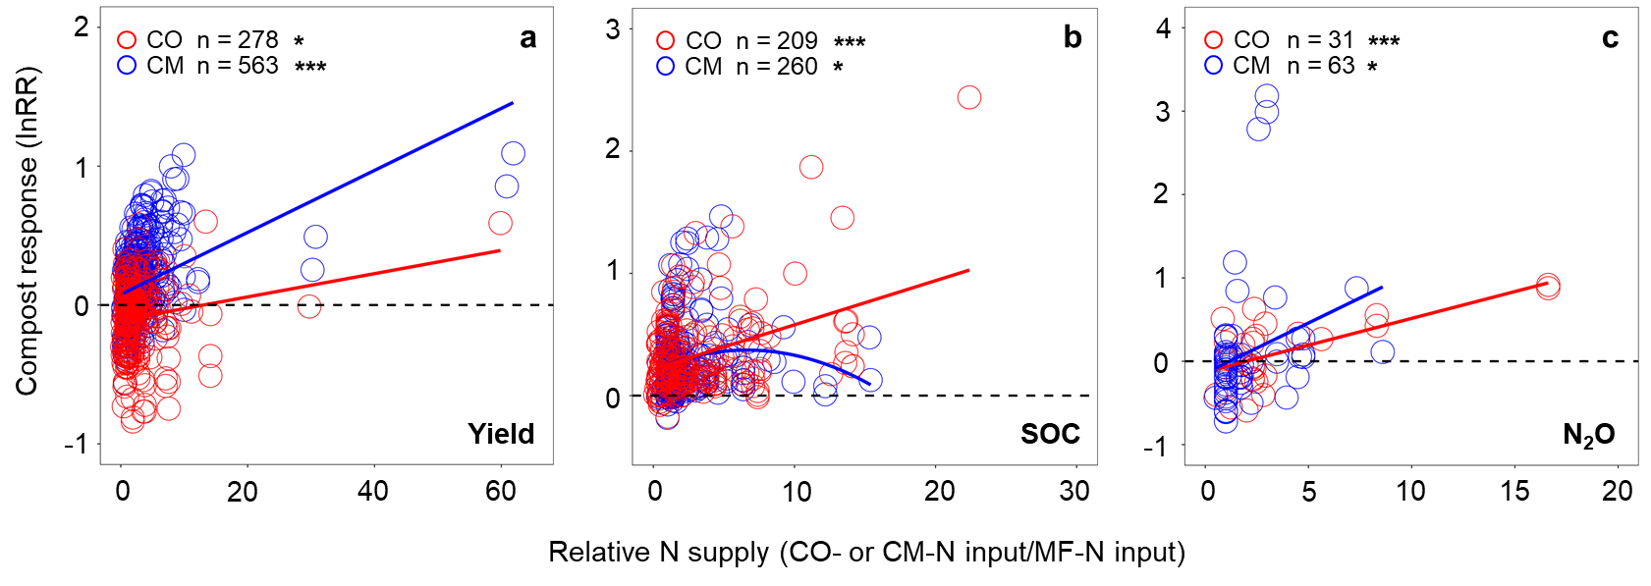
Extended Data Fig. 9 The relationships between ratio of C input to N input and SOC response (lnRR). Relationships in very low SOC soil (a), low SOC soil (b), moderate and high SOC soil (c). This analysis was conducted on SOC effect with CM. *P<0.05, **P<0.01 and ***P<0.001 indicate significant relationships.

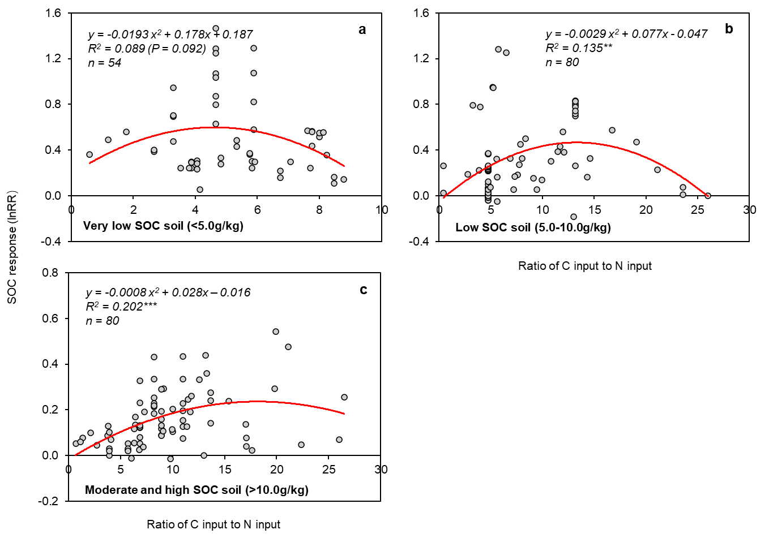

Extended Data Fig. 10 Influence of site-biophysical conditions on the effects of compost. a-f Influence of crop type (a), soil texture (b), soil SOC (c), soil pH (d), climate mean annual temperature (MAT) (e) and climate mean annual precipitation (MAP) (f) on relative change of CO or CM to MF in N₂O (%). CO (compost only) and CM (compost+mineral fertilizer). Values are mean effect sizes with 95% confidence intervals (Cl) and number of observations above bars. Mean effect sizes are considered significant if the 95% CI does not include 0. A ratio of 0 (dotted line) indicates no difference between CO or CM and MF. Values larger or smaller than zero indicate higher (>0) or lower (<0) values with CO or CM than with MF. *P<0.05, **P<0.01 and ***P<0.001 indicate significant differences between differential site-biophysical conditions.

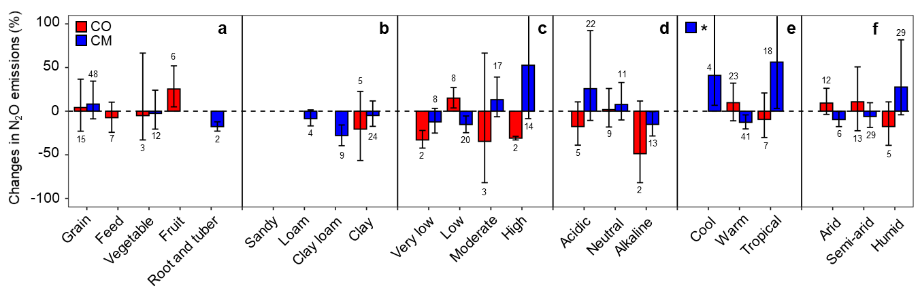

Extended Data Fig. 11 The comprehensive benefits of yield and SOC with compost (CO and CM) under different N supply (a, h), crop type (b, i), soil texture (c, j), soil SOC (d, k), soil pH (e, i), MAT (f, m), and MAP (g, n). CO compost only (red), CM compost+mineral fertilizer (blue). Classification of N supply see Extended Data Fig. 5, Classifications of crop type, soil texture, soil SOC, soil pH, MAT, and MAP see Fig. 3. Values are mean effect sizes with 95% confidence intervals (Cl). The vertical dotted line indicates the overall effect of yield, the horizontal line indicates the overall effect of SOC.

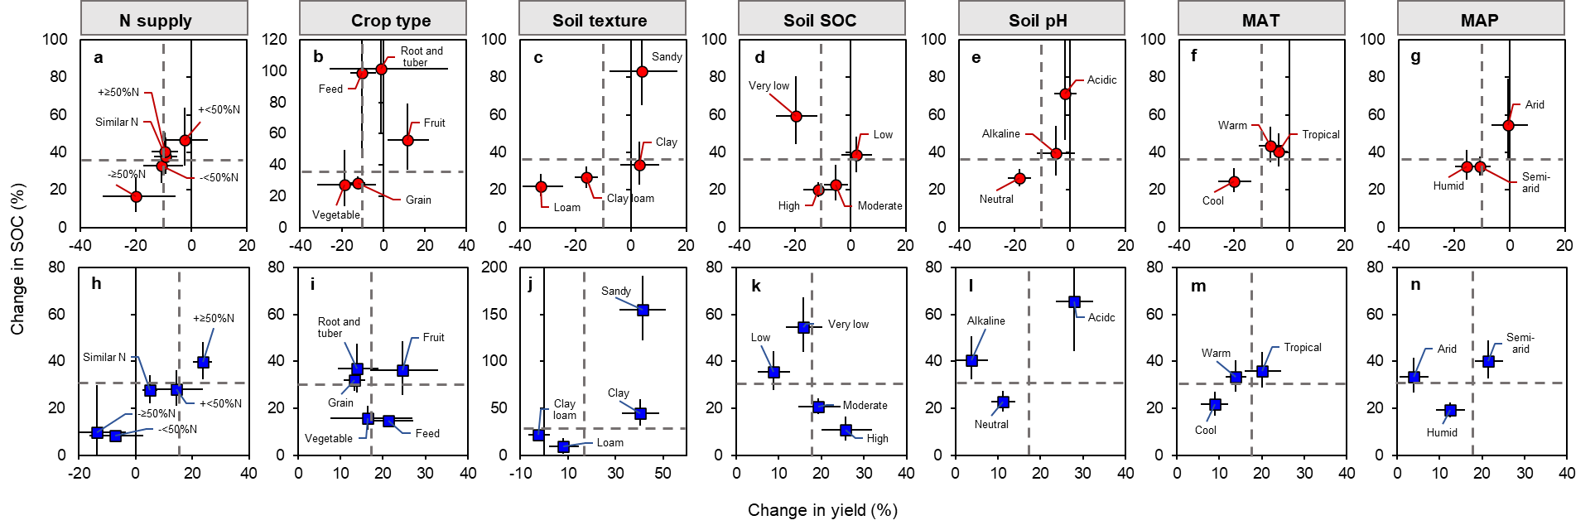

Extended Data Fig. 12 Influence of compost characteristics on compost effects. a-d Influence of C/N ratio (a), C/P ratio (b), pH (c) and electric conductivity (EC) (e) on relative change of CO or CM to MF in N₂O emissions (%). CO (compost) and CM (compost+mineral fertilizer). Values are mean effect sizes with 95% confidence intervals (Cl) and number of observations above bars. Mean effect sizes are considered significant if the 95% CI does not include 0. A ratio of 0 (dotted line) indicates no difference between CO or CM and MF. Values larger or smaller than zero indicate higher (>0) or lower (<0) values with CO or CM than with MF. *P<0.05, **P<0.01 and ***P<0.001 indicate significant differences between differential compost characteristics.

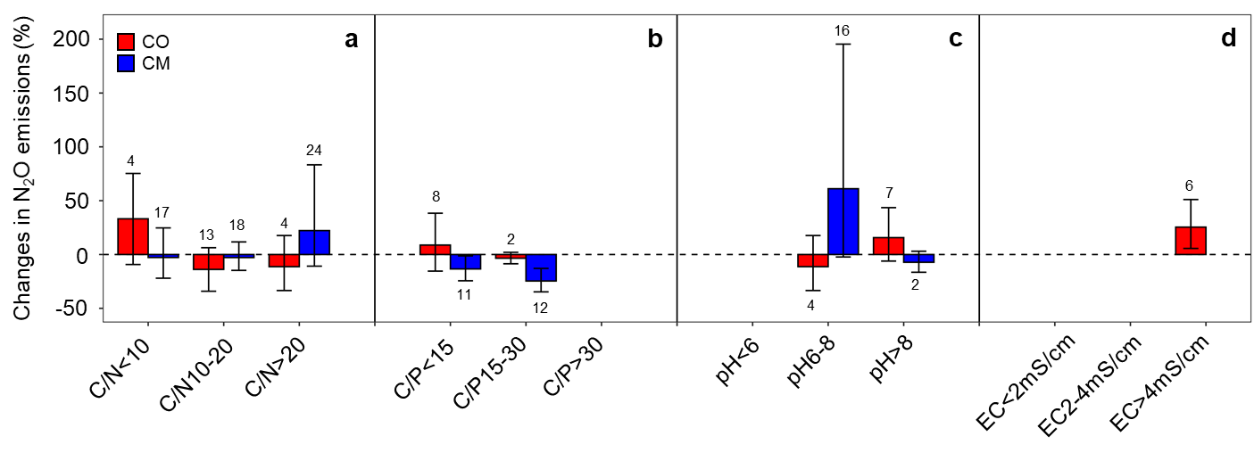

Extended Data Fig. 13 The comprehensive benefits of yield and SOC with compost (CO and CM) under different C/N ratio (a, e), C/P ratio (b, f), pH (c, g) and EC (d, h) of compost, and comprehensive benefits with different C/N ratio compost under very low SOC soil (i, k) and high SOC soil (j, l). CO compost only (red), CM compost+mineral fertilizer (blue). Classification of C/N ratio, C/P ratio, pH and EC of compost see Fig. 4. Values are mean effect sizes with 95% confidence intervals (Cl). The vertical dotted line indicates the overall effect of yield, the horizontal line indicates the overall effect of SOC.

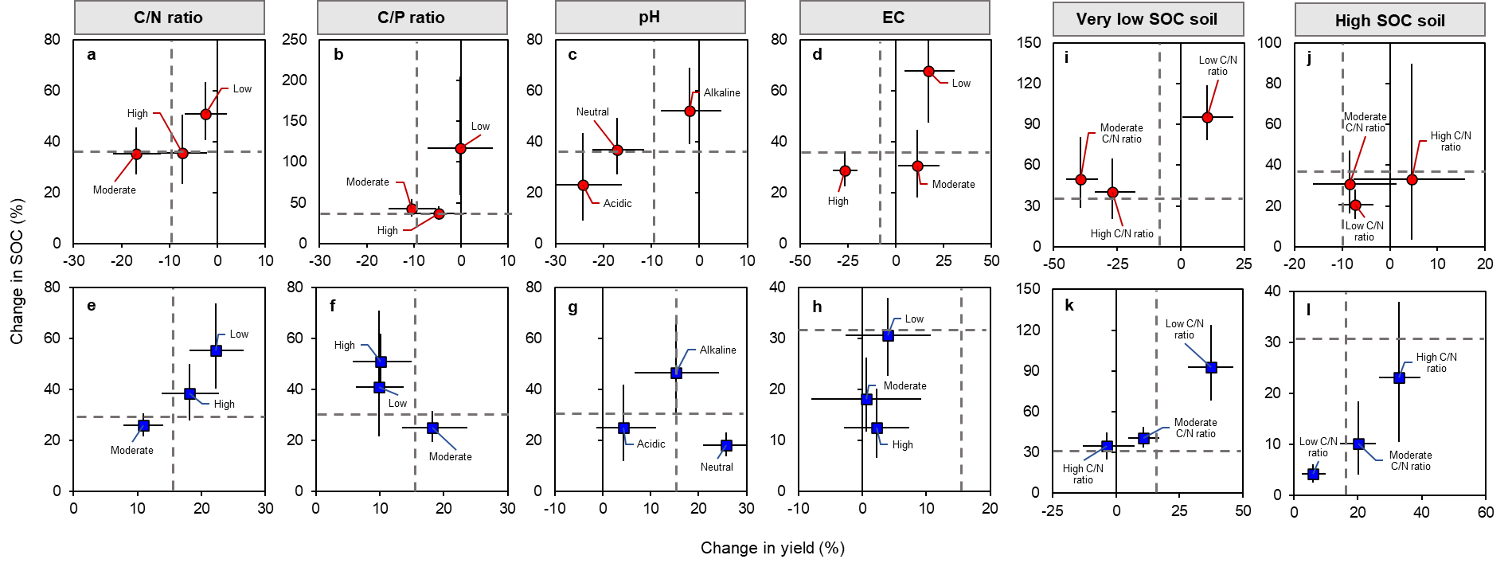

Extended Data Fig. 14 The relationship between compost-C input (kg ha⁻¹ y⁻¹) and soil SOC sequestration rate (kg ha⁻¹ y⁻¹, SOCSR) globally (a), in Asia (b), North America (c), Europe (d) and Africa (e). *P<0.05, **P<0.01 and ***P<0.001.

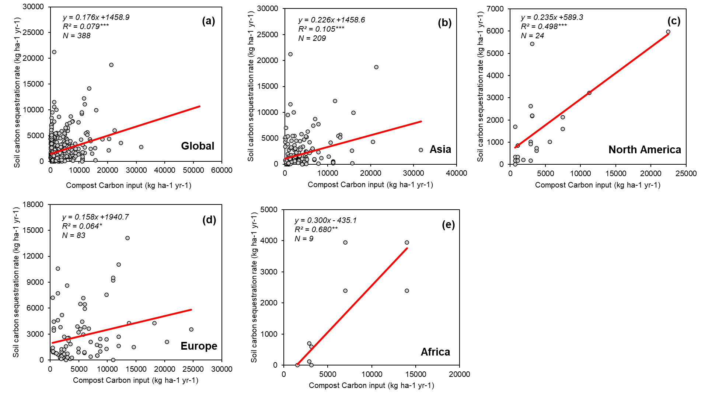

Extended Data Fig. 15 Relationship between the relative N supply compared to mineral fertilizer with compost+mineral fertilizer (CM) and yield globally (a), in Asia (b), North America (c), Europe (d) and Africa (e). *P<0.05, **P<0.01 and ***P<0.001.

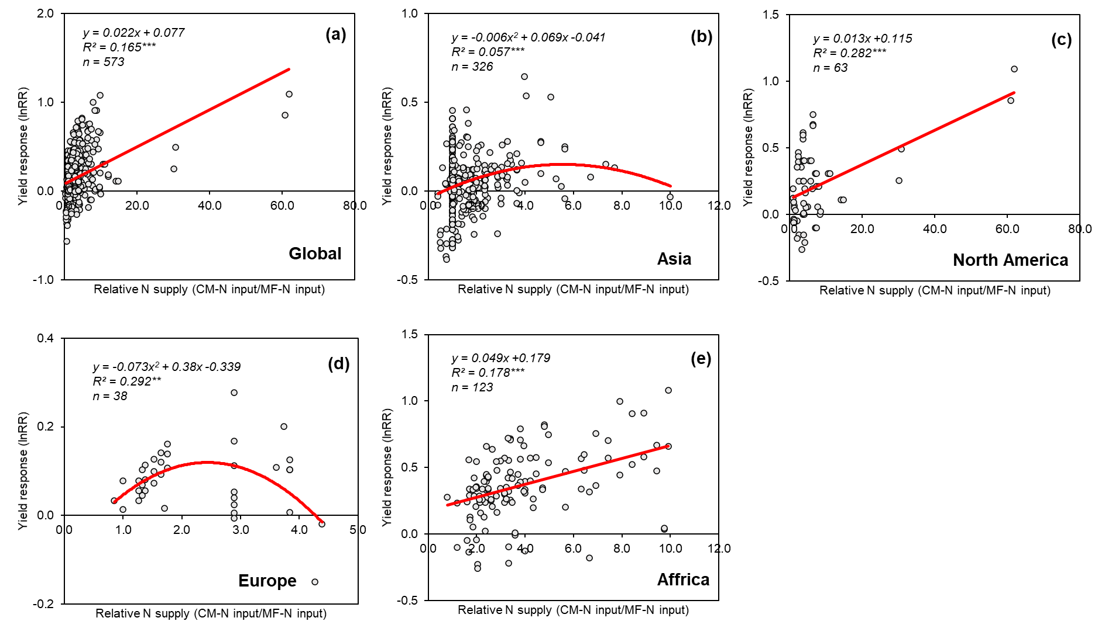

Extended data Table 1 Summary of site-studied system characteristics with CO (compost only) and CM (compost+mineral fertilizer) included in this meta-analysis.
Indicator |  | CO |  |  |  | CM
Indicator | Unit | Mean | Range |  | N | Mean | Range |  | N
Indicator | Unit | Mean | 25th | 75th | N | Mean | 25th | 75th | N
Published time | y | 2012 | 2010 | 2016 | 508 | 2014 | 2010 | 2016 | 891
Locations
Latitude | ° | 30.8 | 22.4 | 44.4 | 508 | 30.3 | 21.3 | 39.4 | 891
Longitude | ° | 20.9 | -7.6 | 85.9 | 508 | 64.0 | 14.4 | 116.0 | 891
Asia | — | / | / | / | 155 | / | / | / | 540
Europe | — | / | / | / | 146 | / | / | / | 106
Africa | — | / | / | / | 78 | / | / | / | 138
Australia | — | / | / | / | 4 | / | / | / | 12
North America | — | / | / | / | 105 | / | / | / | 95
South America | — | / | / | / | 20 | / | / | / | /
Climates
MAT | ℃ y⁻¹ | 16.4 | 11.0 | 21.5 | 508 | 18.1 | 13.7 | 23.0 | 891
MAP | mm y⁻¹ | 757.7 | 515.8 | 2913.4 | 508 | 812.7 | 515.8 | 1051.8 | 891
Crop types
Grain | — | / | / | / | 273 | / | / | / | 618
Feed | — | / | / | / | 75 | / | / | / | 66
Vegetable | — | / | / | / | 48 | / | / | / | 57
Fruit | — | / | / | / | 23 | / | / | / | 24
Roots and tubers | — | / | / | / | 37 | / | / | / | 19
Other crops | — | / | / | / | 49 | / | / | / | 107
Soil properties
Soil depth | cm | 21.2 | 20.0 | 20.0 | 433 | 19.9 | 20.0 | 20.0 | 748
Sandy | — | / | / | / | 28 | / | / | / | 52
Loam | — | / | / | / | 42 | / | / | / | 61
Clay loam | — | / | / | / | 63 | / | / | / | 116
Clay | — | / | / | / | 70 | / | / | / | 143
Soil organic C | g/kg | 11.7 | 5.8 | 14.0 | 377 | 10.6 | 4.6 | 14.4 | 730
Soil pH | — | 6.5 | 5.8 | 7.6 | 420 | 6.6 | 5.6 | 7.6 | 734
Compost characteristics
Pig manure | — | / | / | / | 28 | / | / | / | 166
Cattle manure | — | / | / | / | 132 | / | / | / | 284
Poultry manure | — | / | / | / | 71 | / | / | / | 56
Municipal sludge | — | / | / | / | 86 | / | / | / | 83
Other feedstocks | — | / | / | / | 179 | / | / | / | 294
C content | % | 23.3 | 13.8 | 31.4 | 432 | 22.7 | 12.5 | 32.0 | 754
N content | % | 1.8 | 1.1 | 2.2 | 485 | 1.8 | 1.0 | 2.1 | 777
P content | % | 1.4 | 0.4 | 2.0 | 300 | 1.3 | 0.5 | 1.8 | 531
C/N ratio | — | 14.4 | 9.5 | 17.3 | 431 | 15.9 | 9.4 | 20.4 | 750
C/P ratio | — | 30.5 | 13.5 | 41.8 | 271 | 29.8 | 10.4 | 37.2 | 492
pH | — | 7.6 | 7.2 | 7.9 | 268 | 7.5 | 7.1 | 7.9 | 337
EC | mS/cm | 6.4 | 3.4 | 6.1 | 135 | 4.6 | 3.2 | 5.4 | 77
N fertilization regimes
CO-N input | kg ha⁻¹ | 342.8 | 120.8 | 359.8 | 470 | / | / | / | /
CM-N input | kg ha⁻¹ | / | / | / | / | 342.0 | 161.5 | 330.0 | 780
MF-N input | kg ha⁻¹ | 141.7 | 80.0 | 170.0 | 446 | 176.0 | 88.2 | 241.6 | 778
Relative N supply | — | 2.9 | 1.0 | 3.0 | 445 | 2.6 | 1.0 | 3.2 | 780
Duration | y | 4.5 | 1.0 | 4.0 | 508 | 4.6 | 2.0 | 3.0 | 891
Extended data Table 2 Comparation of magnitudes of compost benefits between ours and previous meta-analysis estimated.
Source | Studying regions | Criteria for data collection | Methods | Indicators | Compost type | Number of observations | Effect size (Lower CI, Upper CI) (%)
Previous  (2017)¹ | Global  (almost in Asia) | The control and treatment must have equal total N rate; Excluded the studies with field trials less than 3 year. | Meta-analysis with weighted by replication | Yield | Total | 150 | 5.0  (2.9, 7.7)
 |  |  |  | SOC | Total | 23 | 45.0  (30.0, 60.6)
 |  |  |  | N₂O emissions | Total | 29 | -7.5  (-21.6, 9.7)
Previous  (2019)² | Global  (almost in Asia and Europe) | The control and treatment could have equal or unequal total N rate; Studies with field trials of less than 3 years and longer. | Meta-analysis with weighted by replication | Yield | Total | 39 | 17.0  (9.2, 25.0)
 |  |  |  | SOC | Total | 158 | 42.7  (32.1, 55.0)
 |  |  |  | － |  | － | －
Our study | Global | The control and treatment could have equal or unequal total N rate; Studies with field trials of less than 3 years and longer. | Meta-analysis with weighted by replication | Yield | CO | 293 | -10.0  (-12.9, -7.1)
 |  |  |  |  | CM | 654 | 15.7  (13.7, 17.7)
 |  |  |  | SOC | CO | 236 | 36.8  (31.6, 42.7)
 |  |  |  |  | CM | 285 | 32.0  (28.2, 36.1)
 |  |  |  | N₂O emissions | CO | 31 | 3.3  (-12.4, 20.5)
 |  |  |  |  | CM | 63 | 6.6  (-8.0, 26.6)
- Xia, L. L., Lam, S. K., Yan, X. Y., & Chen, D. L. How Does Recycling of Livestock Manure in Agroecosystems Affect Crop Productivity, Reactive Nitrogen Losses, and Soil Carbon Balance? Environ. Sci. Technol. 51, 7450-7457 (2017).
- Luo, G. W. et al. Organic amendments increase crop yields by improving microbe-mediated soil functioning of agroecosystems: A meta-analysis. Soil Biol. Biochem. 124, 105-115 (2018).

Extended data Table 3 N₂O emissions factors (EF, %) for CO and CM.
Factor | N | Average | 95% CI
Factor | N | Average | Lower | Upper
EF-MF | 73 | 0.90 | 0.54 | 1.39
EF-CO | 23 | 0.44 | 0.13 | 0.95
EF-CM | 51 | 0.49 | 0.31 | 0.71
IPCCª | - | 1.00 | - | -
ª Default N₂O emission factors proposed by the Intergovernmental Panel on Climate Change (IPCC, 2006).

Extended data Table 4 Between group heterogeneity (QB) of CO and CM effects on crop yield, soil organic carbon (SOC) and nitrous oxide (N₂O) emissions. CO (compost only) and CM (compost+mineral fertilizer) effects. *P<0.05, **P<0.01 and ***P<0.001.
Category | Crop yield |  |  | SOC |  |  | N₂O
Category | df | QB | P value | df | QB | P value | df | QB | P value
Overall | 1 | 27.66 | 0.0002*** | 1 | 0.28 | 0.1724 | 1 | 0.04 | 0.8212

Extended data Table 5 Between group heterogeneity (QB) of differential categories with CO (compost only) effect on crop yield, soil organic carbon (SOC) and nitrous oxide (N₂O) emissions. *P<0.05, **P<0.01 and ***P<0.001.
Category | Crop yield |  |  | SOC |  |  | N₂O
Category | df | QB | P value | df | QB | P value | df | QB | P value
Region | 5 | 4.12 | 0.0004*** | 4 | 1.38 | 0.1080 | 4 | 1.02 | 0.4458
Duration | 2 | 0.84 | 0.0516 | 2 | 1.45 | 0.0168* | 1 | 0.41 | 0.2986
Relative N supply | 4 | 0.47 | 0.4978 | 4 | 1.16 | 0.2048 | 3 | 1.67 | 0.2172
Crop types | 4 | 1.66 | 0.0192* | 4 | 8.48 | 0.0002*** | 3 | 0.54 | 0.7068
Soil texture | 3 | 7.32 | 0.0002*** | 3 | 3.37 | 0.0002*** | / | / | /
Soil organic C | 3 | 3.49 | 0.0002*** | 3 | 4.27 | 0.0002*** | 3 | 1.98 | 0.2204
Soil pH | 2 | 4.04 | 0.0002*** | 2 | 5.23 | 0.0002*** | 2 | 1.39 | 0.1982
MAT | 2 | 3.11 | 0.0002*** | 2 | 1.42 | 0.0210* | 1 | 0.37 | 0.3356
MAP | 2 | 1.35 | 0.0080* | 2 | 1.75 | 0.0080** | 2 | 0.65 | 0.4450
Compost C/N ratio | 2 | 2.34 | 0.0006*** | 2 | 1.14 | 0.0448* | 2 | 0.99 | 0.2828
Compost C/P ratio | 2 | 0.52 | 0.0666 | 2 | 0.88 | 0.1646*** | 1 | 0.03 | 0.7300
Compost pH | 2 | 1.46 | 0.0214* | 2 | 0.46 | 0.3766 | 1 | 0.32 | 0.2470
Compost EC | 2 | 3.15 | 0.0002*** | 2 | 0.38 | 0.0584 | / | / | /

Extended data Table 6 Between group heterogeneity (QB) of differential categories with CM (compost+mineral fertilizer) effect on crop yield, soil organic carbon (SOC) and nitrous oxide (N₂O) emissions. *P<0.05, **P<0.01 and ***P<0.001.
Category | Crop yield |  |  | SOC |  |  | N₂O
Category | df | QB | P value | df | QB | P value | df | QB | P value
Region | 4 | 16.74 | 0.0004*** | 4 | 6.22 | 0.0002*** | 4 | 15.54 | 0.0036**
Duration | 2 | 0.39 | 0.1188 | 2 | 0.29 | 0.2852 | 2 | 2.32 | 0.2016
Relative N supply | 4 | 8.78 | 0.0002*** | 4 | 1.22 | 0.0470* | 2 | 5.86 | 0.0216*
Crop types | 4 | 0.79 | 0.0792 | 4 | 0.54 | 0.2758 | 2 | 0.38 | 0.7310
Soil texture | 3 | 9.79 | 0.0002*** | 3 | 11.02 | 0.0002*** | 2 | 1.00 | 0.0980
Soil organic C | 3 | 1.95 | 0.0002*** | 3 | 6.34 | 0.0002*** | 3 | 5.95 | 0.0566
Soil pH | 2 | 5.83 | 0.0002*** | 2 | 4.37 | 0.0002*** | 2 | 2.33 | 0.2474
MAT | 2 | 1.18 | 0.0010*** | 2 | 0.69 | 0.0556 | 2 | 8.35 | 0.0112*
MAP | 2 | 3.75 | 0.0002*** | 2 | 2.47 | 0.0002*** | 2 | 2.75 | 0.1584
Compost C/N ratio | 2 | 1.46 | 0.0008*** | 2 | 3.02 | 0.0002*** | 2 | 1.35 | 0.4628
Compost C/P ratio | 2 | 0.71 | 0.0140* | 2 | 2.33 | 0.0004*** | 1 | 0.21 | 0.2100
Compost pH | 2 | 0.70 | 0.0666 | 2 | 1.10 | 0.0010*** | 1 | 0.46 | 0.6498
Compost EC | 2 | 0.01 | 0.9102 | 2 | 0.14 | 0.0782 | / | / | /

Extended data Table 7 Between group heterogeneity (QB) of differential compost C/N ratio effects on crop yield and soil organic carbon (SOC) under very low SOC (<5g/kg), high SOC (>15g/kg, d) soils. CO (compost) and CM (compost+mineral fertilizer). *P<0.05, **P<0.01 and ***P<0.001.
Category | Crop yield |  |  | SOC
Category | df | QB | P value |  | df | QB | P value
CO-very low SOC | 2 | 9.75 | 0.0002*** |  | 2 | 2.09 | 0.0754
CM-very low SOC | 2 | 3.15 | 0.0002*** |  | 2 | 2.35 | 0.0004***
CO-high SOC | 2 | 0.23 | 0.0822 |  | 2 | 0.16 | 0.4992
CM-high SOC | 2 | 1.37 | 0.0002*** |  | 2 | 0.27 | 0.0336*

