Supporting Information
"Design, Synthesis, and In Vitro Evaluation of Indazole–Pyridine Scaffolds Against Breast Cancer Cell Lines"

Kinjal Parmar^{1*}, Ishan Panchal²
^{*1}Research Scholar, Department of Pharmaceutical Chemistry, Faculty of Pharmacy, Parul University, P.O: Limda, Ta: Waghodia-391760, Vadodara, Gujarat, India
² Department of Pharmaceutical Chemistry, Parul College of Pharmacy and Research, Faculty of Pharmacy, Parul University, P.O: Bopal, Ahmedabad-380058, Gujarat, India

5-Methyl-1H-indazol-3-amine (2):
Melting Point: 191-193 ⁰C (literature-193-195 ⁰C), R_{f} Value: 0.33 (70 % Ethyl acetate in n-Hexane). IR (KBr) ν (cm⁻¹): 3398, 3325 (N-H str.), 3020 (C-H str., aromatic), 2913 (C-H str., aliphatic), 1621 (N-H bend) 1536 (C=N str., Indazolyl), 1504 (C=C str., aromatic).

Ethyl 5-(phenylamino) nicotinate (5a)
IR (KBr) ν (cm⁻¹): 3340 (N-H str), 3060 (C-H str), 2980, 2870 (C-H str), 1722 (Ester C=O str), 1600, 1575 (C=C str), 1510 (C=N str), 1325 (C–N str), 1175 (C–O str),755, 700 (C–H out-of-plane bending). MS: m/z: 243.30 (M+1)⁺

Ethyl 5-(p-tolylamino)nicotinate (5b)
IR (KBr) ν (cm⁻¹): 3342 (N–H, str), 3058 (Ar C–H str), 2955, 2872 (C–H, str), 1720 (C=O, str), 1602 (C=C, str), 1512 (C=N, str), 1320 (C–N, str), 1235, 1170 (C–O, str),. MS: m/z: 257.13 (M+1)⁺

Ethyl 5-(cyclopentylamino) nicotinate (5c)
IR (KBr) ν (cm⁻¹): 3345 (N–H, str), 2956, 2870 (C–H, str), 1718 (C=O, str), 1605 (C=C, str), 1515 (C=N, str), 1330 (C–N, str), 1230, 1170 (C–O, str); MS: m/z: 235.14 (M+1)⁺

Ethyl 5-(o-tolylamino) nicotinate (5d)
IR (KBr) ν (cm⁻¹): 3348 (N–H, str), 3062 (Ar C–H str), 2954, 2871 (C–H str), 1719 (C=O str), 1603 (C=C str), 1513 (C=N, str), 1324 (C–N, str), 1232, 1168 (C–O, str), MS: m/z: 257.20 (M+1)⁺

Ethyl 5-((2-chlorophenyl)amino) nicotinate (5e)
IR (KBr) ν (cm⁻¹): 3345 (N–H, str), 3060 (C–H, str), 2952, 2870 (C–H, str), 1717 (C=O, str), 1600 (C=C, str), 1510
(C=N, str), 1322 (C–N, str), 1230, 1165 (C–O, str), 760 (C–Cl str). MS: m/z: 293.08 (M+1)⁺

Ethyl 5-((4-(trifluoromethyl)phenyl)amino) nicotinate (5f)
IR (KBr) ν (cm⁻¹): 3340 (N–H, str), 3060 (C–H, str), 2950, 2870 (C–H, str), 1720 (C=O, str), 1602 (C=C, str), 1512 (C=N, str), 1325 (C–N, str), 1245, 1168 (C–O, str), 840–830 (C–F, str). MS: m/z : 311.10 (M+1)⁺

Ethyl 5-((4-fluorophenyl)amino)nicotinate (5g)
IR (KBr) ν (cm⁻¹): 3342 (N–H, str), 3062 (C–H, str), 2954, 2870 (C–H, str), 1718 (C=O, str), 1600 (C=C, str), 1510 (C=N, str), 1323 (C–N, str), 1230, 1165 (C–O, str), 835–820 (C–F, str). MS: m/z: 261.11 (M+1)⁺

Ethyl 5-((4-methoxyphenyl)amino)nicotinate (5h)
IR (KBr) ν (cm⁻¹): 3340 (N–H, str), 3060 (C–H, str), 2952, 2870 (C–H, str), 1720 (C=O, str), 1602 (C=C, str), 1512 (C=N, str), 1324 (C–N, str),1245, 1168 (C–O str), 1035 (C–O str), 820, 795 (C–H out-of-plane bending). MS: m/z: 272.13 (M+1)⁺

Ethyl 5-morpholinonicotinate (5i)
IR (KBr) ν (cm⁻¹): 2948, 2870 (C–H, str), 1716 (C=O, str), 1600 (C=C, str), 1508 (C=N, str), 1305 (C–N, str), 1240, 1170 (C–O, str), 1110–1030 (C–O, str). MS: m/z : 237.12 (M+1)⁺

Ethyl 5-(pyrrolidin-1-yl) nicotinate (5j)
IR (KBr) ν (cm⁻¹): 2950, 2870 (C–H, str), 1718 (C=O, str),1600 (C=C, str), 1510 (C=N, str),1302 (C–N, str), 1240, 1165 (C–O, str) . MS: m/z: 221.20 (M+1)⁺

5-(Phenylamino)nicotinic acid (6a)
Melting Point: 230-232 ⁰C. IR (KBr) ν (cm⁻¹): 3256 (N-H, str), 3053 (C-H, str), 1701 (C=O, str), 1552 (C=N, str.), 1496 (C=C, Ar). MS: m/z: 215.25 (M+1)⁺.

5-(p-Tolylamino)nicotinic acid (6b)
Melting Point: 215-217 ⁰C , IR (KBr) ν (cm⁻¹): 3290 (N-H, str), 3050 (C-H, str), 1708 (C=O, str), 1596 (C=N, str), 1515 (C=C, Ar). MS: m/z: 229.25 (M+1)⁺

5-(Cyclopentylamino)nicotinic acid(6c)
Melting Point: 202-204 ⁰C , IR (KBr) ν (cm⁻¹): 3290 (N-H, str), 3050, 2905 (C-H, str), 1708 (C=O, str), 1596 (C=N, str), 1516 (C=C, Ar). MS: m/z: 207.25 (M+1)⁺

5-(o-Tolylamino)nicotinic acid (6d)
Melting Point: 221-223 ⁰C , IR (KBr) ν (cm⁻¹): 3345 (N-H, str), 3079, 2939 (C-H, str), 1712 (C=O, str), 1585 (C=N, str), 1486 (C=C, Ar). MS: m/z : 229.25 (M+1)⁺

5-((2-Chlorophenyl)amino)nicotinic acid (6e)
Melting Point: 223-225 ⁰C , IR (KBr) ν (cm⁻¹): 3398 (N-H, str), 3070 (C-H str), 1731 (C=O, str), 1585 (C=N, str), 1524 (C=C,Ar). MS: m/z: 249.20 (M+1)⁺.

5-((4-(Trifluoromethyl)phenyl)amino)nicotinic acid (6f)
Melting Point: 196-198 ⁰C , IR (KBr) ν (cm⁻¹): 3323 (N-H, str), 3089 (C-H, str), 1715 (C=O, str), 1598 (C=N, str). MS: m/z: 283.25 (M+1)+.

5-((4-Fluorophenyl)amino)nicotinic acid (6g)
Melting Point: 242-244 ⁰C , IR (KBr) ν (cm⁻¹): 3276 (N-H, str), 3056 (C-H, str), 1589 (C=N, str.), 1508 (C=C, Ar). MS: m/z: 233.25 (M+1)⁺.

5-((4-Methoxyphenyl)amino)nicotinic acid (6h)
Melting Point: 230-232 ⁰C, IR (KBr) ν (cm⁻¹): 3256 (N-H, str), 3050 (C-H, str), 1704 (C=O, str), 1594 (C=N, str), 1514 (C=C, Ar). MS: m/z: 245.30 (M+1)⁺

5-Morpholinonicotinic acid (6i)
Melting Point: 208-210 ⁰C, IR (KBr) ν (cm⁻¹): 3076, 2966, 2945 (C-H, str), 1708 (C=O, str), 1584 (C=N, str). MS: m/z: 209.25 (M+1)⁺

5-(Pyrrolidin-1-yl) nicotinic acid(6j)
Melting Point: 205-207 ⁰C, IR (KBr) ν (cm⁻¹): 3075, 2968, 2945 (C-H, str), 1711 (C=O, str), 1584 (C=N, str), 1451 (C=C, Ar), Mass: 193.15 (M+1)⁺

(3-amino-5-methyl-1H-indazol-1-yl)(5(phenylamino)pyridin-3-yl)methanone (7a)
White crystals (yield 76%), Melting Point: 198-200 ⁰C , IR (KBr) ν (cm⁻¹): 3458, 3335 (N-H str), 3060 (C-H str), 1674 (C=O str), 1555 (C=N, str), 1498 (C=C, Ar). ¹H-NMR (400 MHz, DMSO-d₆) δ 8.590 – 8.500 (m, 2H, ArH), 8.461 (d, J = 2.7 Hz, 1H, ArH), 8.236 (d, J = 8.4 Hz, 1H, ArH), 7.929-7.914 (m, 1H, ArH), 7.734-7.724 (m, 1H, ArH), 7.463-7.437 (m, 1H, ArH), 7.334-7.278 (m, 2H, ArH), 7.190-7.162 (m, 2H, ArH), 6.939-6,897 (m, 1H, ArH), 6.503 (s, 2H, -NH), 2.451 (s, 3H, CH₃). ¹³C-NMR (101 MHz, DMSO-d₆) δ 164.28, 153.34, 141.97, 140.99, 140.43, 139.22, 138.34, 133.71, 131.09, 130.55, 129.43, 122.93, 120.96, 120.64, 120.30, 117.43, 115.25, 20.93. MS: m/z: 344.40 (M+1)⁺

(3-Amino-5-methyl-1H-indazol-1-yl)(5-(tolylamino)pyridin-3-yl)methanone (7b)
Melting Point: 188-190 ⁰C , IR (KBr) ν (cm⁻¹): 3455, 3335 (N-H, str), 3023 (C-H, str), 1671 (C=O, str), , 1556 (C=N, str), 1514 (C=C, Ar). ¹H-NMR (400 MHz, DMSO-d₆) δ 8.520 – 8.470 (m, 1H, ArH), 8.442-8.419 (m, 2H, ArH), 8.236 (d, J = 8.4 Hz, 1H, ArH), 7.861-7.850 (m, 1H, ArH), 7.731 (s, 1H, ArH), 7.450-7.425 (m, 1H, ArH), 7.131-7.076 (m, 4H, ArH), 6.507 (s, 2H, -NH₂), 2.446 (s, 3H, CH₃), 2.240 (s, 3H, CH₃). ¹³C-NMR (101 MHz, DMSO-d₆) δ 164.39, 153.33, 140.43, 139.85, 139.82, 139.19, 138.35, 133.68, 131.06, 130.54, 130.19, 129.84, 122.08, 120.63, 120.28, 118.25, 115.25, 20.92, 20.31. MS: m/z: 358.40 (M+1)⁺

(3-amino-5-methyl-1H-indazol-1-yl)(5-(cyclopentylamino) pyridin-3-yl)methanone (7c)
Melting Point: 174-178 ⁰C , IR (KBr) ν (cm⁻¹): 3403, 3328 (N-H str), 3075 (C-H, str), 2936, 2866 (C-H, str), 1655 (C=O, str), 1556 (C=N, str), 1524 (C=C, Ar). ¹H-NMR (400 MHz, DMSO-d₆) δ 8.278-8.221 (m, 2H, ArH), 8.064 (d, J = 2.8 Hz, 1H, ArH), 7.719 (s, 1H, ArH), 7.436 (d, J = 8.8 Hz, 1H, ArH), 7.346-7.335 (m, 1H, ArH), 6.456 (s, 2H, -NH₂), 6.072 (d, J = 6.8 Hz, 1H, ArH), 3.790-3.714 (m, 1H, -CH), 2.447 (s, 3H, ArCH₃), 1.986-1.907 (m, 2H, -CH₂), 1.729-1.610 (m, 2H, -CH₂), 1.581 1.424 (m, 4H, -CH₂). ¹³C-NMR (101 MHz, DMSO-d₆) δ 165.09, 153.16, 143.70, 138.38, 137.22, 136.71, 133.54, 130.99, 130.53, 120.59, 120.24, 118.77, 115.23, 53.27, 32.32, 23.65, 20.91. MS: m/z: 336.40 (M+1)⁺

(3-Amino-5-methyl-1H-indazol-1-yl)(5-(o-tolylamino)pyridin-3-yl)methanone (7d)
Melting Point: 178-180 ⁰C , IR (KBr) ν (cm⁻¹): 3478, 3363 (N-H, str), 3069 (C-H, str), 1668 (C=O, str), 1556 (C=N, str), 1528 (C=C, str). ¹H-NMR (400 MHz, DMSO-d₆) δ 8.650-8.575 (m, 1H, ArH), 8.460-8.150 (m, 3H, ArH), 7.950-7.875 (m, 1H, ArH), 7.790-7.700 (m, 1H, ArH), 7.460 (d, J = 8.4 Hz, 1H, ArH), 7.329-7.215 (m, 2H, ArH), 7.097-7.060 (m, 1H, ArH), 6.552 (s, 2H, -NH₂), 2.447 (s, 3H, ArCH₃), 2.246 (s, 3H, ArCH₃). ¹³C-NMR (101 MHz, DMSO-d₆) δ 162.61, 153.59, 138.47, 138.20, 136.15, 134.07, 131.30, 131.26, 126.98, 125.19, 124.38, 121.70, 120.78, 120.41, 115.26, 20.93, 17.78. MS: m/z : 358.20 (M+1)⁺

(5-(2-chlorophenylamino)pyridin-3-yl)(3-amino-5-methyl-1H-indazol-1-yl)methanone (7e)
Melting Point: 192-194 ⁰C , IR (KBr) ν (cm⁻¹): 3439, 3345 (N-H, str), 3060 (C-H, str), 1656 (C=O, str), 1556 (C=N, str), 1529 (C=C, Ar). ¹H-NMR (400 MHz, DMSO-d₆) δ 9.071 (s, 1H, ArH), 8.649 (d, J = 2.0 Hz, 1H, ArH), 8.551 (d, J = 2.4 Hz, 1H, ArH), 8.246 (d, J = 8.4 Hz, 1H, ArH), 8.090-8.079 (m, 1H, ArH), 7.735 (s, 1H, ArH), 7.607 (d, J = 8.4 Hz, 2H, ArH), 7.460 (dd, J = 8.6, 1.7 Hz, 1H, ArH), 7.280 (d, J = 8.4 Hz, 2H, ArH), 6.533 (s, 2H, -NH₂), 2.454 (s, 3H, ArCH₃). ¹³C-NMR (101 MHz, DMSO-d₆) δ 164.16, 153.37, 141.88, 141.29, 138.99, 138.79, 138.32, 133.73, 131.09, 130.49, 130.26, 128.13, 124.35, 124.33, 123.24, 120.65, 120.30, 120.01, 115.25, 20.92. MS: m/z: 378.35 (M+1)⁺

(5-(4-(trifluoromethyl)phenylamino)pyridin-3-yl)(3-amino-5-methyl-1H-indazol-1-yl)methanone (7f)
Melting Point: 230-232 ⁰C , IR (KBr) ν (cm⁻¹): 3458, 3338 (N-H, str), 3075 (C-H, str), 1656 (C=O, str), 1556 (C=N, str), 1519 (C=C, Ar). ¹H NMR (400 MHz, DMSO-d₆) δ 8.605 (s, 1H, ArH), 8.470 (d, J = 2.7 Hz, 1H, ArH), 8.300- 8.170 (m, 2H, ArH), 7.870-7.810 (m, 1H, ArH), 7.755-7.710 (m, 1H, ArH), 7.498-7.396 (m, 3H, ArH), 7.324-7.282 (m, 1H, ArH), 7.043-7.001 (m, 1H, ArH), 6.509 (s, 2H, -NH₂), 2.446 (s, 3H, CH₃). 13C-NMR (101 MHz, DMSO-d₆) δ 163.91, 153.41, 146.27, 142.77, 142.35, 138.33, 137.32, 133.77, 131.21, 131.14, 130.59, 126.76, 125.77, 123.40, 120.66, 120.32, 119.97, 119.65, 115.43, 115.25, 20.93. MS: m/z : 412.40 (M+1)⁺

(5-(4-fluorophenylamino)pyridin-3-yl)(3-amino-5-methyl-1H-indazol-1-yl)methanone (7g)
Melting Point: 216-218 ⁰C , IR (KBr) ν (cm⁻¹): 3449, 3329 (N-H, str), 3042 (C-H, str), 1664 (C=O, str), 1555 (C=N), 1505 (C=C, Ar). ¹H-NMR (400 MHz, DMSO-d₆) δ 8.530-8.507 (m, 2H, ArH), 8.408 (d, J = 2.8 Hz, 1H, ArH), 8.231 (d, J = 8.4 Hz, 1H, ArH), 7.859-7.848 (m, 1H, ArH), 7.732-7.723 (m, 1H, ArH), 7.448 (dd, J = 8.5, 1.7 Hz, 1H, ArH), 7.216-7.124 (m, 4H, ArH), 6.502 (s, 2H, -NH₂), 2.450 (s, 3H, CH₃). ¹³C-NMR (101 MHz, DMSO-d₆) δ 164.26, 158.23, 155.87, 153.33, 140.81, 139.95, 139.62, 138.34, 138.26, 138.24, 133.70, 131.09, 130.53, 122.34, 120.62, 120.29, 119.77, 119.69, 116.10, 115.88, 115.25, 20.92. MS: m/z : 362.40 (M+1)⁺

(5-(4-methoxyphenylamino)pyridin-3-yl)(3-amino-5-methyl-1H-indazol-1-yl)methanone (7h)
Melting Point: 194-196 ⁰C, IR (KBr) ν (cm⁻¹): 3440, 3328 (N-H, str), 3059 (C-H, str), 1669 (C=O, str), 1555 (C=N str), 1508 (C=C, Ar). ¹H-NMR (400 MHz, DMSO-d₆) δ 8.448-8.436 (q, J = 1.7 Hz, 1H, ArH), 8.345-8.213 (m, 3H, ArH), 7.760-7.700 (m, 2H, ArH), 7.440 (d, J = 8.5 Hz, 1H, ArH), 7.161-7.120 (m, 2H, ArH), 6.946-6.905 (m, 2H, ArH), 6.495 (s, 2H, -NH₂), 3.726 (s, 3H, -OCH₃), 2.445 (s, 3H, ArCH₃). ¹³C-NMR (101 MHz, DMSO-d₆) δ 164.45, 154.59, 153.25, 140.78, 139.79, 138.94, 138.30, 134.46, 133.63, 131.02, 130.49, 121.03, 120.90, 120.58, 120.24, 115.20, 114.73, 55.17, 20.88. MS: m/z : 374.40 (M+1)⁺

(3-amino-5-methyl-1H-indazol-1-yl)(5-morpholinopyridin-3-yl)methanone (7i)
Melting Point: 188-190 ⁰C , IR (KBr) ν (cm⁻¹): 3440, 3316 (N-H, str), 2965, 2858 (C-H, str), 1651 (C=O, str), 1561 (C=N, str). ¹H-NMR (400 MHz, DMSO-d₆) δ 8.514 (d, J = 1.6 Hz, 1H, ArH), 8.444 (d, J = 2.9 Hz, 1H, ArH), 8.240 (d, J = 8.0 Hz, 1H, ArH), 7.777-7.765 (m, 1H, ArH), 7.721 (s, 1H, ArH), 7.455 (dd, J = 8.5, 1.6 Hz, 1H, ArH), 6.517 (s, 2H, -NH₂), 3.778-3.754 (m, 4H, -OCH₂), 3.243-3.219 (m, 4H, -CH₂), 2.450 (s, 3H, CH₃). ¹³C-NMR (101 MHz, DMSO-d₆) δ 164.55, 153.30, 145.85, 140.55, 138.96, 138.32, 133.70, 131.09, 130.52, 122.40, 120.65, 120.28, 115.22, 65.86, 47.61, 20.93. MS: m/z : 338.20 (M+1)⁺

(3-amino-5-methyl-1H-indazol-1-yl)(5-(pyrrolidin-1-yl)pyridin-3-yl)methanone (7j)
Melting Point: 218-220 ⁰C , IR (KBr) ν (cm⁻¹): 3435, 3312 (N-H, str), 2969, 2845 (C-H, str), 1659 (C=O, str), 1554 (C=N, str). ¹H-NMR (400 MHz, DMSO-d₆): δ 8.314 (s, 1H, ArH), 8.248-8.227 (d, J = 8.4 Hz, 1H, ArH), 8.052-8.045 (d, J = 2.9 Hz, 1H, ArH), 7.719-7.710 (m, 1H, ArH), 7.459 – 7.433 (m, 1H, ArH), 7.357-7.331 (m, 1H, ArH), 6.486 (s, 2H, -NH₂), 3.397-3.288 (m, 4H, -NCH₂), 2.448 (s, 3H, CH₃), 2.011-1.947 (m, 4H, CH₂). ¹³C-NMR (101 MHz, DMSO-d₆): δ 165.02, 153.20, 136.88, 135.44, 133.60, 131.04, 130.48, 120.61, 120.25, 118.59, 115.22, 47.09, 24.90, 20.94. MS: m/z: 322.30 (M+1)⁺

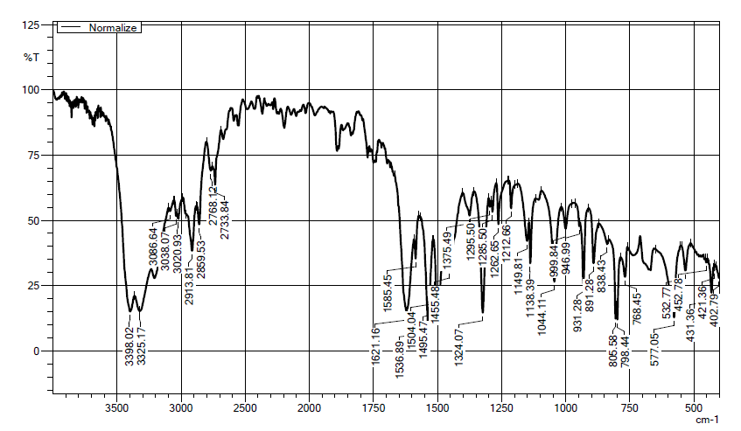S1: IR spectra of 5-methyl-1H-indazol-3-amine (2)
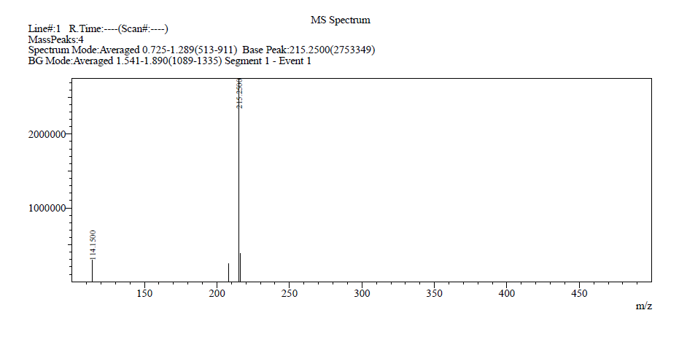S2: Mass spectra of 5-(Phenylamino) nicotinic acid (6a)
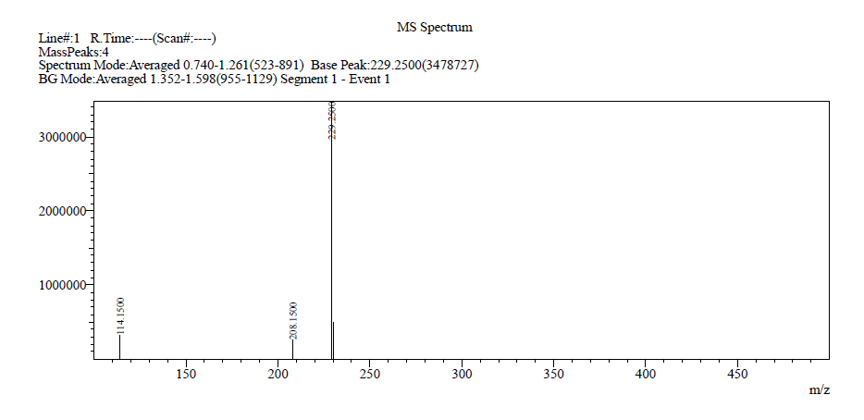 S3: Mass spectra of 5-(p-Tolylamino)nicotinic acid (6b)

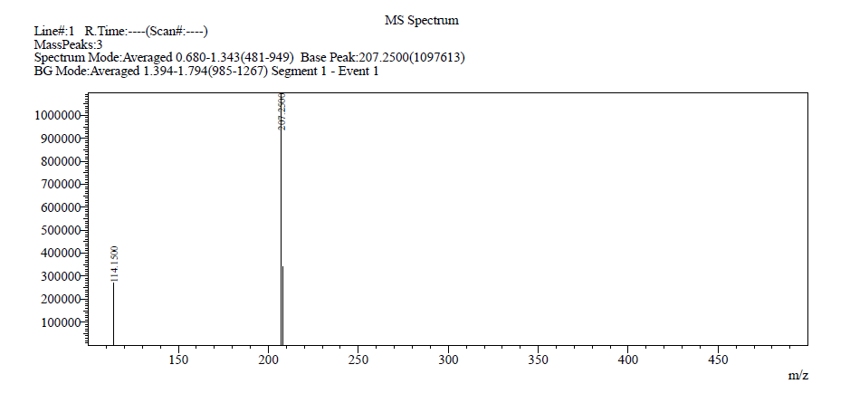
S4: Mass spectra of 5-(Cyclopentylamino)nicotinic acid (6c)

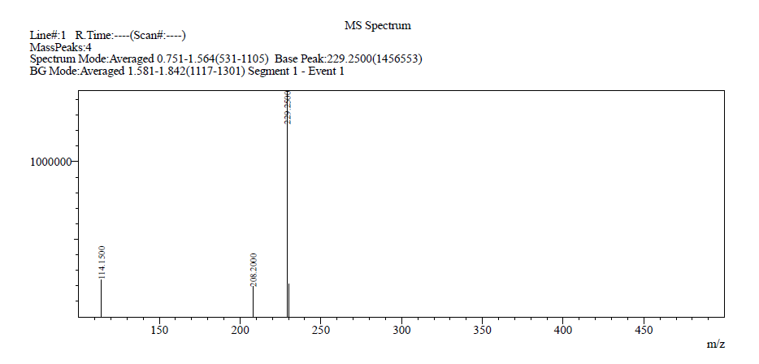
S5: Mass spectra of 5-(o-Tolylamino)nicotinic acid (6d)

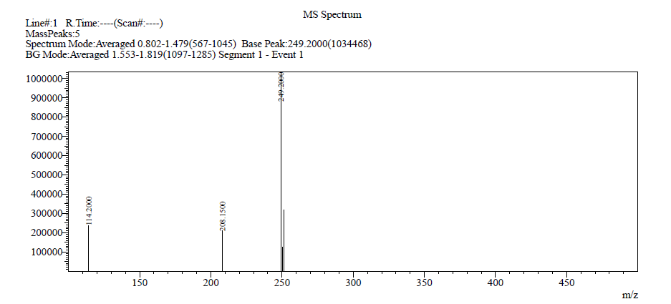
S6: Mass spectra of 5-((2-Chlorophenyl)amino)nicotinic acid (6e)

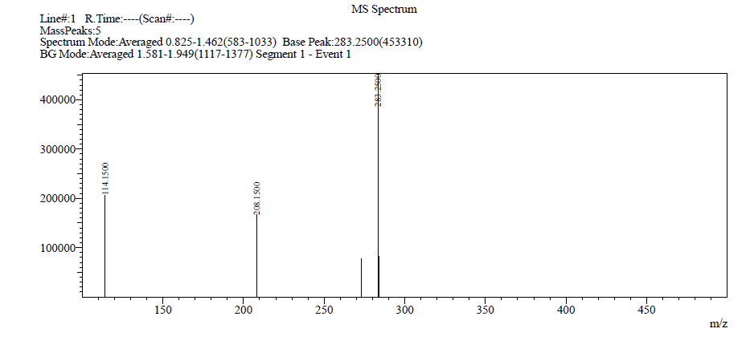
S7: Mass spectra of 5-((4-(Trifluoromethyl)phenyl)amino)nicotinic acid (6f)
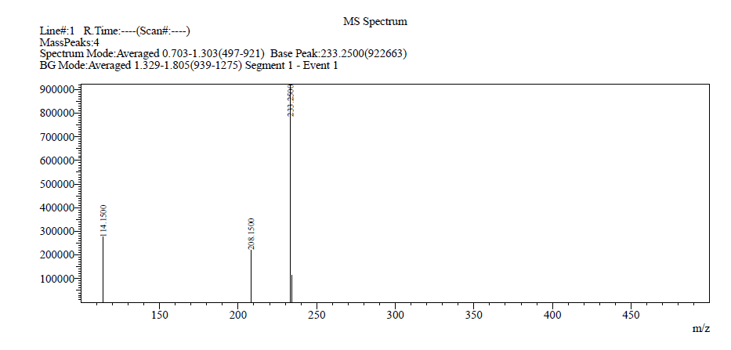
S8: Mass spectra of 5-((4-Fluorophenyl)amino)nicotinic acid (6g)

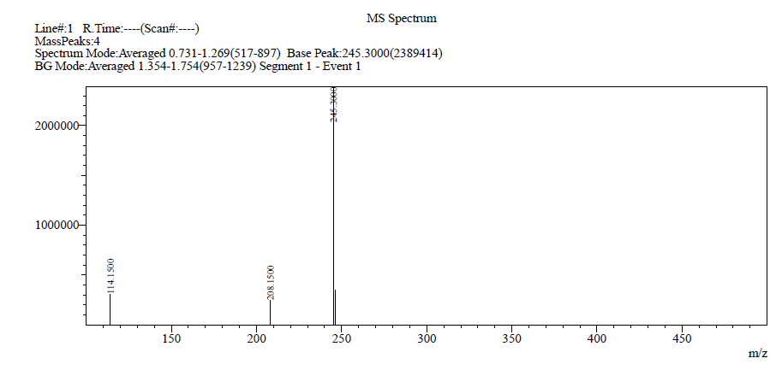
S9: Mass spectra of 5-((4-Methoxyphenyl)amino)nicotinic acid (6h)

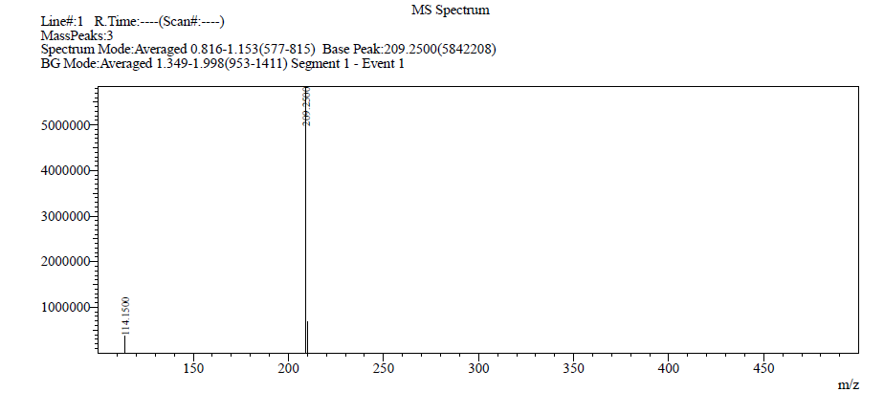
S10: Mass spectra 5-Morpholinonicotinic acid (6i)

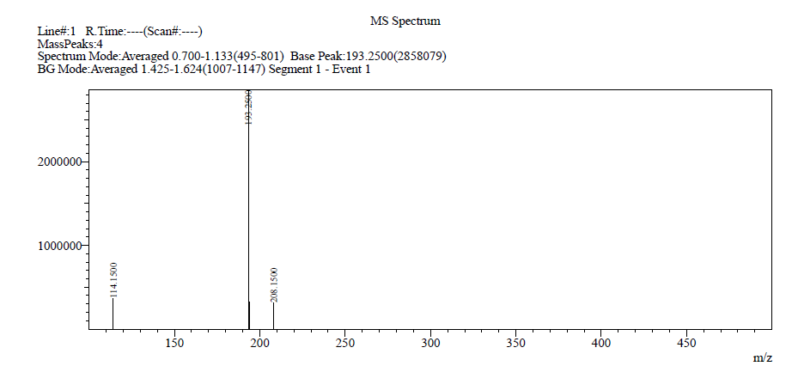
S11: Mass spectra of 5-(Pyrrolidin-1-yl)nicotinic acid (6j)

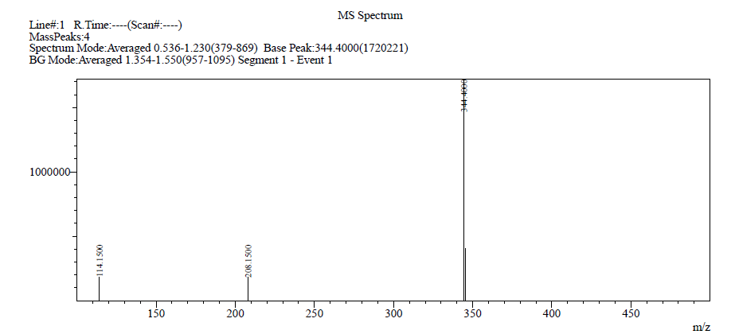S12: Mass spectra of (3-Amino-5-methyl-1H-indazol-1-yl)(5-(phenylamino)pyridin-3-yl)methanone (7a)
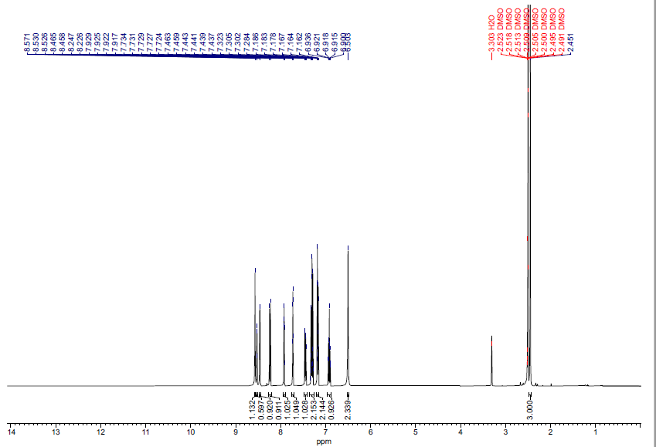
S13: ¹HNMR spectra of (3-Amino-5-methyl-1H-indazol-1-yl)(5-(phenylamino)pyridin-3-yl)methanone (7a)
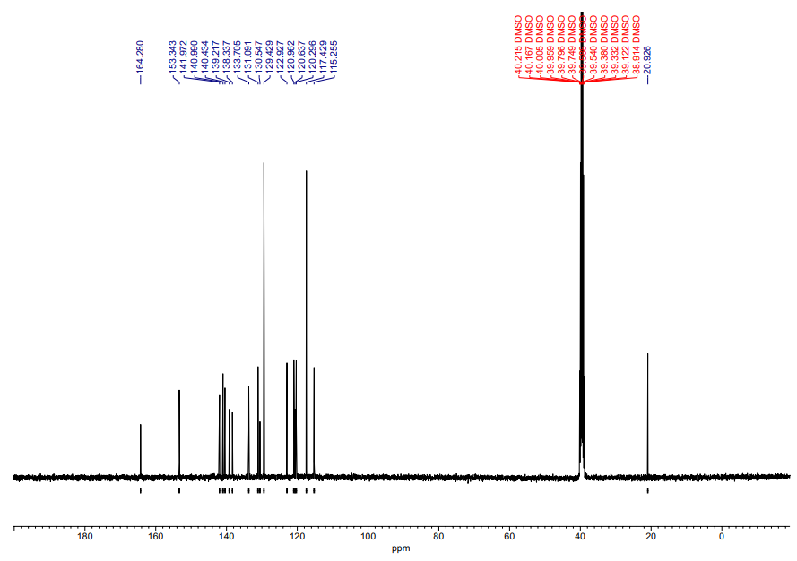
S14: ¹³C NMR spectra of (3-Amino-5-methyl-1H-indazol-1-yl)(5-(phenylamino)pyridin-3-yl)methanone (7a)

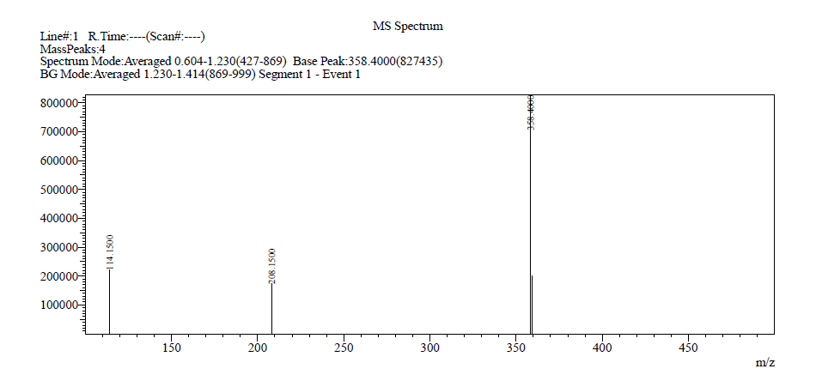
S15: Mass spectra of (3-Amino-5-methyl-1H-indazol-1-yl)(5-(p-tolylamino)pyridin-3-yl)methanone (7b)

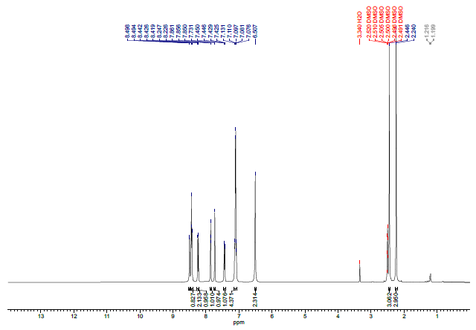
S16: ¹H NMR spectra of (3-Amino-5-methyl-1H-indazol-1-yl)(5-(p-tolylamino)pyridin-3-yl)methanone (7b)
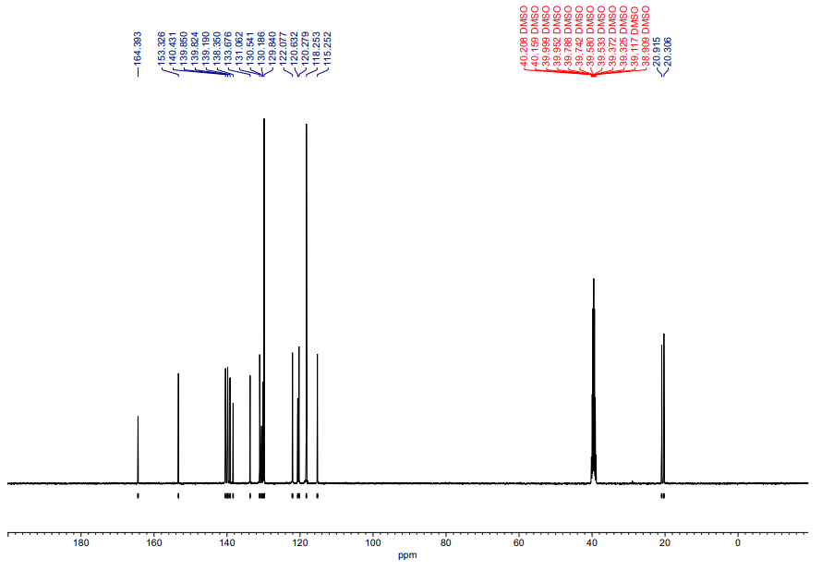
S17: ¹³C NMR spectra of (3-Amino-5-methyl-1H-indazol-1-yl)(5-(p-tolylamino)pyridin-3-yl)methanone (7b)
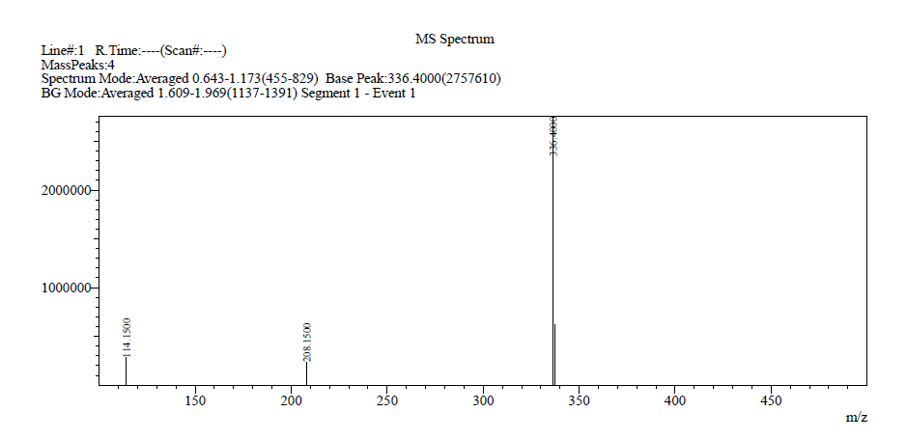
S18: Mass spectra of (3-Amino-5-methyl-1H-indazol-1-yl)(5-(cyclopentylamino)pyridin-3-yl)methanone (7c)
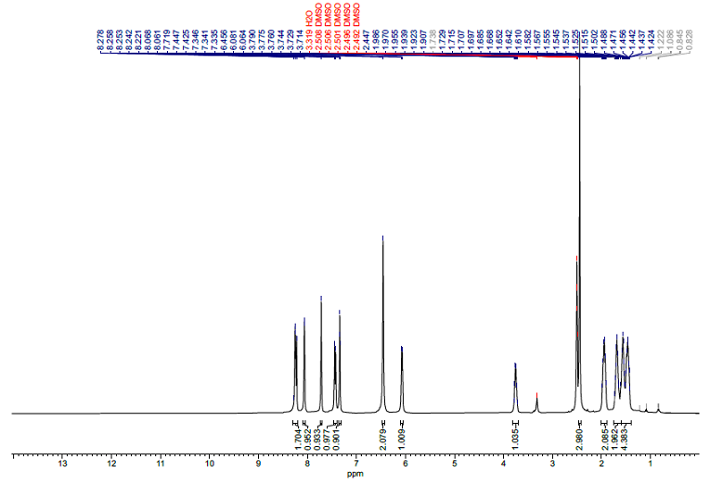
S19: ¹H NMR spectra of (3-Amino-5-methyl-1H-indazol-1-yl) (cyclopentylamino)pyridin-3-yl)methanone (7c)

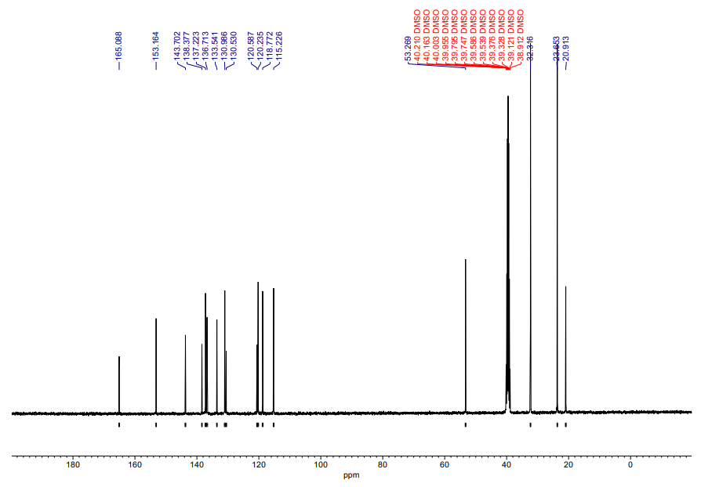
S20: ¹³C NMR spectra of (3-Amino-5-methyl-1H-indazol-1-yl) (cyclopentylamino)pyridin-3-yl)methanone (7c)

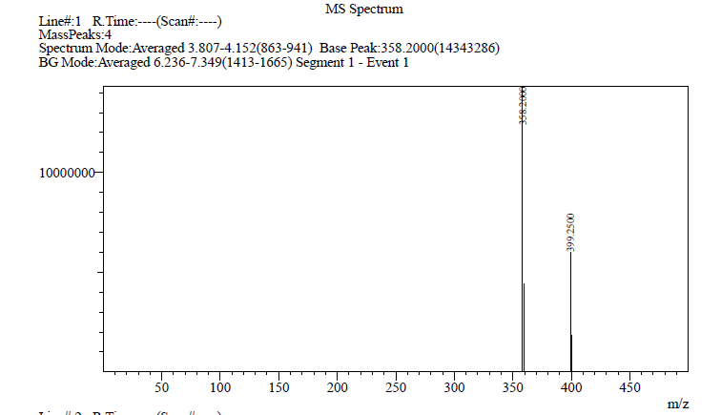
S21: Mass spectra of (3-Amino-5-methyl-1H-indazol-1-yl)(5-(o-tolylamino)pyridin-3-yl)methanone (7d)
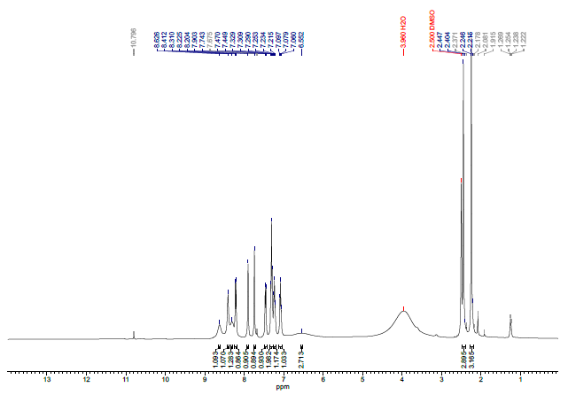
S22: ¹H NMR spectra of (3-Amino-5-methyl-1H-indazol-1-yl)(5-(o-tolylamino)pyridin-3-yl)methanone (7d)

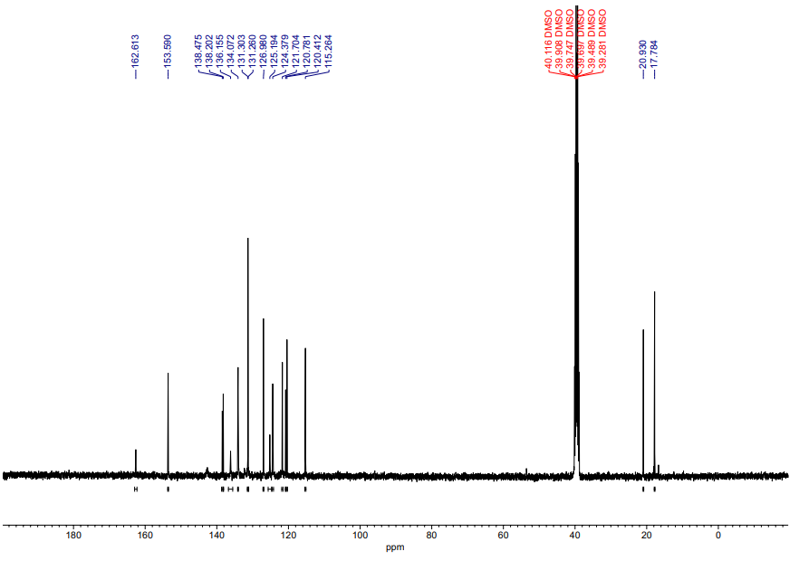
S 23: ¹³C NMR spectra of (3-Amino-5-methyl-1H-indazol-1-yl)(5-(o-tolylamino)pyridin-3-yl)methanone (7d)

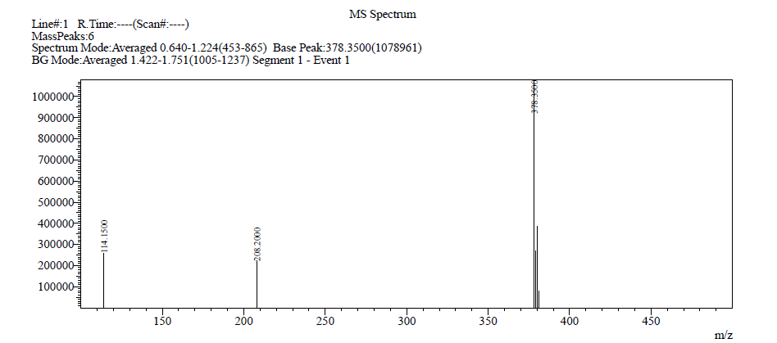
S24: Mass spectra of (3-Amino-5-methyl-1H-indazol-1-yl) (5 (( 2 chlorophenyl) amino) pyridin-3-yl)methanone (7e)

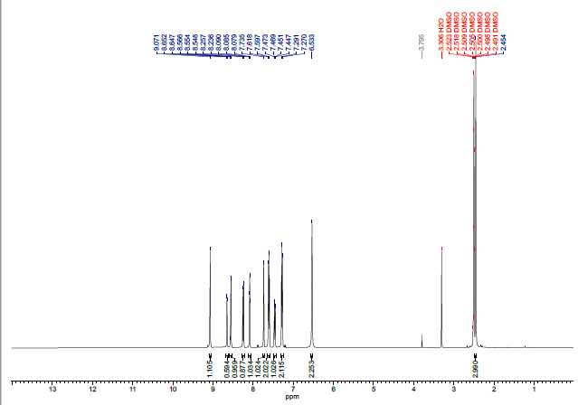
S25: ¹H NMR spectra of (3-Amino-5-methyl-1H-indazol-1-yl)(5-((2-chlorophenyl) amino)pyridin-3-yl)methanone (7e)

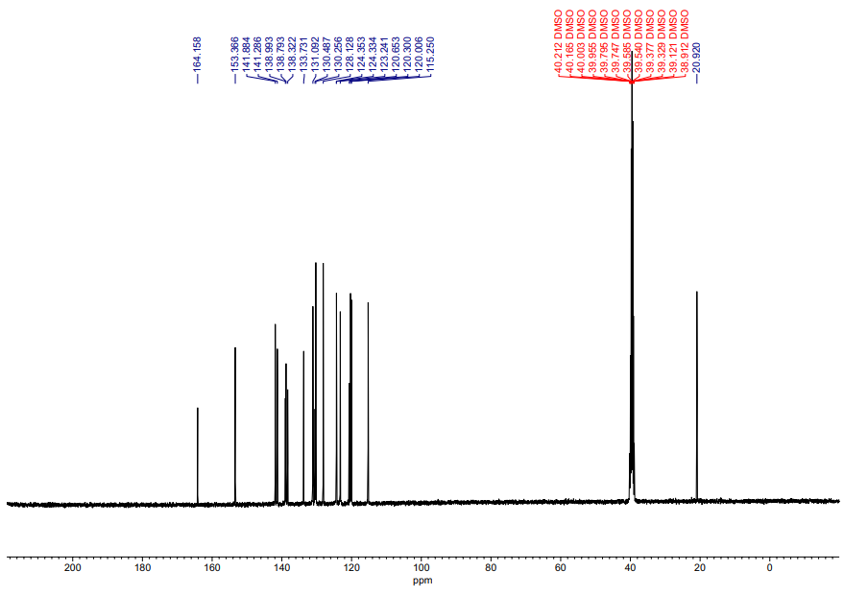
S26: ¹³C NMR spectra of (3-Amino-5-methyl-1H-indazol-1-yl)(5-((2-chlorophenyl) amino)pyridin-3-yl)methanone (7e)

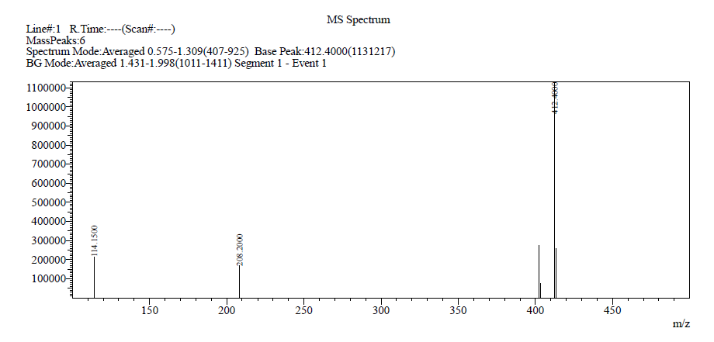
S27: Mass spectra of (3-Amino-5-methyl-1H-indazol-1-yl)(5-((4-(trifluoromethyl)phenyl) amino)pyridin-3-yl)methanone (7f)

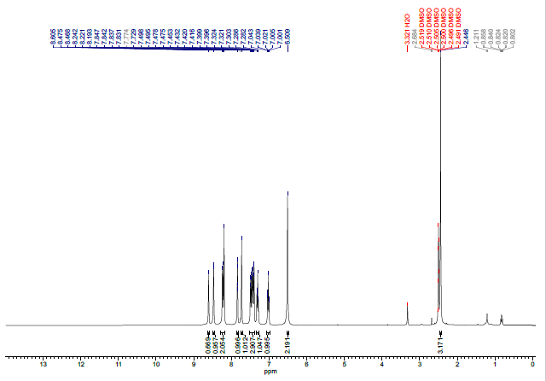
S28: ¹H NMR spectra of (3-Amino-5-methyl-1H-indazol-1-yl)(5-((4-(trifluoromethyl) phenyl) amino) pyridin-3-yl)methanone (7f)

S29: ¹³C NMR spectra of (3-Amino-5-methyl-1H-indazol-1-yl)(5-((4-(trifluoromethyl) phenyl) amino) pyridin-3-yl)methanone (7f)
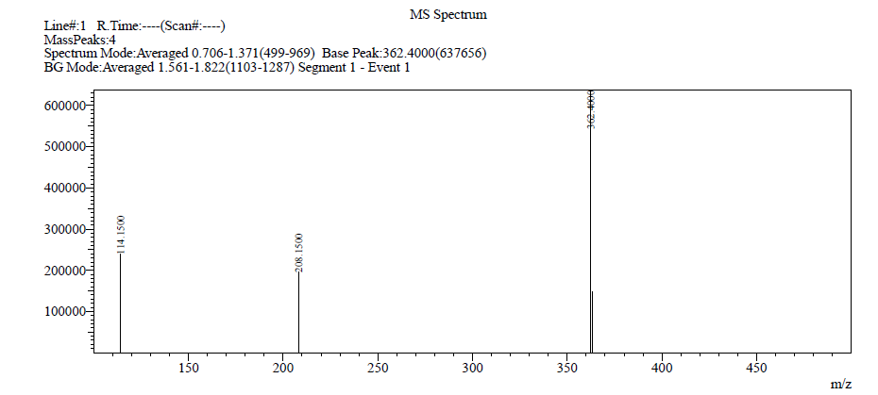
S30: Mass spectra of (3-Amino-5-methyl-1H-indazol-1-yl)(5-((4-fluorophenyl) amino)pyridin-3-yl)methanone (7g)
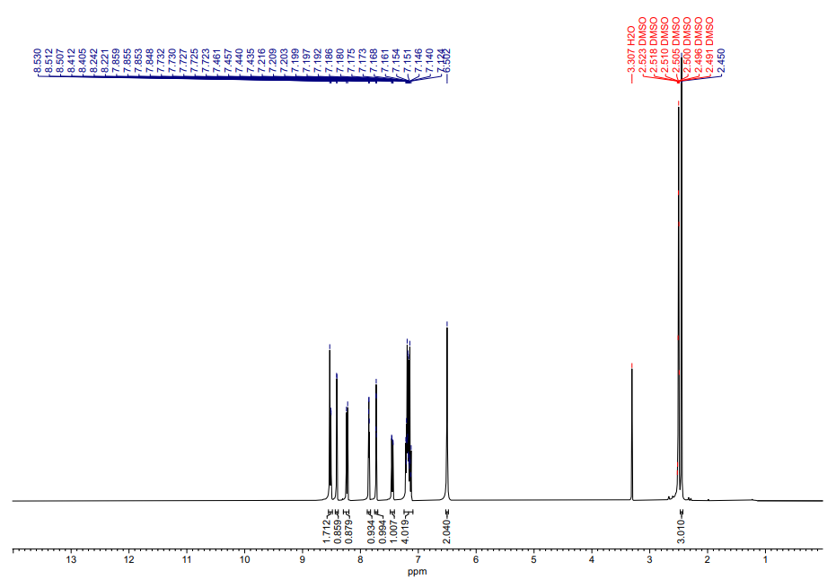
S31: ¹H NMR spectra of (3-Amino-5-methyl-1H-indazol-1-yl)(5-((4-fluorophenyl)amino) pyridin-3-yl)methanone (7g)

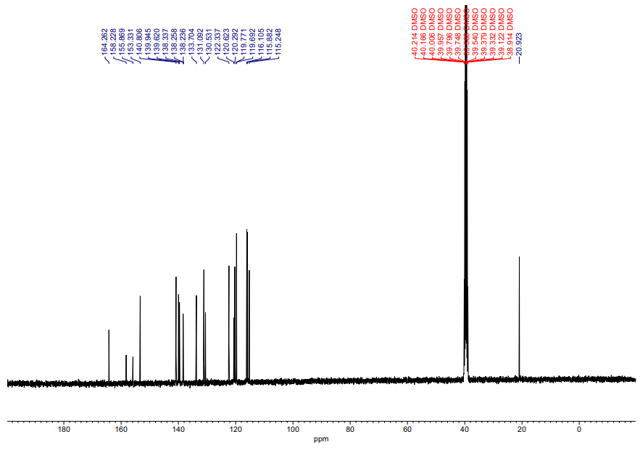
S32: ¹³C NMR spectra of (3-Amino-5-methyl-1H-indazol-1-yl)(5-((4-fluorophenyl)amino) pyridin-3-yl)methanone (7g)

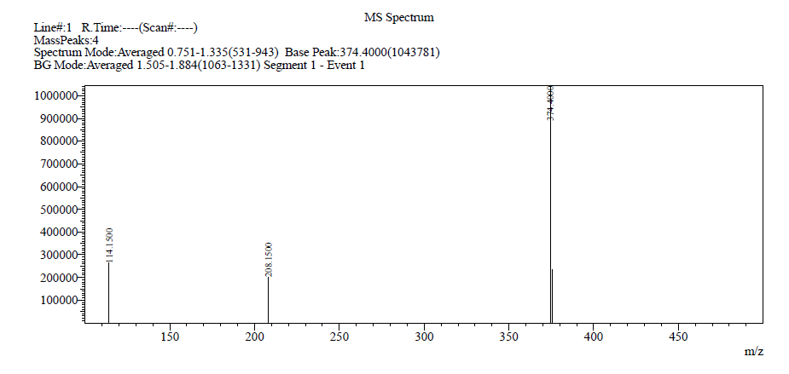
S33: Mass spectra of (3-Amino-5-methyl-1H-indazol-1-yl)(5-((4-methoxyphenyl)amino) (7h)
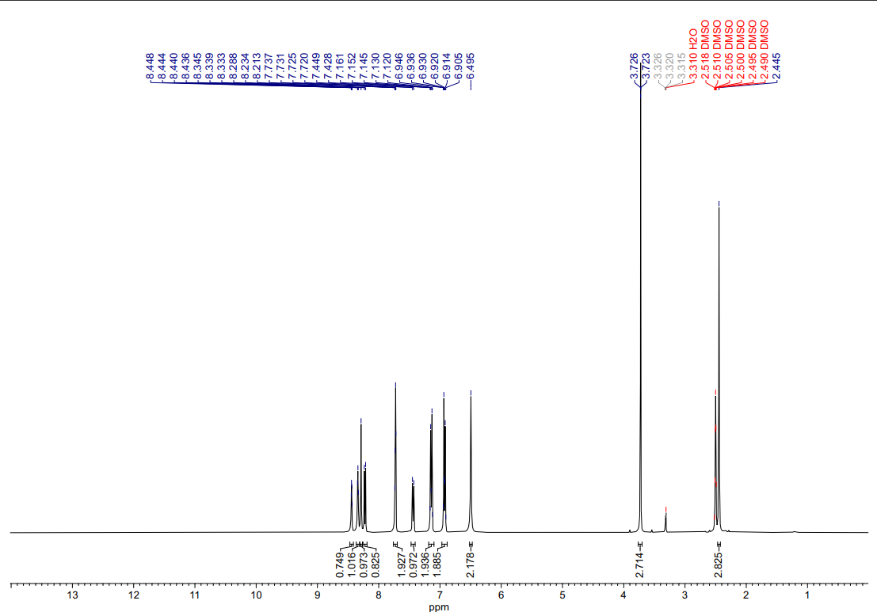
S34: ¹H NMR spectra of (3-Amino-5-methyl-1H-indazol-1-yl)(5-((4-methoxyphenyl)amino) (7h)
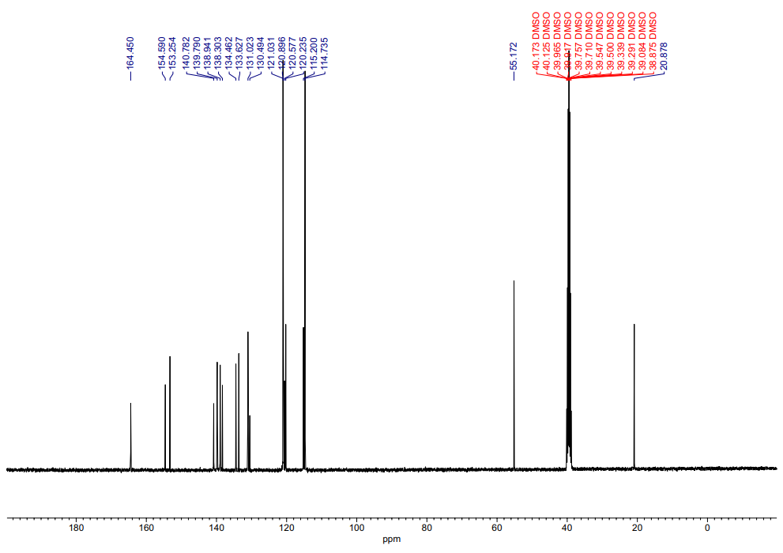S35: ¹³C NMR spectra of (3-Amino-5-methyl-1H-indazol-1-yl)(5-((4-methoxyphenyl)amino) (7h)

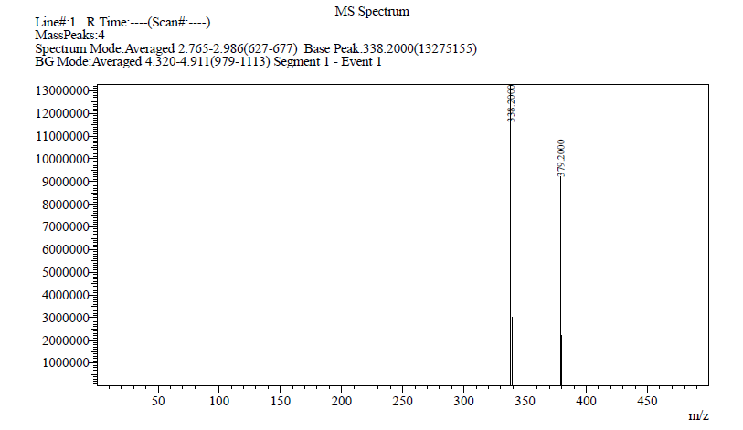 S36: Mass spectra of (3-Amino-5-methyl-1H-indazol-1-yl)(5-morpholinopyridin-3-yl)methanone (7i)
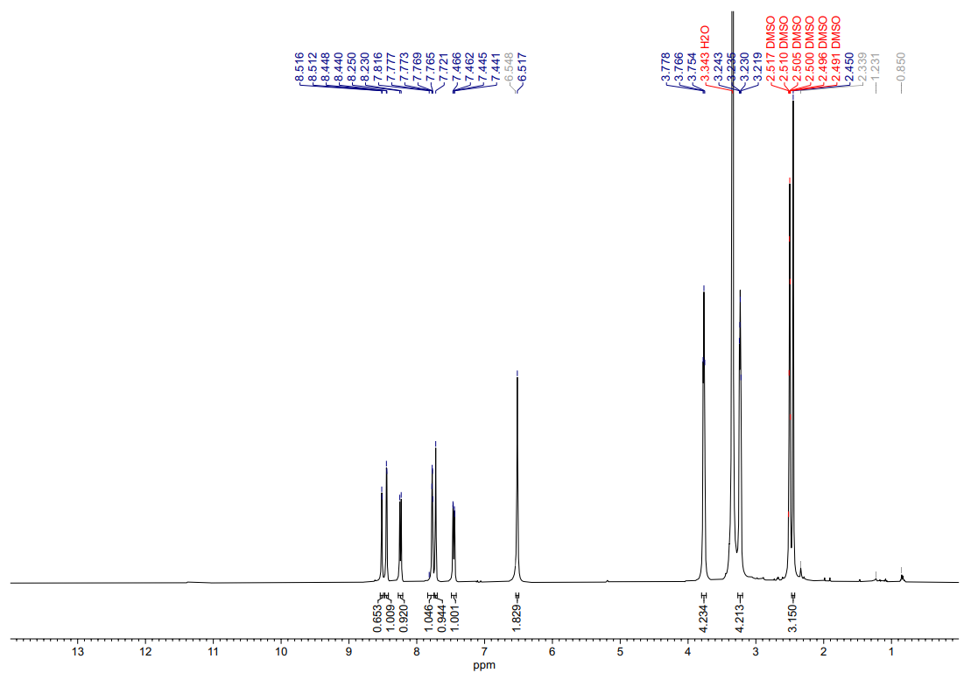
S37: ¹H NMR spectra of (3-Amino-5-methyl-1H-indazol-1-yl)(5-morpholinopyridin-3-yl)methanone (7i)

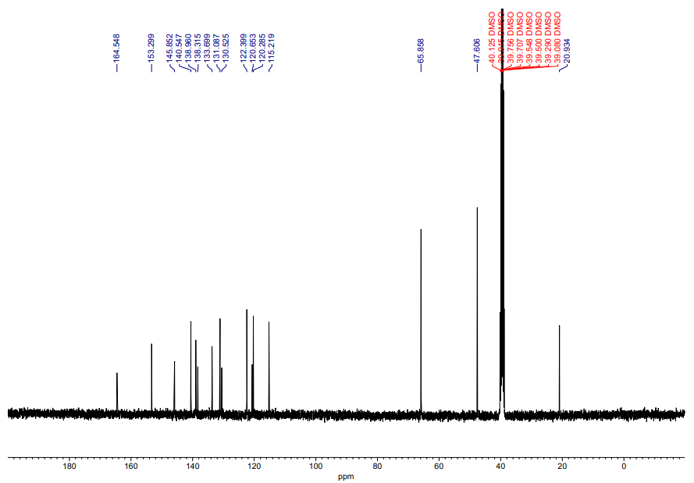
S38: ¹³ C NMR spectra of (3-Amino-5-methyl-1H-indazol-1-yl)(5-morpholinopyridin-3-yl)methanone (7i)

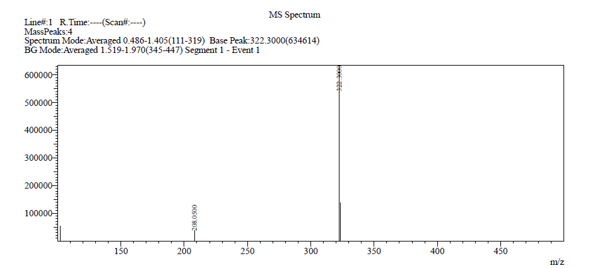
S39: Mass spectra of (3-Amino-5-methyl-1H-indazol-1-yl)(5-(pyrrolidin-1-yl)pyridin-3-yl)methanone (7j)

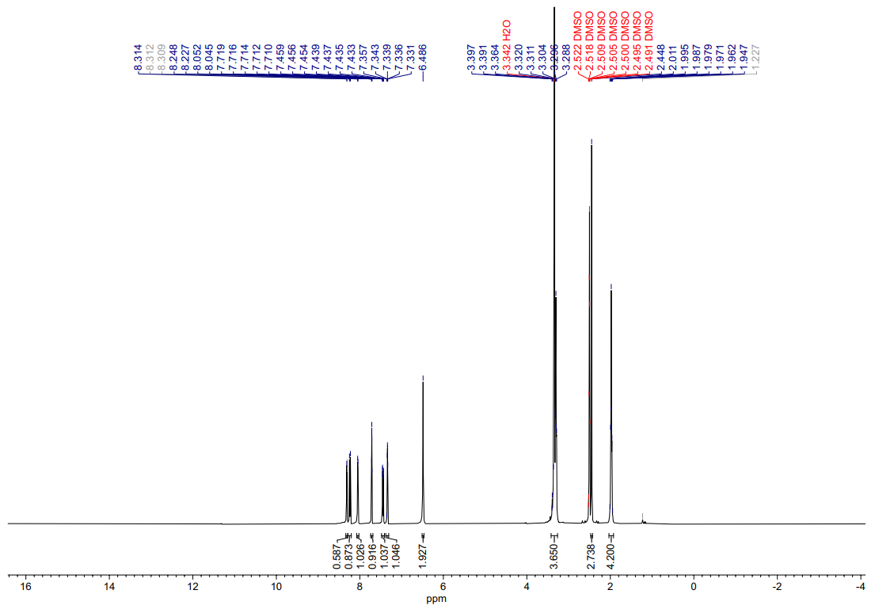
S40: ¹H NMR spectra of (3-Amino-5-methyl-1H-indazol-1-yl)(5-(pyrrolidin-1-yl)pyridin-3-yl)methanone (7j)

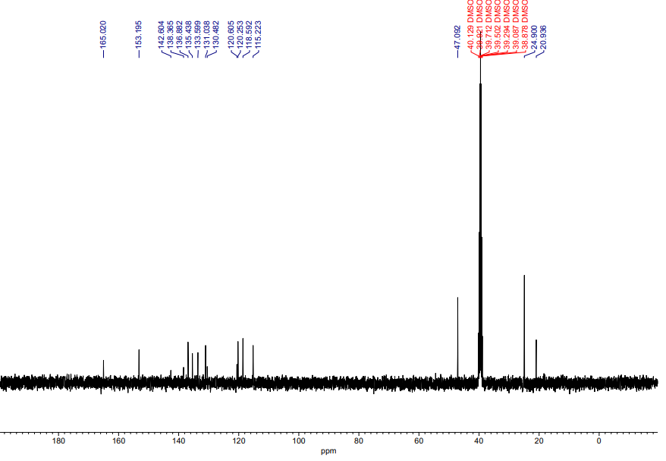
S41: ¹³ C NMR spectra of (3-Amino-5-methyl-1H-indazol-1-yl)(5-(pyrrolidin-1-yl)pyridin-3-yl)methanone (7j)

