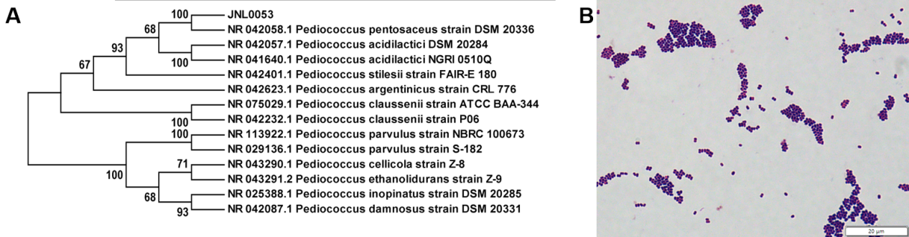
Figure S1 (A) Phylogenetic tree of the P. pentosaceus JNL0053 constructed by the Neighbor-Joining method based on 16S rDNA gene sequence comparison. (B) Gram staining results of P. pentosaceus JNL0053.
Supplementary data
Supplementary Fig. 1.(A-B) qPCR analysis of Kmo (A) and KYNU (B) in mouse colon tissues. Data represent mean values ± SEM (n = 3 per group). Statistical analysis was performed using unpaired T test. *p<0.05, **p<0.01,***p<0.001.
Supplementary Fig. 2. (A-B) Wilcoxon rank-sum test on genus level of (A)Akkemansia and (B)Bifidobacterium
Supplementary Fig.3 Mechanistic study of metabolite Di acid to alleviate the symptoms of colitis in mice (A)Experimental mechanistic diagram, (B)qPCR expression levels of IL-6, iNOS (C), TNF-a (D), AHR (G), CYP1A1 (H), and MUC2 (I)of the upper layer of Caco2 cells after 48h of co-cultivation, (E-F)flow cytometric analysis of the lower layer of primary mouse splenocytes of Th17 differentiation, (J)protein levels of cytokines IL-22 and IL-17F (K)in the supernatants of lower layer cells, (L)protein levels analyzed by Western Blot after co-incubation and (M)grayscale quantification. Data represent mean values ± SEM (n = 3 per group). Statistical analysis was performed using unpaired T test. *p<0.05, **p<0.01.
Supplementary Fig. 4. Protein levels of cytokine IL-4 in the supernatants of lower cells after N-Ace (A)and Di acid (B)treatment. Data represent mean values ± SEM (n = 3 per group). Statistical analysis was performed using unpaired T test.
Supplementary Fig. 5. Mechanistic study of metabolite proctolin to alleviate colitis symptoms in mice qPCR expression levels of IL-6 (A), iNOS (B), TNF-a (C), AHR (D), CYP1A1 (E), and MUC2 (F)in the upper layer of Caco2 cells after co-culturing for 48h.
Supplementary Fig. 6 Mechanistic study of metabolite Inulin to alleviate the symptoms of colitis in mice qPCR expression levels of IL-6 (A), iNOS (B), TNF-a (C), AHR (D), CYP1A1 (E), and MUC2 (F)in the upper layer of Caco2 cells after co-culturing for 48h.

Supplementary Table 1 Primer sequences
Species | Prime | Sequence (5’→3’)
Mouse | β-actin | F:GGCTGTATTCCCCTCCATCG | R:CCAGTTGGTAACAATGCCATGT
 | IL-6 | F:CTGCAAGAGACTTCCATCCAG | R:AGTGGTATAGACAGGTCTGTTGG
 | CXCL5 | F:CAGAAGGAGGTCTGTCTGGAT | R:GCTTTCTTTTTGTCACTGCCCA
 | CXCL10 | F:AGGGCCATAGGGAAGCTTGA | R:TTCTTTTTCATCGTGGCAATGATCT
 | CCR5 | F:AGGCACCAGCACAAACCTTC | R:AGGCCAGTTCCTTGTACAGGTC
 | CCR7 | F:AGAGGCTCAAGACCATGACGGA | R:TCCAGGACTTGGCTTCGCTGTA
 | MUC2 | F:GAACGGGGCCATGGTCAG | R:TGAGTGCATCTTCCCGGTTC
 | CCR8 | F:TACGCAGTGCTTCTTTGCCT | R:AGGTGACTGGAGCCTTATCTGG
 | IL-17F | F:GAAGGCTGGGAACTGTCCTC | R:GGGGTCTCGAGTGATGTTGT
 | IL-22 | F:ATCAGCGGTGACGACCAGAA | R:TCTCCACTCTCTCCAAGCTTTT
 | IL-4 | F:AGCTGCAGAGACTCTTTCGG | R:CAGTGATGTGGACTTGGACTCA
Human | β-actin | F:CATGTACGTTGCTATCCAGGC | R:CTCCTTAATGTCACGCACGAT
 | MUC2 | F:AATTCCTCTCTGACGGCGTG | R:ATCCTCACACACCACATCGG
 | IL-6 | F:-GACAGCCACTCACCTCTTCA | R:TTCACCAGGCAAGTCTCCTC′
 | AHR | F:CACAAGGAGTGGACGAAGCC | R:TTATCCAGCAGGCACCTCAG
 | iNOS | F:CCTTACGAGGCGAAGAAGGACAG | R:CAGTTTGAGAGAGGAGGCTCCG′
 | TNF-α | F:-GTCAGATCATCTTCGA ACC | R:CAGATAGATGGGCTCATACC

