Table S1 Baseline characteristics in the male and female participants
Variables | Male (n=15538) | Female (n=10146) | p
Age, n(%) |  |  | <0.001
<45 | 7926 (51.0) | 5025 (49.5)
45~59 | 4383 (28.2) | 3364 (33.2)
≥60 | 3229 (20.8) | 1757 (17.3)
Occupation, n(%) |  |  | <0.001
Worker staff | 12822 (82.5) | 7907 (77.9)
Managerial staff | 1633 (10.5) | 1257 (12.4)
Technical staff | 745 (4.8) | 308 (3.0)
Logistics staff | 338 (2.2) | 674 (6.6)
Education, n(%) |  |  | <0.001
Junior middle school or below | 5850 (37.6) | 4427 (43.6)
Senior middle school or equivalent | 4539 (29.2) | 2640 (26.0)
College or above | 5149 (33.1) | 3079 (30.3)
Smoking status, n(%) |  |  | <0.001
Never | 4068 (26.2) | 9979 (98.4)
Still | 9354 (60.2) | 136 (1.3)
Quit | 2116 (13.6) | 31 (0.3)
Alcohol consumption, n(%) |  |  | <0.001
Never | 9303 (59.9) | 9878 (97.4)
Occasionally | 5131 (33.0) | 238 (2.4)
Regular | 1104 (7.1) | 30 (0.3)
Physical exercise, n(%) |  |  | <0.001
Never | 1415 (9.1) | 915 (9.0)
Occasionally | 6777 (43.6) | 4143 (40.8)
Regular | 7346 (47.3) | 5088 (50.1)
High‐salt diet, n(%) | 4181 (26.9) | 1671 (16.5) | <0.001
High‐fat diet, n(%) | 3538 (22.8) | 1439 (14.2) | <0.001
High‐sugar diet, n(%) | 3058 (19.7) | 2117 (20.9) | 0.022
Hypertension, n(%) | 4739 (30.5) | 2295 (22.6) | <0.001
Diabetes, n(%) | 1305 (8.4) | 536 (5.3) | <0.001
Hyperuricemia, n(%) | 2867 (18.5) | 140 (1.4) | <0.001
Dyslipidemia, n(%) | 6734 (43.3) | 2578 (25.4) | <0.001
BMI(kg/m²), n(%) |  |  | <0.001
<18.5 | 7320 (47.1) | 6307 (62.2)
18.5~23.9 | 512 (3.3) | 690 (6.8)
24~27.9 | 6138 (39.5) | 2443 (24.1)
≥28 | 1568 (10.1) | 706 (7.0)
SUA, μmol/L | 353.0 (310.0, 402.0) | 264.0 (229.0, 302.0) | <0.001
SCR, μmol/L | 75.0 (68.0, 82.0) | 58.0 (53.0, 64.0) | <0.001
ALT, U/L | 32.0 (23.0, 47.0) | 21.0 (16.0, 29.0) | <0.001
AST, U/L | 33.0 (28.0, 40.0) | 29.0 (24.0, 35.0) | <0.001
TC, mmol/L | 4.6 (4.1, 5.2) | 4.70 (4.1, 5.3) | <0.001
TG, mmol/L | 1.7 (1.2, 2.6) | 1.3 (0.9, 1.9) | <0.001
HDL-C, mmol/L | 1.3 (1.1, 1.5) | 1.5 (1.3, 1.7) | <0.001
LDL-C, mmol/L | 3.0 (2.5, 3.5) | 3.1 (2.6, 3.6) | <0.001
SBP, mmHg | 125.0 (113.0, 136.0) | 117.0 (105.0, 131.0) | <0.001
DBP, mmHg | 79.0 (71.0, 87.0) | 75.0 (68.0, 84.0) | <0.001
FPG, mmol/L | 5.1 (4.7, 5.6) | 5.0 (4.7, 5.4) | <0.001
ALP, U/L | 69.0 (58.0, 82.0) | 59.0 (48.0, 73.0) | <0.001
eGFR, mL/min/1.73m² | 104.0 (94.2, 112.0) | 106.0 (95.7, 113.0) | <0.001
jian | 11.4 (9.0, 14.4) | 11.1 (9.0, 13.7) | <0.001
CKD, n(%) | 906 (5.83) | 313 (3.08) | <0.001
Abbreviations: BMI, body mass index; SUA, serum uric acid; Scr, serum creatinine; ALT, alanine aminotransferase; AST, aspartate aminotransferase; TC, total cholesterol; TG, triglyceride; HDL‐C, high‐density lipoprotein cholesterol; LDL-C, low‐density lipoprotein cholesterol; SBP, systolic blood pressure; DBP, diastolic blood pressure; FPG, fasting plasma glucose; ALP, alkaline phosphatase; eGFR, estimated glomerular filtration rate; CKD, chronic kidney disease.

Table S2 The CKD morbidity status of subjects with varying baseline characteristics
Variables | Total (N=25684) |  |  | Males (N=15538) |  |  | Females (N=10146)
Variables | n | N | Inc (%) | n | N | Inc (%) | n | N | Inc (%)
Age
＜45 | 479 | 12951 | 3.70 | 358 | 7926 | 4.52 | 121 | 5025 | 2.41
45-59 | 330 | 7747 | 4.26 | 233 | 4383 | 5.32 | 97 | 3364 | 2.88
≥60 | 410 | 4986 | 8.22ª | 315 | 3229 | 9.76ª | 95 | 1757 | 5.41ª
Occupation
Worker staff | 1017 | 20729 | 4.91 | 769 | 12822 | 6.00 | 248 | 7907 | 3.14
Managerial staff | 106 | 2890 | 3.67 | 74 | 1633 | 4.53 | 32 | 1257 | 2.55
Technical staff | 41 | 1053 | 3.89 | 34 | 745 | 4.56 | 7 | 308 | 2.27
Logistics staff | 55 | 1012 | 5.43ª | 29 | 338 | 8.58ª | 26 | 674 | 3.86
Education
Junior middle school or below | 624 | 10277 | 6.07 | 456 | 5850 | 7.79 | 168 | 4427 | 3.79
Senior middle school or equivalent | 329 | 7179 | 4.58 | 253 | 4539 | 5.57 | 76 | 2640 | 2.88
College or above | 266 | 8228 | 3.23 | 197 | 5149 | 3.83 | 69 | 3079 | 2.24
Income
<¥1000 | 74 | 1214 | 6.10 | 70 | 1051 | 6.66 | 4 | 163 | 2.45
¥1000~¥1999 | 614 | 12254 | 5.01 | 480 | 7516 | 6.39 | 134 | 4738 | 2.83
¥2000~¥4999 | 514 | 11859 | 4.33 | 346 | 6769 | 5.11 | 168 | 5090 | 3.30
¥5000~¥9999 | 15 | 322 | 4.66 | 9 | 179 | 5.03 | 6 | 143 | 4.20
≥¥10000 | 2 | 35 | 5.71ª | 1 | 23 | 4.35ª | 1 | 12 | 8.33
Smoking status
Never | 523 | 14047 | 3.72 | 216 | 4068 | 5.31 | 307 | 9979 | 3.08
Still | 516 | 9490 | 5.44 | 510 | 9354 | 5.45 | 6 | 136 | 4.41
Quit | 180 | 2147 | 8.38ª | 180 | 2116 | 8.51ª | 0 | 31 | 0.00
Alcohol consumption
Never | 792 | 19181 | 4.13 | 488 | 9303 | 5.25 | 304 | 9878 | 3.08
Occasionally | 321 | 5369 | 5.98 | 312 | 5131 | 6.08 | 9 | 238 | 3.78
Regular | 106 | 1134 | 9.35ª | 106 | 1104 | 9.60ª | 0 | 30 | 0.00
Physical exercise
Never | 140 | 2330 | 6.01 | 110 | 1415 | 7.77 | 30 | 915 | 3.28
Occasionally | 500 | 10920 | 4.58 | 369 | 6777 | 5.44 | 131 | 4143 | 3.16
Regular | 579 | 12434 | 4.66ª | 427 | 7346 | 5.81ª | 152 | 5088 | 2.99
Hypertension
No | 604 | 18650 | 3.24 | 426 | 10799 | 3.94 | 178 | 7851 | 2.27
Yes | 615 | 7034 | 8.74ª | 480 | 4739 | 10.13ª | 135 | 2295 | 5.88ª
Diabetes
No | 1078 | 24655 | 4.37 | 790 | 14839 | 5.32 | 288 | 9816 | 2.93
Yes | 141 | 1029 | 13.70ª | 116 | 699 | 16.60ª | 25 | 330 | 7.58ª
Hyperuricemia
No | 984 | 22677 | 4.34 | 683 | 12671 | 5.39 | 301 | 10006 | 3.01
Yes | 235 | 3007 | 7.82ª | 223 | 2867 | 7.78ª | 12 | 140 | 8.57ª
Dyslipidemia
No | 626 | 16372 | 3.82 | 426 | 8804 | 4.84 | 200 | 7568 | 2.64
Yes | 593 | 9312 | 6.37ª | 480 | 6734 | 7.13ª | 113 | 2578 | 4.38ª
High‐salt diet
No | 936 | 19832 | 4.72 | 675 | 11357 | 5.94 | 261 | 8475 | 3.08
Yes | 283 | 5852 | 4.84 | 231 | 4181 | 5.52 | 52 | 1671 | 3.11
High‐fat diet
No | 972 | 20707 | 4.69 | 696 | 12000 | 5.80 | 276 | 8707 | 3.17
Yes | 247 | 4977 | 4.96 | 210 | 3538 | 5.94 | 37 | 1439 | 2.57
High‐sugar diet
No | 987 | 20509 | 4.81 | 748 | 12480 | 5.99 | 239 | 8029 | 2.98
Yes | 232 | 5157 | 4.50 | 158 | 3058 | 5.17 | 74 | 2117 | 3.50
BMI(kg/m2)
＜18.5 | 39 | 1202 | 3.24 | 25 | 512 | 4.88 | 14 | 690 | 2.03
18.5-23.9 | 496 | 13627 | 3.64 | 345 | 7320 | 4.71 | 151 | 6307 | 2.39
24-27.9 | 485 | 8581 | 5.65 | 385 | 6138 | 6.27 | 100 | 2443 | 4.09
≥28 | 199 | 2274 | 8.75ª | 151 | 1568 | 9.63ª | 48 | 706 | 6.80ª
Note: N, the total number of the participants; n, the number of incidence cases; Inc, the incidence rate; a, p < 0.05 when comparing cumulative incidence rates within each subgroup. Abbreviation: BMI, body mass index.

Table S3 Standardized mean differences of variables after PSM
Variables | SMDs | Variables | SMDs | Variables | SMDs
Age | 0.011 | Hypertension | 0.017 | TC | 0.006
Occupation | 0.010 | Diabetes | 0.003 | TG | 0.004
Education | 0.013 | Hyperuricemia | 0.004 | HDLC | 0.007
Smoking status | 0.012 | Dyslipidemia | 0.011 | LDLC | 0.014
Alcohol consumption | 0.005 | BMI | 0.010 | SBP | 0.014
Physical exercise | 0.015 | SUA | 0.016 | DBP | 0.006
High‐salt diet | 0.002 | Scr | 0.014 | FPG | 0.007
High‐fat diet | 0.006 | ALT | 0.005 | ALP | 0.004
High‐sugar diet | 0.008 | AST | 0.004 | e-GFR | 0.013
Note: The abbreviations are the same as in Table S1.
Table S4 Baseline characteristics between the two groups with serum IBIL levels of ≥11.4 μmol/L and <11.4 μmol/L
Variables | Before PSM |  |  | After PSM
Variables | IBIL<11.4 μmol/L  (n=13021) | IBIL≥11.4 μmol/L  (n=12663) | p | IBIL<11.4 μmol/L  (n=8753) | IBIL≥11.4 μmol/L  (n=8753) | p
age | 44.0 (38.0, 55.0) | 45.0 (39.0, 56.0) | <0.001 | 44.0 (38.0, 56.0) | 44.0 (39.0, 54.0) | 0.845
Occupation, n(%) |  |  | 0.774 |  |  | 0.927
Worker staff | 10530 (80.9) | 10199 (80.5) |  | 7040 (80.4) | 7064 (80.7)
Managerial staff | 1465 (11.3) | 1425 (11.3) |  | 997 (11.4) | 969 (11.1)
Technical staff | 528 (4.1) | 525 (4.2) |  | 355 (4.1) | 359 (4.1)
Logistics staff | 498 (3.82) | 514 (4.06) |  | 361 (4.12) | 361 (4.12)
Education, n(%) |  |  | <0.001 |  |  | 0.690
Junior middle school or below | 5170 (39.7) | 5107 (40.3) |  | 3514 (40.1) | 3543 (40.5)
Senior middle school or equivalent | 3539 (27.2) | 3640 (28.7) |  | 2456 (28.1) | 2405 (27.5)
College or above | 4312 (33.1) | 3916 (30.9) |  | 2783 (31.8) | 2805 (32.0)
Smoking status, n(%) |  |  | <0.001 |  |  | 0.736
Never | 6823 (52.4) | 7224 (57.0) |  | 4761 (54.4) | 4806 (54.9)
Still | 5267 (40.5) | 4223 (33.3) |  | 3277 (37.4) | 3253 (37.2)
Quit | 931 (7.2) | 1216 (9.6) |  | 715 (8.2) | 694 (7.9)
Alcohol consumption, n(%) |  |  | <0.001 |  |  | 0.949
Never | 9866 (75.8) | 9315 (73.6) |  | 6601 (75.4) | 6618 (75.6)
Occasionally | 2572 (19.8) | 2797 (22.1) |  | 1772 (20.2) | 1761 (20.1)
Regular | 583 (4.5) | 551 (4.4) |  | 380 (4.3) | 374 (4.3)
Physical exercise, n(%) |  |  | <0.001 |  |  | 0.620
Never | 1284 (9.9) | 1046 (8.3) |  | 780 (8.9) | 791 (9.0)
Occasionally | 5783 (44.4) | 5137 (40.6) |  | 3779 (43.2) | 3715 (42.4)
Regular | 5954 (45.7) | 6480 (51.2) |  | 4194 (47.9) | 4247 (48.5)
High‐salt diet, n(%) | 3056 (23.5) | 2796 (22.1) | 0.008 | 1998 (22.8) | 1990 (22.7) | 0.900
High‐fat diet, n(%) | 2623 (20.1) | 2354 (18.6) | 0.002 | 1676 (19.1) | 1696 (19.4) | 0.716
High‐sugar diet, n(%) | 2659 (20.4) | 2516 (19.9) | 0.277 | 1762 (20.1) | 1790 (20.5) | 0.612
Hypertension, n(%) | 3497 (26.9) | 3537 (27.9) | 0.055 | 2391 (27.3) | 2326 (26.6) | 0.276
Diabetes, n(%) | 948 (7.3) | 893 (7.1) | 0.493 | 609 (7.0) | 602 (6.9) | 0.858
Hyperuricemia, n(%) | 1473 (11.3) | 1534 (12.1) | 0.048 | 1012 (11.6) | 981 (11.2) | 0.475
Dyslipidemia, n(%) | 4602 (35.3) | 4710 (37.2) | 0.002 | 3094 (35.3) | 3112 (35.6) | 0.788
BMI(kg/m²), n(%) |  |  | 0.002 |  |  | 0.927
<18.5 | 6882 (52.9) | 6745 (53.3) |  | 4668 (53.3) | 4681 (53.5)
18.5~23.9 | 593 (4.6) | 609 (4.8) |  | 410 (4.7) | 420 (4.8)
24~27.9 | 4306 (33.1) | 4275 (33.8) |  | 2915 (33.3) | 2914 (33.3)
≥28 | 1240 (9.5) | 1034 (8.2) |  | 760 (8.7) | 738 (8.4)
SUA | 315.0 (264.0, 373.0) | 319.0 (265.0, 377.0) | 0.004 | 316.0 (263.0, 373.0) | 315.0 (261.0, 373.0) | 0.266
Scr | 68.0 (59.0, 77.0) | 69.0 (60.0, 78.0) | <0.001 | 68.0 (59.0, 77.0) | 68.0 (59.0, 77.0) | 0.445
ALT | 26.0 (19.0, 39.0) | 28.0 (20.0, 41.0) | <0.001 | 27.0 (19.0, 40.0) | 27.0 (20.0, 40.0) | 0.147
AST | 31.0 (26.0, 38.0) | 32.0 (26.0, 39.0) | <0.001 | 31.0 (26.0, 38.0) | 31.0 (26.0, 38.0) | 0.575
TC | 4.5 (4.0, 5.1) | 4.7 (4.2, 5.3) | <0.001 | 4.6 (4.1, 5.2) | 4.6 (4.1, 5.2) | 0.862
TG | 1.5 (1.1, 2.2) | 1.6 (1.1, 2.3) | <0.001 | 1.5 (1.1, 2.2) | 1.6 (1.1, 2.3) | 0.086
HDLC | 1.3 (1.1, 1.5) | 1.4 (1.1, 1.6) | <0.001 | 1.3 (1.1, 1.6) | 1.3 (1.1, 1.6) | 0.654
LDLC | 3.0 (2.5, 3.5) | 3.1 (2.6, 3.5) | <0.001 | 3.0 (2.6, 3.5) | 3.0 (2.6, 3.5) | 0.538
SBP | 122.0 (109.0, 134.0) | 122.0 (110.0, 135.0) | <0.001 | 122.0 (109.0, 134.0) | 121.0 (110.0, 134.0) | 0.386
DBP | 77.0 (69.0, 86.0) | 78.0 (70.0, 86.0) | <0.001 | 77.0 (70.0, 86.0) | 77.0 (70.0, 86.0) | 0.806
FPG | 5.1 (4.7, 5.5) | 5.1 (4.7, 5.5) | 0.363 | 5.1 (4.7, 5.5) | 5.0 (4.7, 5.5) | 0.004
ALP | 66.0 (54.0, 80.0) | 65.0 (54.0, 78.0) | <0.001 | 65.0 (54.0, 79.0) | 65.0 (54.0, 79.0) | 0.415
e-GFR | 105 (95.3, 113) | 104 (94.2, 112) | <0.001 | 105 (94.6, 113) | 105 (95.4, 112) | 0.509
Note: The abbreviations are the same as in Table S1.

Table S5 Association between serum IBIL levels and CKD in the total, male and female participants after propensity score matching treatment
Variables | Ranges (within-group median), μmol/L | HRs (95% CI) | P
Total | P for trend = 0.041
Q1 | ≤9.1 (7.8) | 1.000 (Reference)
Q2 | 9.1 ~ 11.3 (10.3) | 0.780 (0.643 ~ 0.946) | 0.012
Q3 | 11.3 ~ 14.0 (12.6) | 0.844 (0.698 ~ 1.021) | 0.080
Q4 | >14.0 (16.5) | 0.788 (0.650 ~ 0.954) | 0.015
Per SD |  | 0.934 (0.871 ~ 1.001) | 0.053
Male | P for trend = 0.016
Q1 | ≤9.1 (7.7) | 1.000 (Reference)
Q2 | 9.1 ~ 11.3 (10.3) | 0.735 (0.587 ~ 0.920) | 0.007
Q3 | 11.3 ~ 14.2 (12.7) | 0.778 (0.624 ~ 0.970) | 0.026
Q4 | >14.2 (16.7) | 0.732 (0.585 ~ 0.917) | 0.007
Per SD |  | 0.904 (0.832 ~ 0.983) | 0.018
Female | P for trend = 0.707
Q1 | ≤9.2 (7.9) | 1.000 (Reference)
Q2 | 9.2 ~ 11.4 (10.4) | 0.898 (0.610 ~ 1.320) | 0.583
Q3 | 11.4 ~ 13.8 (12.5) | 1.029 (0.708 ~ 1.494) | 0.883
Q4 | >13.8 (16.2) | 1.035 (0.712 ~ 1.504) | 0.856
Per SD |  | 1.018 (0.891 ~ 1.162) | 0.793
Note: The models were adjusted for age, occupation, education, income, smoking status, alcohol consumption, physical exercise, high-salt diet, high-fat diet, high-sugar diet, BMI, baseline eGFR, hypertension, diabetes, hyperuricemia, dyslipidemia, SUA, SCR, ALT, AST, TC, TG, H-DLC, and L-DLC.

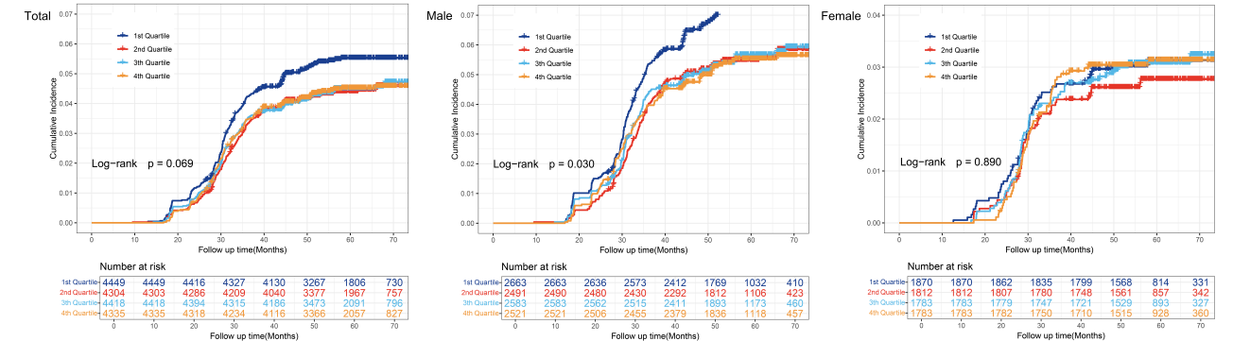
Figure S1 Cumulative incidence of CKD by quartile of serum IBIL concentration
Note: In this figure, the x-axis showed the follow-up time in months, and the y-axis showed the cumulative incidence of serum IBLI in different quartiles. Comparisons of differences among groups in the cumulative incidence of serum IBIL in different quartiles were based on the lowest quartile, which served as the reference point for comparison.

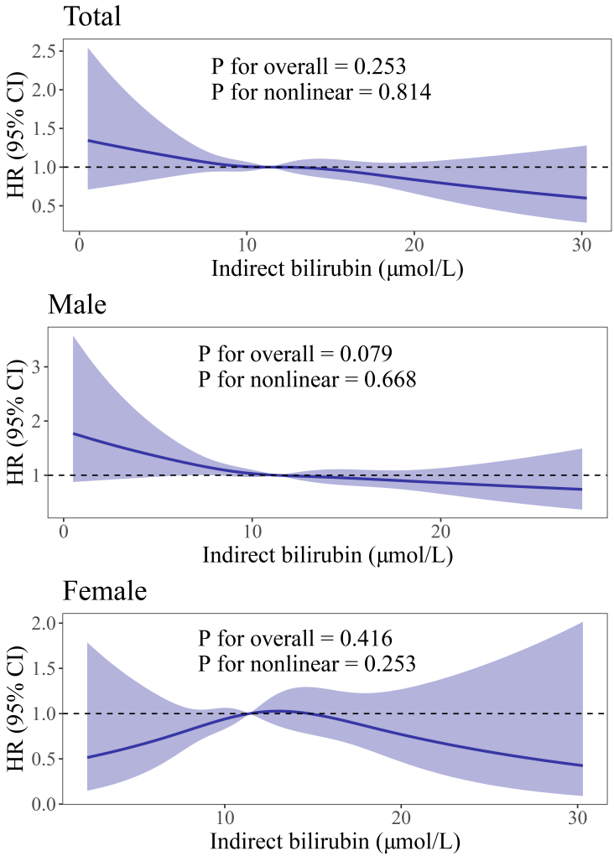
Figure S2 Dose-response relationships between serum IBIL levels and risk of CKD in the total, male and female participants after PSM
Note: Restricted cubic spine with 4 knots was performed to determine the serum IBIL and CKD dose-response relationship. In this figure, the solid blue lines indicated the adjusted HRs, and the blue shaded areas represented 95% CIs for HRs; the x-axes showed the level of serum IBIL, and the y-axes showed the HRs for CKD. The adjusted confounders are identical to those utilized in Model 4 of the Cox proportional hazards model.

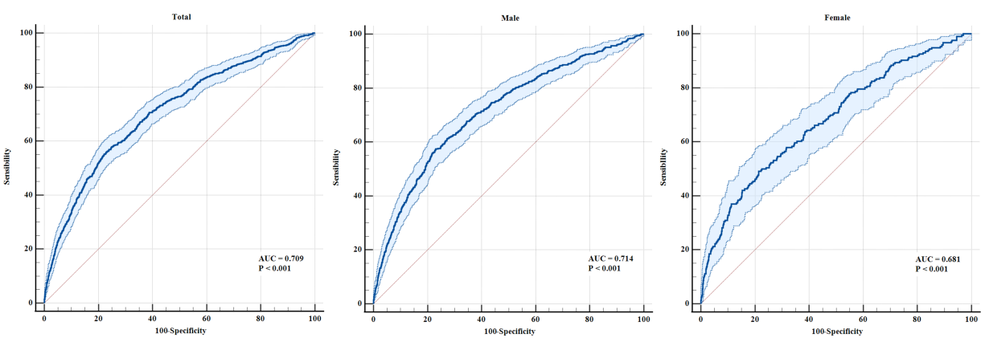
Figure S3 Receiver operator characteristic curves between serum IBIL and CKD after PSM
Note: Model adjusted for age, occupation, education, income, smoking status, alcohol consumption, physical exercise, high-salt diet, high-fat diet, high-sugar diet, BMI, baseline eGFR, hypertension, diabetes, hyperuricemia, dyslipidemia, SUA, SCR, ALT, AST, TC, TG, H-DLC, and L-DLC.

Table S6 The AUC, sensitivity, and specificity of serum IBIL for CKD after PSM
 | AUC (95% CIs) | P | Sensitivity (%) | Specificity (%) | Youden's index
Total | 0.709 (0.702 ~ 0.716) | <0.001 | 56.24 | 76.75 | 0.330
Male | 0.714 (0.705 ~ 0.723) | <0.001 | 57.50 | 76.81 | 0.343
Female | 0.681 (0.670 ~ 0.691) | <0.001 | 49.07 | 78.54 | 0.276

