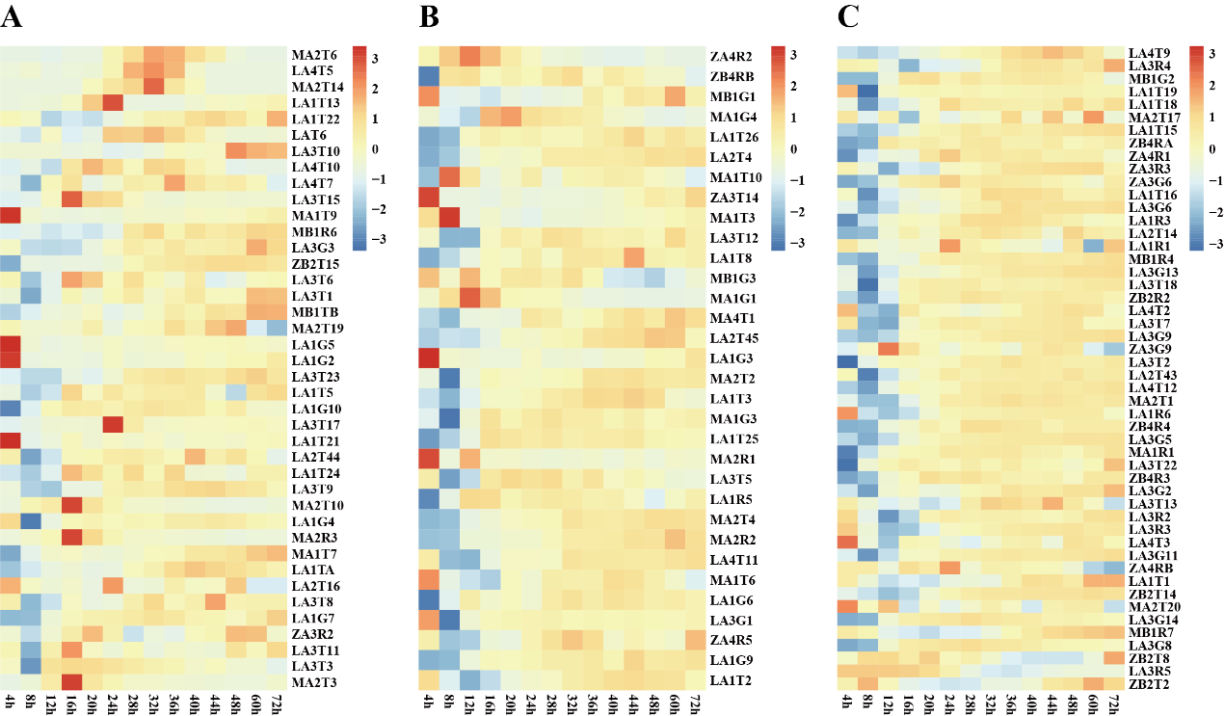
Fig. S1 Salt tolerance test of the strains.
According to the comparison of OD600 absorbance values in 500 mM NaCl TSB medium and normal TSB medium, it is classified as follows: A Halophilic bacteria: average OD600 (NaCl)/OD600 (normal) > 1.1. B Halotolerant bacteria: 1.0 < average OD600 (NaCl)/OD600 (normal) < 1.1. C Non-halotolerant bacteria: average OD600 (NaCl)/OD600 (normal) < 1.0.
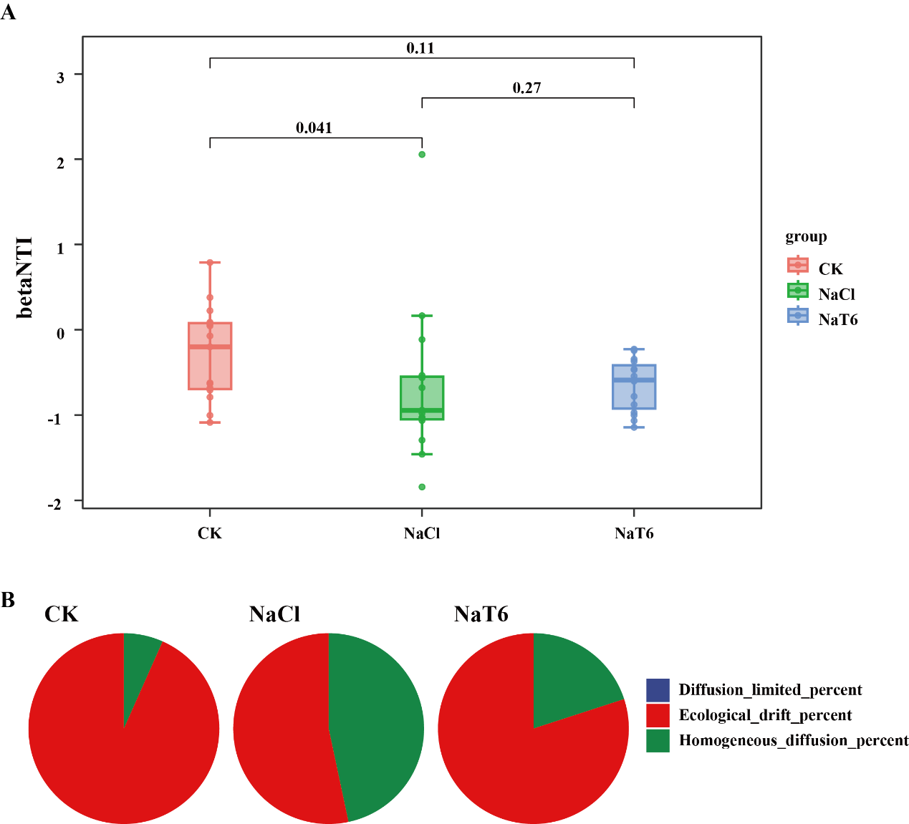
Fig. S2 The effects of different treatments on community assembly mechanisms.
A Boxplot of betaNTI values across different sampling groups (CK, NaCl, NaT6); B Pie charts showing the relative contributions of community assembly processes (Diffusion limited percent, Ecological drift percent, Homogeneous diffusion percent) in CK, NaCl, and NaT6 groups, respectively.
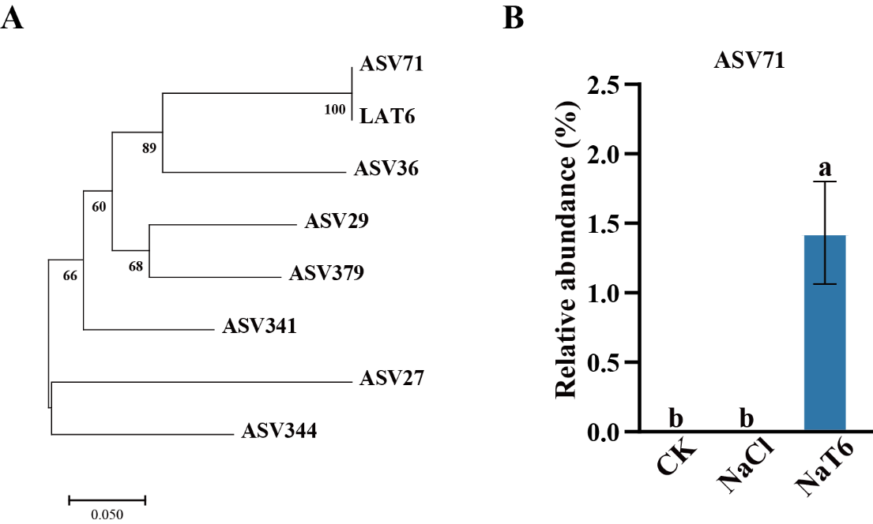
Fig. S3 Colonization of LAT6.
A Phylogenetic analysis of LAT6 and ASV showed that ASV71 has 100% similarity with LAT6. B The abundance of ASV71 in different treatments.
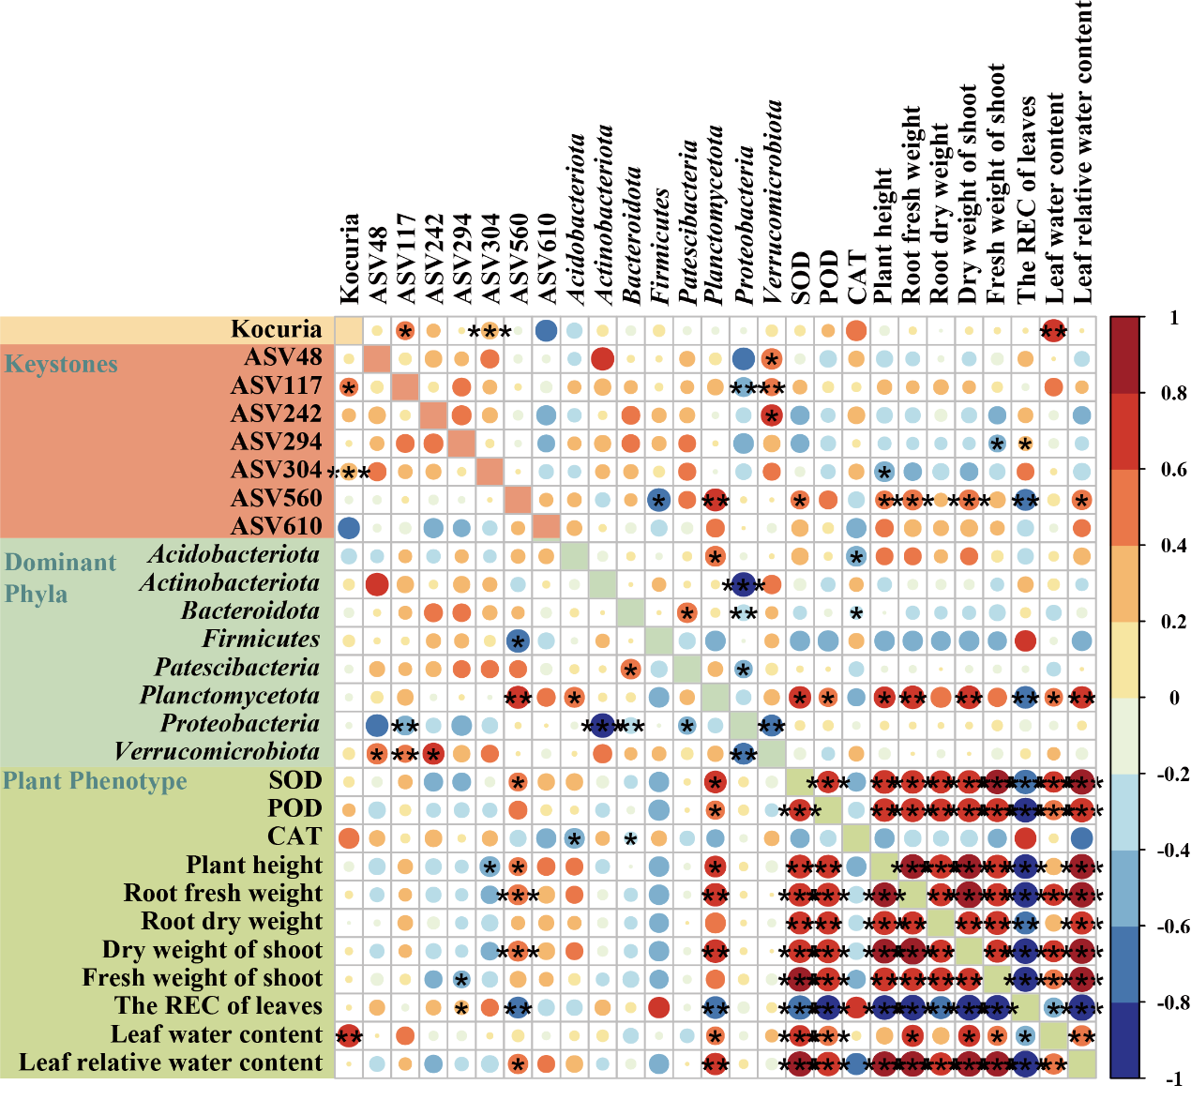
Fig. S4 Heatmap showing the correlation analysis results between keystone taxa, dominant bacterial phyla, and plant phenotypic traits. The color gradient represents the correlation coefficient (from –1 to 1), with red indicating positive correlation and blue indicating negative correlation. Asterisks denote the significance levels: * P < 0.05, ** P < 0.01, *** P < 0.001. Keystone taxa, dominant phyla, and plant phenotypes (including physiological indices like SOD, POD, CAT and growth–related traits) are displayed on the y–axis and x–axis respectively, visualizing their pairwise associations in the studied system.

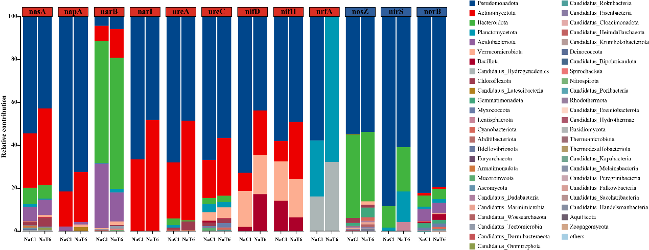
Fig. S5 The contributions of different microbial genera to 12 important phyla related to the N cycle. The horizontal axis at the top indicates the corresponding functional names, and different colors in the columns represent different microbial classifications.

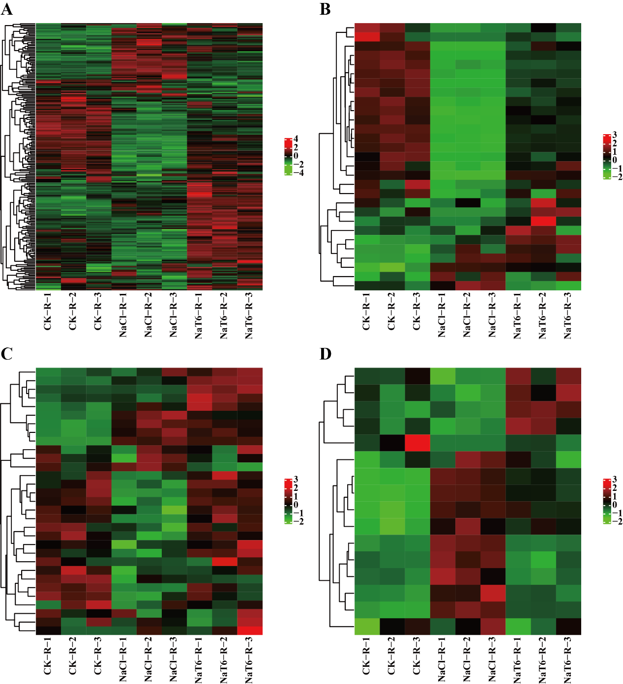
Fig. S6 Expression analysis of nitrate transporters genes. Heat map showing the expression of NPF (A), NRT2 (B), CLC (C)and SLAC1/SLAH (D) nitrate transporters genes between the CK, NaCl, and the NaT6 groups in root tissue, genes showing similar patterns of expression are clustered.

Table S1 Identification of Plant Growth-Promoting Characteristics of Strains
ID | Taxonomy | Nitrogen Fixation | Siderophore Production | IAA Production
LA1T1 | Bacillus sp. | + | + | +
LA1T2 | Curtobacterium sp. | + | + | +
LA1T3 | Curtobacterium sp. | + |  | +
LA1T5 | Kocuria sp. | +
LAT6 | Kocuria sp. | + | + | +
LA1T8 | Bacillus sp. | + | + | +
LA1T13 | Kocuria sp. | + |  | +
LA1T15 | Bacillus sp. | + | + | +
LA1T16 | Bacillus sp. | + | +
LA1T18 | Bacillus sp. | + | + | +
LA1T19 | Bacillus sp. | + |  | +
LA1T21 | Bacillus sp. | + | + | +
LA1T22 | Bacillus sp. | + | +
LA1T24 | Kocuria sp. |  | + | +
LA1T25 | Bacillus sp. | + | + | +
LA1T26 | Bacillus sp. | + |  | +
LA1G2 | Bacillus sp. | + | +
LA1G3 | Bacillus sp. | + | + | +
LA1G4 | Bacillus sp. | + | + | +
LA1G5 | Bacillus sp. | + | + | +
LA1G6 | Priestia sp. | + |  | +
LA1G7 | Brevibacterium sp. | + | +
LA1G9 | Bacillus sp. | + | + | +
LA1G10 | Bacillus sp. | + | + | +
LA1R1 | Arthrobacter sp. | + | + | +
LA1R3 | Bacillus sp. | + | +
LA1R5 | Bacillus sp. | + | + | +
LA1R6 | Curtobacterium sp. | + |  | +
LA1TA | Priestia sp. | + | + | +
LA2T4 | Paenarthrobacter sp. | + | + | +
LA2T14 | Bacillus sp. | + | + | +
LA2T16 | Bacillus cereus | + | + | +
LA2T43 | Bacillus sp. | + | + | +
LA2T44 | Bacillus sp. | + |  | +
LA2T45 | Bacillus sp. |  | +
LA3T1 | Kocuria sp.
LA3T2 | Pseudarthrobacter oxydans | + |  | +
LA3T3 | Bacillus sp. | + | + | +
LA3T5 | Bacillus sp. | + | +
LA3T6 | Planococcus sp. | + | + | +
LA3T7 | Bacillus sp. | + |  | +
LA3T8 | Paenarthrobacter sp. | + | + | +
LA3T9 | Bacillus sp. | +
LA3T10 | Planococcus sp. | + | +
LA3T11 | Arthrobacter sp. | + | + | +
LA3T12 | Bacillus sp. | + | + | +
LA3T13 | Rhodococcus sp. | + | + | +
LA3T15 | Kocuria sp. | + |  | +
LA3T17 | Kocuria sp. | + | + | +
LA3T18 | Priestia sp. | + | + | +
LA3T22 | Bacillus sp. | + |  | +
LA3T23 | Bacillus sp. | + | + | +
LA3G1 | Priestia sp. | + | + | +
LA3G2 | Arthrobacter sp. RF4 | + |  | +
LA3G3 | Arthrobacter sp. | + | + | +
LA3G5 | Arthrobacter sp. RF4 | + |  | +
LA3G6 | Arthrobacter sp. | + | + | +
LA3G8 | Bacillus sp. | + |  | +
LA3G9 | Arthrobacter sp. | + |  | +
LA3G11 | Arthrobacter sp. | + |  | +
LA3G13 | Arthrobacter sp. | + |  | +
LA3G14 | Bacillus sp. | + | + | +
LA3R2 | Arthrobacter sp. | + | + | +
LA3R3 | Arthrobacter sp. | + |  | +
LA3R4 | Labedella sp. | + |  | +
LA3R5 | Microbacterium sp. | + |  | +
LA4T2 | Arthrobacter sp. |  |  | +
LA4T3 | Arthrobacter pascens | + |  | +
LA4T5 | Kocuria sp. |  |  | +
LA4T7 | Bacillus sp. | + | +
LA4T9 | Bacillus sp. | + | + | +
LA4T10 | Kocuria sp. | + |  | +
LA4T11 | Arthrobacter sp. | + |  | +
LA4T12 | Arthrobacter sp. | + |  | +
MA1T3 | Zhihengliuella sp. | + |  | +
MA1T6 | Bacillus sp. | +
MA1T7 | Bacillus sp. |  | + | +
MA1T9 | Halomonas sp. | + | + | +
MA1T10 | Halomonas sp. | + | + | +
MA1R1 | Isoptericola sp. | + | + | +
MA1G1 | Isoptericola sp. | + | + | +
MA1G3 | Zhihengliuella sp. | + | + | +
MA1G4 | Isoptericola sp. | + |  | +
MA2T1 | Arthrobacter sp. | + |  | +
MA2T2 | Halomonas sp. | + |  | +
MA2T3 | Isoptericola sp. | + | +
MA2T4 | Arthrobacter sp. | + | +
MA2T6 | Zhihengliuella sp.
MA2T10 | Isoptericola sp. | + | + | +
MA2T14 | Kocuria sp. | + | + | +
MA2T17 | Bacillus pumilus | + | +
MA2T19 | Bacillus sp. | +
MA2T20 | Bacillus pumilus | +
MA2R1 | Isoptericola sp. | + |  | +
MA2R2 | Paenarthrobacter sp. | + | + | +
MA2R3 | Paenarthrobacter sp. | + | + | +
MA4T1 | Paenarthrobacter sp. | + | + | +
ZA3T14 | Bacillus sp. | + | + | +
ZA3G6 | Bacillus sp. | + | + | +
ZA3G9 | Bacillus sp. | + | + | +
ZA3R2 | Bacillus sp. | + | + | +
ZA3R3 | Bacillus sp. | + | + | +
ZA4R1 | Bacillus sp. | + | +
ZA4R2 | Isoptericola sp. | + | +
ZA4R5 | Algoriphagus sp. |  | + | +
ZA4RB | Bacillus sp. | +
MB1G1 | Bacillus sp. | + | + | +
MB1G2 | Bacillus sp. | + | + | +
MB1G3 | Jeotgalibacillus sp. | + | + | +
MB1R4 | Priestia sp. | + | + | +
MB1R6 | Planococcus sp. | + | + | +
MB1R7 | Rhodococcus sp. | + | + | +
MB1TB | Bacillus sp. | + | + | +
ZB2T2 | Bacillus sp. |  |  | +
ZB2T8 | Bacillus sp. | + | + | +
ZB2T14 | Bacillus pumilus | + | + | +
ZB2T15 | Bacillus sp. | + |  | +
ZB2R2 | Bacillus sp. | + | + | +
ZB4R3 | Bacillus sp. | + | +
ZB4R4 | Bacillus sp. | + | + | +
ZB4RA | Bacillus sp. | + | +
ZB4RB | Bacillus sp. | + | +

