Impacts of structural change in global trade on sustainable development
Jiayu Wang^{1, 2, 5}, Ke Wang^{1, 2, 3, 4, *}, Klaus Hubacek^{5, *}, Kuishuang Feng⁶, Yuli Shan⁵, Yi-Ming Wei^{1, 2, 3, 4}
¹ Center for Energy and Environmental Policy Research, Beijing Institute of Technology, Beijing, China
² School of Management and Economics, Beijing Institute of Technology, Beijing, China
³ Sustainable Development Research Institute for Economy and Society of Beijing, Beijing, China
⁴ Beijing Key Lab of Energy Economics and Environmental Management, Beijing, China
⁵ Integrated Research on Energy, Environment and Society (IREES), Energy and Sustainability Research Institute Groningen, University of Groningen, Groningen 9747 AG, the Netherlands
⁶ Department of Geographical Sciences, University of Maryland, College Park, Maryland, 20742, USA
* Corresponding authors. wangkebit@bit.edu.cn (KW) and k.hubacek@rug.nl (KH)

Table S1 List of indicators and SDGs
Goal | Target | Sub-target ¹ | Indicator | Dimension
4 Ensure inclusive and equitable quality education | 4.4 Increase the number of youth and adults who have relevant skills | 4.4.1 Proportion of people with information and communications technology skills | (1) High- and medium-skilled labor | Society
6 Ensure availability and sustainable management of water and sanitation | 6.3 Improve water quality by reducing pollution | 6.3.2 Proportion of water with good quality | (2) Water pollution ² | Environment
 | 6.4 Increase water-use efficiency and ensure sustainable withdrawals and supply of freshwater | 6.4.1 Water-use efficiency | (3) Blue water consumption | Environment
 |  | 6.4.2 Freshwater withdrawal as a proportion of available freshwater resources | (4) Blue water withdrawal | Environment
7 Ensure access to energy | 7.3 Double the global rate of improvement in energy efficiency | 7.3.1 Energy intensity | (5) Total fossil fuel consumption | Environment
8 Promote economic growth, employment and decent work | 8.1 Sustain per capita economic growth | 8.1.1 Annual growth rate of real GDP per capita | (6) GDP | Economy
8 Promote economic growth, employment and decent work | 8.4 Improve global resource efficiency | 8.4.1 Material footprint | (7) Mineral resource use ³ | Environment
9 Promote sustainable industrialization | 9.4 Improve resource-use efficiency and environmentally sound technologies and processes | 9.4.1 CO₂ emission per unit of value added | (8) CO₂ emission | Environment
10 Reduce inequality within and among countries | 10.4 Adopt policies, especially fiscal, wage and social protection policies, and achieve greater equality | 10.4.1 Labour share of GDP | (9) Compensation of employees | Economy
11 Make cities and human settlements sustainable | 11.6 Reduce the adverse per capita environmental impact of cities, pay special attention to air quality | 11.6.2 Annual mean levels of fine particulate matter (e.g. PM2.5 and PM10) | (10) PM emissions | Environment
12 Ensure sustainable consumption and production patterns | 12.2 Achieve the sustainable management and efficient use of natural resources | 12.2.1 Material footprint | (7) Mineral resource use ³ | Environment
13 Take urgent action to combat climate change | 13.2 Integrate climate change measures into national policies | 13.2.2 Total GHG emissions per year | (11) GHG emissions | Environment
14 Sustainably use oceans and marine resources | 14.1 Reduce marine pollution of all kinds | 14.1.1 (a) Index of coastal eutrophication | (2) Water pollution ² | Environment
15 Sustainably manage forests | 15.1 Ensure the sustainable use of freshwater ecosystems, in particular forests, wetlands, mountains and drylands | 15.1.1 Forest area as a proportion of total land area | (12) Forest area loss | Environment
17 Strengthen the Global Partnership for Sustainable Development | 17.1 Strengthen domestic resource mobilization to improve domestic capacity for tax and other revenue collection | 17.1.1 Total government revenue as a proportion of GDP, by source | (13) Taxes on production | Economy
Note: ¹ “Sub-target” refers to UNSD (2017).
² Indicator “water pollution” is a proxy for both target 6.3 and target 14.1.
³ Indicator “mineral resource use” is a proxy for both target 8.4 and target 12.2.

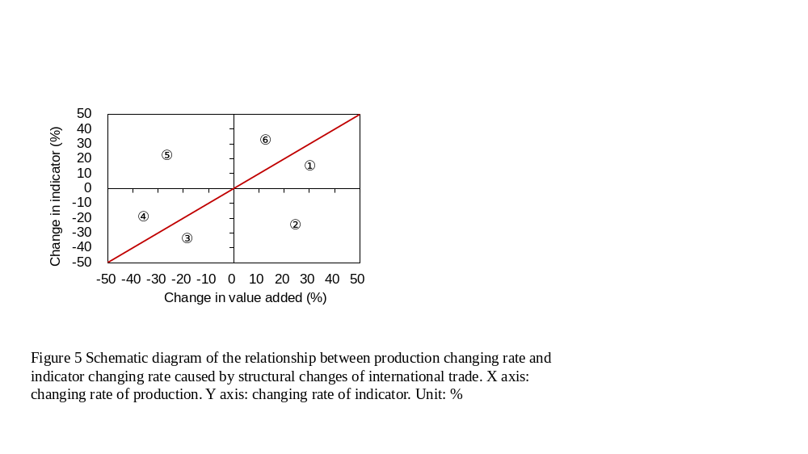
Figure S1 Coupling versus decoupling impacts of structural change in global trade. The horizontal axis represents percentage change in value added and the y-axis represents percentage change in indicator in a single time period. The red line represents the boundary between coupling and decoupling, where data points below the red line refer to decoupling, while data points above show coupling.

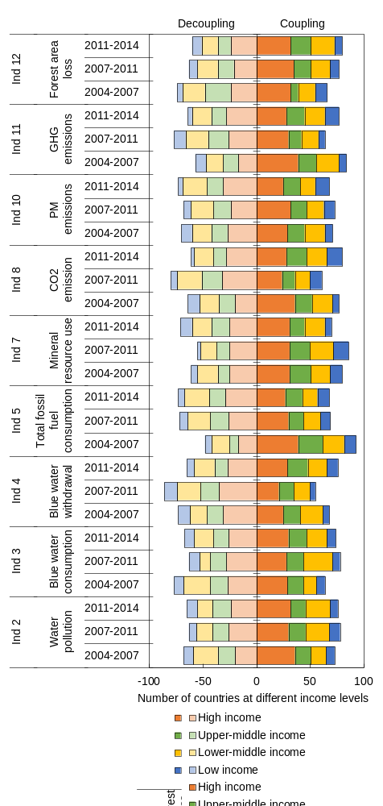
Figure S2 Coupling versus decoupling effects of global trade for each resource and environmental SDG indicators and countries. The horizontal axis represents number of countries at different income levels and the y-axis represents indicators and time periods.
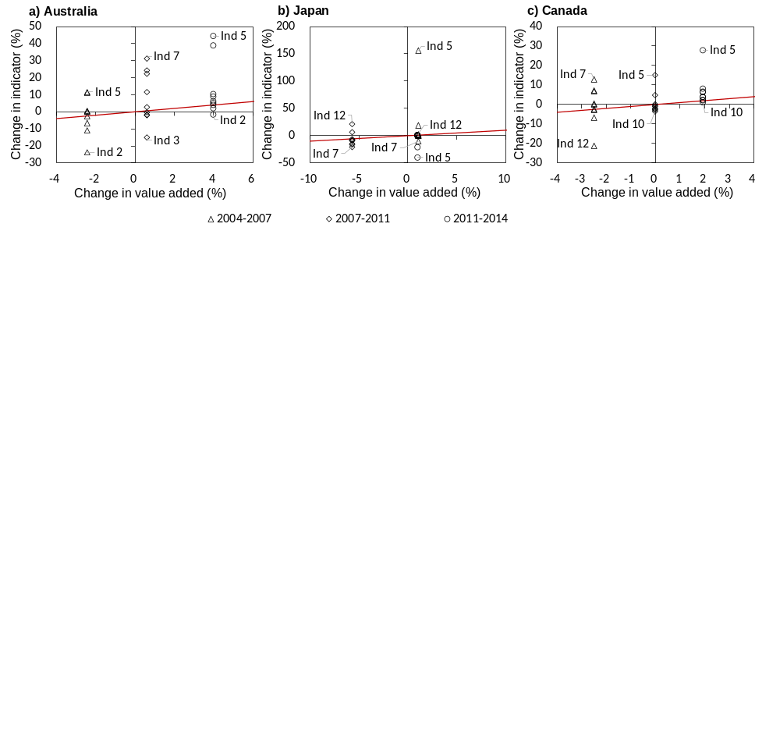
Figure S3 Coupling versus decoupling effects of structural change in global trade for each resource and environmental SDG indicators and three high-income countries. a) Impacts on Australia, b) impacts on Japan, c) impacts on Canada. The horizontal axis represents percentage change in value added and the y-axis represents percentage change in indicator. Triangles, rhombus, and circles refer to effects driven by structural change in trade during 2004-2007, 2007-2011, and 2011-2014, respectively. The red line indicates percentage change in value added equals the percentage change in an SDG indicator and represents the boundary between coupling and decoupling. Considering social and economic SDG indicators were not sensitive to structural change in global trade based on the previous analysis, only nine environment and resource related SDG indicators are included in this figure.

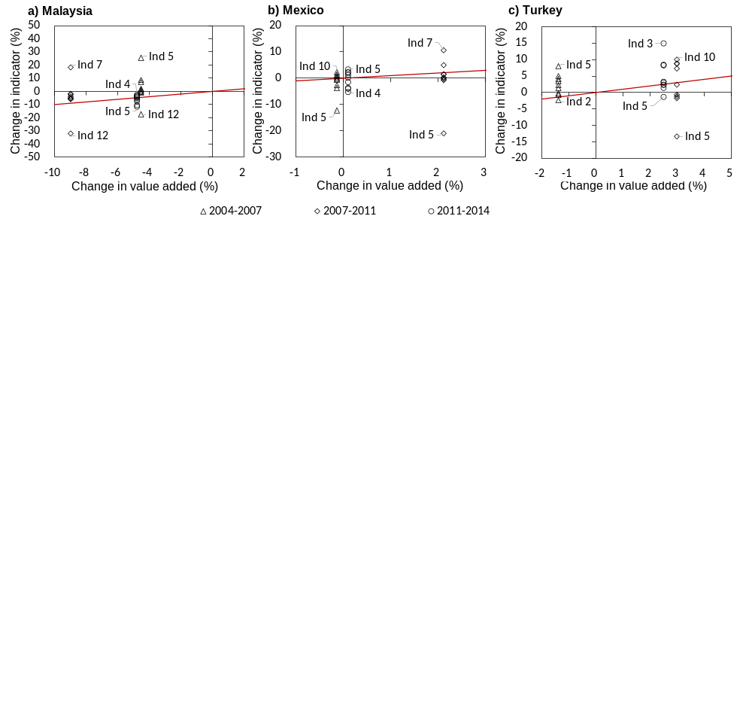
Figure S4 Coupling versus decoupling effects of structural change in global trade for each resource and environmental SDG indicators and three upper-middle-income countries. a) Impacts on Malaysia, b) impacts on Mexico, c) impacts on Turkey. The horizontal axis represents percentage change in value added and the y-axis represents percentage change in indicator. Triangles, rhombus, and circles refer to effects driven by structural change in trade during 2004-2007, 2007-2011, and 2011-2014, respectively. The red line indicates percentage change in value added equals the percentage change in an SDG indicator and represents the boundary between coupling and decoupling. Considering social and economic SDG indicators were not sensitive to structural change in global trade based on the previous analysis, only nine environment and resource related SDG indicators are included in this figure.

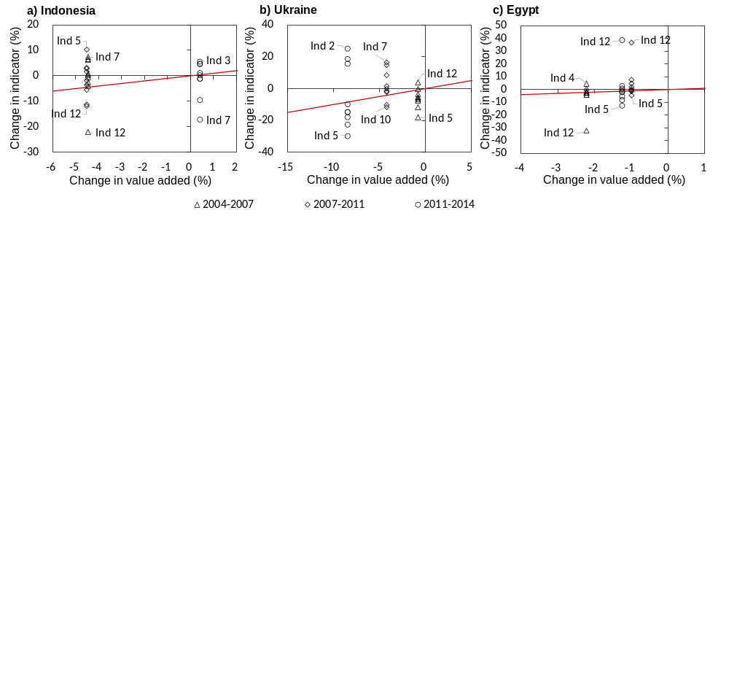
Figure S5 Coupling versus decoupling effects of structural change in global trade for each resource and environmental SDG indicators and three lower-middle-income countries. a) Impacts on Indonesia, b) impacts on Ukraine, c) impacts on Egypt. The horizontal axis represents percentage change in value added and the y-axis represents percentage change in indicator. Triangles, rhombus, and circles refer to effects driven by structural change in trade during 2004-2007, 2007-2011, and 2011-2014, respectively. The red line indicates percentage change in value added equals the percentage change in an SDG indicator and represents the boundary between coupling and decoupling. Considering social and economic SDG indicators were not sensitive to structural change in global trade based on the previous analysis, only nine environment and resource related SDG indicators are included in this figure.

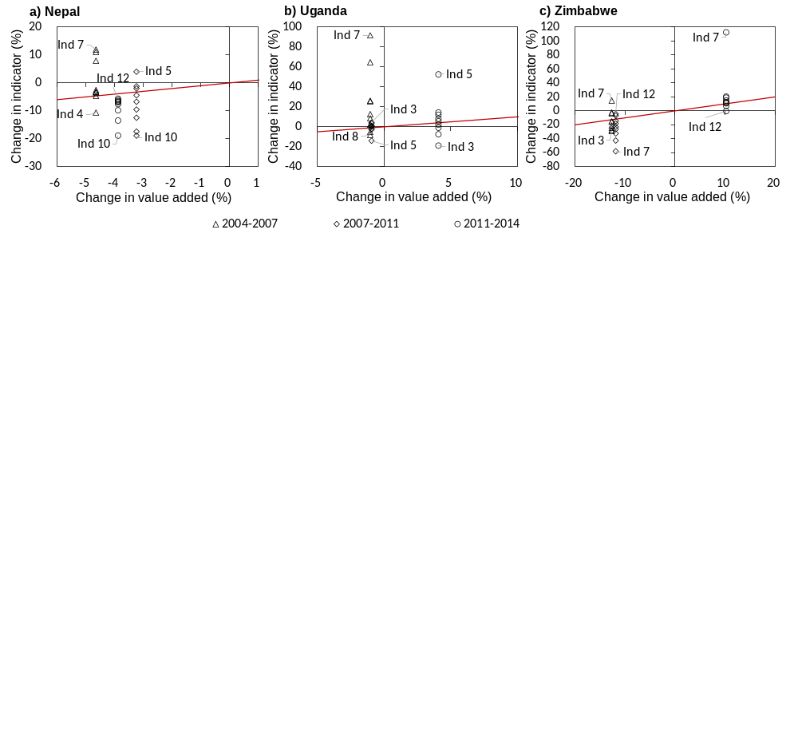
Figure S6 Coupling versus decoupling effects of structural change in global trade for each resource and environmental SDG indicators and three low-income countries. a) Impacts on Nepal, b) impacts on Uganda, c) impacts on Zimbabwe. The horizontal axis represents percentage change in value added and the y-axis represents percentage change in indicator. Triangles, rhombus, and circles refer to effects driven by structural change in trade during 2004-2007, 2007-2011, and 2011-2014, respectively. The red line indicates percentage change in value added equals the percentage change in an SDG indicator and represents the boundary between coupling and decoupling. Considering social and economic SDG indicators were not sensitive to structural change in global trade based on the previous analysis, only nine environment and resource related SDG indicators are included in this figure.

Derivation process of the currency conversion
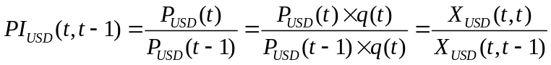 (1)

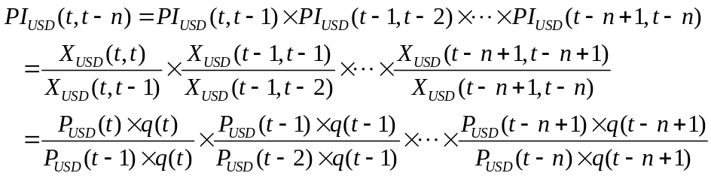 (2)

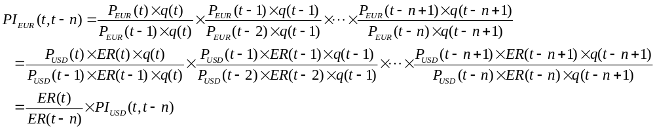
(3)
Symbols in the above three equations are interpreted as follows:
PI (t, t-1): annual price index showing the price change between the year t and the previous year;
PI (t, t-n): chained price index showing the price change during year t-n to year t;
P (t): production price in year t;
P (t-n): production price in year t-n;
q (t): production volume measured in physical unit of year t;
q (t-n): production volume measured in physical unit of year t-n;
X (t, t): production volume measure in monetary unit (namely total output in MRIO table) and current-year price of year t;
X (t, t-n): production volume measure in monetary unit (namely total output in MRIO table) and “t-n”-year price of year t;
ER (t): exchange rates between USD and EUR in year t;
ER (t-n): exchange rates between USD and EUR in year t-n;
Note that symbols with subscript “USD” and “EUR” were measured in US dollar and Euro, respectively.

