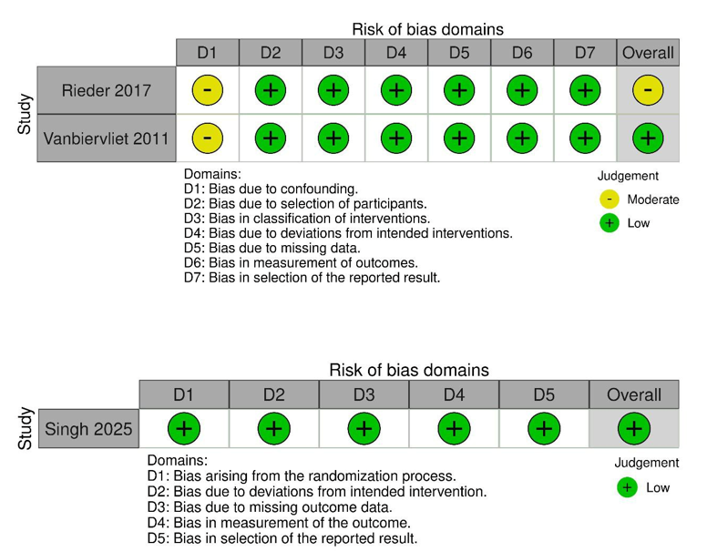

Figure S1. Quality of the included clinical trials
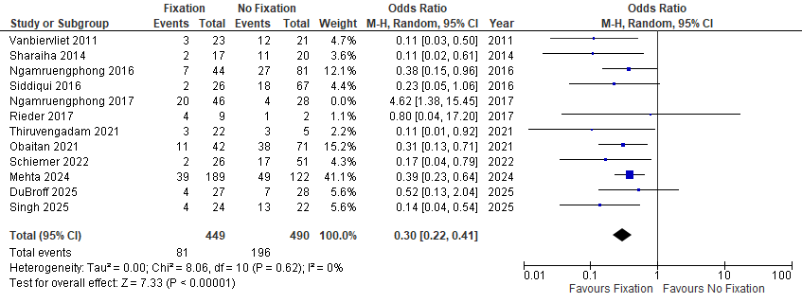
Figure S2. Leave one out for stent migration.
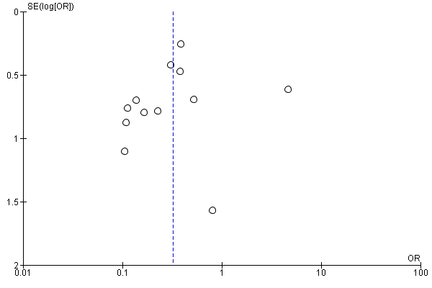
Figure S3. Funnel plot for stent migration
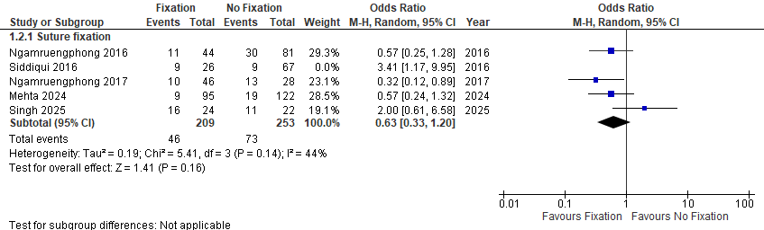
Figure S4. leave one out for Adverse events for suture fixation

Table S1. Search Strategy
PubMed (n = 862) | stent[Title/Abstract] AND fixation[Title/Abstract]
Scopus (n =1514) | TITLE-ABS-KEY (Stent AND fixation)
Web Of Science (n = 1207) | Stent AND fixation (Topic)
Representing the search strategy used in each database, along with the number of records exported in each.
Table S2. quality of the included cohort studies
Study ID | Case Definition Adequate | Representativeness of Exposed Cohort | Selection of Non-Exposed Cohort | Ascertainment of Exposure | Outcome Not Present at Start | Overall Selection | Comparability | Ascertainment of Outcome | Same Method for Cases and Controls | Follow-up Adequacy | Overall Outcome | Overall
DuBroff 2025 | 0 | 1 | 1 | 1 | 1 | 3 | 1 | 1 | 1 | 1 | 3 | 7
Mehta 2024 | 1 | 1 | 1 | 1 | 1 | 4 | 2 | 1 | 1 | 1 | 3 | 9
Ngamruengphi | 1 | 1 | 1 | 1 | 1 | 4 | 1 | 1 | 1 | 1 | 3 | 8
Ngamruengpho | 1 | 1 | 1 | 1 | 1 | 4 | 2 | 1 | 1 | 1 | 3 | 9
Obaitan 2021 | 0 | 1 | 1 | 1 | 1 | 3 | 1 | 1 | 0 | 1 | 2 | 7
Schiemer 2022 | 0 | 1 | 1 | 1 | 1 | 3 | 1 | 1 | 0 | 1 | 2 | 6
Sharaiha 2014 | 1 | 1 | 1 | 1 | 1 | 4 | 1 | 1 | 0 | 1 | 2 | 7
Siddiqui 2016 | 1 | 1 | 1 | 1 | 1 | 4 | 2 | 1 | 1 | 1 | 3 | 9
Thiruvengadam | 1 | 1 | 1 | 1 | 1 | 4 | 1 | 1 | 0 | 1 | 2 | 7
The Newcastle Ottawa scale (NOS) was utilized to assess the quality of observational studies included. Assessment was conducted across multiple domains: potential bias arising from the study participants' selection, the groups' comparability, and the ascertainment of the outcome

