Genomic and metabolomic insights into Trichoderma harzianum T9, a resilient biocontrol fungus from arid environments

Francisco Vargas-Gasca¹, Enrique Pola-Sánchez⁵, Ana Valeria García-Lartigue⁵, Alan D. Gomez-Vargas², Pablo Cruz-Morales³, Ana Calheiros de Carvalho³, Daniela Rago³, Linda Ahonen³, Elva Teresa Aréchiga-Carvajal⁴, José Manuel Villalobos-Escobedo^{5,6}*, and Vianey Olmedo-Monfil¹*.
Supplementary material
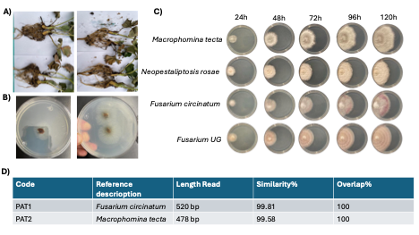
Supplementary Figure 1. Isolation of highly aggressive pathogenic fungal strains from strawberry plants. A) Strawberry seedlings infected with pathogenic fungi. B) Isolation of phytopathogenic fungi from leaves on PDA medium. C) Pathogenic fungal strains isolated from strawberry plants. D) Identification of two isolated strains from strawberry plants using the ITS fragment and BLAST analysis against the NCBI database.

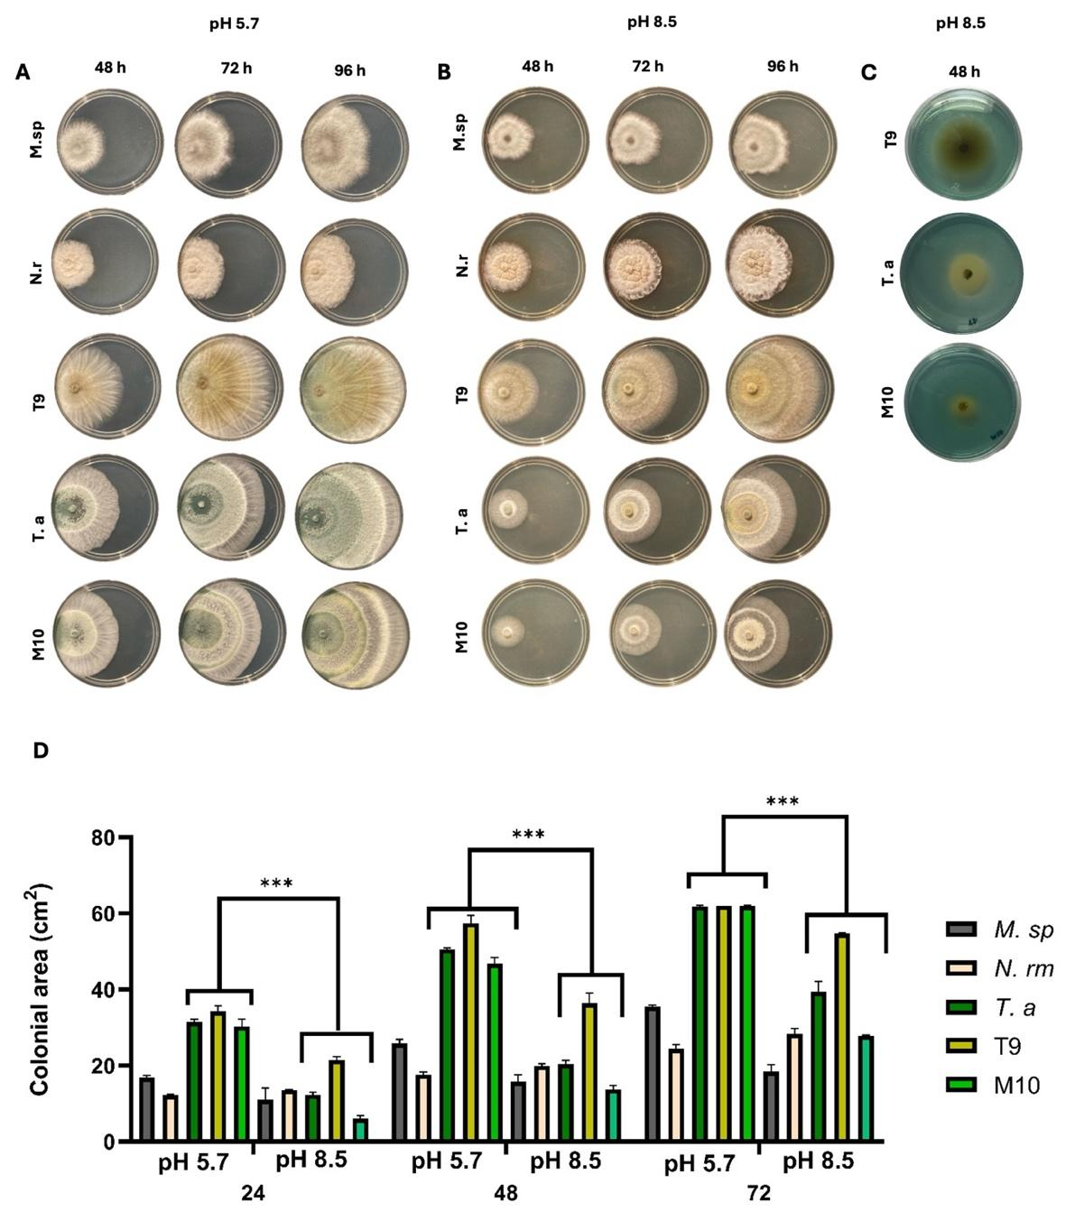
Supplementary Figure 2. T. harzianum strain T9 exhibits superior growth under extreme alkaline conditions. Colony growth of the pathogens Macrophomina sp. (M.sp) and Neopestalioptosis rosae (N.r), along with Trichoderma harzianum T9, T. harzianum M10, and T. atroviride IMI206040 (T.a) on PDA medium at pH 5.7 (A) or pH 8.5 (B). Photographs were taken at 48, 72, and 96 hours of incubation. Colony growth of T. harzianum T9, T. harzianum M10, and T. atroviride IMI206040 (T.a) on PDA medium at pH 8.5 with bromothymol blue as a pH indicator (C). Comparison of the average colony area of Trichoderma strains and phytopathogens grown on PDA medium at pH 5.7 and 8.5 (D). Asterisks indicate statistical differences according to the Tukey-HSD test at a significance level of α < 0.05, with *p < 0.05. n=3.
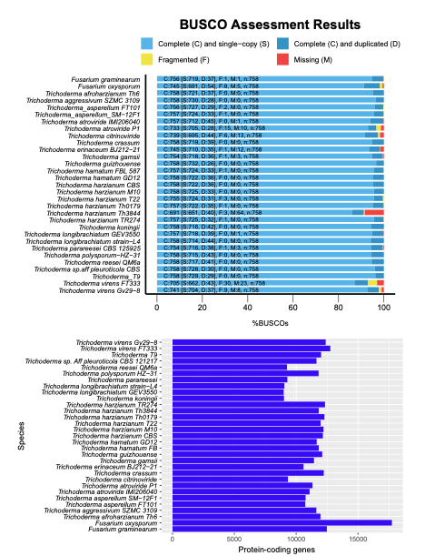
Supplementary Figure 3. (A) Genome quality analysis using BUSCO (Benchmarking Universal Single-Copy Orthologs) of the fungi dataset, based on exons extracted with gffread. (B) amount of protein predicted in each genome used in this work.

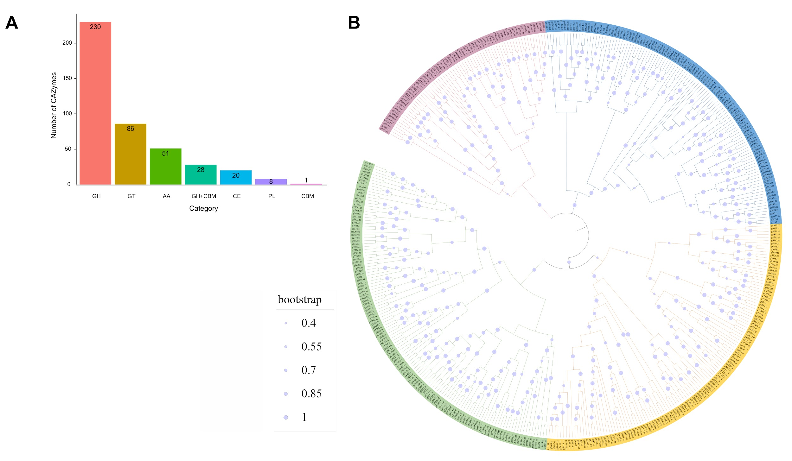
Supplementary Figure 4. Identification of CAZymes in the genome of T. harzianum T9. The identified CAZymes include GH (Glycoside Hydrolases), GT (Glycosyltransferases), PL (Polysaccharide Lyases), CE (Carbohydrate Esterases), CBM (Carbohydrate-Binding Modules), and AA (Auxiliary Activities). A) Number of CAZymes found in each group. B) Phylogenetic distribution of CAZymes with signal peptide.

Table S1. Unpublished genomes submitted to open access databases.

Species | Webpage
Trichoderma erinaceum | https://www.ncbi.nlm.nih.gov/nuccore/JALIRY000000000.1
Trichoderma konin | https://www.ncbi.nlm.nih.gov/nuccore/BCGH00000000.1
Trichoderma crasum | https://mycocosm.jgi.doe.gov/Tricr1/Tricr1.home.html
Trichoderma pleuroticola | https://mycocosm.jgi.doe.gov/Trichpleur1/Trichpleur1.home.html
Trichoderma aggressivum | https://mycocosm.jgi.doe.gov/Triag1/Triag1.home.html
Trichoderma harzianum M10 | https://mycocosm.jgi.doe.gov/TriharM10_1/TriharM10_1.home.html
Trichoderma afroharzianum | https://www.ncbi.nlm.nih.gov/nuccore/2707202863
Trichoderma harzianum T22 | https://mycocosm.jgi.doe.gov/TriharT22_1/TriharT22_1.home.html

Table S2.- Summary of de novo genome assembly statistics for Trichoderma harzianum T9 utilizing next-generation sequencing technologies and assembly tools.
Statistic | Trichoderma_T9
contigs | 142
contigs (>= 0 bp) | 142
contigs (>= 1000 bp) | 130
Largest contig | 2547181
Total length | 39853892
Total length (>= 0 bp) | 39853892
Total length (>= 1000 bp) | 39846154
N50 | 903272
GC (%) | 48.24
Mismatches | -
# N's per 100 kbp | 0
# N's | 0

Table S3.- Summary of TEs annotations.
Classification | Total length (bp) | Count | Proportion (%) | Number of distinct classifications
DNA Transposon | 73359 | 89 | 0.184069852 | 2
LINEs | 179531 | 97 | 0.450472943 | 1
LTRs | 919979 | 377 | 2.308379317 | 8
Other (Simple Repeat, Microsatellite, RNA) | 430285 | 9851 | 1.07965616 | 2624
Unclassified | 613216 | 1191 | 1.538660264 | 26
Sum | 2216370 | 11605 | 5.561238536 | 2661

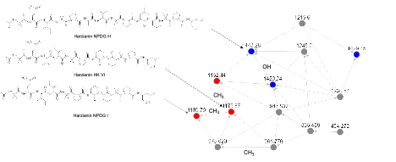

Supplementary Figure 5. Analysis of the ion network with the highest abundance in the samples and the largest number of residues detected in the metabolome. The colors in the circles indicate the species in which each ion from the network was detected.

Table S4.- Mass spectrometry peaks associated with the compound Harzianin.

Compound CID | Name | Molecular formula [M+H]⁺ | Accurate mass [M+H]⁺ | Exact mass  [M+H]⁺ | Error (ppm)
CID: 85176069 | Harzianin HK VI | C₅₈H₁₀₂N₁₂O₁₃ | 1175.7762 | 1175.7768 | 0.5
CID: 164623695 | Harzianin NPDG I | C₅₉H₁₀₄N₁₂O₁₃ | 1189.7918 | 1189.7924 | 0.5
CID: 164624124 | Harzianin NPDG H | C₇₁H₁₂₃N₁₅O₁₆ | 1142.9344 | 1442.9350 | 0.4
CID: 164609972 | Harzianin NPDG D | C₇₀H₁₂₁N₁₅O₁₇ | 1444.9154 | 1444.9143 | 0.7
CID: 164618139 | Harzianin NPDG F | C₇₀H₁₂₁N₁₅O₁₆ | 1428.9198 | 1428.9194 | 0.2
CID: 164627999 | Harzianin NPDG B | C₆₉H₁₁₉N₁₅O₁₇ | 1430.8982 | 1430.8987 | 0.3
CID: 164617195 | Harzianin NPDG E | C₆₉H₁₁₉N₁₅O₁₆ | 1414.9030 | 1414.9037 | 0.5

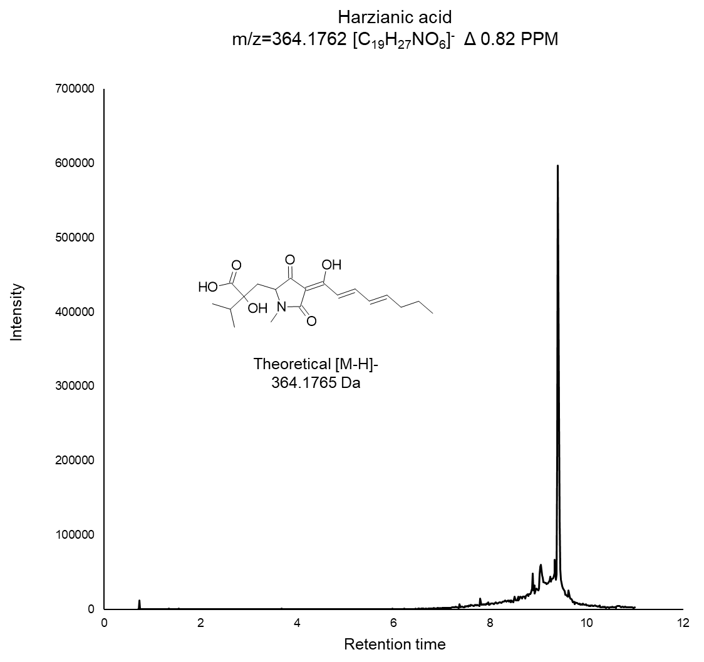
Supplementary Figure 6. Mass spectrum of the peak and molecular structure corresponding to the metabolite Harzianic acid, with a molecular weight of 364.1765 Da, detected in T9.
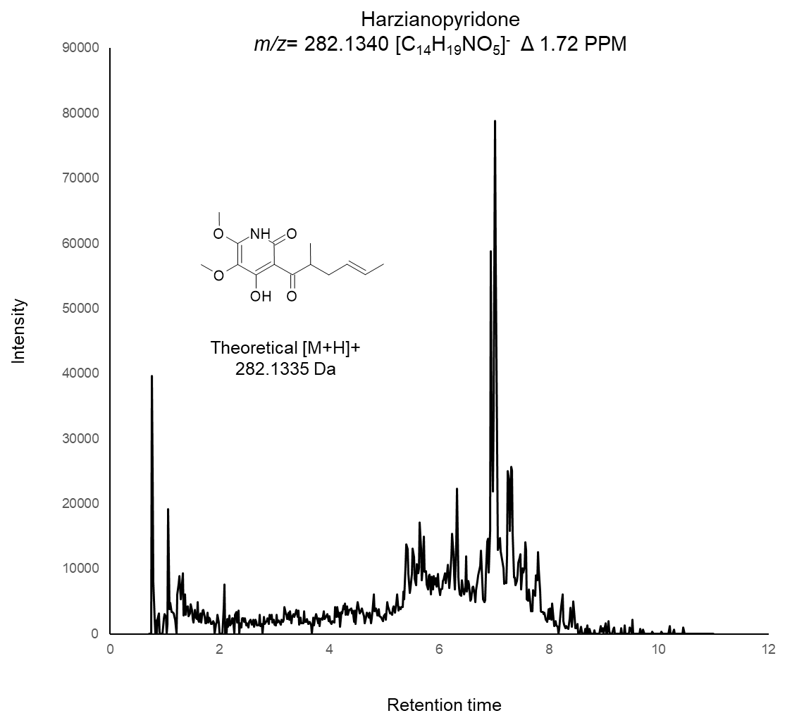
Supplementary Figure 7. Mass spectrum of the peak and molecular structure corresponding to the metabolite Harzianopyridone, with a molecular weight of 282.1335 Da, detected in T9.

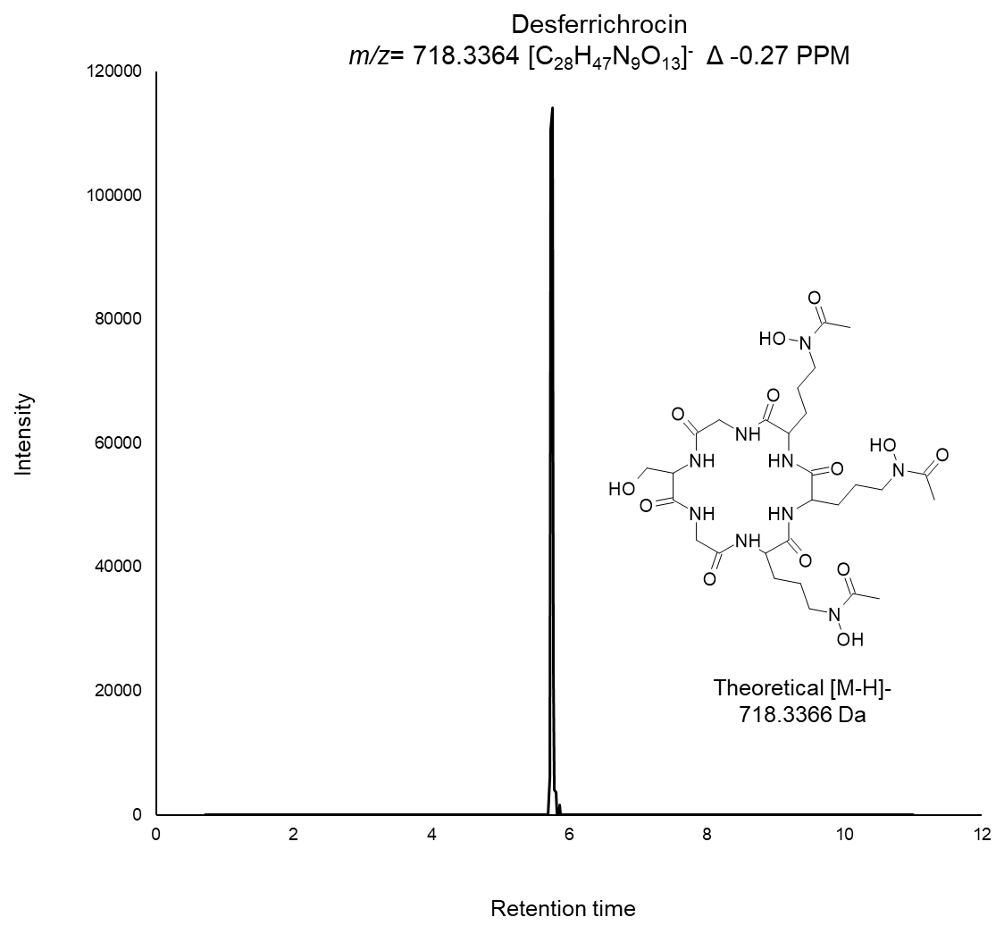
Supplementary Figure 8. Mass spectrum of the peak and molecular structure corresponding to the metabolite Desferrichrocin, with a molecular weight of 718.3366 Da, detected in T9.

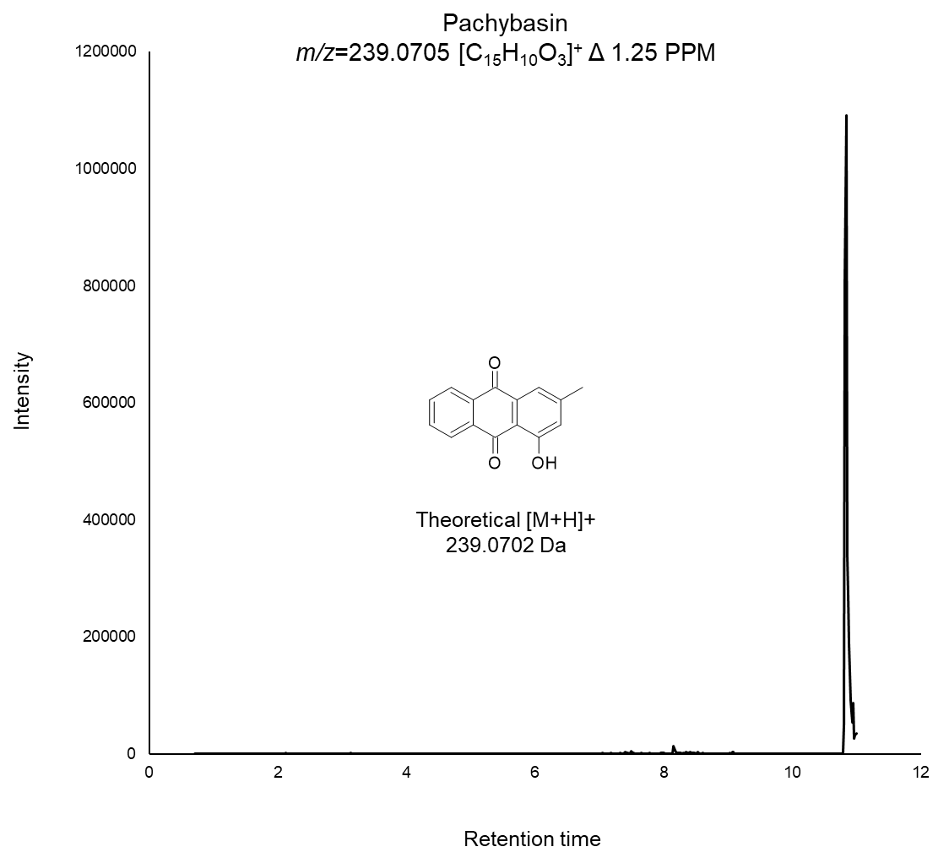
Supplementary Figure 9. Mass spectrum of the peak and molecular structure corresponding to the metabolite Pachybasin, with a molecular weight of 239.0702 Da, detected in T9.

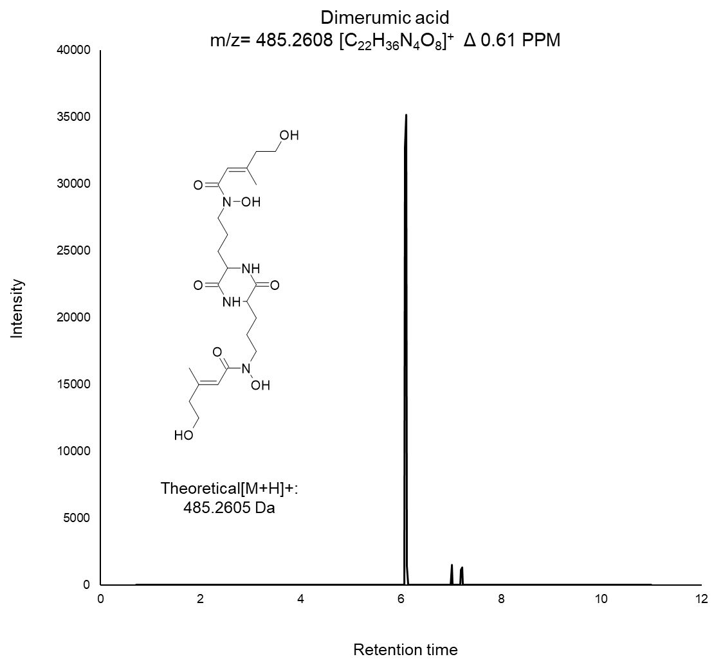
Supplementary Figure 10. Mass spectrum of the peak and molecular structure corresponding to the metabolite Dimerumic acid, with a molecular weight of 485.2605 Da, detected in T9.

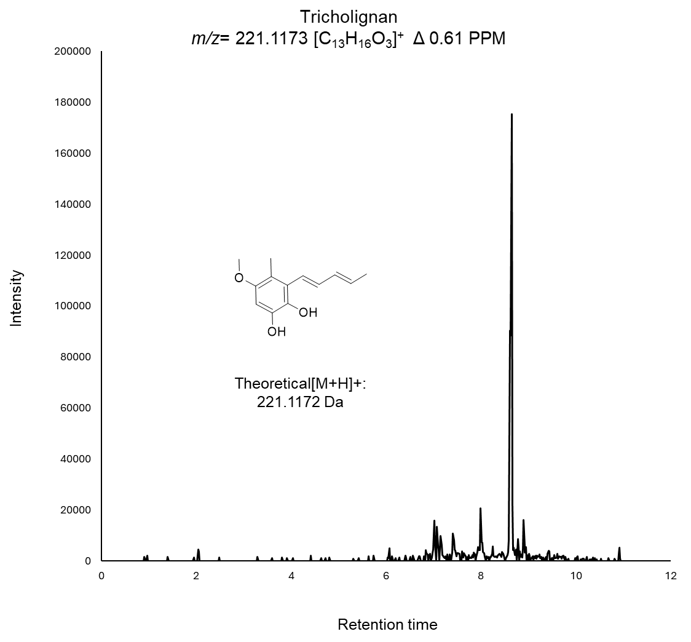

Supplementary Figure 11. Mass spectrum of the peak and molecular structure corresponding to the metabolite Tricholignan, with a molecular weight of 221.1172 Da, detected in T9.

Table S5.- Correlation between Biosynthetic Gene Clusters (BGCs) identified in the T. harzianum T9 genome and compounds detected via Mass Spectrometry.
Region | Type | From | To | Detected by mass spectrometry | Predicted product
19.2 | NRPS | 566,965 | 612,382 | Dimerumic acid
4.2 | T1PKS | 562,363 | 609,956 | trichoxide
11.1 | fungal-RiPP-like,T1PKS | 5,285 | 85,346 | tricholignan A
27.1 | T1PKS,NRPS, betalactone | 363,457 | 415,321 | harzianopyridone
7.2 | NRPS | 1,183,311 | 1,242,378 | Desferrichrocin
5.1 | T1PKS, NRPS | 27,622 | 117,710 | Harzianins, 11 and 14 membered petaibols
2.2 | T1PKS | 1,530,995 | 1,579,214
20.1 | fungal-RiPP-like, NRPS-like | 268,517 | 347,744 |  | choline
77.1 | NRPS | 9,410 | 35,247
37.2 | NRPS | 163,570 | 210,423 |  | verticillin or related
14.2 | NRPS, T1PKS | 482,056 | 582,131 |  | dichlorodiaporthin and potentially others
7.3 | terpene | 1,283,135 | 1,304,646
34.1 | NRPS, T1PKS | 12,164 | 88,239
3.4 | terpene | 1,478,830 | 1,500,425
49.1 | NRPS, T1PKS | 97,139 | 149,638 |  | phyllostictines or related
37.1 | T1PKS | 69,495 | 116,664
48.1 | NRPS, T1PKS,fungal-RiPP-like | 104,335 | 190,426 |  | fujikurins or related
14.1 | T1PKS | 192,390 | 239,089 |  | aurofusarin
10.2 | T1PKS | 431,163 | 479,919
10.1 | T1PKS | 351,822 | 399,612 |  | Citrinin or related
8.2 | T1PKS | 871,697 | 919,405
1.1 | fungal-RiPP-like | 499,109 | 561,913
1.2 | NRPS-like | 2,423,654 | 2,466,956
1.3 | NRPS | 2,503,091 | 2,547,181
2.1 | T1PKS | 924,929 | 973,540
2.3 | NRPS | 1,973,495 | 2,020,165
3.1 | T1PKS | 482,674 | 530,706
3.2 | T1PKS | 790,766 | 838,790
3.3 | terpene | 1,124,834 | 1,146,207
4.1 | terpene | 237,765 | 259,263
5.2 | NRPS | 1,355,454 | 1,398,872
7.1 | fungal-RiPP-like, NRPS-like,isocyanide | 1,060,309 | 1,142,850
7.4 | NRPS,T1PKS | 1,362,592 | 1,415,218
8.1 | T1PKS | 184,290 | 231,948
8.3 | T1PKS | 1,112,551 | 1,158,025
8.4 | NRPS | 1,256,064 | 1,315,720
10.3 | fungal-RiPP | 786,310 | 833,759
10.4 | NRPS | 982,309 | 1,029,130
11.2 | fungal-RiPP-like | 262,474 | 331,006
11.3 | fungal-RiPP-like | 608,823 | 670,074
12.1 | terpene | 664,524 | 685,869
12.2 | NRPS-like | 890,044 | 935,262
14.3 | terpene | 777,094 | 798,689
15.1 | terpene | 257,074 | 278,248
15.2 | fungal-RiPP-like, NRPS-like | 345,952 | 442,983
18.1 | NRPS-like | 219,651 | 263,151
19.1 | NRPS-like | 102,167 | 145,256
20.2 | terpene | 393,713 | 414,981
22.1 | T1PKS | 408,416 | 455,351
28.1 | fungal-RiPP-like | 449,347 | 510,075
29.1 | fungal-RiPP-like | 347,136 | 410,994
34.2 | T1PKS | 311,926 | 360,477
35.1 | isocyanide-nrp | 84,901 | 140,140
38.1 | terpene | 124,784 | 146,462
40.1 | fungal-RiPP-like | 122,578 | 183,415
42.1 | NRPS,T1PKS | 1 | 83,788 |  | Trichorzianines
45.1 | NRPS-like | 193,879 | 237,734
47.1 | T1PKS | 55,605 | 97,184
47.2 | T1PKS | 150,669 | 200,562
53.1 | NRPS,fungal-RiPP-like,T1PKS | 33,289 | 131,620
64.1 | fungal-RiPP-like | 1 | 67,585
81.1 | NRPS | 1 | 34,176
Undetermined | PKS | Undetermined | Undetermined | Pachybasin

