Extended Data
Extended Data Figure 1 | Additional Evaluation Metrics for PanPep, DlpTCR, and ERGO-II on the Peptide-TCRβ Binding Data Provided by PanPep.
Extended Data Figure 2 | Benchmarking PanPep, DlpTCR, and ERGO-II using the Original Test Datasets from the Respective Control Studies.
Extended Data Figure 3 | Confusion Matrices of the Two Negative Sampling Strategies in Majority and Few-Shot Groups.
Extended Data Figure 4 | Additional Evaluation Metrics of PanPep, DlpTCR, and ERGO-II on the Newly Curated Independent Dataset.
Extended Data Figure 5 | Additional Evaluation Metrics of Reproduced PanPep on the Independent Dataset.
Extended Data Figure 6 | Additional Evaluation Metrics of 10-fold Reproduced PanPep on the Peptide-TCRα Binding Scenario.
Extended Data Figure 7 | Additional Evaluation Metrics of 10-fold Reproduced PanPep on the Peptide-TCRαβ Binding Scenario.
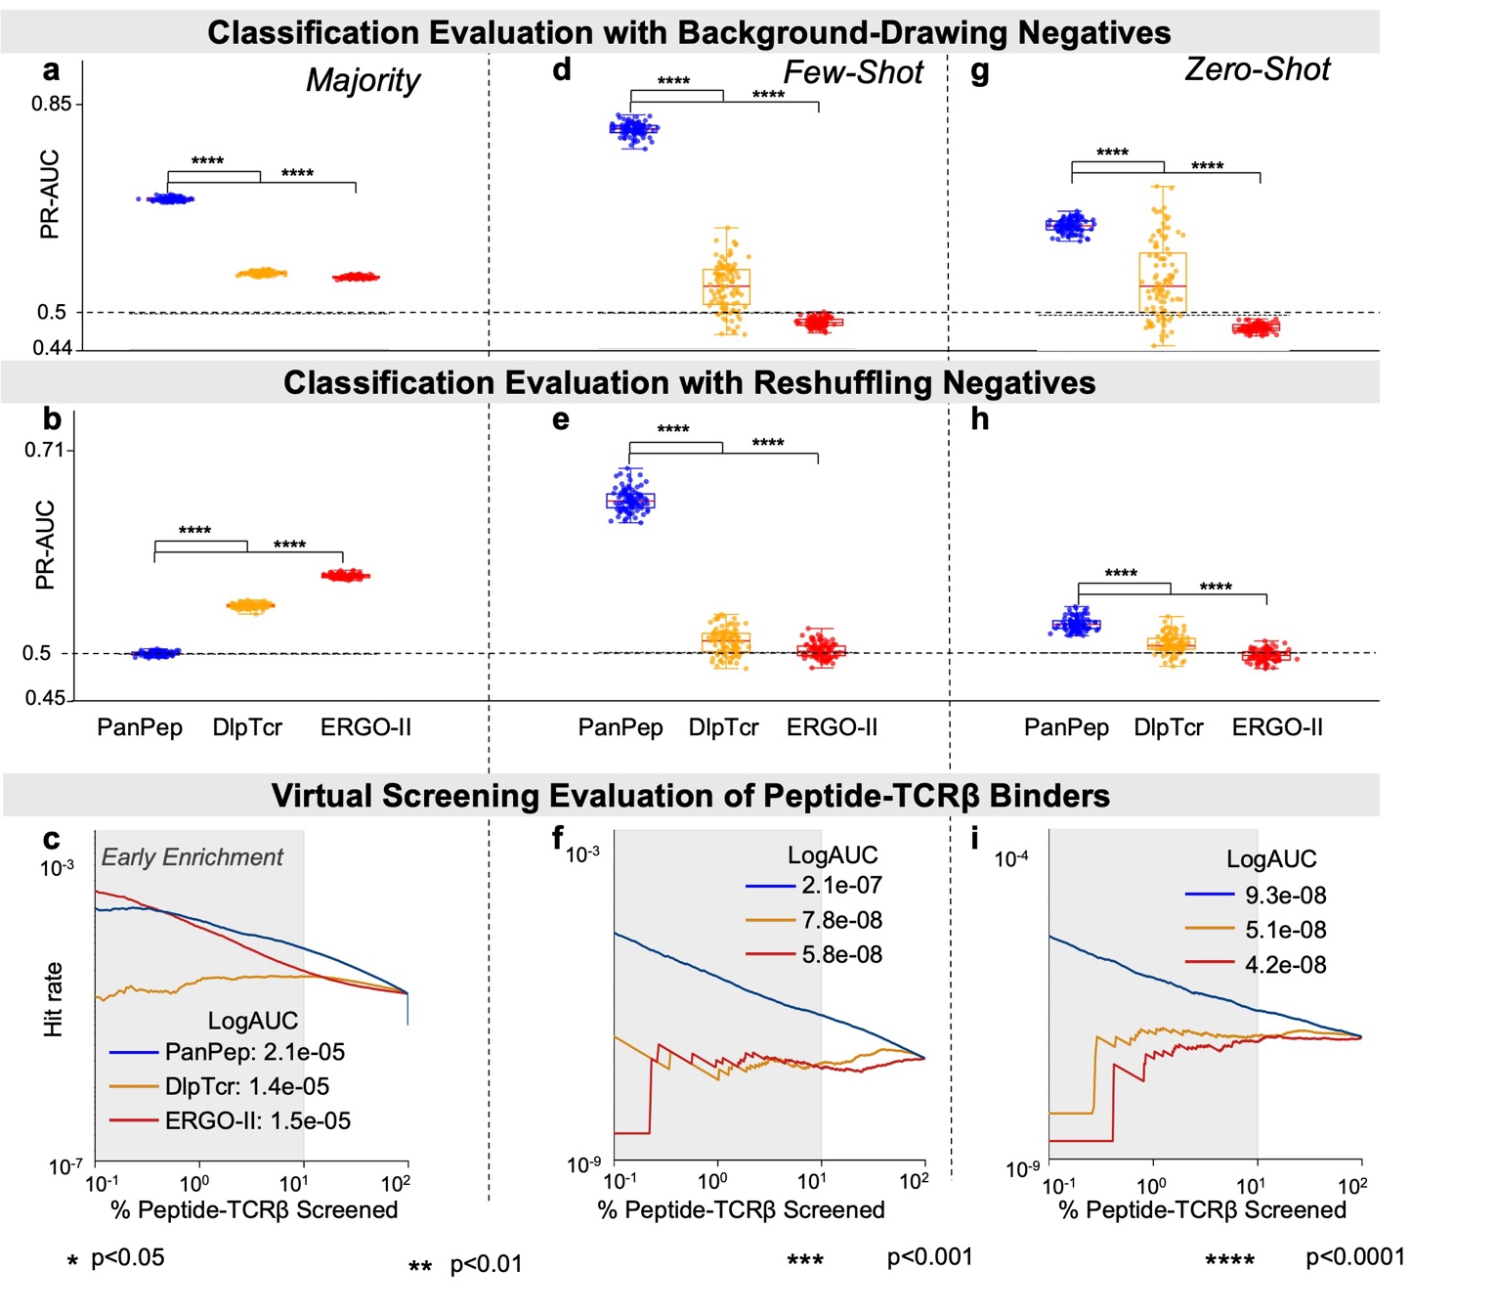
Extended Data Fig. 1 | Additional Evaluation Metrics for PanPep, DlpTCR, and ERGO-II on the Peptide-TCRβ Binding Data Provided by PanPep. (a-c) PR-AUCs from balanced classification evaluations with background-drawing negatives under 100-fold cross-validation in the majority, few-shot, and zero-shot settings. (d-f) PR-AUCs from balanced classification evaluations with background-drawing negatives under 100-fold cross-validation. (g-i) Hit rates evaluating virtual screening efficiency in ranking true TCRβ binders.
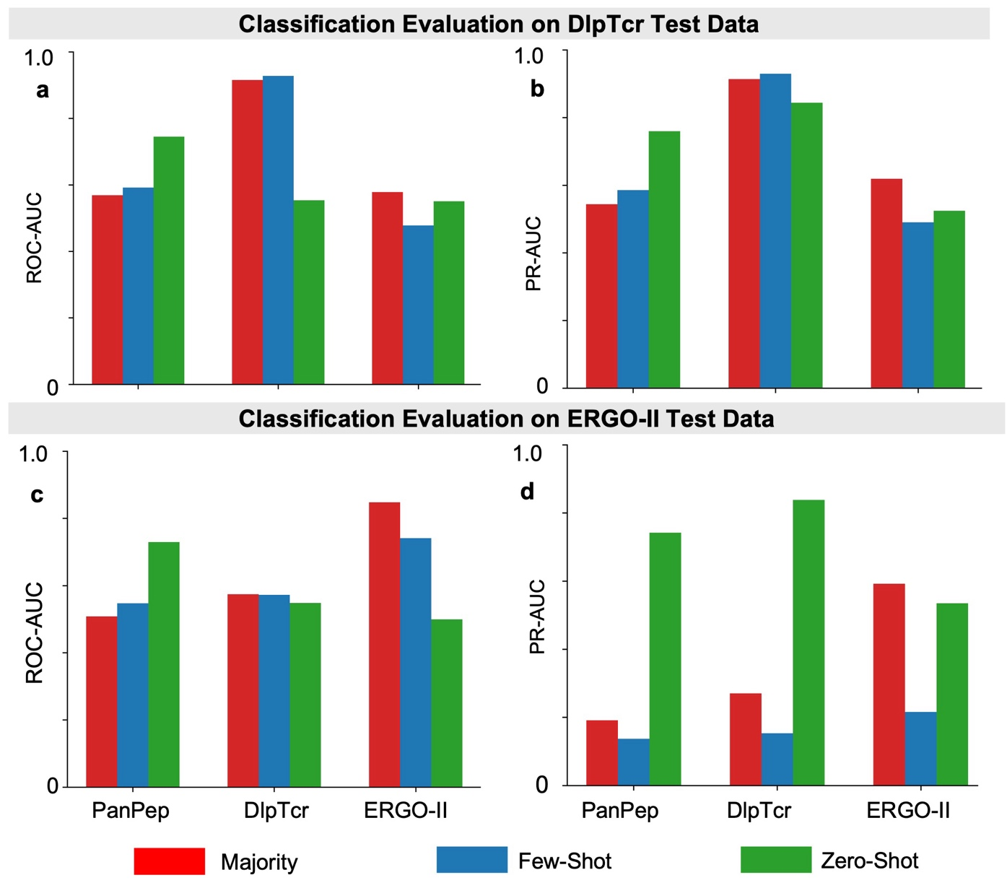
Extended Data Fig. 2 | Benchmarking PanPep, DlpTCR, and ERGO-II using the Original Test Datasets from the Respective Control Studies. (a-b) ROC-AUC and PR-AUC scores of PanPep, DlpTCR, and ERGO-II evaluated on the test dataset provided in the DlpTCR study. (c-d) Corresponding evaluation results on the test dataset provided in the ERGO-II study.
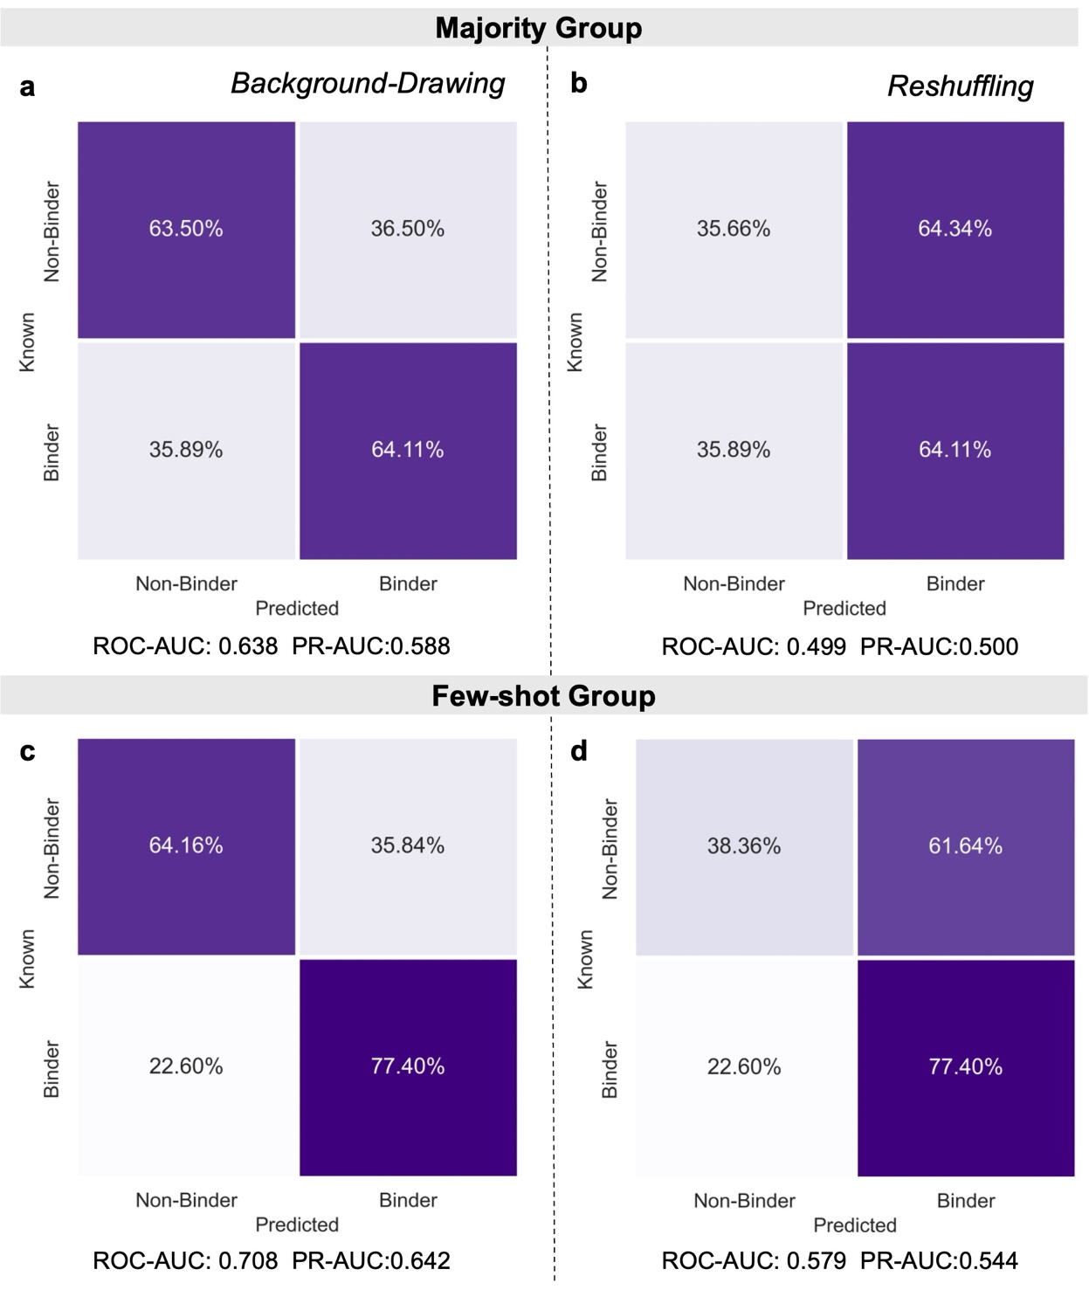
Extended Data Fig. 3 | Confusion Matrices of the Two Negative Sampling Strategies in Majority and Few-Shot Groups. (a-b) Confusion matrices with corresponding ROC-AUC and PR-AUC scores for the majority group from one representative fold of 100-fold cross-validation under background-drawing and reshuffling strategies. (c-d) Corresponding confusion matrices and scores for the few-shot group.

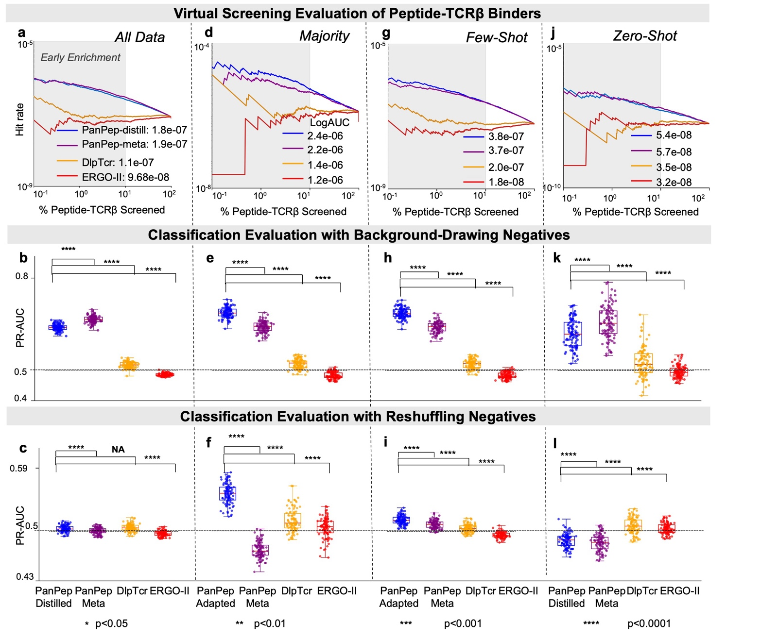
Extended Data Fig. 4 | Additional Evaluation Metrics of PanPep, DlpTCR, and ERGO-II on the Newly Curated Independent Dataset. (a-c) Hit rates from virtual screening evaluations and PR-AUC scores from classification evaluations using background-drawing and reshuffling strategies in the zero-shot setting on the entire dataset. (d-f) Corresponding evaluations for the majority group in the majority setting. (g-i) Corresponding evaluations for the few-shot group in the few-shot setting. (j-l) Corresponding evaluations for the zero-shot group in the zero-shot setting.

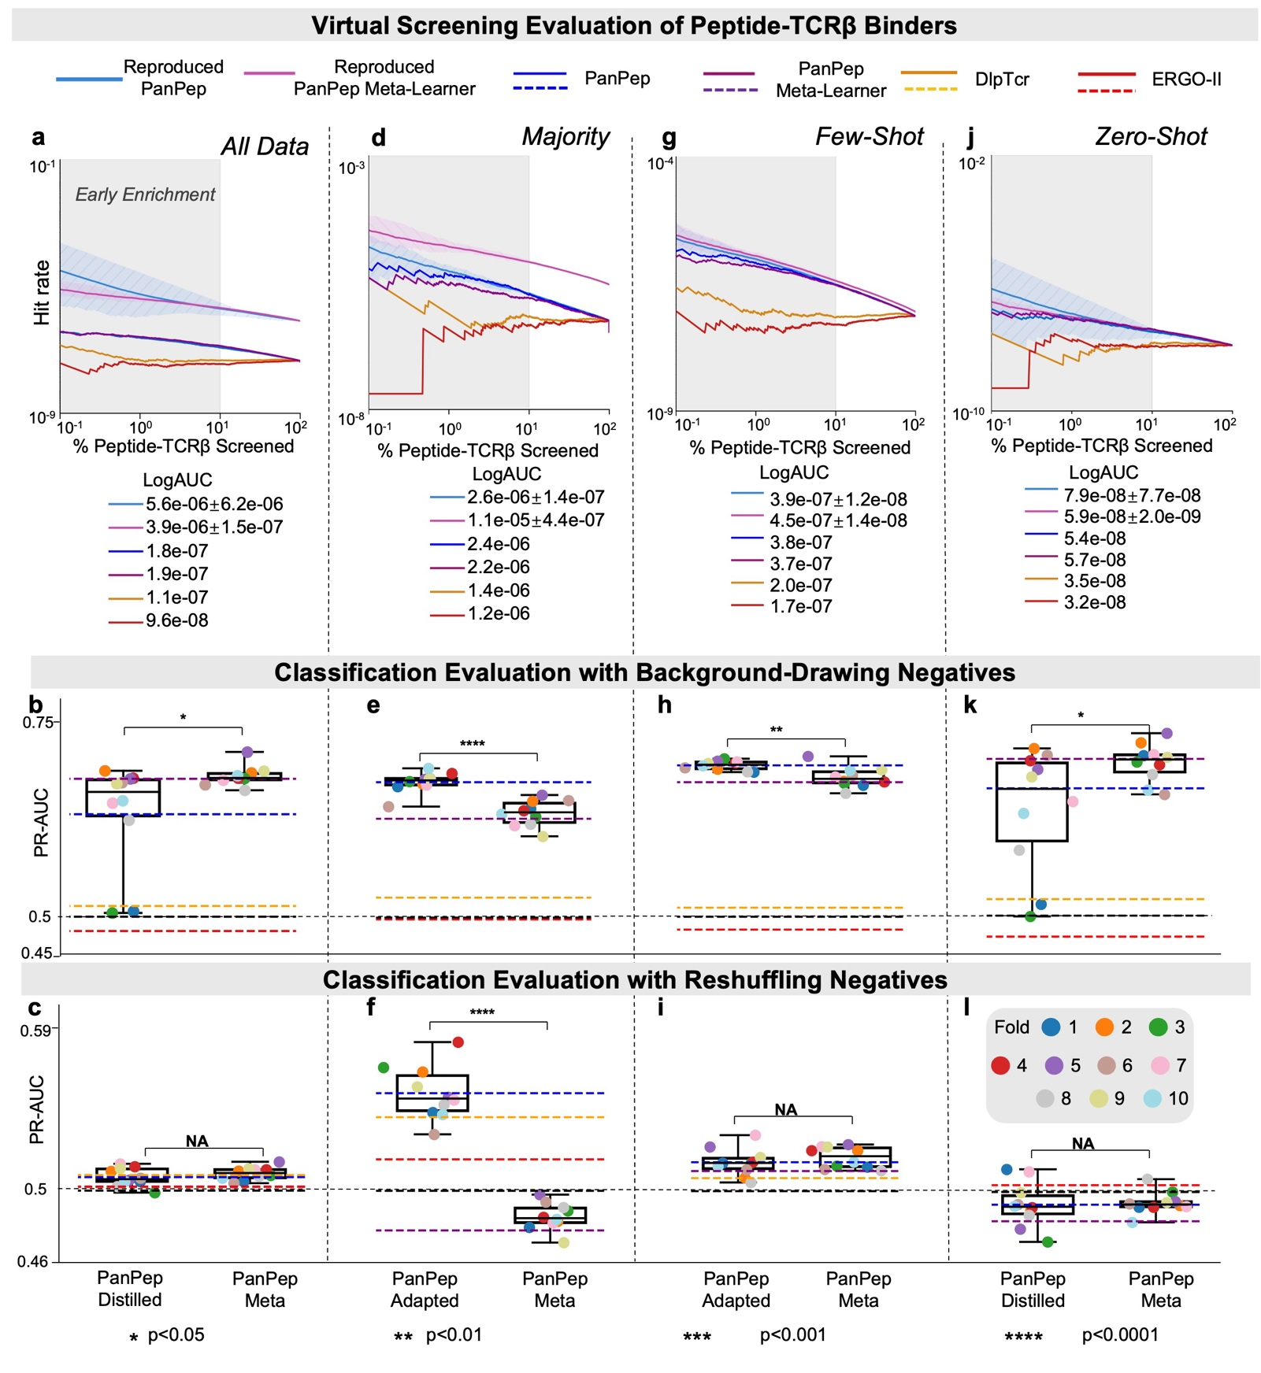
Extended Data Fig. 5 | Additional Evaluation Metrics of Reproduced PanPep on the Independent Dataset. (a-c) Hit rates from virtual screening evaluations and PR-AUC scores from classification evaluations using background-drawing and reshuffling strategies in the zero-shot setting on the entire dataset. (d-f) Corresponding evaluations for the majority group in the majority setting. (g-i) Corresponding evaluations for the few-shot group in the few-shot setting. (j-l) Corresponding evaluations for the zero-shot group in the zero-shot setting.
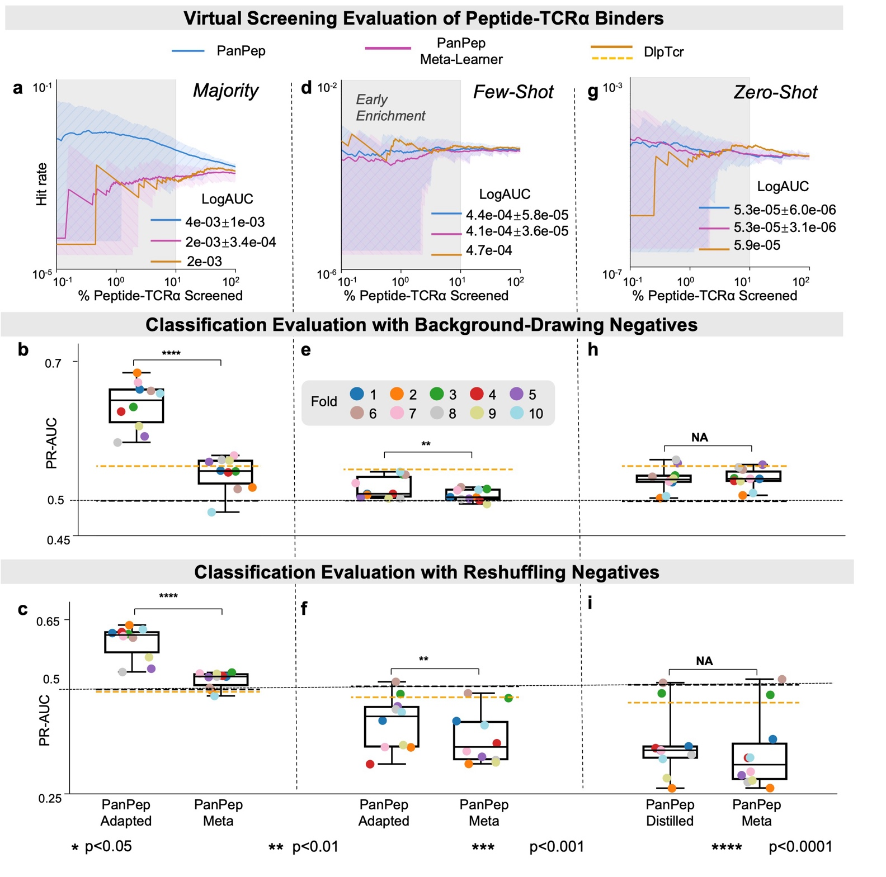
Extended Data Fig. 6 | Additional Evaluation Metrics of 10-fold Reproduced PanPep on the Peptide-TCRα Binding Scenario. (a-c) Hit rates from virtual screening evaluations and PR-AUC scores from classification evaluations using background-drawing and reshuffling strategies in the majority setting. (d-f) Corresponding evaluations in the few-shot setting. (g-i) Corresponding evaluations in the zero-shot setting.
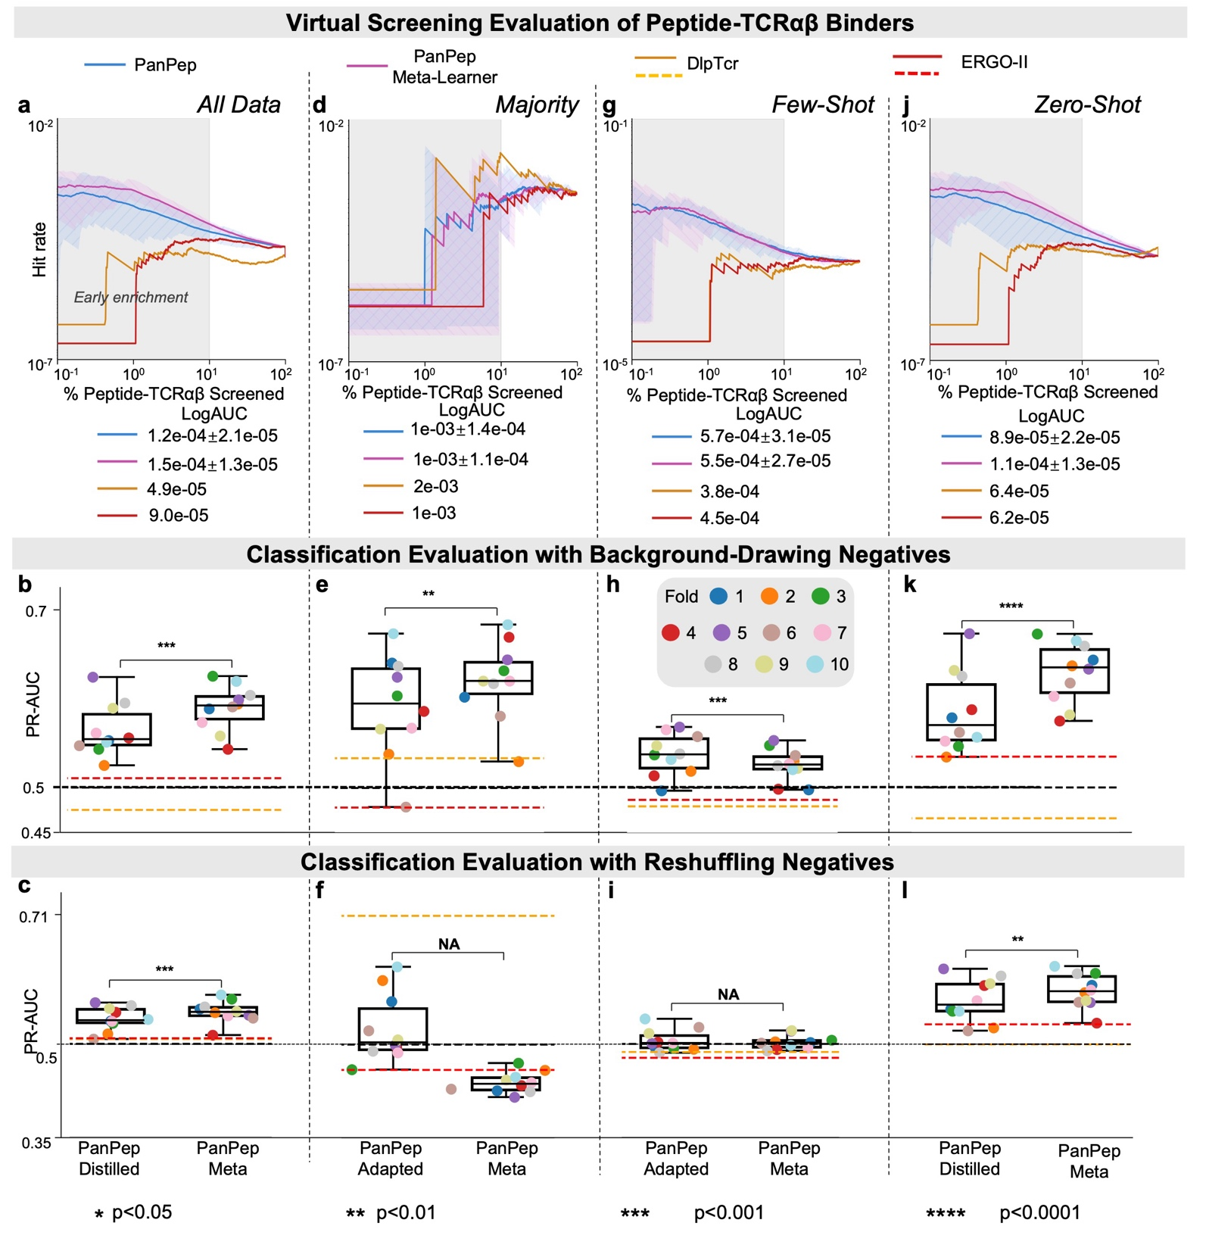
Extended Data Fig. 7 | Additional Evaluation Metrics of 10-fold Reproduced PanPep on the Peptide-TCRαβ Binding Scenario. (a-c) Hit rates from virtual screening evaluations and PR-AUC scores from classification evaluations using background-drawing and reshuffling strategies in the zero-shot setting on the entire dataset. (d-f) Corresponding evaluations for the majority group in the majority setting. (g-i) Corresponding evaluations for the few-shot group in the few-shot setting. (j-l) Corresponding evaluations for the zero-shot group in the zero-shot setting.

