Supplementary metarials
Figure 1
A
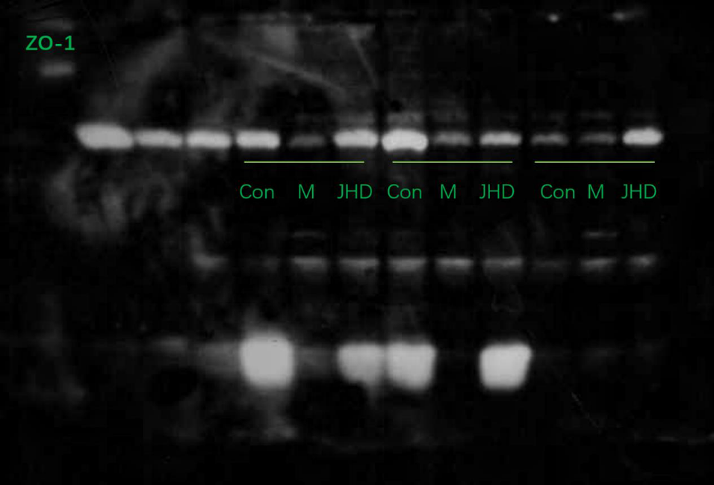
B
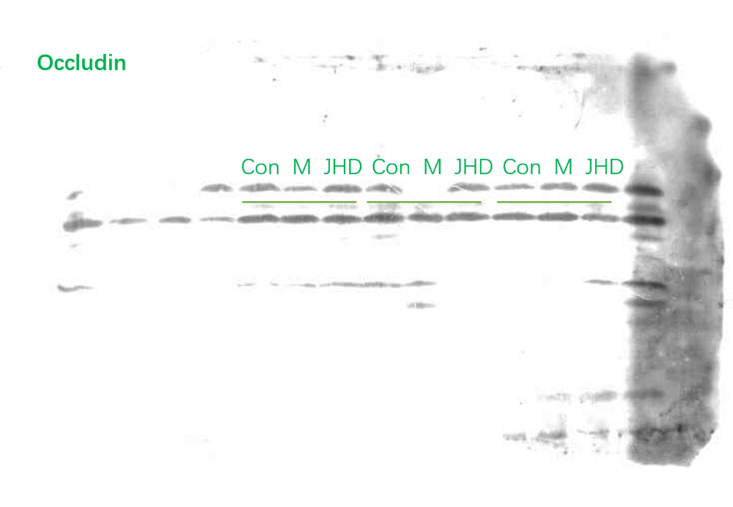
C 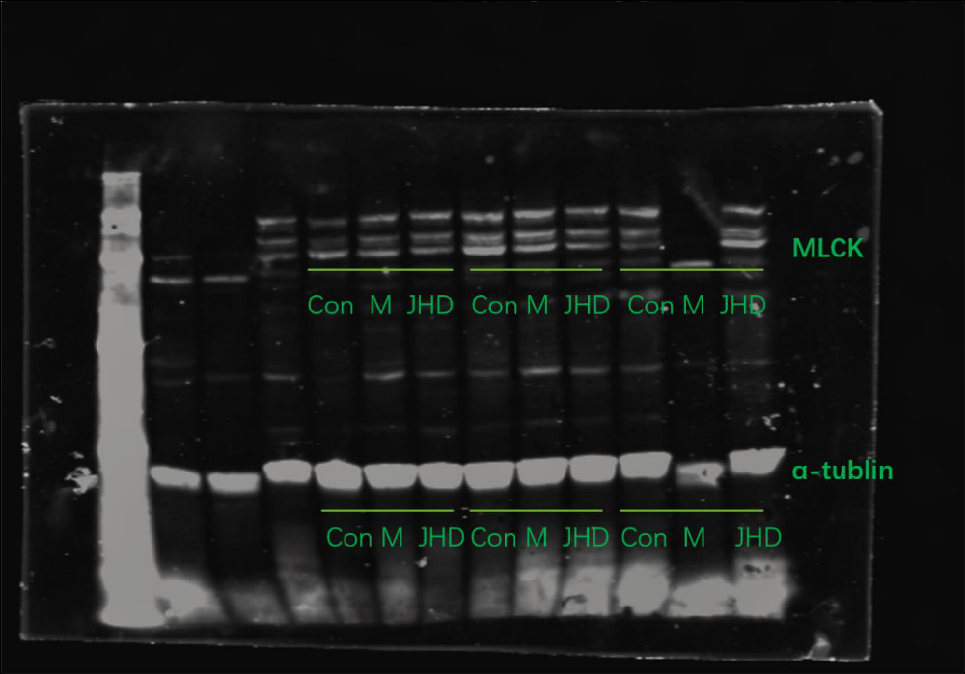
D 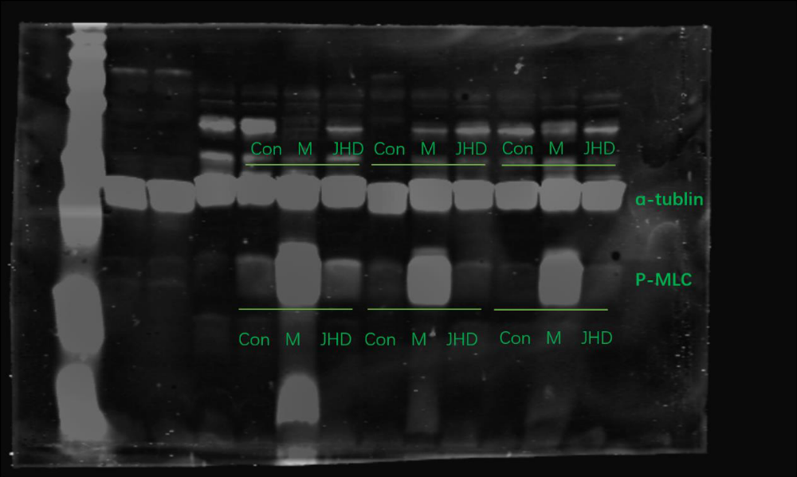
Figure 1.(A-B) Western blot analysis of ZO-1 and Occludin protein expression level in intestine. （C-D）)Western blot analysis of MLCK and p-MLC protein expression level in intestine.

