Supplementary Information
Mechanically Excellent Nacre-inspired Protective Steel-Concrete Composite against Hypervelocity Impacts

Yong Mei^{1,4,†}, Jinming Liu¹, Yuan Cui¹, Feng Li¹, Xuke Tang^{2,†}, Miao Sun⁵, Ruiqiang Chi⁵, Yongbo Zhang^{3,}*, Ao Zhang^{1,}*, Ke Chen^{2,}*

¹Institute of Defense Engineering, AMS, PLA, Beijing, 100036, China

²Beijing Advanced Innovation Center for Biomedical Engineering, Key Laboratory of Bio-inspired Smart Interfacial Science and Technology of Ministry of Education, School of Chemistry, Beihang University (BUAA), Beijing, 100191, China

³School of Aeronautic Science and Engineering, Beihang University (BUAA), Beijing 100191, China

⁴State Key Laboratory of Explosion Science and Technology, Beijing Institute of Technology, Beijing 100081, China

⁵Hypervelocity Impact Research Center, Harbin Institute of Technology, Harbin 150080, China

*Corresponding author
Email: chenke0119@buaa.edu.cn, zhangyongbo@buaa.edu.cn, zhangao202012@163.com.

This PDF file includes:
Supplementary Text
Supplementary Figs. 1 to 6
Captions for Supplementary Movies 1 to 3
Other Supplementary Material for this manuscript includes the following:

The working principle of a two-stage light-gas gun system
The working principle of a two-stage light-gas gun is introduced as following: i) filling high-pressure N₂ into high-pressure first-stage gas chamber; ii) the start button releases the high-pressure N₂ to derive the plunger placed in the pump pipe; iii) the plunger accelerates the movement and compresses the H₂ gas filled into the pump tube to do work, so that H₂ gas can reach the state of high temperature and high pressure in a short time; iv) H₂ gas with high temperature and high pressure is impacted on the metal diaphragm within the high pressure cone section and causes it to break, and then the high temperature and high pressure gas enters the launching tube. v) the projectile is placed in the cartridge case, which are located in the launching tube. After the high-temperature and high-pressure gas enters the launching tube, it will be accelerated; vi) when the projectile with is consigned to the exit of the launching tube, the projectile continues to fly along the trajectory and hits the target piece placed in the vacuum target cabin.
Before shooting, we weigh the projectile and the sabots, inspect the integrity of the target, keep the image on the front of the target, lift the target into the target bin, keep the image on the back of the target, adjust the target to ballistic center and high-speed photography area, and check the trigger switch of high-speed camera; during the experimental test, we install the projectile after closing the door, connect launch tube with high pressure cone end, install the first-stage piston, and start the vacuum pump of the target chamber. After the vacuum degree of the target chamber is nearly zero, we use N₂ to fill the first-stage gas chamber up to a setting pressure, and then close the vacuum pump. Next, we close the door after filling a setting pressure of H₂ in the pump tube, open fill-in light. After opening trigger mode of high-speed camera, we record the last shooting stamping value, and then require all employees to leave the lab. Subsequently, we simultaneously press the launch button and the high-speed camera button. After the impact test, the high-speed photographic images should be saved, and the final target shooting speed is also measured and recorded. The target pieces are lifted out of the target cabin, the residual projectile is also checked in the target cabin, and save the image of the impacted target.

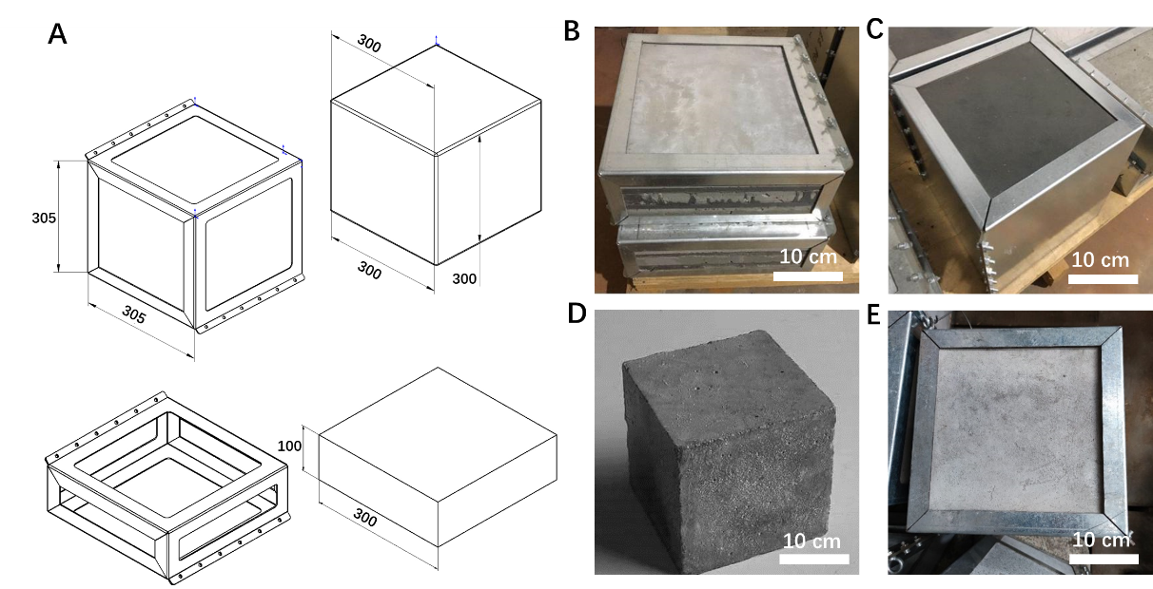
Supplementary Fig. 1. Schematic diagram of home-made galvanized iron molds and digital photos of these target materials. (A) Design of two types of home-made galvanized iron molds (305 mm × 305 mm × 305 mm and 305 mm × 305 mm × 105 mm) for packaging these different sized target materials. (B) The galvanized iron-packaged NISC target materials (Size: 300 mm × 300 mm × 100 mm). (C) The galvanized iron-packaged NISC target materials (Size: 300 mm × 300 mm × 300 mm). (D) Pure concrete (Size: 300 mm × 300 mm × 300 mm). (E) The galvanized iron-packaged concrete target material (Size: 300 mm × 300 mm × 300 mm).

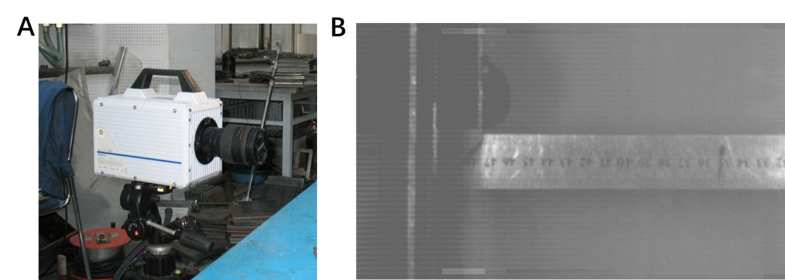
Supplementary Fig. 2. Photron SA5 high-speed camera (A) and the calibration image (B) for recording a striking velocity of a projectile.

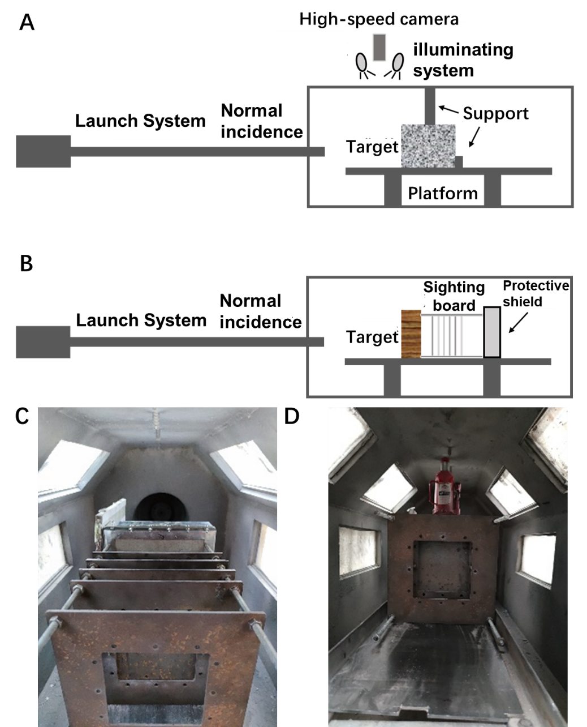
Supplementary Fig. 3. The experimental support set-up for hypervelocity impact tests of the target materials on a two-stage light-gas gun. (A) Schematic diagram of experimental upper support and rear support for the relatively thick target materials. (B) Schematic diagram of the experimental sighting board and protective shield for the NISC-100 target material.

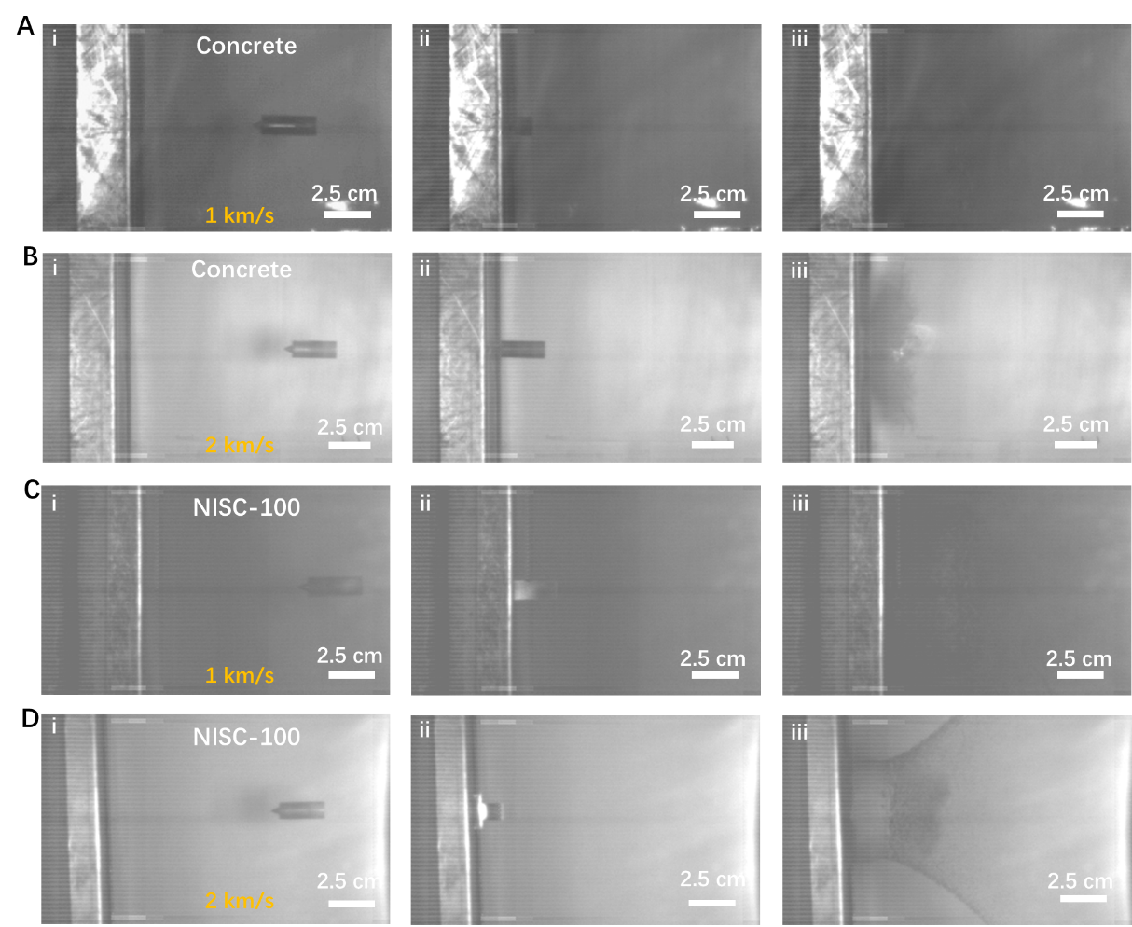
Supplementary Fig. 4. The in situ observation of the experimental impact process for different types of concrete target materials, recorded by the high-speed camera at different impact speeds. (A) The impact process of the pure concrete at a striking velocity of 1 km/s. (B) The impact process of pure concrete at a striking velocity of 2 km/s. (C) The impact process of the NISC-100 at a striking velocity of 1 km/s. (D) The impact process of the NISC-100 at a striking velocity of 2 km/s.

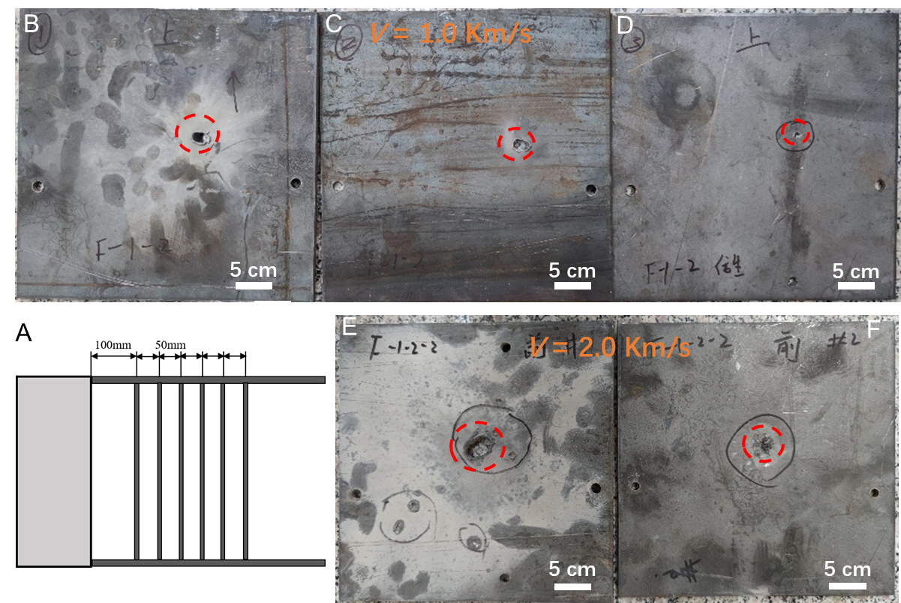
Supplementary Fig. 5. The observation of the bullet holes in the experimental sighting board, based on the hypervelocity impact tests of the NISC-100 target at different striking velocities. (A) Schematic diagram of the overall arrangement of the experimental sighting boards behind a target. (B-D) The morphologies of these bullet holes in the first-third layered sighting boards at a striking velocity of 1 km/s. (E,F) the bullet holes/impact crater morphologies in the first and second layered sighting boards at a striking velocity of 2 km/s.

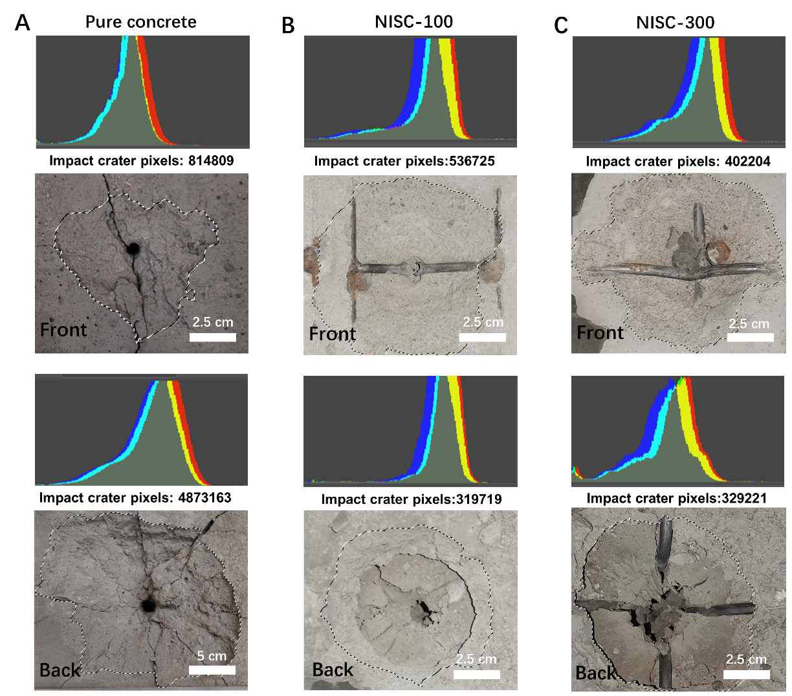
Supplementary Fig. 6. The contour areas and dimensions of the impact craters in the first layer and the back of these target materials, respectively, calculated by Photoshop software. (A) Pure concrete. (B) NISC-100. (C) NISC-300. Top: The frontal pure concrete and the first layer NISC target material; Bottom: The back of the pure concrete and the first layer NISC target material.

Supplementary Table 1. The specification of the target materials for static mechanical properties.
Target | Length × Width × Height (Compression test) | Length × Width × Height  (Bending test)
Concrete | 90 mm × 90 mm × 150 mm | 160 mm × 20 mm × 40 × mm
NISC | 90 mm × 90 mm × 150 mm | 160 mm × 20 mm × 40 mm

Supplementary Table 2. Summary of test parameters of these targets by using a two-stage light gas gun.
Targets | Set velocity  (km/s) | Projectile mass  (g) | Total projectile mass  (g) | Actual velocity  (km/s)
Pure concrete | 1 | 5.76 | 9.98 | 1.080
Pure concrete | 2 | 5.76 | 10.16 | 1.937
NISC | 1 | 5.76 | 10.01 | 1.118
NISC | 2 | 5.76 | 10.10 | 1.984

