Supplemental Material
MYBPC3 (c.194C>T) mutation-mediated RyR2 dysfunction contributes to pathogenic phenotypes of DCM revealed by hiPSC modeling
Manting Xie^{1,2#}, Bingbing Xie^{1#}, Ying Chen³, Xingqiang Lai¹, Jixing Gong¹, Nan Cao^{1*}, Andy Peng Xiang^{1*}, Qiuling Xiang^{1*}
- Center for Stem Cell Biology and Tissue Engineering, Key Laboratory for Stem Cells and Tissue Engineering, Ministry of Education, Zhongshan School of Medicine, Sun Yat-sen University, Guangzhou, Guangdong, P. R. China (510080).
- Scientific Development and Management Office, Sun Yat-sen Memorial Hospital, Sun Yat-sen University, Guangzhou, Guangdong, China(510235).
3. Department of Cardiology, Sun Yat-sen Memorial Hospital, Sun Yat-sen University, Guangzhou, Guangdong, China(510235).
*Corresponding authors:
Qiuling Xiang, E-mail: xiangql@mail.sysu.edu.cn; Tel: +8620-87335982; Fax: +8620-87335858
Andy Peng Xiang, E-mail: xiangp@mail.sysu.edu.cn; Tel: +8620-87335822; Fax: +8620-87335858
Nan Cao, E-mail:caon3@mail.sysu.edu.cn; Tel: +020-87335890; Fax: +020-87335890
Supplemental Table S1：List of the DNA primers used in RT-PCR.
Primers | Sequences (5' to 3')
NANOG-F | AAGGTCCCGGTCAAGAAACAG
NANOG-R | CTTCTGCGTCACACCATTGC
OCT4-F | CGAGCAATTTCCAAGCTCCTGAA
OCT4-R | TCGGGCACTGCAGGAACAAATTC
SOX2-F | CCCCCGGGCGGCAATAGCA
SOX2-R | TCGGCGCCGGGGAGATACAT
Sev-F | GGATCACTAGGTGATATCGAGC
Sev-R | ACCAGACAAGAGTTTAAGAGATATGTATC
KOS-F | ATGCACCGCTACGACGTGAGCGC
KOS-R | ACCTTGACAATCCTGATGTGG
MYC-F | TAACTGACTAGCAGGCTTGTCG
MYC-R | TCCACATACAGTCCTGGATGATGATG
KLF-F | TTCCTGCATGCCAGAGGAGCCC
KLF-R | AATGTATCGAAGGTGCTCAA

Supplemental Table S2：List of the RNA primers used in RT-qPCR.
NANOG-F | TTTGTGGGCCTGAAGAAAACT
NANOG-R | AGGGCTGTCCTGAATAAGCAG
OCT4-F | GACAGGGGGAGGGGAGGAGCTAGG
OCT4-R | CTTCCCTCCAACCAGTTGCCCCAAAC
SOX2-F | GGGAAATGGGAGGGGTGCAAAAGAGG
SOX2-R | TTGCGTGAGTGTGGATGGGATTGGTG
T-F | TATGAGCCTCGAATCCACATAGT
T-R | CCTCGTTCTGATAAGCAGTCAC
MESP1-F | AGCCCAAGTGACAAGGGACAACT
MESP1-R | AAGGAACCACTTCGAAGGTGCTGA
EOMES-F | CATGCAGGGCAACAAAATGTATG
EOMES-R | GTGTTGTTGTTATTTGCGCCTTTGT
ISL1-F | ATCAGGTTGTACGGGATCAAATG
ISL1-R | ATGAGATACACCTTGGAGGG
GATA4-F | GTGTCCCAGACGTTCTCAGTC
GATA4-R | GGGAGACGCATAGCCTTGT
MEF2C-F | GAACGTAACAGACAGGTGACAT
MEF2C-R | CGGCTCGTTGTACTCCGTG
MYH6-F | GCTGGTCACCAACAATCCCTA
MYH6-R | CGTCAAAGGCACTATCGGTGG
MYL7-F | ACATCATCACCCATGGAGACGAGA
MYL7-R | GCAACAGAGTTTATTGAGGTGCCC
TNNT2-F | GGAGGAGTCCAAACCAAAGCC
TNNT2-R | TCAAAGTCCACTCTCTCTCCATC
NPPA-F | CAACGCAGACCTGATGGATTT
NPPA-R | AGCCCCCGCTTCTTCATTC
NPPB-F | TGGAAACGTCCGGGTTACAG
NPPB-R | CTGATCCGGTCCATCTTCCT
MYBPC3-F | CAAGGTCTATCTGTTCGAGCTG
MYBPC3-R | AGAATCCCAGTGTCCTCATGG
CASQ2-F | GGCAGAAGAGGGGCTTAATTT
CASQ2-R | GAAGACACCGGCTCATGGTAG
DUOX2-F | ACGGTGTGTATCAGGCTCTG
DUOX2-R | CACGTCGGAAAGAACATGGTAG
PCDHGA3-F | TTGCCTGAGTTTCCGAAATGG
PCDHGA3-R | TCAGACACCGAGTAGCGGAT
SMOC2-F | TTCTCGGCGCTCACGTTTTT
SMOC2-R | GTTGAAATTCACAACGGGAAAGG
ACAN-F | ACTCTGGGTTTTCGTGACTCT
ACAN-R | ACACTCAGCGAGTTGTCATGG
FBLN5-F | CTCACTGTTACCATTCTGGCTC
FBLN5-R | GACTGGCGATCCAGGTCAAAG
GAPDH-F | GGTCGGAGTCAACGGATTTG
GAPDH-R | CGGTGCCATGGAATTTGCC

Supplemental Table S3：List of the primary and secondary antibodies used in this study.
Antibodies | Dilutions | Cat. NO | Supplier
Rabbit anti-OCT4 | 1：250 | A7920 | ABclonal
Rabbit anti-SOX2 | 1：250 | A11501 | ABclonal
Mouse anti-SSEA4 | 1：250 | ab16287 | Abcam
Rabbit anti-TUBB3 | 1：250 | A17913 | ABclonal
Rabbit anti-SOX17 | 1：250 | Bs-12205R | Bioss
Mouse anti-αSMA | 1：250 | ab7817 | Abcam
Rabbit anti-cTnT | 1：250 | ab209813 | Abcam
Mouse anti-actinin -antantanti-α-actinin | 1：250 | ab18061 | Abcam
Mouse anti-cMyBP-C | 1：100 | sc-137180 | SANTA CRUZ

Supplement Figure 1. Validation of the healthy person-specific human induced pluripotent stem cells (Ctrl-hiPSCs). (A) Brightfield image and alkaline phosphatase staining of the peripheral blood derived hiPSCs (scale bar: right—100 μm; left—50 μm). (B) Karyotype analysis of Ctrl-hiPSCs line. (C) Sanger sequencing of MYBPC3. (D) RT-PCR of the gene expression of pluripotency. 1: NANOG; 2: OCT4; 3: SOX2; 4: Sev; 5: KOS; 6: MYC; 7: KLF. (E) Immunofluorescent staining for OCT4, SOX2, SSEA4 and DAPI (scale bar: 45 μm). (F) Immunofluorescent staining of three germ layers (scale bar: 45 μm).

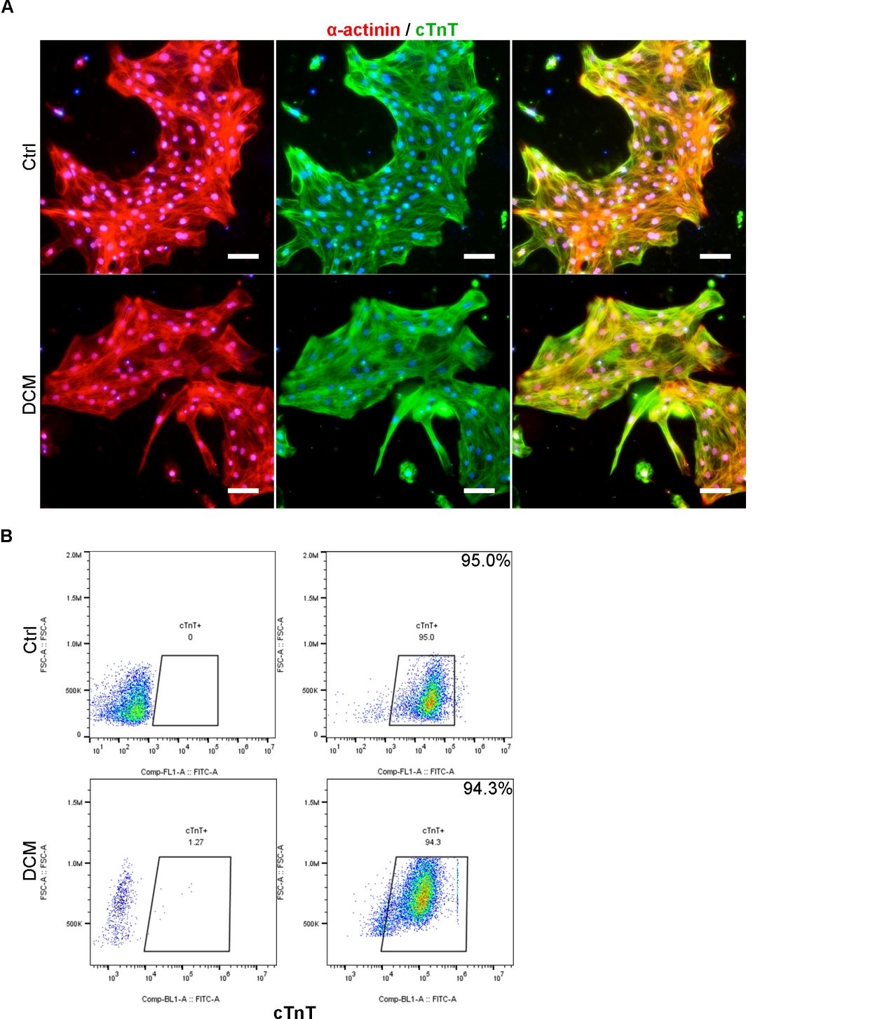
Supplement Figure 2. Efficiency of hiPSCs differentiation into cardiomyocytes. (A) Immunofluorescent staining of α-actinin and cTnT (scale bar—45 μm). (B) Flow cytometry analysis of cTnT positive cells.

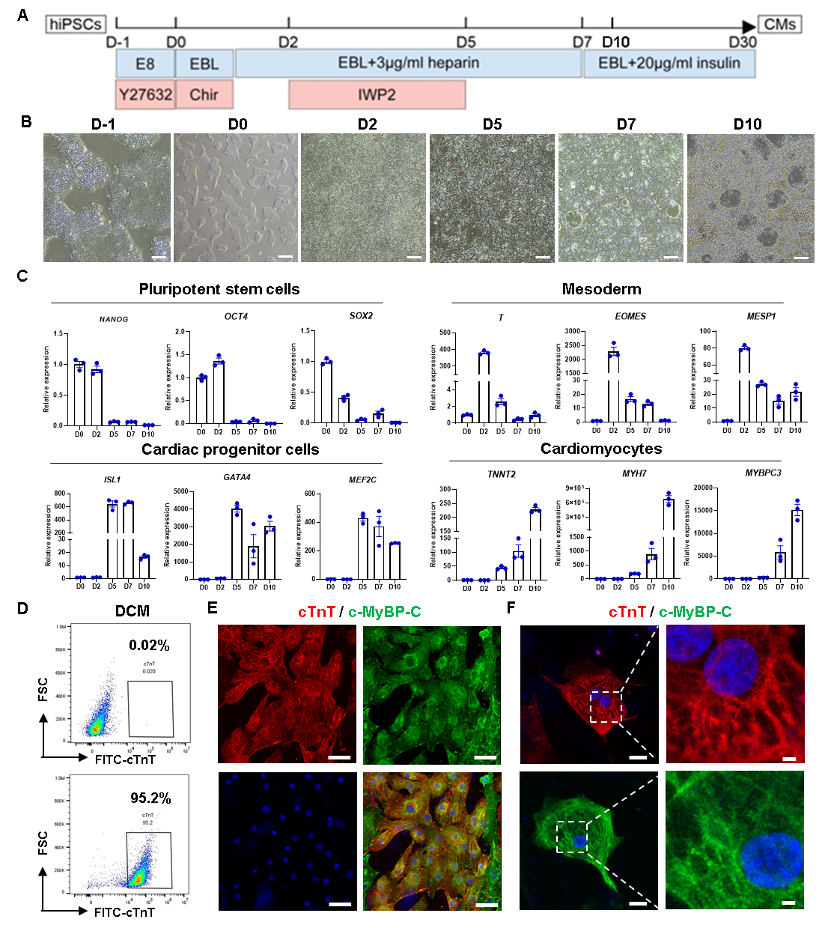
Supplement Figure 3. Generation of the dilated cardiomyopathy patient-specific induced pluripotent stem cell derived cardiomyocytes (DCM-hiPSC-CMs). (A) Schematic of hiPSC-CMs induction. (B) Brightfield images of hiPSC-CMs induction from day -1 to day 10 (scale bar—100 μm). (C) Relative mRNA expression of pluripotent stem cells, mesoderm cells, cardiac progenitor cells and cardiomyocytes markers. (D) Flow cytometry analysis of cTnT positive cells. (E) Immunofluorescent staining of cTnT and cMyBP-C (scale bar—50 μm). (F) Immunofluorescent staining of cTnT and cMyBP-C (scale bar—20 μm).

