Table S1. Crystallographic parameters and refinement details for the target crystals
 | AW8 | AW12 | AW19 | AW23 | AW33
Empirical formula | C₁₄H₁₀N₃O₂Cl₃ | C₁₄H₁₀N₃O₂Cl₃ | C₁₄H₁₁N₄O₄Cl | C₁₈H₁₄N₃O₂Cl | C₁₄H₁₈N₃O₂Cl
Formula weight | 358.60 | 358.60 | 334.72 | 339.77 | 295.76
Crystal system | monoclinic | monoclinic | monoclinic | monoclinic | monoclinic
Space group | P2₁/n | P2₁/c | C2/c | P2₁/c | P2₁/c
Unit cell paramaters
a (Å) | 9.1703(8) | 14.0356(10) | 30.0549(13) | 8.0560(9) | 9.3713(3)
b (Å) | 11.3613(12) | 14.9442(10) | 6.9324(2) | 7.6108(9) | 13.5104(4)
c (Å) | 15.1992(13) | 7.0371(5) | 14.4089(7) | 26.8092(19) | 12.0313(5)
β (º) | 106.479(9) | 92.118(7) | 97.938(4) | 95.629(8) | 102.815(4)
V (Å³) | 1518.5(3) | 1475.03(18) | 2973.4(2) | 1635.8(3) | 1485.34(9)
Z | 4 | 4 | 8 | 4 | 4
d_{calc} (Mg m⁻³) | 1.569 | 1.615 | 1.495 | 1.380 | 1.323
F(000) | 728 | 728 | 1376 | 704 | 624
Absorption coefficient, μ (mm⁻¹) | 0.612 | 5.725 | 2.533 | 2.199 | 2.326
T (K) | 293 | 296 | 296 | 296 | 293
Absorption correction | multi-scan methods [23]
T_{min}/T_{max} | 0.852/1.000 | 0.716/1.000 | 0.884/1.000 | 0.808/1.000 | 0.766/1.000
Θ range for data collection (º) | 2.79–28.66 | 4.32–75.84 | 5.95–76.11 | 3.31–76.12 | 4.84–75.99
No of measured reflections | 6340 | 10036 | 5525 | 3276 | 5774
No of independent reflections | 3356 | 3030 | 3008 | 3276 | 3004
No of observed reflections | 2529 with I>2σ(I) | 2585 with I>2σ(I) | 2579 with I>2σ(I) | 2139 with I>2σ(I) | 2495 with I>2σ(I)
Refinement method
Final R indices: R, wR(F²) | 0.051/0.136 | 0.104/0.275 | 0.043/0.114 | 0.080/0.205 | 0.052/0.141
Goodness-of-fit on F², S | 1.077 | 1.183 | 1.055 | 1.059 | 1.043
Data/parameters | 3356/267 | 3030/224 | 3008/217 | 3276/228 | 3004/190
Extinction ceofficient | 0.008(2) | - | - | 0.032(6) | -
Largest diff. peak and hole (eÅ⁻³) | +0.321/-0.298 | +0.687/-0.372 | +0.268/-0.348 | +0.324/-0.311 | +0.293/-0.341
(Δ/σ)_{max} | 0.000 | 0.000 | 0.001 | 0.000 | 0.000

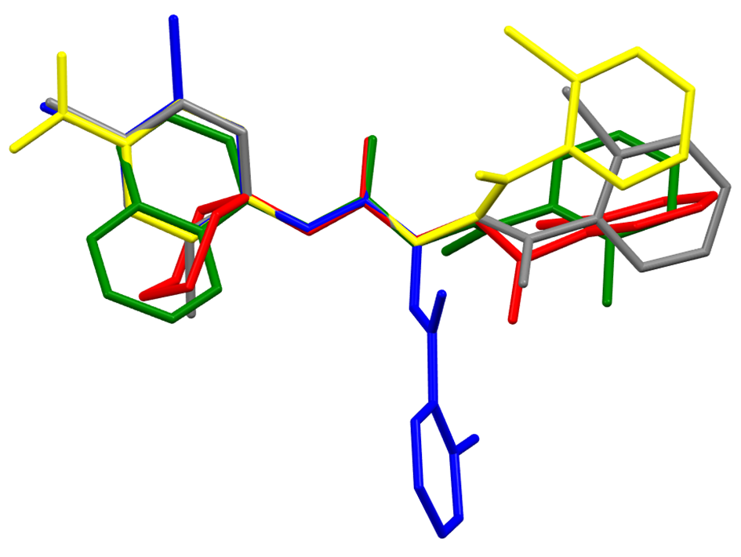

Fig.S1. Overlay of X-ray molecules of AW8 (grey), AW12 (blue), AW19 (yellow), AW23 (green) and AW33 (red) by least-squares fitting of the C21, N1, C2 and N4 atoms. The H atoms and the disordered benzene ring B of AW8 and AW12 are omitted.

Table S2 Characteristic IR frequencies and assignments for AWs tested.
Type and origin of vibrations* | AW8 | AW12 | AW 19 | AW23 | AW33 | AW38
Type and origin of vibrations* | Location of bands [cm⁻¹]
ν_{as}(N–H) | 3317 | 3310 | 3335 | 3359 | 3343 | 3383-3196
νs(N–H) | 3198 | - | 3210 | 3177 | 3102 | 3196
ν (C–H (ν) | 3105, 3021, 2902 | 2933 | 3097, 3023 | 3012 | 2929-2859 | 3010
ν(C=O) | 1704 | - | 1715 | 1715 | - | 1708
ν(C=O),  δ(N–H) | - | 1688, 1665 | 1648 | 1635 | 1689 | 1652
ν(C=N) , C=C (ν) | 1612, 1583, 1525 | 1580, 1522 | 1613,1594, 1560 | 1595,1544 | 1549 | 1592-1524
ν_{as}(N–N) | 1457 | 1473 | 1456 | 1471 | 1484 | 1432
ν(C–N), ν(N–N) | 1299, 1225 | 1297,1230 | 1300,1225 | 1231 | - | 1289-1253
ν(C–N), ν(N–N) | 1243 | 1243 | 1264 | 1259 | 1242 | 1253
δ(C–H) (aromatic, pos.meta₎ | 900–860 | - | - | - | - | -
δ(C–H) (aromatic, pos.orto) | - | 765-742 | - | - | - | -
ν(C–Cl) | 810–720 | 821-742 | 726 | 789-763 | 769 | 897
ν(C–NO₂) | - | - | 852-835 | - | - | -
δ(C–H) | 780–740 | 765-742 | 765-748 | - | 769 | 769
* ν - stretching vibration, δ - deformation vibration, s - symmetrical, as – asymmetrical
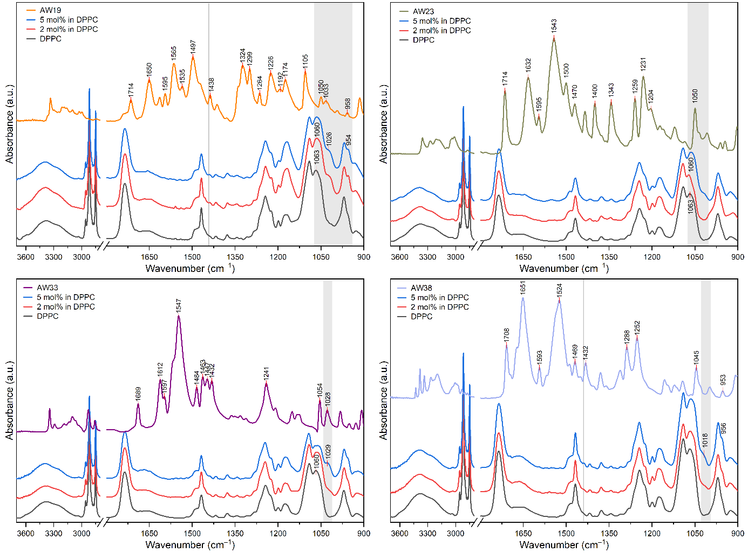
Fig. S2. The ATR-FTIR spectra of AW19, AW23, AW33 and AW38 series dissolved in DMSO in the form of the dry film from the top for 2 and 5 and AW in DPPC, and pure DPPC (black line) at room temperature. Spectra were offset on the vertical scale for clarity. The multibilayers were equilibrated at 1% RH.

