Supplementary Materials

Fold | Accuracy | AUC | Precision |  | Recall |  | Specificity |  | F1-Score
 |  |  | Class 0 | Class 1 | Class 0 | Class  1 | Class 0 | Class  1 | Class 0 | Class  1
1 | 1.00 | 0.99 | 1.00 | 1.00 | 1.00 | 0.97 | 0.97 | 1.00 | 1.00 | 0.99
2 | 1.00 | 0.97 | 1.00 | 1.00 | 1.00 | 0.91 | 0.91 | 1.00 | 1.00 | 0.95
3 | 1.00 | 1.00 | 1.00 | 1.00 | 1.00 | 1.00 | 1.00 | 1.00 | 1.00 | 1.00
4 | 1.00 | 1.00 | 1.00 | 1.00 | 1.00 | 0.99 | 0.99 | 1.00 | 1.00 | 0.99
5 | 1.00 | 1.00 | 1.00 | 1.00 | 1.00 | 1.00 | 1.00 | 1.00 | 1.00 | 1.00

Supplementary Table 1: Performance analysis of 5-fold cross-validation using different metrics for 0.2 hour onset dataset.

Fold | Accuracy | AUC | Precision |  | Recall |  | Specificity |  | F1-Score
 |  |  | Class 0 | Class 1 | Class 0 | Class  1 | Class 0 | Class  1 | Class 0 | Class  1
1 | 1.00 | .99 | 1.00 | .96 | 1.00 | .98 | .98 | 1.00 | 1.00 | .97
2 | 1.00 | 1.00 | 1.00 | .98 | 1.00 | .92 | .92 | 1.00 | 1.00 | .95
3 | 1.00 | .99 | 1.00 | .98 | 1.00 | .97 | .97 | 1.00 | 1.00 | .97
4 | 1.00 | 1.00 | 1.00 | .98 | 1.00 | .97 | .97 | 1.00 | 1.00 | .98
5 | 1.00 | .99 | 1.00 | .99 | 1.00 | .96 | .96 | 1.00 | 1.00 | .97
Supplementary Table 2: Performance analysis of 5-fold cross-validation using different metrics for 0.4 hour onset dataset.

Fold | Accuracy | AUC | Precision |  | Recall |  | Specificity |  | F1-Score
 |  |  | Class 0 | Class 1 | Class 0 | Class  1 | Class 0 | Class  1 | Class 0 | Class  1
1 | 1.00 | .99 | 1.00 | .96 | 1.00 | .96 | .96 | 1.00 | 1.00 | .96
2 | 1.00 | 1.00 | 1.00 | .97 | 1.00 | .96 | .96 | 1.00 | 1.00 | .96
3 | 1.00 | .99 | 1.00 | .93 | 1.00 | .95 | .95 | 1.00 | 1.00 | .94
4 | 1.00 | .99 | 1.00 | .97 | 1.00 | .94 | .94 | 1.00 | 1.00 | .96
5 | 1.00 | .99 | 1.00 | .98 | 1.00 | .96 | .96 | 1.00 | 1.00 | .97

Supplementary Table 3: Performance analysis of 5-fold cross-validation using different metrics for 0.6 hour onset dataset.

Fold | Accuracy | AUC | Precision |  | Recall |  | Specificity |  | F1-Score
 |  |  | Class 0 | Class 1 | Class 0 | Class  1 | Class 0 | Class  1 | Class 0 | Class  1
1 | 1.00 | 1.00 | 1.00 | .96 | 1.00 | .99 | .99 | 1.00 | 1.00 | .98
2 | 1.00 | 1.00 | 1.00 | .91 | 1.00 | .96 | .96 | 1.00 | 1.00 | .94
3 | 1.00 | 1.00 | 1.00 | .88 | 1.00 | .93 | .93 | 1.00 | 1.00 | .90
4 | 1.00 | 1.00 | 1.00 | .95 | 1.00 | .97 | .97 | 1.00 | 1.00 | .96
5 | 1.00 | 1.00 | 1.00 | .96 | 1.00 | .97 | .97 | 1.00 | 1.00 | .97
Supplementary Table 4: Performance analysis of 5-fold cross-validation using different metrics for 0.8 hour onset dataset.

Supplementary Table 5: Performance analysis of 5-fold cross-validation using different metrics for 1 hour onset dataset.

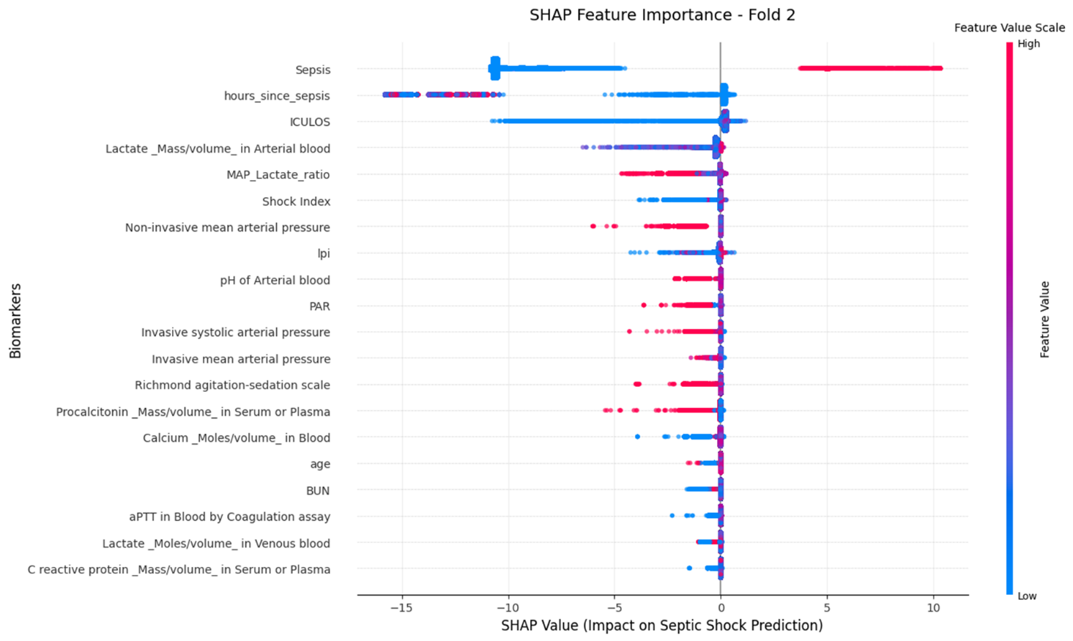

Fold | Accuracy | AUC | Precision |  | Recall |  | Specificity |  | F1_Score
 |  |  | Class 0 | Class 1 | Class 0 | Class  1 | Class 0 | Class 1 | Class 0 | Class  1
1 | 1.00 | 1.00 | 1.00 | .94 | 1.00 | .99 | .99 | 1.00 | 1.00 | .97
2 | 1.00 | 1.00 | 1.00 | .90 | 1.00 | .95 | .95 | 1.00 | 1.00 | .92
3 | 1.00 | 1.00 | 1.00 | .86 | 1.00 | .95 | .95 | 1.00 | 1.00 | .90
4 | 1.00 | 1.00 | 1.00 | .96 | 1.00 | .99 | .99 | 1.00 | 1.00 | .97
5 | 1.00 | 1.00 | 1.00 | .91 | 1.00 | .98 | .98 | 1.00 | 1.00 | .94

Supplementary Figure 1: SHAP summary plot for fold 2 illustrating the contribution of the top features to the septic shock prediction.
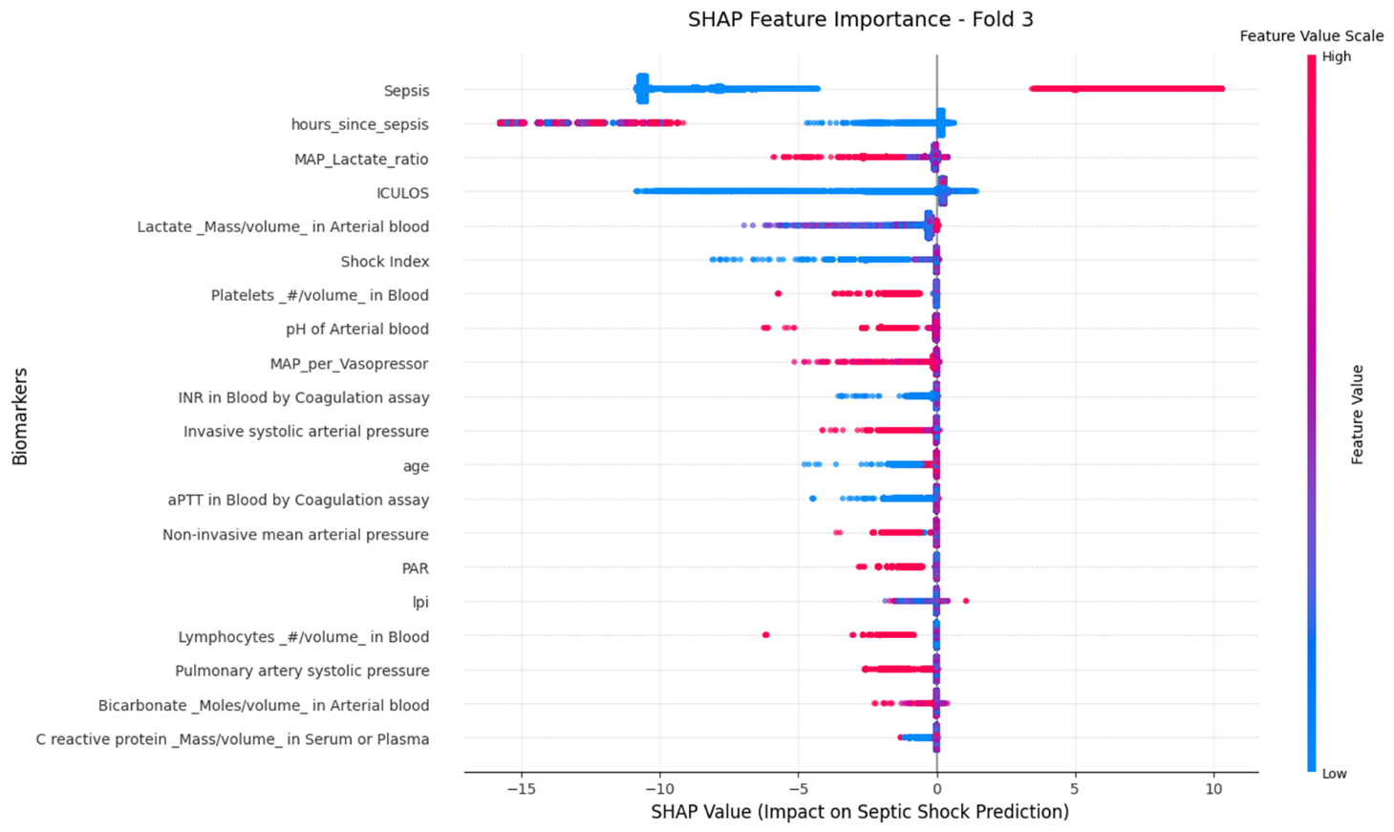

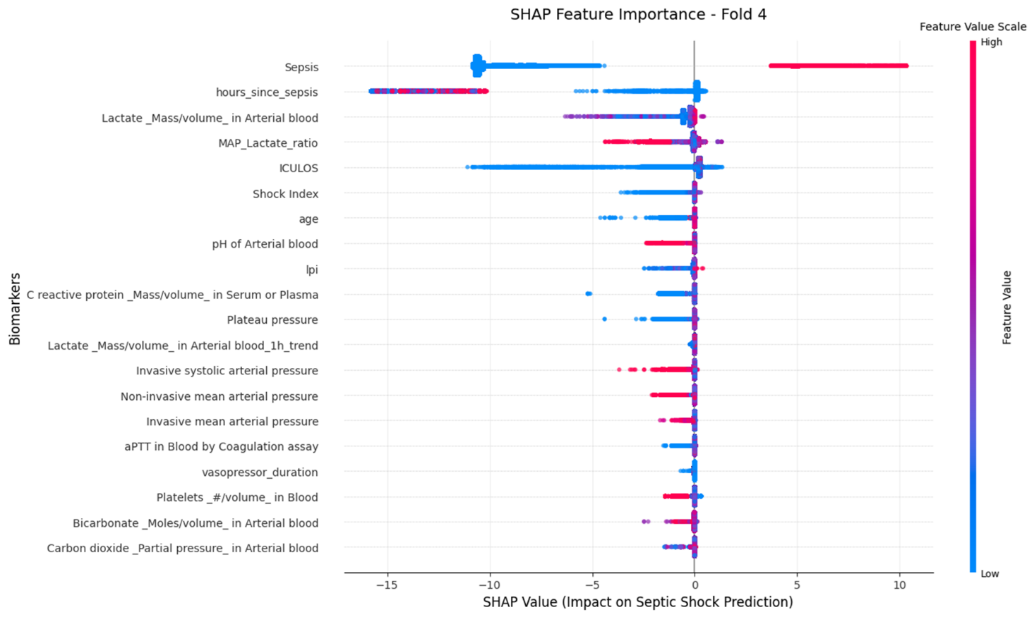
Supplementary Figure 2: SHAP summary plot for fold 3 illustrating the contribution of the top features to the septic shock prediction.
Supplementary Figure 3: SHAP summary plot for fold 4 illustrating the contribution of the top features to the septic shock prediction.

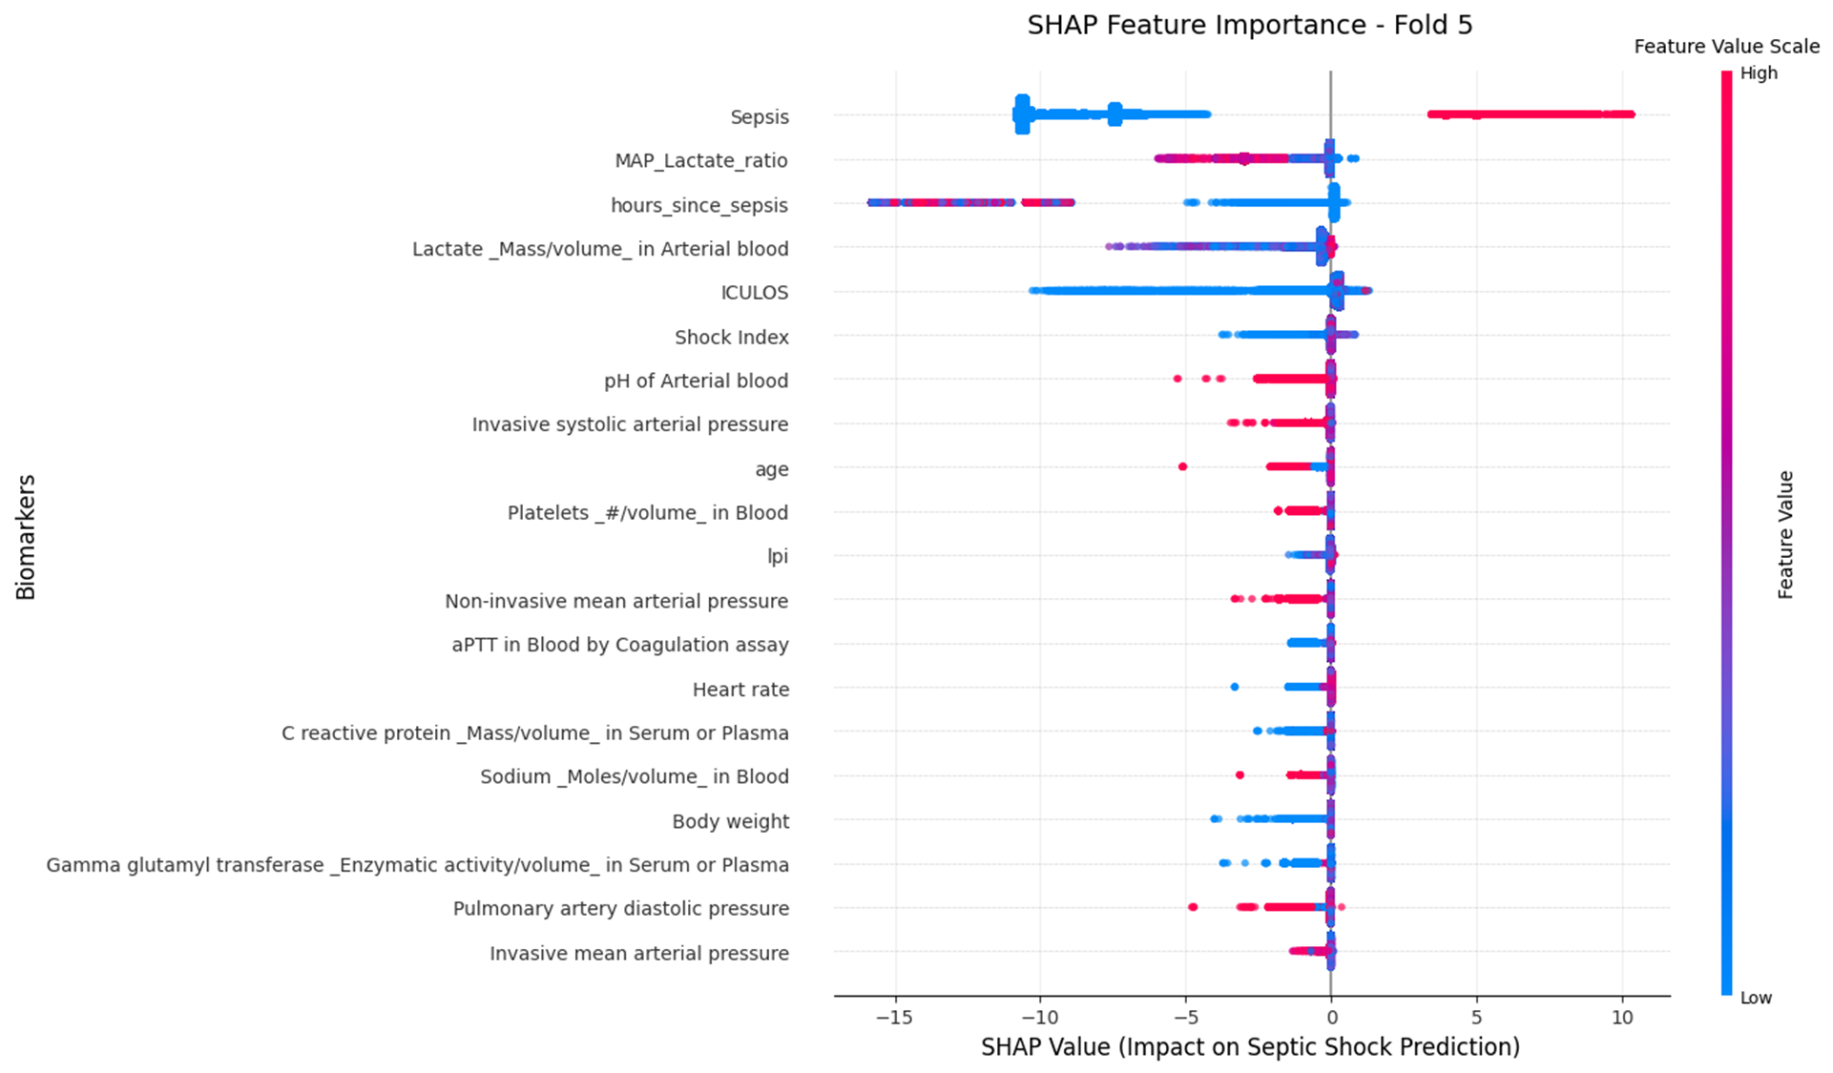

Supplementary Figure 4: SHAP summary plot for fold 5 illustrating the contribution of the top features to the septic shock prediction.

List of features for ablation study:
Observation Features: 'Heart rate','Pulmonary artery diastolic pressure','Pulmonary artery systolic pressure','Invasive systolic arterial pressure','Invasive mean arterial pressure','Non-invasive mean arterial pressure','Body weight','Carbon dioxide _Partial pressure_ in Arterial blood','C reactive protein _Mass/volume_ in Serum or Plasma','Lactate _Moles/volume_ in Venous blood','Lactate _Mass/volume_ in Arterial blood','Sepsis','INR in Blood by Coagulation assay','Calcium _Moles/volume_ in Blood','Platelets _#/volume_ in Blood','Ventilator rate','Lactate _Mass/volume_ in Arterial blood_1h_trend','pH of Arterial blood','Lymphocytes _#/volume_ in Blood','aPTT in Blood by Coagulation assay','Richmond agitation-sedation scale','Phosphate _Moles/volume_ in Blood','Bicarbonate _Moles/volume_ in Arterial blood','Sodium _Moles/volume_ in Blood','Gamma glutamyl transferase _Enzymatic activity/volume_ in Serum or Plasma','Procalcitonin _Mass/volume_ in Serum or Plasma','Alkaline phosphatase _Enzymatic activity/volume_ in Blood','Plateau pressure'.

Pharma Features: 'MAP_per_Vasopressor', 'vasopressor_duration'.
Demographic Features: 'age'
Derived Features: 'ICULOS', 'lpi', 'hours_since_sepsis', 'BUN', 'Shock Index', 'PAR', 'MAP_Lactate_ratio'.

