Analysis of the genetic structure and selection signature of Xiangyang Black pigs using whole-genome resequencing data

Zhong Xu^{1†}, Zipeng Li^{1†}, Mu Qiao¹, Jiawei Zhou¹, Yu Zhang¹,Yue Feng¹, Hua Sun¹, Tong Chen¹, Dake Chen¹, Favour Oluwapelumi Oyelami², Shuqi Mei^{1,3}, Junjing Wu^{1*}, Xianwen Peng^{1,3*}

† These authors contributed equally to this work.

* Correspondence:
Junjing Wu
jeanne1106@126.com
Xianwen Peng
pxwpal@163.com
¹ Hubei Key Laboratory of Animal Embryo and Molecular Breeding, Institute of Animal Husbandry and Veterinary, Hubei Provincial Academy of Agricultural Sciences, Wuhan 430064, China
² The John Curtin School of Medical Research, Australian National University, Canberra 2600, Australia
³ Hubei Hongshan Laboratory, Wuhan 430064, China

Figure.S1 Genome-wide distribution of detected SNPs on 19 chromosomes for the Xiangyang Black pigs.
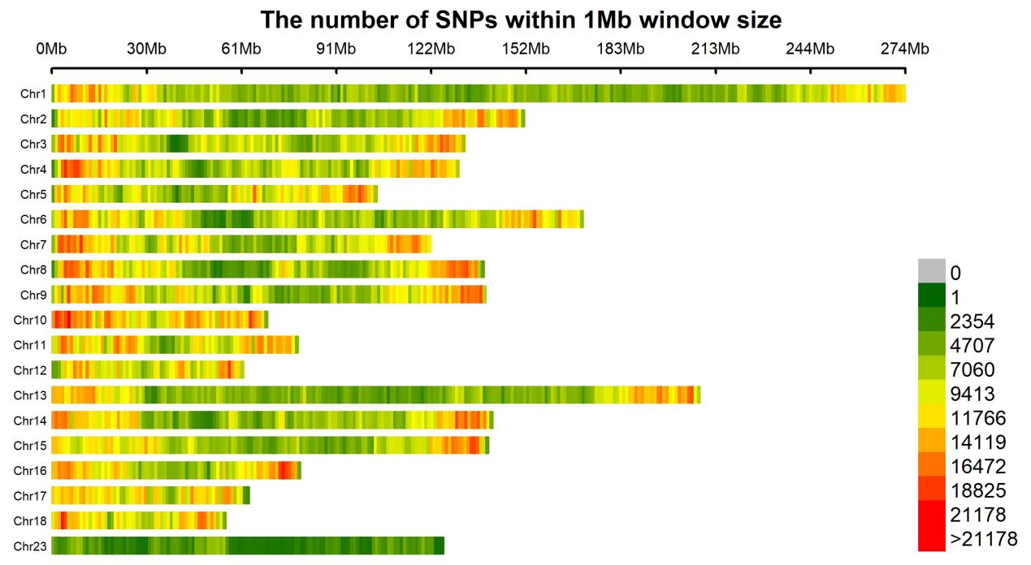

Figure.S2 ADMIXTURE analysis with presumed ancestral groups (K=2 to 5)

