Evaluation of a 3-month intervention with high protein, omega-3 LC-PUFA enriched oral nutritional supplement on body weight, inflammation, muscle strength and patient reported outcomes in patients with cancer
Supportive Care in Cancer
P. B. Holečková ¹, V. Rosenberg², V. Lanska³, M. Tomecka⁴, J. Smitka⁴
1 Bulovka University Hospital and 1st Faculty of Medicine Charles University Prague, Czech Republic
2 Department of Radiation Oncology, Faculty hospital J.A. Reiman, Prešov, Slovakia
3 Medical statistics, Institute for Clinical and Experimental Medicine, Prague, Czech Republic
4 Danone Nutricia, Prague, Czech Republic
*Correspondence: petra.holeckova@bulovka.cz

Methods
Instructions for 30-second chair stand test
The 30-second chair stand test (CST) was used to assess the number of times the patient was able to stand up from a chair in 30 seconds and was conducted according to the following instructions (in local language) for patients supplied to clinics ‘Alternate standing up from a chair and sitting down with your arms crossed on your chest (palms resting in your collarbones) for 30 seconds. The test begins with the patient sitting upright in the centre of the chair, feet on the floor approximately shoulder-width apart, with one foot slightly in front of the other for balance.
Patient reported measures
Questions asked by the healthcare professional about patient’s taste and smell changes:
Has your perception of taste and smell changed during oncological treatment (question completed after 3rd month)?
Yes/No
If yes, how has your sense of smell changed compared to before beginning your anti-cancer treatment, even if just a little? Please select all that apply
☐ I do not smell anything at all
☐ I smell less (experiencing a difference in the intensity of odours in general)
☐ I am more sensitive to certain odours
☐ I detect new unpleasant smells
☐ I don’t perceive food smells in the same way I did before
☐ I do not perceive any change in my smell perception.

If yes, how has your sense of taste changed compared to before beginning your anti-cancer treatment, even if just a little? Please select all that apply.
☐ I do not taste anything at all
☐ I taste less (experiencing a difference in the intensity of flavours in general)
☐ I am more sensitive to certain taste
☐ I experience new unpleasant tastes in my mouth
☐ I don’t perceive food tastes the way I did before
☐ I do not perceive any change in my taste perception.

Questions asked by the healthcare professional about how patients felt (at 3 months).
Mark the boxes that best describe your feelings.
☐ I feel I have more energy
☐ I feel I have more strength
☐ I feel better in general
☐ I can handle more movement
☐ I am able to do my activities better
☐ I was told that I look better
☐ I am able to maintain a healthy weight

Questions asked by the healthcare professional about patient’s perceived benefit of the study oral nutritional supplement (ONS)
What is the specific benefit of FortiCare Advanced which you felt?
 | 1st month | 3rd month
It supplemented my daily food intake | YES NO | YES NO
My physical condition has improved | YES NO | YES NO
I have gained weight | YES NO | YES NO
It Supports my treatment | YES NO | YES NO
It Gives me back my lost strength | YES NO | YES NO
I am more self-reliant | YES NO | YES NO
All of the above | YES NO | YES NO
Without benefit | YES NO | YES NO

Results
Recruitment and patient characteristics
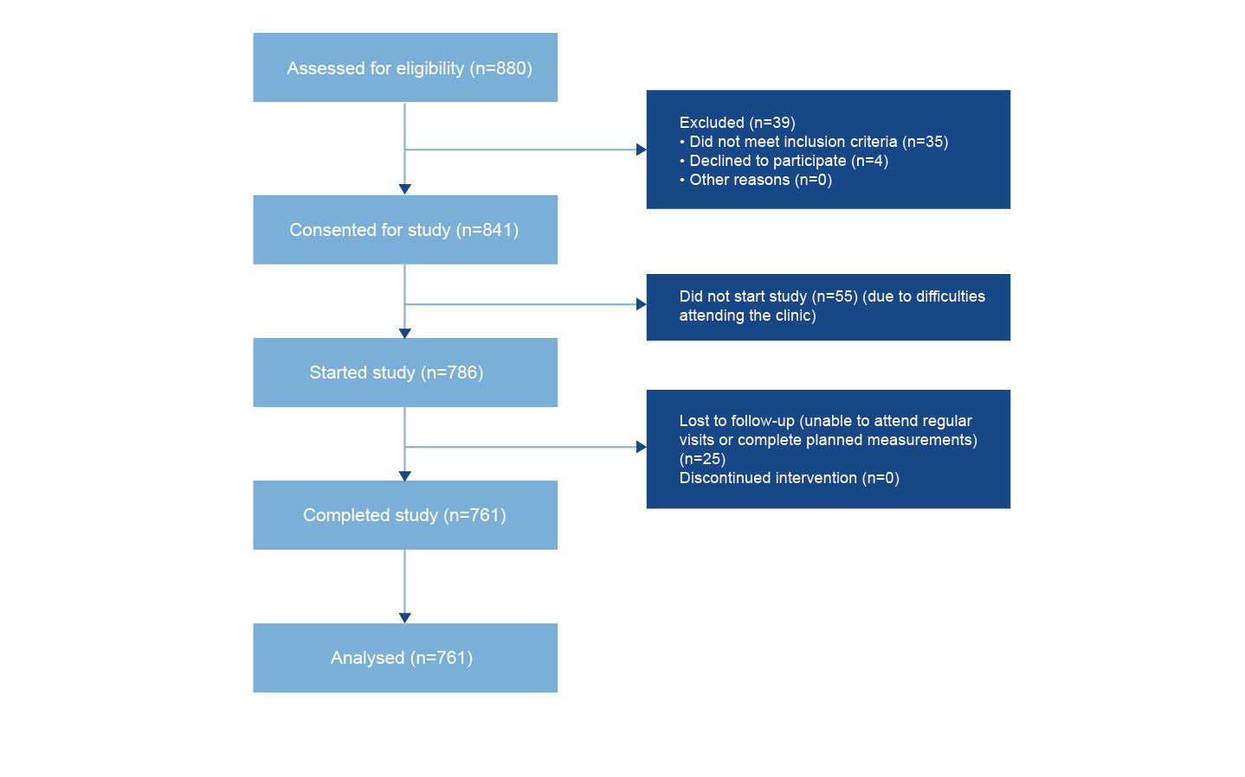
Figure S1. Flow diagram of patient recruitment and study participation.

Laboratory parameters
There was a statistically significant decrease in mean CRP of 7.5 mg/L from baseline to three months (p<0.001) and a statistically significant increase in mean albumin of 1.0 g/dL from baseline to three months (p<0.001) (Figure S1).
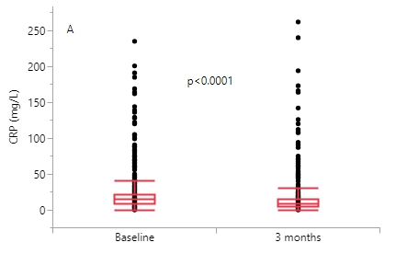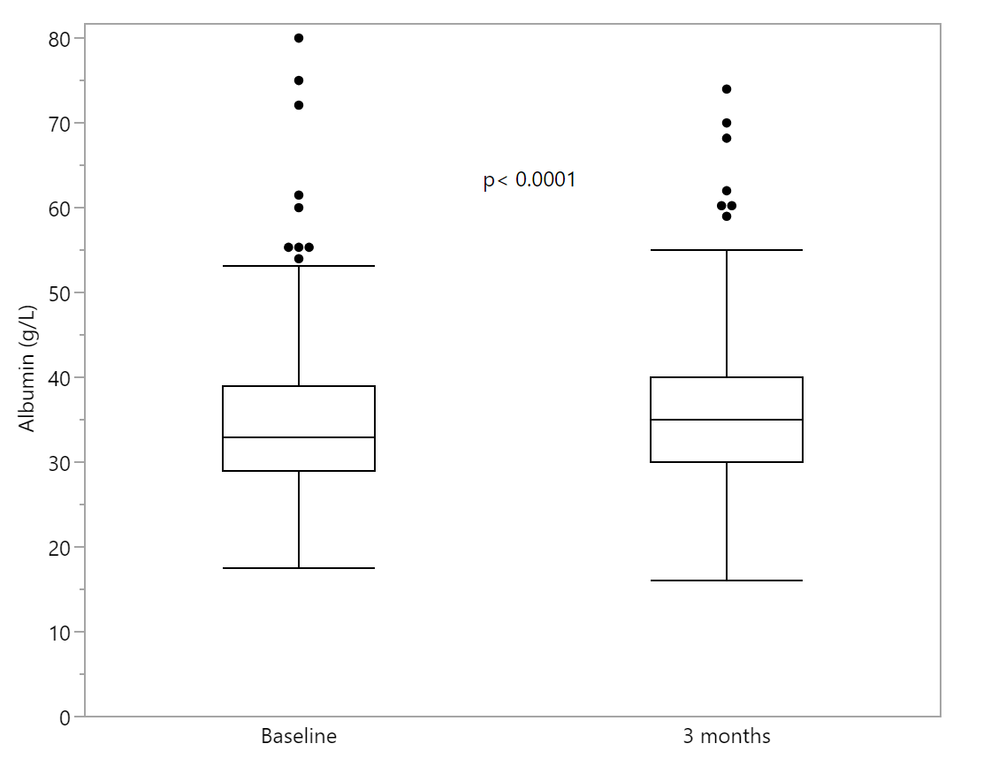
A
B
Figure S1. Laboratory parameters: (A) C-reactive protein and (B) Albumin. The box extends from the 25th percentile (1st quartile = Q1) to the 75th percentile (3rd quartile = Q3), its height is the interquartile range (IQR). The line inside the box represents the median. The whiskers extend down to Q1 - 1.5IQR or the minimum, and up to Q3 + 1.5IQR or the maximum.

Muscle strength
There was a statistically significant improvement in muscle strength from baseline to three months, mean hand-grip strength increased by 1.2 kg (p<0.0001) and the mean number of stand ups in the 30 second chair stand test increased by 1.4 (p<0.0001) (Figure S2).

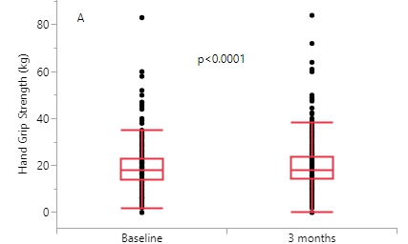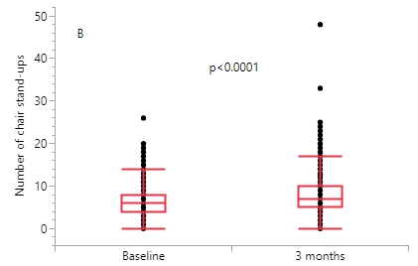
A
B
Figure S2. Muscle strength as assessed by (A) Hand Grip Strength and (B) Chair Stand Test. The box extends from the 25th percentile (1st quartile = Q1) to the 75th percentile (3rd quartile = Q3), its height is the interquartile range (IQR). The line inside the box represents the median. The whiskers extend down to Q1 - 1.5IQR or the minimum, and up to Q3 + 1.5IQR or the maximum.

Taste and smell changes
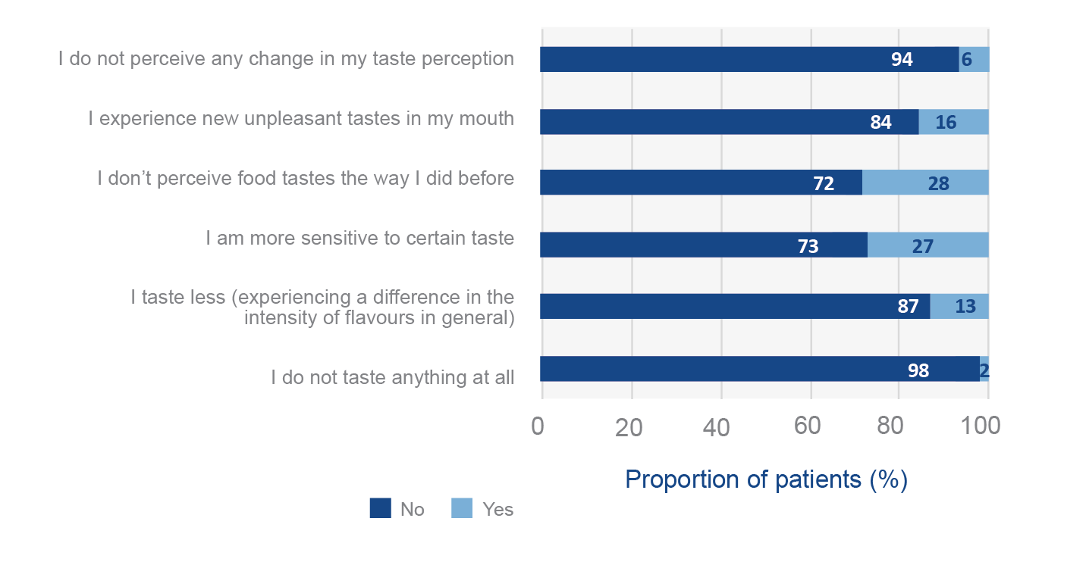
A

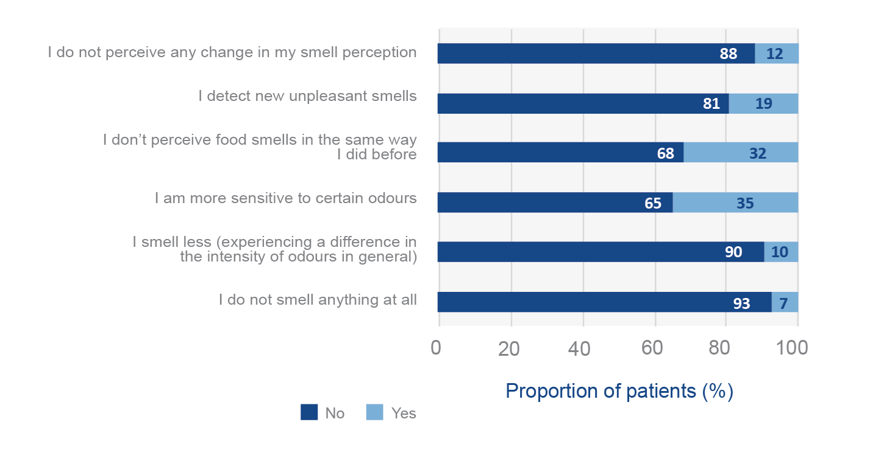
B
Figure 7. Changes in taste (A) and smell (B) perception from before the beginning of anti-cancer treatment reported by patients at 3 months (n=260).

