Journal of Gastrointestinal Cancer
Transabdominal ultrasonography for the preoperative diagnosis of advanced lymph node metastasis in patients with colon cancer: A retrospective cohort study

Running title: Transabdominal US for advanced LNM in colon cancer

Ken Imaizumi, MD, PhD¹, Shigenori Homma, MD, PhD¹, Mutsumi Nishida, PhD², Takeshi Soyama, MD, PhD³, Ryosuke Shimura, MD³, Yusuke Kudo, PhD², Satomi Omotehara², Isao Yokota, PhD⁴, Ryo Takagi, PhD⁴, Hiroki Matsui, MD¹, Yoichi Miyaoka, MD¹, Nobuki Ichikawa, MD, PhD¹, Tadashi Yoshida, MD, PhD¹, Norihiko Takahashi, MD, PhD¹, Akinobu Taketomi, MD, PhD¹

¹Department of Gastroenterological Surgery I, Graduate School of Medicine, Hokkaido University, Sapporo, Hokkaido, Japan
²Division of Laboratory and Transfusion Medicine, Diagnostic Center for Sonography, Hokkaido University Hospital, Sapporo, Hokkaido, Japan
³Department of Diagnostic and Interventional Radiology, Hokkaido University Hospital, Sapporo, Hokkaido, Japan
⁴Department of Biostatistics, Graduate School of Medicine, Hokkaido University, Sapporo, Hokkaido, Japan

Corresponding author: Shigenori Homma, MD, PhD
E-mail: homma.s@nifty.com

Online Resource 1. Diagnostic capabilities for lymph node features by ultrasonography
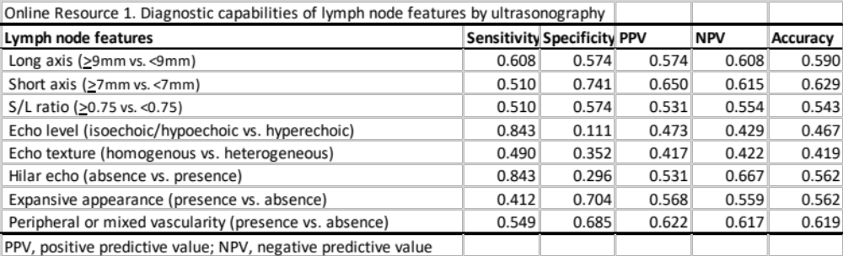

Online Resource 2. Sensitivity and specificity of computed tomography and ultrasonography for detecting the clinicopathological features
