Supplementary Material

1. Decision Variables in the Replenishment Policy
We parameterize the replenishment policy using the following decision variables:
$t_{0}$ : initial time of replenishment.
$Q_{0}$ : quantity ordered in the initial replenishment
$s$ : reorder threshold at which additional replenishment is triggered
$Q$ : quantity ordered in subsequent replenishments
$t_{end}$ ​: termination point for the policy's applicability
In this formulation, the review frequency ($R$) is treated as a fixed parameter configured externally rather than as a decision variable, allowing for more adaptable policy designs. The only two decision variables that are actually shown to the user are the next replenishment variables ${(t}_{0},Q_{0})$. Figure 1 summarises the replenishment policy as parametrized in the ZEOS Inventory Optimization Tool.
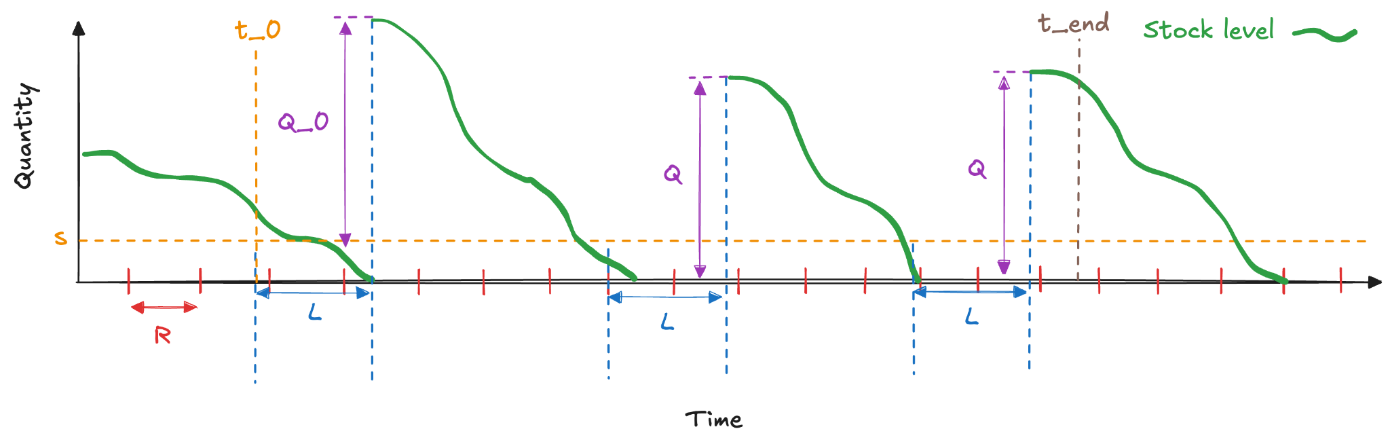
Figure 1. Illustration of a replenishment policy as parameterized in the ZEOS Replenishment Engine. $R$ is the review frequency, L is the replenishment lead time, $Q_{0}$ is the initial replenishment quantity while $Q$ are subsequent replenishment quantities.

2. Demand Forecast Model
- Sale extrapolation
We define demand as in-stock sales. Accordingly, observed sales are classified into in-stock and stock-out sales. Both sales and demand are considered at the configuration SKU (cSKU, color) level, where "in-stock" refers to all individual SKUs (sSKU, size) of a given color being available. The sale extrapolation process is a preprocessing step that converts sales data into demand data, facilitating direct demand modeling and leveraging a larger pool of sales data.
To extrapolate cSKU sales, we employ sales and stock availability data at the size level. For each cSKU, in-stock sales at the size level (represented in purple in the middle plot) serve as anchor points. Using the demand distribution at the size level (depicted in the left plot), the demand for missing sizes is calculated (shown in the right plot).
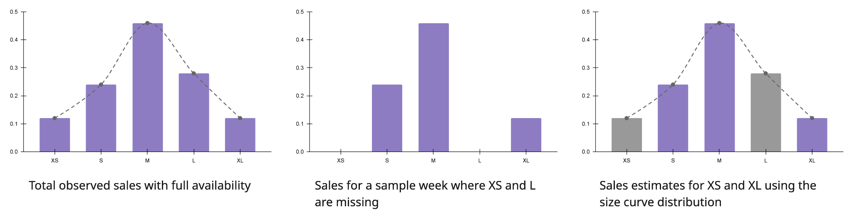
Fig. 2 Illustration of sale extrapolation with size distribution
The current sales extrapolation methodology is evaluated by substituting the in-stock size with a stock-out size and comparing the resulting extrapolated demand against the actual demand. The method yields a Weighted Average Percentage Error (WAPE) of 6%, though it is important to note that sample selection bias may also contribute to this result.
Some key challenges for the current sales extrapolation method are below:
- Ineffectiveness for Single-Size SKUs: The method proves ineffective for SKUs that consist of a single size, as it does not account for variations in size distribution.
- Limitations During Full Stock-Outs: The methodology fails when all sizes of a SKU are out of stock, as it lacks a reliable anchor point for extrapolation.
- Assumption of Static Demand Size Distribution: The model assumes that the demand size distribution is static, which can lead to inaccuracies, particularly for SKUs with limited historical data.
- Lack of Generalization Across SKUs: The method does not generalize well across different SKUs, limiting its applicability to a wider range of products.
- Exclusion of Cannibalization Effects: The methodology does not consider cannibalization, potentially resulting in overestimations of aggregate demand. This limitation can lead to inaccuracies when forecasting total demand at the SKU level.

- Demand Forecasting
The demand is extrapolated from sale by available articles. So the demand is assumed accurate and used as labels for demand modeling, framed as a time series regression problem. The dataset is organized into time series, each representing one SKU over time, with each data point as a vector of features for a specific week (e.g.,sales, availability, price, time, article static information; see Feature Engineering). Demand forecasting is conducted at the SKU and weekly level.
To improve the quality of the dataset and avoid bias introduced by sparse time series, a dense representation of the data is used. Missing data points, including stock-out weeks, are filled using appropriate imputation methods, ensuring that the time series remains continuous. This approach allows the model to better capture temporal patterns without being influenced by gaps in the data. By representing the time series in a dense format, we ensure that the training data contains all necessary anchor points, improving the quality and robustness of the demand forecasts.
The demand forecasting is applied to replenishment recommendations, with results formatted for compatibility with the recommendation engine’s sampling and stock simulation. The result schema includes indexes such as config_sku, merchant_id, time index, and quantiles (q1, q5, q10, ..., q95, q99). These quantiles are derived from confidence intervals generated using conformal prediction (citation), providing a probabilistic representation of demand distributions for downstream simulations.
The forecasting model operates at the configuration SKU and week level, with a 12-week horizon. The inference scope is restricted to "active" SKUs—defined as those with positive stock or sales in the past 18 weeks, capturing approximately 90% of data gaps. This scope includes 2 million simple SKUs and about 70,000 configuration SKUs (depending on execution dates).
Feature engineering is performed before training, linking various feature types (e.g., article info, time, holidays, stock, prices, sales) to generate the training dataset.
3. Model Details & Engineering:
The LightGBM model provided by MLForecast from Nixtla was selected for time series forecasting. MLForecast is a high-performance Python library designed for time series forecasting using gradient-boosted decision trees like LightGBM. It simplifies the process of training, evaluating, and deploying forecasting models by integrating efficient handling of time series features, enabling scalability to large datasets. LightGBM is particularly well-suited for structured data forecasting tasks due to its ability to handle large-scale datasets and capture complex interactions between features with high computational efficiency.
In this project, MLForecast with LightGBM was leveraged to train a regression-based model for demand forecasting. The model was designed to predict demand at the configuration SKU level over a 12-week horizon. Instead of directly optimizing quantiles through a quantile loss function, Conformal Prediction was used to compute confidence intervals, which were then transformed into quantiles (q2.5, q5, q10, ..., q95, q97.5). This approach ensures that the derived quantiles are probabilistically valid and reflect the uncertainty of the forecasts accurately.
Conformal Prediction is a statistical framework that provides prediction intervals with a predefined confidence level, offering robust uncertainty quantification. This method ensures that the prediction intervals are consistent with the desired coverage, regardless of data distribution or noise. By transforming these intervals into quantiles, we can capture demand distributions while retaining the rigor and reliability of Conformal Prediction.
The MLForecast library provides tools for automatically generating lag-based features, rolling windows, and other time-based transformations to enhance model performance. This allowed us to capture temporal patterns and trends in the time series data effectively.
A post-processing step is implemented to incorporate business insights and decompose demand forecasts from the configuration SKU level to the simple SKU level. This decomposition is based on the size distribution, ensuring that the forecasts reflect the specific demand patterns at the individual SKU level.
The evaluation process serves two primary purposes:
- Evaluation of the Machine Learning Method: This involves comparing the performance of the machine learning model with a naive method, which mimics human prediction performance.
- Evaluation of the Trained Model: This focuses on assessing the accuracy and robustness of the trained model's predictions.
Return Lead Time Model
The returns model is an integral component of the broader inventory optimization framework, addressing the uncertainty and temporal dynamics of customer returns. By accurately forecasting return flows, the model informs inventory management decisions, ensuring alignment between stock availability and demand. It operates as a probabilistic forecasting mechanism, embedded within the inventory optimization tool to provide insights into the timing and magnitude of returns. Its core formulation is as follows:
${Returns}_{t}=α_{t-1}{Outbound}_{t-1}+α_{t-2}{Outbound}_{t-2}+...+α_{t-T}{Outbound}_{t-T}$
Here, $α_{t}$ denotes the probability of a return from outbound transactions at time $t$. The weighted contributions of lagged outbound data account for return delays, varying customer behaviour, and logistical factors. The model is implemented at multiple levels of granularity, such as overall returns, commodity-specific returns, and configuration-level returns. The configuration-level implementation significantly outperforms broader aggregates, reducing Weighted Absolute Percentage Error (WAPE) and bias by approximately 10 percentage points compared to baseline models. This precise modeling of returns enhances the inventory optimization tool’s capability to handle complex, dynamic systems, contributing to improved operational efficiency and profitability.
The returns sub-model contributes to the inventory optimization tool in the following ways:
- Demand Adjustments: By forecasting returns, the tool can dynamically adjust net demand, reducing the risk of overstocking or understocking.
- Lead-Time Variability: Incorporating return lead-time distributions allows the model to anticipate delayed inventory inflows, ensuring more accurate inventory allocation.
- Cost Optimization: By aligning return forecasts with outbound stock management, the tool minimizes costs associated with surplus inventory and reprocessing returned items.
Replenishment Lead Time Model
To model the variability in lead times announced by merchants, we implemented a sampling method based on a gamma distribution. This approach accounts for the inherent uncertainty and variability in lead times while ensuring that the sampled values remain within reasonable bounds. The process is outlined as follows:
The expected lead time, denoted as EEE, is provided by the merchant. This value represents the merchant's forecast for the lead time required to fulfill an order, typically based on historical data and operational constraints.
To capture the variability in lead time, we utilize a gamma distribution with the following parameters:
- Shape Parameter ($k$): The shape parameter is set to $2E$. This choice ensures that the distribution is centered around the expected lead time while allowing for variability. The factor of 2 allows the distribution to be more spread out, reflecting the natural uncertainty in lead time predictions.
- Scale Parameter ($θ$): The scale parameter is fixed at 0.4. This value controls the spread of the distribution and is chosen based on empirical data, balancing the range of possible lead times with the expected lead time.
A sample lead time $L$ is drawn from the gamma distribution with the specified shape parameter $k$ and scale parameter $θ$. The sampling process can be mathematically expressed as follows:
$L_{sample}\sim Gamma(k=2E, θ=0.4)$
After the sample is drawn, the value of $L_{sample}$​ is rounded to the nearest integer to represent whole days, ensuring that the lead time is expressed in discrete units of time.
To ensure that the sampled lead time remains within realistic and operationally feasible limits, two clamping operations are applied:
- Minimum Clamp: The sampled lead time is clamped to a minimum value of 1 day. This prevents the lead time from being negative or zero, which would be unrealistic in the context of order fulfillment.
- Maximum Clamp: The sampled lead time is also clamped to a maximum value of $2E$, ensuring that the lead time does not exceed twice the expected value. This upper bound prevents the model from generating excessively large lead times that are outside the typical range of merchant operations.
Finally, the clamped and rounded sampled lead time is converted to an integer type for consistency and to ensure compatibility with other components of the forecasting system.
This methodology provides a robust way to simulate lead time variability, taking into account both the expected lead time and inherent uncertainty. By using a gamma distribution with appropriate parameters, we are able to model a realistic range of lead times that reflect the variability observed in historical data.

