Supplementary material for: Weight loss leads to notable effects on OA pain and function but induces bone resorption

Table S1. Overview of the full studies regarding pain and KL scores.
 |  | SMC0212301 (N=1176) | SMC0212302 (N=1030)
Treatment | Pla | 588 (50.0%) | 509 (49.4%)
 | sCT | 588 (50.0%) | 521 (50.6%)
BMI | Median (Q1, Q3) | 28.4 (25.7, 31.6) | 28.3 (25.5, 31.9)
Kellgren-Lawrence grade, target knee | 2 | 1032 (87.8%) | 809 (78.5%)
 | 3 | 144 (12.2%) | 221 (21.5%)
Kellgren-Lawrence grade, non-target knee | Missing | 12 | 10
 | 0 | 36 (3.1%) | 56 (5.5%)
 | 1 | 230 (19.8%) | 186 (18.2%)
 | 2 | 644 (55.3%) | 458 (44.9%)
 | 3 | 222 (19.1%) | 293 (28.7%)
 | 4 | 32 (2.7%) | 27 (2.6%)
Womac pain score, 0-500 points, target | Median (Q1, Q3) | 229 (179, 286) | 235 (190, 290)
 | Missing | 0 | 1
Womac pain score, 0-500 points, non-target | Median (Q1, Q3) | 173 (90, 253) | 183 (90, 267)
 | Missing | 19 | 76

Description S2. Setting the persistent pain group threshold.
We estimated the within-patient variation from screening to month 01 (M01). We found following variations (SD):
SMC0212301, target knee: 61 WOMAC pain points
SMC0212301, non-target knee: 55 WOMAC pain points
SMC0212302, target knee: 57 WOMAC pain points
Based on these SDs we set a lower threshold for minimal pain allowed at M01 at 140 points. The figure below provides an overview of the distribution of patients with persistent pain or lack of persistent pain in the target knee.
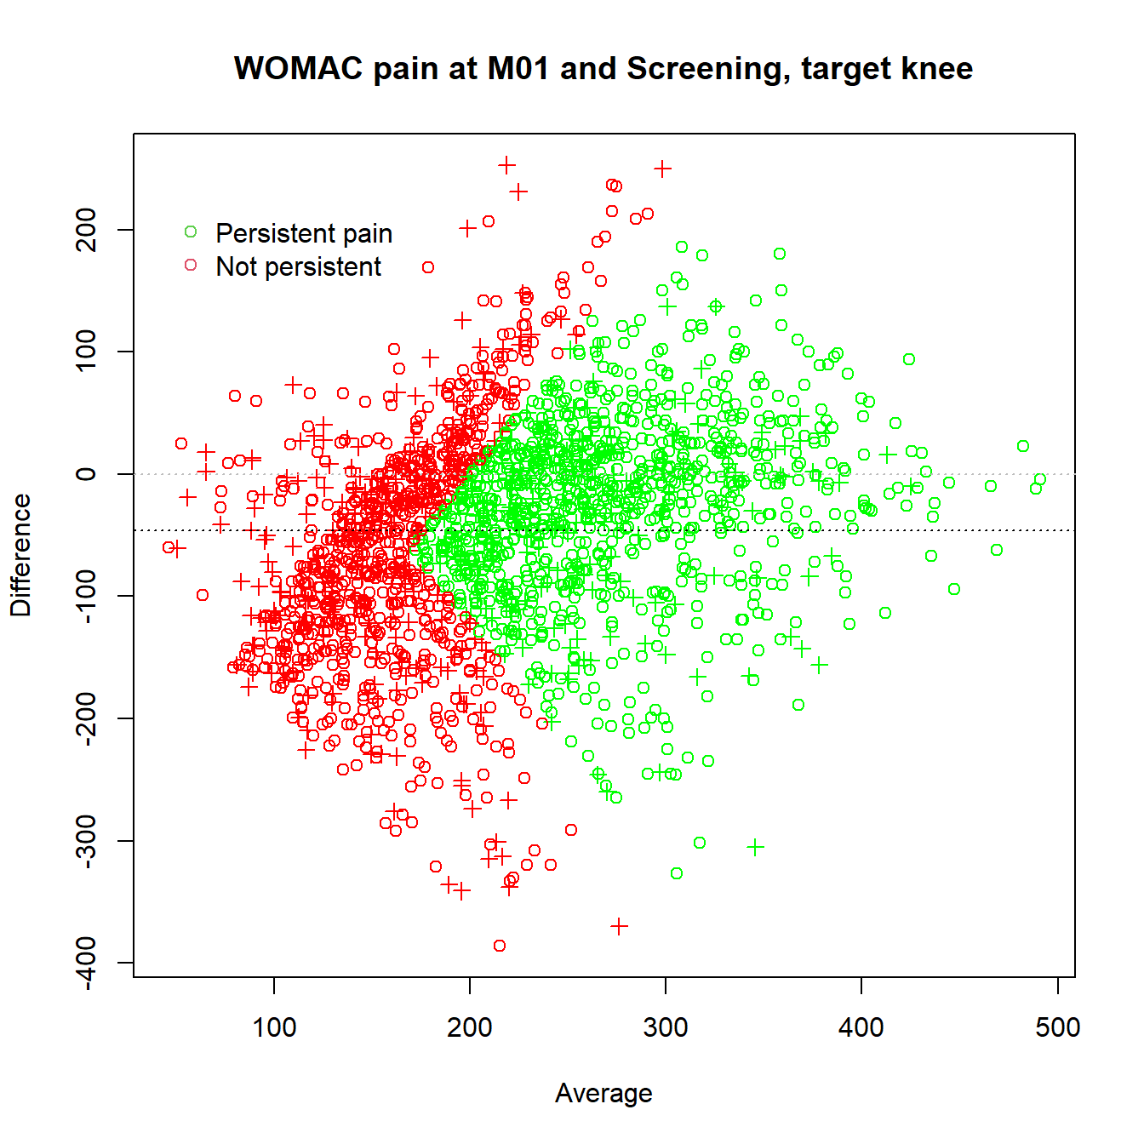
Figure S1. Bland-Altman plot. Distribution of patients with persistent pain in target knee: WOMAC pain >=200 pt at screening and >=140 at month. Crosses marks patients where non-target knee was included.

Table S3. Association between WOMAC scores and overweight at the baseline
There was a statistically significant difference in the WOMAC scores between the weight groups at baseline. On average, obese patients had higher scores, except for pain, than lean and overweight patients (Table S3).
  - Table 2. Difference between weight groups at baseline in patients with persistent painful and radiographic knee OA. Data are shown as differences in means with 95% confidence intervals adjusted for sex, age, and race. The p-values are corrected for multiple comparisons by Bonferroni’s method.
 | Obese vs. Lean | Obese vs. Overweight | Overweight vs. Lean
WOMAC total | 156 (231, 81)  <0.001 | 86 (144, 29)  0.010 | 70 (142, -3)  0.18
WOMAC function | 126 (187, 68)  <0.001 | 71 (115, 27)  0.005 | 55 (111, 0)  0.15
WOMAC stiffness | 16 (24, 8)  <0.001 | 7 (13, 0)  0.10 | 9 (17, 1)  0.068
WOMAC pain | 14 (29, -1)  0.18 | 9 (20, -2)  0.36 | 5 (20, -9)  1.0

TABLE S3. BASELINE CHARACTERISTICS OF patients witH WEIGHT MEASUREMENT at 24M versus PATIENT WITHOUT WEIGHT AT 24M

 | Weight measured at M24 (N=1485) | Weight not measured at M24 (N=721)
STUDY_CODE
SMC0212301 | 848 (57.1%) | 328 (45.5%)
SMC0212302 | 637 (42.9%) | 393 (54.5%)
Treatment
Pla | 791 (53.3%) | 306 (42.4%)
sCT | 694 (46.7%) | 415 (57.6%)
BMI
Median (Q1, Q3) | 28.2 (25.4, 31.6) | 28.5 (25.9, 31.9)
Kellgren-Lawrence grade, target
2 | 1238 (83.4%) | 603 (83.6%)
3 | 247 (16.6%) | 118 (16.4%)
Kellgren-Lawrence grade, non-target
N-Miss | 12 | 10
0 | 60 (4.1%) | 32 (4.5%)
1 | 271 (18.4%) | 145 (20.4%)
2 | 756 (51.3%) | 346 (48.7%)
3 | 344 (23.4%) | 171 (24.1%)
4 | 42 (2.9%) | 17 (2.4%)
Womac pain score, 0-500 points, target
Median (Q1, Q3) | 232 (186, 288) | 232 (182, 290)
Missing | 0 | 1
Womac pain score, 0-500 points, non-target
Median (Q1, Q3) | 175 (89, 258) | 183 (92, 262)
Missing | 49 | 46
Persistent pain at M1
Missing | 107 | 152
No | 533 (38.7%) | 225 (39.5%)
Yes | 845 (61.3%) | 344 (60.5%)

Table S4. summary stats for the biomarkers
 | >5% weight loss (N=98) | Stable (N=638) | >5% weight gain (N=70) | Total (N=806)
BMI
Lean/Overweight | 52 (53.1%) | 407 (63.8%) | 40 (57.1%) | 499 (61.9%)
Obese | 46 (46.9%) | 231 (36.2%) | 30 (42.9%) | 307 (38.1%)
C2M (baseline)
N | 44 | 351 | 41 | 436
Median (Q1, Q3) | 0.21 (0.15, 0.25) | 0.23 (0.18, 0.32) | 0.22 (0.17, 0.30) | 0.23 (0.17, 0.31)
C2M (year 2)
N | 43 | 350 | 42 | 435
Median (Q1, Q3) | 0.21 (0.16, 0.29) | 0.23 (0.18, 0.32) | 0.20 (0.16, 0.30) | 0.23 (0.17, 0.31)
C3M (baseline)
N | 44 | 351 | 41 | 436
Median (Q1, Q3) | 5.41 (5.12, 6.87) | 6.10 (5.08, 7.28) | 5.89 (5.10, 7.06) | 6.06 (5.09, 7.24)
C3M (year 2)
N | 43 | 350 | 42 | 435
Median (Q1, Q3) | 5.62 (5.08, 7.74) | 6.52 (5.41, 7.80) | 6.45 (5.37, 7.84) | 6.45 (5.34, 7.83)
NMID (baseline)
N | 62 | 417 | 43 | 522
Median (Q1, Q3) | 22.21 (18.07, 27.54) | 21.93 (18.25, 27.52) | 21.22 (17.33, 29.53) | 21.91 (18.16, 27.61)
NMID (year 2)
N | 62 | 419 | 45 | 526
Median (Q1, Q3) | 21.52 (18.09, 28.50) | 21.42 (17.06, 26.02) | 19.44 (16.00, 24.54) | 21.16 (17.06, 26.09)
sCTX (baseline)
N | 62 | 417 | 43 | 522
Median (Q1, Q3) | 0.24 (0.18, 0.29) | 0.24 (0.17, 0.32) | 0.24 (0.17, 0.29) | 0.24 (0.17, 0.32)
sCTX (year 2)
N | 62 | 419 | 45 | 526
Median (Q1, Q3) | 0.40 (0.28, 0.49) | 0.34 (0.23, 0.44) | 0.29 (0.18, 0.38) | 0.34 (0.23, 0.44)
uCTX-I (baseline)
N | 60 | 398 | 43 | 501
Median (Q1, Q3) | 1.70 (1.10, 2.29) | 1.68 (1.13, 2.27) | 1.60 (1.05, 2.44) | 1.68 (1.12, 2.28)
uCTX-I (year 2)
N | 61 | 410 | 41 | 512
Median (Q1, Q3) | 1.84 (1.12, 2.66) | 1.42 (0.95, 2.08) | 1.07 (0.82, 1.60) | 1.43 (0.95, 2.12)
uCTX-II (baseline)
N | 60 | 398 | 43 | 501
Median (Q1, Q3) | 260.00 (168.75, 395.00) | 253.50 (164.50, 373.75) | 260.00 (150.50, 401.00) | 255.00 (162.00, 379.00)
uCTX-II (year 2)
N | 61 | 410 | 41 | 512
Median (Q1, Q3) | 274.00 (160.00, 460.00) | 242.50 (159.25, 353.50) | 232.00 (163.00, 369.00) | 243.00 (160.00, 364.25)

