Supplementary Figure 1: Overall cumulative incidence curve for long-term stroke recurrence
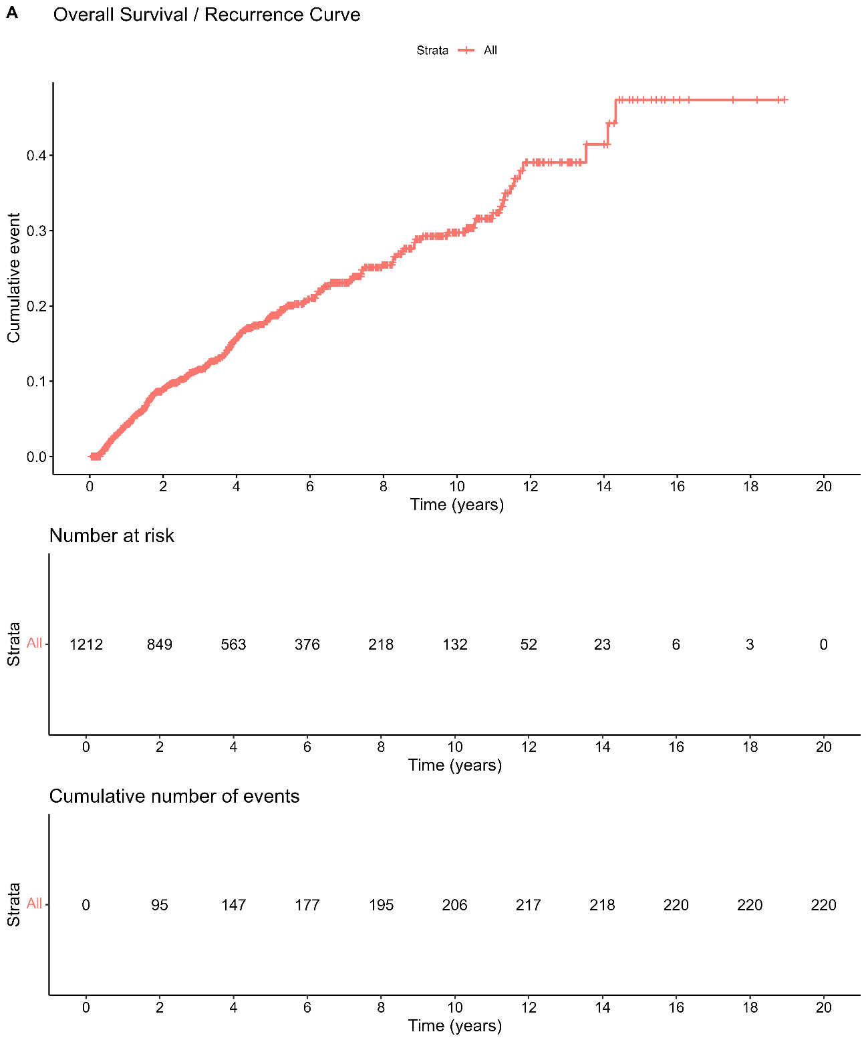
Legend: Overall cumulative incidence curve for long-term stroke recurrence in the study cohort. The plot shows the cumulative incidence of recurrent cerebrovascular events (ischaemic stroke, haemorrhagic stroke, or TIA) over the entire follow-up period. The number at risk and cumulative number of events at each time point are displayed below the main curve. Time is shown in years from index stroke to event, censoring, or end of study.
Supplementary Table S1. Multivariable Fine–Gray model for ischaemic long-term stroke recurrence
Variable | sHR (95% CI) | P-value
Initial Severity | 0.965 (0.941–0.99) | 0,007
CHA2DS2 VASc | 1.024 (0.925–1.135) | 0,644
AF Status: At Stroke Onset | 0.681 (0.434–1.07) | 0,096
AF Status: AFDAS | 0.465 (0.28–0.772) | 0,003
Small Vessel Disease | 1.449 (0.978–2.146) | 0,064
Large Artery Atherosclerosis | 1.976 (1.302–2.999) | 0,001
Anticoagulants Type: VKA | 0.673 (0.463–0.978) | 0,038
Anticoagulants Type: DOAC | 0.538 (0.367–0.789) | 0,002
Legend: All variables included in the final model are shown. sHR, subdistribution hazard ratio; CI, confidence interval.

Supplementary Table S2. Multivariable Fine–Gray model for haemorrhagic long-term stroke recurrence
Variable | sHR (95% CI) | P-value
Initial Severity | 0.946 (0.865–1.034) | 0,221
CHA2DS2 VASc | 1.096 (0.813–1.476) | 0,548
AF Status: At Stroke Onset | 0.959 (0.19–4.85) | 0,96
AF Status: AFDAS | 1.506 (0.395–5.747) | 0,549
Small Vessel Disease | 3.236 (1.053–9.944) | 0,04
Large Artery Atherosclerosis | 1.598 (0.366–6.971) | 0,533
Anticoagulants Type: VKA | 1.032 (0.334–3.192) | 0,956
Anticoagulants Type: DOAC | 0.12 (0.014–1.007) | 0,051
Legend: All variables included in the final model are shown. sHR, subdistribution hazard ratio; CI, confidence interval.

