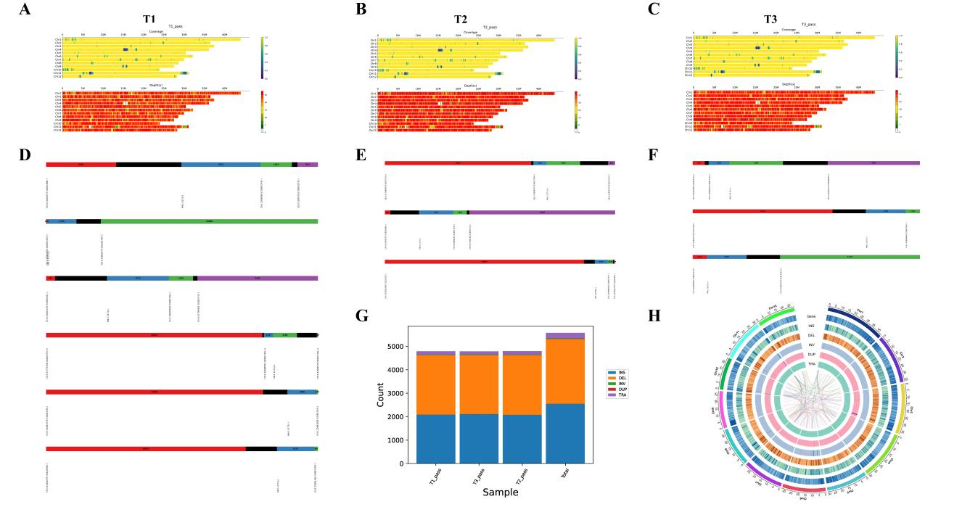Fig.1. Analysis of shoot leaf insertion sites in rice seedlings of T1, T2 and T3 generations. Figures (A), (B) and (C) Average sequencing depth as well as coverage of each window within the genome corresponding to the T1, T2 and T3 generation. Figure (D) Comparison plot of reads supporting exogenous sequence insertion of T1. Figure(E) Comparison plot of reads supporting exogenous sequence insertion of T2. Figure(F) Comparison plot of reads supporting exogenous sequence insertion of T3. Figure (G) Frequency distribution of structural variants across samples.
Note: INS: insertion, DEL: deletion, INV: inversion, DUP: duplication, TRA: interchromosomal translocation. Figure (H) Distribution of each type of structural variation across the genome.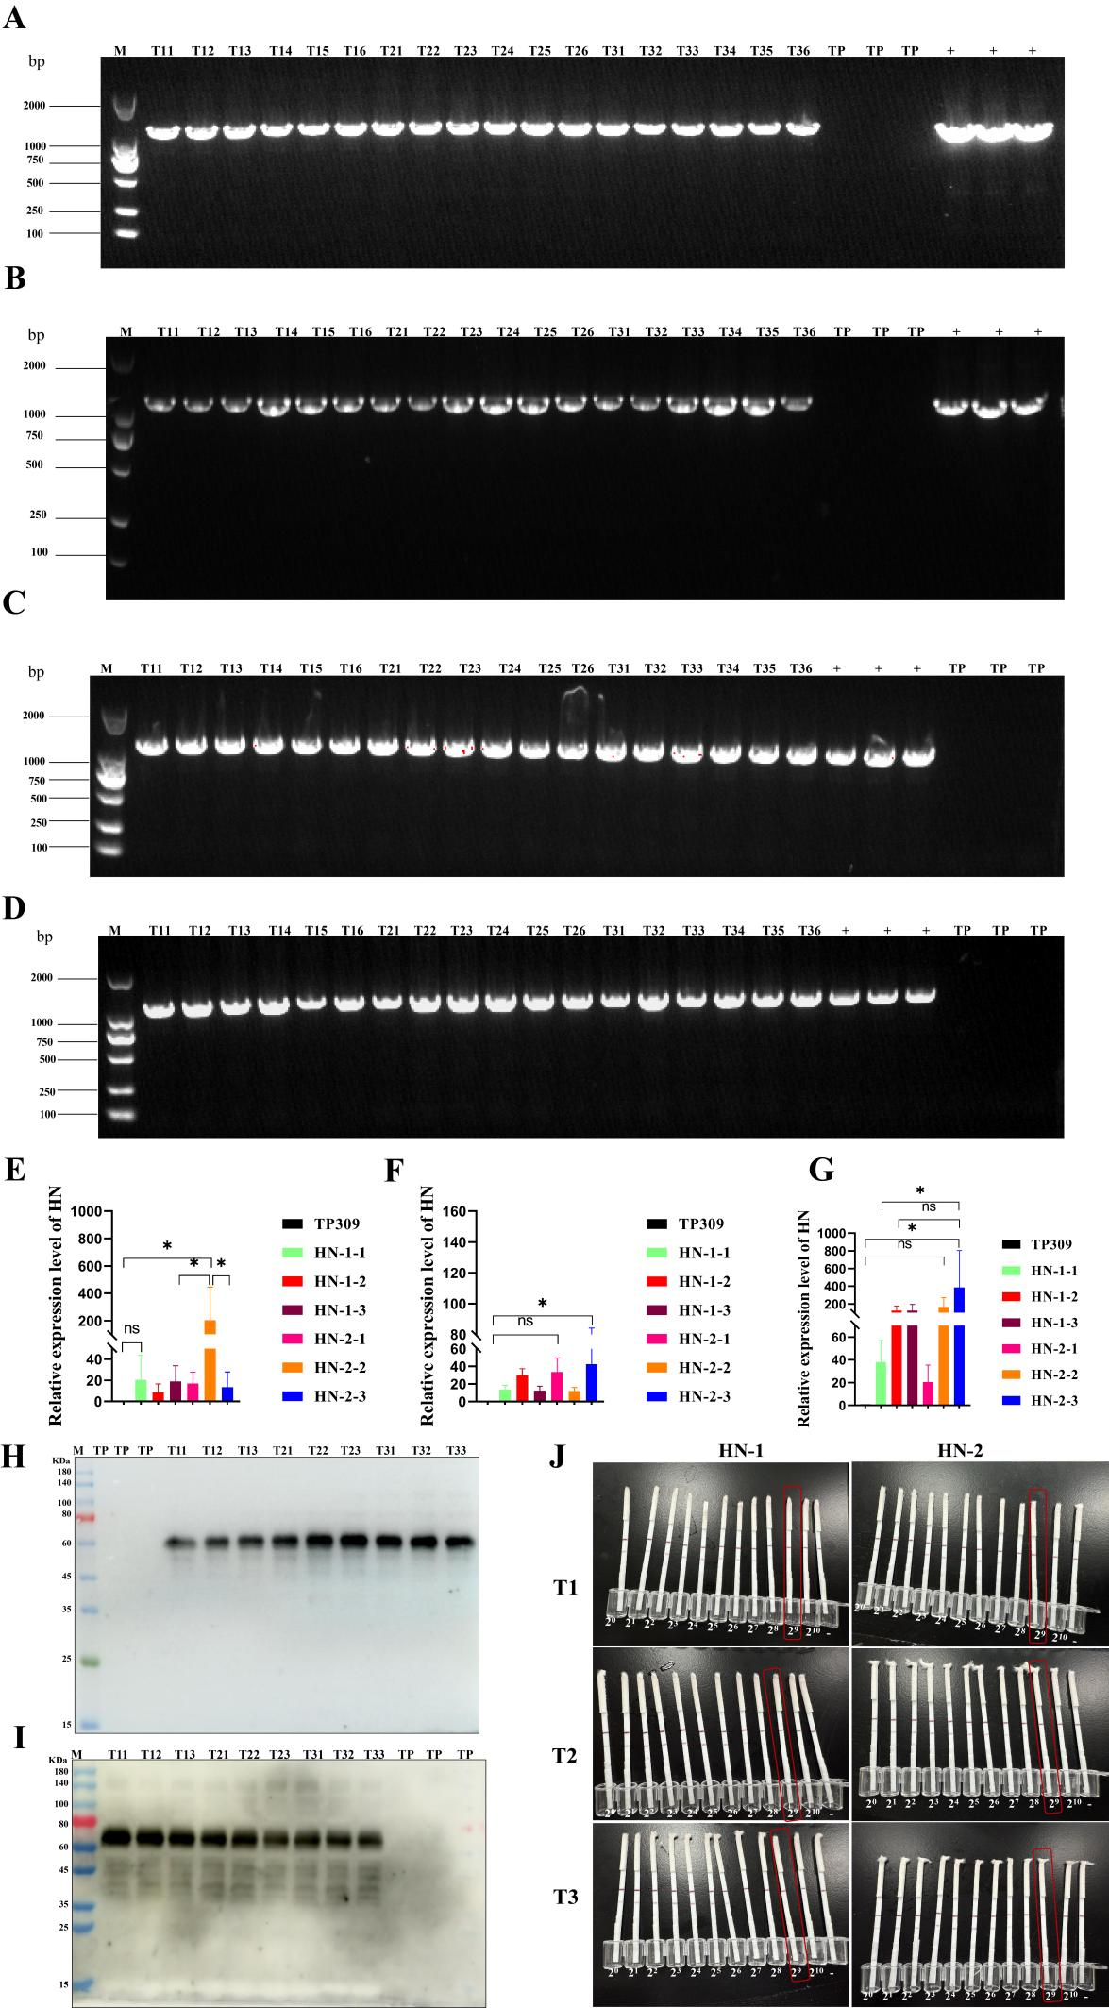.
Fig.2. Stable expression of HN antigen in different generations of rice. (A) and (C) PCR (amplicon size: 1138 bp) was used to detect HN genes in rice leaves at the flowering stage and in rice spikes in different generations from HN-1; (B) and (D) PCR (amplicon size: 1138 bp) was used to detect HN genes in rice leaves at the flowering stage and in rice spikes in different generations from HN-2; T11-T16: The T1 generation of the transgenic strain was randomly selected from six, T21-26: The T2 generation of the transgenic strain was randomly selected from six, T31-T36: The T3 generation of the transgenic strain was randomly selected from six, TP indicates TP309, + indicates positive plasmid (The labelling in the figures is based on this method); (E), (F) and (G) show the mRNA levels of the HN gene (amplicon size: 264 bp) detected in leaves of rice plants at the flowering stage for generations T1-T3, respectively.; HN-1-1 to HN-1-3 shown in the figure represent three randomly taken HN-1 plants; HN-2-1 to HN-2-3 represent three randomly taken HN-2 plants; (H) and (I) Western blot detection of HN gene expression in rice seeds of different generations from HN-1 and HN-2; In the figure, T11-T13 represent randomly selected plants of three T1 generations; T21-T23 represent randomly selected plants of three T2 generations; T31-T33 represent randomly selected plants of three T3 generations. (J) Test strips were used to detect the titre of HN antigen in rice seeds of different generations (mass: volume = 1:5).
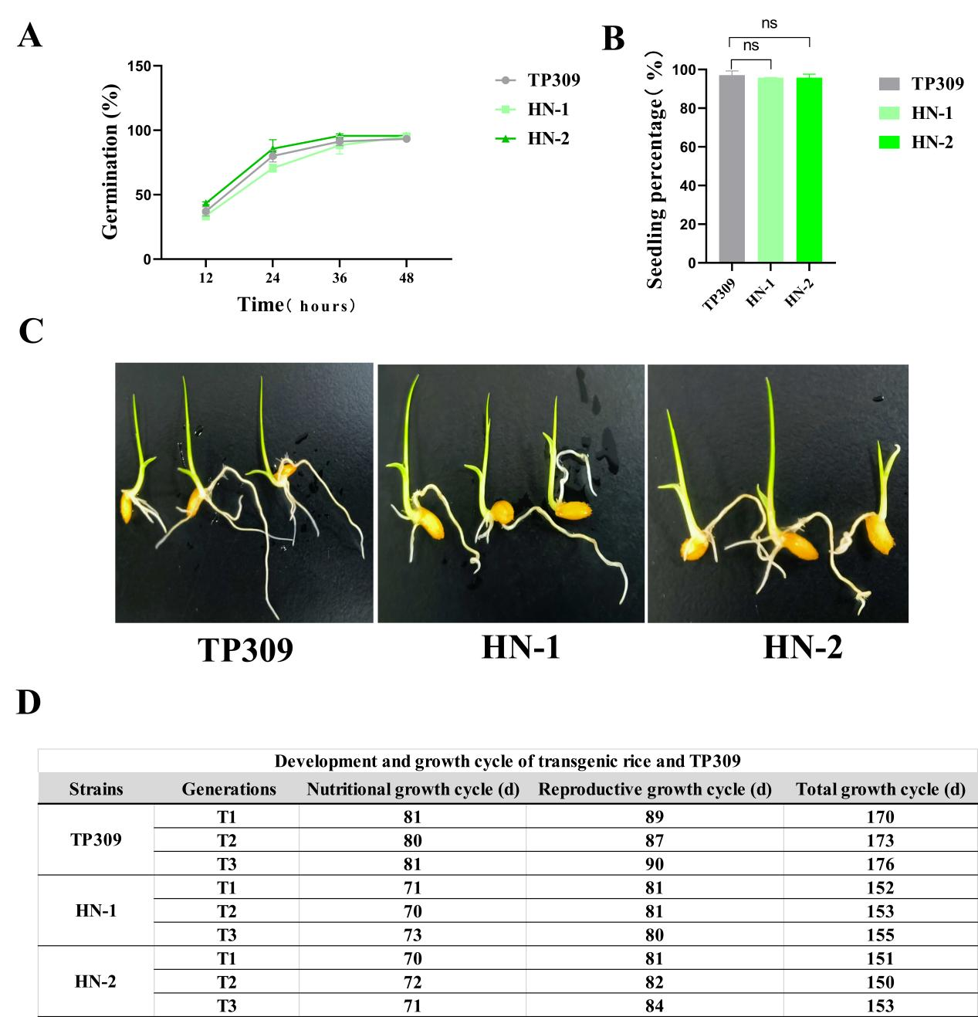
Fig.3. Germination and seedling percentage assessment of HN-1, HN-2 transgenic rice: (A) Germination of transgenic rice. (B) seedling percentage of transgenic rice. (C) Visualisation of germination of tra

nsgenic rice. (D) Development and growth cycle of transgenic rice and TP309.
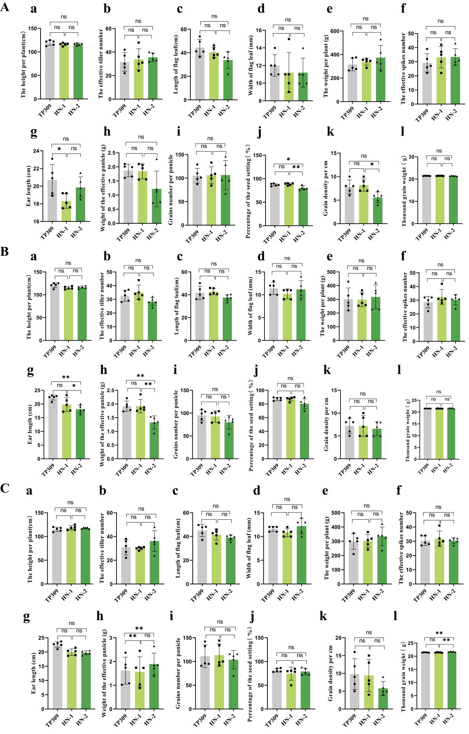
Fig.4. Combined agronomic traits of T1-T3 generation transformant strains and TP309. (A), (B) and (C) corresponded to 12 comprehensive agronomic traits recorded in T1-T3 generations, including: a, The height per plant ; b, The effective tiller number; c, length of flag leaf ; d, width of flag leaf ; e, The weight per plant; f, The effective spikes number ; g, Ear length; h, weight of the effective paicle ; i, grains number of per panicle; j, percentage of the seed setting; k, grain density per cm; and l, Thousands grain weight; The data were statistically significantly different from those of the above data by One-way ANOVA, where * is p<0.05, ** p<0.01, *** p<0.001, and **** p<0.0001. Both HN-1 and HN-2 were assessed with five randomly selected plants.
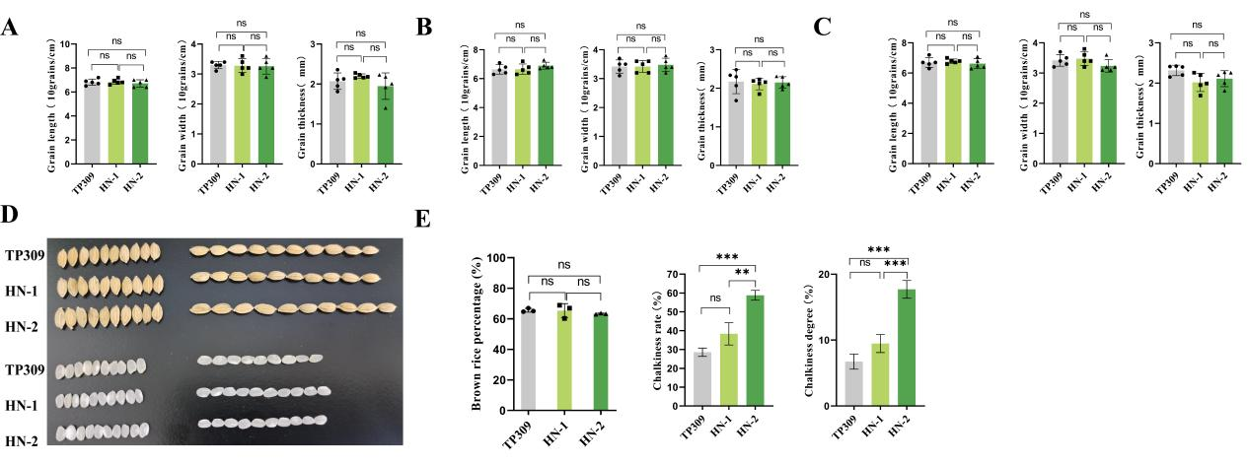
Fig.5. Grain phenotypes of T1-T3 generation transformant strains and TP309. (A), (B) and (C) Comparison of rice grain morphology data for each strain in the T1, T2 and T3 generation, from left to right, grain length, grain width and grain thickness; (D) Rice grain phenotypes (brown rice on top, fine rice on bottom); (E) Comparison of rice grain quality among the strains, from left to right, in order of brown rice percentage, chalkiness and chalkiness. The data were statistically significantly different from those of the above data by One-way ANOVA, where * is p<0.05, ** p<0.01, *** p<0.001, and **** p<0.0001. Both HN-1 and HN-2 were assessed with five randomly selected plants.

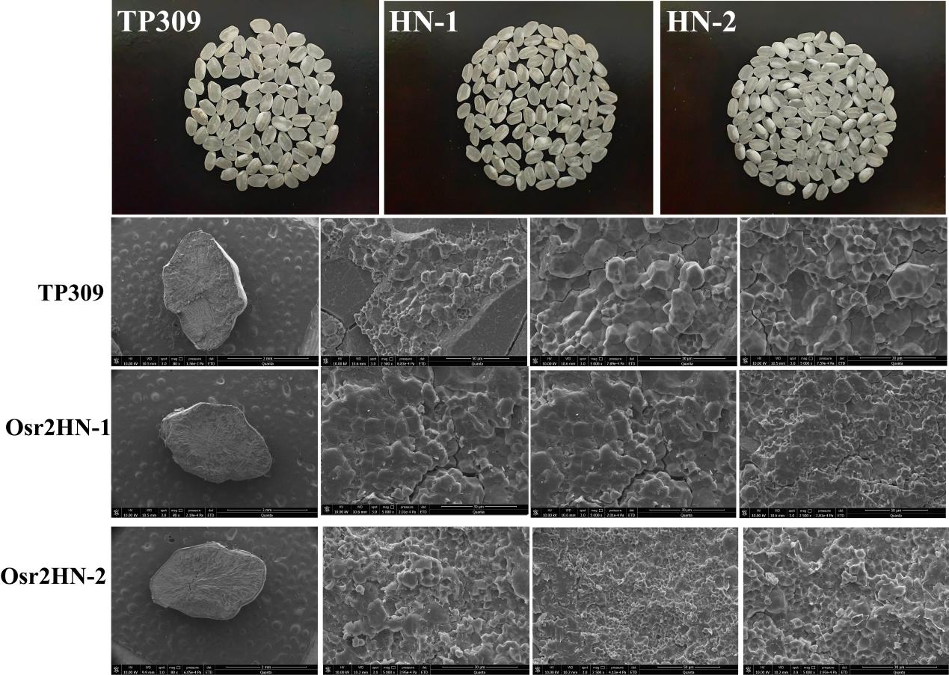
Fig.6. Scanning electron microscope detection of TP309, Osr2HN-1, Osr2HN-2 respectively rice of T3 grain chalkiness. Three replicates for each strain.
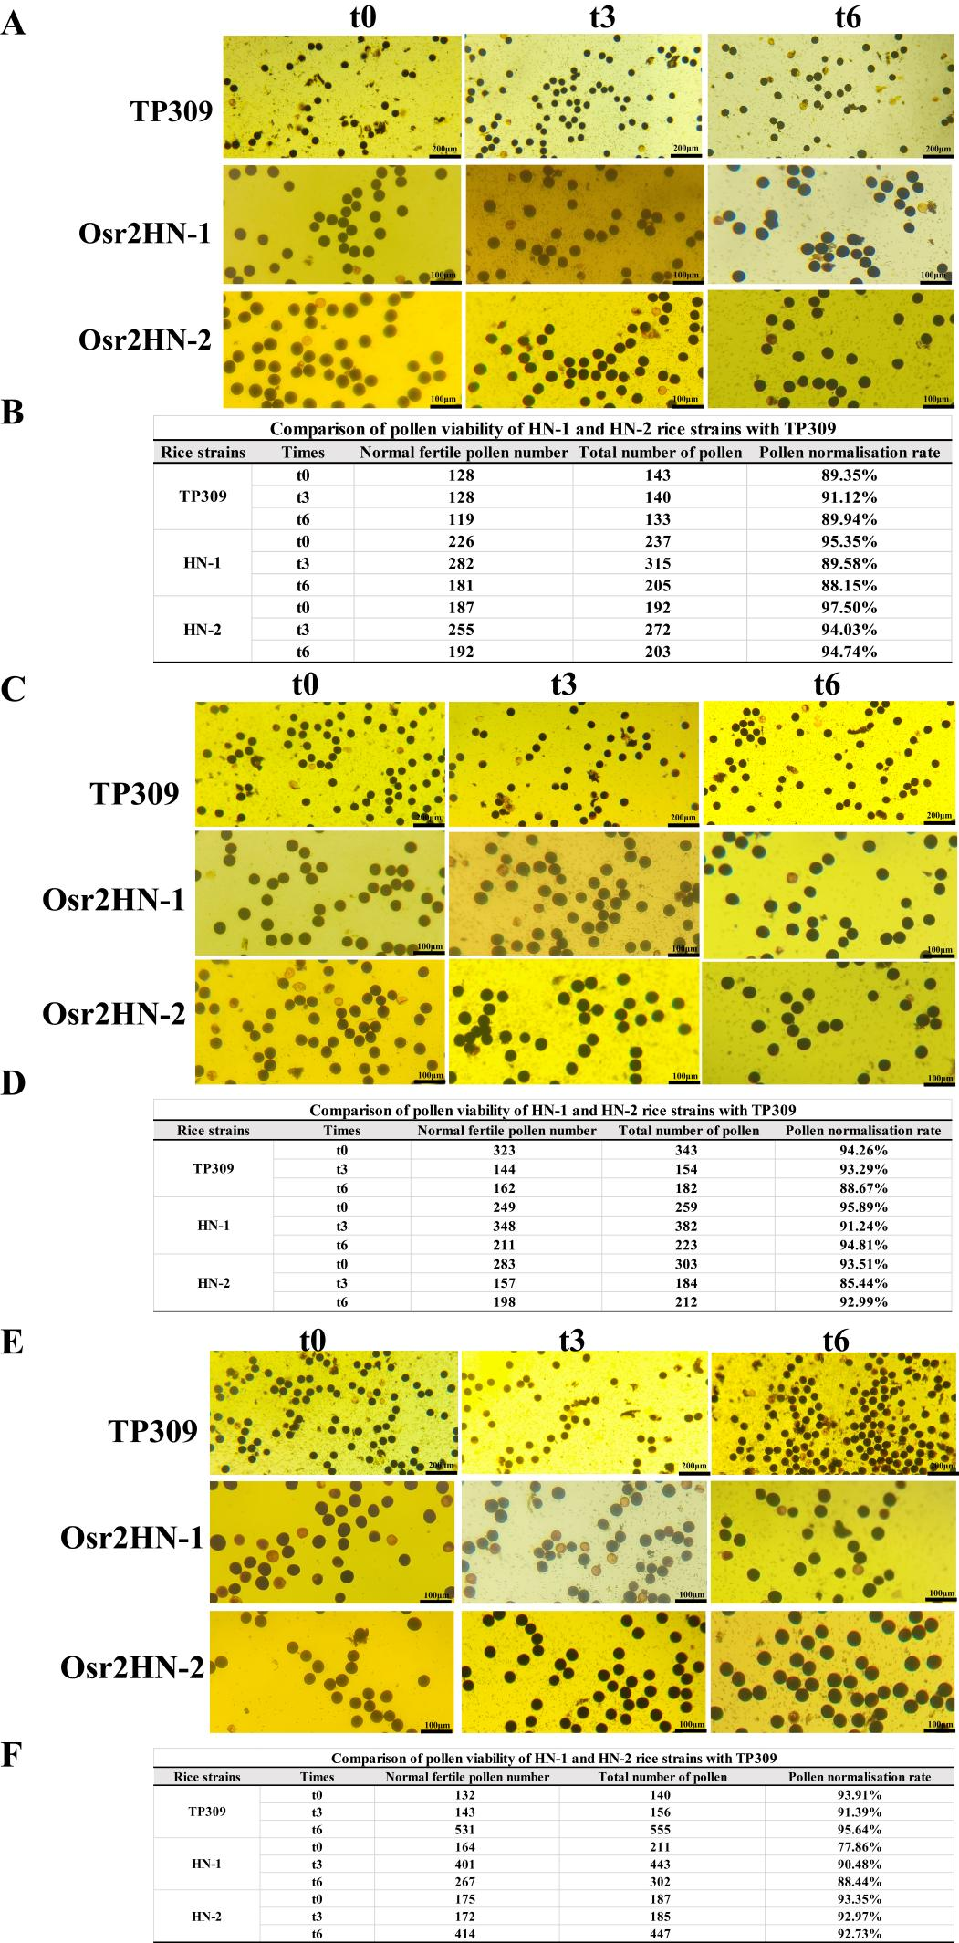
Fig.7. Comparison of pollen viability between transformant strains of T1-T3 generations and TP309. (A) and (B) corresponds to the comparison and statistics of pollen viability of T1 generation transformant strain and TP309, respectively; (C) and (D) corresponds to the comparison and statistics of pollen viability of T2 generation transformant strain and TP309, respectively; (E) and (F) corresponds to the comparison and statistics of pollen viability of T3 generation transformant strain and TP309,respectively. Each plant should have at least three replicates.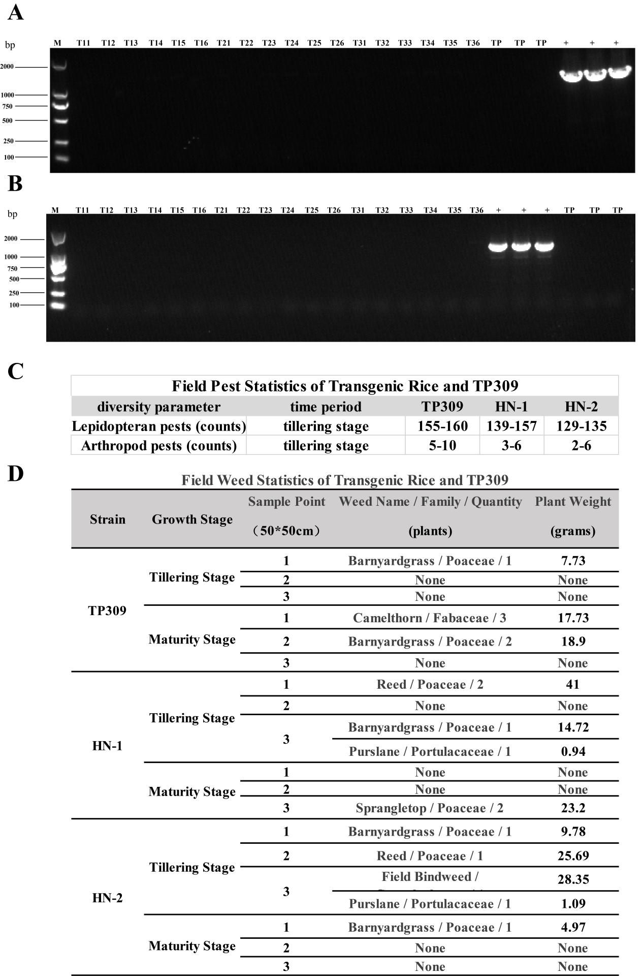
Fig.8. Safety evaluation of rice strains transgenic for HN-1 and HN-2 genes. (A) and (B) PCR result of the spread of foreign gene to surrounding weeds from HN-1 and HN-2. T11-T16: The T1 generation of the transgenic strain was randomly selected from six, T21-26: The T2 generation of the transgenic strain was randomly selected from six, T31-T36: The T3 generation of the transgenic strain was randomly selected from six, TP indicates TP309, + indicates positive plasmid (The labelling in the figures is based on this method); (C) and (D) Outdoor field biodiversity analysis of transgenic rice and TP309.

Supplementary materials
Table 1-1 Primers used to amplify HN and HygR gene
primer | primer sequence（5′-3′） | lengths
HN-F | ACTACTGCTACACCCACAACG | 1138bp
HN-R | ACGAGGAGCGGGACGAT | 1138bp
HN-F | ACGACACCCAGAACCGCAAGA | 264bp
HN-R | CGTAGACCGGGAACCAGACG | 264bp
HygR-F | CTTCTGCGGGCGATTT | 195bp
HygR-R | ACTGGAGCGAGGCGATG | 195bp

Table 1-2 PCR reaction system（50µL）
Reaction system | volumes（50µL）
2xRapid Taq master mix (P222-01,Vazyme) | 25µL
ddH2O | Add to 50µL
HN-F | 1µL
HN-R | 1µL
cDNA | 2µL

Table 1-3 qPCR reaction system（20µL）
Reaction system | volumes（20µL）
2xChamQ Universal SYBR qPCR Master Mix | 10µL
ddH₂O | Add to 20µL
HN-F | 0.4µL
HN-R | 0.4µL
cDNA | 2µL

