Supplemental Materials

Title: Time-use differences in 24-hour movement behaviours by sociodemographic and health-related factors among Japanese adults

Author (s): Yu-Tai Liu, Ai Shibata, Kaori Ishii, Sayaka Kurosawa, Koichiro Oka

Figure legends
Supplemental Figure 1. The percentage differences with bootstrap 95 confidence intervals in 24-hour movement behaviour composition between age groups and the sample mean.

Supplemental Figure 2. The percentage differences with bootstrap 95 confidence intervals in 24-hour movement behaviour composition between annual household income and the sample mean.

Supplemental Figure 3. The percentage differences with bootstrap 95 confidence intervals in 24-hour movement behaviour composition between smoking status and the sample mean.

Supplemental Figure 4. The percentage differences with bootstrap 95 confidence intervals in 24-hour movement behaviour composition between alcohol consumption and the sample mean.

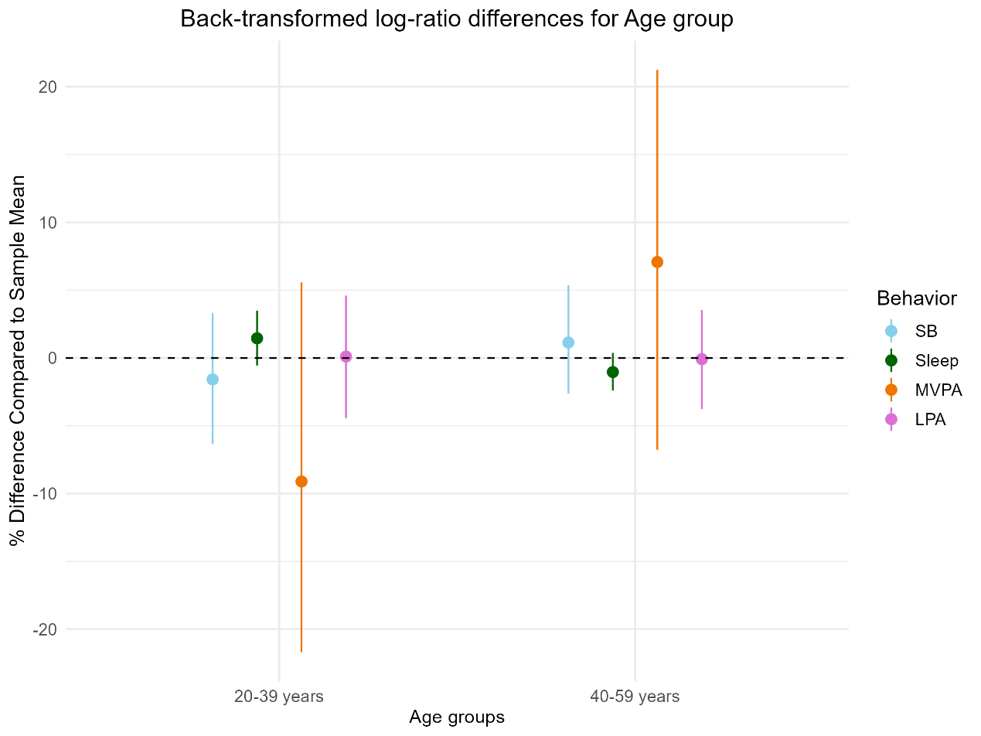
Supplemental Figure 1. The percentage differences with bootstrap 95 confidence intervals in 24-hour movement behaviour composition between age groups and the sample mean. SB: sedentary behaviours, MVPA: moderate-vigorous physical activity, LPA: light physical activity.

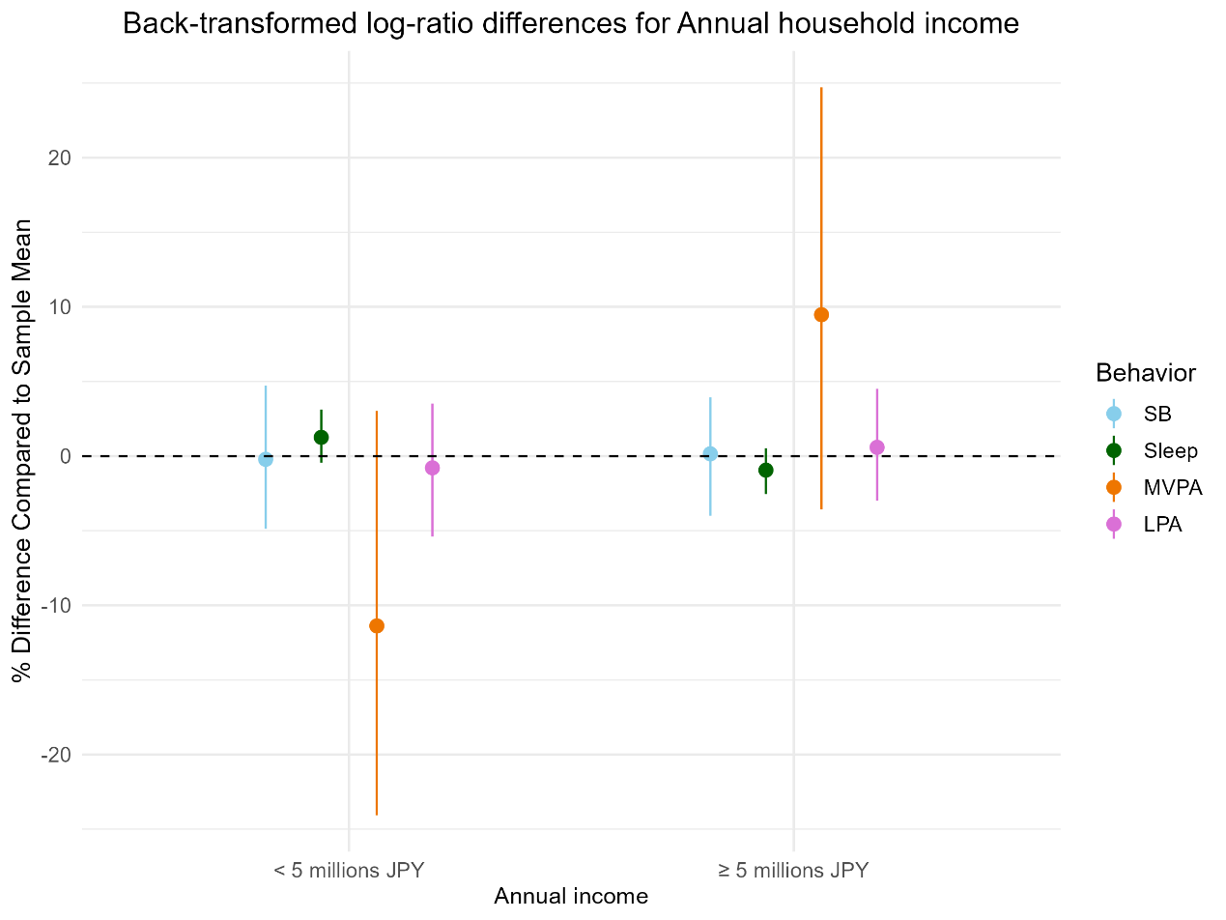
Supplemental Figure 2. The percentage differences with bootstrap 95 confidence intervals in 24-hour movement behaviour composition between annual household income and the sample mean. SB: sedentary behaviours, MVPA: moderate-vigorous physical activity, LPA: light physical activity.

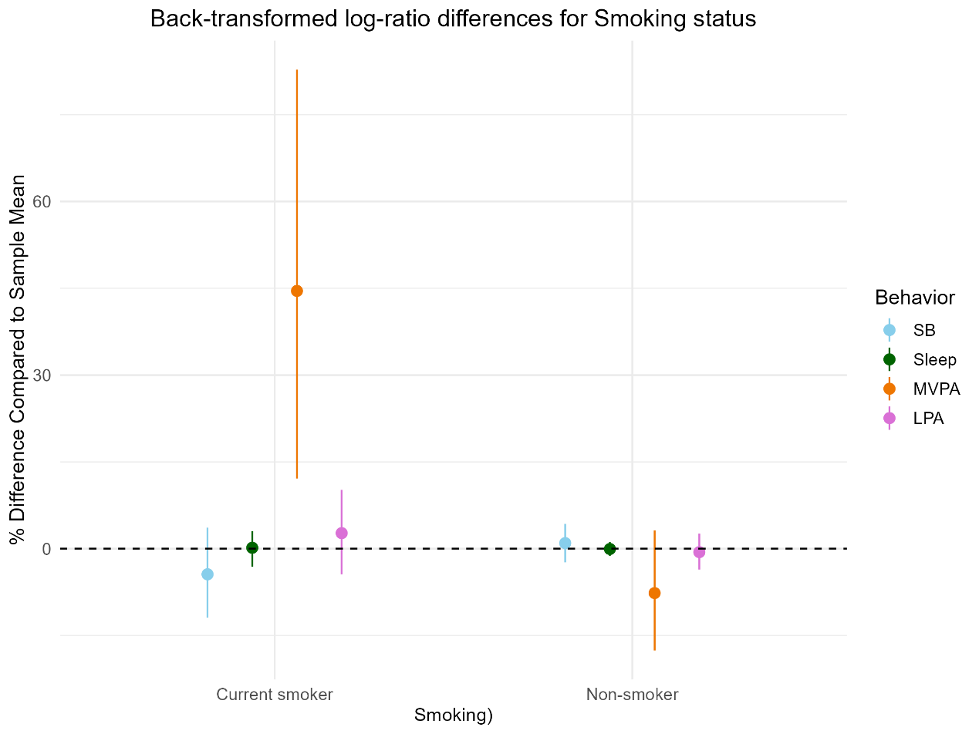
Supplemental Figure 3. The percentage differences with bootstrap 95 confidence intervals in 24-hour movement behaviour composition between smoking status and the sample mean. SB: sedentary behaviours, MVPA: moderate-vigorous physical activity, LPA: light physical activity.

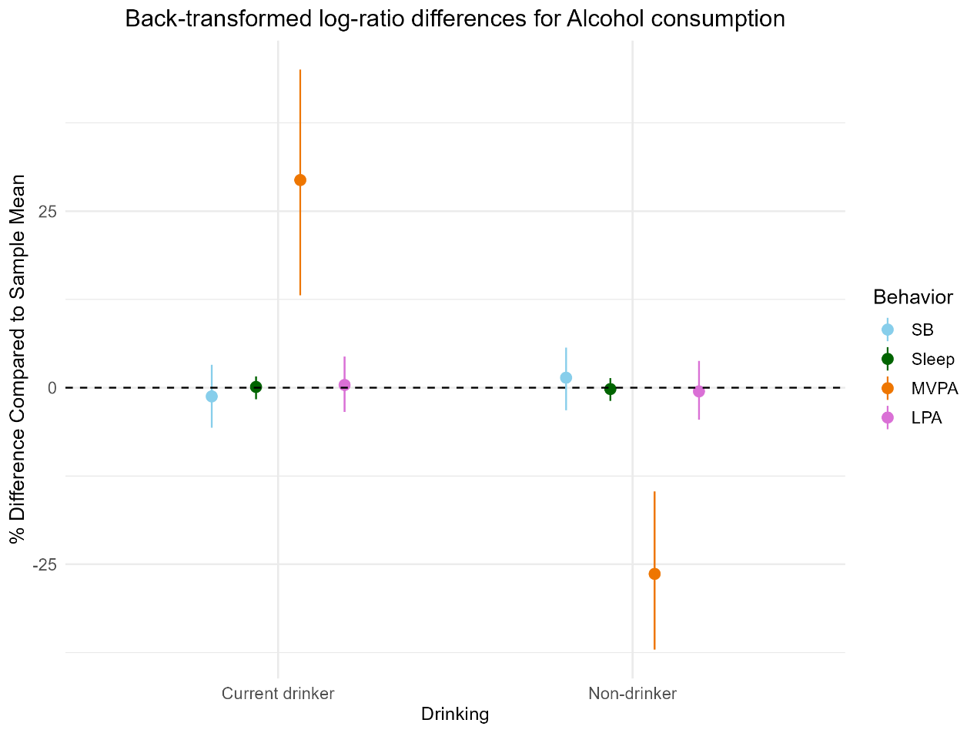
Supplemental Figure 4. The percentage differences with bootstrap 95 confidence intervals in 24-hour movement behaviour composition between alcohol consumption and the sample mean. SB: sedentary behaviours, MVPA: moderate-vigorous physical activity, LPA: light physical activity.

