Supplementary Figures

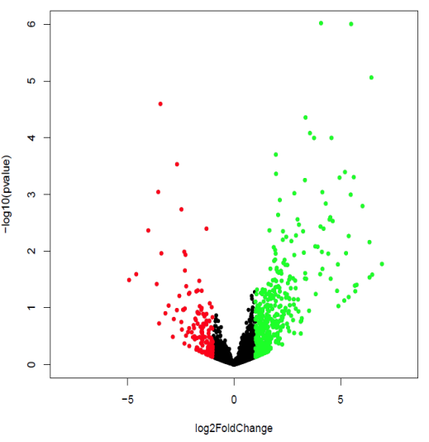

SI Figure – 1: Volcano plot representation for differential species expression, this scatter plot shows statistical significance (P value) versus magnitude of fold change [log2fc]. [The green highlighted regions representing up regulated [having log2fc >1], red region is down regulated [having log2fc <1] and neutrally expressed species represented as black [between log2fc -1 to 1].

SI Figure -2: Distribution of Oral Hygiene Status Among Study Participants (n=25)

A

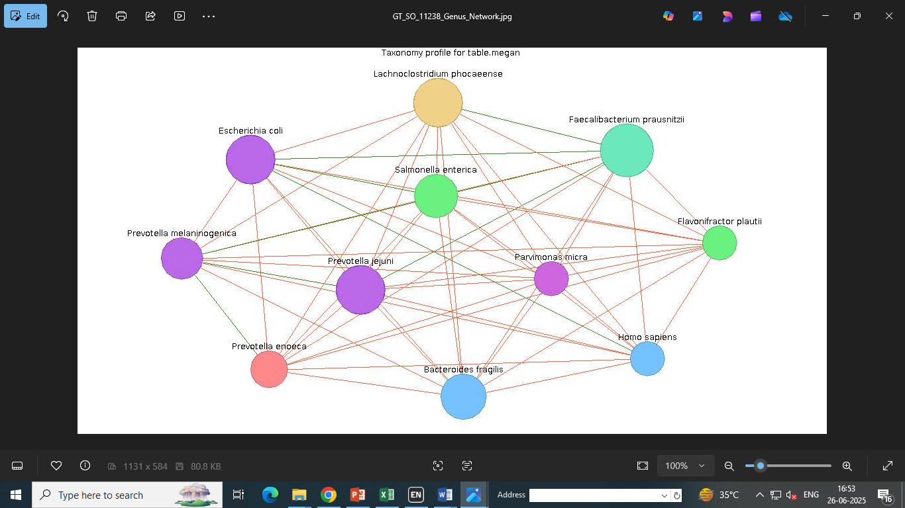
B

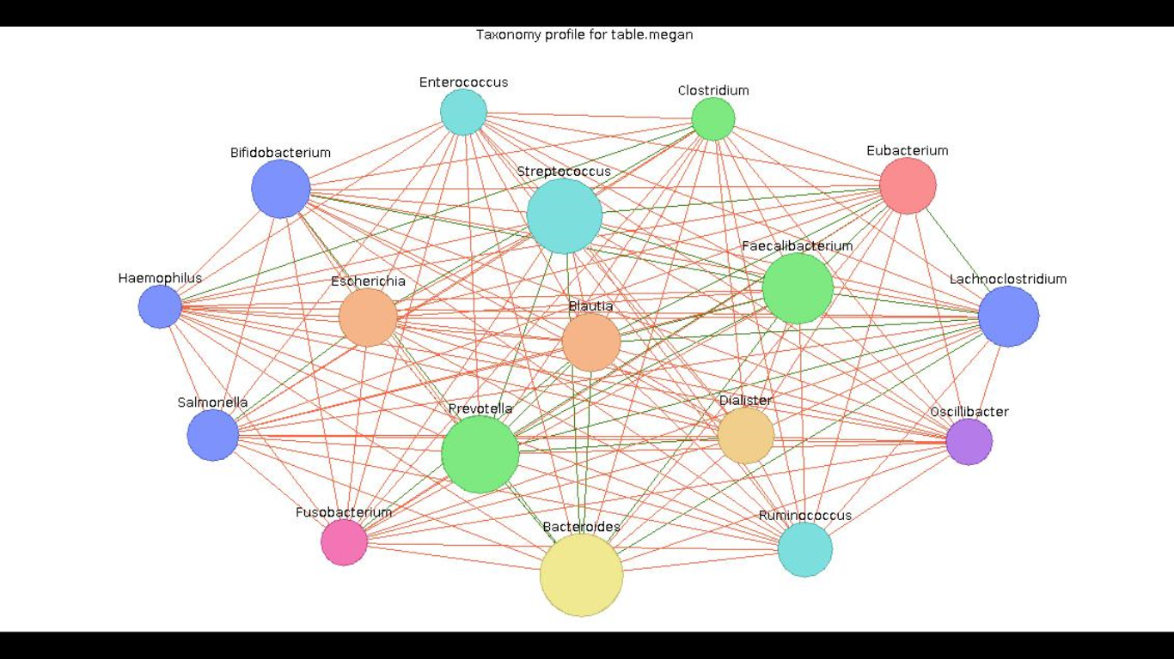

SI Figure -3: Co-occurrence (crosstalk) network of microbial genera in EOCRC tumor tissue. Nodes represent microbial taxa at the genus level (node size proportional to relative abundance). Edges represent co-occurrence relationships based on Jaccard similarity indices, with width proportional to the similarity score. Only taxa with ≥1% relative abundance and present in 30–90% of samples were included. Network constructed and visualized using MEGAN v6.21.5.
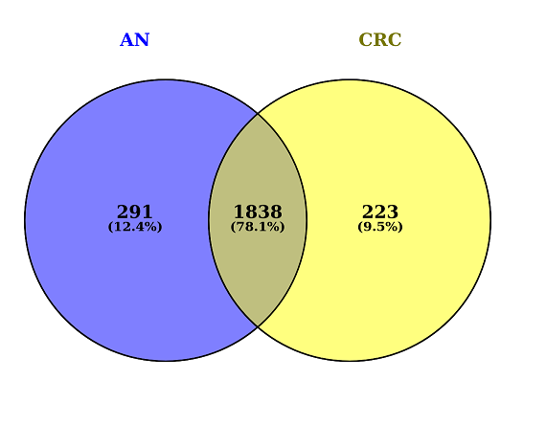
SI Figure -4: A Venn diagram, representing the shared and unique OTU's of the microbiome at species level between CRC and adjacent normal

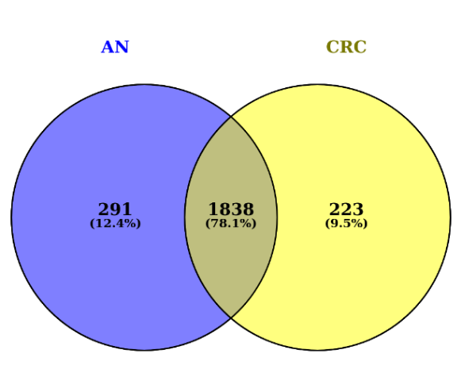
SI Figure - 4: A Venn diagram, representing the shared and unique OTU's of the microbiome at species level between CRC and adjacent normal
A
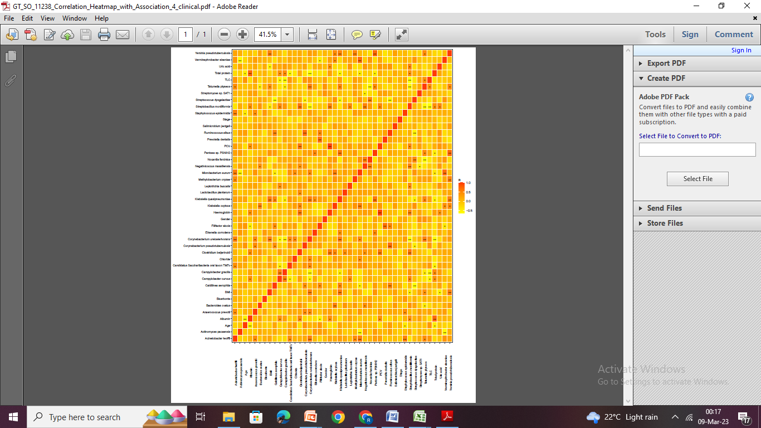
AA

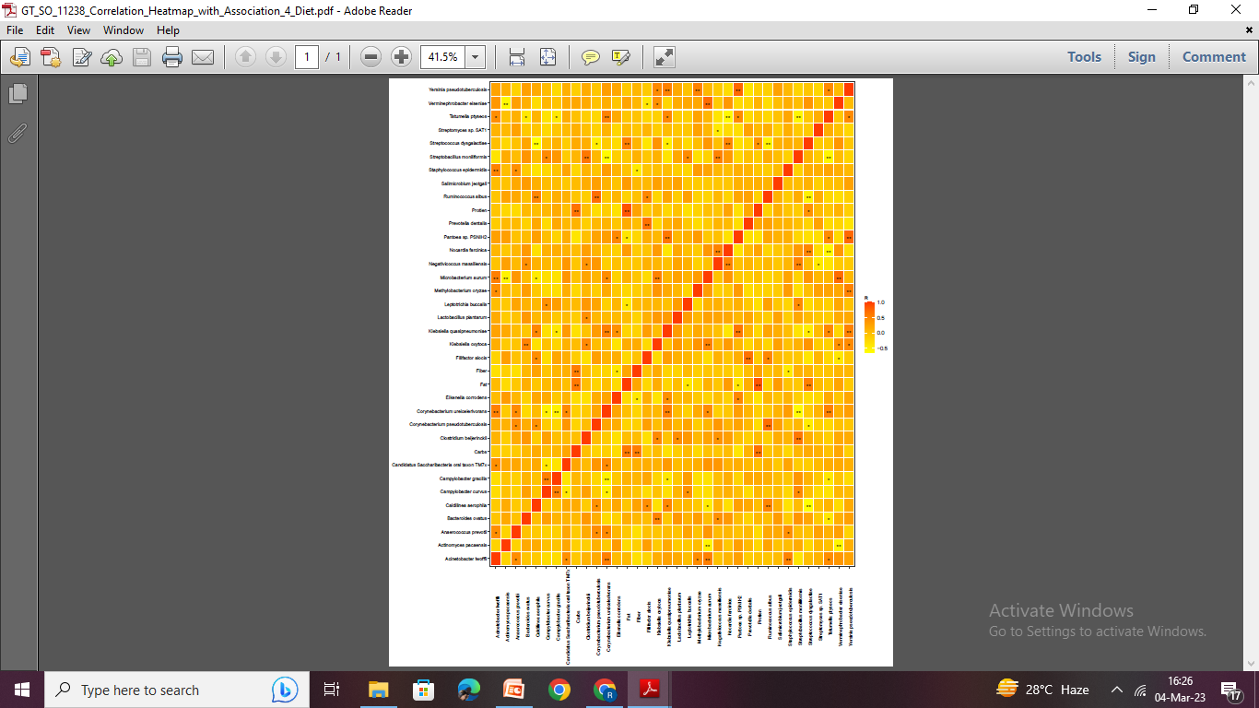
B

SI Figures 5 A and B: Correlation heatmaps generated using Spearman's correlation method. A- illustrates associations between microbial taxa and clinical parameters, while B- Depicts correlations with dietary factors (carbohydrate, protein, fat, and fiber). Statistical significance is denoted by asterisks: p < 0.01 = "", 0.01 < p < 0.05 = "*", and p ≥ 0.05 is left unmarked. Darker red colors indicate stronger positive correlations, while lighter shades represent weaker or negative correlations.

Supplementary Tables

SI Table 1- Distribution of patients according to total oral hygiene index (OHI) score and interpretation
Total OHI Score | Oral Hygiene Interpretation | Number of Patients (n)
0 | Excellent oral hygiene | 1
1 | Good oral hygiene | 8
2 | Fair oral hygiene | 10
3 | Poor oral hygiene | 6

SI Table 2- ROC Curve Metrics and Correlation of CRC associated Microbial Species
Species | AUC | Sensitivity | Specificity | PPV | NPV | Accuracy | P value | Correlation
Caldilinea aerophila | 0.76 | 0.7 | 0.83 | 0.81 | 0.71 | 0.76 | 0.01 | +ve
Filifactor alocis | 0.6 | 0.53 | 0.91 | 0.88 | 0.65 | 0.72 | 0.03 | +ve
Prevotella dentalis | 0.51 | 0.69 | 0.5 | 0.6 | 0.6 | 0.6 | 0.42 | +ve
Streptococcus dysgalactiae | 0.68 | 0.23 | 0.33 | 0.27 | 0.28 | 0.28 | 0.047 | -ve
Leptotrichia buccalis | 0.59 | 0.08 | 0.91 | 0.5 | 0.48 | 0.48 | 1 | -ve

SI Table 3 - Significantly Enriched Microbial Species Identified in Tumor Tissue by DESeq2 Analysis
S. No. | Species | log2FoldChange | lfcSE | stat | P value | padj
1 | Negativicoccus massiliensis | 25.05 | 2.91 | 8.59 | 0.000 | 0.000
2 | Leptotrichia buccalis | 6.45 | 1.45 | 4.45 | 0.000 | 0.001
3 | Coryn. pseudotuberculosis | 4.15 | 1.25 | 3.32 | 0.001 | 0.035
4 | Staphylococcus epidermidis | 4.08 | 0.83 | 4.90 | 0.000 | 0.000
5 | Campylobacter gracilis | 3.81 | 1.44 | 2.64 | 0.008 | 0.135
6 | Caldilinea aerophila | 3.76 | 0.97 | 3.89 | 0.000 | 0.007
7 | Tatumella ptyseos | 3.56 | 0.91 | 3.94 | 0.000 | 0.007
8 | Campylobacter curvus | 3.34 | 1.48 | 2.25 | 0.024 | 0.250
9 | Acinetobacter lwoffii | 3.04 | 1.04 | 2.93 | 0.003 | 0.080
10 | Microbacterium aurum | 2.31 | 0.96 | 2.41 | 0.016 | 0.199
11 | Streptomyces sp. SAT1 | 2.15 | 0.67 | 3.23 | 0.001 | 0.041
12 | Eikenella corrodens | 2.10 | 0.93 | 2.26 | 0.024 | 0.250
13 | Filifactor alocis | 2.07 | 0.68 | 3.05 | 0.002 | 0.064
14 | Klebsiella quasipneumoniae | 2.04 | 0.90 | 2.27 | 0.023 | 0.243
15 | Anaerococcus prevotii | 1.98 | 0.93 | 2.12 | 0.034 | 0.285
16 | Actinomyces pacaensis | 1.97 | 0.56 | 3.52 | 0.000 | 0.022
17 | Methylobacterium oryzae | 1.96 | 0.53 | 3.72 | 0.000 | 0.013
18 | Coryne. ureicelerivorans | 1.96 | 0.97 | 2.02 | 0.043 | 0.341
19 | Streptobacillus moniliformis | 1.95 | 0.77 | 2.54 | 0.011 | 0.149
20 | Streptococcus dysgalactiae | 1.93 | 0.74 | 2.59 | 0.010 | 0.148
21 | Salimicrobium jeotgali | 1.82 | 0.85 | 2.14 | 0.033 | 0.282
22 | Pantoea sp. PSNIH2 | 1.70 | 0.74 | 2.32 | 0.020 | 0.230
23 | Clostridium beijerinckii | 1.66 | 0.58 | 2.86 | 0.004 | 0.085
24 | Candidatus Saccharibacteria | 1.61 | 0.78 | 2.08 | 0.038 | 0.317
25 | Nocardia farcinica | 1.34 | 0.68 | 1.98 | 0.048 | 0.358
26 | Yersinia pseudotuberculosis | 1.08 | 0.54 | 1.98 | 0.048 | 0.358
27 | Bacteroides ovatus | -1.30 | 0.45 | -2.88 | 0.004 | 0.085
28 | Verminephrobacter eiseniae | -1.71 | 0.87 | -1.97 | 0.049 | 0.362
29 | Ruminococcus albus | -2.31 | 1.01 | -2.29 | 0.022 | 0.238
30 | Klebsiella oxytoca | -2.47 | 0.79 | -3.12 | 0.002 | 0.053
31 | Prevotella dentalis | -2.68 | 0.74 | -3.62 | 0.000 | 0.018
32 | Lactobacillus plantarum | -3.46 | 0.82 | -4.21 | 0.000 | 0.003

SI Table 4 - Correlation between clinical parameters and species (p<0.05)

Variable 1 | Variable 2 | R | P
Age | Staphylococcus epidermidis | -0.41232 | 0.040543
Albumin | Clostridium beijerinckii | 0.4694 | 0.017919
Albumin | Streptobacillus moniliformis | 0.416869 | 0.038164
Albumin | Campylobacter curvus | 0.407895 | 0.042964
Albumin | Filifactor alocis | -0.4794 | 0.015315
BMI | Klebsiella quasipneumoniae | 0.59273 | 0.001794
BMI | Corynebacterium ureicelerivorans | 0.553779 | 0.004079
BMI | Tatumella ptyseos | 0.404357 | 0.044981
BMI | Streptobacillus moniliformis | -0.39743 | 0.049146
Chloride | Corynebacterium ureicelerivorans | 0.454052 | 0.02261
Chloride | Microbacterium aurum | 0.430689 | 0.031615
Haemoglobin | Streptobacillus moniliformis | 0.540026 | 0.005328
PCV | Clostridium beijerinckii | 0.605081 | 0.001353
PCV | Streptobacillus moniliformis | 0.484458 | 0.014121
TLC | Tatumella ptyseos | 0.407564 | 0.043149
TLC | Campylobacter curvus | -0.50182 | 0.01059
TLC | Campylobacter gracilis | -0.55219 | 0.00421
TLC | Streptobacillus moniliformis | -0.63323 | 0.00068
Total protein | Streptobacillus moniliformis | 0.423031 | 0.035122
Total protein | Campylobacter curvus | 0.404089 | 0.045137
Total protein | Microbacterium aurum | -0.40547 | 0.044339
Total protein | Pantoea sp. PSNIH2 | -0.46214 | 0.020026
Total protein | Candidatus Saccharibacteria oral taxon TM7x | -0.49059 | 0.012777
Total protein | Klebsiella quasipneumoniae | -0.49342 | 0.012195
Total protein | Corynebacterium ureicelerivorans | -0.60344 | 0.001405
Uric acid | Streptobacillus moniliformis | 0.50005 | 0.010913

SI Table 5 - Comparison of Patient Dietary Intake with Recommended Nutrient Ranges

Nutrient content | Normal Range | Mean ± SD
Calories | 1600 - 2400 (Kcal)/day | 1257 ± 390
Protein | 55 - 60 g/day | 51.3 ± 23.1
Carbohydrates | 225 - 325 g/day | 158.4 ± 38.9
Fat | 44 -77 g/day | 44.3 ± 16.8
Fiber | 30 - 38 g/day | 19.8 ± 5.8

SI Table 6: Correlation between Dietary Components and species (p<0.05)

Var1 | Var2 | R | P
Fiber | Eikenella corrodens | -0.41 | 0.044
Fiber | Staphylococcus epidermidis | -0.44 | 0.027
Fat | Pantoea sp. PSNIH2 | -0.4 | 0.046
Fat | Streptococcus dysgalactiae | 0.57 | 0.003
Fat | Leptotrichia buccalis | -0.41 | 0.039
Protein | Streptococcus dysgalactiae | 0.41 | 0.043

