Supporting Information

Darcy-Scale Experimental Investigation of Intermittent Particle Transport in Porous Media and its Impact on Injectivity

Tongtong Yu*, Dag Chun Standnes†, Espen Kowalewski‡, Daniel Lie Carlsen*,
Ketil Djurhuus*

* Energy & Technology, NORCE Research AS, Bergen, Norway
† Equinor ASA, Bergen, Norway
‡ Equinor ASA, Trondheim, Norway

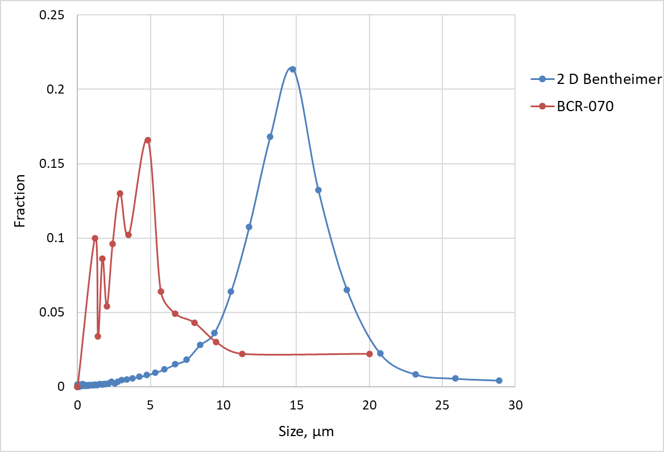
Fig. S1. Comparison of the pore throat size distribution of 2-Darcy Bentheimer sandstone (data from (Shiran, Sadaak, Solbakken, Toigo, & Zamani, 2024)) and the particle size distribution (mass fraction) of quartz particle (BCR®-070) (data from the BCR®-070 certificate of analysis). The BCR®-070 size distribution is reported as a cumulative mass fraction based on Stokes diameter.

