Supporting Information

Aramid Nanofiber@Al₂O₃ Composite Aerogels toward Ultra-High Near Infrared Transmittance and Low Thermal Conductivity for Robust Passive Thermal Managements

Yanan Chen^{1,2†} Sijia Ge^{2†} Hong Li^{1,2} Ling Liu^{2,3} Xueyan Hu^{2,3} Peiying Hu⁴ Xiaodong Wu¹* Sheng Cui¹* and Jin Wang^{2,3}*

¹ College of Materials Science and Engineering, Nanjing Tech University, Nanjing 211816, P. R. China
² Key Laboratory of Multifunctional Nanomaterials and Smart Systems, Suzhou Institute of Nano-Tech and Nano-Bionics, Chinese Academy of Sciences, Suzhou 215123, P. R. China
³ School of Nano-Tech and Nano-Bionics, University of Science and Technology of China, Hefei 230026, P. R. China
⁴ State Key Laboratory of New Textile Materials and Advanced Processing, Wuhan Textile University, Wuhan 430200, P.R. China
† These authors contributed equally to this work.

*Corresponding author
Email: wuxiaodong@njtech.edu.cn, scui@njtech.edu.cn, jwang2014@sinano.ac.cn

1. Supporting Figures
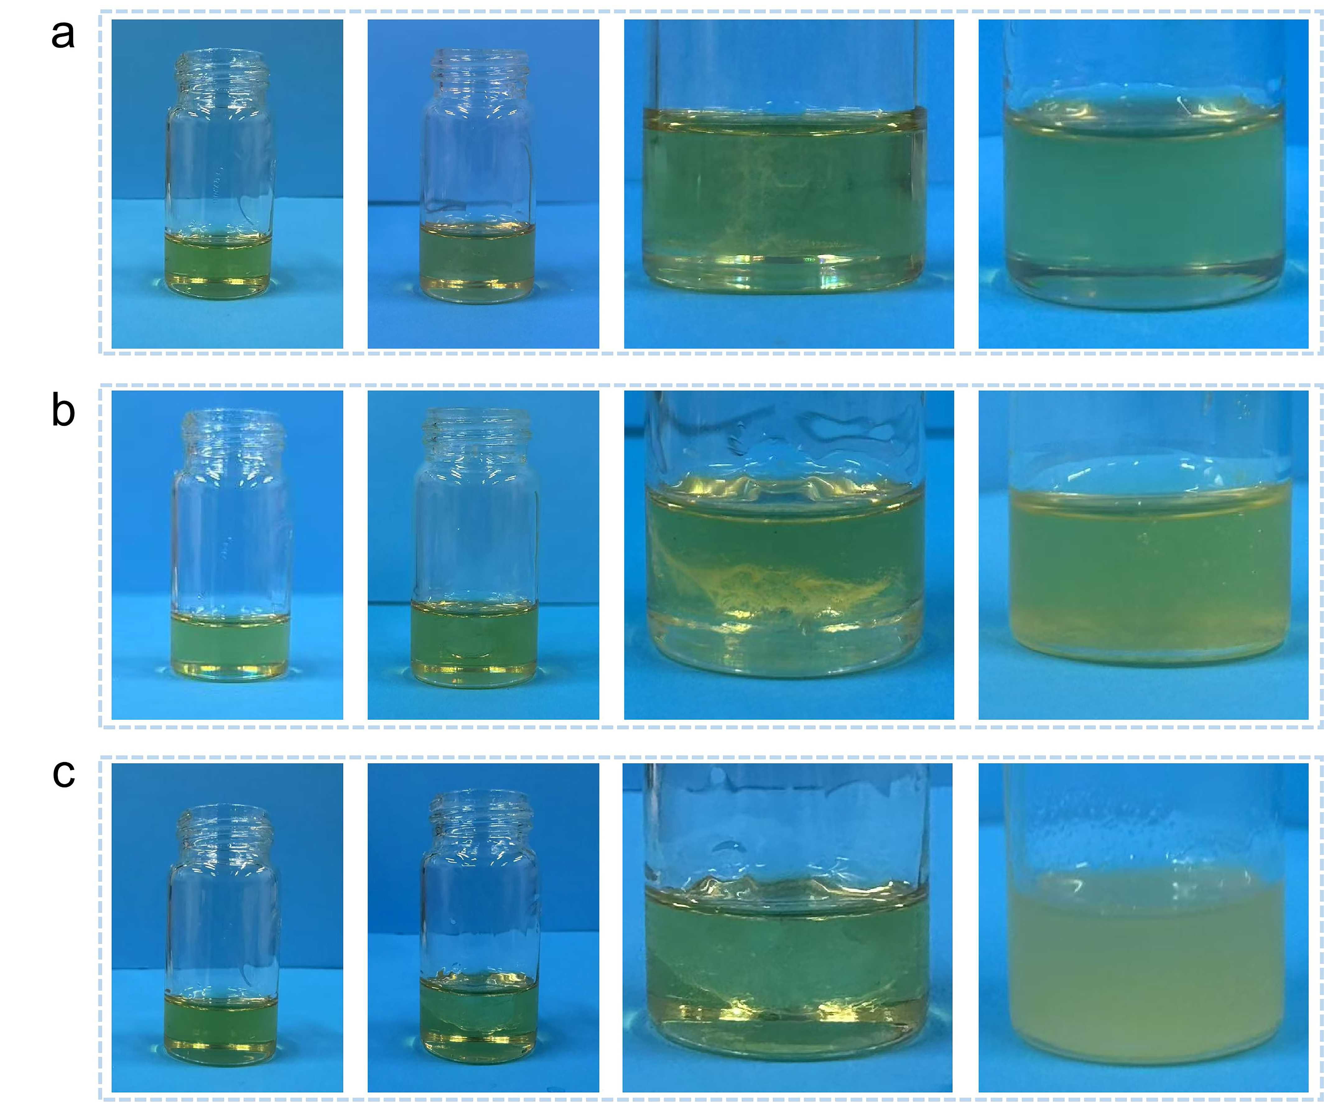
Fig. S1 a Clear phase separation observed prior to stirring, and a homogeneous system is formed after stirring; b Mild phase separation persists after stirring; c Pronounced phase separation remains evident post-stirring

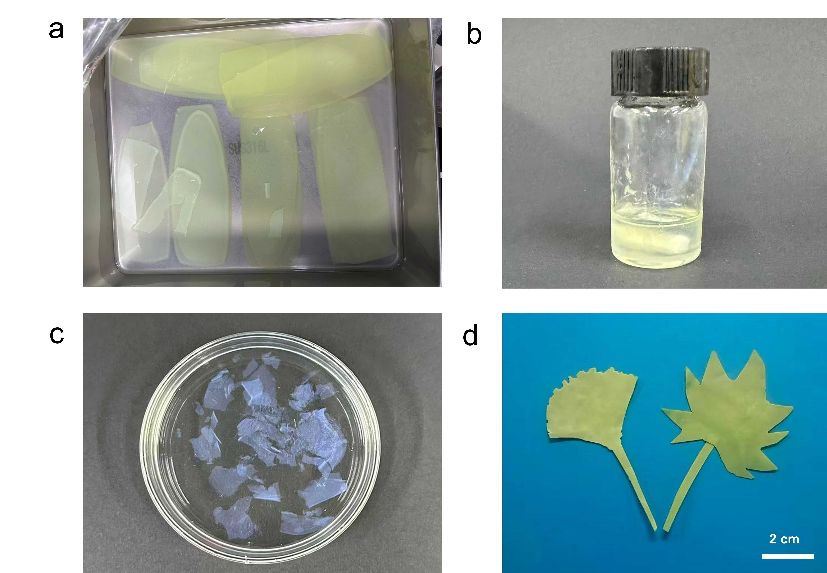
Fig. S2 a Photo image of ANF@Al₂O₃ aging in PO; b Mixture of ANF and Al sol at a higher Al₂O₃ ratio after thorough stirring; c Gel obtained from b, which was severely fragmented and failed to form a monolithic structure; d Photo image of ANF@Al₂O₃ cut into the shapes of ginkgo leaves and phoenix tree leaves

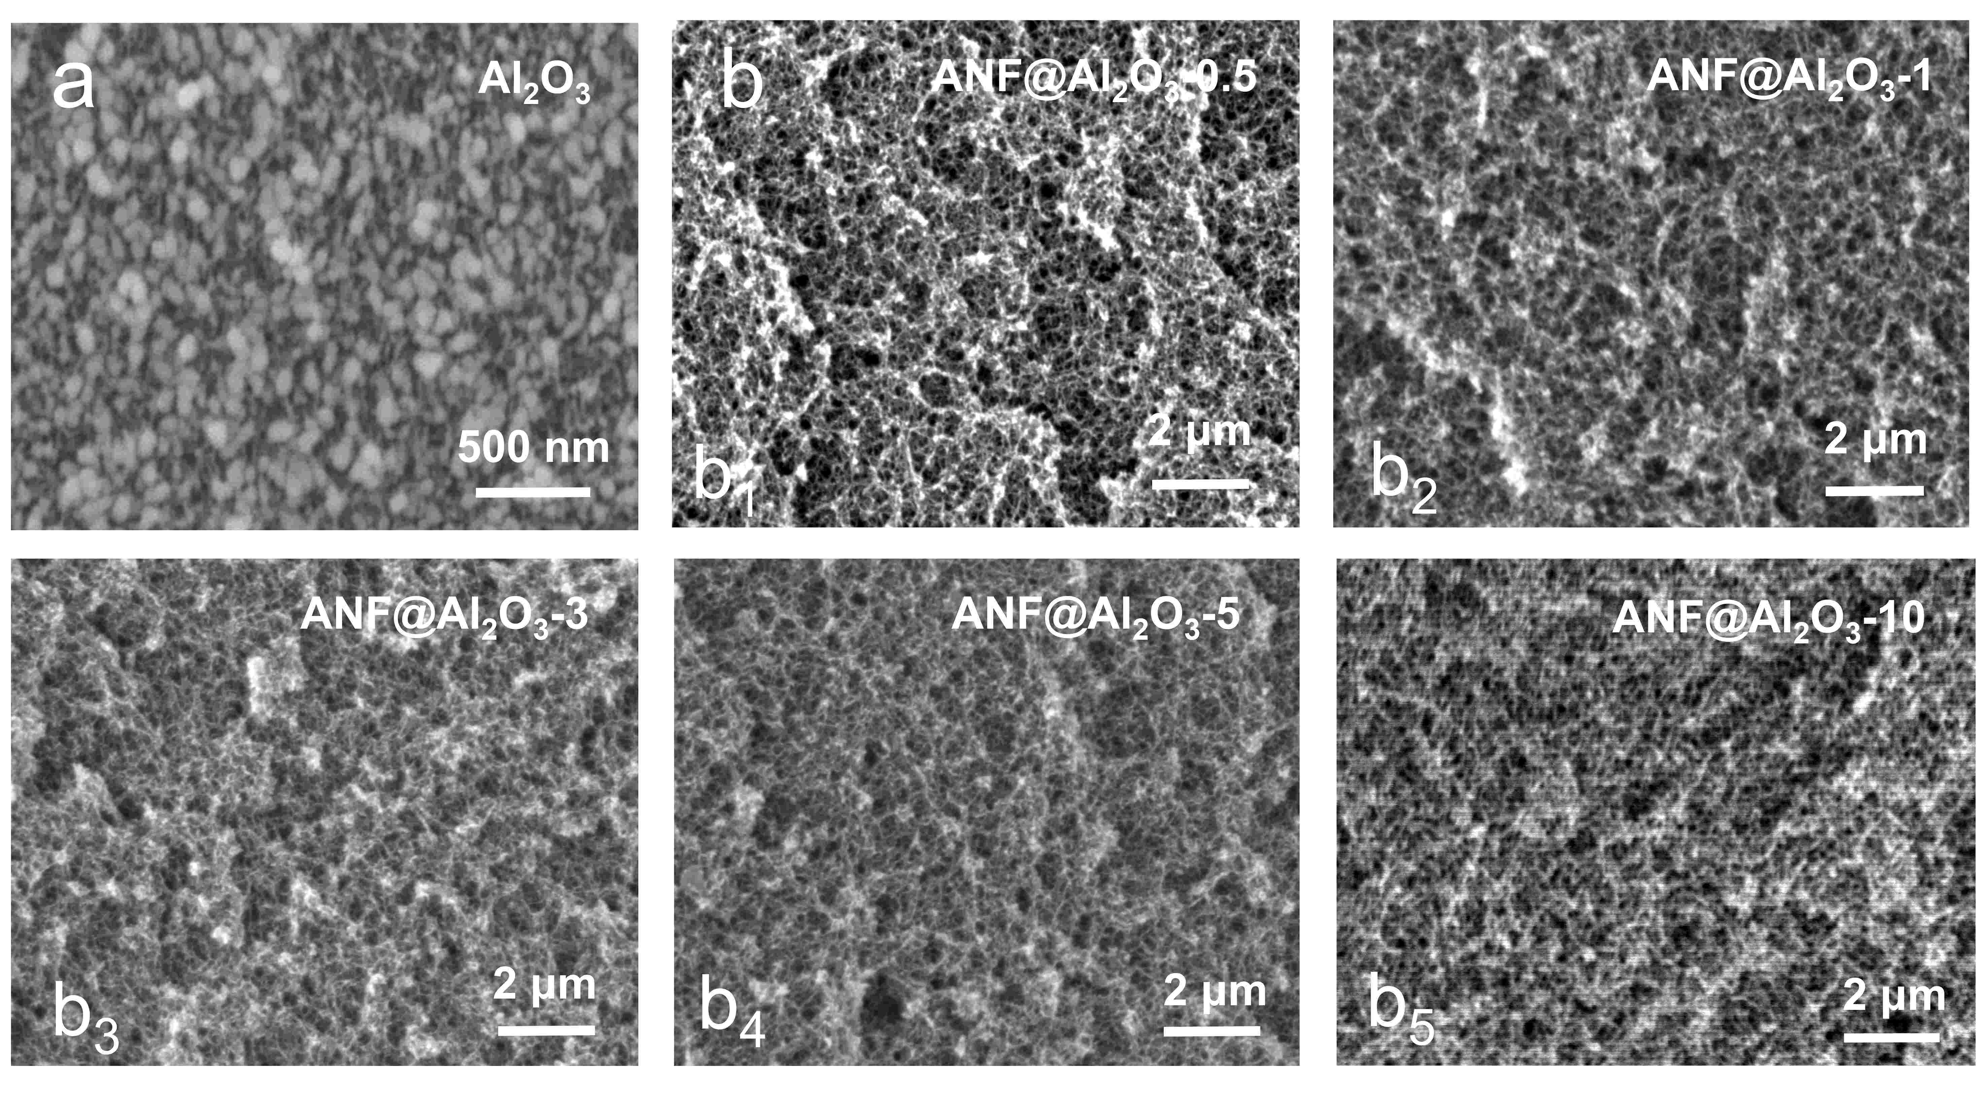
Fig. S3 SEM images of a Al₂O₃ aerogel and b ANF@Al₂O₃ aerogels as indicated

Fig. S4 EDS mapping images of a Al₂O_{3,} b ANF and c ANF@Al₂O₃-10

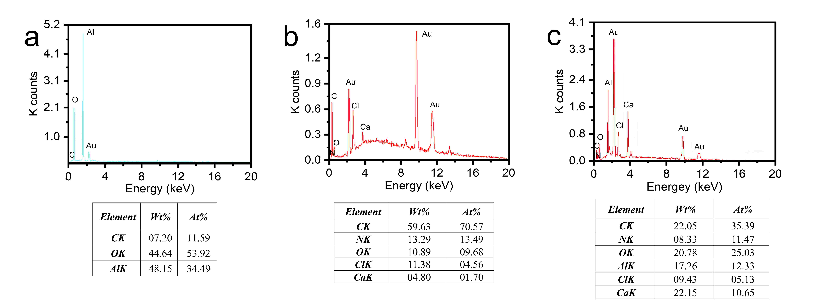
Fig. S5 EDS spectra of a Al₂O₃, b ANF, and c ANF@Al₂O₃-10

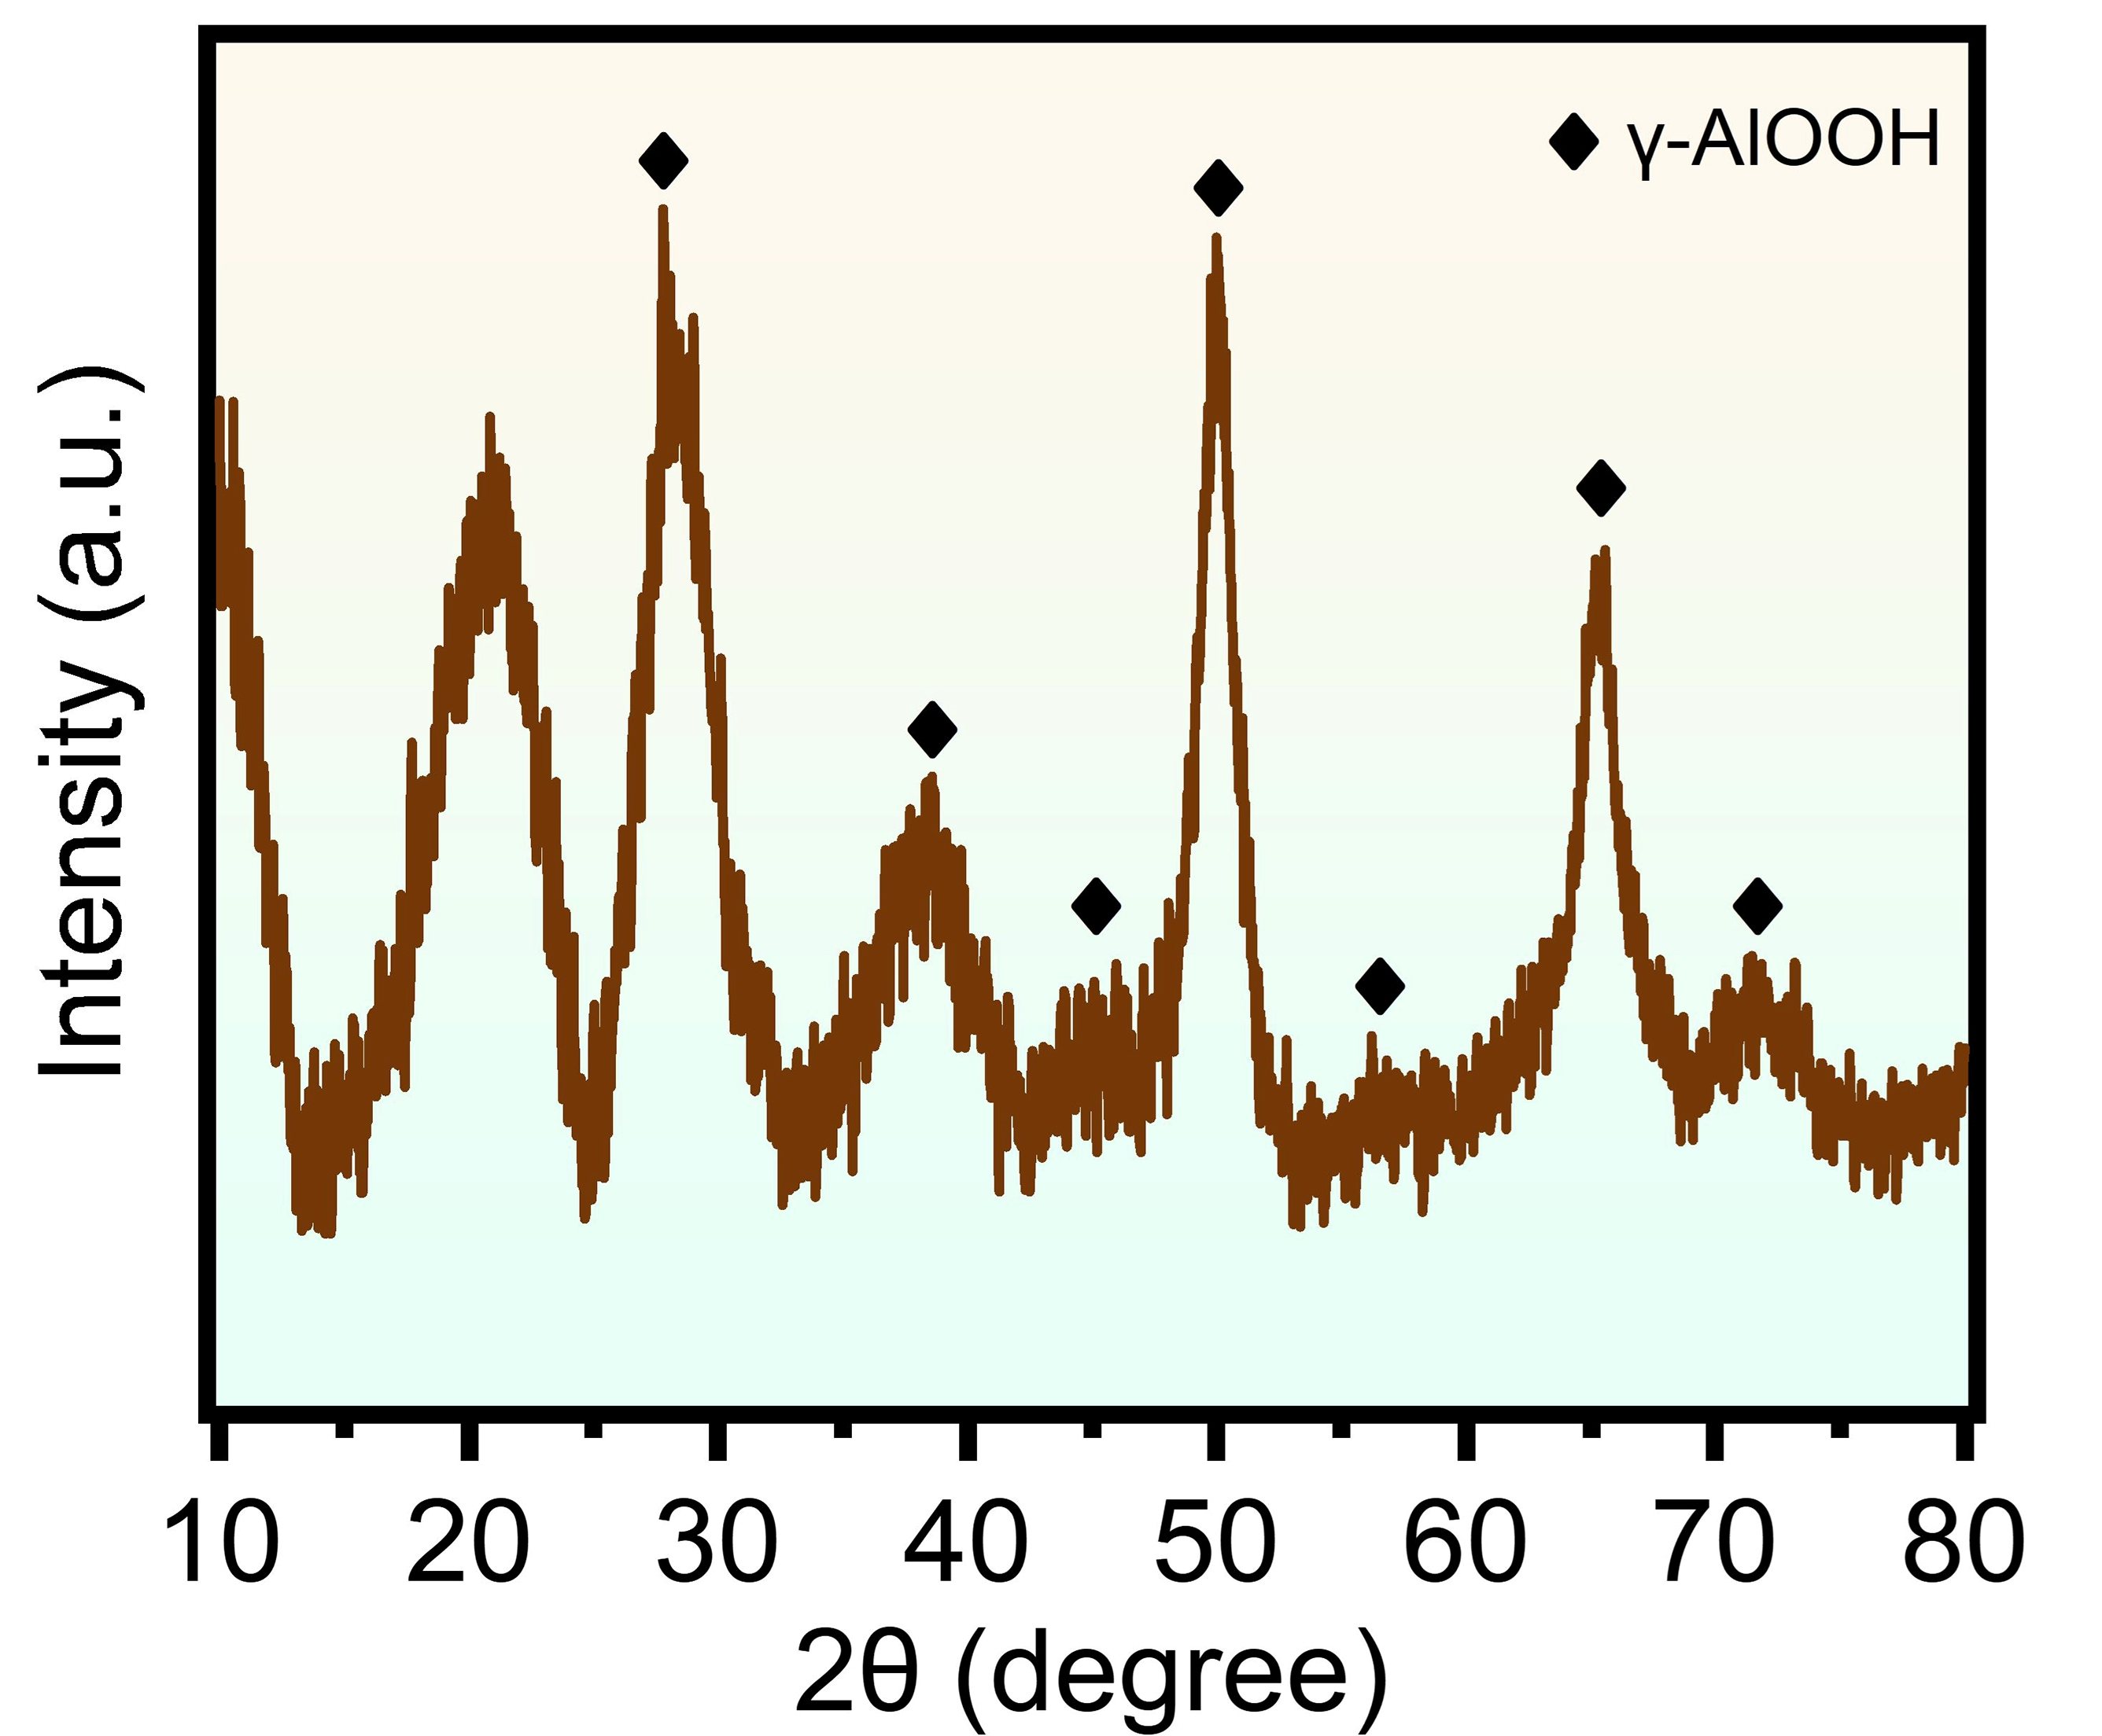
Fig. S6 XRD pattern of Al₂O₃ aerogel

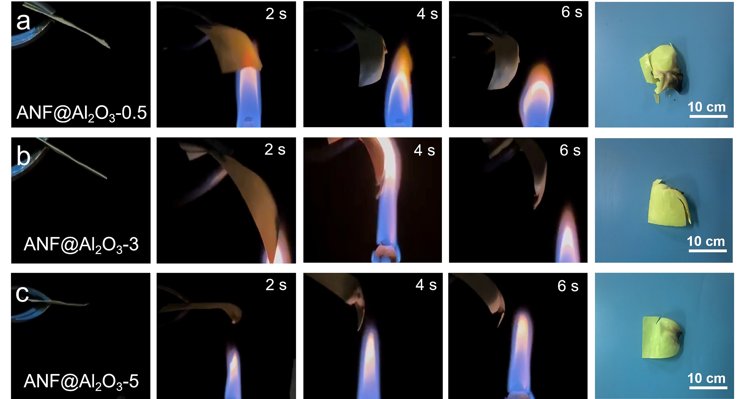
Fig. S7 Flame resistance and post-combustion morphology of a ANF@Al₂O₃-0.5, b ANF@Al₂O₃-3, and c ANF@Al₂O₃-5

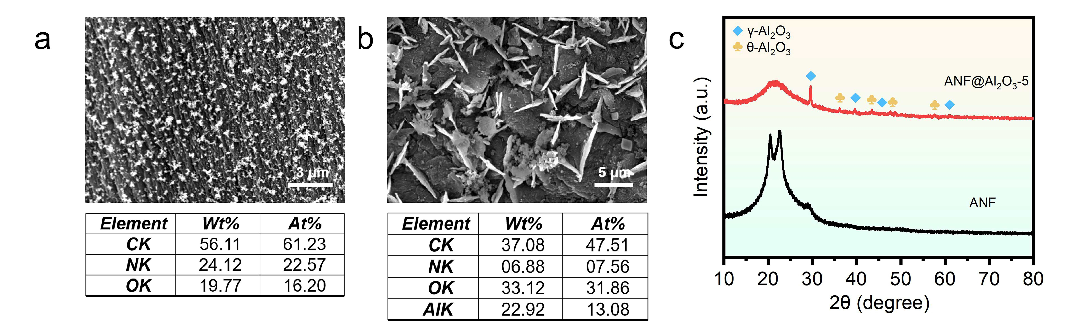
Fig. S8 SEM images and elemental compositions of a ANF and b ANF@Al₂O₃-5 after heating with an alcohol lamp; c XRD patterns of ANF and ANF@Al₂O₃-5 after heating with an alcohol lamp

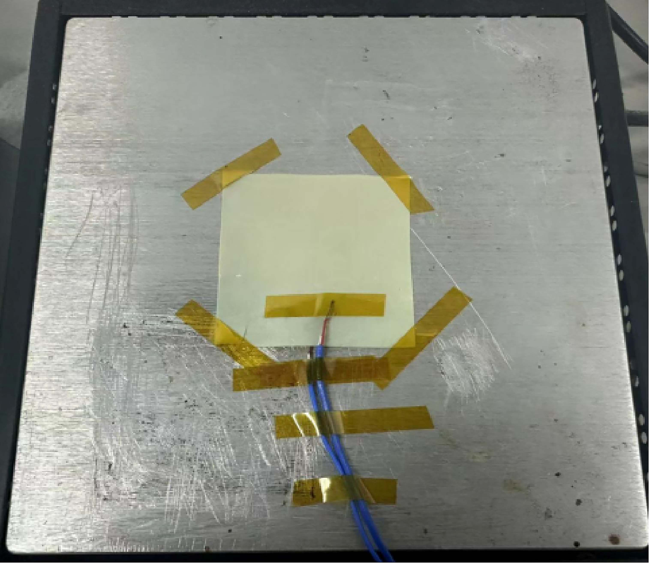
Fig. S9 Photograph of ANF@Al₂O₃ placed on the heating plate

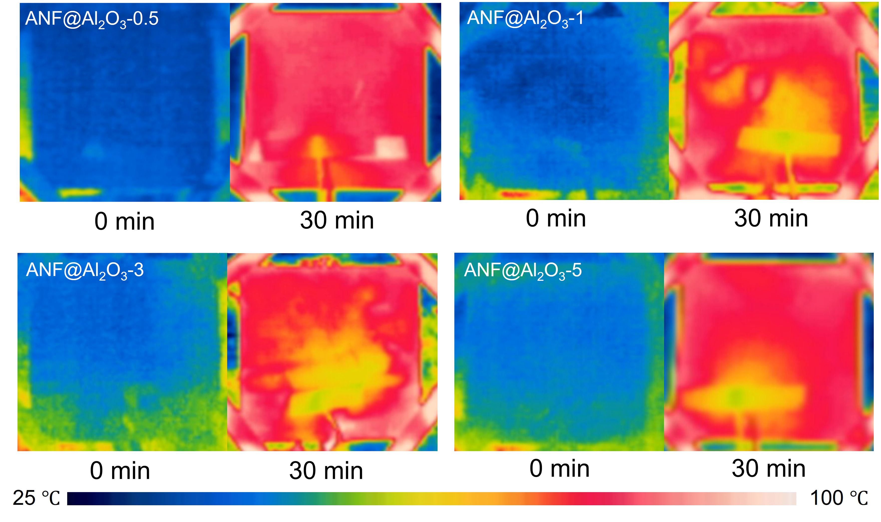
Fig. S10 Infrared thermal images showing temperature changes of ANF@Al₂O₃-0.5, 1, 3, and 5 before and after 30 min of heating

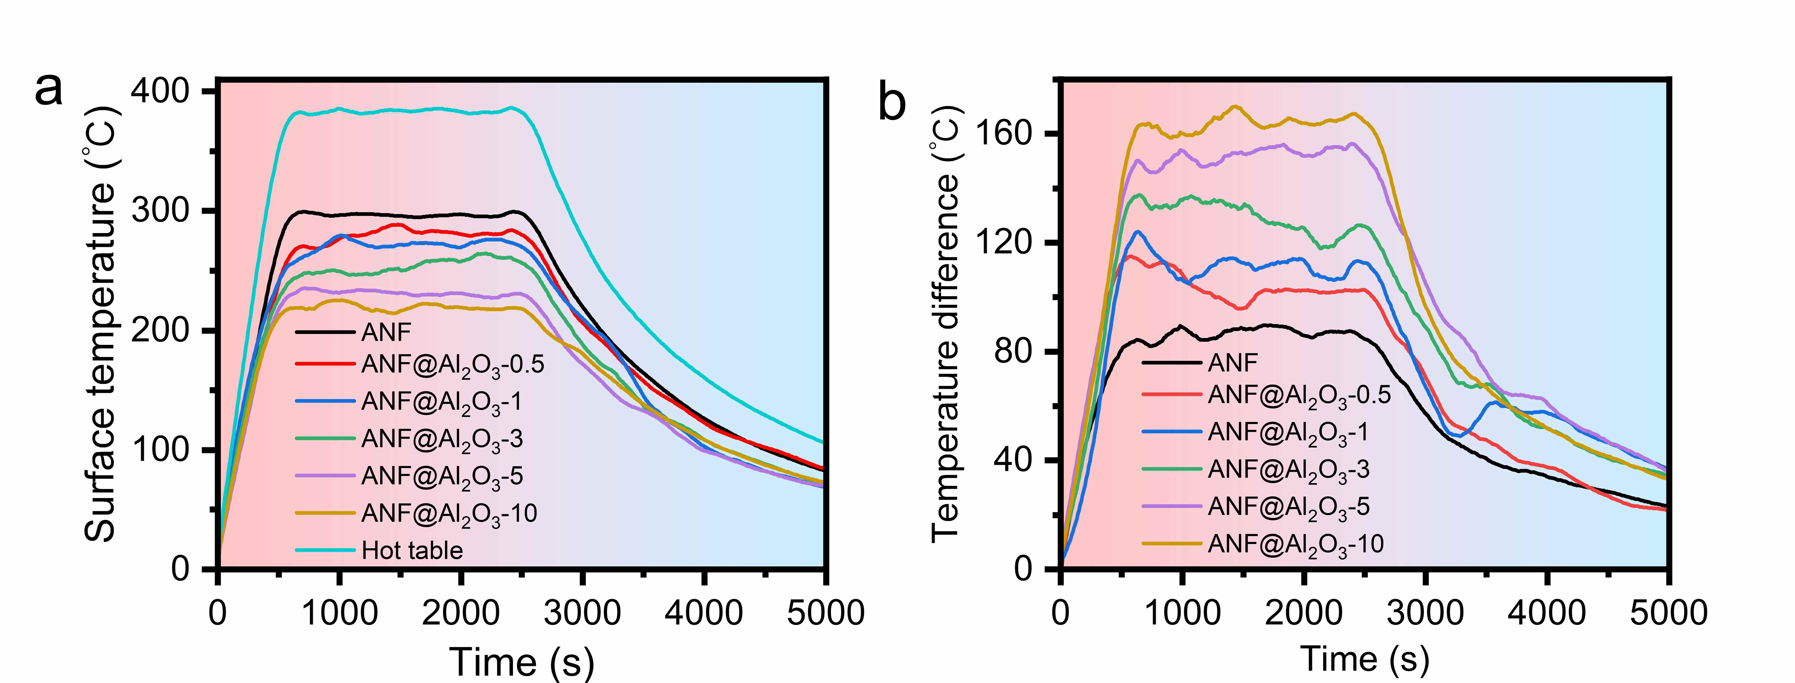
Fig. S11 a Surface temperature profiles of ANF and ANF@Al₂O₃ aerogels during heating on a 400 °C hot plate; b Temperature differences between the surfaces of ANF and ANF@Al₂O₃ relative to the 400 °C hot plate

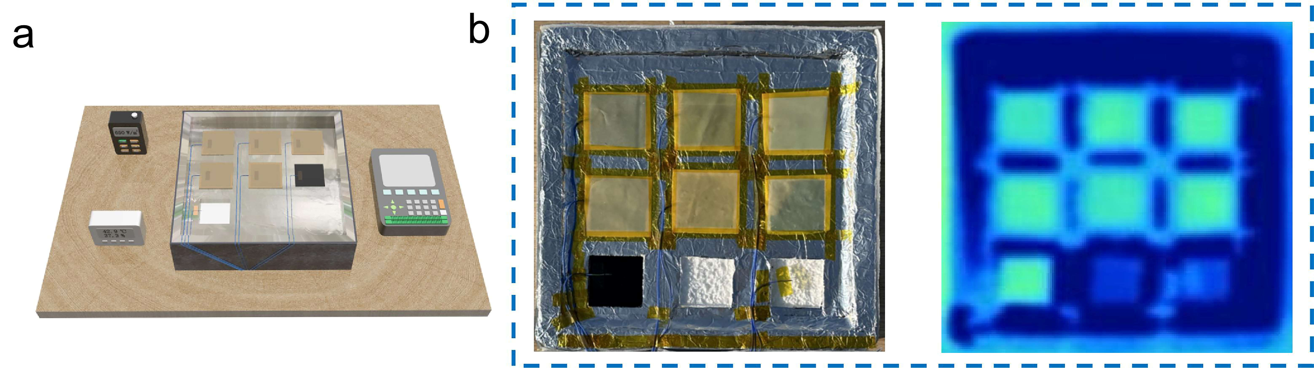
Figure S12. a Enlarged view of the device; b Photograph and infrared image during solar heating
.

2. Supporting Table
Table S1 Synthesis parameters and composition of ANF@Al₂O₃-n aerogels
Sampleª | Al sol (g) | ANF sol (g) | Mass fraction (wt.%)
ANF | 0.000 | 40.000 | 0
ANF@Al₂O₃-0.5 | 1.614 | 38.386 | 7.1
ANF@Al₂O₃-1 | 3.228 | 36.772 | 8.8
ANF@Al₂O₃-3 | 9.684 | 30.316 | 12.6
ANF@Al₂O₃-5 | 16.140 | 23.860 | 32.0
ANF@Al₂O₃-10 | 32.925 | 7.075 | 39.3

ª the weight percentage of Al₂O₃ were calculated by the Equation:
where M indicates molecular weight and m stands for mass.

Table S2 Specific surface area and pore structure of ANF@Al₂O₃-n aerogels
Sample | BET specific surface areas (m²/g) | BJH adsorption pore volumes (cm³/g) | BJH adsorption average pore diameters (nm) | Micropore volumes (cm³/g) | Micropore specific surface areas (m²/g)
ANF | 392.18 | 0.97 | 18.97 | 0.013 | 38.08
ANF@Al₂O₃-0.5 | 292.53 | 1.58 | 32.74 | 0.011 | 34.49
ANF@Al₂O₃-1 | 279.85 | 0.73 | 18.28 | 0.006 | 23.56
ANF@Al₂O₃-3 | 278.97 | 0.56 | 15.41 | 0.008 | 22.02
ANF@Al₂O₃-5 | 245.79 | 0.47 | 15.69 | 0.006 | 19.95
ANF@Al₂O₃-10 | 178.10 | 0.34 | 16.37 | 0.005 | 16.18
Al₂O₃ | 393.09 | 3.55 | 3.054 | 3.065 | -

Table S3 Elemental composition of ANF@Al₂O₃-n aerogels
Sample | Wt%
Sample | C | N | O | Al | Cl | Ca
ANF | 59.63 | 13.29 | 10.89 | 0.00 | 11.38 | 4.80
ANF@Al₂O₃-0.5 | 55.14 | 14.11 | 18.13 | 1.37 | 3.60 | 7.64
ANF@Al₂O₃-1 | 42.45 | 14.59 | 14.91 | 2.14 | 8.38 | 17.52
ANF@Al₂O₃-3 | 46.98 | 8.72 | 17.39 | 5.27 | 7.91 | 13.73
ANF@Al₂O₃-5 | 47.08 | 9.16 | 23.61 | 7.44 | 4.92 | 7.79
ANF@Al₂O₃-10 | 22.05 | 8.33 | 20.78 | 17.26 | 9.43 | 22.15
Al₂O₃ | 7.20 | 0.00 | 44.64 | 48.15 | 0.00 | 0.00
Sample | At%
Sample | C | N | O | Al | Cl | Ca
ANF | 70.57 | 13.49 | 9.68 | 0.00 | 4.56 | 1.70
ANF@Al₂O₃-0.5 | 64.89 | 14.24 | 16.02 | 0.72 | 1.44 | 2.70
ANF@Al₂O₃-1 | 56.45 | 16.63 | 14.89 | 1.27 | 3.78 | 6.98
ANF@Al₂O₃-3 | 61.29 | 9.76 | 17.03 | 3.06 | 3.50 | 5.37
ANF@Al₂O₃-5 | 58.88 | 9.82 | 22.16 | 4.14 | 2.09 | 2.92
ANF@Al₂O₃-10 | 35.39 | 11.47 | 25.03 | 12.33 | 5.13 | 10.65
Al₂O₃ | 11.59 | 0.00 | 53.92 | 34.49 | 0.00 | 0.00

Table S4 Mechanical properties of ANF@Al₂O₃-n aerogels
Sample | Tensile elongation at break (%) | Tensile strength (MPa) | Elastic modulus (MPa) | Increase in elastic modulus (%)
ANF | 10.250 | 1.129 | 19.862±2.808 | 0
ANF@Al₂O₃-0.5 | 5.460 | 1.150 | 36.316±2.080 | 82.840
ANF@Al₂O₃-1 | 3.197 | 0.979 | 38.179±1.032 | 92.221
ANF@Al₂O₃-3 | 1.650 | 0.690 | 41.869±3.800 | 110.799
ANF@Al₂O₃-5 | 1.888 | 0.416 | 25.415±1.668 | 27.955
ANF@Al₂O₃-10 | 1.102 | 0.238 | 24.088±3.141 | 20.873

Table S5 Transmittance of ANF@Al₂O₃-n aerogels in the visible range, near-infrared range, and across the full spectral range
Sample | %T
Sample | 380-780 nm | 780-2500 nm | 380-2500 nm
ANF | 41.94 | 89.32 | 80.93
ANF@Al₂O₃-0.5 | 33.88 | 89.27 | 78.81
ANF@Al₂O₃-1 | 37.39 | 90.56 | 80.05
ANF@Al₂O₃-3 | 38.11 | 89.06 | 79.34
ANF@Al₂O₃-5 | 40.23 | 90.42 | 80.95
ANF@Al₂O₃-10 | 34.17 | 90.77 | 80.28

Table S6 The average temperature of each sample under solar heating from 10:30 to 14:00
Sample | Average temperature from 10:30 to 14:00 (℃)
ANF | 41.62
ANF@Al₂O₃-0.5 | 43.44
ANF@Al₂O₃-1 | 43.92
ANF@Al₂O₃-3 | 45.56
ANF@Al₂O₃-5 | 46.62
ANF@Al₂O₃-10 | 50.46
Black glass plate | 39.14
Ambient | 29.33

Table S7 Density of ANF@Al₂O₃-n polymer solution
Sample | Polymer density (g/cm³)
ANF | 1.44±0.01
ANF@Al₂O₃-0.5 | 1.46±0.03
ANF@Al₂O₃-1 | 1.49±0.02
ANF@Al₂O₃-3 | 1.60±0.02
ANF@Al₂O₃-5 | 1.73±0.03
ANF@Al₂O₃-10 | 2.20±0.04

