Supplementary Information

Synthesis of the Photocatalysts:
PCN was synthesized by the polymerization reaction of cynauric acid-melamine super-molecular assembly under high temperature. In a typical synthesis, 5 gram cynauric acid and 5 gram melamine was mixed with 180 mL water and 20 mL isopropyl alcohol, and magnetically stirred for 24 hours. The white precursor was then collected by centrifugation and dried in vacuum overnight. Dry precursor was calcined at 600 ºC for 3 hours with temperature ramping rate of 5 ºC/min in nitrogen flow. The as prepared yellow sample was washed with water, ethanol, and dried in vacuum oven over night, and then pulverized by ball milling.
Grafting of the sodium cyanaminate moiety on the polymeric carbon nitride framework was realized by molten salt treatment. In a typical synthesis, 1 g PCN and 2 g NaSCN was mixed with a small amount of water for improving the contact of the salt and PCN. The mixture was then dried in vacuum overnight before subject to 400 ºC heating in a tube furnace with nitrogen flow. PCN-NaCA-1, PCN-NaCA-2, and PCN-NaCA-3 was, respectively, prepared by mixing 0.5, 1, and 2 gram of NaSCN with 1 gram PCN under the otherwise same reaction condition.
mpg-C₃N₄ was synthesized via reported method. In a typical synthesis, 3 gram cyanamide (Sigma-Aldrich) was dissolved in 7.5 g SiO₂ colloid in aqueous suspension (Ludox HS40, Sigma-Aldrich) in a 20 mL glass vial. The transparent liquid mixture was magnetically stirred and heated with oil bath at 70 ºC overnight. The solid mixture in the glass vial was then transferred into a ceramic crucible with lid. The crucible was heated in a muffle furnace at 823 K for 4 hours under nitrogen flow, and the temperature ramping rate was 2.3 K/min. The as-obtained powder was pulverized and immersed in 4 M NH₄HF₂ solution for 24 h for template removal, followed by repeated washing with distilled water and ethanol. The powder was finally dried at 323 K under vacuum.

General Procedure of the Photocatalytic Reactions:

Batch Photocatalytic Reaction:
The photocatalytic hydrogen peroxide production reactions were conducted in jacketed glass reactor filled with 50 mL glycerol aqueous solution (0.38 M) and catalyst. The pH of the mixture was adjusted by KOH or HClO₄ to the expected value. The photoreactor was irradiated by solar simulator with energy density of 100 mW/cm² on the outer-surface of the jacketed reactor. The reaction mixture was sampled at specific time intervals.

Continuous Serial Micro-Batch Reaction:
Two peristaltic pumps were used to feed the photocatalyst suspension and gaseous oxygen. A T-shaped mixing device was used to connect the oxygen feeding tubing and reaction mixture feeding tubing. Continuous gas-solid-liquid triphasic mixture segments are produced and pushed into a coil reactor made of PTFE tubing (Φ1.6 x 3.2 mm) with volume of 92 mL. A column LED array (Household White Light LED column) is placed coaxially inside the coil reactor. The sample was collected with a flask at the end of the flow reactor (Figure S1).
Reaction mixture preparation: photocatalyst was dispersed in 1000 mL glycerol aqueous solution with concentration of 0.38 M by ultrasonication for 30 min in dark. The reaction mixture was magnetically stirred during pumping.

Hydrogen Peroxide Concentration Measurement:
The concentration of the hydrogen peroxide was determined with DPD/POD method reported elsewhere, which is based on the horsedish peroxides (POD)-catalyzed oxidation of N, N-diethyl- p-phenylenediamine (DPD) by hydrogen peroxide. The calibration curve is prepared with a series of H₂O₂ solutions with known concentrations. The concentration of the standard H₂O₂ solution was determined by KMnO₄ titration, and Na₂C₂O₄ standard solution was employed for the analysis of the concentration of the titrant (KMnO₄ solution).

Apparent Quantum Yield (AQY) Measurement:
Reaction mixture was prepared by ultra-sonication dispersion of 10 mg PCN-NaCA-2 in 35 mL glycerol aqueous solution with concentration of 0.38 mol/L. 2 mL of the oxygen saturated reaction mixture was added into a quantz cuvette, which was capped by septum and wrapped by aluminum foil with a 1 cm² window. The cuvette was then subject to monochromatic light irridiation for a short time duration, e.g. λ = 380 nm, 420 nm light irradiation for 0.5 min, 450 nm light irradiation for 3 min, 475 nm, 500 nm, and 550 nm light irradiation for 30 min.
The amount of photons (Mp) absorbed by the photocatalyst was calculated by the equation:
$$\text{Mp}\text{ = }\frac{{\text{P}}_{\text{λ}}\text{ ×}\text{a}\text{ × }\text{t}}{{\text{E}}_{\text{λ}}\text{ ×}{\text{N}}_{\text{A}}}\text{ ×(1- }{\text{10}}^{\text{-}\text{A}}\text{)}$$
P_{λ} is the power density on the surface of the cuvette; a is the area of the window on the cuvette (0.0001 m²); t is the irradiation time (s); E_{λ} is the energy per photon; N_{A} is Avogadro’s constant ($6.02 × {10}^{23} {mol}^{-1}$); A is the absorbance of the cuvette with reaction mixture at λ nm on UV-Vis spectrometer with the water as the background.
The apparent quantum yield (AQY) was calculated by the equation:
$$\text{AQY =} \frac{\text{ 2×Amount of }{\text{H}}_{\text{2}}{\text{O}}_{\text{2}}}{{\text{M}}_{\text{p}}}\text{ × 100 \%}$$
Characterizations:
FT-IR spectra was collected on Thermo Scientific Nicolet iS 50 with diamond attenuate total reflection (ATR) unit. The morphology of the catalyst samples were determined by scanning electron microscope (SEM) and high resolution transmission electron microscope (HRTEM) on Hitachi S4300 and JEOL 2100, respectively. X-ray diffraction patterns of the catalysts were obtained on a Rigaku D/MAX 2500 diffractometer with Cu radiation (Cu Kα=0.15406 nm). X-ray photoelectron spectroscopy (XPS) patterns was recorded on an ESCA laboratory 220i-XL spectrometer with an Al Kα (1486.6 eV) X-ray source and a charge neutralizer; all the binding energy were calibrated to C 1s peak at 284.6 eV. BET surface area was measured via nitrogen sorption at 77 K on a surface area analyzer (QuadraSorb SI); the samples were degassed at 200 ºC before nitrogen adsorption. Contents of nitrogen and carbon in the sample was analyzed with vario El cube (Elementar, Germany). The UV-Vis absorbance property the samples was recorded on Shimazu UV-2600.

Ultrafast spectroscopy measurement:
The fs-TAS data was collected on a commercial transient absorption spectrometer (HELIOS, Ultrafast systems). The laser was generated by the 1 kHz Astrella (Coherent Corp.) Ti:sapphire regenerative amplifier (800 nm) and was split to generate pump and probe pulses. The pump pulse passed a TOPAS-Prime (Light Conversion, Ltd.) optical parametric amplifier to generate the 365 nm excitation pulse. The energy density of the excitation pulse was tuned by a natural density filter wheel. The probe light was generated by focusing the 800 nm light through a sapphire crystal. The time resolution of this setup was 120 fs.
Sample preparation:
20 mg sample was dispersed in 20 mL glycerol aqueous solution with concentration of 0.38 M. The suspension was ultrasonicated for 12 h, and then centrifuged at a rotation speed of 5000 rpm for 10 min to remove the large carbon nitride aggregates. The homogeneous suspension was subjected to fs-TAS measurement. The aerobic experiments were conducted with oxygen-saturated suspension; and the anaerobic experiments was conducted with high-vacuum treated suspension.

SPV and TPV measurement:
The SPV spectra measurement was conducted based on the lock-in amplifier., The measurement system consists of a 500 W xenon lamp with monochromator (SBP500, Zolix) as light sourve, a lock-in amplifier (SR830, Stanford Research Systems, Inc.) with a light chopper (SR540, Stanford Research Systems, Inc.), and a sample chamber. The monochromatic light was chopped with a frequency of 23 Hz. The monochromator and the lock-in amplifier were controlled by a computer. The input resistance of the lock-in amplifier is 10 MΩ. SPV spectra were carried out by scanning from low photon energy to high.
The TPV measurement system consists of a Nd:YAG laser source (Polaris II, New Wave Research, Inc.) providing 355 nm laser pulse radiation (pulse width 5 ns), a 500 MHz digital phosphor oscilloscope (TDS 5054, Tektronix) with a preamplifier, and a sample chamber. The oscilloscope was triggered by a synchronous signal provided by a photomultiplier. The input resistance of the preamplifier is 100 MΩ.

Mott–Schottky plots measurement
The sample film was applied on the FTO electrode by spin coating. The slurry was prepared by mixing 20 mg catalyst, 2.7 mL of isopropyl alcohol, 0.9 mL H₂O, and 40 μL Nafion solution (5%, Sigma-Aldrich) under ultrasonication. The impedance-potential values for Mott–Schottky plots were measured in nitrogen-saturated 0.2 M Na₂SO₄ with Ag/AgCl as the reference electrode and Pt as the counter electrode. The data was collected in the voltage range of –0.5 V to +1.3 V at 1000 Hz frequency.

Electrochemical oxygen reduction reaction (ORR) performance measurement:
The electrochemical ORR performance is evaluated on a CHI 760E workstation equipped with PINE rotating ring disk electrode (RRDE) unit. The electrochemical system setup is assembled on the basis of three-electrode configuration consisting of catalyst-coated RRDE working electrode, Ag/AgCl reference electrode, Pt/C counter electrode, and O₂-saturated 0.1 M KOH electrolyte. The working electrode is fabricated by a traditional “drop-casting” method. Specifically, the ink was prepared by mixing 5 mg of catalyst, 750 μL of isopropyl alcohol, 250 μL of water, and 10 μL of Nafion solution (5%) under ultrasonication. Next, 10 μL ink was dropped onto the surface of electrode and dried in air under room temperature. The loading of the catalyst on RRDE electrode is 0.202 mg cm⁻².
The RRDE has an electrode area of 0.2475 cm² for disk electrode, 0.1866 cm² for ring electrode, and a collection efficiency of 37%. The cathodic current density come from disk current normalized by electrode area (0.2475 cm²), and the anodic current density come from ring current normalized by ring electrode area (0.1866 cm²) and collection efficiency (37%).
H₂O₂ production selectivity ($S_{H_{2}O_{2}}$) is calculated according to the following formula:
$${\text{S}}_{{\text{H}}_{\text{2}}{\text{O}}_{\text{2}}}\text{=2×}\frac{\frac{{\text{I}}_{\text{r}}}{\text{N}}}{{\text{I}}_{\text{d}}\text{+}\frac{{\text{I}}_{\text{r}}}{\text{N}}}\text{×100\%}$$
Where N is the collection efficiency, I_{r}/N is the normalized ring electrode current, I_{d} is disk electrode current.

Density functional theory (DFT) calculation method:
The explored model is linear melon structure with infinite repeating unit with edge nitrogen saturated by hydrogen (for PCN) or replaced by cyanaminate sodium salt unit (for PCN-NaCA). The calculations were based on spin-polarized density functional theory (DFT) using projector augmented wave (PAW) methods, as implemented in the Vienna ab initial simulation package (VASP 5.2). A plane-wave basis set with 400 eV kinetic-energy cut-off was used to expand the wave function of valence electrons. The generalized gradient approximation (GGA) with the Perdew-Burke-Ernzerhof (PBE) functional was used for describing the exchange-correlation interactions.
In this work, we construct 1-D nano-line to module the PCN and PCN-NaCA. 20 Å vacuum space was set to prevent the interaction between adjacent nanolines. The Brillouin-zone integration was sampled with 5 × 1 × 1 k-points Monkhorst-Pack mesh. The structural relaxations were performed by computing the Hellmann–Feynman forces within the total energy and force convergences of 10⁻⁴ eV and 10⁻² eV/Å, respectively. The adsorption energy E_{ad} of interaction between the carbon nitride and oxygen molecule is calculated based on the following equation:
E_{ads} = E_{(CN+O2)} - E_{(CN)} - E_{(O2)}
where E_{(CN+O2)} and E_{(CN)} is, respectively, the total free energy of carbon nitride with and without dioxygen molecule, E_{(O2)} is the free energy of dioxygen molecule.
The electro-catalytic active sites and process of oxygen reduction reaction (ORR) on the surface of carbon nitride were examined by first-principle calculations. Only intermediate states in the ORR process were considered, and energy barriers might exist but were not considered in here. The calculation is based on the following reaction steps:
* + O₂ (g) = * O₂ (1)
* O₂ + H⁺ + e⁻ = * OOH (2)
* OOH + H⁺ + e⁻ = * + H₂O₂ (g) (3)

Where * represents the surface adsorption.

Supplemental Figures, Tables, and Notes

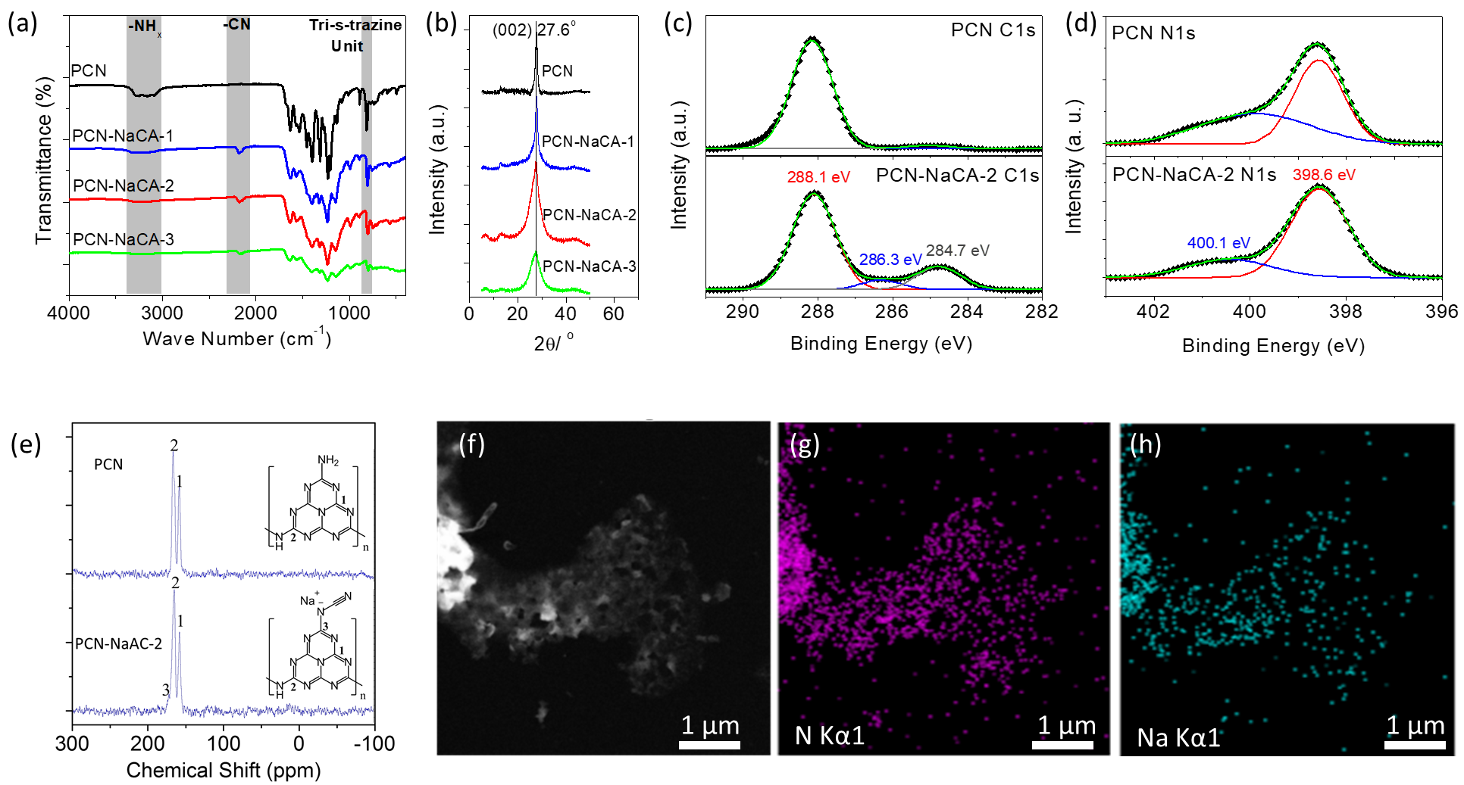
Figure S1. Characterization of the photocatalysts. (a) FT-IR spectra of the functional groups the photocatalysts. (b) X-ray diffraction patterns of the samples. (c, d), the chemical environment of the nitrogen and carbon analyzed by XPS. C_{1s} and N_{1s} XPS profiles of PCN and PCN-NaCA-2 and their respective deconvoluted peaks. (e) ¹³C-NMR spectra of PCN and PCN-NaCA-2. STEM image (f), EDS mapping of nitrogen (g) and sodium (h) of PCN-NaCA-2.

Interpretation of the characterizations:
FT-IR spectra: The absorption peak at 808 cm⁻¹ is due to the out-of-plane bending of the tri-s-triazine unit. For PCN, strong and broad absorption peak at 3000 cm⁻¹ to 3500 cm⁻¹ from the N-H stretching vibration is observed, stating the presence of rich amino groups. With the increase of the salt/PCN ratio (from PCN-NaCA-1 to PCN-NaCA-3), the asymmetric vibration peak of cyano group at 2175 cm⁻¹ grows, and the N-H vibration peak decreases simultaneously, demonstrating the conversion of the amino group to the cyanaminate moiety.
XRD patterns: The PCN presents a strong and sharp X-ray diffraction peak at 27.6 º, demonstrating the layer stacking structure on (002) direction with interlayer spacing of 0.33 nm. All PCN-NaCA-n samples present the same diffraction angle, i.e., the introduction of sodium cyanaminate moiety does not alter the interlayer spacing of the stackings. However, further polymerization reaction in molten salt changes the intensity and width of the diffraction peak. As compared to PCN, PCN-NaCA-2 shows much stronger and wider diffraction peak. This states that further polyerization reaction in the molten salt produces new carbon nitride layer stackings with much thinner thickness than that of PCN.
XPS profiles: For the sample PCN, C 1s peaks can be deconvoluted into three peaks at 288.1 eV, 286.3 eV, and 284.7 eV, which are respectively assigned to the N−C=N in the heptazine unit, the carbon atoms connected to −NH_{2/1} or cyano groups, and the adventitious carbon (C−C or C=C). In C_{1s} profile of PCN-NaCA-2, the percentage of the deconvoluted peaks at 286.3 eV increased. Based on the analysis on the FT-IR and ¹³C spectra, this intensified peak is repeatedly stating the formation of the cyanaminate moiety on the edge of the carbon nitride framework as well. The deconvoluted peak at 398.6 eV is assigned to the C-N=C in the heptazine unit; and peak at 400.1 eV is attributed to the tertiary N atoms (C-N₃), the N atoms in the amino group (-NH₂) at the edge conjugated plane, as well as the secondary amine (−NH−) moiety connecting two heptazine units. Comparing to sample PCN, the percentage of the 400.1 eV peak decreases, indicating the depletion of the amino group on the edge of the heptazine unit, which is consistent to the analysis in FTIR spectra, and should be the combined results of further polymerization reaction in the molten salt and the formation of the sodium cyanaminate moiety. The content of sodium in PCN-NaCA-2 is 3.99 (atom.) % as determined by XPS.
¹³C NMR spectra: In the ¹³C NMR spectra of PCN and PCN-NaCA-2, the peaks at 157 ppm and 164 ppm are assigned to the C(3N) and C(2N, NH_{x}), respectively. For the sample PCN-NaCA-2, there is an additional peak appearing at 171 ppm is assigned to the carbon connecting with the sodium cyanaminate moiety.
STEM-EDS: Uniform distribution of sodium in the matrix is observed.
Elemental Analysis: The C/N ratio of the framework is, respectively, 0.685 and 0.719 for PCN and PCN-NaCA-2.

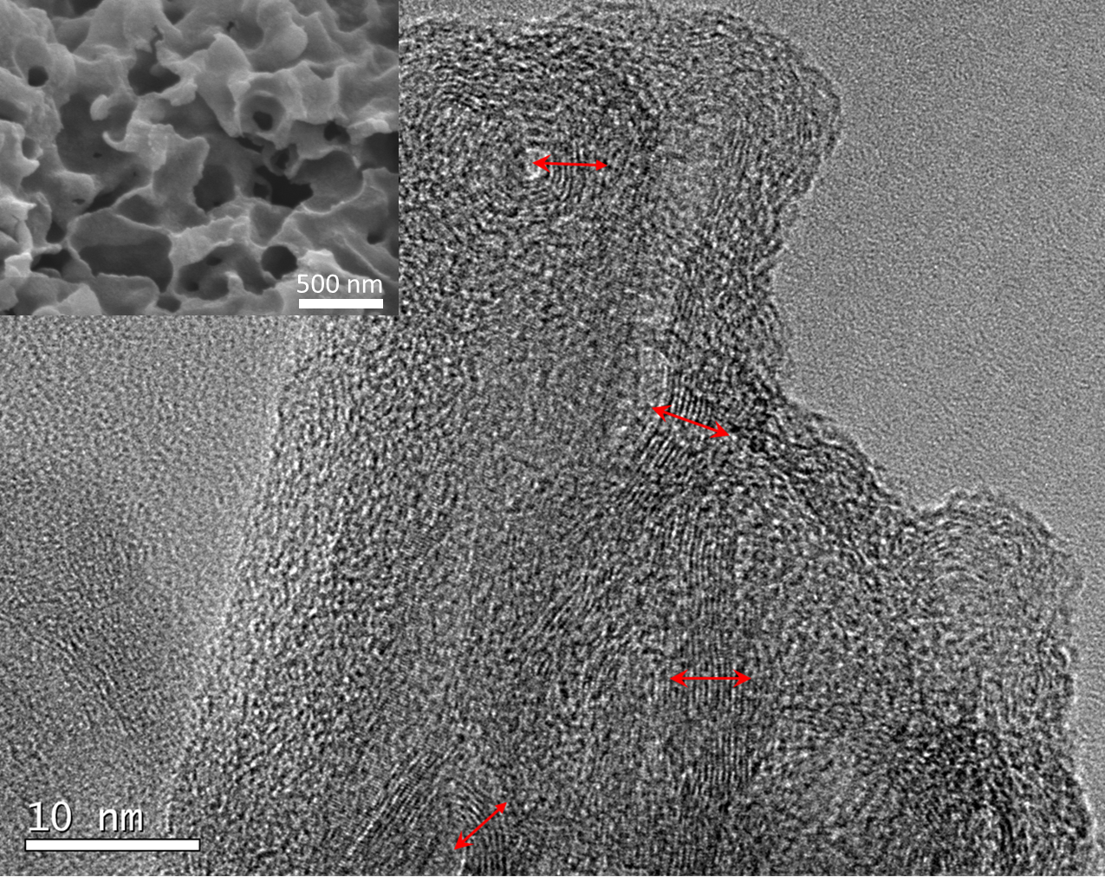
Figure S2. High resolution TEM (HRTEM) image of the PCN-NaCA-2. The image clearly shows the corrugated carbon nitride thin layers with a thickness of around 5 nm. Inset, SEM image PCN-NaCA-2, showing sheet-like morphology.

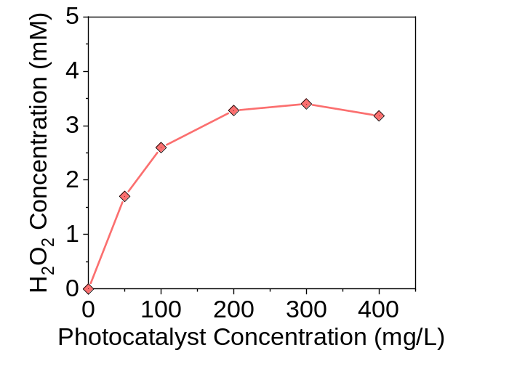
Figure S3. Photocatalytic H₂O₂ production performance of PCN-NaCA-2 in 50 mL batch photo-reactor with various photocatalyst concentrations. Reaction conditions, 50 mL aqueous suspension containing 10 mg PCN-NaCA-2 and 0.38 mol/L glycerol, 1 atm. O₂, irradiation with a solar simulator (100 mW/cm² on the outer-surface of the jacketed photo-reactor) for 1 hour.

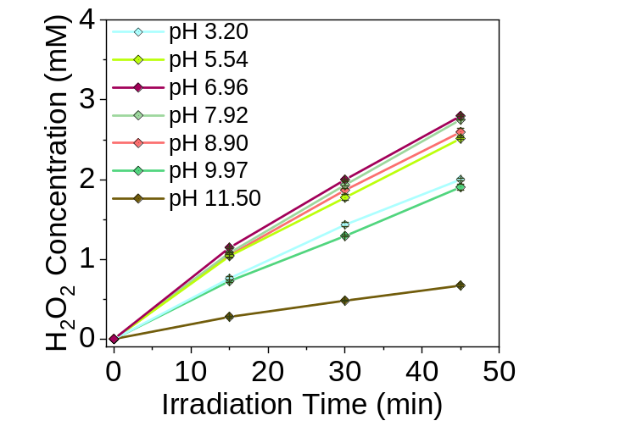

Figure S4. The impact of the initial pH value of the suspension on the performance of PCN-NaCA-2 in the photocatalytic H₂O₂ production. Reaction conditions, 50 mL aqueous suspension containing 10 mg PCN-NaCA-2 and 0.38 mol/L glycerol, 1 atm. O₂, irradiation with a solar simulator (100 mW/cm² on the outer-surface of the jacketed photo-reactor).

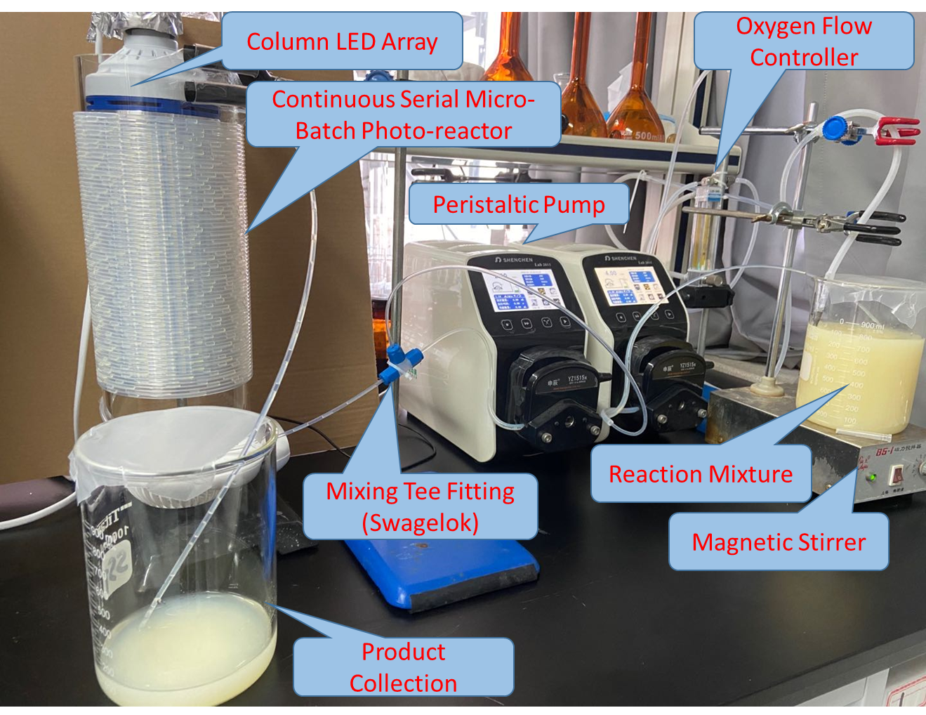
Figure S5. Photograph of the continuous serial micro-batch photo-reactor for 1 liter scale reaction.

Table S2. PL Lifetime of photo-induced charge carriers and their relative contribution in PCN and PCN-NaCA-2.
Sample | τ₁ | A₁ | τ₂ | A₂ | τ_{avg} (ns)
PCN | 1.35 | 0.447 | 9.10 | 0.553 | 8.27
PCN-NaCA-2 | 0.88 | 0.600 | 4.26 | 0.400 | 3.46
Notes: The samples were characterized by the time resolved photoluminescence spectroscope with a single photon picosecond laser at a wavelength of 355 nm. The PL decay curves was fitted exponentially using the following equation:
$$I\left(t\right)=A_{1}e^{-t/τ_{1}}+ A_{2}e^{-t/τ_{2}}$$
where, A1 and A2 represent the normalized amplitudes of each decay component, and τ₁ and τ₂ are values of the lifetime components, respectively. The average life time is calculated based on the following equation:
$$τ_{avg}=(A_{1}τ_{1}^{2}+A_{2}τ_{2}^{2})/(A_{1}τ_{1}+A_{2}τ_{2})$$

For carbon nitride, polymerization reaction continues in the molten salt, and the polymerization degree can be improved, as shown in XRD/HR-TEM data in Figures S1 and S2, and the reference.¹⁰ Increased polymerization degree leads to extended π-conjugated systems and delocalized π-electrons, and thus enhances the charge migration rate.¹¹ Therefore, on PCN-NaCA-2, the photo-induced charges can move to the trapping sites more efficiently, which results in the short PL decay lifetime.¹²

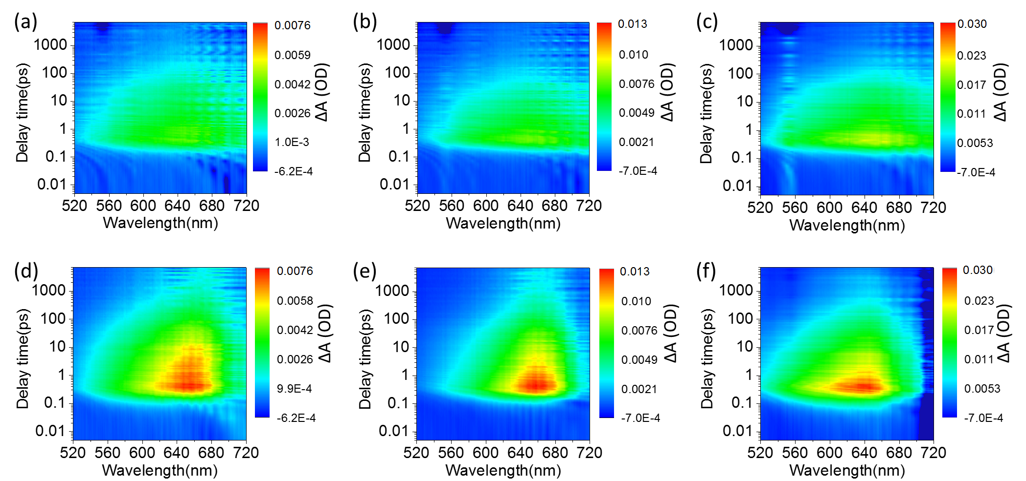
Figure S6. Femtosecond transient absorption spectra (fs-TAS) of PCN-NaCA-2 after excitation by 365 nm laser pulse with energy density of 35.8 (a,d), 79.6 (b, c), 278.7 (c, f) μJ/cm² in glycerol aqueous solution (0.38 M) under vacuum (a, b, and c) and in 1 atm. oxygen atmosphere (d, e, and f).

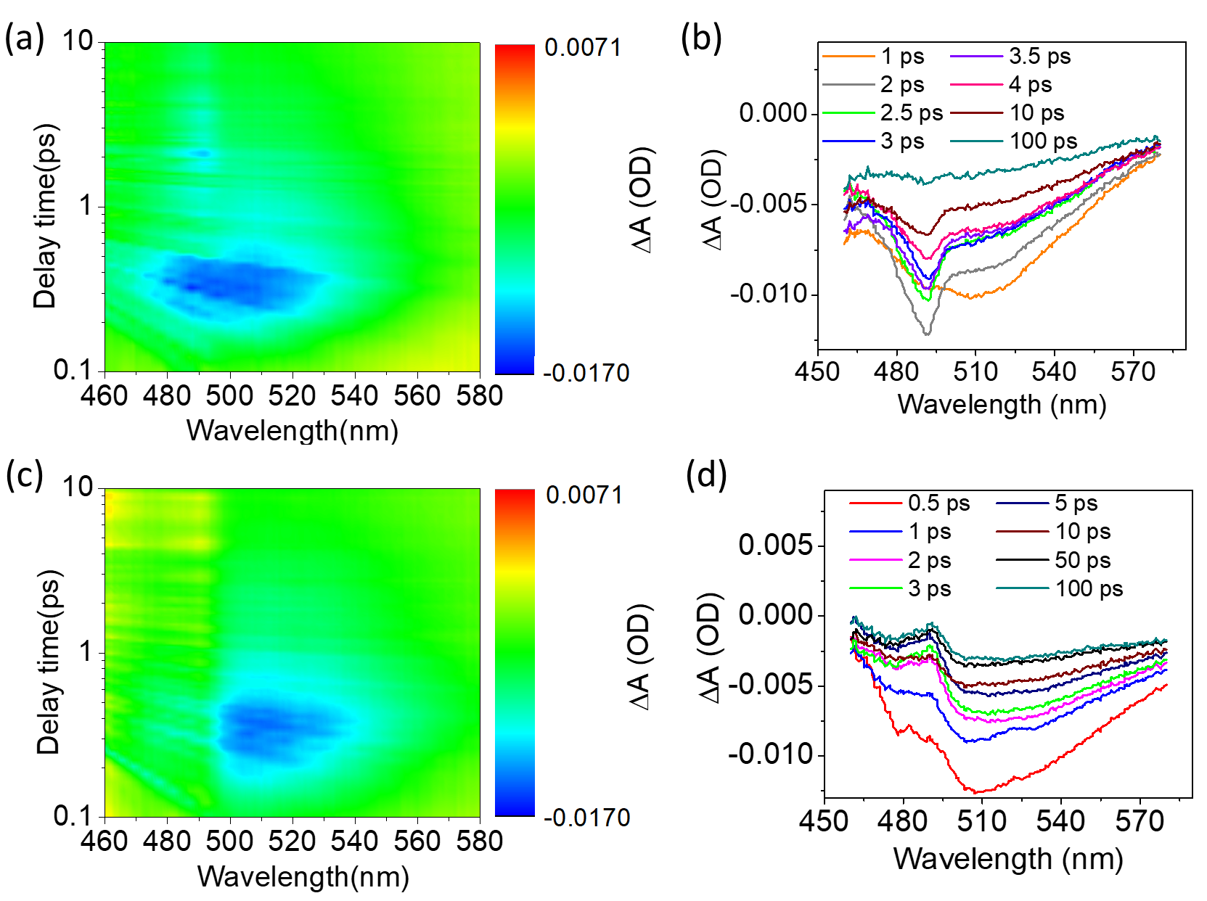
Figure S7. Femtosecond transient absorption spectra (fs-TAS) of PCN after excitation by 365 nm laser pulse with energy density of 278.7 μJ/cm² in glycerol aqueous solution (0.38 M) in oxygen (a, b) and under vacuum (c, d) conditions.

Figure S8. The decay kinetics of femtosecond transient absorption spectra (fs-TAS) bleach signal of the PCN after excitation by 365 nm laser pulse with energy density of 278.7 μJ/cm² in glycerol aqueous solution (0.38 M) in oxygen and under vacuum conditions.

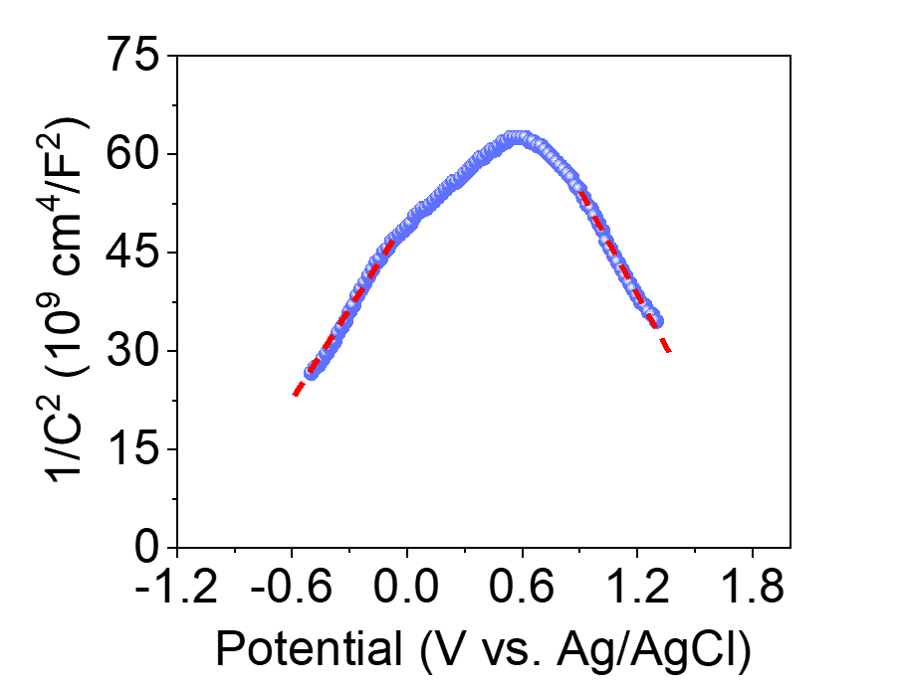

Figure S9. Mott-Schottky plots of PCN-NaCA-2 in dark at the frequency of 1000 Hz with a three-electrode system.

References

. Shalom, M., Inal, S., Fettkenhauer, C., Neher, D. and Antonietti, M. Improving Carbon Nitride Photocatalysis by Supramolecular Preorganization of Monomers. J. Am. Chem. Soc. 135, 7118-7121 (2013).
.Wang, X., Maeda, K., Chen, X., Takanabe, K., Domen, K., Hou, Y., Fu, X. and Antonietti, M. Polymer Semiconductors for Artificial Photosynthesis: Hydrogen Evolution by Mesoporous Graphitic Carbon Nitride with Visible Light. J. Am. Chem. Soc. 131, 1680-1681 (2009).
. Moon, G.-h., Kim, W., Bokare, A. D., Sung, N.-e. and Choi, W. Solar production of H₂O₂ on reduced graphene oxide–TiO₂ hybrid photocatalysts consisting of earth-abundant elements only. Energy Environ. Sci. 7, 4023-4028 (2014).
. Wei, X., Xie, T., Peng, L., Fu, W., Chen, J., Gao, Q., Hong, G. and Wang, D. Effect of Heterojunction on the Behavior of Photogenerated Charges in Fe₃O₄@Fe₂O₃ Nanoparticle Photocatalysts. J. Phys. Chem. C 115, 8637-8642 (2011).
. Jiang, T., Xie, T., Chen, L., Fu, Z. and Wang, D. Carrier concentration-dependent electron transfer in Cu₂O/ZnO nanorod arrays and their photocatalytic performance. Nanoscale 5, 2938-2944 (2013).
. Yu, H., Shi, R., Zhao, Y., Bian, T., Zhao, Y., Zhou, C., Waterhouse, G. I. N., Wu, L.-Z., Tung, C.-H. and Zhang, T. Alkali-assisted synthesis of nitrogen deficient graphitic carbon nitride with tunable band structures for efficient visible-light-driven hydrogen evolution. Adv. Mater. 29, 1605148 (2017).
. Gao, H., Yan, S., Wang, J., Huang, Y. A., Wang, P., Li, Z. and Zou, Z. Towards efficient solar hydrogen production by intercalated carbon nitride photocatalyst. Phys. Chem. Chem. Phys. 15, 18077-18084 (2013).
. Zhang, G., Li, G., Heil, T., Zafeiratos, S., Lai, F., Savateev, A., Antonietti, M. and Wang, X. Tailoring the Grain Boundary Chemistry of Polymeric Carbon Nitride for Enhanced Solar Hydrogen Production and CO2 Reduction. Angew. Chem. Int. Ed. 58, 3433-3437 (2019).
. Yu, H., Shi, R., Zhao, Y., Bian, T., Zhao, Y., Zhou, C., Waterhouse, G. I. N., Wu, L.-Z., Tung, C.-H. and Zhang, T. Alkali-Assisted Synthesis of Nitrogen Deficient Graphitic Carbon Nitride with Tunable Band Structures for Efficient Visible-Light-Driven Hydrogen Evolution. Adv. Mater. 29, 1605148 (2017). 10. Zhang, G., Lin, L., Li, G., Zhang, Y., Savateev, A., Zafeiratos, S., Wang, X. and Antonietti, M. Ionothermal Synthesis of Triazine–Heptazine-Based Copolymers with Apparent Quantum Yields of 60 % at 420 nm for Solar Hydrogen Production from “Sea Water”. Angew. Chem. Int. Ed. 57, 9372-9376 (2018). 11. Lin, L., Yu, Z. and Wang, X. Crystalline Carbon Nitride Semiconductors for Photocatalytic Water Splitting. Angew. Chem. Int. Ed. 58, 6164-6175 (2019). 12. Kumar, P., Vahidzadeh, E., Thakur, U. K., Kar, P., Alam, K. M., Goswami, A., Mahdi, N., Cui, K., Bernard, G. M., Michaelis, V. K. and Shankar, K. C₃N₅: A Low Bandgap Semiconductor Containing an Azo-Linked Carbon Nitride Framework for Photocatalytic, Photovoltaic and Adsorbent Applications. J. Am. Chem. Soc. 141, 5415-5436 (2019).

