Design, Synthesis, in-vitro Hydrolysis and Biological Evaluation of Antioxidant Conjugated Mutual Prodrugs of Ibuprofen
Rajat Goyal¹, Sumeet Gupta¹*, Prabodh Chander Sharma²
¹MM College of Pharmacy, Maharishi Markandeshwar (Deemed to be University), Mullana-Ambala, Haryana, 133207, India
²School of Pharmaceutical Sciences, Delhi Pharmaceutical Sciences and Research University (DPSRU), Government of NCT of Delhi, New Delhi, 110017, India

*Corresponding Address
Prof. (Dr.) Sumeet Gupta
Dean and Principal
MM College of Pharmacy,
Maharishi Markandeshwar (Deemed to be University),
Mullana-Ambala, Haryana, India-133207
Email ID: sumeetgupta25@gmail.com
Contact Number: +918059930156
Table of Contents

Spectral Data
IR, ¹H and ¹³C NMR and Mass spectra of synthesized ibuprofen prodrugs.
- IR Spectra

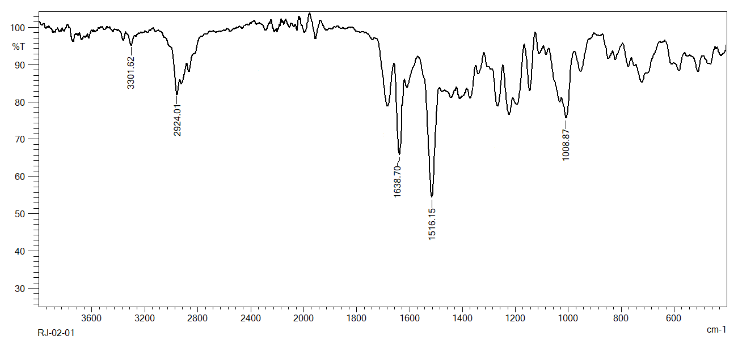
RJ-02-01
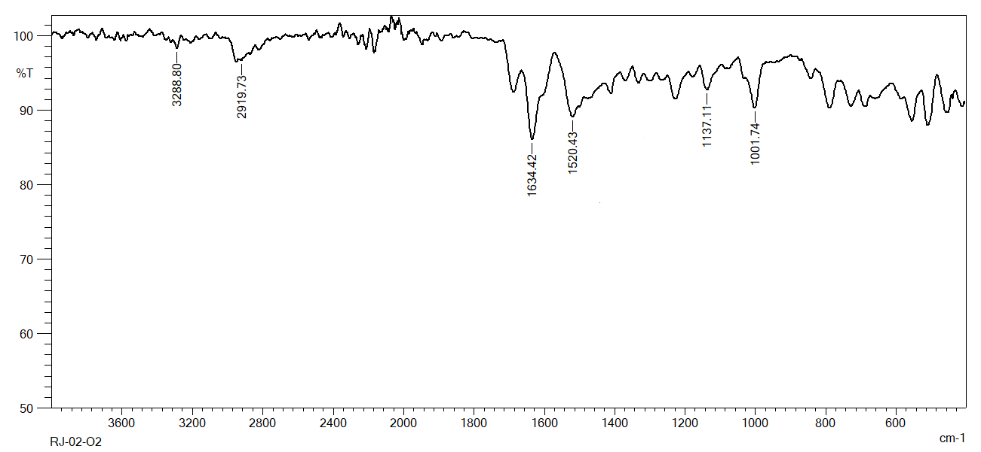
RJ-02-02
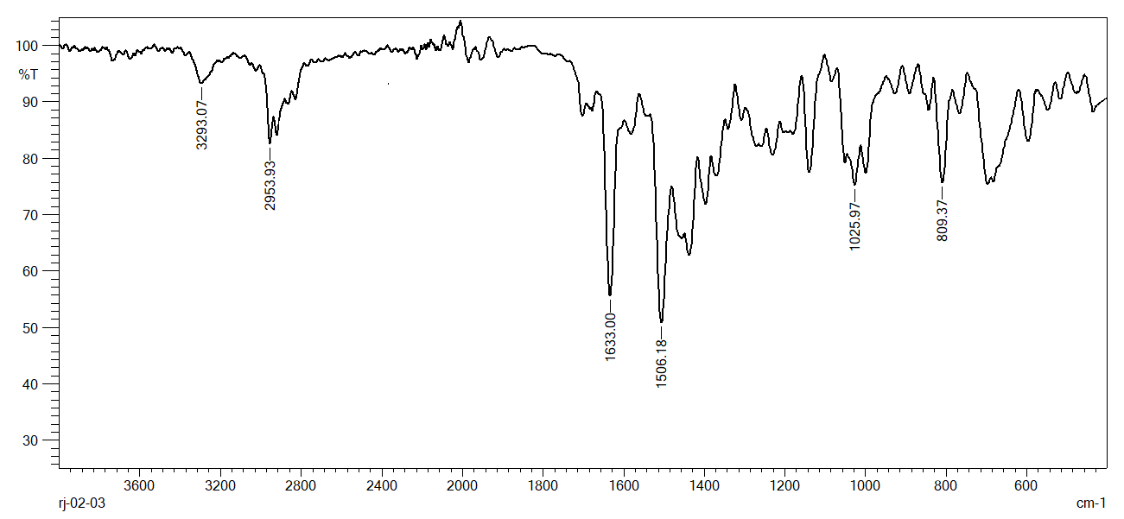
RJ-02-03
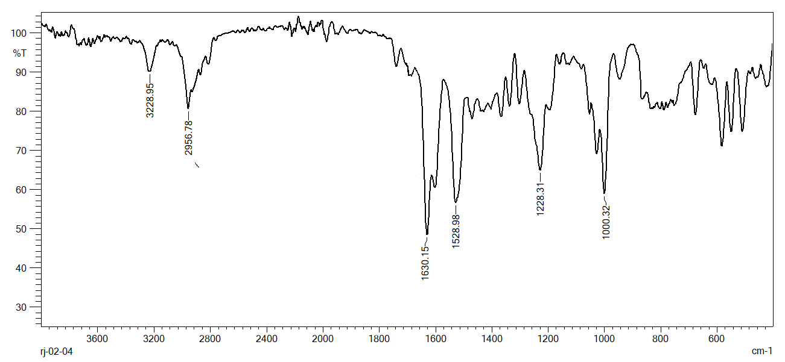
RJ-02-04
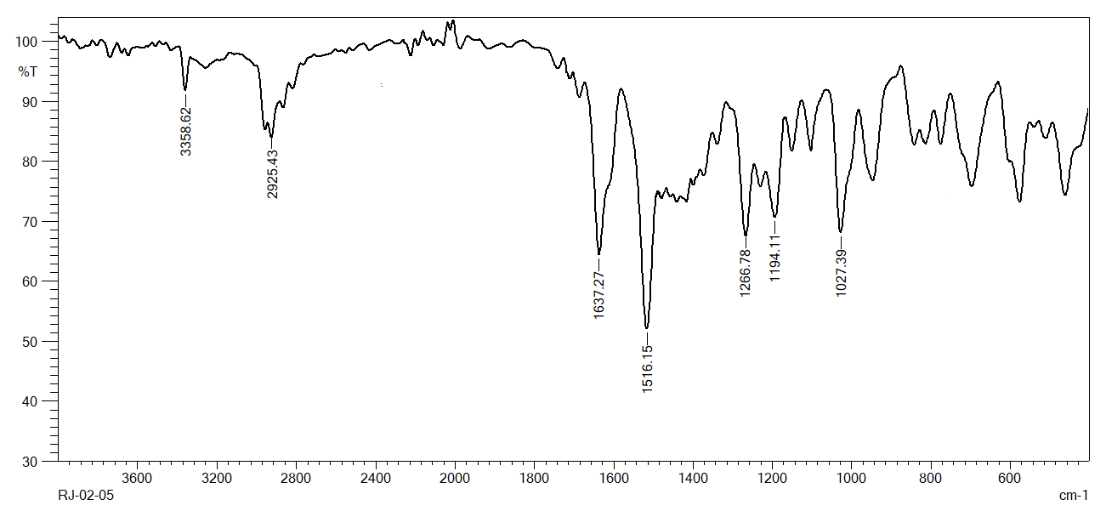
RJ-02-05
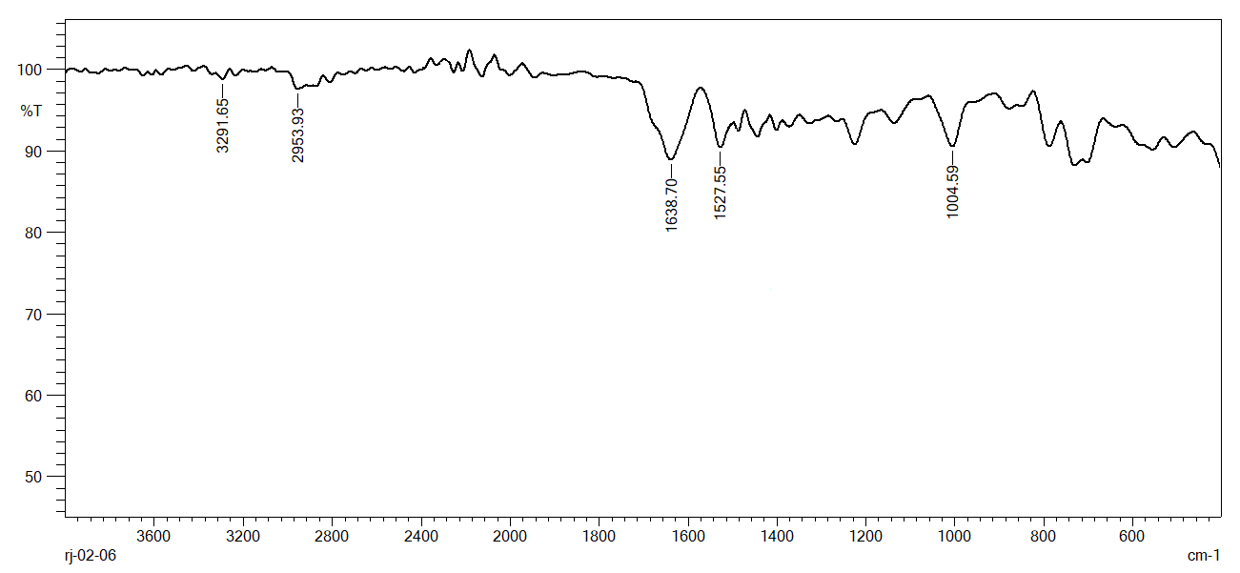
RJ-02-06
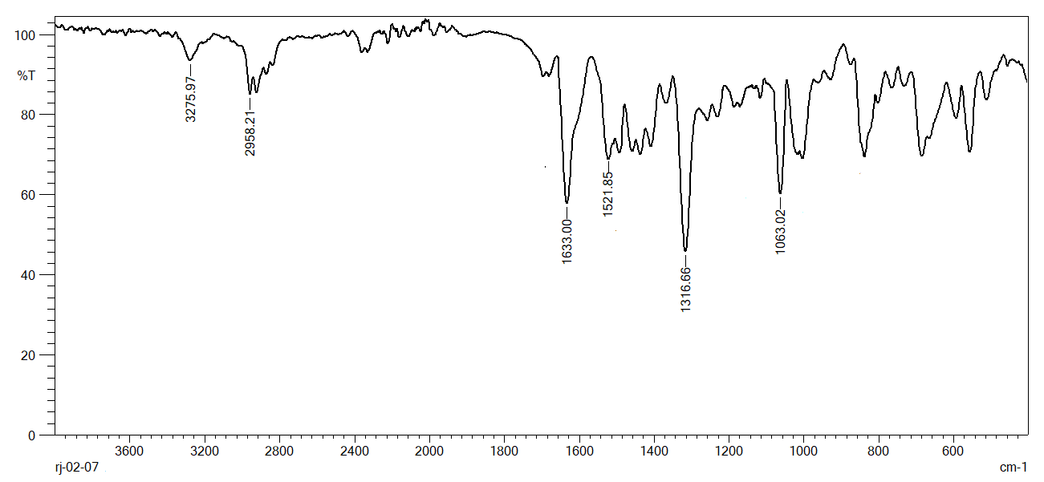
RJ-02-07
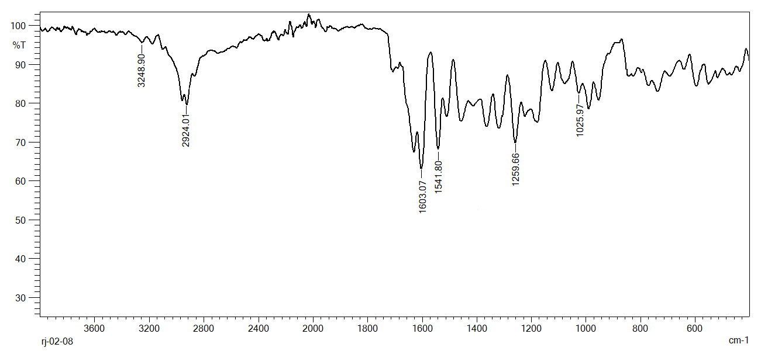
RJ-02-08
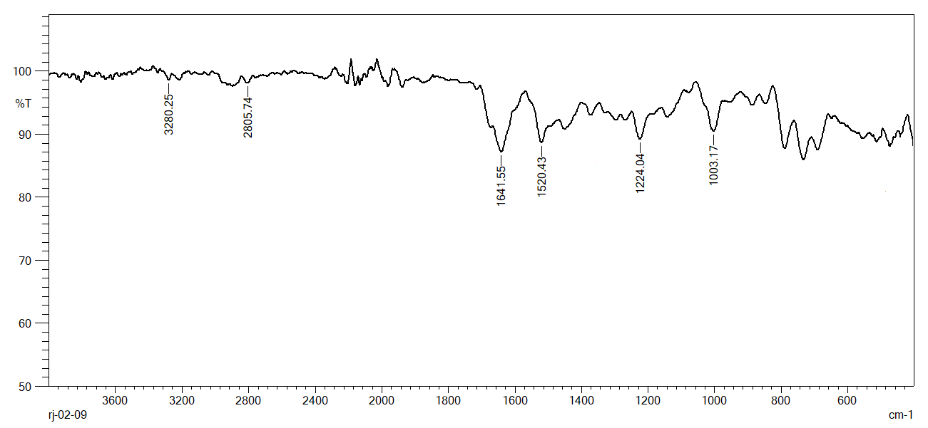
RJ-02-09
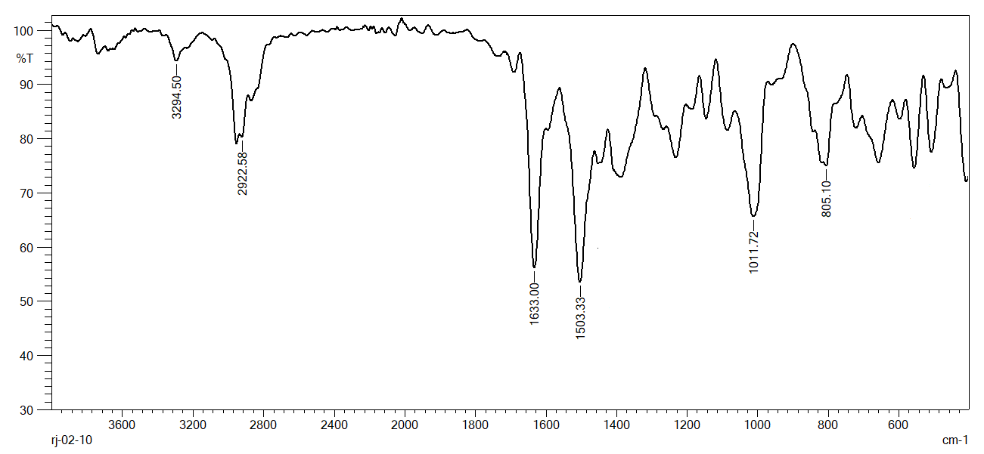
RJ-02-10

- ¹H-NMR Spectra

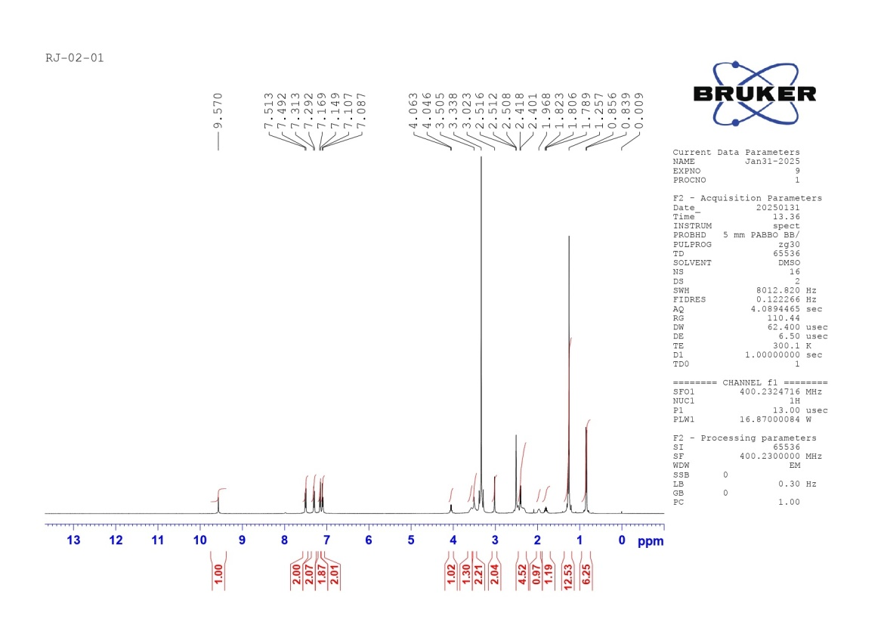
RJ-02-01
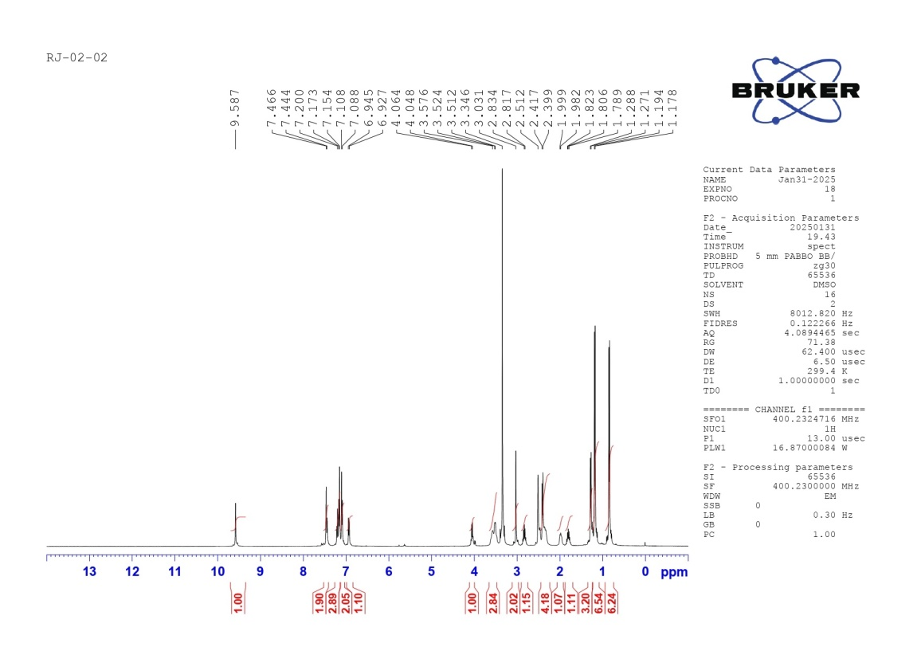
RJ-02-02
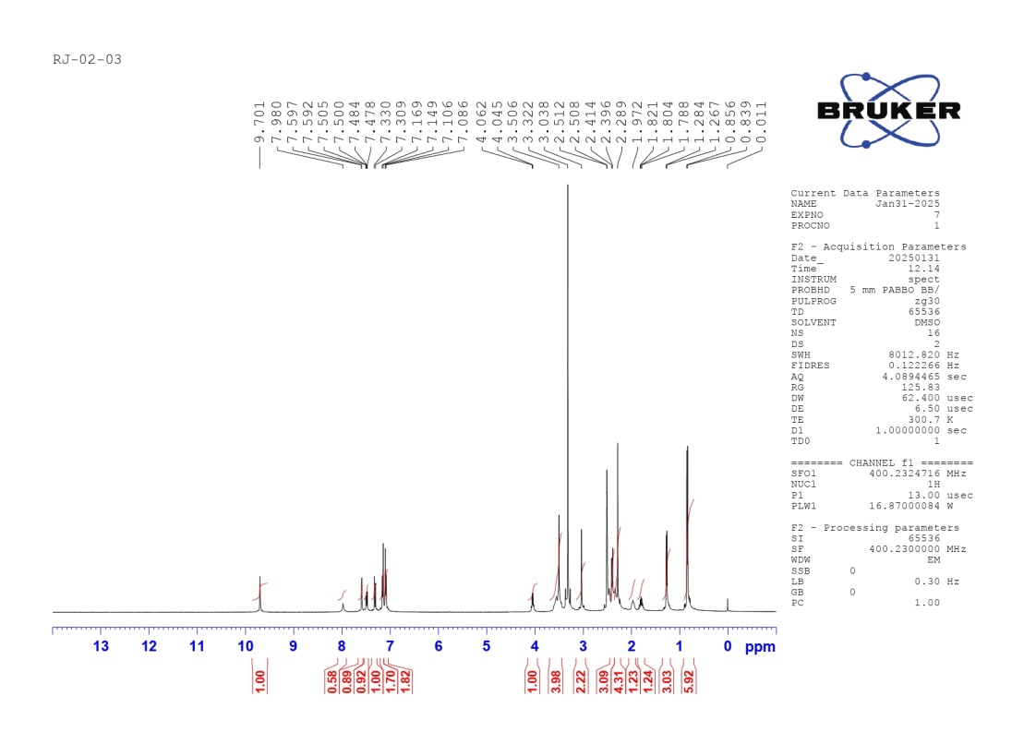
RJ-02-03
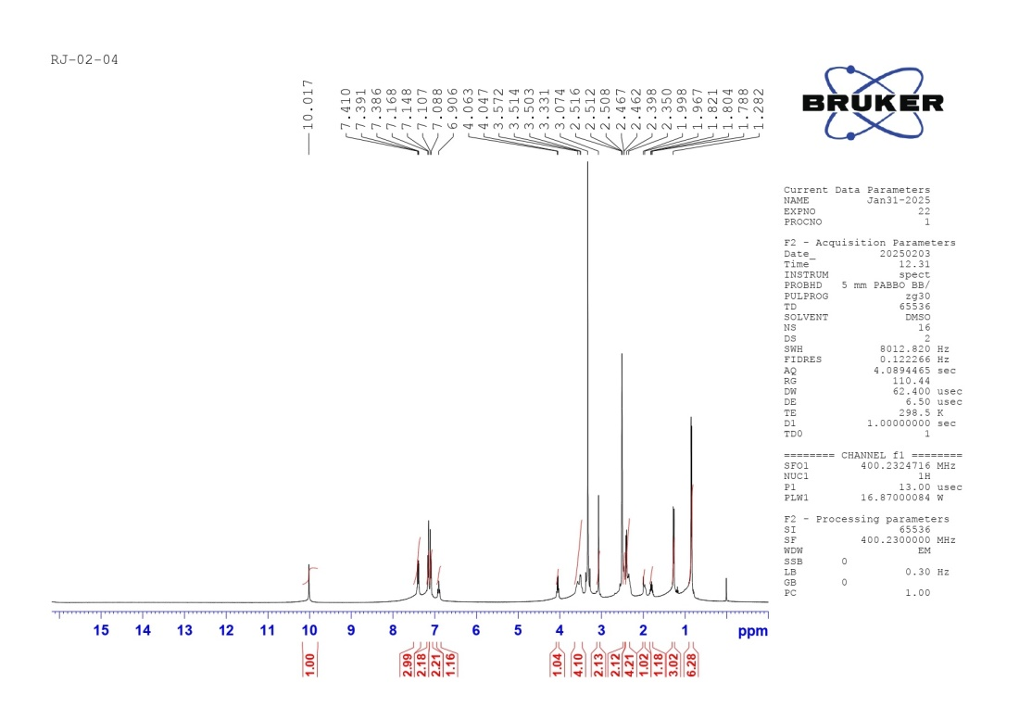
RJ-02-04

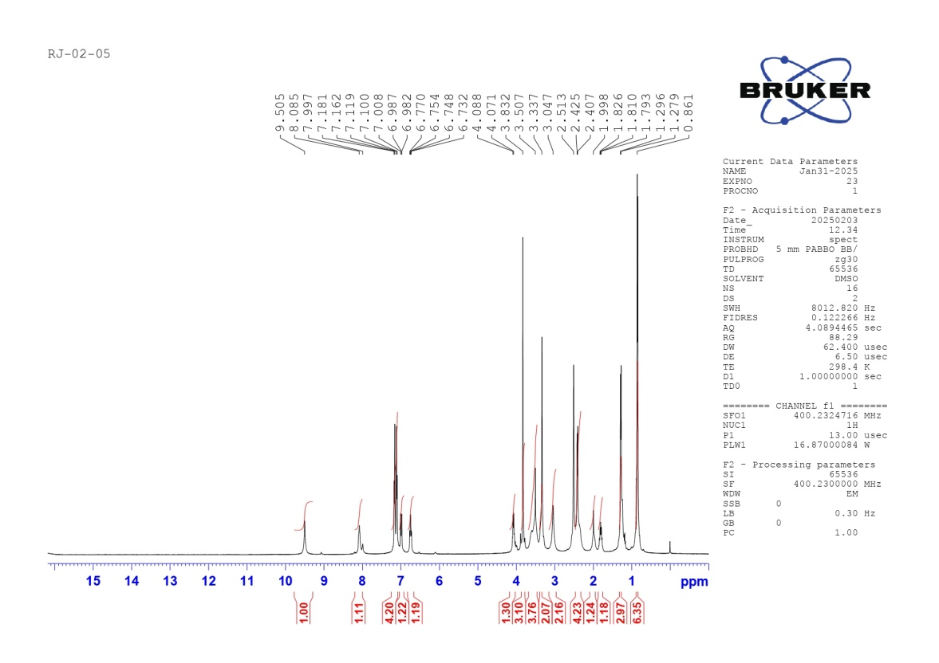
RJ-02-05
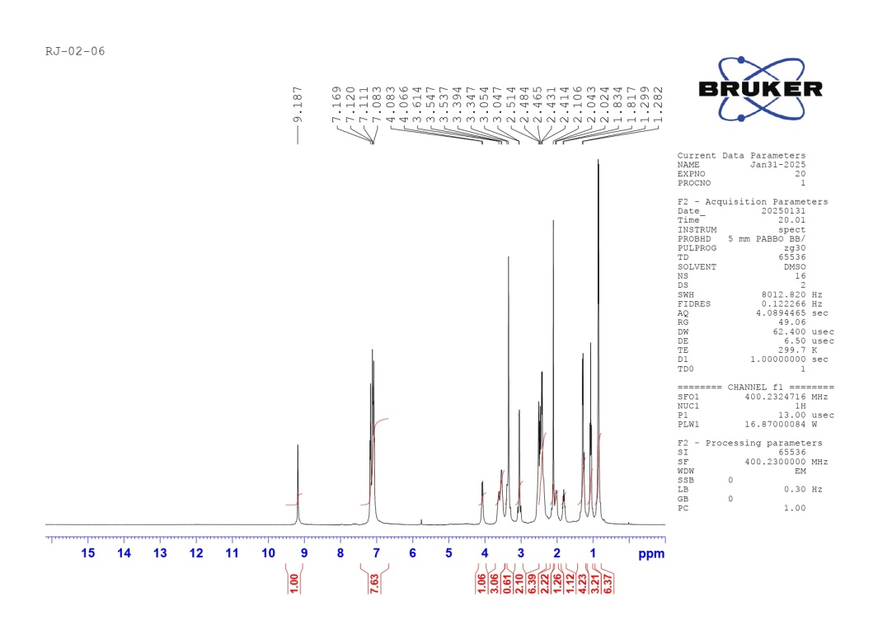
RJ-02-06
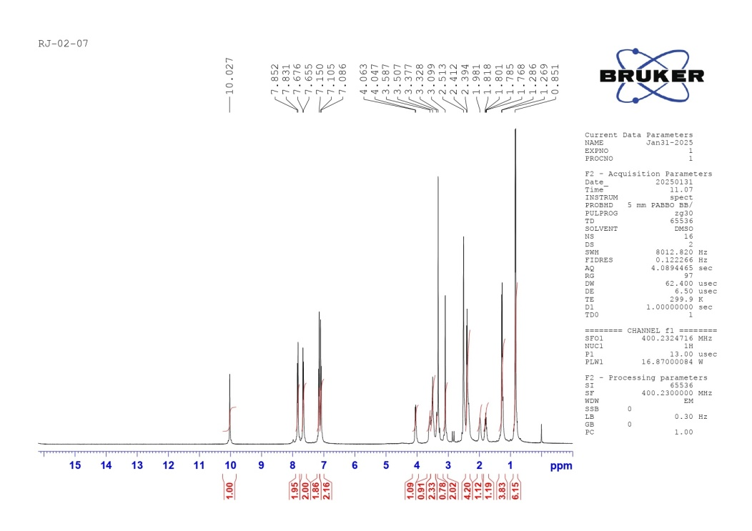
RJ-02-07
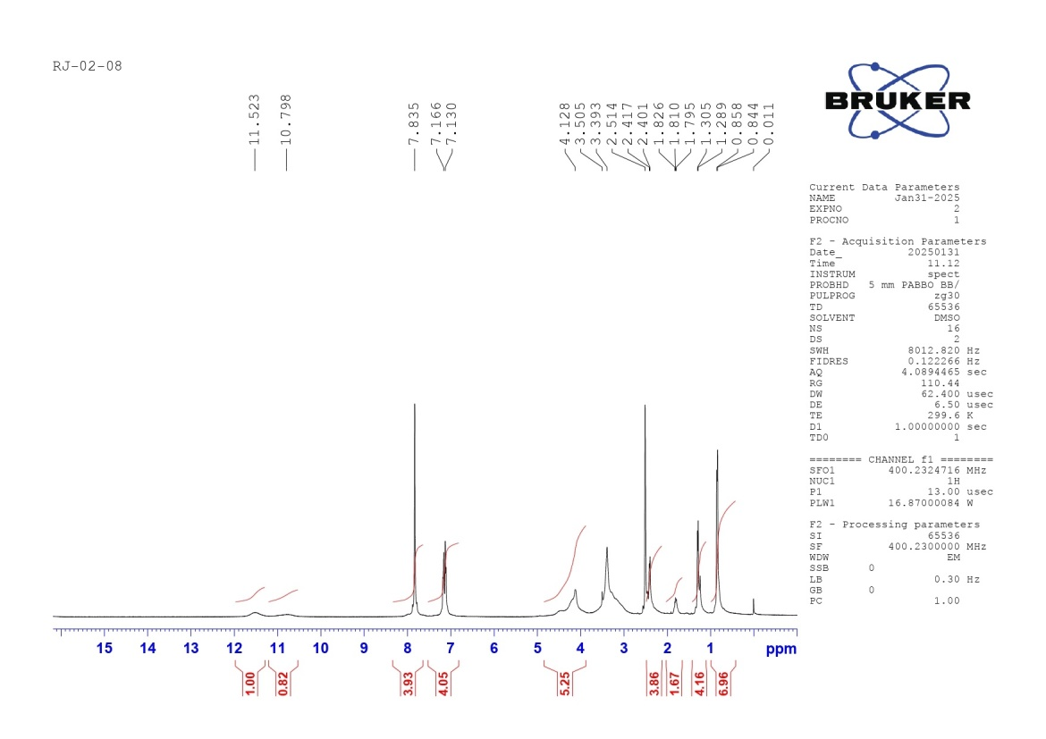
RJ-02-08

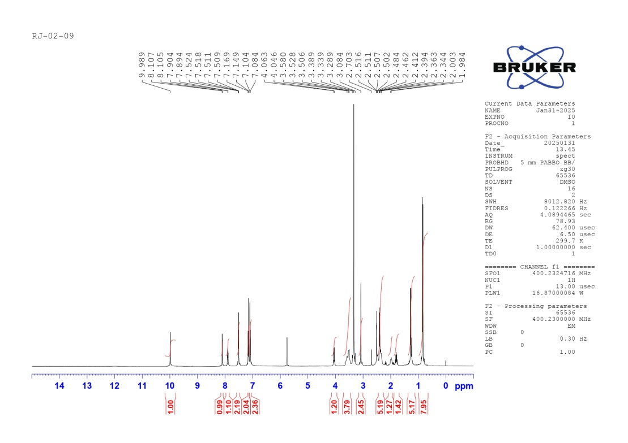
RJ-02-09
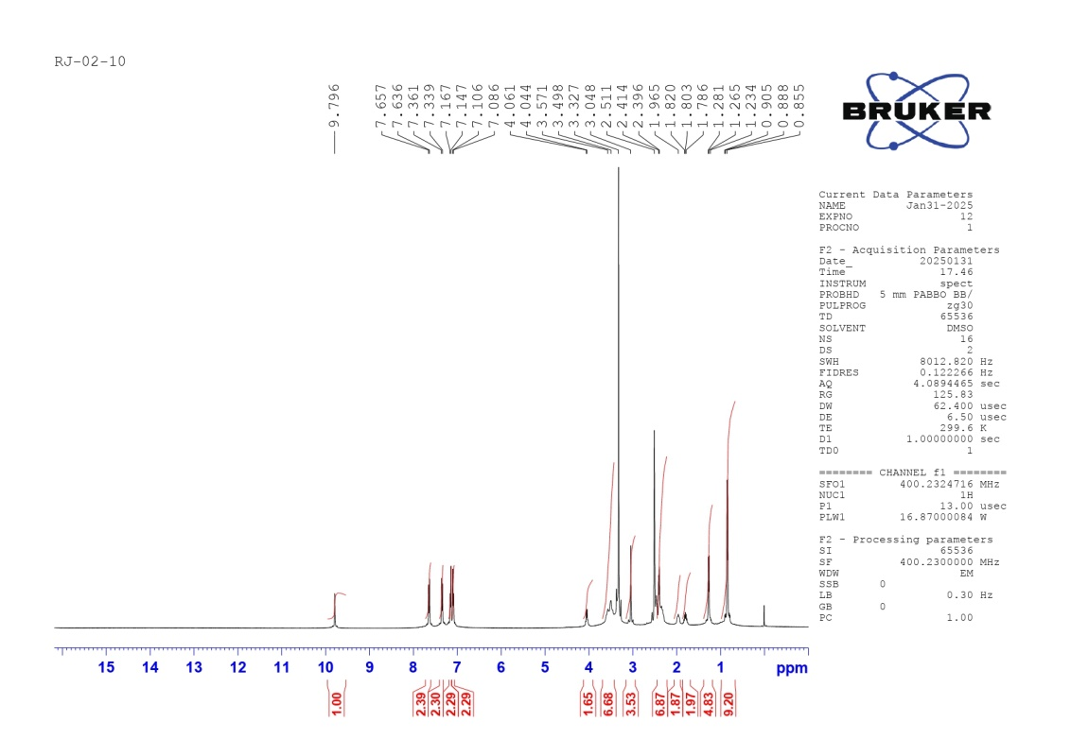
RJ-02-10

- ¹³C-NMR Spectra

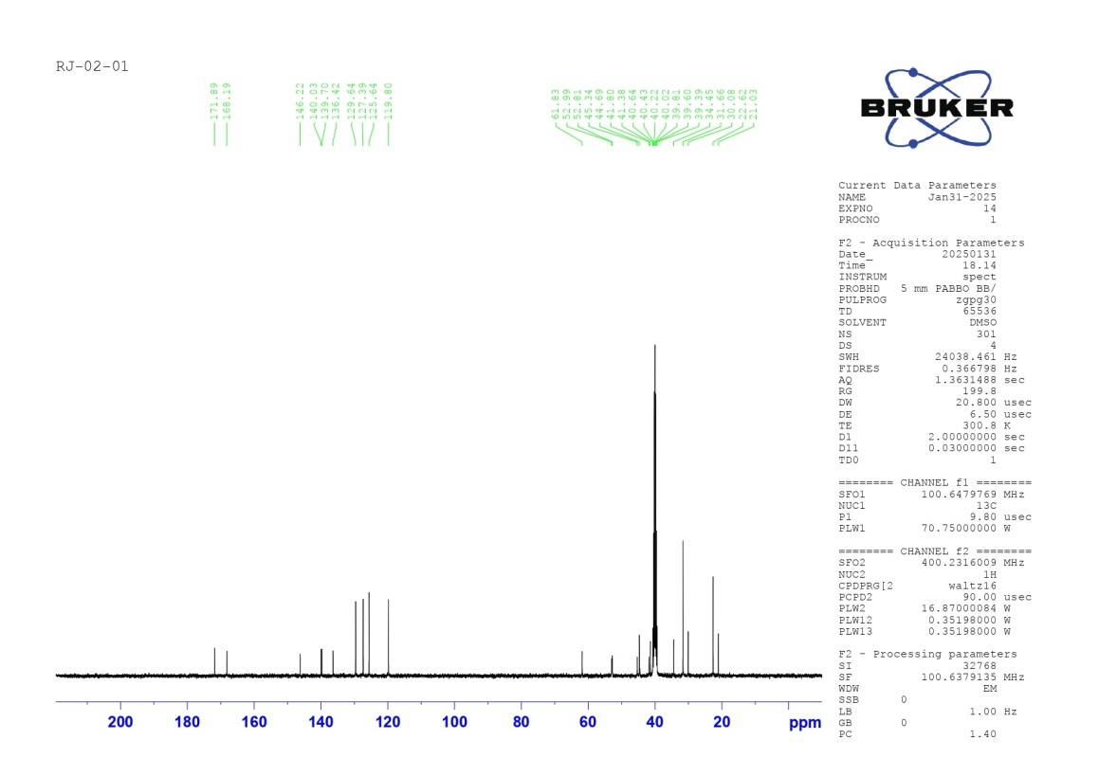
RJ-02-01
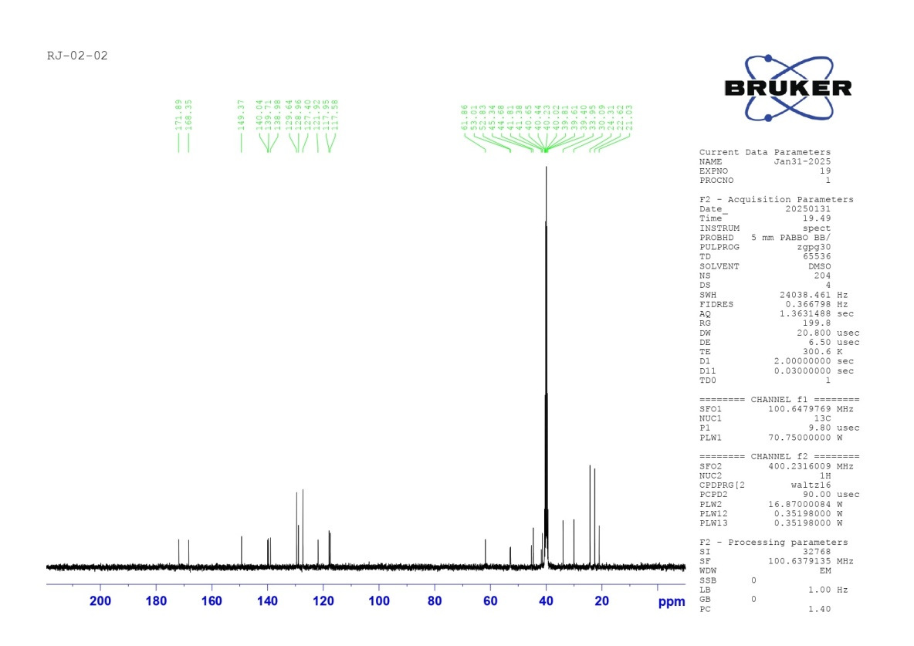
RJ-02-02
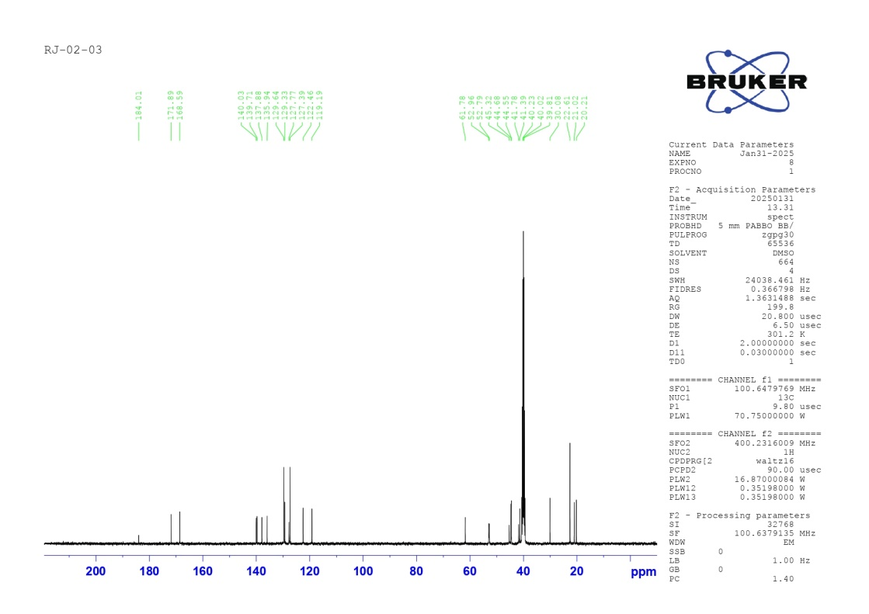
RJ-02-03
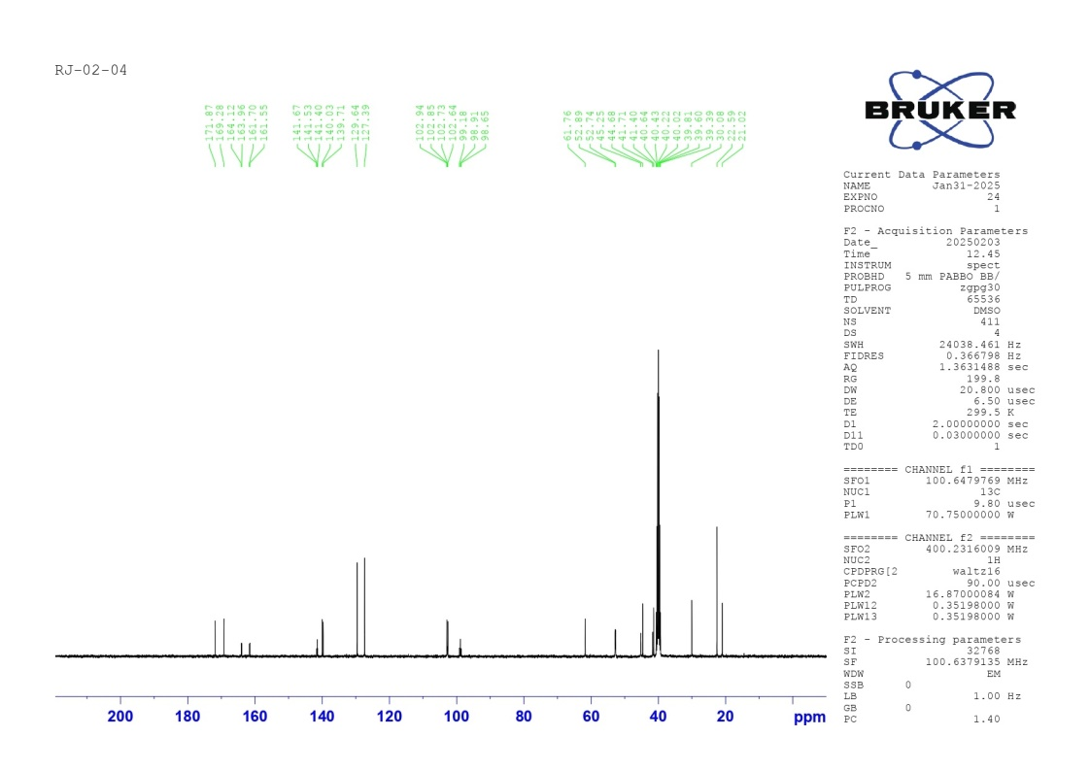
RJ-02-04
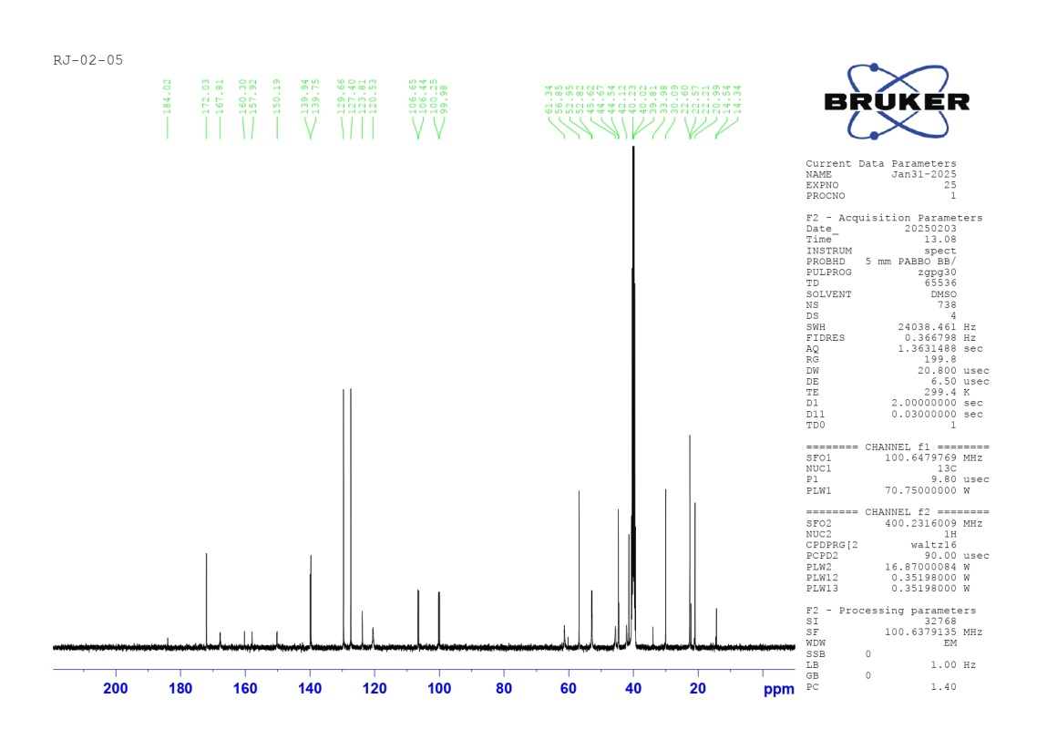
RJ-02-05
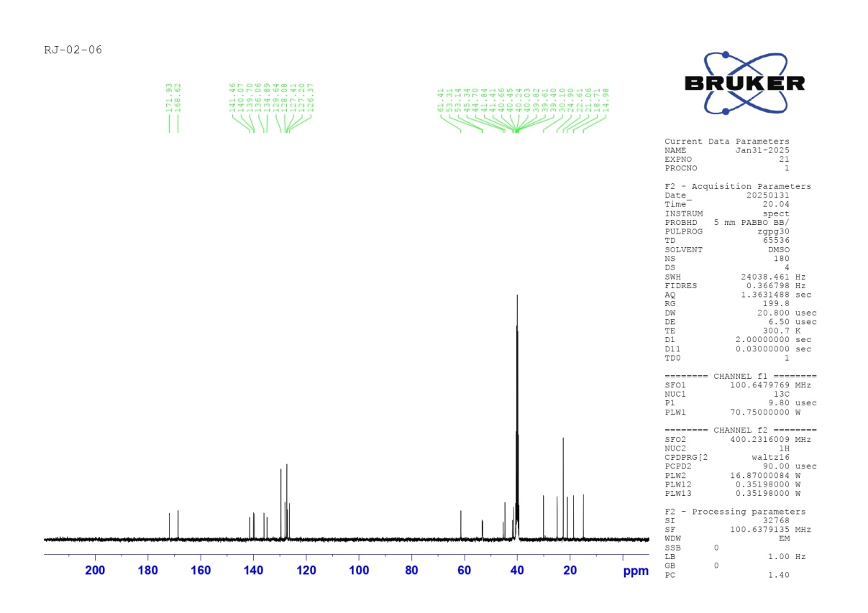
RJ-02-06
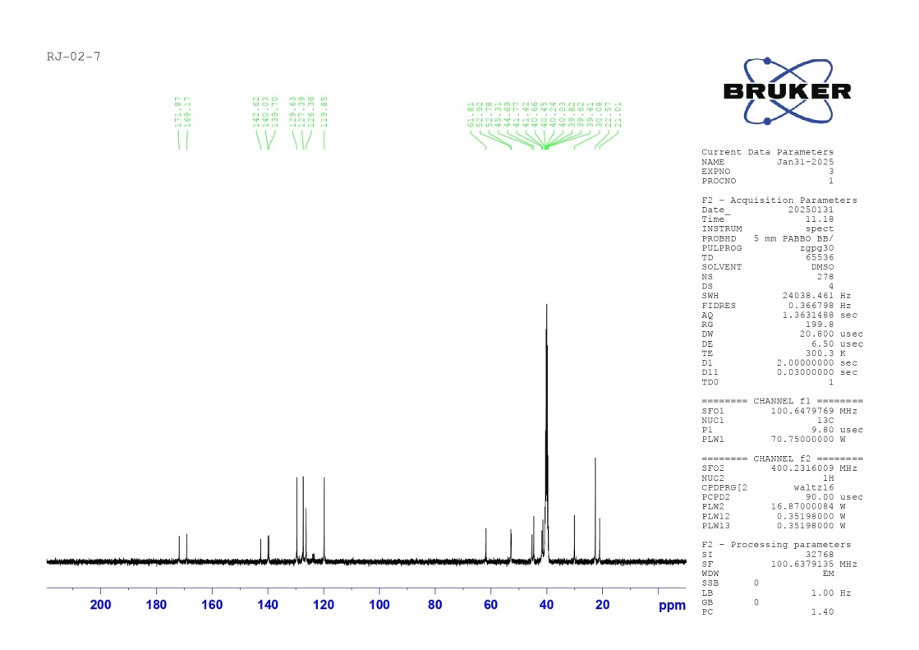
RJ-02-07
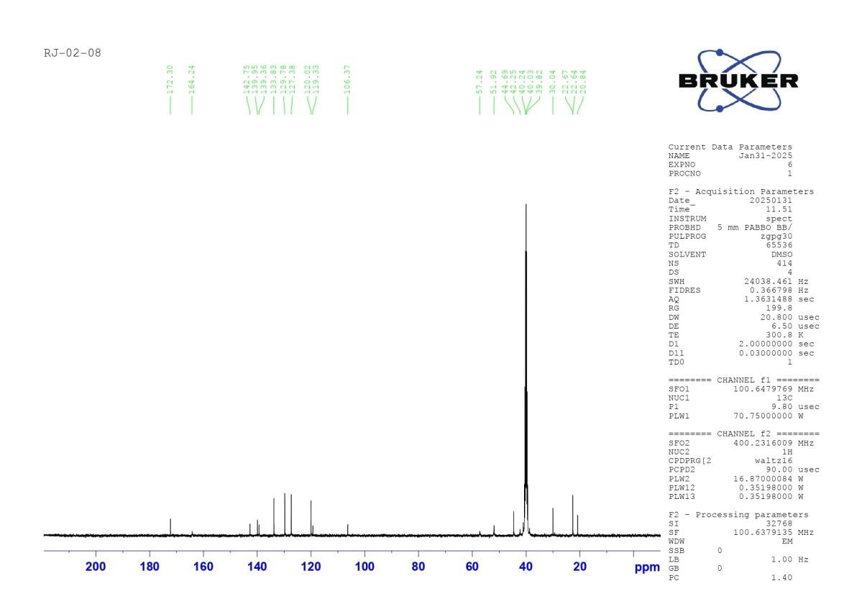
RJ-02-08
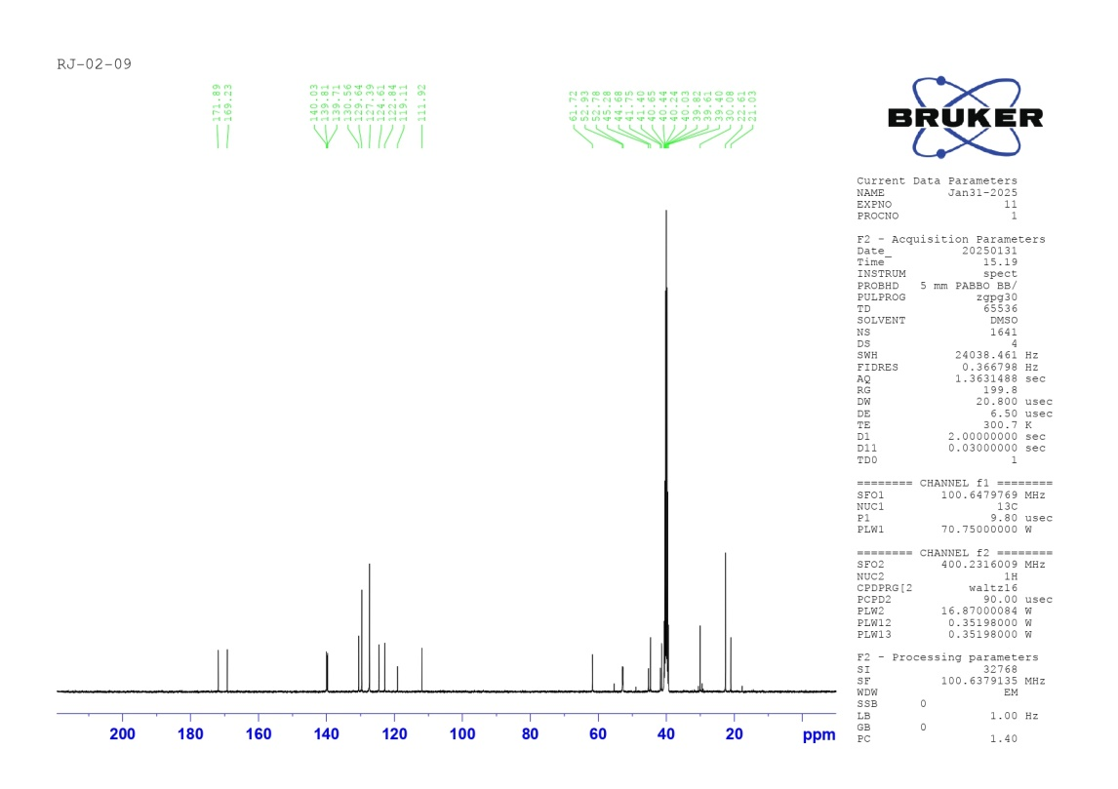
RJ-02-09
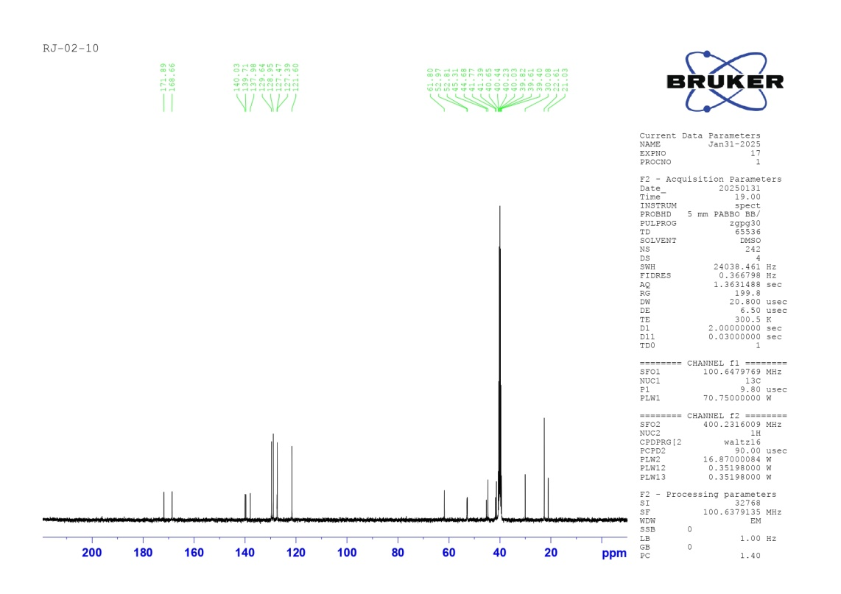
RJ-02-10
- Mass Spectra

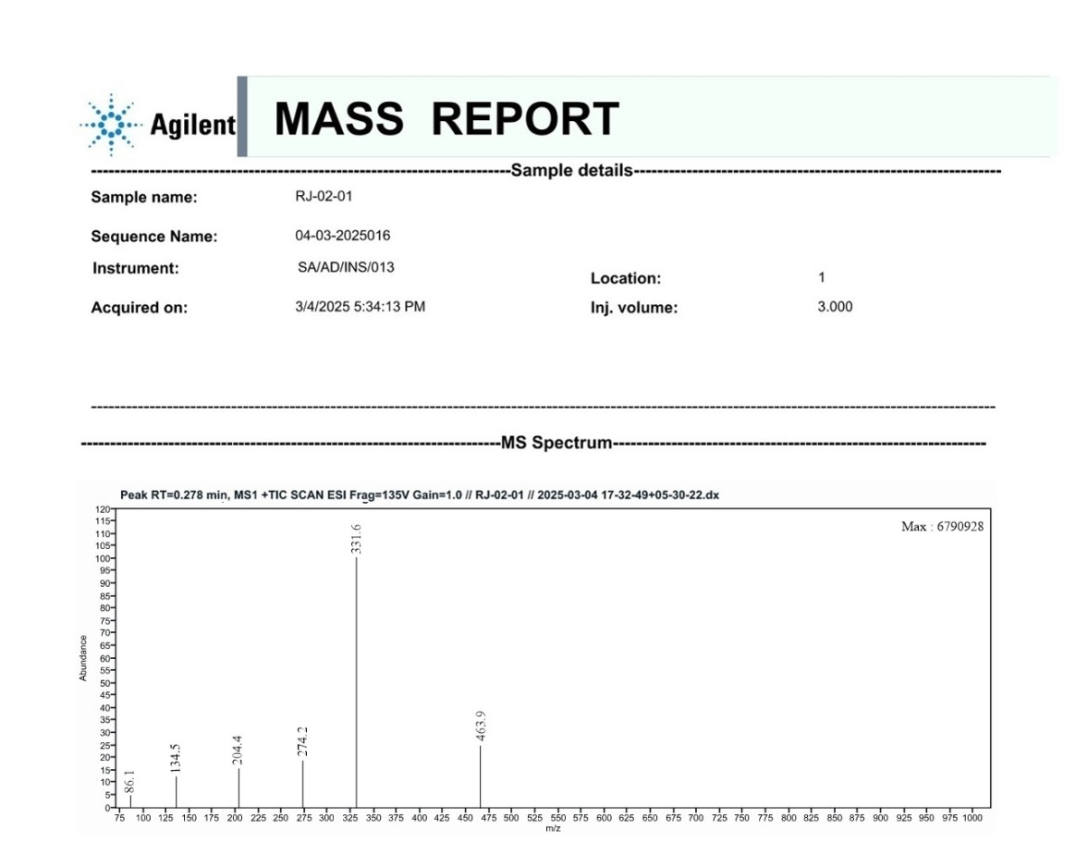
RJ-02-01
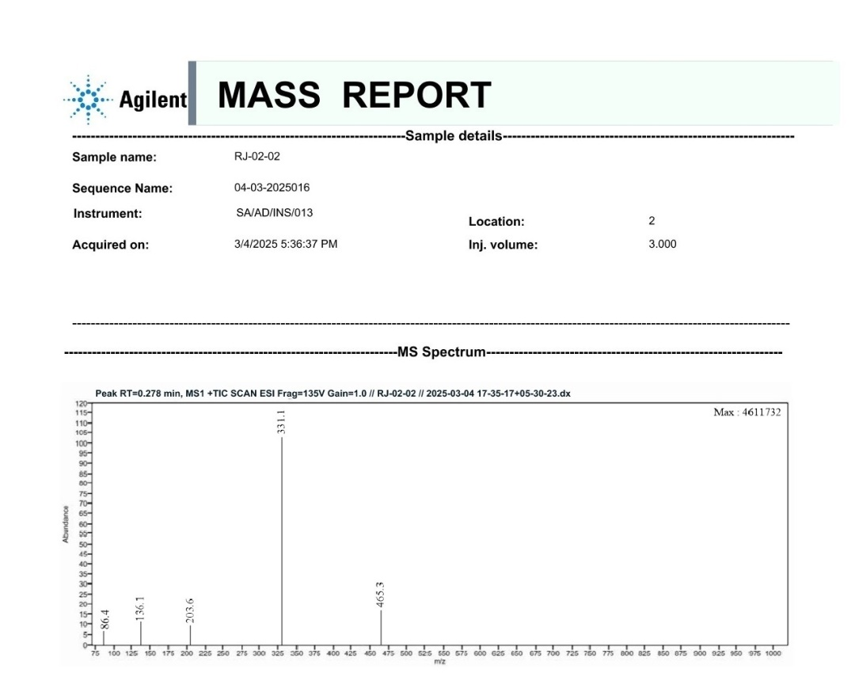
RJ-02-02
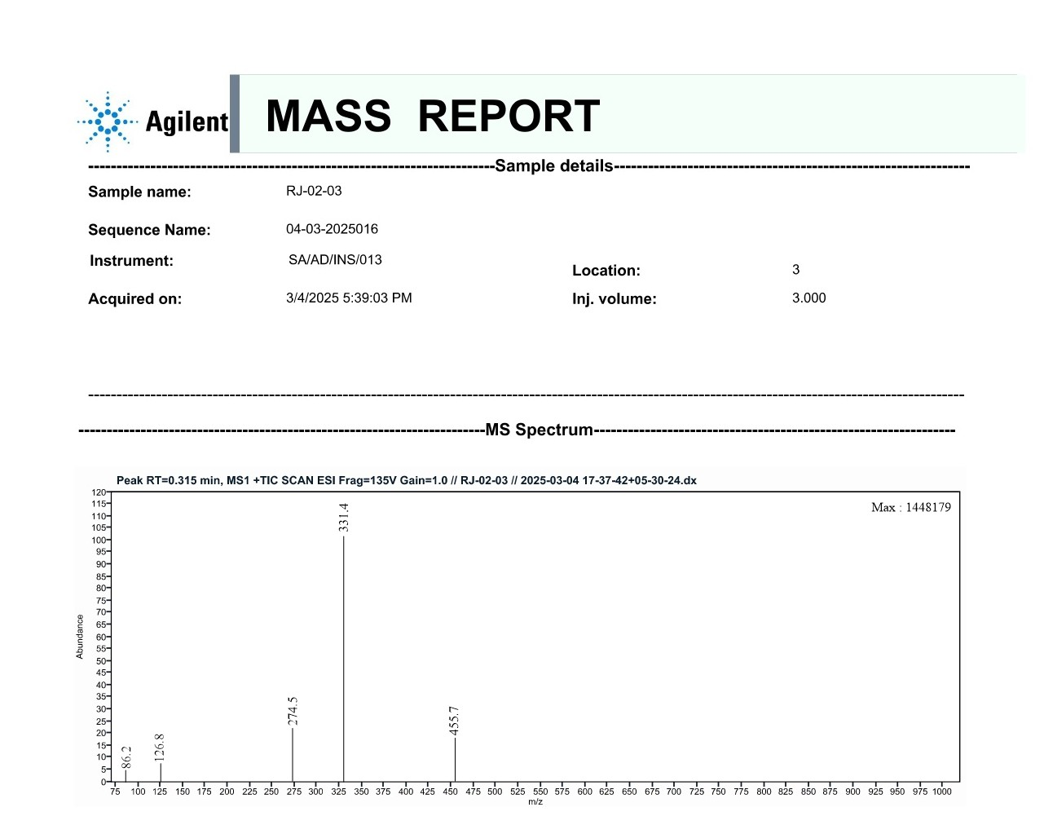
RJ-02-03
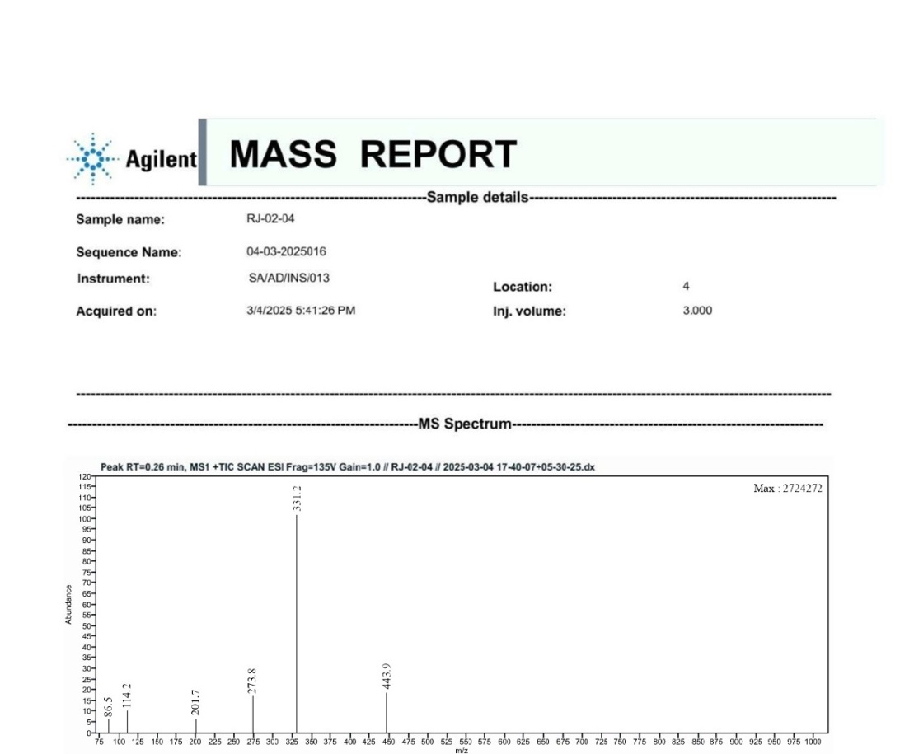
RJ-02-04
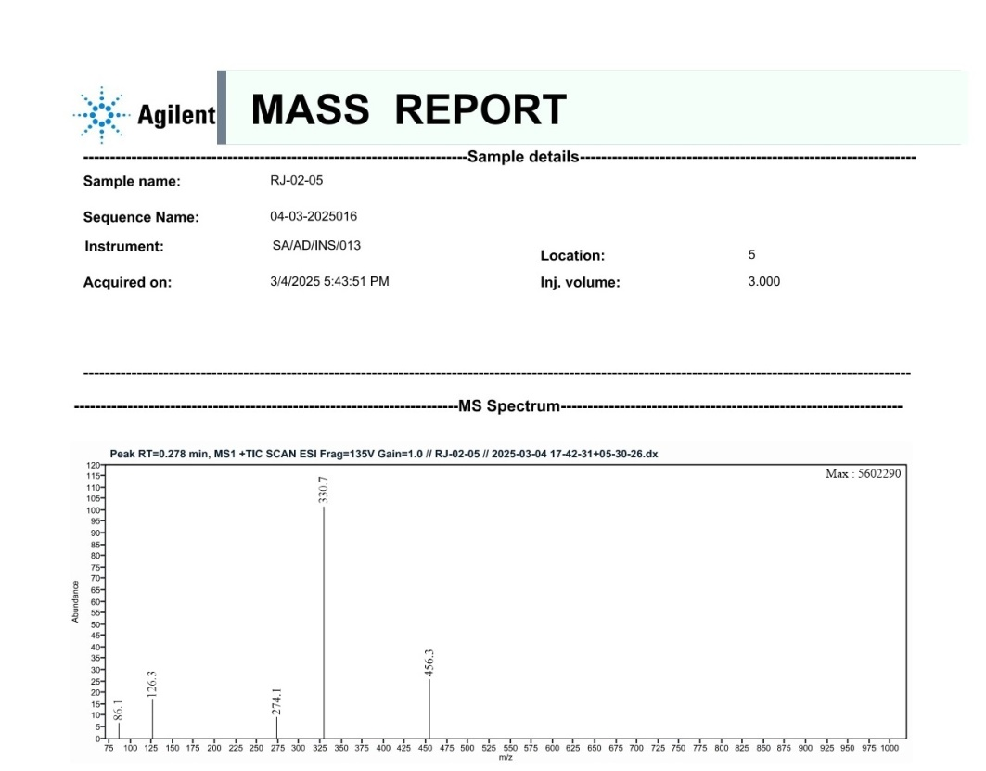
RJ-02-05
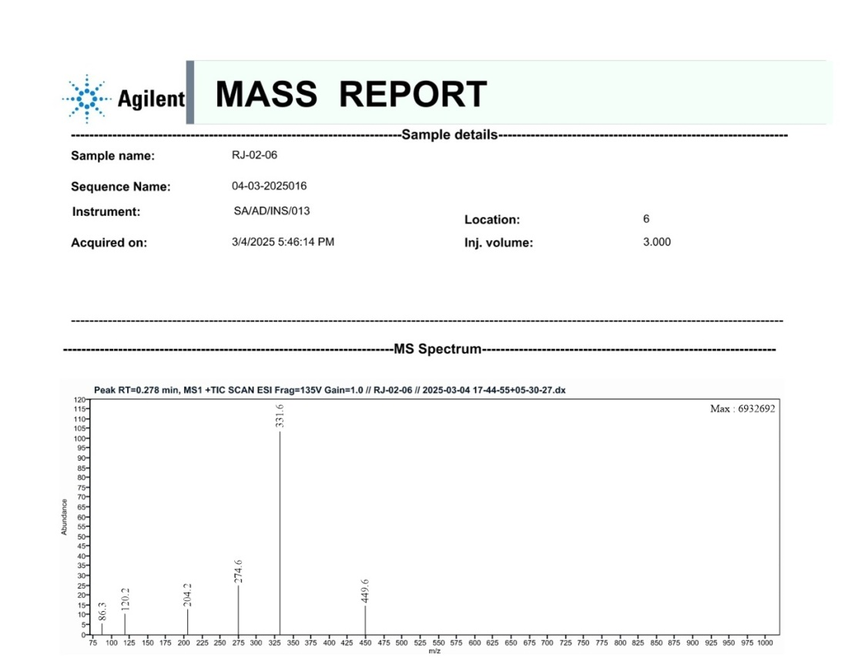
RJ-02-06
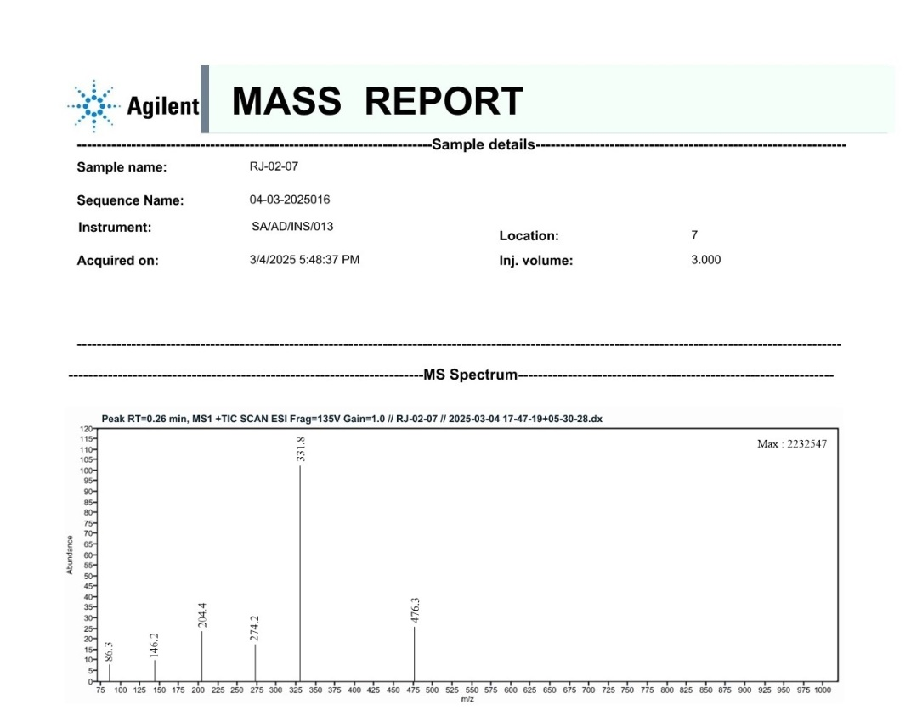
RJ-02-07
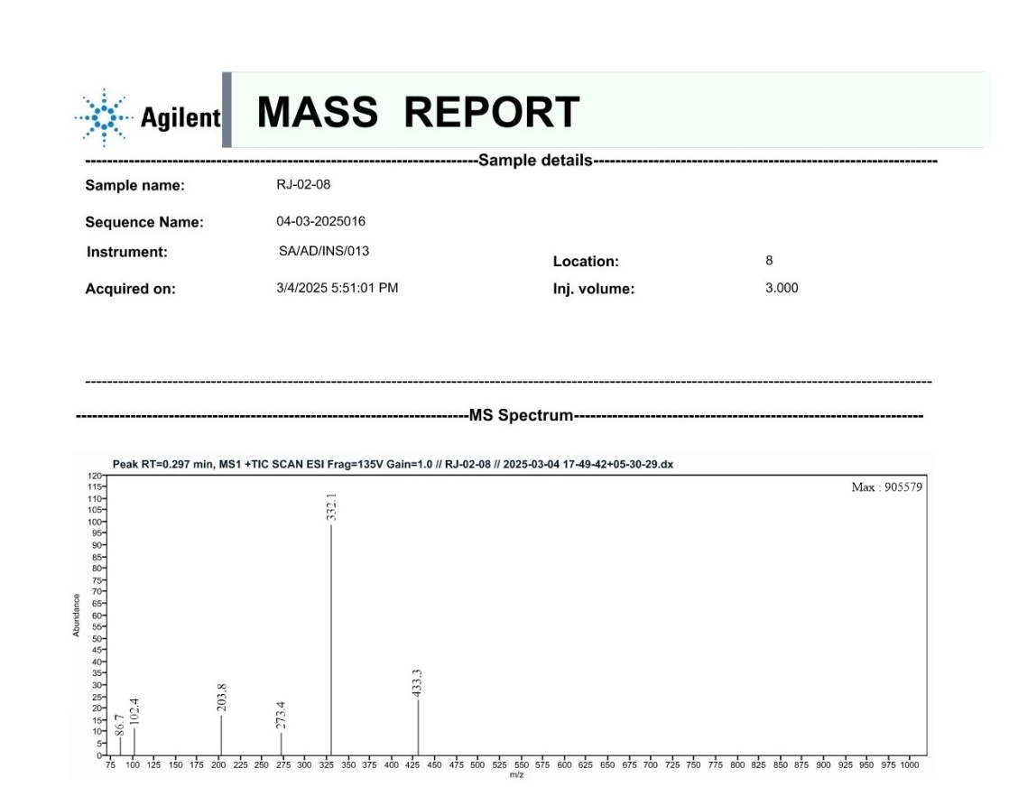
RJ-02-08
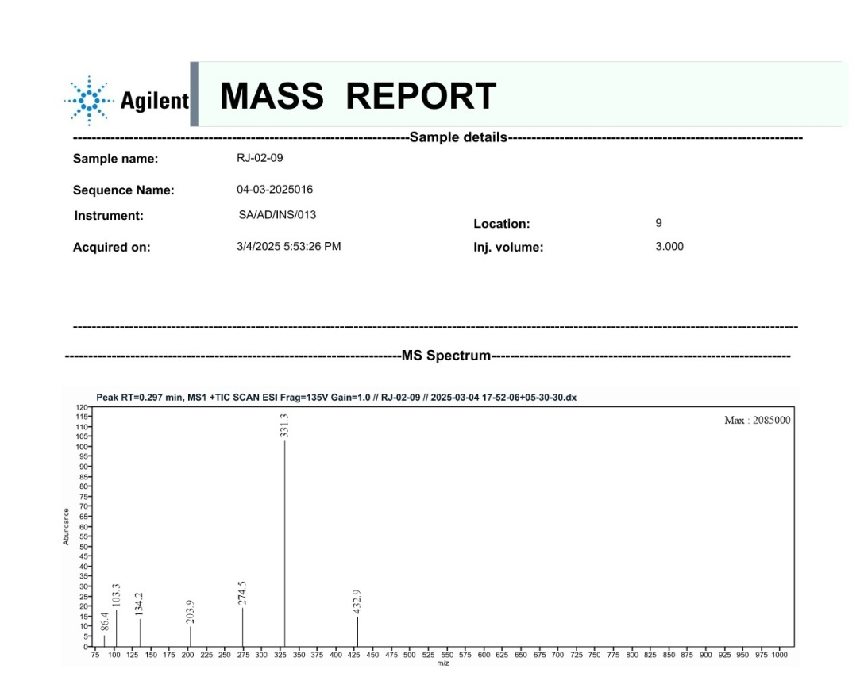
RJ-02-09
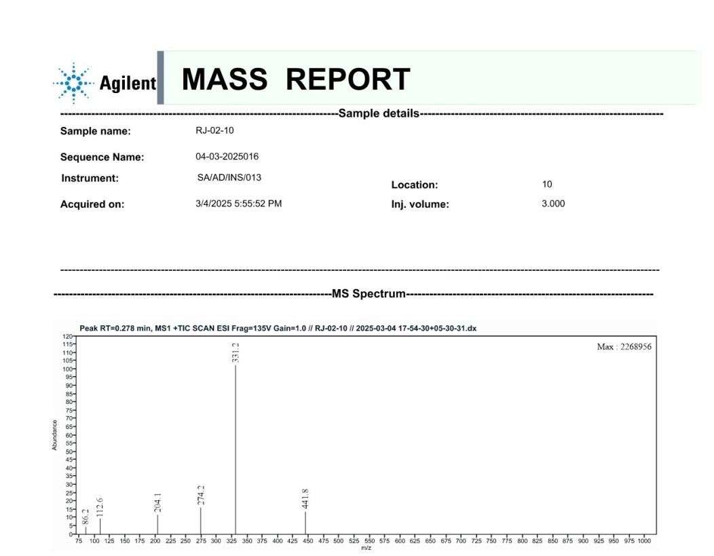
RJ-02-10

