Supplementary Materials

Table of Contents

1 Infinium Global Screening Array (GSA) cluster file generation and characterization 2
2 Study sample selection rationale 3
3 Data, Datasets, and Data organization 4
3.1 WGS data 5
4 Principal Component Analysis (PCA) 7
4.1 Methods 8
4.1.1 Datasets 8
4.1.2 Principal Component Analysis 8
4.1.3 PCA analysis testing – randomization experiment 9
4.2 Results 9
4.3 R code 11
5 Sample DNA contamination estimation and detection 13
5.1 Regression-based method to detect sample contamination 13
6 GSA quality control analyses 16
6.1 Quality control for BeadChip Array 16
6.2 Quality control for GSA triplicate samples 17
6.3 Quality control of GSA triplicate VCF files 19
6.4 Quality control of GSA assays 19
7 Transitions and transversions 21
7.1 Transitions and transversions with special focus on complementary transversions 21
8 GSA, rWGS and 1KG comparison 22
9 Miscellaneous code used to generate figures and results 24
24
References 24

Infinium Global Screening Array (GSA) cluster file generation and characterization
A total of 7 plates containing Coriell samples across 14 diversity panels and 5 plates of Sanford Biobank samples were run in order to create a cluster file for the GSA with custom content (Sanford chip). Each plate was run 3 times (by 3 different technicians, on two different robots, using 2 lots of the Infinium HTS kit). Genotyping data was generated for 1,104 individuals in triplicate. The proportion of females to males was roughly 1:1 and the ethnic composition was as follows:

- 644 Coriell samples covering major ethnic groups (46 individuals per each group):
- Finns in Finland
- Han Chinese
- British in the United Kingdom
- Puerto Ricans in Puerto Rico
- Mexicans in Los Angeles, USA
- Japanese in Tokyo
- Iberians in Spain
- Peruvians in Lima
- Yoruba in Ibadan
- Kinh in Ho Chi Minh City
- African ancestry in Southwest US
- African Caribbean in Barbados
- Mende in Sierra Leone
- Indian Telugu in the UK
- 460 individuals semi-randomly selected from the local population (from the Sanford Biobank) including Native Americans (50) and trios (10) from internal research.

With the exception of the Native Americans and research trios, samples from the biobank were selected to assess two different methods of DNA extraction in the laboratory. To evaluate biases in cluster file generation at two physically different locations and from different input DNA samples, we compared a cluster file generated by Illumina to the one generated in-house. We found high correlation of p10GC values when the cluster files were compared indicating no major physical location specific or sample selection biases. Additionally, the utility of the GSA for assaying genotypes within the MAP59 genes was checked by overlaying MAP59 assays on all assays in the plot; this found no major differences between cluster files; minor off-diagonal differences were assays with different p10GC values relative to each other. The majority of the MAP59 assays had lower p10GC values in both the Illumina cluster file and the Imagenetics cluster file (Figure S1). Assessment of the reproducibility of cluster file curation between institutes was performed in collaboration with the bioinformatics staff at Illumina, Inc. (https://www.illumina.com, Ryan Kelly and Jeremy Pierce, unpublished data).
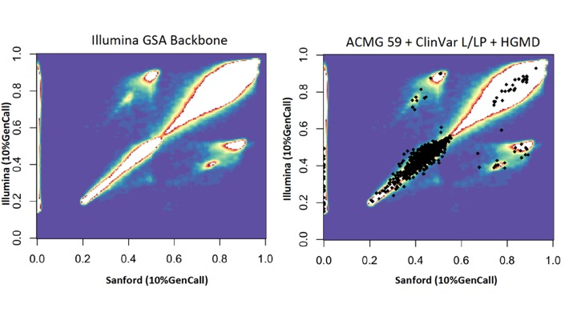
Figure S1. Comparison of p10GC between Illumina and Sanford cluster files. Left panel shows all data, and right panel shows ACMG59 ClinVar pathogenic / likely pathogenic assays overlaid as black squares on top of all the data.

Study sample selection rationale
Large-scale genotyping and sequencing studies select large sample sizes and typically target a sample size of over 1000 (1-4). To determine the validity of variation at a frequency >1% in the general population, Lee S et. al. proposed a framework to calculate a sample size given a target variation rate in the general population (Table 1) (5). With a finite sample size N, variants that are rare may not be observed. Supposing the population MAF for the j^{th} variant is m_{j} and $θ_{j}$ is the chance that the variant j is observed in the sample size N,

$θ_{j}=1-{(1-m_{j})}^{2N}$

then the sample size required to observe the variant j with at least $θ_{j}$ is

$$N=\frac{ln⁡(1-θ_{j})}{2ln⁡(1-m_{j})}$$

Table S1. Minimum number of samples required for a 99.9% chance to detect variation at a given minor allele frequency (MAF)
MAF | Minimum N
0.1 | 33
0.01 | 344
0.001 | 3,453
0.0001 | 34,537

To have a 99.9% chance of detecting variants with a MAF between ~1% and ~10%, a sample set of 263 samples from the Coriell Institute were selected to be genotyped in triplicate on the GSA as well as resequenced with Illumina WGS technology. The minor allele frequency for each GSA assay included in the 1000 Genomes Phase 3 data defined the number of needed samples, and this number was close to the theoretical number computed using the method of Lee S et al.

Data, Datasets, and Data organization
Dataset samples for analytical validation of Global Screening Array (GSA) data were selected from the 1000 Genomes project – Phase 3 (258) and the personal genomes project (5). The integrated genotype data from 1KG was downloaded and evaluated for coverage. 1KG genotype data covered 594,364 GSA assays. We also downloaded deep sequenced WGS from 1KG (pWGS; >51x) to evaluate rWGS, 1KG, and GSA data (ftp://ftp.1000genomes.ebi.ac.uk/vol1/ftp/phase3/data). We resequenced 263 samples on Illumina HiSeqX to an average depth of 37x generating 731 million 150 bp paired-end reads (22.3 TB).

Table S2. Summary of samples in different datasets
Dataset | Total number of samples | Overlap with our dataset | Genotyping technology | Acronym
1000 Genomes Genotype Data – Phase 3 | 2,504 | 258 | WES, WGS, Array | 1KG
1000 Genomes WGS data* | 27 | 24 | WGS | pWGS
Resequenced WGS | 263 | 263 | WGS | rWGS
GSA | 789 (263 x 3) | 789 (263x3) | Array | GSA
*ftp://ftp.1000genomes.ebi.ac.uk/vol1/ftp/phase3/data

The data for resequenced WGS (rWGS) and public WGS (pWGS) were organized on AWS S3 bucket (Figure S2). All rWGS data files were mapped to canonical identifiers and file names were changed accordingly. Of the 1,104 samples used to generate the cluster file for GSA, 72 samples were included among the 263 samples in our primary validation dataset.
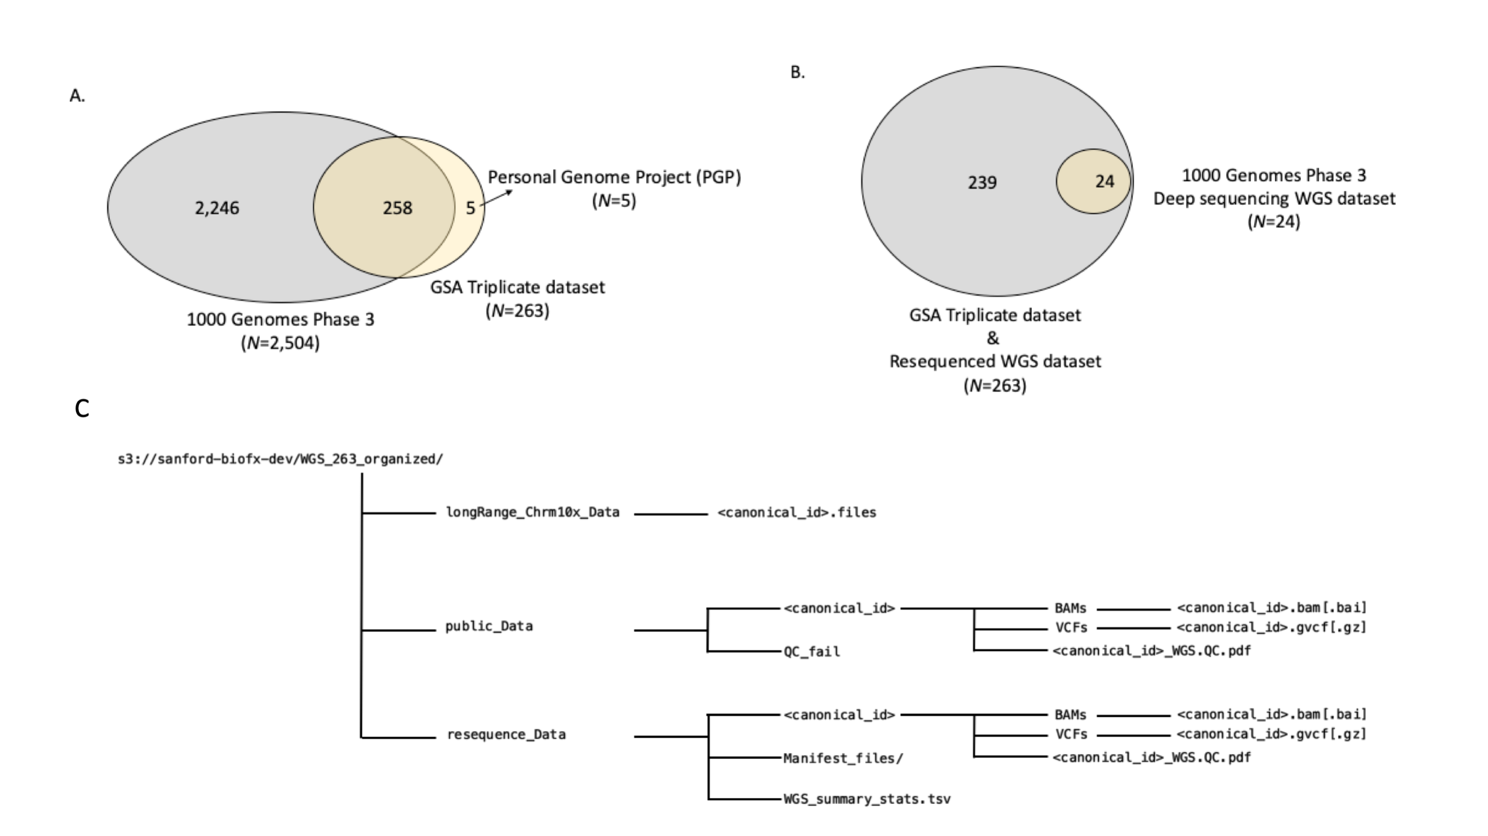
Figure S2. Datasets and their intersections with the samples we selected from public databases. (A) 1000 Genomes Phase 3 intersection with GSA triplicate dataset. (B) 1000 Genomes Phase 3 deep sequencing WGS dataset (pWGS) relative to internally resequenced WGS dataset (rWGS). Data-structure and organization of WGS data on Sanford Imagenetics AWS S3 bucket (s3://sanford-biofx-dev).

WGS data
Whole Genome Sequence (WGS) data were either downloaded and reprocessed (pWGS) or resequenced (rWGS) and processed via GenomeNext and organized in a AWS S3 bucket (s3://sanford-biofx-dev). All WGS data and subsets are summarized in Table 3.

Table S3. WGS data subsets and summary
Datasets | Total samples | Pass QC | Fail QC | In_263 | Data size
1000 Genomes (public data – pWGS) | 27 | 24 | 3 | 24 | 3.9 TB
WGS resequenced data (rWGS) | 263 | 263 | 0 | 263 | 22.3 TB

Quality metrics were extracted from the quality control (QC) PDF files from GenomeNext for reprocessed public data (n=24) and resequenced data (n=263) (Tables 2 and 3, respectively). Average depth of sequencing was computed using mapped read information and read-lengths for the resequenced data (n=263) (Figure S3) and reprocessed public data (n=24) (Table 4). We also plotted the correlation of reported total processed reads vs. mapped reads to see if the relationship were linear and found it to be true (Figure S3). To check for completeness of all data downloaded from GenomeNext, we generated a matrix of samples and all files expected under a given sample folder (e.g., BAM files, VCF files, etc.).
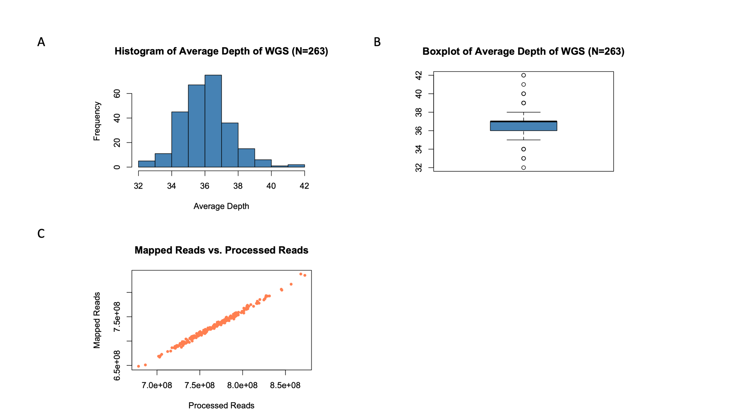
Figure S3. rWGS average read depth and read mapping statistics

Table S4. Public WGS (pWGS) from 1000 Genome download data and reprocess – summary statistics (QC pass samples)
Number | Samples | Processed | Discordant Reads | Mapq0 Reads | Unmapped Reads | Mapped | Average Depth
1 | HG02568 | 351,034,149 | 13,138,544 | 16,981,365 | 17,085,394 | 333,948,755 | 28
2 | HG03642 | 542,600,081 | 15,585,266 | 25,999,215 | 29,199,287 | 513,400,794 | 43
3 | HG01112 | 715,889,080 | 5,143,810 | 28,755,439 | 34,474,661 | 681,414,419 | 57
4 | HG00268 | 708,112,489 | 8,060,456 | 23,238,117 | 31,080,453 | 677,032,036 | 56
5 | HG03052 | 621,081,848 | 12,327,266 | 27,273,419 | 34,021,121 | 587,060,727 | 49
6 | NA18525 | 691,324,110 | 6,066,440 | 24,689,237 | 35,224,296 | 656,099,814 | 55
7 | NA20502 | 555,380,187 | 14,943,032 | 21,499,779 | 27,541,973 | 527,838,214 | 44
8 | NA18939 | 707,535,350 | 9,012,312 | 27,467,556 | 35,170,903 | 672,364,447 | 56
9 | HG01051 | 652,257,648 | 10,613,568 | 29,427,170 | 33,266,466 | 618,991,182 | 52
10 | HG00419 | 634,226,577 | 13,039,306 | 24,610,921 | 29,159,792 | 605,066,785 | 50
11 | HG03742 | 673,937,258 | 8,956,384 | 31,205,876 | 41,136,371 | 632,800,887 | 53
12 | NA19017 | 684,218,155 | 11,919,738 | 26,028,294 | 33,872,947 | 650,345,208 | 54
13 | HG01583 | 559,018,341 | 16,729,388 | 28,016,975 | 28,188,257 | 530,830,084 | 44
14 | HG00759 | 674,497,471 | 8,640,158 | 26,677,264 | 37,193,265 | 637,304,206 | 53
15 | NA19625 | 558,605,495 | 14,154,724 | 26,788,262 | 29,961,242 | 528,644,253 | 44
16 | HG01879 | 702,755,507 | 10,916,274 | 31,347,708 | 37,853,242 | 664,902,265 | 55
17 | HG01565 | 704,005,178 | 5,996,396 | 32,309,214 | 38,524,040 | 665,481,138 | 55
18 | HG01500 | 701,396,054 | 7,301,854 | 30,206,300 | 39,157,697 | 662,238,357 | 55
19 | HG01595 | 680,506,455 | 9,664,216 | 27,312,725 | 32,948,460 | 647,557,995 | 54
20 | HG00096 | 673,258,313 | 8,050,208 | 26,562,107 | 34,103,197 | 639,155,116 | 53
21 | NA19648 | 518,560,848 | 16,857,166 | 22,170,885 | 25,502,828 | 493,058,020 | 41
22 | NA20845 | 680,309,740 | 5,575,390 | 33,374,680 | 35,523,873 | 644,785,867 | 54
23 | HG02922 | 654,279,912 | 14,496,960 | 29,971,267 | 34,502,437 | 619,777,475 | 52
24 | HG03006 | 710,155,053 | 10,211,988 | 32,526,942 | 40,699,895 | 669,455,158 | 56
 | Average Statistics | 639,789,387 | 10,725,035 | 27,268,363 | 33,141,337 | 606,648,050 | 51
samples failed QC = (NA19238, NA19239 – single reads; not paired end);
HG00276 is not on the list for PCR-free WGS; only low-coverage – but was processed by Databricks (GRCh37, GRCh38)
Mapped = Processed – Unmapped
Genome length = 3x10⁹
Read length – 250 bp
Supplementary Information – Nature paper states additional 2 trios were sequenced by PCR-free WGS, however (1 CEPH: NA12878, NA12891, NA12892, 1 YRI: NA19238, NA19239, NA19240) – All these are missing PCR-free data in the portal

Table S5. GenomeNext resequenced rWGS summary (N=263)
Statistic | Processed | Discordant | Mapq0 | Unmapped | Mapped | Average Depth
Minimum | 678,435,694 | 1,382,636 | 26,482,204 | 29,491,105 | 648,242,190 | 32
1st Qu. | 746,809,500 | 2,343,146 | 30,216,560 | 34,461,232 | 711,046,138 | 36
Median | 766,996,302 | 3,191,934 | 31,927,018 | 36,287,654 | 730,666,603 | 37
Mean | 767,540,183 | 3,799,360 | 31,937,208 | 36,312,190 | 731,227,993 | 36.57
3rd Qu. | 786,304,491 | 4,793,391 | 33,625,400 | 38,189,484 | 748,822,998 | 37
Maximum | 872,634,555 | 11,171,256 | 39,221,563 | 44,400,703 | 837,856,118 | 42

Principal Component Analysis (PCA)
Principal component analysis (PCA) is a standard technique to synthesize and summarize the main structural components of a data table containing measurements of different variables. PCA and Multi-dimensional reduction (MDR) techniques are frequently used in genotyping analyses to detect population structure (6), batch effects (DNA source, genotyping centers, chip versions, etc.), etc. Batch effects are highly undesirable in large-scale genotyping but are realistically unavoidable. These are best identified and minimized prior to any large study analyses. Given this challenge, we hypothesized that the PCA signature for super-populations should remain unaltered between different datasets in the absence of major technical variables that interfere with genotyping processes across datasets. In order to test this hypothesis, we used publicly available 1000 Genomes (Phase III) genotype data from 2504 samples, performed PCA analysis, and generated the super-population structure as a positive control. We compared these results to PCA plots generated using GSA genotyping data generated in-house on two independent datasets - ~ 700 samples (dataset 1) and ~ 900 samples (dataset 2).

Methods

Datasets
Publicly available 1000 Genomes data, Phase 3– positive control and Imagenetics GSA data – test data were used in the PCA analysis.

Principal Component Analysis
Principal Component Analysis (PCA) was performed on 1000 Genome subsets and Imagenetics GSA genotyping data subsets using a C VCF-parsing program to read variant data into a sparse matrix (Matrix) in R (credit – bwlewis.github.io). Using the R package – irlba, the sparse data matrix was operated on to detect principal components, and using threejs, the 3D principal components were visualized. Additionally, we used PLINK to process the merged 258 sample 1KG VCF file and generate PCA data utilizing just the autosomal GSA assays and the 1KG genotypes. PLINK generates eigenvalues (amount of variation explained by each principal component), and eigenvectors (data points along different principal components / dimensions for each sample). We plotted the first three principal components and colored them based on the super population codes in the 1KG (Figure S4).
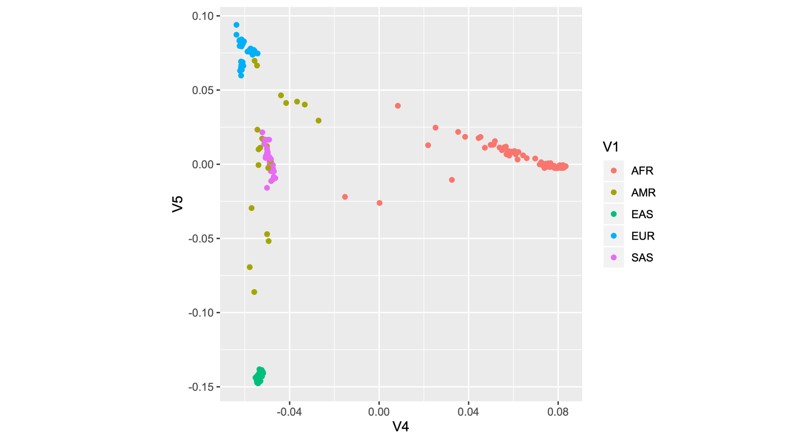
Figure S4. PCA plot using eigenvalues and eigenvectors generated using PLINK for 258 1KG samples

PCA analysis testing – randomization experiment
To detect subtle systematic biases in GSA datasets, we randomly sub-sampled both the genomic loci (rows) and samples (columns) from Dataset 2. We synthetically created matrices with the following dimensions (rows x columns): (a) 10,000 x 500 (b) 10,000 x 900 (c) 600,000 x 900. Each matrix of a particular dimension was created independently three times, and PCA analysis was performed to check for deviation from expected population structure observed in the 1K.

Results
We analyzed the 1KG data by performing PCA on 2,504 individuals’ genotype data. These analyses were done on genotypes from all 1KG data, chromosome 1KG data, and 1KG data intersecting with GSA loci (all genotyped loci, chromosome 20, and GSA-specific loci). The super-population structure was reproducible and consistent across all three analyses of the 1KG and detected genotype differences between on X chromosome: XX (females) and XY (males). We observed that 586,043 loci were sufficient to distinguish the 5 known major super-population groups. We considered these results to be our positive control for subsequent test analyses with GSA genotype data (Figure S5). To test the hypothesis that population structure would be reproducible if no other major variables distorted the expected structure, we applied PCA to the GSA data. Restricting GSA loci to autosomes (removal of sex chromosome and mitochondrial loci), our results were identical to those observed with the 1000 Genome Phase III genotype data (Figure S5). To validate this observation and ensure the absence of hidden, unobserved global variates, we performed a random sub-sampling experiment involving both genomic loci and samples (Figure S6). The results were consistently and reproducibly comparable to the positive control dataset and autosomal GSA datasets (Figure S7); this confirmed minimal technical artifacts in the GSA dataset.
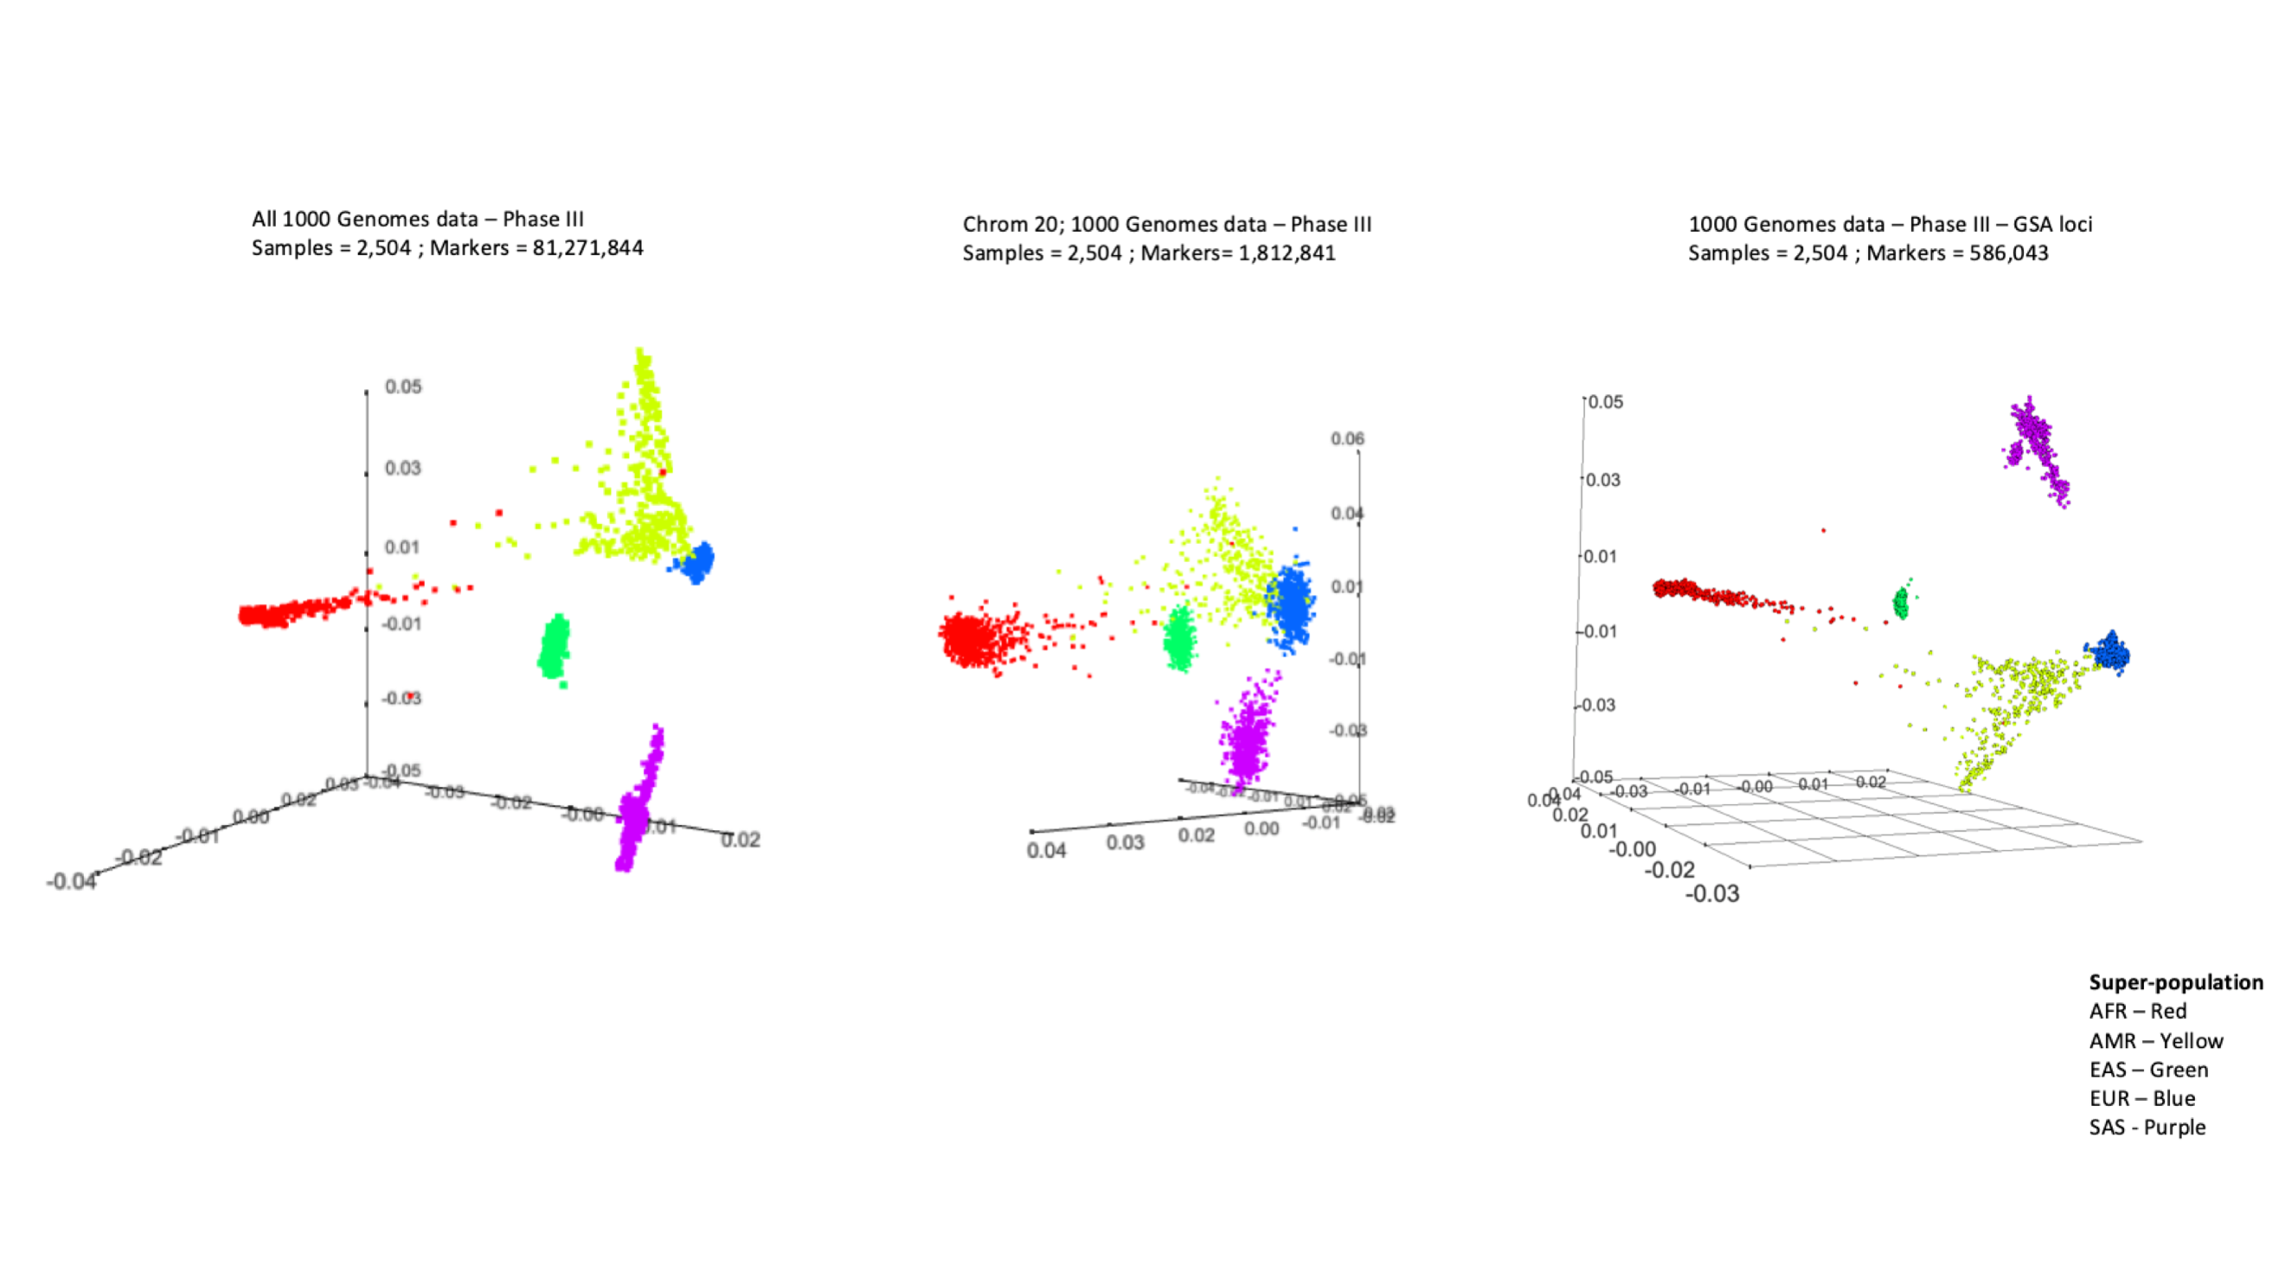
Figure S5. PCA of 1000 Genomes dataset separating into 5 major super-population groups. (a) All 1000 Genome data – left panel (b) 1000 Genome data – chromosome 20 – middle panel, (c) 1000 Genome data – GSA probe loci only.
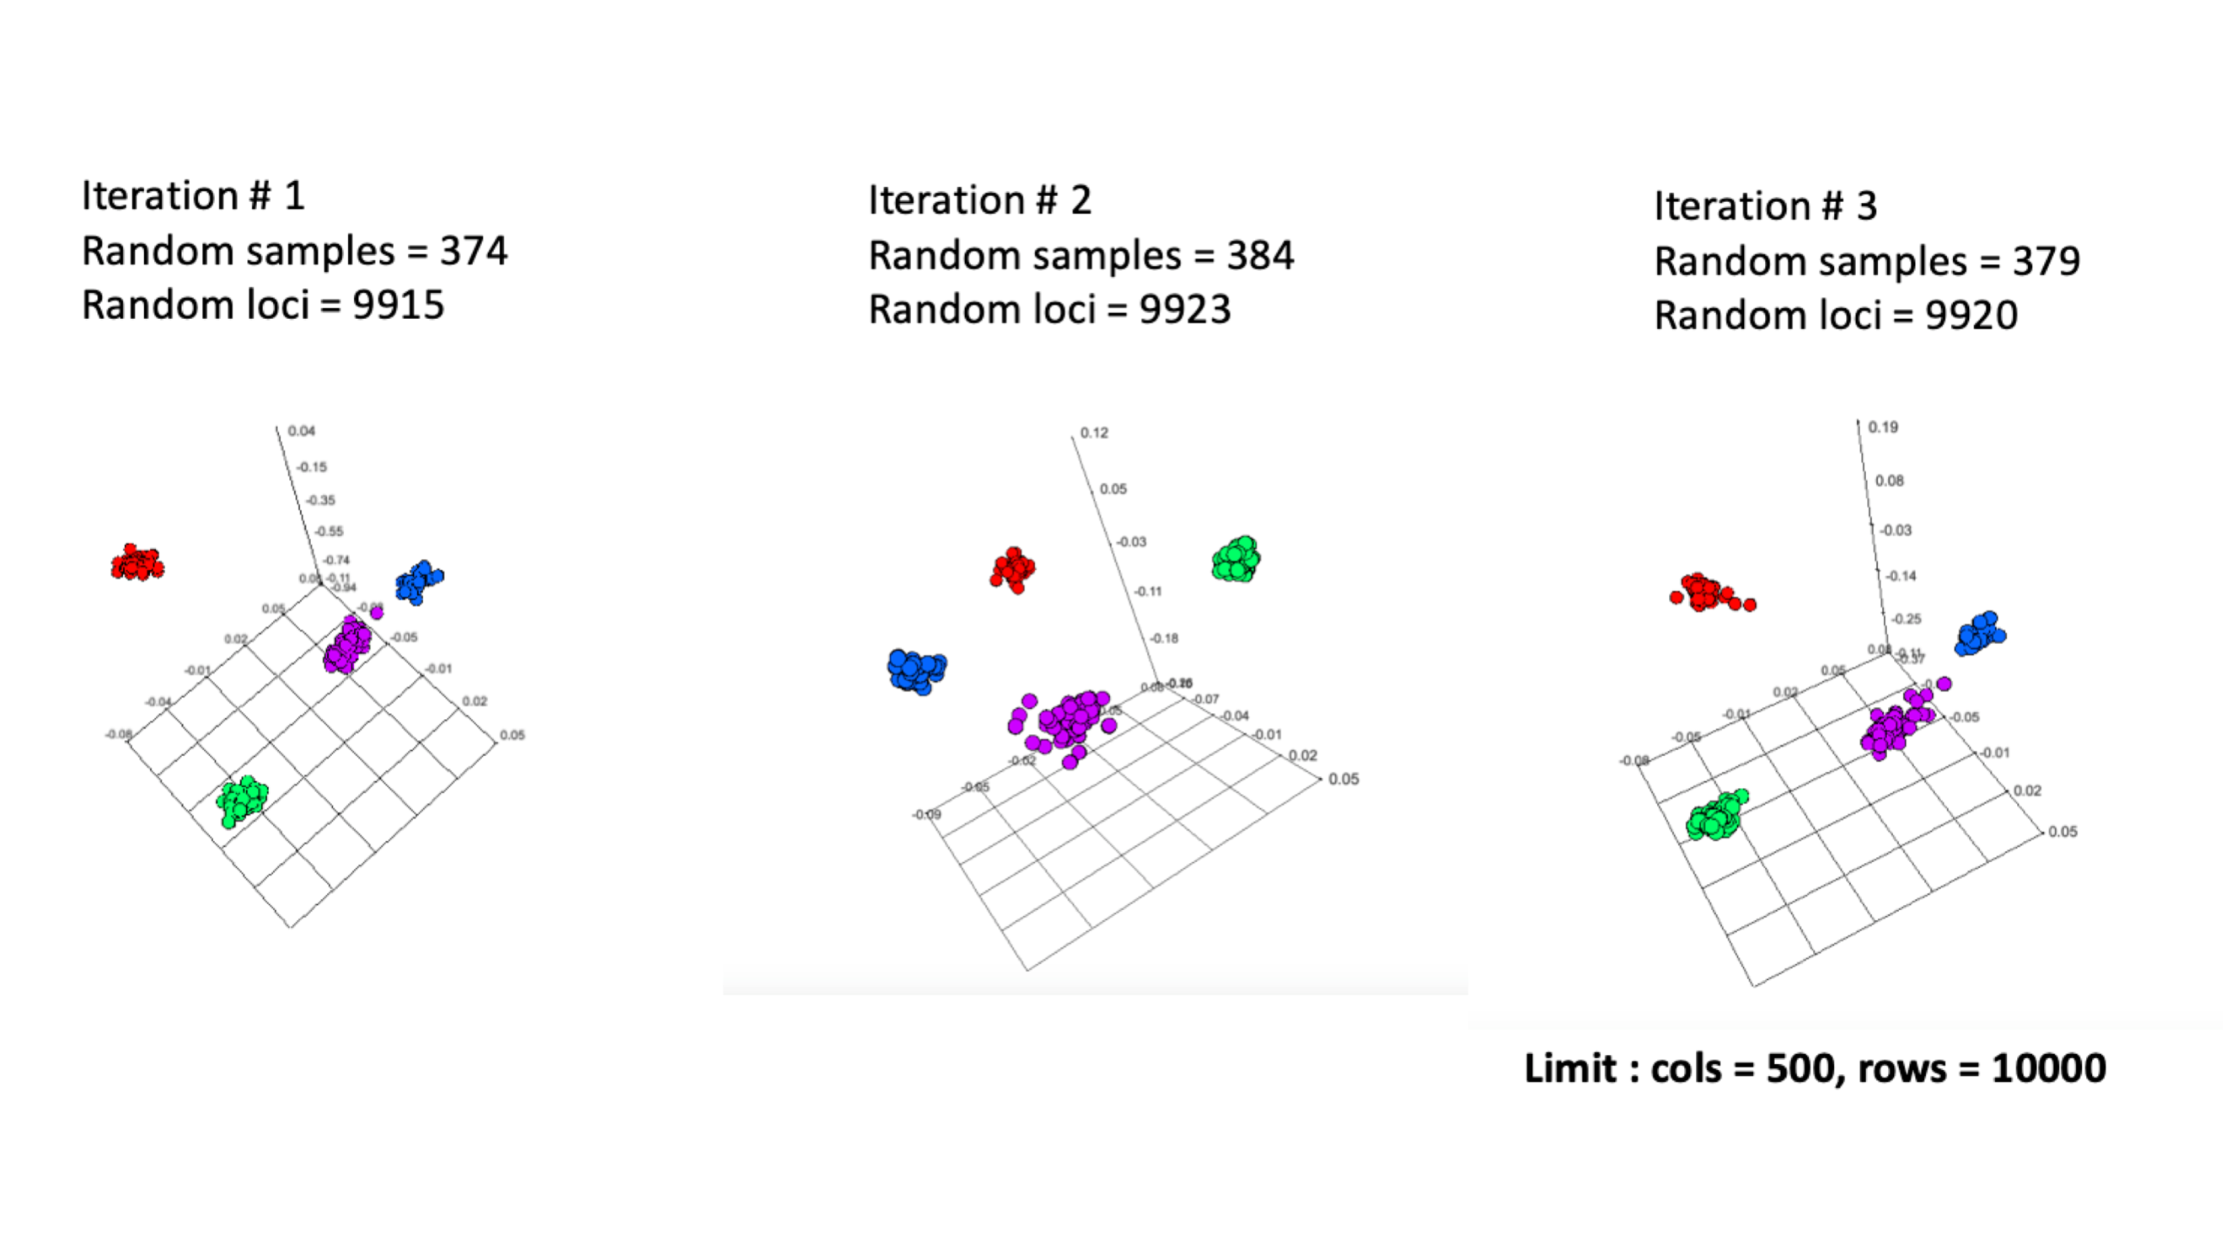
Figure S6. PCA performed on randomly selected samples and loci; same matrix size (10000 x 500) experiment was iterated 3 times.
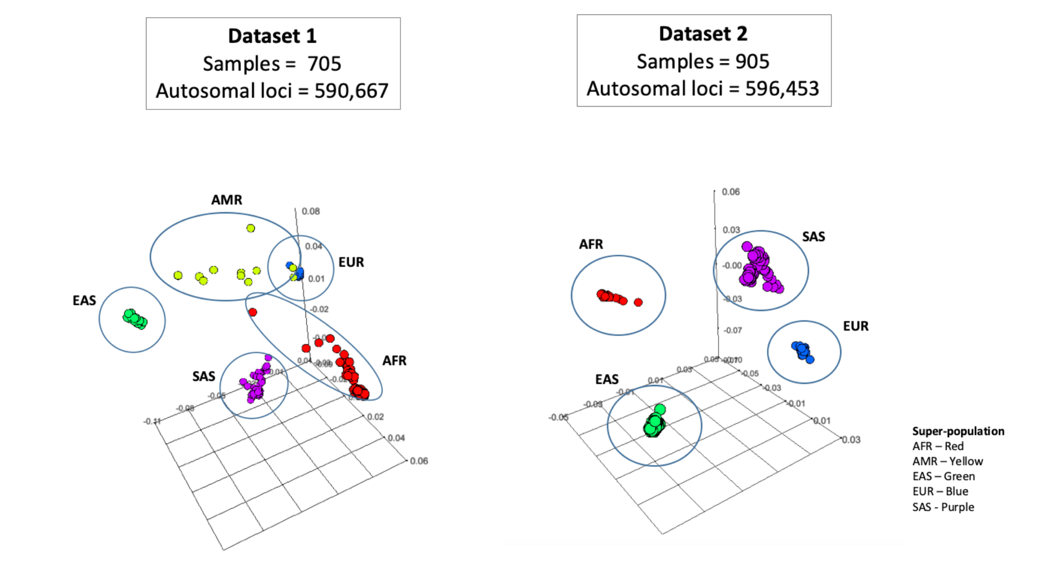
Figure S7. PCA of Imagenetics GSA autosomal datasets separating into 5 major super-population groups. Left panel – Dataset 1; Right panel - Dataset 2.

R code
Code based on https://bwlewis.github.io/1000_genomes_examples/PCA.html
library(Matrix)
library(irlba)
library(threejs)

p = pipe("zcat /Users/703398698/Documents/Projects/GSA_Freq_validation/popln/mergedFile_batch1_genoCallRate_gt98_callRate_gt9975_mod.autosomes.VCF.Z | sed /^#/d | cut -f '10-' | /Users/703398698/Documents/Projects/GSA_Freq_validation/popln/parse_gsa | cut -f '1-2' ")
x = read.table(p, colClasses=c("integer","integer"), fill=TRUE, row.names=NULL)
gsa = sparseMatrix(i=x[,2], j=x[,1], x=1.0)
dim(gsa)
cm = colMeans(gsa)
p = irlba(gsa, nv=3, nu=3, tol=0.1, center=cm)
ids = readLines(pipe("zcat /Users/703398698/Documents/Projects/GSA_Freq_validation/popln/mergedFile_batch1_genoCallRate_gt98_callRate_gt9975_mod.autosomes.VCF.Z | sed -n /^#CHROM/p | tr '\t' '\n' | tail -n +10"))
ped = read.table(url("ftp://ftp.1000genomes.ebi.ac.uk/vol1/ftp/technical/working/20130606_sample_info/20130606_g1k.ped"),sep="\t",header=TRUE,row.names=2)[ids,6,drop=FALSE]
pop = read.table("ftp://ftp.1000genomes.ebi.ac.uk/vol1/ftp/phase3/20131219.populations.tsv",sep="\t",header=TRUE)
pop = pop[1:26,]
super = pop[,3]
names(super) = pop[,2]
super = factor(super)
ped$Superpopulation = super[as.character(ped$Population)]
N = length(levels(super))
scatterplot3js(p$u, col=rainbow(N)[ped$Superpopulation], size=0.5)
library(Matrix)
library(irlba)
library(threejs)

p = pipe("zcat /Users/703398698/Documents/Projects/GSA_Freq_validation/popln/mergedFile_batch2_mod_genoCallRate_gt98_callRate_gt9975_subNoCallwithRef.autosomes.VCF.Z | sed /^#/d | cut -f '10-' | /Users/703398698/Documents/Projects/GSA_Freq_validation/popln/parse_gsa | cut -f '1-2' ")

x = read.table(p, colClasses=c("integer","integer"), fill=TRUE, row.names=NULL)
gsa = sparseMatrix(i=x[,2], j=x[,1], x=1.0)
dim(gsa)
cm = colMeans(gsa)
p = irlba(gsa, nv=3, nu=3, tol=0.1, center=cm)

ids = readLines(pipe("zcat /Users/703398698/Documents/Projects/GSA_Freq_validation/popln/mergedFile_batch2_mod_genoCallRate_gt98_callRate_gt9975_subNoCallwithRef.autosomes.VCF.Z | sed -n /^#CHROM/p | tr '\t' '\n' | tail -n +10"))
ped = read.table(url("ftp://ftp.1000genomes.ebi.ac.uk/vol1/ftp/technical/working/20130606_sample_info/20130606_g1k.ped"),sep="\t",header=TRUE,row.names=2)[ids,6,drop=FALSE]
pop = read.table("ftp://ftp.1000genomes.ebi.ac.uk/vol1/ftp/phase3/20131219.populations.tsv",sep="\t",header=TRUE)
pop = pop[1:26,]
super = pop[,3]
names(super) = pop[,2]
super = factor(super)
ped$Superpopulation = super[as.character(ped$Population)]
N = length(levels(super))
scatterplot3js(p$u, col=rainbow(N)[ped$Superpopulation], size=0.5)

p = pipe("zcat /Users/703398698/Desktop/GSA/pca/gsa_b1_out_mod_auto.VCF.Z | sed /^#/d | cut -f '10-' | /Users/703398698/Documents/Projects/GSA_Freq_validation/popln/parse_gsa | cut -f '1-2' ")
x = read.table(p, colClasses=c("integer","integer"), fill=TRUE, row.names=NULL)
gsa = sparseMatrix(i=x[,2], j=x[,1], x=1.0)
dim(gsa)
cm = colMeans(gsa)
p = irlba(gsa, nv=3, nu=3, tol=0.1, center=cm)
ids = readLines(pipe("zcat /Users/703398698/Desktop/GSA/pca/gsa_b1_out_mod_auto.VCF.Z | sed -n /^#CHROM/p | tr '\t' '\n' | tail -n +10"))
ped = read.table(url("ftp://ftp.1000genomes.ebi.ac.uk/vol1/ftp/technical/working/20130606_sample_info/20130606_g1k.ped"),sep="\t",header=TRUE,row.names=2)[ids,6,drop=FALSE]
pop = read.table("ftp://ftp.1000genomes.ebi.ac.uk/vol1/ftp/phase3/20131219.populations.tsv",sep="\t",header=TRUE)
pop = pop[1:26,]
super = pop[,3]
names(super) = pop[,2]
super = factor(super)
ped$Superpopulation = super[as.character(ped$Population)]
N = length(levels(super))
scatterplot3js(p$u, col=rainbow(N)[ped$Superpopulation], size=0.5)

p = pipe("zcat /Users/703398698/Desktop/GSA/pca/gsa_b2_out_mod_auto.VCF.Z | sed /^#/d | cut -f '10-' | /Users/703398698/Documents/Projects/GSA_Freq_validation/popln/parse_gsa | cut -f '1-2' ")
x = read.table(p, colClasses=c("integer","integer"), fill=TRUE, row.names=NULL)
gsa = sparseMatrix(i=x[,2], j=x[,1], x=1.0)
dim(gsa)
cm = colMeans(gsa)
p = irlba(gsa, nv=3, nu=3, tol=0.1, center=cm)
ids = readLines(pipe("zcat /Users/703398698/Desktop/GSA/pca/gsa_b2_out_mod_auto.VCF.Z | sed -n /^#CHROM/p | tr '\t' '\n' | tail -n +10"))
ped = read.table(url("ftp://ftp.1000genomes.ebi.ac.uk/vol1/ftp/technical/working/20130606_sample_info/20130606_g1k.ped"),sep="\t",header=TRUE,row.names=2)[ids,6,drop=FALSE]
pop = read.table("ftp://ftp.1000genomes.ebi.ac.uk/vol1/ftp/phase3/20131219.populations.tsv",sep="\t",header=TRUE)
pop = pop[1:26,]
super = pop[,3]
names(super) = pop[,2]
super = factor(super)
ped$Superpopulation = super[as.character(ped$Population)]
N = length(levels(super))
scatterplot3js(p$u, col=rainbow(N)[ped$Superpopulation], size=0.5)

Sample DNA contamination estimation and detection
GSA measures the relative intensity of fluorescently labeled probes associated with A and B alleles. After normalizing the intensities, the Illumina software assigns a genotype for each genomic locus assayed as AA (homozygous A, B-allele frequency (BAF) =~ 0; absence of B allele), or AB (heterozygous, BAF =~ 0.5; 50% B allele), or BB (homozygous B, BAF =~ 1; 100% B-allele). A missing genotype is assigned in positions with intensities outside the expected clusters. In addition, the output also contains the estimated abundance of the B allele called the B allele frequency (BAF) and the log-likelihood ratio (LLR) of observed signal intensity at a given locus relative to expected signal intensity.

Regression-based method to detect sample contamination
The regression-based method detects contamination by identifying shifts in signal between the expected and the B allele frequency in sites called as homozygous*. Consider a sample with AA genotype at a particular genomic location whose DNA sample is contaminated. As the population frequency of the minor allele (B allele) increases, the sample is increasingly likely to be contaminated with the B allele (7). In absence of sample contamination, we expect BAF values close to 0, 0.5, and 1 for genotypes AA, AB and BB, respectively; however, in presence of contamination, the expected BAF scales with the level of contamination.

$$E\left[ BAF \right| g=AA; ∝, p_{B}]= ∝p_{B}$$
and, $E\left[ BAF \right| g=BB; ∝, p_{A}]= 1 - ∝p_{A}$

where $p_{A}$ and $p_{B}$ are the population frequencies of A and B, $∝$ is the contamination level (fraction; range 0 - 1).

This gives a linear regression model for BAF
$$BAF= γ+ αp+τI\left(g=AA\right)+ε$$

Where $γ$ is the intercept, $p=\left\{\begin{aligned}p_{B}, if g=AA \\ {-p}_{A}, if g=BB\end{aligned}\right.$ , $τ$ is the difference between expected BAF for AA and BB genotypes, and $ε$ is the normally distributed error term. The test for contamination can be evaluated by testing the null hypothesis that $α$=0 against the one-sided alternative that $α>0$.

In addition to using publicly available databases that record population frequency of the A and B alleles, allele frequencies can also be estimated from the Illumina genotyping cluster file that we generated from the 1,104 samples from diverse population groups. Using the cluster file, we estimated the minor allele frequency (MAF) $f$

$$f=\frac{\left(2*mC\right)+hC}{(2*T)}$$

Where $mC$ is the minor allele genotype count, $hC$ is the heterozygous genotype count, and $T$ is the total count of all genotypes at a particular genotyping locus. Following this derivation of the MAF, it is feasible, given the minor allele frequency and that the genotype is AA, (i) to calculate the probability that B is the minor allele and (ii) to compute the expected BAF.

$$\operatorname{Pr}\left(B is minor allele \right|g=AA and f)= \frac{Pr⁡(B is minor allele, g=AA and f)}{\operatorname{Pr}\left(B is minor allele, g=AA and f\right)+Pr⁡(A is minor allele, g=AA and f)}$$

$$\operatorname{Pr}\left(B is minor allele \right|g=AA and f)=\frac{{(1-f)}^{2}}{{(1-f)}^{2}+f^{2}}$$

$$E\left[BAF\right|g=AA; α, f]=α\frac{f(1-f)}{{(1-f)}^{2}+f^{2}}$$

where $α$ is level of contamination. The linear regression model can be updated to:

$$BAF= γ+ αf+τI\left(g=AA\right)+ε$$

Jun, G et. al. show that the linear regression model to calculate BAF using minor allele frequency is identical to population frequency-based computation; therefore, this method allows detection of contamination using genotypes encoded either as AA, AB or BB, and removes the necessity to decode the A and B alleles to their respective reference genome nucleotides (A, C, G, or T). This method also allows for implementation of sample contamination detection in early stages of data analysis and serves as a sample contamination detection quality control step. Using linear regression analysis of known and predicted DNA contamination, we generated a standard curve for a continuum of contamination between DNA samples from genetically unrelated individuals and between DNA samples from genetically related individuals (Figure S8). Additionally, we evaluated the relationship between sample contamination and GSA call-rate and heterozygous to homozygous call ratio (Figure S9).
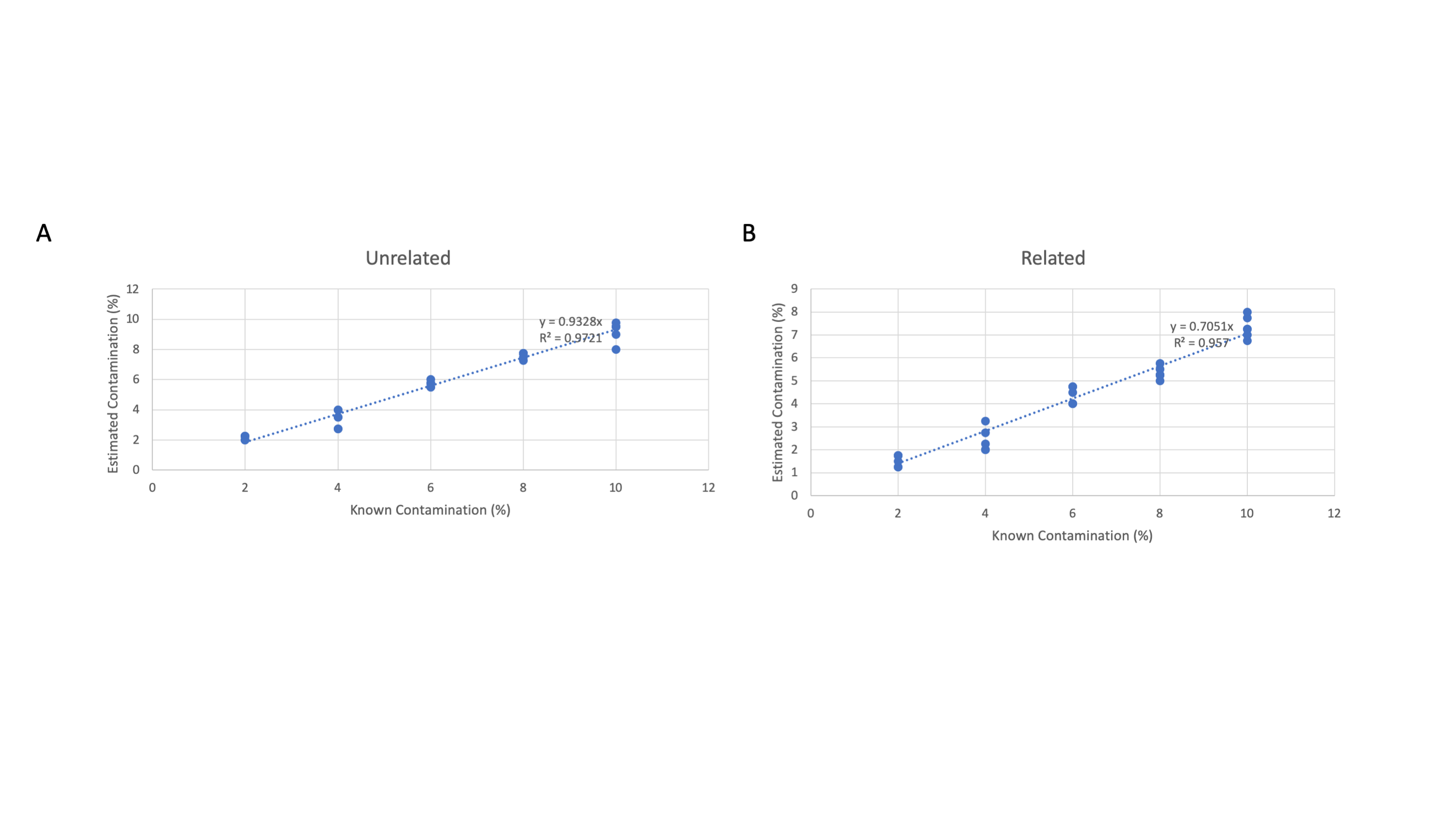
Figure S8. Standard linear regression data fit to estimated and known level of sample DNA contamination. These data were generated on triplicate sample contaminations for a given contamination level – e.g: 2,3,4,5, and 10 percent respectively (a) Unrelated sample contamination dataset (b) Related sample contamination dataset
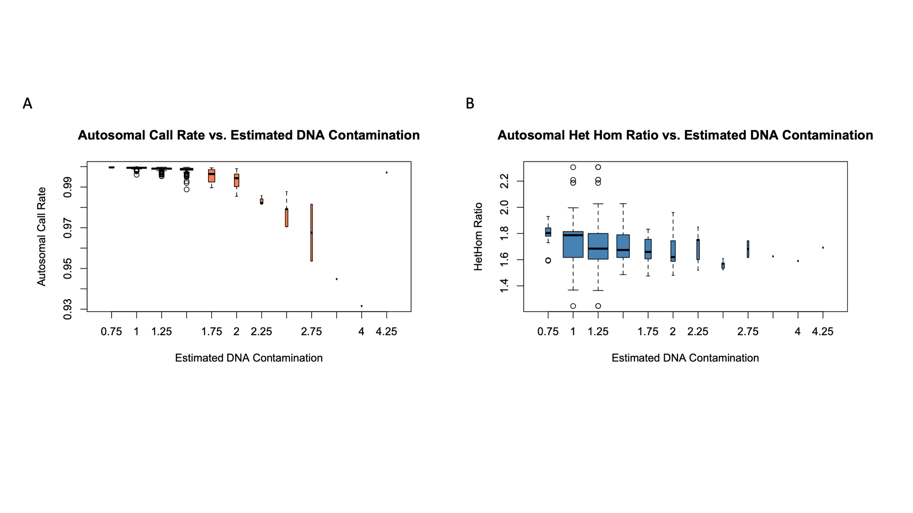
Figure S9. Quality control : Comparison of autosomal call rate and het/hom ratio to sample contamination. Quality control analysis GSA – Call rate vs. estimated DNA contamination; GSA Het / Hom Ratio vs. estimated DNA contamination

GSA quality control analyses
Quality control (QC) for the GSA was performed at multiple levels including (a) the BeadChip Array, (b) sample replicate, and (c) the VCF statistics.

Quality control for BeadChip Array
QC for GSA data at the level of BeadChip was evaluated for (a) call rate, (b) p10GC, and (c) sample contamination. Each BeadChip was analyzed and the data was plotted using the R-code (below) to detect outlier samples (Figure S10).
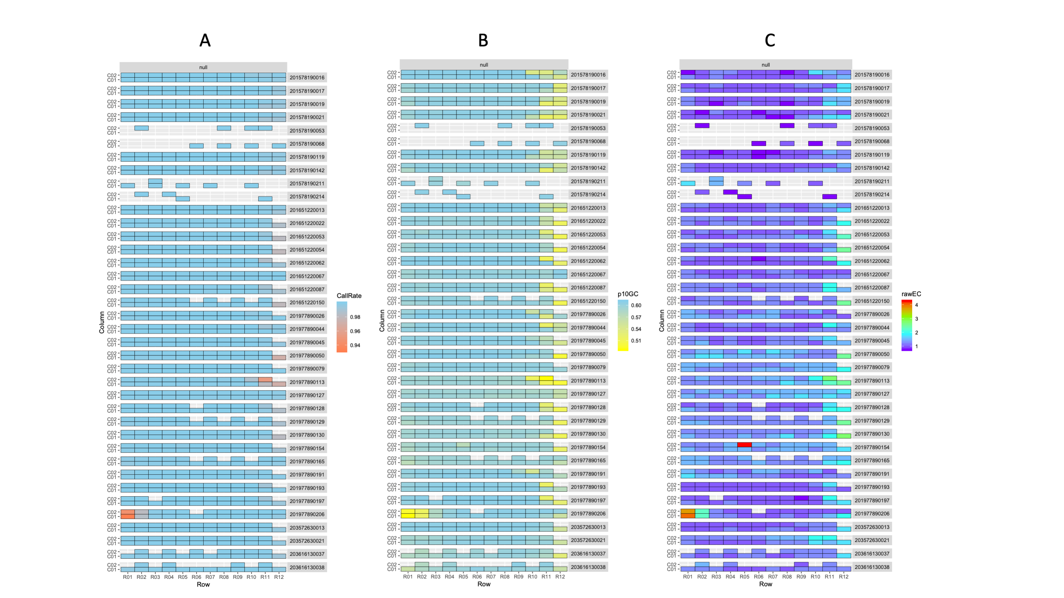
Figure S10. Quality control : BeadChip
df<-read.table("/Users/703398698/Documents/Projects/GSA_replicates/GSA_WGS_263/dataset_263_master_QC.csv", sep="," , header=T)
ggplot(df, aes(Row, Column, fill=CallRate)) + geom_tile(colour="black") + facet_grid(BeadChip~Group) + scale_fill_gradient(low="coral", high="skyblue") + theme(strip.text.y=element_text(angle=360))

df<-read.table("/Users/703398698/Documents/Projects/GSA_replicates/GSA_WGS_263/dataset_263_master_QC.csv", sep="," , header=T)
ggplot(df, aes(Row, Column, fill=CallRate)) + geom_tile(colour="black") + facet_grid(BeadChip~Group) + scale_fill_gradient(low="yellow", high="skyblue") + theme(strip.text.y=element_text(angle=360))

df<-read.table("/Users/703398698/Documents/Projects/GSA_replicates/GSA_WGS_263/dataset_263_master_QC.csv", sep="," , header=T)
ggplot(df, aes(Row, Column, fill=rawEC)) + geom_tile(colour="black") + facet_grid(BeadChip~Group) + scale_fill_gradient(colours=rev(rainbow(4))) + theme(strip.text.y=element_text(angle=360))

Quality control for GSA triplicate samples
QC for GSA triplicate samples were evaluated in tandem as R1, R2, and R3, respectively, across the quality control metrics of (a) call rate, (b) p10GC, (c) sample contamination, (d) no genotype calls, and (e) heterozygous genotype / homozygous genotype ratio (Figure S11). Additionally, replicate sample outliers were detected by applying a Z-score method to call rate data (Figure S12). The R-code used to generate these plots is shown below:
ds <- read.table("/Users/703398698/Desktop/GSA/Supplementary_Data/triplicate_VCF/merged_genomeStudio_VCFStats.csv", sep=",", header=T)

ggplot(ds, aes(Dataset, Sample, fill=withGenotypes/TotalGSAAssays)) + geom_tile(color="gray")+scale_fill_gradient(low="coral", high="skyblue") + labs(title="Call Rate \n", fill="Call Rate\n") + theme(axis.text.y=element_text(size=3))

ggplot(ds, aes(Dataset, Sample, fill=withGenotypes/TotalGSAAssays)) + geom_tile(color="gray")+scale_fill_gradientn(colours=rainbow(4))+ labs(title="Call Rate \n", fill="Call Rate\n") + theme(axis.text.y=element_text(size=3))

ggplot(ds, aes(Dataset, Sample, fill=p10GC)) + geom_tile(color="gray")+scale_fill_gradientn(colours=rainbow(4)) + labs(title="p10GC \n", fill="p10GC\n") + theme(axis.text.y=element_text(size=3))

ggplot(ds, aes(Dataset, Sample, fill=rawEC)) + geom_tile(color="gray")+scale_fill_gradientn(colours=rev(rainbow(4))) + labs(title="Estimated DNA Contamination \n", fill="Est Contam\n") + theme(axis.text.y=element_text(size=3))

ggplot(ds, aes(Dataset, Sample, fill=NoGenotypes)) + geom_tile(color="gray")+scale_fill_gradient(low="skyblue", high="coral") + labs(title="No Genotype Calls \n", fill="No Genotype Calls\n") + theme(axis.text.y=element_text(size=3))

ggplot(ds, aes(Dataset, Sample, fill=auto_het_SNV/auto_homalt_SNV)) + geom_tile(color="gray")+scale_fill_gradientn(colours=rainbow(4)) + labs(title="Het / Hom Ratio\n", fill="Het / Hom Ratio\n") + theme(axis.text.y=element_text(size=3))

tmp<-cbind(df,'Z_score'=(df$Autosome_data-599557)/sqrt(var(df$Autosome_data)))
plot(tmp$Z_score, pch=16, cex=1, col="steelblue", ylab="Z-Score")
abline(h=-4, lty=2)
abline(h=-2, lty=2)
abline(h=0, lty=1, col="red")

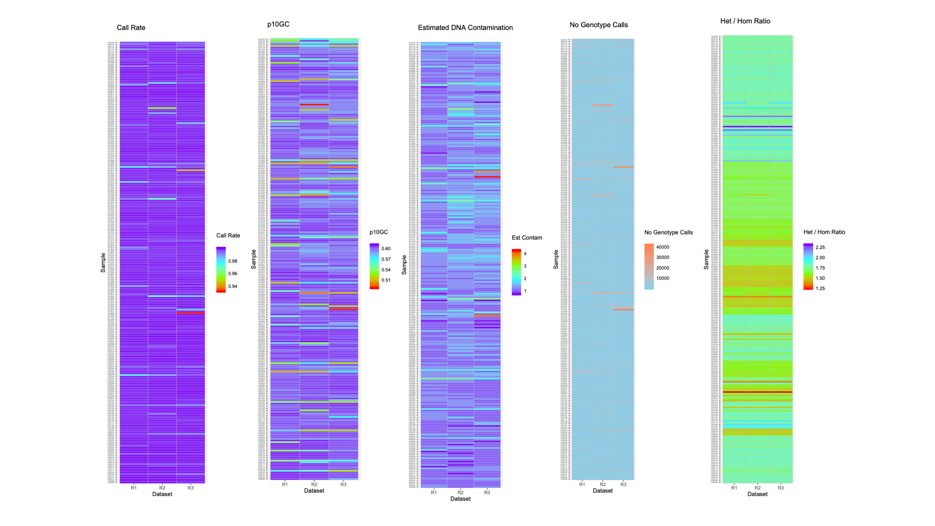
Figure S11. Quality control : sample triplicate analysis
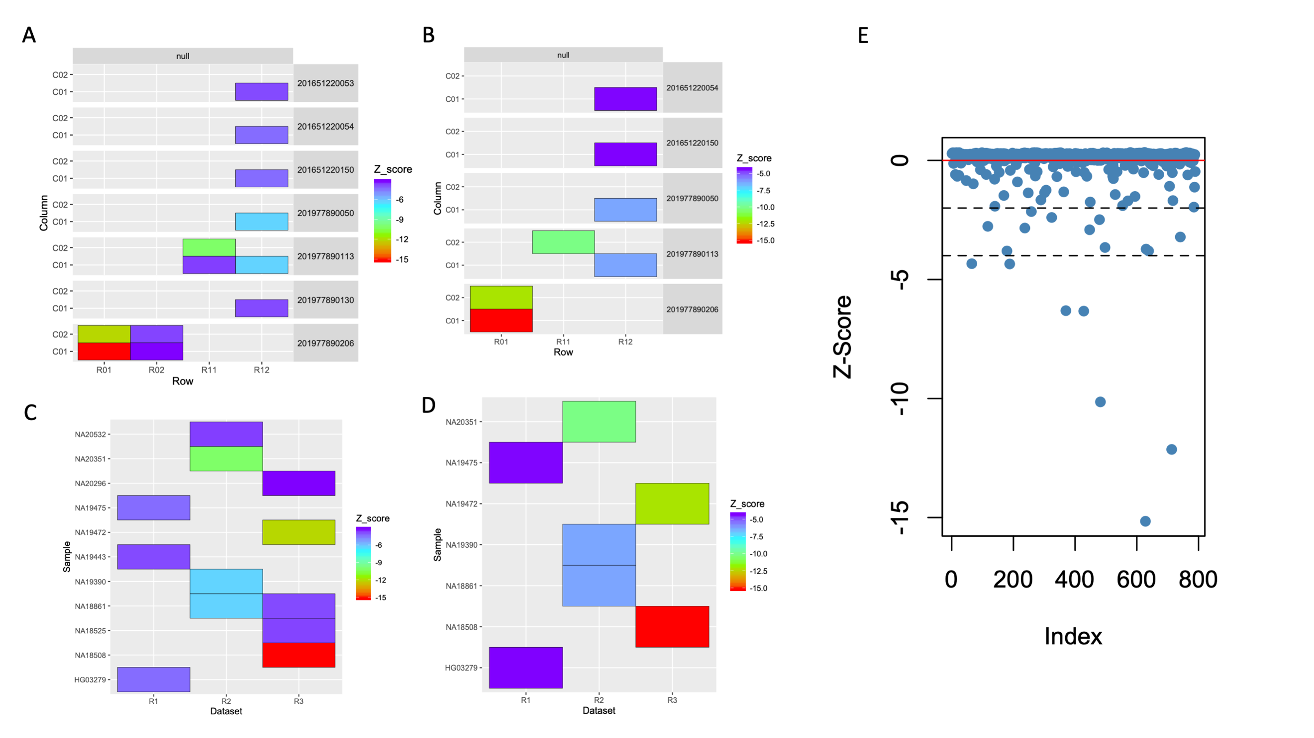
Figure S12. Quality control : outlier detection analysis

Quality control of GSA triplicate VCF files
We evaluated 236 samples’ triplicate VCF files for quality. Summary statistics for each replicate VCF file were generated using rtg (a program for VCF statistics) and plotted relative to each other to detect correlation (Figure S13). It was run as follows: rtg VCFstats [sampleid_replicate#.vcf.gz]. The summary of this analysis is the file ‘GSA_236_triplicates_VCFSummary.xls].
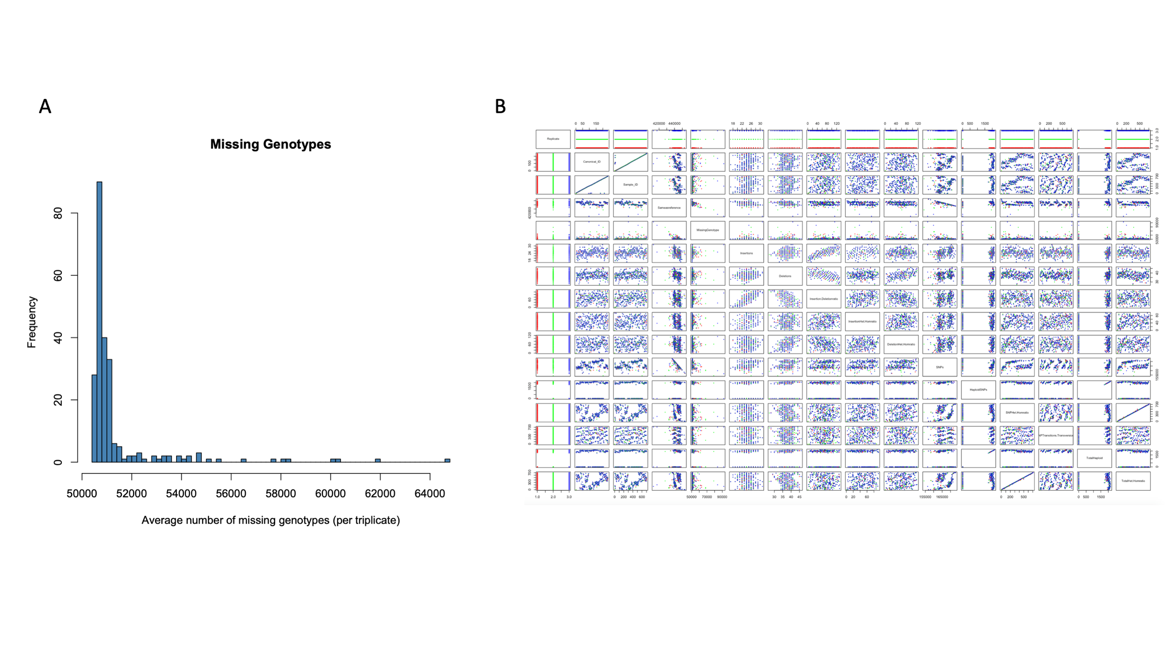
Figure S13. Quality control : call rate and vcf statistics

Quality control of GSA assays
Each GSA assay was evaluated for probability of genotyping success. Using all triplicate data (253 x 3), the probability of genotyping success was calculated as a product of call-rate and concordance. Because each sample was required to have all three replicates for this analysis, five samples were removed from the 263-sample data set due to outlier detection (sample contamination and /or poor genotype call rate). Using the probability of genotyping success as a cut-off, we tabulated the number of assays that “passed” and failed to meet the cutoff (Table S6). The most stringent cut-offs were very close to 1 suggesting the majority of the GSA assays had high probability of genotyping success (Figure S14 and Table 12).
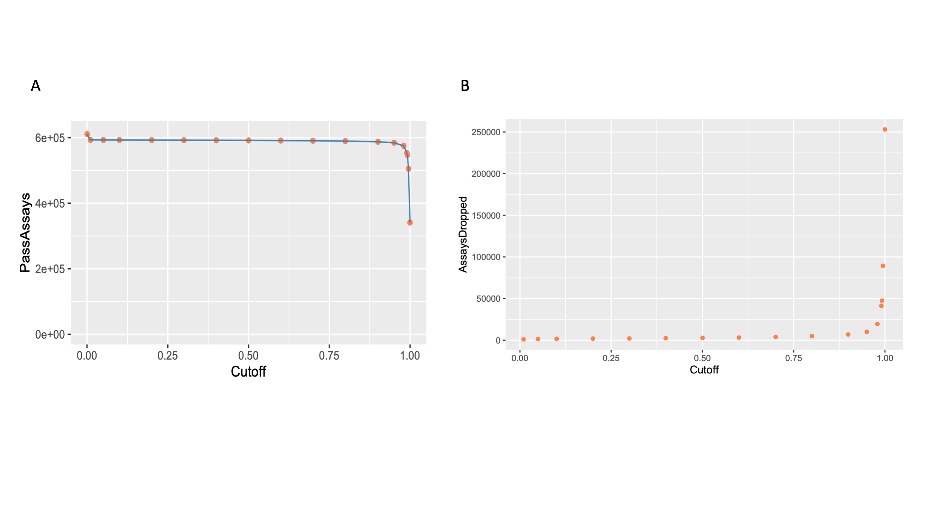
Figure S14. Quality control : tritration of cut-offs

Table S6. Tally of number of pass and fail GSA assays as a function of titrating cutoffs
Cutoff | Total Assays | Assays without 1KG data | Number of Assays Pass Cutoff | Number of Assays  Dropped; Failed Cutoff
0.01 | 610,771 | 16,407 | 593,286 | 1,078
0.05 | 610,771 | 16,407 | 592,998 | 1,366
0.1 | 610,771 | 16,407 | 592,792 | 1,572
0.2 | 610,771 | 16,407 | 592,542 | 1,822
0.3 | 610,771 | 16,407 | 592,284 | 2,080
0.4 | 610,771 | 16,407 | 591,971 | 2,393
0.5 | 610,771 | 16,407 | 591,599 | 2,765
0.6 | 610,771 | 16,407 | 591,152 | 3,212
0.7 | 610,771 | 16,407 | 590,515 | 3,849
0.8 | 610,771 | 16,407 | 589,516 | 4,848
0.9 | 610,771 | 16,407 | 587,431 | 6,933
0.95 | 610,771 | 16,407 | 584,364 | 10,000
0.98 | 610,771 | 16,407 | 574,964 | 19,400
0.99 | 610,771 | 16,407 | 553,004 | 41,360
0.992 | 610,771 | 16,407 | 546,893 | 47,471
0.995 | 610,771 | 16,407 | 505,091 | 89,273
1 | 610,771 | 16,407 | 341,216 | 253,148
*pragmatic cutoff of 0.98.

Transitions and transversions
GSA SNV assays were stratified by the type of nucleotide change, i.e., transition (purine to purine and pyrimidine to pyrimidine) or transversion (purine to pyrimidines and vice versa). Transversions performed poorer than transitions across the performance metrics of Sensitivity, Specificity, PPV, and Concordance (Figure S16).
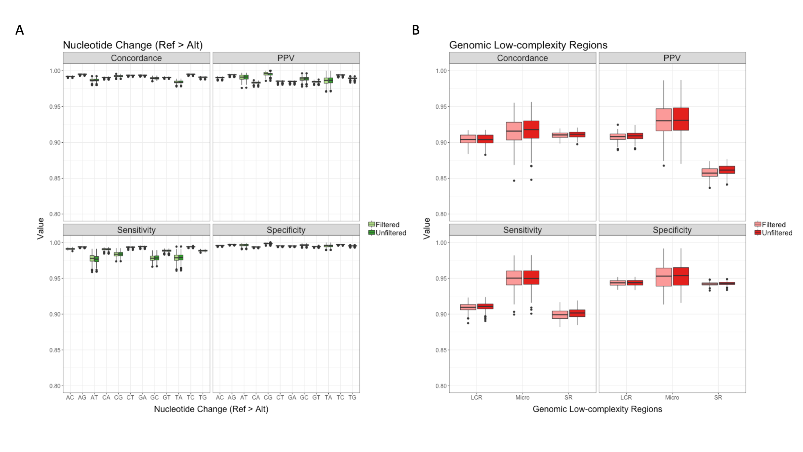
Figure S15. Performance metrics : nucleotide change and low-complexity regions

Transitions and transversions with special focus on complementary transversions
Transitions interchange bases of similar shape, whereas transversions interchange bases of differing structure, i.e., one-ring pyrimidines (C, T) for two-ring purines (A, G) or vice versa (Figure S17). Given 4 nucleotide bases (A,C,G,T), there are a total of 16 possible interchanges (4x4). 8 transitions and 8 transversions. However, 4 “transitions” of the 8 possible transitions are unobserved due to self-interchange (e.g., A>A). This leaves 12 total interchanges: 4 transitions and 8 transversions (Figure S17). The 4 possible transitions are: A>G, G>A, C>T, and T>C. The 8 possible transversions are: A>C, C>A, A>T, T>A, C>G, G>C, G>T, T>G. Of the 8 possible transversions, half (4) are changes between complementary nucleotides (e.g., A>T) (Figure S17).
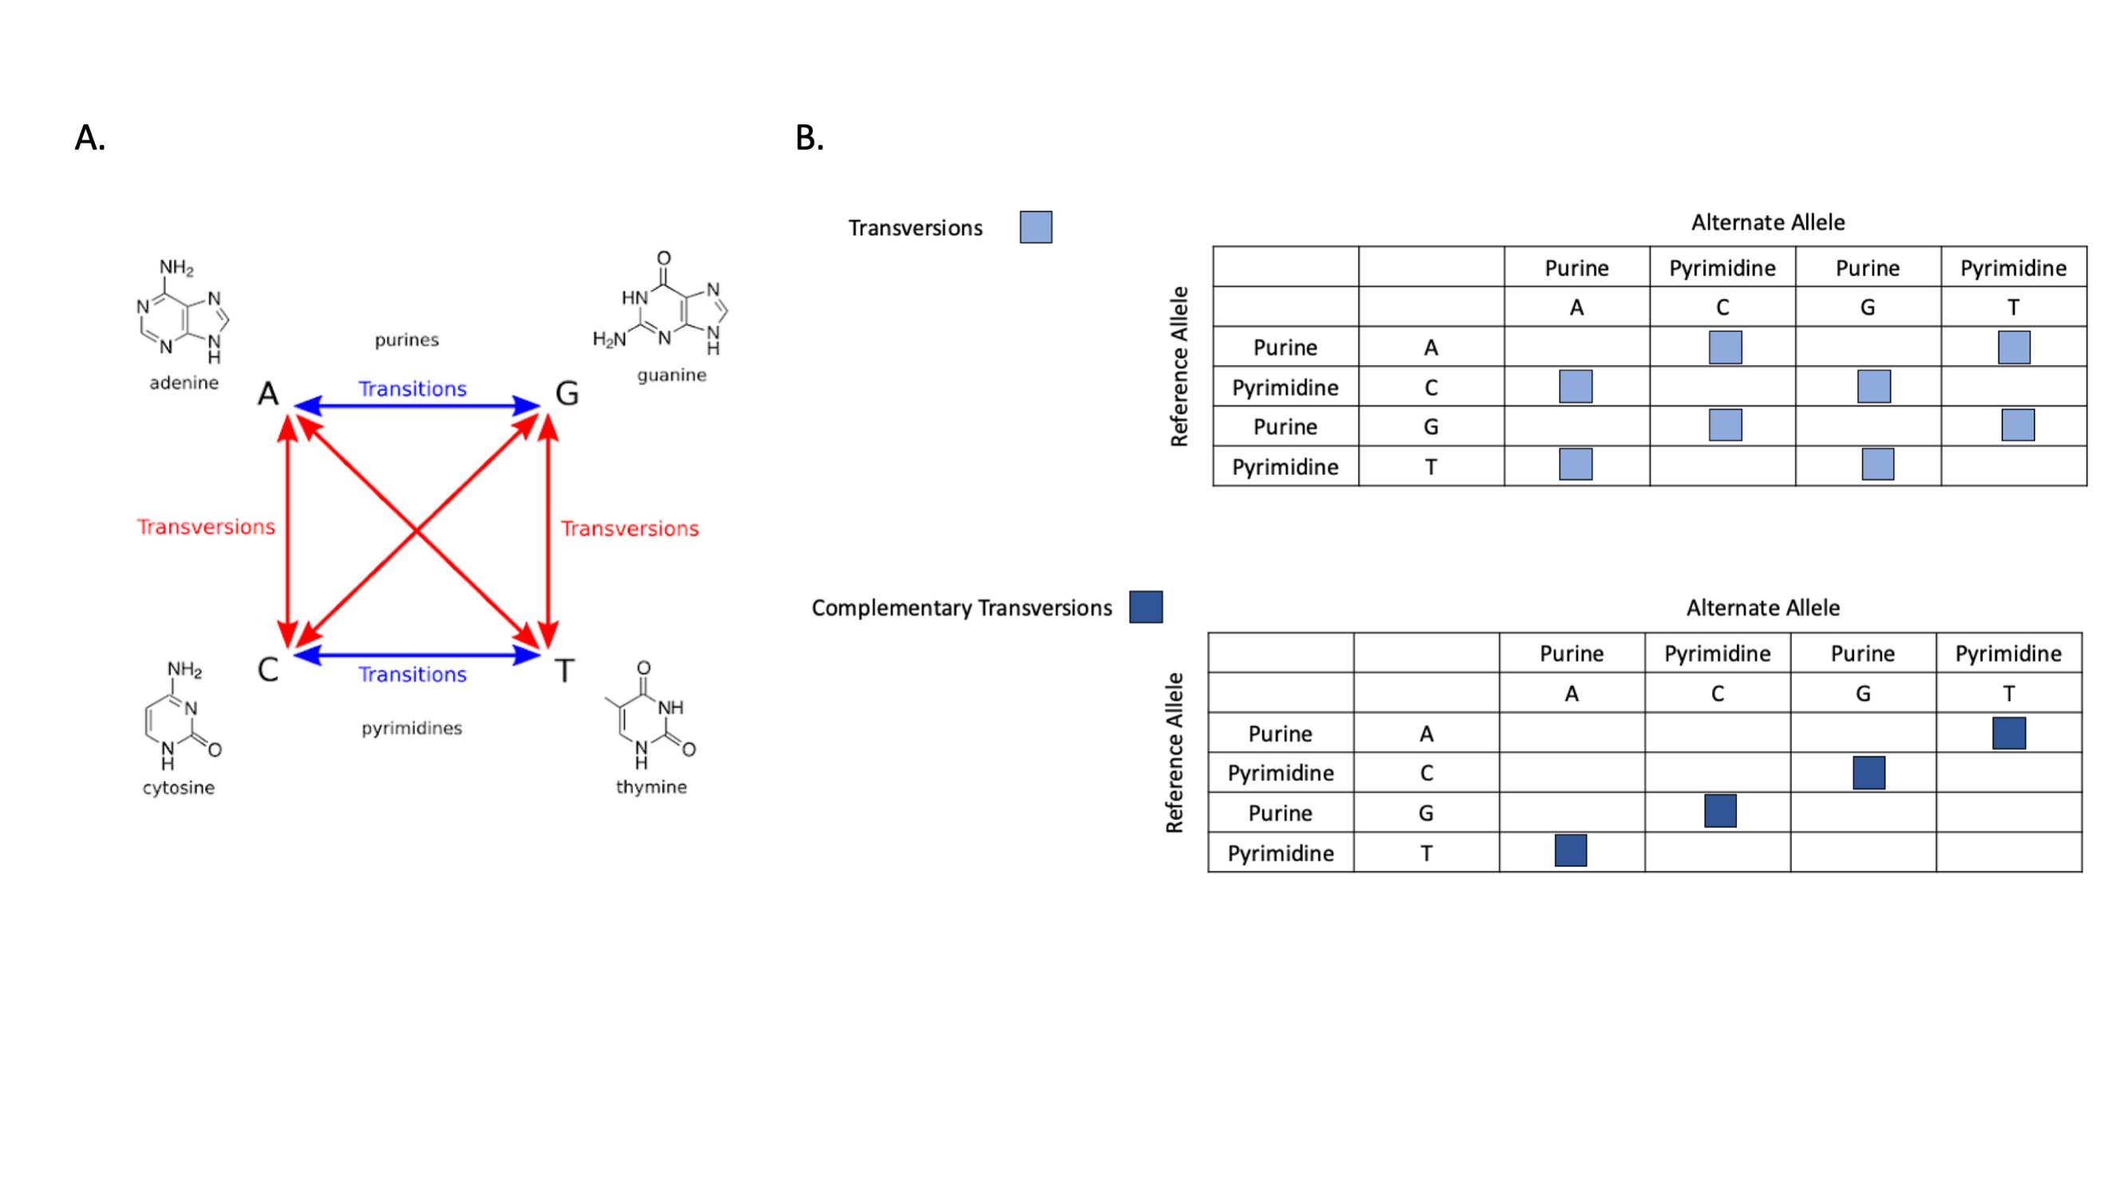
Figure S16. Schematic diagram showing a total of 12 possible transitions and transversions. Transversions from reference allele to alternate allele in SNVs. Top panel shows all 8 possible transversions (highlighted with light blue squares). Bottom panel shows a subset of 4 of 8 transversions that are complementary bases relative to each other (dark blue squares).

GSA, rWGS and 1KG comparison
Comparison of GSA, rWGS and 1KG genotypes detected discordances, e.g., the GSA calling a variant homozygous reference or heterozygote when the 1KG or WGS called the genotype as homozygous non-reference. Expected numbers of false negatives were gathered from literature (8-10). The observed false negatives were computed by dataset comparison (Table S7) and are shown relative to expected values observed in literature.

Table S7. False negative rate expected vs. observed relative to 1KG
 | Expected (theoretical) | Observed (empirical) GSA vs 1KG / rWGS vs. 1KG
SNP arrays vs. 1KG (9) | 1.5x10⁻⁴ – 3x10⁻⁴ | ~ 1x10⁻³
WGS vs. 1KG (8, 10) | 3x10⁻⁷ | ~ 2x10⁻⁴

Assays were analyzed for how many assays would fail / be filtered out if PPV were equal to 1 were considered as a cut-off for each GSA assay. These were triaged by alternate allele frequency bins from rare (0-0.1%) to most common (90-100%) variation (Table S8).

Table S8. Array and WGS GSA assays with PPV < 1 relative to 1KG Phase 3 data were considered as failed / filtered. Data were binned by alternate allele frequency.
Allele frequency (%) bins | Total QC pass assays | Assays with PPV ==1; WGS vs 1KG, GSA vs. 1KG | % left | % filtered
0-0.1 | 17454 | 3283 | 19 | 81
0.1-1 | 138342 | 99508 | 72 | 28
1-5 | 104272 | 88235 | 85 | 15
5-10 | 58421 | 48532 | 83 | 17
10-20 | 78631 | 66027 | 84 | 16
20-30 | 52398 | 44511 | 85 | 15
30-40 | 36620 | 31223 | 85 | 15
40-50 | 27476 | 23563 | 86 | 14
50-60 | 23053 | 20041 | 87 | 13
60-70 | 20134 | 17799 | 88 | 12
70-80 | 19210 | 17318 | 90 | 10
80-90 | 14312 | 13103 | 92 | 8
90-100 | 4023 | 3564 | 89 | 11
Total | 594,346 | 476,707

In order to evaluate GSA assays relative to the Platinum genome regions that were classified either as low-confidence or high-confidence bases, 610,731 GSA assays were intersected with these annotations. Over 541,000 (89%) GSA assays reside in high-confidence regions, and over 69,600 (11%) reside in the low-confidence regions (Table S9).

Table S9. GSA assay intersected with Platinum Genome high-confidence and low-confidence regions
Class | Count | Percent
Platinum genome low-confidence region GSA assays | 69,654 | 11.4
Platinum genome high-confidence region GSA assays | 541,077 | 88.6
Total | 610,731 | 100

When the high-error subset (three-way discordance analysis) of GSA assays (542 assays) were intersected with low confidence annotations of the Platinum Genome, 43% (235) resided within the low-confidence annotation category (Table S10).

Table S10. GSA assays intersected with Platinum Genome high-confidence and low-confidence regions grouped by high error subset and full subset
 | Platinum High Conf | Platinum Low Conf | % Plat High Conf | %Plat Low Conf | Total
High Error Subset | 307 | 235 | 57 | 43 | 542
Full Set | 541,077 | 69,654 | 89 | 11 | 610,731

Miscellaneous code used to generate figures and results

All GSA manifest file QC pass assays’ call rate
library("scatterplot3d")
gsaCR <- read.table("/Users/703398698/Desktop/GSA/triplicate/ACMG59/callRate_triplicates.txt", header = T)
gsaCRmat<-as.matrix(gsaCR)
gsaCRqc <- read.table("/Users/703398698/Desktop/GSA/triplicate/ACMG59/callRate_triplicates_minusqc11.txt", header=T)
gsaCRqcMat<-as.matrix(gsaCRqc)
all <- read.table("/Users/703398698/Desktop/GSA/triplicate/ACMG59/dataset_263_allRep_callRate.txt")
allqc <- read.table("/Users/703398698/Desktop/GSA/triplicate/ACMG59/dataset_252_allRep_minusQC_callRate.txt")

par(mfrow=c(2,2))
scatterplot3d(all$V5, all$V9, all$V13, pch=16, color="steelblue", xlab="GSA Replicate 1", ylab="GSA Replicate 2", zlab="GSA Replicate 3", xlim=c(0.93,1), ylim=c(0.93,1), zlim=c(0.93,1), main="GSA CallRate - All samples (263)")
scatterplot3d(allqc$V5, allqc$V9, allqc$V13, pch=16, color="coral", xlab="GSA Replicate 1", ylab="GSA Replicate 2", zlab="GSA Replicate 3", xlim=c(0.93,1), ylim=c(0.93,1), zlim=c(0.93,1), main="GSA CallRate - QC pass samples (252)")
scatterplot3d(gsaCRmat, xlim=c(0.93, 1), ylim=c(0.93,1), zlim=c(0.93,1), pch=16, color="steelblue", xlab="MAP59 Replicate 1", ylab="MAP59 Replicate 2", zlab="MAP59 Replicate 3", main="MAP59 CallRate - All samples (263)")
scatterplot3d(gsaCRqcMat, xlim=c(0.93, 1), ylim=c(0.93,1), zlim=c(0.93,1), pch=16, color="coral", xlab="MAP59 Replicate 1", ylab="MAP59 Replicate 2", zlab="MAP59 Replicate 3", main="MAP59 CallRate - QC pass samples (252)")

SSXFRSCTIMGA002:sample_replicates 703398698$ grep -v sample merged_concordance.out | awk '$3<=0.999 {print}’
NA20351 R1R2 0.997252907413263 R2R3 0.997269376213194 R1R3 0.999944348788068
SSXFRSCTIMGA002:sample_replicates 703398698$ grep -v sample merged_concordance.out | awk '$5<=0.999 '{print}’
NA18508 R1R2 0.999989880505637 R2R3 0.996006970177906 R1R3 0.995986106867193
NA19472 R1R2 0.999991571125373 R2R3 0.995812760922903 R1R3 0.995835680516832
NA20351 R1R2 0.997252907413263 R2R3 0.997269376213194 R1R3 0.999944348788068
SSXFRSCTIMGA002:sample_replicates 703398698$ grep -v sample merged_concordance.out | awk '$7<=0.999 {print }'
NA18508 R1R2 0.999989880505637 R2R3 0.996006970177906 R1R3 0.995986106867193
NA19472 R1R2 0.999991571125373 R2R3 0.995812760922903 R1R3 0.995835680516832

References

1. Biesecker LG, Mullikin JC, Facio FM, Turner C, Cherukuri PF, Blakesley RW, et al. The ClinSeq Project: piloting large-scale genome sequencing for research in genomic medicine. Genome Res. 2009;19(9):1665-74.
2. Genomes Project C, Abecasis GR, Altshuler D, Auton A, Brooks LD, Durbin RM, et al. A map of human genome variation from population-scale sequencing. Nature. 2010;467(7319):1061-73.
3. Genomes Project C, Abecasis GR, Auton A, Brooks LD, DePristo MA, Durbin RM, et al. An integrated map of genetic variation from 1,092 human genomes. Nature. 2012;491(7422):56-65.
4. Genomes Project C, Auton A, Brooks LD, Durbin RM, Garrison EP, Kang HM, et al. A global reference for human genetic variation. Nature. 2015;526(7571):68-74.
5. Lee S, Abecasis GR, Boehnke M, Lin X. Rare-variant association analysis: study designs and statistical tests. Am J Hum Genet. 2014;95(1):5-23.
6. Reich D, Price AL, Patterson N. Principal component analysis of genetic data. Nature Genetics. 2008;40(5):491-2.
7. Jun G, Flickinger M, Hetrick KN, Romm JM, Doheny KF, Abecasis GR, et al. Detecting and estimating contamination of human DNA samples in sequencing and array-based genotype data. Am J Hum Genet. 2012;91(5):839-48.
8. Zook JM, Chapman B, Wang J, Mittelman D, Hofmann O, Hide W, et al. Integrating human sequence data sets provides a resource of benchmark SNP and indel genotype calls. Nature Biotechnology. 2014;32(3):246-51.
9. Belsare S, Levy-Sakin M, Mostovoy Y, Durinck S, Chaudhuri S, Xiao M, et al. Evaluating the quality of the 1000 genomes project data. BMC Genomics. 2019;20(1):620.
10. Wall JD, Tang LF, Zerbe B, Kvale MN, Kwok P-Y, Schaefer C, et al. Estimating genotype error rates from high-coverage next-generation sequence data. Genome Res. 2014;24(11):1734-9.

*We extended the 7. Jun G, Flickinger M, Hetrick KN, Romm JM, Doheny KF, Abecasis GR, et al. Detecting and estimating contamination of human DNA samples in sequencing and array-based genotype data. Am J Hum Genet. 2012;91(5):839-48. methodology not only to include the sites that are called as homozygous, but also to include sites that have missing genotypes. The purpose of including genotype sites that are missed by the Illumina genotyping software. This effect is due to ambiguous signal intensity to confidently call one of three possible genotypes (AA, or AB, or BB).

