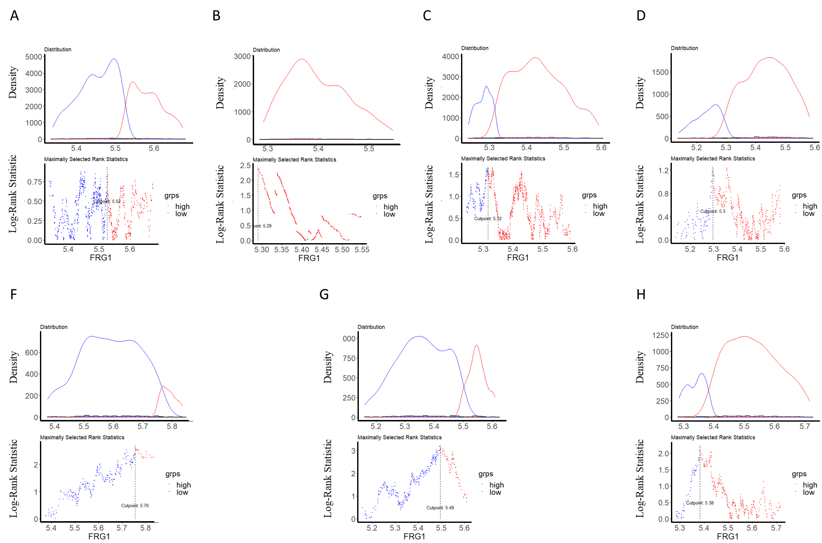

Supplementary Figure S1. Optimal cut-off points determination of FRG1 expression for KM plot in different cancer types. res.cut() function was used and plotted using plot() for (A) breast cancer, (B) Prostate cancer (C) lung cancer (D) Colorectal cancer (E) Cervix uteri cancer, (F) Stomach cancer and (G) Liver cancer.

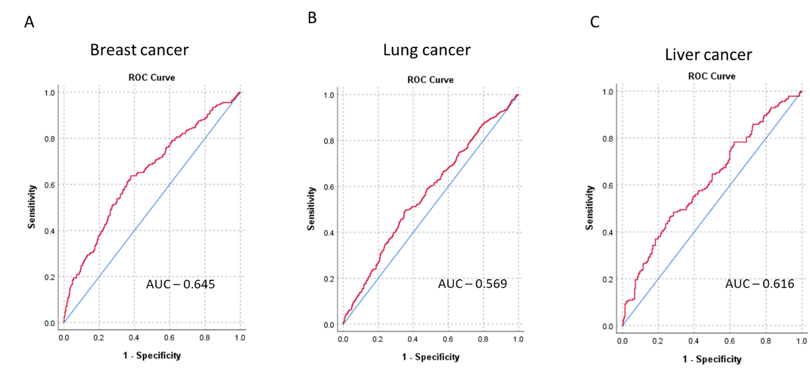

Supplementary Figure S2. The time-dependent receiver operating characteristic (ROC) curve for (A) Breast cancer, (B) Lung cancer and, (C) Liver cancer.

