Supplementary material

Evaluating the suitability of fin clips as a tool for dietary biochemical analyses in pelagic teleosts

Jessica Henkens^{1*}, Lauren Meyer¹, Thomas M Clarke¹, Bradley Hayman¹, Kirsten Rough² and Ryan Baring¹

¹College of Science and Engineering, Flinders University, Adelaide, SA, Australia,
²Australian Southern Bluefin Tuna Industry Association, Port Lincoln, SA, Australia

Journal name: Marine Biology

*Correspondence: Jessica Henkens, College of Science and Engineering, Flinders University, Adelaide, SA, Australia. Email: jessica.henkens@flinders.edu.au

Table S1. ANOSIM main test comparing stable isotopes (δ ¹³C, δ ¹⁵N, C:N) of southern bluefin tuna (Thunnus maccoyii) across different tissue types (muscle, liver, pectoral fin clips) between regions (Encounter Bay, Port Lincoln, Port MacDonnell) and years within regions for Encounter Bay (2022, 2023) and Port MacDonnell (2023, 2024). The table includes p-values average R values. Bolded values indicate statistically significant differences (p < 0.05).
Tissue type | Factor | P-value | Average R
δ ¹³C
 | Region | 0.983 | -0.09
Muscle | Encounter Bay (2022-2023) | 0.012 | 0.49
 | Port MacDonnell (2023-2024) | 0.033 | 0.25
 | Region | 0.223 | 0.03
Liver | Encounter Bay (2022-2023) | 0.092 | 0.25
 | Port MacDonnell (2023-2024) | 0.0006 | 0.54
 | Region | 0.419 | 0.004
Pectoral fin | Encounter Bay (2022-2023) | 0.449 | 0.005
 | Port MacDonnell (2023-2024) | 0.204 | 0.10
δ ¹⁵N
 | Region | 0.959 | 0.08
Muscle | Encounter Bay (2022-2023) | 0.0009 | 0.81
 | Port MacDonnell (2023-2024) | 0.525 | -0.02
 | Region | 0.025 | 0.10
Liver | Encounter Bay (2022-2023) | 0.0003 | 0.64
 | Port MacDonnell (2023-2024) | 0.0006 | 0.63
 | Region | 0.172 | 0.04
Pectoral fin | Encounter Bay (2022-2023) | 0.364 | 0.03
 | Port MacDonnell (2023-2024) | 0.154 | 0.12
C:N
 | Region | 0.0001 | 0.21
Muscle | Encounter Bay (2022-2023) | 0.0002 | 0.98
 | Port MacDonnell (2023-2024) | 0.014 | 0.33
 | Region | 0.0001 | 0.46
Liver | Encounter Bay (2022-2023) | 0.818 | -0.13
 | Port MacDonnell (2023-2024) | 0.482 | -0.02
 | Region | 0.713 | -0.03
Pectoral fin | Encounter Bay (2022-2023) | 0.566 | -0.04
 | Port MacDonnell (2023-2024) | 0.35 | 0.02

Table S2. Pairwise test results from ANOSIM analyses comparing δ ¹⁵N and C:N isotope of southern bluefin tuna (Thunnus maccoyii) in liver tissue between regions (Encounter Bay, Port Lincoln captive, Port MacDonnell). The table includes p-values and average R values. Bolded values indicate statistically significant differences (p < 0.05).
Tissue type | Regions | P-value | Average R
δ ¹⁵N
 | Encounter Bay –  Port Lincoln (captive) | 0.435 | -0.004
 | Encounter Bay –  Port MacDonnell | 0.109 | 0.053
 | Port Lincoln (captive) –  Port MacDonnell | 0.0006 | 0.38
C:N
 | Encounter Bay –  Port Lincoln (captive) | 0.0001 | 0.75
Liver | Encounter Bay –  Port MacDonnell  Port Lincoln (captive) –  Port MacDonnell | 0.0001  0.019 | 0.36  0.17

Table S3. Main test results from ANOSIM comparing total lipid content (%) of southern bluefin tuna (Thunnus maccoyii) across different tissue types (muscle, liver, pectoral fin clips) between regions (Encounter Bay, Port Lincoln, Port MacDonnell) and years within regions for Encounter Bay (2022, 2023) and Port MacDonnell (2023, 2024). The table includes p-values average R values. Bolded values indicate statistically significant differences (p < 0.05).
Tissue type | Factor | P-value | Average R
 | Region | 0.0001 | 0.282
Muscle | Encounter Bay (2022-2023) | 0.974 | -0.176
 | Port MacDonnell (2023-2024) | 0.0001 | 0.54
 | Region | 0.16 | 0.038
Liver | Encounter Bay (2022-2023) | 0.304 | 0.055
 | Port MacDonnell (2023-2024) | 0.001 | 0.37
 | Region | 0.445 | 0
Pectoral fin | Encounter Bay (2022-2023) | 0.261 | 0.068
 | Port MacDonnell (2023-2024) | 0.20 | 0.035

Table S4. Pairwise test results from ANOSIM analyses comparing total lipid content (%) of southern bluefin tuna (Thunnus maccoyii) in muscle tissue between regions (Encounter Bay, Port Lincoln captive, Port MacDonnell). The table includes p-values and average R values. Bolded values indicate statistically significant differences (p < 0.05).
Tissue type | Regions | P-value | Average R
Muscle | Encounter Bay –  Port Lincoln (captive) | 0.0001 | 0.865
 | Encounter Bay –  Port MacDonnell | 0.008 | 0.101
 | Port Lincoln (captive) –  Port MacDonnell | 0.008 | 0.24

Table S5. Main test results from ANOSIM analyses comparing fatty acid profiles of southern bluefin tuna (Thunnus maccoyii) across different tissue types (muscle, liver, pectoral fin clips) between regions (Encounter Bay, Port Lincoln, Port MacDonnell) and years within regions for Encounter Bay (2022, 2023) and Port MacDonnell (2023, 2024). The table includes p-values average R values. Bolded values indicate statistically significant differences (p < 0.05).
Tissue type | Factor | P-value | Average R
 | Region | 0.0001 | 0.41
Muscle | Encounter Bay (2022-2023) | 0.092 | 0.23
 | Port MacDonnell (2023-2024) | 0.0001 | 0.90
 | Region | 0.015 | 0.13
Liver | Encounter Bay (2022-2023) | 0.453 | -0.003
 | Port MacDonnell (2023-2024) | 0.032 | 0.32
 | Region | 0.0001 | 0.34
Pectoral fin | Encounter Bay (2022-2023) | 0.098 | 0.22
 | Port MacDonnell (2023-2024) | 0.0001 | 0.75

Table S6. Pairwise test results from ANOSIM analyses comparing fatty acid profiles of southern bluefin tuna (Thunnus maccoyii) across different tissue types (muscle, liver, pectoral fin clips) between regions (Encounter Bay, Port Lincoln captive, Port MacDonnell). The table includes p-values and average R values. Bolded values indicate statistically significant differences (p < 0.05).
Tissue type | Regions | P-value | Average R
Muscle | Encounter Bay –  Port Lincoln (captive) | 0.0001 | 0.42
 | Encounter Bay –  Port MacDonnell | 0.0001 | 0.40
 | Port Lincoln (captive) –  Port MacDonnell | 0.005 | 0.25
Liver | Encounter Bay –  Port Lincoln (captive)  Encounter Bay –  Port MacDonnell  Port Lincoln (captive) –  Port MacDonnell | 0.541  0.0008  0.095 | -0.02  0.23  0.09
Pectoral fin | Encounter Bay –  Port Lincoln (captive) | 0.0001 | 0.48
 | Encounter Bay –  Port MacDonnell  Port Lincoln (captive) –  Port MacDonnell | 0.0002  0.0001 | 0.24  0.44

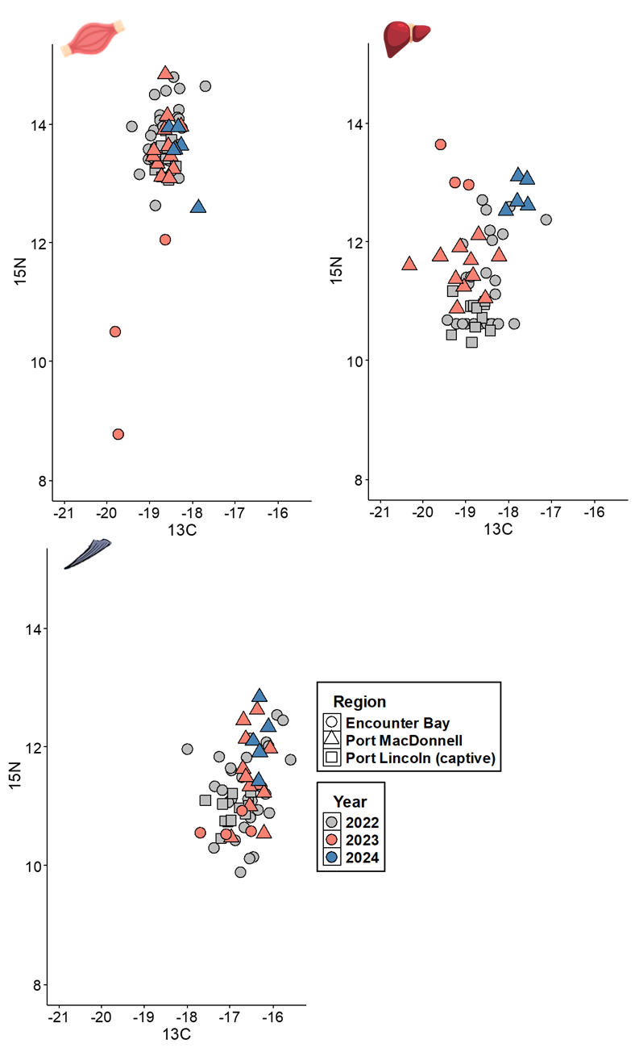

Figure S1. Biplot of southern bluefin tuna (Thunnus maccoyii) stable isotopes (δ ¹³C, δ ¹⁵N) between regions and years across muscle, liver, and pectoral fin clips. Regions are represented by shapes and colours denote years.
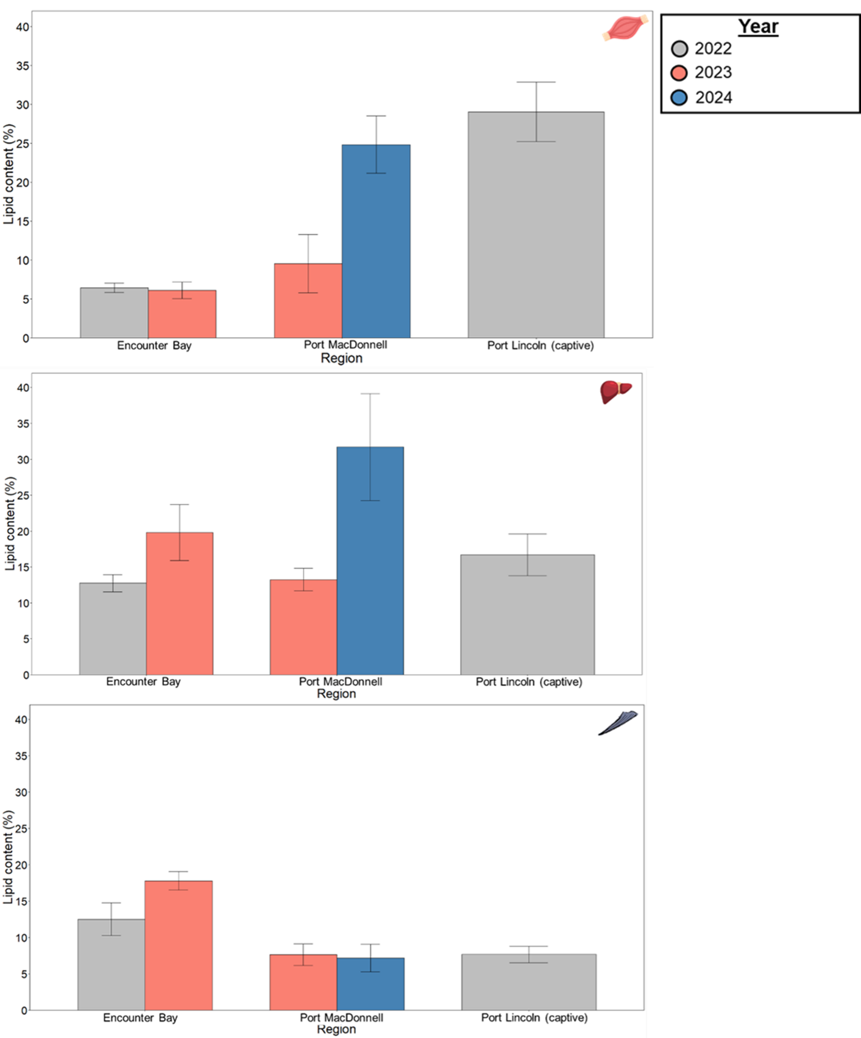

Figure S2. Histogram of southern bluefin tuna (Thunnus maccoyii) average (± standard error) total lipid content (%) between regions across muscle, liver, and pectoral fin clips. Years are represented by colours.

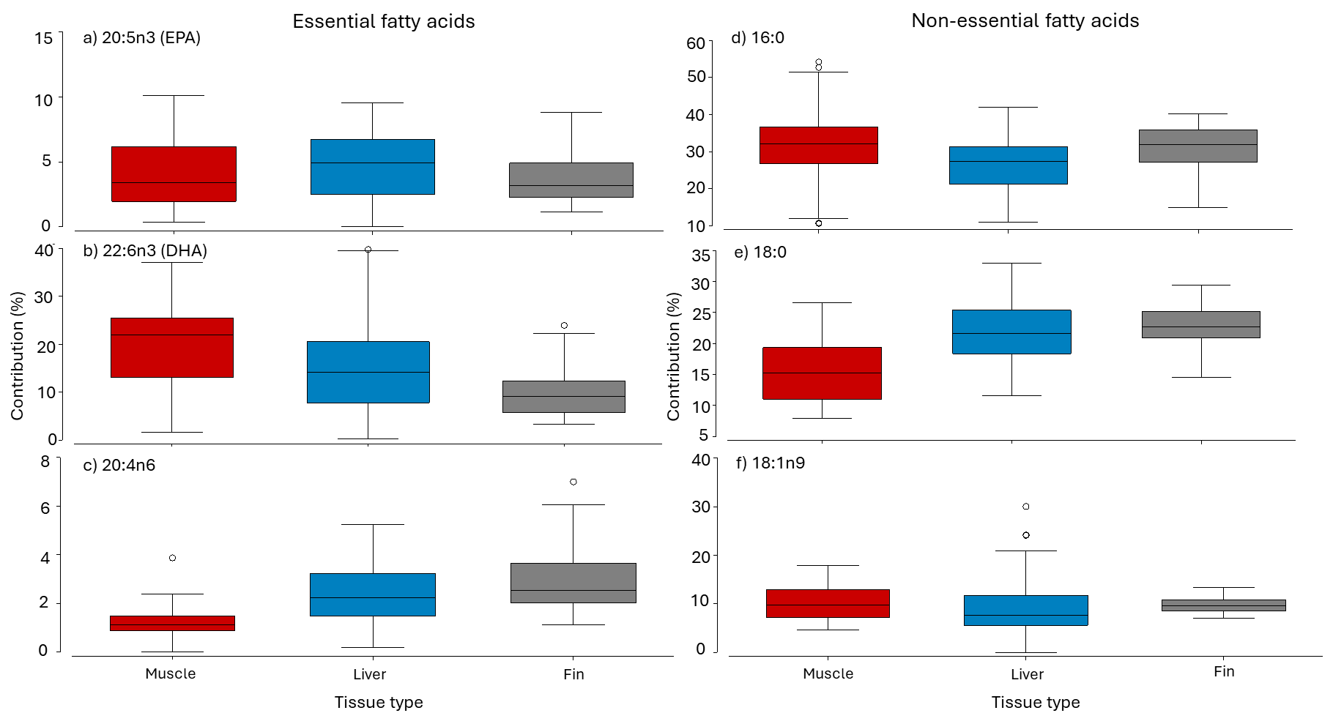

Figure S3. Boxplots of southern bluefin tuna (Thunnus maccoyii) essential fatty acids: a) 20:5n3 (EPA), b) 22:6n3 (DHA), c) 20:4n6, and non-essential fatty acids: d) 16:0, e) 18:0, f) 19:1n9, between tissue types (muscle, liver, and fin).

