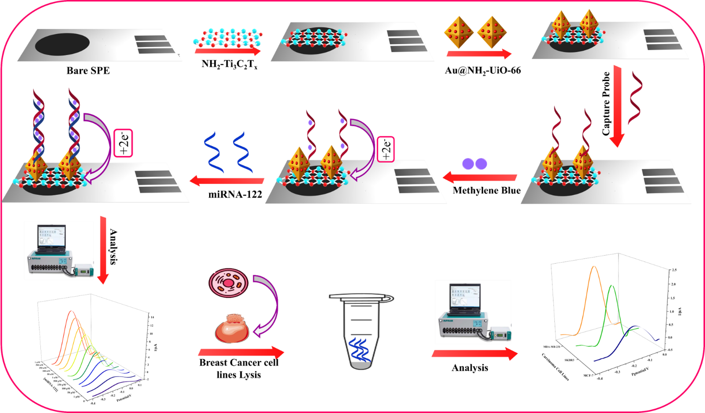
Scheme 1. Illustration of the proposed biosensor for the visual determination of miRNA-122.

