A 2D/3D Nanoplatform for Electrochemical Diagnosis of miRNA-122 in Breast Cancer Cell Lines

Ali Esmaeilian ^{a, b}, Nastaran Arab ^{b}, Fatemeh Yazdian ^{*c}, Morteza Hosseini ^{*b}, Seyed Mohammad Reza Mortazavi ^{b}, Mohammad Reza Ganjali ^{d}

ª Department of Life Science Engineering, Alborz Campus, University of Tehran, Tehran, Iran
^{b} Nanobiosensors Lab, Department of Life Science Engineering, Faculty of New Sciences & Technologies, University of Tehran, Tehran, Iran
^{c} Department of Life Science Engineering, Faculty of New Science and Technologies, University of Tehran, Tehran, Iran
^{d} Center of Excellence in Electrochemistry, School of Chemistry, College of Science, University of Tehran, Tehran, Iran

* Correspondence: Fatemeh Yazdian; Morteza Hosseini
E-mail address: yazdian@ut.ac.ir
E-mail address: Hosseini_m@ut.ac.ir

Table S1 Oligonucleotide sequences
Oligonucleotide name | Sequence
DNA capture probe (CP) | 5՛-SH-(CH)₆-CAAACACCATTGTCACACTCCA-3՛
DNA detect probe (DP) (miRNA-122) | 5՛-TGGAGTGTGACAATGGTGTTTG-3՛
miRNA-103 | 5՛-AGCAGCAUUGUACAGGGCUAUGA-3՛
miRNA-21 | 5՛-UAGCUUAUCAGACUGAUGUUGA-3՛
miRNA-191 | 5՛-CAACGGAATCCCAAAAGCAGCTG-3՛
miRNA-141 | 5՛-GGTAGAAATGGTCTGTCACAT-3՛
Single-mismatched miRNA (SM) | 5՛-TGGAATGTGACAATGGTGTTTG-3՛
Three-mismatched (TM) | 5՛-TCGAATGTGACAATTGTGTTTG-3՛
Fig. S1. (A) PVC card, (B) and (C) Stencil tool, (D) Carbon ink, (E) Screen-printed biosensor without silver adhesive and reference electrode, (F) Sliver ink, (G) Screen-printed biosensor

Fig. S2. (A) EDX of UiO-66-NH₂. (B) EDX of Au@UiO-66-NH₂. (C) UiO-66-NH₂’s elemental maps. (D) Au@UiO-66-NH₂’s elemental maps
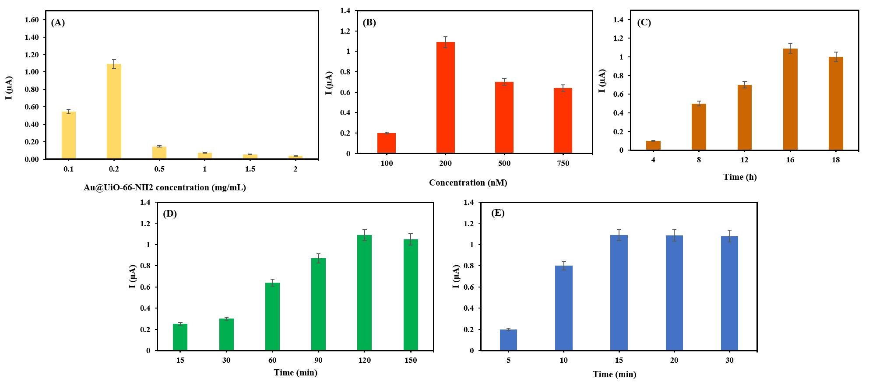
Fig. S3. Optimization of key parameters for the electrochemical biosensor. (A) Optimization of Au@UiO-66-NH₂ concentration, (B) Optimization of probe concentration, (C) Optimization of probe immobilization time, (D) Optimization of hybridization time between capture and miRNA-122 (E) Optimization of methylene blue incubation time. (DPV respond of biosensor between -1.5 to 1 and scan rate was 300 mV/s in 0.2 M PBS solution, n=3)
Table S2 assesses the performance of the developed biosensor for miRNA-122 detection in comparison with previously reported biosensors.
Biosensing mechanism | Nanomaterial | LOD | Linear range | Ref.
CP/MB/TCEP | Au | 0.1 fM | 0.1 fM- 0.5 nM | [1]
CP/GO/PB | GO/PB | 1.5 fM | 10 fM- 10 nM | [2]
CP/MB | rGO/Au | 1.73 pM | 10 pM- 10 µM | [3]
CP/ P19 protein | AuNPs | - | 10 aM- 1µM | [4]
Label-free | GRP | 1.06 pM | - | [5]
CP/MB | AuHFGNs / PnBA-MXene | 0.003 aM | 0.01 aM- 10 nM | [6]
TDN /HCR / HRP enzyme | AuNPs | 0.74 aM | - | [7]
CP/MB/Endonuclease-assisted | AuNPs/ PDDA | 30 aM | 100 aM-1 nM | [8]
CP/MB | Au@NH2-UiO-66/ MXene | 503fM | 1 pM - 0.75 µM | This study
CP: Capture probe, MB:Methylene Blue, TCEP: tris(2-carboxyethyl) phosphine hydrochloride, GO: Graphene Oxide, PB: Prussian blue, rGO: Reduced graphene oxide, AuNPs: Gold nanoparticales, GRP: Graphene, AuHFGNs: Hierarchical flower-like gold, PnBA: poly (n-butyl), TDN: Tetrahedral DNA nanostructure, PDDA: diallyldimethylammonium chloride
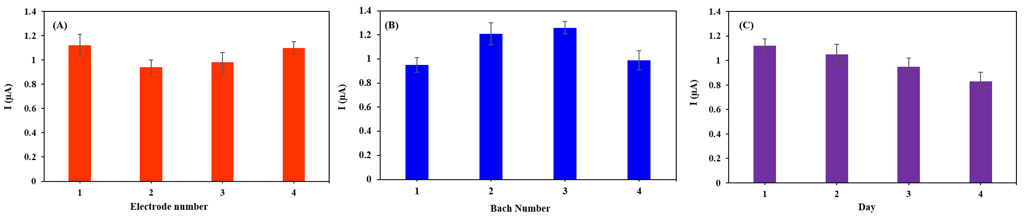
Fig. S4. (A) Biosensor repeatability with 2 measures in different concentrations of 1 pM, 1 nM (B) Biosensor reproducibility with 4 autonomous electrodes, (C) stability of biosensor after strong 14 days. (n=3).

Reference
1. Wang T, Viennois E, Merlin D, Wang G (2015) Microelectrode miRNA sensors enabled by enzymeless electrochemical signal amplification. Analytical chemistry 87 (16):8173–8180
2. Wang F, Chu Y, Ai Y, Chen L, Gao F (2019) Graphene oxide with in-situ grown Prussian Blue as an electrochemical probe for microRNA-122. Microchimica Acta 186:1–9
3. Kasturi S, Eom Y, Torati SR, Kim C (2021) Highly sensitive electrochemical biosensor based on naturally reduced rGO/Au nanocomposite for the detection of miRNA-122 biomarker. Journal of Industrial and Engineering Chemistry 93:186–195
4. Labib M, Khan N, Ghobadloo SM, Cheng J, Pezacki JP, Berezovski MV (2013) Three-mode electrochemical sensing of ultralow microRNA levels. Journal of the American Chemical Society 135 (8):3027–3038
5. Kilic T, Kaplan M, Demiroglu S, Erdem A, Ozsoz M (2016) Label-free electrochemical detection of microRNA-122 in real samples by graphene modified disposable electrodes. Journal of The Electrochemical Society 163 (6):B227
6. Ranjbari S, Rezayi M, Arefinia R, Aghaee-Bakhtiari SH, Hatamluyi B, Pasdar A (2023) A novel electrochemical biosensor based on signal amplification of Au HFGNs/PnBA-MXene nanocomposite for the detection of miRNA-122 as a biomarker of breast cancer. Talanta 255:124247
7. Shen D, Hu W, He Q, Yang H, Cui X, Zhao S (2021) A highly sensitive electrochemical biosensor for microRNA122 detection based on a target-induced DNA nanostructure. Analytical Methods 13 (25):2823–2829
8. Miao P, Wang B, Yu Z, Zhao J, Tang Y (2015) Ultrasensitive electrochemical detection of microRNA with star trigon structure and endonuclease mediated signal amplification. Biosensors and Bioelectronics 63:365–370

