Supplementary Materials

Cardiac MyD88 mediates inflammatory injury and adverse remodeling in diabetes

Wu Luo, Gaojun Wu, Xiaojun Chen, Qiuyan Zhang, Chunpeng Zou, Jun Liu, Nipon Chattipakorn, Yi Wang, Guang Liang

Supplemental information includes 11 figures and 1 table. All the other data are available from the authors on request.

Table S1 the primer sequences of target genes for qPCR

Gene | Species | ForwardPrimer | ReversedPrimer
MyHC | Rat | GAGGAGAGGGCGGACATT | ACTCTTCATTCAGGCCCTTG
Col-I | Rat | GACATCCCTGAAGTCAGCTGC | TCCCTTGGGTCCCTCGAC
TGF-β | Rat | GCAACAACGCAATCTATGAC | CCTGTATTCCGTCTCCTT
TNF-α | Rat | TACTCCCAGGTTCTCTTCAAGG | GGAGGCTGACTTTCTCCTGGTA
IL-6 | Rat | GAGTTGTGCAATGGCAATTC | ACTCCAGAAGACCAGAGCAG
IL-1β | Rat | CACCTCTCAAGCAGAGCACAG | GGGTTCCATGGTGAAGTCAAC
β-actin | Rat | AAGTCCCTCACCCTCCCAAAAG | AAGCAATGCTGTCACCTTCCC
TNF-α | Mouse | TGATCCGCGACGTGGAA | ACCGCCTGGAGTTCTGGAA
MyHC | Mouse | CAAAGGCAAGGCAAAGAAAG | TCACCCCTGGAGACTTTGTC
Col-I | Mouse | TGGCCTTGGAGGAAACTTTG | CTTGGAAACCTTGTGGACCAG
TGF-β | Mouse | TGGAGCAACATGTGGAACTC | GTCAGCAGCCGGTTACCA
IL-6 | Mouse | GAGGATACCACTCCCAACAGACC | AAGTGCATCATCGTTGTTCATACA
IL-1β | Mouse | ACTCCTTAGTCCTCGGCCA | CCATCAGAGGCAAGGAGGAA
β-actin | Mouse | TATGCTCTCCCTCACGCCATCC | GTCACGCACGATTTCCCTCTCAG

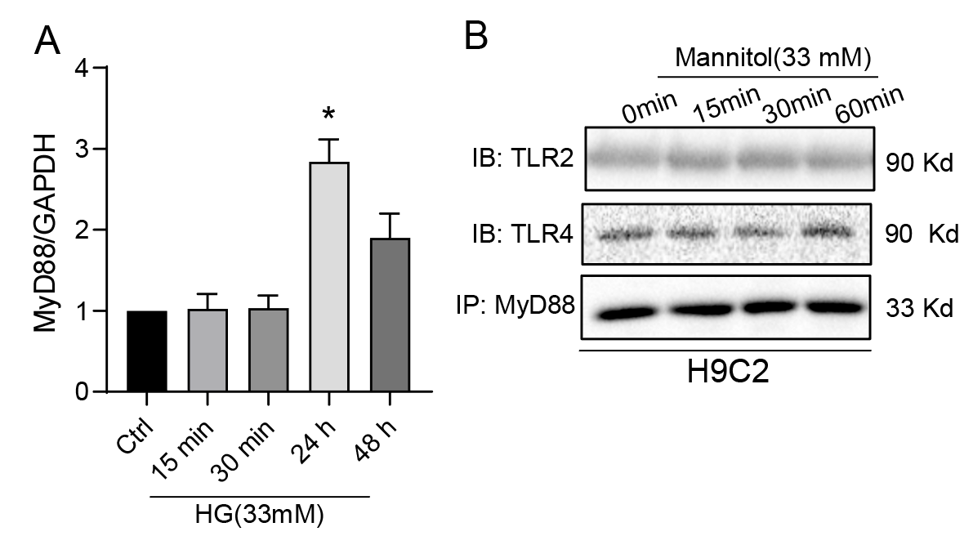
Supplementary Figure S1. (A)Densitometric quantification of blots in Figure 1G. Values are reported as Mean ± SEM [n = 3; * p<0.05 vs Ctrl]. (B) H9C2 cells were challenged by 33mM mannitol for indicated time and then the interaction of MyD88/TLR2 or MyD88/TLR4 was examined using Co-IP assay. Representative blots were shown from 3 independent experiments.

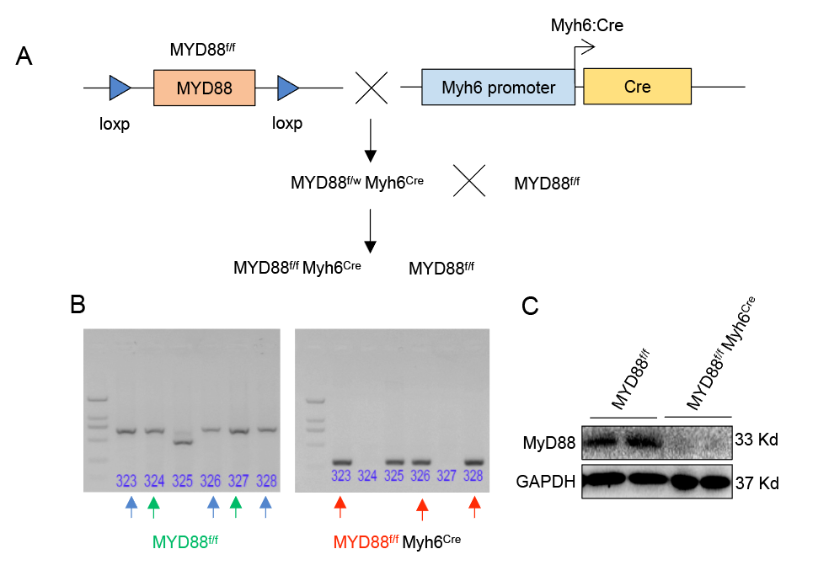
Supplementary Figure S2. Generation of cardiomyocyte-specific MyD88 knockout mouse. (A) Diagram depicting the generation of cardiomyocyte-specific MyD88 knockout mice (MyD88^{f/f}-Myh6^{Cre}) using the Cre-loxP method. Mice floxed for MyD88 (MyD88^{f/f}) were crossed with mice carrying Cre-transgene under the promoter of Myh6 gene (Myh6-Cre) that led to the generation of MyD88^{f/f}-Myh6^{Cre} mice. MyD88^{f/f}-Myh6^{Cre} mice were further crossed with MyD88^{f/f} mice to generate MyD88^{f/f}-Myh6^{Cre} mice. (B) Genotyping was performed using genomic DNA isolated from 3-weeks old mice and loxP or Cre sequence-specific primers by PCR. The PCR products were separated using agarose gel electrophoresis to identify PCR products of 484 bp (MYD88^{w/w}), 689 bp (MYD88^{f/f}), 484/689 bp (MYD88^{f/w}) and 300 bp (Myh6:Cre). (C) Immunoblot for MyD88 performed on whole heart lysates obtained from 6-months old MYD88^{f/f} and MyD88^{f/f}-Myh6^{Cre} mice demonstrate successful knockdown of MyD88 in the heart of MyD88^{f/f}-Myh6^{Cre} mice. GAPDH was used as a loading control for immunoblotting.

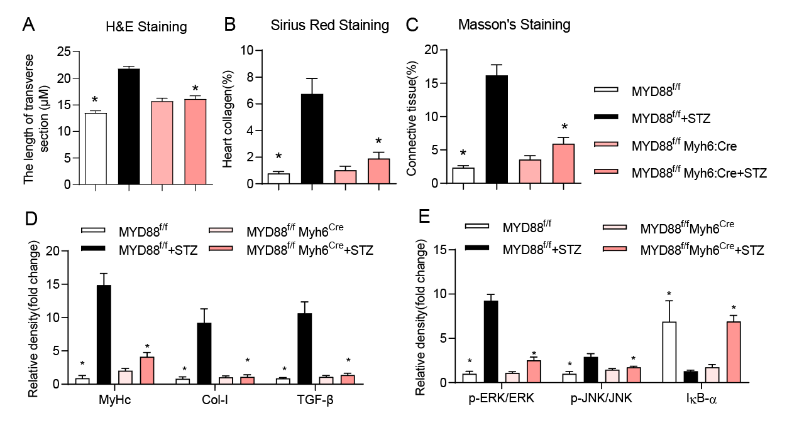
Supplementary Figure S3. (A) The bar graph shows the quantification of myocardial cell size (the representative staining images are presented in Figure 2F). (B) Quantification of Sirius red staining in Figure 2G. (C) Quantification of Masson’s Trichrome staining in Figure 2G. (D) Densitometric quantification of blots in Figure 2H. (E) Densitometric quantification of blots in Figure 2J. Values are reported as Mean ± SEM [n = 7 per group; * p<0.05, vs STZ-treated group].

Supplementary Figure S4. (A) Densitometric quantification of blots in Figure 3B. (B) Densitometric quantification of blots in Figure 3C. (C) Densitometric quantification of blots in Figure 3E. Values are reported as Mean ± SEM [n = 3; * p<0.05, vs HG].

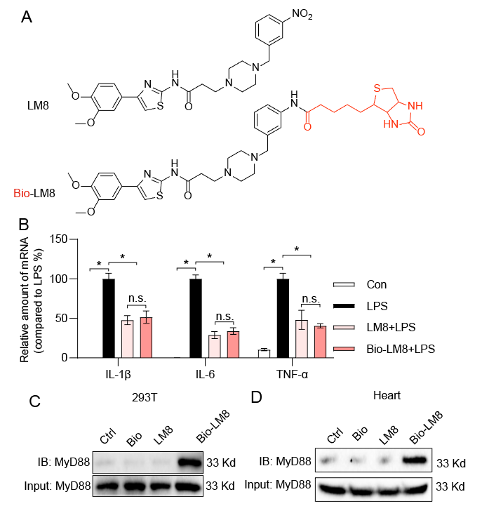
Supplementary Figure S5. LM8 physically interacts with MyD88 in the heart tissues. (A) Chemical structure of MyD88 inhibitor LM8 and biotin-labeled LM8 (bio-LM8). (B) H9C2 cells were pretreated with 10 μM LM8 or bio-LM8 and then exposed to LPS (0.5μg/ml) for 12 hours prior to RNA extraction and real-time qPCR assay for TNF-α and IL-6 genes. (C and D) Pre-loading bio-LM8 streptavidin-agarose beads were incubated with lysates prepared from MyD88-overexpressing 293T cells (C) and wild-type mice heart tissues (D), and then biotin-based pulldown assay was performed which indicated binding between LM8 and MyD88. Streptavidin-agarose beads, biotin and LM8 alone were used as a control. The elution was then loaded on SDS-PAGE for immunoblot analysis. Total lysates were used as input control. Values are reported as Mean ± SEM [n = 3; * p<0.05, vs LPS].

Supplementary Figure S6. (A) Densitometric quantification of blots in Figure 4B. (B) Densitometric quantification of blots in Figure 4C. (C) Densitometric quantification of blots in Figure 4D. (D) Densitometric quantification of blots in Figure 4J. Values are reported as Mean ± SEM [n = 3; * p<0.05, vs HG].

Supplementary Figure S7. LM8 prevents HG-induced inflammation and injury in primary neonatal rat primary cardiomyocytes (NRPCs). NRPCs were pretreated with 10 μM of MyD88 inhibitor LM8 or vehicle for 30 minutes before exposure to HG for 15 minutes. Later, total and nuclear proteins were extracted to perform immunoblot for (A) p-ERK, ERK, p-JNK, and JNK, and (B) IKB-α. Western blot demonstrated HG-induced ERK and JNK activation and reduced IKB-α expression that were restored in LM8-treated NRPCs. Immunoblotting performed for P65 on the nuclear fraction indicated increased HG-induced P65 translocation to the nucleus, which was reduced following LM8 treatment in NRPCs. Cultured NRPCs were pretreated with 10 μM of MyD88 inhibitor LM8 or its vehicle for 30 minutes and then exposed to HG for 12 and 24 hours to extract total RNA and proteins. (C) Real-time PCR showed HG-induced expression of TNF-α, IL-6 and IL1-β, and the reduction of these molecules following LM8 treatment (n=3). (D) Immunoblotting and (E) qPCR for MyHc, Col-I and TGF-β showed the induction of these molecules by HG, which were reduced following LM8 treatment in NRPCs (n=3/group). *P<0.05 vs HG-treated group.

Supplementary Figure S8. (A) The bar graph shows the quantification of myocardial cell size (the representative staining images are presented in Figure 5F). (B) Quantification of Sirius red staining in Figure 5G. (C) Quantification of Masson’s Trichrome staining in Figure 5G. (D)Densitometric quantification of blots in Figure 5H. (E) Densitometric quantification of blots in Figure 5J. (F and G) Anti-TNF-α staining in heart tissue sections showed inhibition of STZ-induced cardiac TNF-α expression by LM8 treatment. (H) Densitometric quantification of blots in Figure 5L. Values are reported as Mean ± SEM [n = 7; * p<0.05, vs STZ-treated mice].

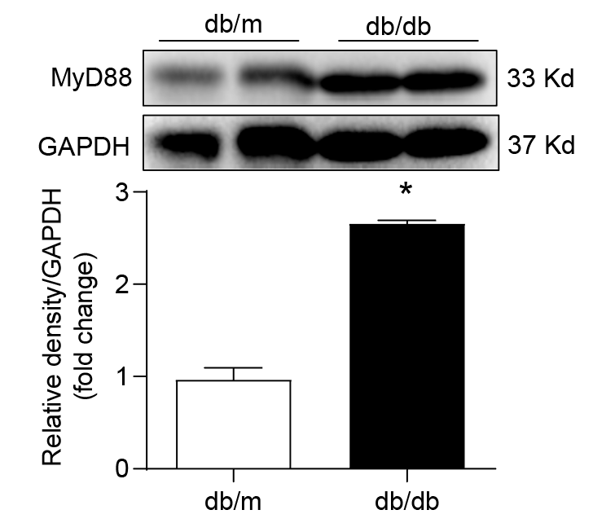
Supplementary Figure S9. MyD88 expression is upregulated in the heart of type 2 diabetic mice. Values are reported as Mean ± SEM [n = 7].

Supplementary Figure S10. LM8 does not affect the blood glucose level and insulin resistance in T2D mouse models. Results from (A) intravenous glucose tolerance tests (IGTT) and (B) insulin tolerance tests (ITT) performed on 14-week old db/m and db/db mice with or without LM8 treatment.

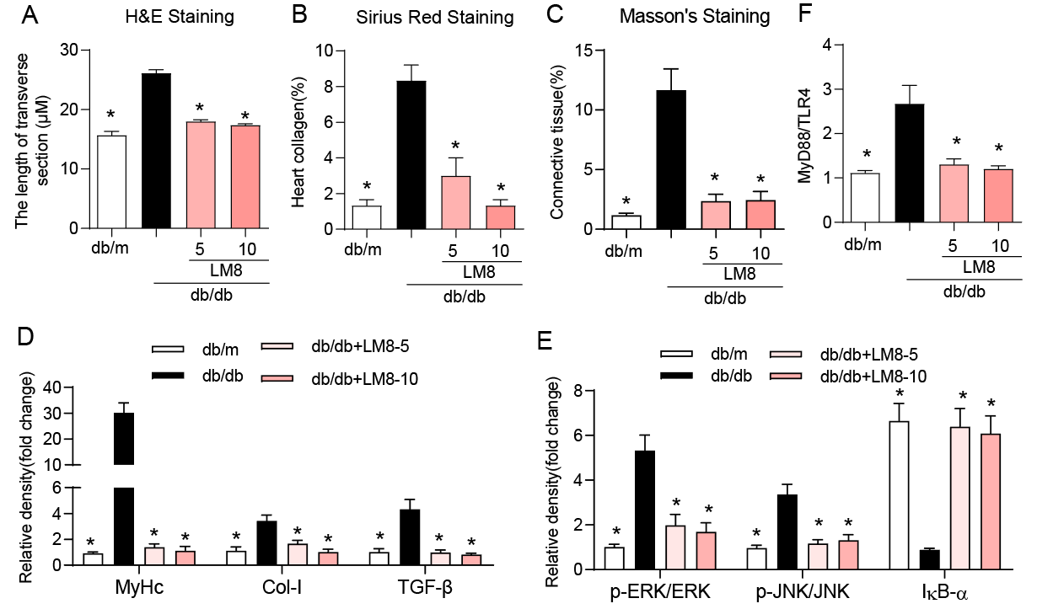
Supplementary Figure S11. (A) The bar graph shows the quantification of myocardial cell size (the representative staining images are presented in Figure 6F). (B) Quantification of Sirius red staining in Figure 6G. (C) Quantification of Masson’s Trichrome staining in Figure 6G. (D)Densitometric quantification of blots in Figure 6H. (E) Densitometric quantification of blots in Figure 6J. (F) Densitometric quantification of blots in Figure 6L. Values are reported as Mean ± SEM [n = 7; * p<0.05, vs STZ-treated mice].

