Supplementary Information
Table S1 GSEA analysis classical datasets definition from Molecular Signatures Database (MSigDB)
MSigDB-database | Database_full_name | Data_set_definition
C2 | human curated datasets from Molecular Signatures Database (MSigDB) | Classical human gene datasets from multiple reliable sources
C3 | Human regulatory target gene datasets from Molecular Signatures Database (MSigDB) | Transcription factor target gene sets and microRNA target gene sets
C5 | human curated datasets based on GO ontology from Molecular Signatures Database (MSigDB) | Classical human GO ontology gene datasets
C8 | Cell type signiture gene datasets from Molecular Signatures Database (MSigDB) | Curated cluster makers from single cell sequencing studies

Table S2 The record for QPCR primers of target genes
Genesymbol | Genbank Accession | Primer Sequences (5' to 3') | Amplicon Size (bp)
β-actin | NM_001101.3 | F: GATGACCCAGATCATGTTTGAGAC | 112
β-actin | NM_001101.3 | R:GGAGTCCATCACGATGCCAGT | 112
BAD | BT008034.1 | F: CCGGAGGATGAGTGACGAGTT | 125
BAD | BT008034.1 | R: CCCACCAGGACTGGAAGACT | 125
GSS | NM_000178.4 | F: GCCTGAATCGCTCAGACTACA | 70
GSS | NM_000178.4 | R: CCCAAAGCTGGCAGAGATGGT | 70
POLD1 | AB209560.1 | F: CCGCTCCTACACGCTCAAT | 106
POLD1 | AB209560.1 | R: GGTCTGGTCGTTCCCATTCT | 106

Table S3 The medical examination record for healthy donors
Record_type | Healthy donor 1 | Healthy donor 2 | Healthy donor 3
Age(years) | 29-32 | 29-32 | 29-32
Duration of infertility (years) | 1-2 | 1-2 | 1-2
Infertility diagnosis | Secondary infertility | Secondary infertility | Secondary infertility
BMI(kg/m2) | 20-23 | 20-23 | 20-23
Endometiral thickness (mm) | 8-10 | 8-10 | 8-10
Endometrial pathology | proliferative phase | proliferative phase | proliferative phase
Pathological endometritis | No | No | No
Antral follicle count | 10-11 | 9-10 | 11-12
Baseline E2 (pg/mL) | 30-50 | 30-50 | 30-50
Baseline FSH (IU/L) | 4-10 | 4-10 | 4-10
Baseline LH (IU/L） | 4-10 | 4-10 | 4-10
Baseline P (pg/mL) | ＜1 | ＜1 | ＜1
Assisted Pregnancy Outcome | Clinical Pregnancy | Clinical Pregnancy | Clinical Pregnancy
Note: BMI, Body Mass Index. FSH, Follicle-Stimulating Hormone. LH, Luteinizing Hormone. P, Progesterone

Table S4 The NAD/NADH ratio was measured in primary human endometrial stromal cells under different treatments of NMN concentrations
0 μM NMN | 50 μM NMN | 100 μM NMN | 200 μM NMN | 500 μM NMN | 100 μM NMN
0.0240 | 0.0374 | 0.0378 | 0.0964 | 0.0627 | 0.0741
0.0151 | 0.0253 | 0.0279 | 0.0780 | 0.0780 | 0.0673
0.0392 | 0.0375 | 0.0700 | 0.0925 | 0.0162 | 0.0325

Table S5 Differential expression genes between different groups of hEnSCs
Total_DEGs | Up-regulated DEGs | Down-regulated DEGs | Comparison_group
387 | 135 | 252 | CG_vs_BG
492 | 174 | 318 | EG_vs_BG
20 | 10 | 10 | EG_vs_CG

Supplemental figure legends and figures
Fig.S1 The measurement of the NAD⁺ / NADH ratio were acquired in endometrial stromal cells aftter the addition of different concentrations of NMN
Fig.S2 The overview of expression patterns in all identified genes were demonstrated for all three treatment groups
a. The heatmap of all identified genes was shown for all three treatment groups; b. PCA graph of all the samples were drawn from three different treatment groups.
Fig.S3 The leading edge analysis of Cell cycle and apoptosis related enriched pathways were preformed between the EG group and the CG group
a. The correlationship diagram was shown for the five significantly enriched pathways related to cell cycle and apopotosis in the comparison between the EG group and the CG group, and the deeper blue color represents higher correlation between the pathways; b. The heatmap of enriched gene from the five significantly enriched pathways related to cell cycle and apopotosis was drawn, the deeper blue color represents the more decreased levels of enriched genes.
Fig.S4 The key changes were demonstrated by the levels of expressed genes in the model of DNA replication pathway
Down-regulated genes were labeled with cyan color and the no-change genes as light purple.

FigS1
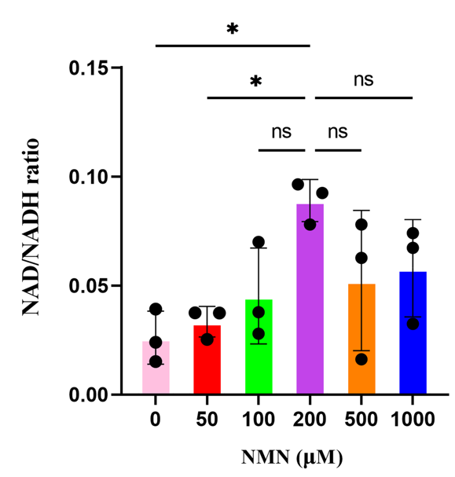

FigS2
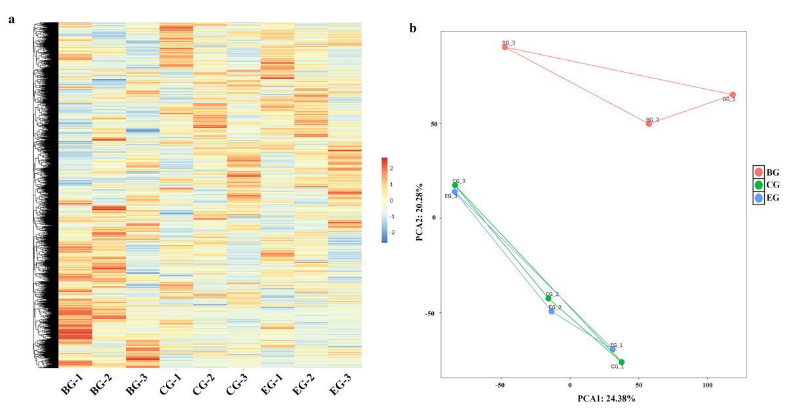

FigS3
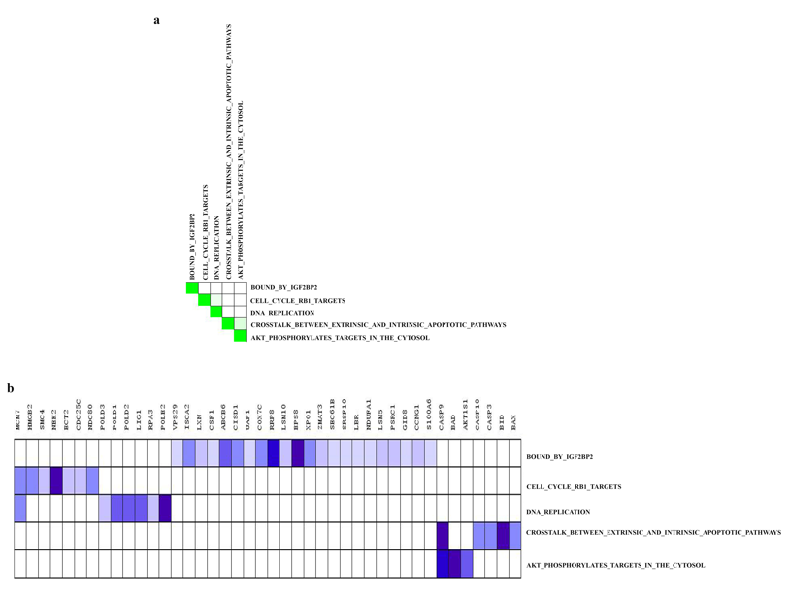

FigS4
