ITS-2 rDNA nemabiome metabarcoding in two isolated populations of roe deer (Capreolus capreolus) reveals variation in gastrointestinal nematode community composition among age classes

Camille Beaumelle^{1,3}* and Libby Redman^{2,}*, Jill de Rijke², Janneke Wit², Slimania Benabed^{1,4}, François Debias¹, Jeanne Duhayer¹, Sylvia Pardonnet¹, Marie-Thérèse Poirel^{1,4}, Gilles Capron⁵, Stéphane Chabot⁵, Benjamin Rey¹, Glenn Yannic³, John S Gilleard^{2,}** and Gilles Bourgoin^{1,4,}**

¹Université de Lyon, Université Lyon 1, CNRS, Laboratoire de Biométrie et Biologie Evolutive UMR 5558, F-69100 Villeurbanne, France
²Comparative Biology and Experimental medicine, Faculty of Veterinary Medicine, Host-Parasites Interactions Program. University of Calgary, Calgary, Alberta, Canada.
³Université Grenoble Alpes, Université Savoie Mont Blanc, CNRS, LECA, 38000, Grenoble, France
⁴Université de Lyon, VetAgro Sup, Campus Vétérinaire de Lyon, F-69280 Marcy l’Etoile, France
⁵Office Français de la Biodiversité, F-75008 Paris, France
*These authors contributed equally to this work
**Co-senior authors
Corresponding author:
E-mail address: camille.beaumelle@univ-smb.fr

A1. Flowchart summarizing the data curation from Illumina amplicon fastq files to the final curating dataset.

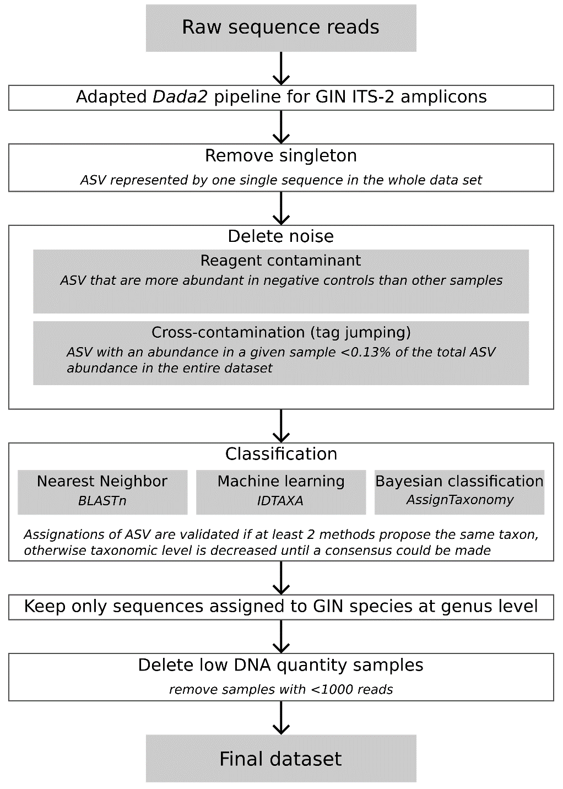
A2. Taxonomic assignment of ASVs using a combination of three separate methods. The “Assignment” column indicates the assignment we use in analyses and is based on the consensus agreement of at least two out of the three assignment methods. Assignments that do not reach the genus level are not used in the analyses All species-level assignments have a degree of confidence associated with them: High confidence indicates all 3 methods predict the same species and moderate confidence indicate 2 out of the 3 methods agree at the species level. Where there is disagreement across any of the three methods the next highest taxonomic level is used for assignment i.e. genus
IDTaxa 60 | AssignTaxonomy | BLASTn consensus of the 3 best matches with identity >90%  (identity values of the 3 best matches) | Assignment | Confidence level of the assignation | List of ASV
Bunostomum
Root | Bunostomum trigonocephalum | Bunostomum trigonocephalum  (92.3%-91.9%-91.6%) | Bunostomum trigonocephalum | moderate confidence | ASV 12
Root | Bunostomum | Root | Root |  | ASV 134 ASV 139
Chabertia
Chabertia ovina | Chabertia ovina | Chabertia ovina  (100%-100%-99.6%)  (99.3%-98.6%-98.2%)  (99.6%-98.9%-98.9%)  (99.3%-99.3%-98.9%)  (100%-98.9%-98.9%)  (100%-98.9%-98.6%) | Chabertia ovina | high confidence | ASV 14  ASV 36 ASV 70 ASV 72 ASV 73 ASV 88
Cooperia
Cooperia punctata | Cooperia punctata | Cooperia punctata  (100%-100%_99.7%) | Cooperia punctata | high confidence | ASV 168
Haemonchus
Haemonchus contortus | Haemonchus contortus | Haemonchus contortus  (100%-100%-100%)  (100%-100%-96.8%)  (97.1%-97.1%-96.8%)  (99.6%-97.5%-97.2%)  (100%-99.3%-99.3%)  96.8%-96.8%-96.4%) | Haemonchus contortus | high confidence | ASV 7  ASV 10 ASV 20  ASV 26 ASV 32  ASV 86
Oesophagostomum
Oesophagostomum venulosum | Oesophagostomum venulosum | Oesophagostomum venulosum  (99.7%-99.7%-99.4%) | Oesophagostomum venulosum | high confidence | ASV 21
Oesophagostomum | Chabertiidae | Oesophagostomum  (96.4%-96.4%-96.4%) | Oesophagostomum |  | ASV 182
Ostertagia
Ostertagia leptospicularis | Ostertagia | Ostertagia leptospicularis  (100%-100%-99.7%)  (100%-99.7%-99.7%)  (99.7%-99.7%-99.3%)  (99.7%-99.7%-99.3%)  (99.3%-99.3%-99.0%)  (100%-100%-99.7%)  (99.7%-99.7%-99.3%)  (99.3%-99.3%-99.0%).  (100%-100%99.5%) | Ostertagia leptospicularis | moderate confidence | ASV 1  ASV 8 ASV 9  ASV 58 ASV 93 ASV 98  ASV 111 ASV 167 ASV 179
Ostertagia | Ostertagia | Ostertagia leptospicularis  (99.0%-99.0%-99.3%)  (99.7%-99.7%-99.3%)  (99.3%-99.3%-99.0%)  (99.7%-99.7%-99.3%)  (99.7%-99.7%-99.3%)  (99.3%-99.3%-99.0%)  (99.3%-99.3%-99.0%)  (100%-100%-100%)  (99.7%-99.7%-99.3%)  (91.1%-90.7%-90.7%)  (99.3%98.9%-99.3%)  (100%-98.6%-100%)  (100%-100%-100%)  (100%-97.9%-100%) | Ostertagia |  | ASV 15  ASV 53 ASV 55  ASV 63 ASV 87  ASV 106 ASV 108 ASV 154 ASV 161 ASV 174 ASV 181 ASV 203  ASV 206 ASV 225
Ostertagia | Ostertagia gruehneri | Ostertagia leptospicularis  (99.7%-99.7%-100%)  (99.3%-99.3%-99.0%)  (99.3%-99.3%-99.0%)  (100%-95.7%-100%)  (100%-96.9%-100%) | Ostertagia |  | ASV 27 ASV 39 ASV 51  ASV 178  ASV 198
Ostertagia leptospicularis | Ostertagia gruehneri | Ostertagia leptospicularis  (99.7%-99.7%-99.3%) | Ostertagia leptospicularis | moderate confidence | ASV 165
Ostertagia | Ostertagia gruehneri | Root | Ostertagia |  | ASV 191
Spiculopteragia
Spiculopteragia spiculoptera | Spiculopteragia spiculoptera | Spiculopteragia spiculoptera  (99.5%-99.5%-99.1%) | Spiculopteragia spiculoptera | high confidence | ASV 184
Spiculopteragia spiculoptera | Spiculopteragia spiculoptera | Spiculopteragia  (99.3%-99.0%-97.9%)  (99.0%-98.6%-98.3%)  (98.6%-98.3%-97.9%)  (98.6%-98.3%-97.9%)  (98.6%-98.3%-97.9%)  (99.0%-98.6%-97.6%)  (99.0%-98.6%-97.6%)  (98.6%-98.3%-97.9%)  (98.6%-98.3%-97.9%)  (98.6%-98.3%-97.9%)  (98.6%-98.3%-97.9%)  (98.6%-98.3%-97.9%)  (98.6%-98.3%-97.9%)  (98.6%-98.3%-97.9%) | Spiculopteragia spiculoptera | moderate confidence | ASV 5 ASV 6  ASV 38 ASV 43 ASV 66 ASV 90 ASV 95  ASV 105 ASV 109 ASV 114 ASV 127 ASV 130 ASV 132 ASV 222
Spiculopteragia | Spiculopteragia spiculoptera | Root | Spiculopteragia |  | ASV 172
Teladorsagia
Teladorsagia circumcincta | Teladorsagia circumcincta | Teladorsagia circumcincta  (99.7%-99.0%-99.3%)  100%-100%-100%)  (99.7%-99.7%-99.7%) | Teladorsagia circumcincta | high confidence | ASV 25 ASV 29 ASV 141
Trichostrongylus
Trichostrongylus axei | Trichostrongylus axei | Trichostrongylus axei  (100%-100%-100%)  (99.3%-99.3%-99.3%)  (98.6%-98.6%-98.6%)  (99.0%-99.0%-99.5%)  99.7%-99.7%-99.7%)  99.7%-99.7%-99.7%)  99.7%-99.7%-99.7%) | Trichostrongylus axei | high confidence | ASV 4  ASV 16 ASV 64  ASV 78 ASV 79 ASV 80 ASV 136
Trichostrongylus colubriformis | Trichostrongylus colubriformis | Trichostrongylus colubriformis  (100%-100%-100%) | Trichostrongylus colubriformis | high confidence | ASV 17
Trichostrongylus | Trichostrongylus vitrinus | Trichostrongylus  (97.2%-96.9%-96.2%) | Trichostrongylus |  | ASV 202
Trichostrongylus | Trichostrongylus | Trichostrongylus vitrinus  (98.7%-94.6%-98.7%) | Trichostrongylus |  | ASV 149
Trichostrongylus | Trichostrongylus | Trichostrongylus  (98.6%-98.3%-97.6%)  (97.6%-97.2%-96.5%)  (96.2%-96.2%-95.8%)  (96.9%-96.2%-95.8%)  (96.5%-95.8%-95.5%)  (97.2%-96.9%-96.2%)  (97.2%-96.9%-96.5%)  (96.9%-96.5%-95.8%)  (97.2%-96.9%-96.2%)  (97.2%-96.9%-96.2%)  (97.6%-97.2%-97.5%)  (97.6%-97.2%-96.9%)  (97.4%-97.0%-97.0%)  (97.2%-96.9%-96.2%) | Trichostrongylus |  | ASV 2 ASV 3  ASV 11  ASV 13 ASV 18  ASV 33 ASV 57 ASV 84 ASV 92  ASV 102 ASV 135 ASV 169 ASV 177 ASV 180
Varestrongylus
Varestrongylus capreoli | Varestrongylus capreoli | Varestrongylus capreoli  (99.1%-100%-99.1%)  (100%-100%-98.8%)  (99.8%-99.8%-98.6%)  (93.4%-94.1%-93.2%)  (95.1%-93.7%-93.7%)  (98.6%-99.5%-98.6%)  (99.5%-99.5%-98.4%)  (99.8%-99.8%-98.6%)  (93.6%-93.9%-93.4%) | Varestrongylus capreoli | high confidence | ASV 41 ASV 44 ASV 62  ASV 101 ASV 124 ASV 143 ASV 148 ASV 156 ASV 234
Root | Varestrongylus capreoli | Varestrongylus capreoli  (95.7%-91.1%-89.8%)  100%-90.8%-89.6%) | Varestrongylus capreoli | moderate confidence | ASV 147 ASV 183
Strongylida
Root | Strongylida | Root | Root |  | ASV 146 ASV 152 ASV 201

A3. Sample accumulation curves for ASV and Taxa of the total data set (without the lungworm Varestrongylus).
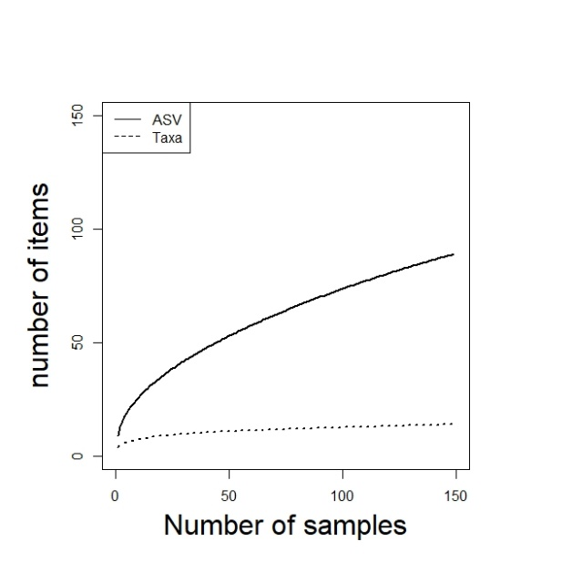

A4. Read relative frequencies of GIN at taxa level in samples of 19 recaptured roe deer. Each taxon is defined by one color. The data are split based on site location (Chizé or Trois Fontaines) and individuals captured in 2018 and 2019.
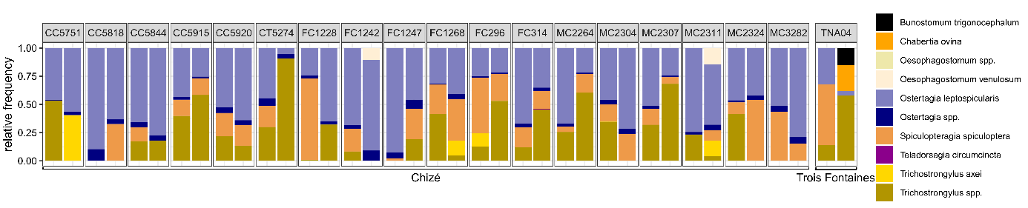

A5. Unrooted maximum likelihood tree of ASVs in samples. Branch lengths are modified with square root correction. Each color corresponds to a different genus.
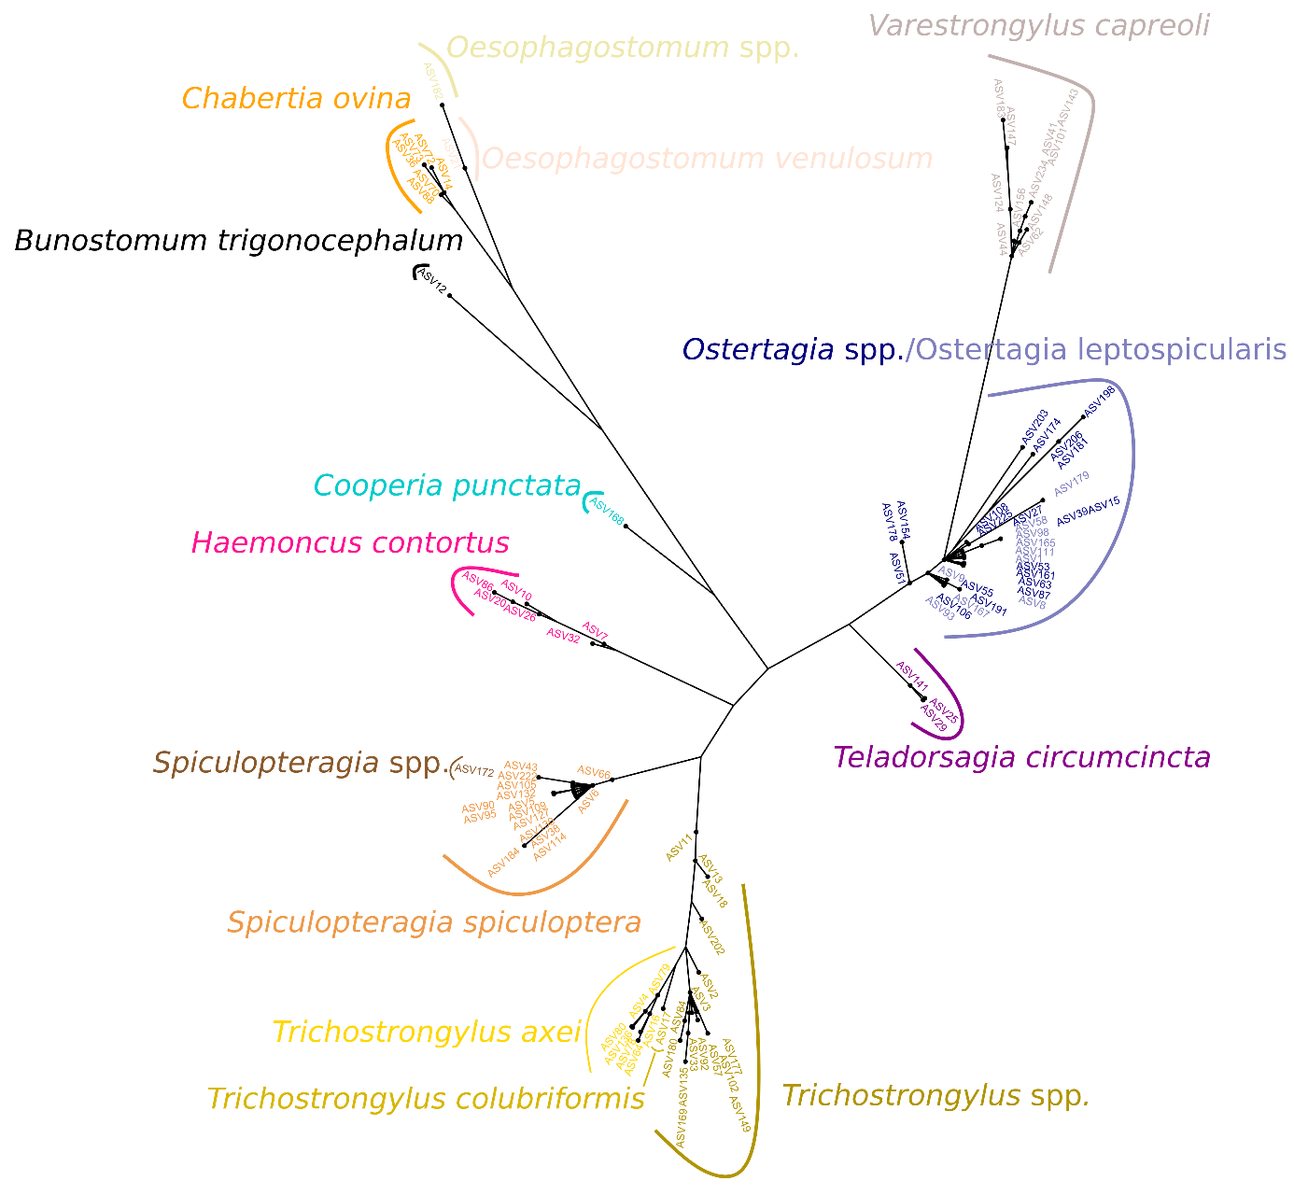
A6a. Results of Kruskal-Wallis tests of the relation between alpha diversities (richness, Simpson and Shannon) computed with 2 taxonomic resolutions (Taxa, ASV) and year of samples (2018 or 2019).
Taxonomic resolution | Diversity index | Χ² | p
ASVs | Richness | 3.20 | -
ASVs | Simpson | 4.08 | *
ASVs | Shannon | 4.41 | *
Taxa | Richness | 0.92 | -
Taxa | Simpson | 2.03 | -
Taxa | Shannon | 1.23 | -

A6b. Results of Spearman's correlation tests of the relation between alpha diversities (richness, Simpson and Shannon) computed with 2 taxonomic resolutions (Taxa, ASV) and the number of L3
Taxonomic resolution | Diversity index | ρ | p
ASVs | Richness | 0.09 | -
ASVs | Simpson | 0.09 | -
ASVs | Shannon | 0.10 | -
Taxa | Richness | 0.09 | -
Taxa | Simpson | 0.11 | -
Taxa | Shannon | 0.10 | -

A6c. Results of Spearman's correlation tests of the relation between alpha diversities (richness, Simpson and Shannon) computed with 2 taxonomic resolutions (Taxa, MOTUs, ASV) and the number of eggs per gram
Taxonomic resolution | Diversity index | ρ | p
ASVs | Richness | -0.04 | -
ASVs | Simpson | 0.06 | -
ASVs | Shannon | 0.03 | -
Taxa | Richness | -0.08 | -
Taxa | Simpson | 0.04 | -
Taxa | Shannon | 0.01 | -

A6d. Results of PerMANOVA tests of the relation between Bray Curtis dissimilarity computed with 2 taxonomic resolutions (Taxa, ASV) and the year, number of L3 or number of eggs per gram
Taxonomic resolution | models | Variables | R² | F-value | P
ASVs | $$β\sim year$$ | residuals | 0.99 | - | -
ASVs | $$β\sim year$$ | year | 0.01 | 1.21 | -
ASVs | $$β\sim epg$$ | residuals | 1.00 | - | -
ASVs | $$β\sim epg$$ | epg | 0.00 | 0.55 | -
ASVs | $$β\sim nb. of L3$$ | residuals | 0.99 | - | -
ASVs | $$β\sim nb. of L3$$ | nb. of L3 | 0.01 | 0.75 | -
Taxa | $$β\sim year$$ | residuals | 0.99 | - | -
Taxa | $$β\sim year$$ | year | 0.01 | 1.25 | -
Taxa | $$β\sim epg$$ | residuals | 1.00 | - | -
Taxa | $$β\sim epg$$ | epg | 0.00 | 0.60 | -
Taxa | $$β\sim nb. of L3$$ | residuals | 1.00 | - | -
Taxa | $$β\sim nb. of L3$$ | nb. of L3 | 0.00 | 0.40 | -

A7a. Set of generalized linear models sorted by AICc value. Alpha diversity, measured with the total richness, was modeled with all possible combinations of age, sex and site variables. The best model is highlighted in bold.
Taxonomic resolution | Generalized linear models | df | AICc | ΔAICc | weight
ASVs | $$α\sim site$$ | 2 | 717.60 | 0.00 | 0.20
ASVs | $$α\sim age+site+age×site$$ | 4 | 718.61 | 1.01 | 0.12
ASVs | $$α\sim sex+site+sex×site$$ | 4 | 718.62 | 1.02 | 0.12
ASVs | $$α\sim sex+site$$ | 3 | 718.65 | 1.05 | 0.12
ASVs | $$α\sim age+site$$ | 3 | 719.31 | 1.71 | 0.08
ASVs | $$α\sim age+sex+site+age×site+sex×site$$ | 6 | 719.37 | 1.76 | 0.08
ASVs | $$α\sim age+sex+site+age×site$$ | 5 | 719.47 | 1.87 | 0.08
ASVs | $$α\sim age+sex+site+sex×site$$ | 5 | 720.32 | 2.72 | 0.05
ASVs | $$α\sim age+sex+site$$ | 4 | 720.48 | 2.87 | 0.05
ASVs | $$α\sim age+sex+site+age×sex+age×site$$ | 6 | 721.10 | 3.50 | 0.03
ASVs | $$α\sim age+sex+site+age×site+sex×site+sex×age$$ | 7 | 721.49 | 3.89 | 0.03
ASVs | $$α\sim age+sex+site+age×sex$$ | 5 | 722.04 | 4.43 | 0.02
ASVs | $$α\sim age+sex+site+age×sex+sex×site$$ | 6 | 722.35 | 4.75 | 0.02
ASVs | $$α\sim 1$$ | 1 | 725.27 | 7.67 | 0.00
ASVs | $$α\sim age$$ | 2 | 725.54 | 7.94 | 0.00
ASVs | $$α\sim sex$$ | 2 | 725.70 | 8.10 | 0.00
ASVs | $$α\sim age+sex$$ | 3 | 726.32 | 8.71 | 0.00
ASVs | $$α\sim age+sex+age×sex$$ | 4 | 728.15 | 10.54 | 0.00
Taxa | $$α\sim site$$ | 2 | 522.27 | 0.00 | 0.21
Taxa | $$α\sim 1$$ | 1 | 522.52 | 0.25 | 0.19
Taxa | $$α\sim sex+site$$ | 3 | 523.95 | 1.69 | 0.09
Taxa | $$α\sim sex$$ | 2 | 524.00 | 1.74 | 0.09
Taxa | $$α\sim age$$ | 2 | 524.31 | 2.05 | 0.08
Taxa | $$α\sim age+site$$ | 3 | 524.33 | 2.06 | 0.08
Taxa | $$α\sim sex+site+sex×site$$ | 4 | 524.57 | 2.31 | 0.07
Taxa | $$α\sim age+sex$$ | 3 | 525.90 | 3.63 | 0.03
Taxa | $$α\sim age+sex+site$$ | 4 | 526.05 | 3.79 | 0.03
Taxa | $$α\sim age+site+age×site$$ | 4 | 526.40 | 4.14 | 0.03
Taxa | $$α\sim age+sex+site+sex×site$$ | 5 | 526.67 | 4.40 | 0.02
Taxa | $$α\sim age+sex+site+age×sex$$ | 5 | 527.08 | 4.82 | 0.02
Taxa | $$α\sim age+sex+age×sex$$ | 4 | 527.13 | 4.86 | 0.02
Taxa | $$α\sim age+sex+site+age×site$$ | 5 | 528.14 | 5.87 | 0.01
Taxa | $$α\sim age+sex+site+age×sex+sex×site$$ | 6 | 528.26 | 6.00 | 0.01
Taxa | $$α\sim age+sex+site+age×site+sex×site$$ | 6 | 528.79 | 6.52 | 0.01
Taxa | $$α\sim age+sex+site+age×sex+age×site$$ | 6 | 529.21 | 6.94 | 0.01
Taxa | $$α\sim age+sex+site+ age×sex+age×site+sexe×site$$ | 7 | 530.43 | 8.16 | 0.00
A7b. Set of generalized linear models sorted by AICc value. Alpha diversity, measured with the Shannon index, was modeled with all possible combinations of age, sex and site variables. The best model is highlighted in bold.
Taxonomic resolution | Generalized linear models | df | AICc | ΔAICc | weight
ASVs | $$α\sim age+sex+site+age×site+sex×site+sex×age$$ | 8 | 86.37 | 0.00 | 0.19
ASVs | $$α\sim age+sex+site+age×site+sex×site$$ | 7 | 86.46 | 0.08 | 0.18
ASVs | $$α\sim age+site+age×site$$ | 5 | 86.82 | 0.45 | 0.15
ASVs | $$α\sim age+sex+site+age×sex+age×site$$ | 7 | 87.21 | 0.83 | 0.12
ASVs | $$α\sim age+sex+site+age×sex+sex×site$$ | 7 | 88.66 | 2.29 | 0.06
ASVs | $$α\sim age+sex+site+sex×site$$ | 6 | 88.80 | 2.43 | 0.06
ASVs | $$α\sim age+sex+site+age×site$$ | 6 | 88.99 | 2.61 | 0.05
ASVs | $$α\sim age+site$$ | 4 | 89.12 | 2.75 | 0.05
ASVs | $$α\sim site$$ | 3 | 89.36 | 2.99 | 0.04
ASVs | $$α\sim age+sex+site+age×sex$$ | 6 | 89.38 | 3.01 | 0.04
ASVs | $$α\sim sex+site+ sex×site$$ | 5 | 89.68 | 3.31 | 0.04
ASVs | $$α\sim age+sex+site$$ | 5 | 91.18 | 4.81 | 0.02
ASVs | $$α\sim sex+site$$ | 4 | 91.45 | 5.08 | 0.01
ASVs | $$α\sim age$$ | 3 | 99.34 | 12.97 | 0.00
ASVs | $$α\sim age+sex+age×sex$$ | 5 | 100.95 | 14.58 | 0.00
ASVs | $$α\sim age+sex$$ | 4 | 101.45 | 15.08 | 0.00
ASVs | $$α\sim 1$$ | 2 | 102.66 | 16.28 | 0.00
ASVs | $$α\sim sex$$ | 3 | 104.71 | 18.34 | 0.00
Taxa | $$α\sim site$$ | 3 | 71.73 | 0.00 | 0.26
Taxa | $$α\sim sexe+site+sex×site$$ | 5 | 72.13 | 0.39 | 0.21
Taxa | $$α\sim age+site$$ | 4 | 73.69 | 1.96 | 0.10
Taxa | $$α\sim sex+site$$ | 4 | 73.8 | 2.06 | 0.09
Taxa | $$α\sim age+sex+site+sex×site$$ | 6 | 73.95 | 2.22 | 0.08
Taxa | $$α\sim 1$$ | 2 | 75.67 | 3.93 | 0.04
Taxa | $$α\sim age+site+age×site$$ | 5 | 75.71 | 3.98 | 0.03
Taxa | $$α\sim age+sex+site+age×sex+sex×site$$ | 7 | 75.74 | 4.01 | 0.03
Taxa | $$α\sim age+sex+site$$ | 5 | 75.77 | 4.03 | 0.03
Taxa | $$α\sim age+sex+site+age×site+sex×site$$ | 7 | 76.04 | 4.31 | 0.03
Taxa | $$α\sim age+sex+site+age×sex$$ | 6 | 76.71 | 4.97 | 0.02
Taxa | $$α\sim age$$ | 3 | 76.86 | 5.12 | 0.02
Taxa | $$α\sim sex$$ | 3 | 77.75 | 6.02 | 0.01
Taxa | $$α\sim age+sex+site+age×site$$ | 6 | 77.83 | 6.10 | 0.01
Taxa | $$α\sim age+sex+site+age×sex+age×site+sex×site$$ | 8 | 77.87 | 6.13 | 0.01
Taxa | $$α\sim age+sex+site+age×sex+age×site$$ | 7 | 78.81 | 7.08 | 0.01
Taxa | $$α\sim age+sex$$ | 4 | 78.96 | 7.22 | 0.01
Taxa | $$α\sim age+sex+age×sex$$ | 5 | 80.29 | 8.55 | 0.00
A7c. Set of generalized linear models sorted by AICc value. Alpha diversity, measured with the Simpson index, was modeled with all possible combinations of age, sex and site variables. The best model is highlighted in bold.
taxonomic resolution | Generalized linear models | df | AICc | ΔAICc | weight
ASVs | $$α\sim age+sex+site+age×sex$$ | 6 | -248.84 | 0 | 0.15
ASVs | $$α\sim age+sex+site+age×sex+age×site$$ | 7 | -248.67 | 0.16 | 0.14
ASVs | $$α\sim age+sex+site+age×site+sex×site+sex×age$$ | 8 | -247.88 | 0.96 | 0.1
ASVs | $$α\sim age+sex+site+age×sex+sex×site$$ | 7 | -247.79 | 1.04 | 0.09
ASVs | $$α\sim age+site+age×site$$ | 5 | -246.91 | 1.92 | 0.06
ASVs | $$α\sim age+sex+site+sex×site$$ | 6 | -246.81 | 2.03 | 0.06
ASVs | $$α\sim age+sex+site+age×site$$ | 6 | -246.72 | 2.11 | 0.05
ASVs | $$α\sim age+sex+site+age×site+sex×site$$ | 7 | -246.65 | 2.19 | 0.05
ASVs | $$α\sim age+sex+site$$ | 5 | -246.53 | 2.31 | 0.05
ASVs | $$α\sim age+site$$ | 4 | -246.51 | 2.33 | 0.05
ASVs | $$α\sim age+sex+age×sex$$ | 5 | -246.3 | 2.54 | 0.04
ASVs | $$α\sim site$$ | 3 | -246.21 | 2.63 | 0.04
ASVs | $$α\sim sex+site+ sex×site$$ | 5 | -245.68 | 3.16 | 0.03
ASVs | $$α\sim sex+site$$ | 4 | -245.63 | 3.21 | 0.03
ASVs | $$α\sim age$$ | 3 | -244.92 | 3.91 | 0.02
ASVs | $$α\sim age+sex$$ | 4 | -244.43 | 4.41 | 0.02
ASVs | $$α\sim 1$$ | 2 | -242.5 | 6.33 | 0.01
ASVs | $$α\sim sex$$ | 3 | -241.28 | 7.56 | 0
Taxa | $$α\sim site$$ | 3 | -107.75 | 0 | 0.21
Taxa | $$α\sim 1$$ | 2 | -106.98 | 0.77 | 0.14
Taxa | $$α\sim sex+site+sex×site$$ | 5 | -106.4 | 1.35 | 0.11
Taxa | $$α\sim sex+site$$ | 4 | -106.15 | 1.60 | 0.1
Taxa | $$α\sim age+site$$ | 4 | -105.82 | 1.93 | 0.08
Taxa | $$α\sim age$$ | 3 | -105.54 | 2.21 | 0.07
Taxa | $$α\sim sex$$ | 3 | -105.21 | 2.55 | 0.06
Taxa | $$α\sim age+sex+site+sex×site$$ | 6 | -104.62 | 3.13 | 0.04
Taxa | $$α\sim age+sex+site$$ | 5 | -104.25 | 3.51 | 0.04
Taxa | $$α\sim age+sex$$ | 4 | -103.84 | 3.91 | 0.03
Taxa | $$α\sim age+site+age×site$$ | 5 | -103.73 | 4.02 | 0.03
Taxa | $$α\sim age+sex+site+age×sex$$ | 6 | -102.94 | 4.81 | 0.02
Taxa | $$α\sim age+sex+site+age×sex+sex×site$$ | 7 | -102.73 | 5.02 | 0.02
Taxa | $$α\sim age+sex+site+age×site+sex×site$$ | 7 | -102.45 | 5.30 | 0.01
Taxa | $$α\sim age+sex+age×sex$$ | 5 | -102.34 | 5.42 | 0.01
Taxa | $$α\sim age+sex+site+age×site$$ | 6 | -102.1 | 5.65 | 0.01
Taxa | $$α\sim age+sex+site+age×sex+age×site$$ | 7 | -100.76 | 6.99 | 0.01
Taxa | $$α\sim age+sex+site+age×sex+age×site+sex×site$$ | 8 | -100.53 | 7.22 | 0.01
A7d. Set of perMANOVA models sorted by AICc value. Bray Curtis dissimilarity is modeled with all possible combinations of age, sex and site variables. The best model is highlighted in bold.
taxonomic resolution | Generalized linear models | k | AICc | ΔAICc | weight
ASVs | $$β\sim age+site+age×site$$ | 4 | 443,65 | 0 | 0,21
ASVs | $$β\sim age+sex+site+age×sex+age×site$$ | 6 | 444,35 | 0,70 | 0,15
ASVs | $$β\sim age+sex+site+age×site$$ | 5 | 444,54 | 0,89 | 0,13
ASVs | $$β\sim age+sex+site+age×site+sex×site$$ | 6 | 444,9 | 1,25 | 0,11
ASVs | $$β\sim age+sex+site+age×site+sex×site+sex×age$$ | 7 | 444,97 | 1,32 | 0,11
ASVs | $$β\sim age+site$$ | 3 | 445,63 | 1,98 | 0,08
ASVs | $$β\sim age+sex+site+age×sex$$ | 5 | 446,12 | 2,47 | 0,06
ASVs | $$β\sim age+sex+site$$ | 4 | 446,3 | 2,65 | 0,06
ASVs | $$β\sim age+sex+site+sex×site$$ | 5 | 446,69 | 3,04 | 0,05
ASVs | $$β\sim age+sex+site+age×sex+sex×site$$ | 6 | 446,76 | 3,11 | 0,04
ASVs | $$β\sim site$$ | 2 | 456,46 | 12,81 | 0
ASVs | $$β\sim sex+site$$ | 3 | 457,25 | 13,60 | 0
ASVs | $$β\sim sex+site+ sex×site$$ | 4 | 457,99 | 14,34 | 0
ASVs | $$β\sim age$$ | 2 | 476,92 | 33,27 | 0
ASVs | $$β\sim age+sex$$ | 3 | 477,68 | 34,03 | 0
ASVs | $$β\sim age+sex+age×sex$$ | 4 | 478,3 | 34,65 | 0
ASVs | $$β\sim 1$$ | 1 | 485,91 | 42,26 | 0
ASVs | $$β\sim sex$$ | 2 | 486,69 | 43,04 | 0
Taxa | $$β\sim age+sex+site+age×sex+age×site$$ | 6 | 410.60 | 0 | 0,18
Taxa | $$β\sim age+sex+site+age×site+sex×site+sex×age$$ | 7 | 411.14 | 0,54 | 0,14
Taxa | $$β\sim age+site+age×site$$ | 4 | 411.33 | 0,73 | 0,12
Taxa | $$β\sim age+sex+site+age×sex$$ | 5 | 411.33 | 0,73 | 0,12
Taxa | $$β\sim age+sex+site+age×sex+sex×site$$ | 6 | 411.85 | 1,25 | 0,1
Taxa | $$β\sim age+sex+site+age×site$$ | 5 | 412.06 | 1,46 | 0,09
Taxa | $$β\sim age+site$$ | 3 | 412.25 | 1,65 | 0,08
Taxa | $$β\sim age+sex+site+age×site+sex×site$$ | 6 | 412.57 | 1,97 | 0,07
Taxa | $$β\sim age+sex+site$$ | 4 | 412.74 | 2,14 | 0,06
Taxa | $$β\sim age+sex+site+sex×site$$ | 5 | 413.25 | 2,65 | 0,05
Taxa | $$β\sim site$$ | 2 | 420.97 | 10,37 | 0
Taxa | $$β\sim sex+site$$ | 3 | 421.74 | 11,14 | 0
Taxa | $$β\sim sex+site+ sex×site$$ | 4 | 422.28 | 11,68 | 0
Taxa | $$β\sim age$$ | 2 | 431.39 | 20,79 | 0
Taxa | $$β\sim age+sex+age×sex$$ | 4 | 431.74 | 21,14 | 0
Taxa | $$β\sim age+sex$$ | 3 | 431.90 | 21,30 | 0
Taxa | $$β\sim 1$$ | 1 | 444.10 | 33,50 | 0
Taxa | $$β\sim sex$$ | 2 | 444.68 | 34,08 | 0
A8a. Generalized linear models selected for taxa and diversity index (Richness, Simpson, Shannon). Gaussian families were used for Simpson and Shannon regression and Poisson family for Richness. The effect of site (Chizé as referent), age (adult as referent) and their interaction are reported when including in the selected model. Parameter estimate with SD are reported with the corresponding z-value (Poisson family) or t-value (Gaussian family) and p-value. Statistical significance is represented by * for p<0.05, **for p<0.01 and *** for p<0.001.

Taxonomic resolution | Diversity index | Best Model selected | Variables | Parameter estimate ± SE | z-val. or  t-val. | p
Taxa | Richness | $$α\sim 1$$ | intercept | 1.37 ± 0.04 | 33.01 | ***
Taxa | Simpson | $$α\sim 1$$ | intercept | -0.06 ± 0.05 | 1.13 | *
Taxa | Shannon | $$α\sim site$$ | intercept | 0.89 ± 0.03 | 31.09 | ***
Taxa | Shannon | $$α\sim site$$ | siteTF | 0.14 ± 0.06 | 2.46 | *

A8b. perMANOVA models selected for taxa. Bray-Curtis dissimilarities matrix were used for regressions. The effect of site (Chizé as referent), age (adult as referent) and the interaction between them are reported when including in the selected model. R² are reported with the corresponding F-value and p-value. Statistical significance is represented by * for p<0.05, **for p<0.01 and *** for p<0.001.

Taxonomic resolution | Best Model selected | Variables | R² | F | p
Taxa | $$β\sim age+site$$ | residuals | 0.79 | - | -
Taxa | $$β\sim age+site$$ | site | 0.12 | 22.35 | ***
Taxa | $$β\sim age+site$$ | age | 0.09 | 17.54 | ***

A9b. Non-metric Multidimensional Scaling (Taxa) of nemabiome based on 14 Taxa from the 149 roe deer of different age and sex in Chizé and Trois Fontaines. The stress has a value of 0.10.
