Supplementary Material
Supplementary Figure 1. Haematological evidence of pyogenic infections.
(a-c) White blood cell (WBC), C-reactive protein, and serum interleukin-1β (IL-1β) values in different groups of rats two weeks after surgery. **P < 0.01, ***P < 0.001, ****P < 0.0001.
Supplementary Figure 2. Imaging scores between different groups. Data are presented as mean ± SD. ns-no significance, ****P < 0.0001.
Supplementary Figure 3. Histological scores of vertebrae in different groups. **P < 0.01, ****P < 0.0001.
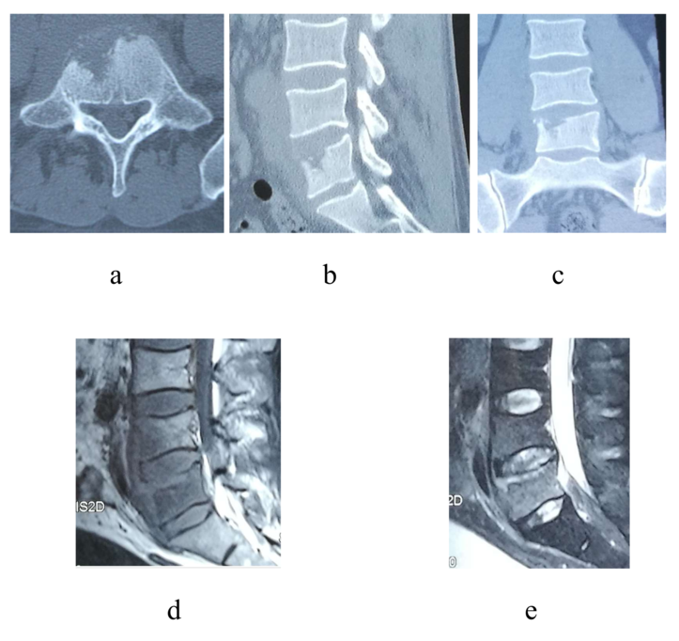
Supplementary Figure 4. (a,b,c) Obvious bone destruction on computed tomography images.(d,e) Inflammatory infiltration and intervertebral abscess on magnetic resonance imaging.

