Supplementary material

Fernández-Lebrero A, Jiménez-Balado J et al. CSF Biomarker Profile of Cerebral Amyloid Angiopathy: Diagnostic Performance and Imaging Correlates in a Hospital-Based Neurology Cohort
Table of Contents:
Supplementary Methods 2
Study participants, the DEGMAR register, and the BIODEGMAR study 2
BIODEGMAR protocol and procedures 3
AD CSF core biomarker measurements and cutoff values 4
Protocol approvals, registrations, and participant consent 5
CSF collection and storage: biomarker measurements 5
Biomarker profiles in CAA 6
Diagnostic Performance of CSF biomarkers 7
CSF Biomarker associations with CAA neuroimaging markers 8
Mathematical framework for determining optimal CSF biomarker cutoffs 9
Supplementary Figures 11
FIGURE S1. Distribution of CSF biomarkers 11
FIGURE S2. Sensitivity analysis excluding patients with possible CAA 12
FIGURE S3. Principal components analysis 12
FIGURE S4. CSF biomarker profiles in the cohort (fully adjusted model) 13
FIGURE S5. CSF biomarkers ROC curves 14
FIGURE S6. CAA discriminatory power of amyloid CSF biomarkers in subjects with AD 15
FIGURE S7. Association between CSF biomarkers and CAA cerebrovascular burden (fully adjusted model) 16
Supplementary Tables 17
TABLE S1. ANCOVA models comparing CSF biomarkers across diagnostic groups 17
TABLE S2. Association between clinical variables and CSF biomarker principal components 18
TABLE S3. ANCOVA models comparing CSF biomarkers across CAA burden groups 19
TABLE S4. ANCOVA models comparing CSF biomarkers by presence of individual CAA MRI markers 20
References 23

This supplementary material has been provided by the authors to give readers additional information.

Supplementary Methods

Study participants, the DEGMAR register, and the BIODEGMAR study
Clinical data, plasma and cerebrospinal fluid (CSF) samples for the ANGMAR study were obtained from the DEGMAR register and the BIODEGMAR cohort study¹. DEGMAR is a prospective, observational registry and database that includes patients evaluated at the Cognitive and Behavioural Neurology Unit of Hospital del Mar (Barcelona, Spain), a reference centre for a population of approximately 350,000 inhabitants. Individuals aged <85 years presenting with cognitive complaints and/or cognitive decline are routinely referred from primary care to the Neurology Department of Hospital del Mar for diagnostic evaluation. Initial work-up at the primary care level includes the Mini-Mental State Examination (MMSE), basic blood tests to exclude treatable causes of cognitive impairment (e.g. vitamin B12 deficiency, thyroid dysfunction, syphilis, HIV) and cranial computed tomography (CT). In the Cognitive and Behavioural Neurology Unit, the diagnostic protocol comprises neurological and neuropsychological evaluation. Further diagnostic procedures—such as brain MRI and/or Alzheimer's disease (AD) biomarker assessment via CSF analysis or amyloid PET—are performed according to clinical guidelines² or, in selected cases, for research purposes only. The clinical diagnoses used in this study included: probable or possible Cerebral Amyloid Angiopathy (CAA) according to the modified Boston criteria (version 2.0)³; mild cognitive impairment (MCI)⁴; and probable or possible Alzheimer’s dementia (AD-d)⁵. All DEGMAR participants provided written informed consent. The registry includes comprehensive sociodemographic, clinical, neuropsychological, and neuroimaging data. BIODEGMAR is a longitudinal, observational cohort derived from DEGMAR. Study procedures include extensive neuropsychological testing, 3T brain MRI, APOE genotyping, lumbar puncture for CSF collection, and blood sampling. Annual follow-up assessments, including clinical and neuropsychological evaluations, are conducted during the first three years after enrolment.
Beyond DEGMAR outpatients, the ANGMAR study also enrolled eligible patients from the inpatient Neurology Service, including the Neurovascular Unit at Hospital del Mar. These cases were prospectively assessed under the same standardized clinical, neuropsychological, MRI, and CSF workflows and contributed plasma and CSF samples through the BIODEGMAR biobanking procedures, ensuring harmonized protocols across recruitment sources.

BIODEGMAR protocol and procedures
Clinical evaluation: Conducted by certified neurologists, including detailed anamnesis, physical examination, and clinical diagnosis.
Neuropsychological evaluation: Performed by trained neuropsychologists following a standardized protocol, including: Mini Mental State Examination⁶, Memory Impairment Screen⁷, Automatic reverse series (Subtest of Test Barcelona cognitive battery, Peña-Casanova, 2005)⁸, Semantic fluency task (Subtest of Test Barcelona cognitive battery, Peña-Casanova, 2005)⁸, Free and Cued Selective Reminding Test⁹, Boston Naming Test¹⁰, Trail Making Test¹¹, Blessed Dementia Rating Scale¹², Alzheimer’s Disease Functional Assessment and Change Scale¹³, Global Deterioration Scale (GDS)¹⁴, and Clinical Dementia Rating (CDR) Scale¹⁵.
Neuroimaging: Brain MRI was performed in all participants unless contraindicated (e.g., pacemaker, non-MRI-compatible aneurysm clips, severe claustrophobia). In such cases, a non-contrast head CT was performed as part of the clinical work-up. MRI acquisition was conducted on 1.5T (General Electric Signa Explorer) or 3T (Philips Achieva) scanners. The imaging protocol included T1- and T2-weighted sequences, high-resolution 3D T1, diffusion-weighted imaging (DWI), fluid-attenuated inversion recovery (FLAIR), gradient echo, and ven-BOLD sequences.
APOE genotyping: Performed at Laboratori de Referència de Catalunya (LRC) using allelic discrimination PCR assays (APOE Real Type®, Progenie Molecular, Valencia, Spain). Two polymorphisms were analyzed: rs7412 (g.8041C>T) and rs429358 (g.7903T>C), defining the APOE ε2, ε3, and ε4 alleles, which correspond to the ApoE2, ApoE3, and ApoE4 isoforms, respectively. APOE ε4 status was categorized as carriers (one or two ε4 alleles) versus non-carriers (no ε4 alleles).
The BIODEGMAR protocol ensures harmonized acquisition, processing, and storage of biospecimens across participants. The same protocol and operating procedures were identically applied to Neurology inpatients, ensuring uniform workflows across recruitment sources.

AD CSF core biomarker measurements and cutoff values
Core AD CSF biomarkers (Aβ42, Aβ40, p-tau181 and t-tau) in the BIODEGMAR cohort were measured at the LRC with LUMIPULSE G600II (Fujirebio¹⁶). CSF sample processing protocol followed a standardized procedure: CSF was collected into a 10 ml sterile polypropylene sterile tube (Sarstedt, Nümbrecht, Germany; cat. no. 62.610.201). Tubes were gently inverted 5 to 10 times and centrifuged at 2000g for 10 minutes at room temperature. Supernatant was aliquoted into 0.5 mL portions using sterile polypropylene tubes (Sarstedt; cat. no. 72.730.006) at the Hospital del Mar laboratory and immediately frozen on dry ice for shipment to the LRC, where samples were stored at −80°C until analysis.
CSF biomarker cutoffs were defined in the CORCOBIA study¹, which aimed to establish reference thresholds for core AD CSF biomarkers across multiple centers (Parc de Salut Mar, Barcelona and Hospital General de Granollers), which work with the same reference laboratory (LRC). In this study, biomarker concentrations were compared between cognitively unimpaired individuals (n = 42) and patients with mild AD dementia (n = 48). Optimal cutoffs were determined using the Youden index (sensitivity + specificity − 1).
The resulting cutoffs and their diagnostic accuracy (area under the curve, AUC) were: Aβ42 750 pg/ml (AUC = 0.809); Aβ42/Aβ40 0.062 (AUC = 0.78); p-tau181 69.85 pg/ml (AUC = 0.81); t-tau 522.0 pg/ml (AUC = 0.79); Aβ42/t-tau 1.755 (AUC = 0.86). Among these, the Aβ42/p-tau181 ratio showed the highest AUC and best balance between sensitivity and specificity. A full description of the CORCOBIA cohort, procedures, and biomarker validation is available in Puig-Pijoan, A, et al.¹.

Protocol approvals, registrations, and participant consent
The ANGMAR study and the BIODEGMAR cohort were approved by the local ethics committee (CEIm Hospital del Mar Research Institute; project codes 2021/9960/I and 2018/7805/I, respectively). Participants in the BIODEGMAR cohort may undergo lumbar puncture either for clinical purposes—according to current diagnostic guidelines and recommendations²—or exclusively for research purposes. Specific informed consent was obtained in each context. All participants, or their legal representatives when applicable, provided written informed consent in accordance with the Declaration of Helsinki.

CSF collection and storage: biomarker measurements
Cerebrospinal fluid (CSF) samples were obtained by lumbar puncture performed at the L3/L4, L4/L5, or L5/S1 intervertebral spaces using a standard spinal needle, between 8:00 and 11:00 AM. CSF was collected into a 10 mL sterile polypropylene tube (Sarstedt, Nümbrecht, Germany; cat. no. 62.610.201). Tubes were gently inverted 5 to 10 times to ensure proper mixing, then centrifuged at 2000g for 10 minutes at 4°C. The supernatant was aliquoted into 1.8 mL sterile polypropylene cryotubes (Thermo Scientific™ Nunc™, Thermo Fisher Scientific, Waltham, MA, USA; cat. no. 377267) and immediately frozen at −80°C for long-term storage.
Core AD CSF biomarkers (Aβ42, Aβ40, p-tau181, and t-tau) were quantified at the Laboratori de Referència de Catalunya (Barcelona, Spain) using the LUMIPULSE G600II automated immunoassay platform (Fujirebio)¹⁶.
Lumbar puncture was not performed in all eligible participants due to patient refusal or medical contraindications. In CAA participants with a history of intracerebral haemorrhage (ICH) or subarachnoid haemorrhage (SAH), lumbar puncture was performed at least three months after the acute event to minimize the potential confounding effects of acute-phase CSF alterations.

Biomarker profiles in CAA
We first examined differences in CSF biomarkers—Aβ40, Aβ42, Aβ42/Aβ40 ratio, p-tau181, t-tau, Aβ42/p-tau181 ratio—across diagnostic groups, including HC, AD, CAA without AD co-pathology (CAA-nonAD) and CAA with AD co-pathology (CAA-AD). To account for potential confounders, analysis of covariance (ANCOVA) models were implemented adjusting for age and sex, given their well-established influence on CSF biomarker levels^{17–19}. Adjusted means and 95% confidence intervals (CI) were reported for each biomarker. Multiple comparisons were corrected using Bonferroni post hoc adjustments (p-value_{bf}).
We also conducted a second series of analyses adjusting for additional potential confounders. To select the variables, given the correlations among CSF biomarkers, we decomposed their shared variance using principal component analysis (PCA). The number of significant principal components was determined via parallel analysis. In this method, we generated random matrices of Gaussian-distributed values with the same dimensions (rows and columns) as the original dataset. For each simulated matrix, we performed a PCA and calculated the eigenvalues for each principal component (PC), yielding an empirical distribution of eigenvalues. We then identified the 95th percentile of each distribution and retained only those PCs from the actual data whose eigenvalues exceeded this threshold. After finding the significant PCs, we studied their association with demographic and risk factors, including age, sex, education, ethnicity, hypertension, diabetes, dyslipidemia, obesity, previous ischemic heart disease and presence of APOE ε4 allele. Those variables significantly associated with PCs were considered for a fully adjusted model: age, sex, education and APOE ε4.

Diagnostic Performance of CSF biomarkers
These series of analyses aimed to evaluate the diagnostic utility of CSF biomarkers for identifying CAA, using MRI (Boston criteria) as the gold standard. For this purpose, diagnostic groups were dichotomized into CAA (with or without AD co-pathology) and non-CAA (with or without AD). We focused on amyloid-related markers for this classification task, given their direct pathophysiological link to CAA. Aβ40 and Aβ42 are the main isoforms implicated in vascular amyloid deposition, and prior studies have consistently reported altered levels of these peptides in CAA, independently of AD co-pathology.
First, we constructed receiver operating characteristic (ROC) curves and calculated the area under the curve (AUC) for each biomarker across the entire sample. These analyses aimed to explore whether CSF biomarkers had any potential to distinguish between CAA and non-CAA subjects.
We then aimed to estimate the optimal cutoff for each biomarker (Aβ40 and Aβ42) in an unbiased manner. To achieve this, we employed 10-fold cross-validation with 50 repeats, using a custom cost function that jointly maximized the AUC and the stability of the cutoff—defined as the frequency with which a particular cutoff was selected across cross-validation runs.
We then additionally assessed the performance (AUC, sensitivity, specificity) of each biomarker-cutoff pair by bootstrapping the results across 10,000 resampled sets of the original cohort. This final step provided a distribution of performance metrics for each dichotomized biomarker. We reported the median performance along with the 95% CI.
Finally, we conducted a sensitivity analysis to evaluate the performance of the previously derived cutoffs in detecting CAA within the subgroup of patients with Alzheimer’s disease (CAA-AD and AD). This analysis aimed to assess the discriminative value of CSF biomarkers in a clinically challenging context of overlapping pathologies.

CSF Biomarker associations with CAA neuroimaging markers
We further examined the relationship between CSF biomarker concentrations and the extent of CAA-related cerebrovascular burden on MRI. These analyses were conducted only in patients with CAA, either with or without AD. To this end, we constructed ANCOVA models comparing CSF biomarker levels across different levels of the CAA-SVD Burden Score^{20,21} (0, 1, 2, 3, and ≥4 points), adjusting for age and sex. Adjusted means and 95% CI were reported for each biomarker across burden score categories. Next, we built additional ANCOVA models to assess the relationship between individual CSF biomarkers and specific MRI markers of CAA³. These models were also adjusted for age and sex, and we reported adjusted marginal means along with 95% CIs. In both analyses, p-values were corrected for multiple comparisons using the Bonferroni method, accounting for the number of CSF markers (p-value_{bf}).

Mathematical framework for determining optimal CSF biomarker cutoffs
Let $B={\{b}_{1},…,b_{K}\}$ be the set of biomarkers under evaluation, $R=\{1, …, R\}$ the set of repetitions, and $V=\{1, …, V\}$ the set of folds used in cross-validation.
For a given biomarker $b∈B$, we define ${\text{ctf}}_{r,v}^{b}$ as the cutoff point that, in repetition $r∈R$ and using fold $v∈V$ as the test set, achieves the highest AUC. Let $\text{auc}\left({\text{ctf}}_{r,v}^{b}\right)$ be the AUC obtained with this cutoff in the test fold $v$.
We then define $C^{b}={\{(\text{ctf}}_{r,v}^{b}, \text{auc}\left({\text{ctf}}_{r,v}^{b}\right), r, v) : \left(r,v\right)∈R×V\}$, which contains all cutoff values found for biomarker $b$, their associated AUCs, and the corresponding repetition and fold identifiers $\left(r,v\right)$.
For each unique cutoff value $c$ identified for biomarker $b$, let $A_{c}=\{\left(x,y,z,t\right)∈C^{b} : x=c\}$ be the subset of instances in which cutoff $c$ was selected. We define $\text{ratio}\left(c\right)=\frac{\#A_{c}}{R⋅V}$ as the relative frequency of cutoff $c$, and $\text{AUC}\left(c\right)=\text{Median}\left(\{y : \left(x,y,z,t\right)∈C^{b}\}\right)$ as the median AUC of this cutoff across all appearances.
The cost function for a cutoff value $c∈C^{b}$ of the biomarker $b$ is then defined as $\text{Cost}\left(c\right)=\text{ratio}\left(c\right)⋅\text{AUC}\left(c\right)$. The final selected cutoff is the one that maximizes this cost function, prioritizing both discriminative power and stability across cross-validation iterations.

Supplementary Figures

FIGURE S1. Distribution of CSF biomarkers
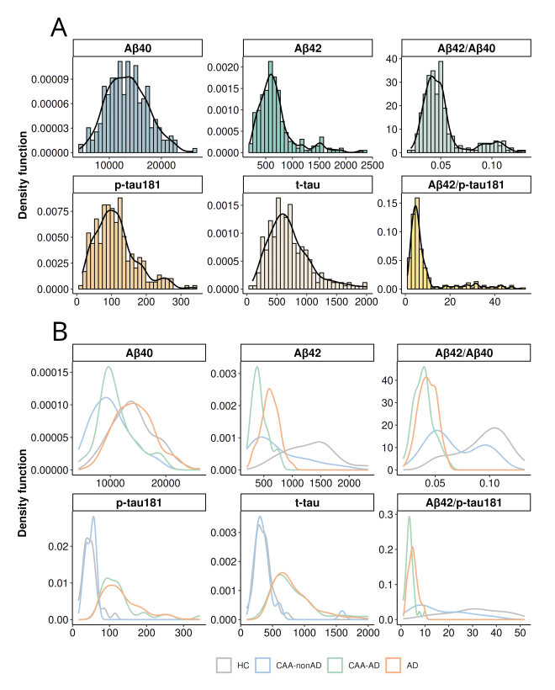
Panel A presents histograms of CSF biomarker distributions across the entire sample, with colours representing different biomarkers. The black line indicates the density function. Panel B stratifies this visualization by clinical diagnosis (HC: grey, CAA-nonAD: blue, CAA-AD: green, AD: orange). Group differences were assessed using the Kruskal-Wallis test, revealing significant differences in CSF biomarker concentrations across all groups (p-value < 0.05/6).

FIGURE S2. Sensitivity analysis excluding patients with possible CAA

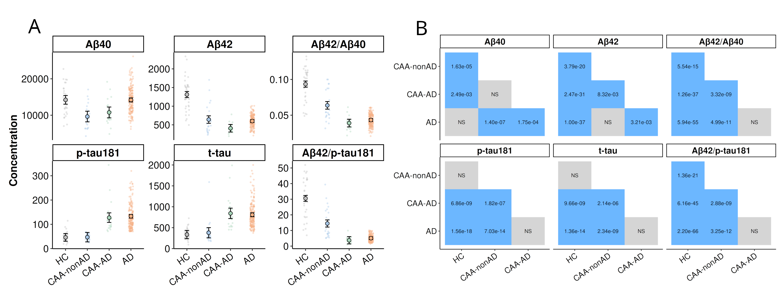

Panel A presents the marginal means and 95% confidence intervals from ANCOVA models comparing CSF biomarkers across groups, adjusted for age and sex. Colours correspond to clinical diagnoses (HC, grey; CAA-nonAD, blue; CAA-AD, green; AD, orange). Panel B displays pairwise comparisons with Bonferroni correction, where blue tiles indicate a p-valuebf <0.05.

FIGURE S3. Principal components analysis
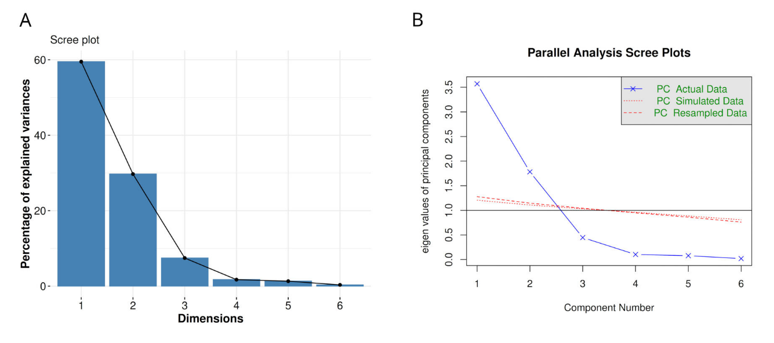
CSF biomarkers were decomposed into principal components (PCs) using principal components analysis (PCA). Panel A displays the scree plot, illustrating the proportion of variance explained by each PC on the Y-axis. Panel B presents the results of the parallel analysis, indicating that two PCs were optimal based on the empirical distribution obtained through resampling (see Methods section for details).

FIGURE S4. CSF biomarker profiles in the cohort (fully adjusted model)
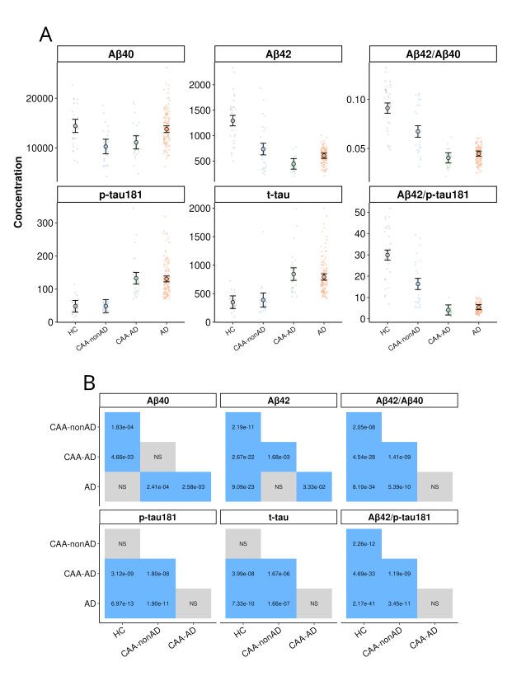
Panel A presents the marginal means and 95% confidence intervals from ANCOVA models comparing CSF biomarkers across groups, adjusted for age, sex, years education and APOE ε4. Colours correspond to clinical diagnoses (HC, grey; CAA-nonAD, blue; CAA-AD, green; AD, orange). Panel B displays pairwise comparisons with Bonferroni correction, where blue tiles indicate a p-value_{bf} < 0.05.

FIGURE S5. CSF biomarkers ROC curves
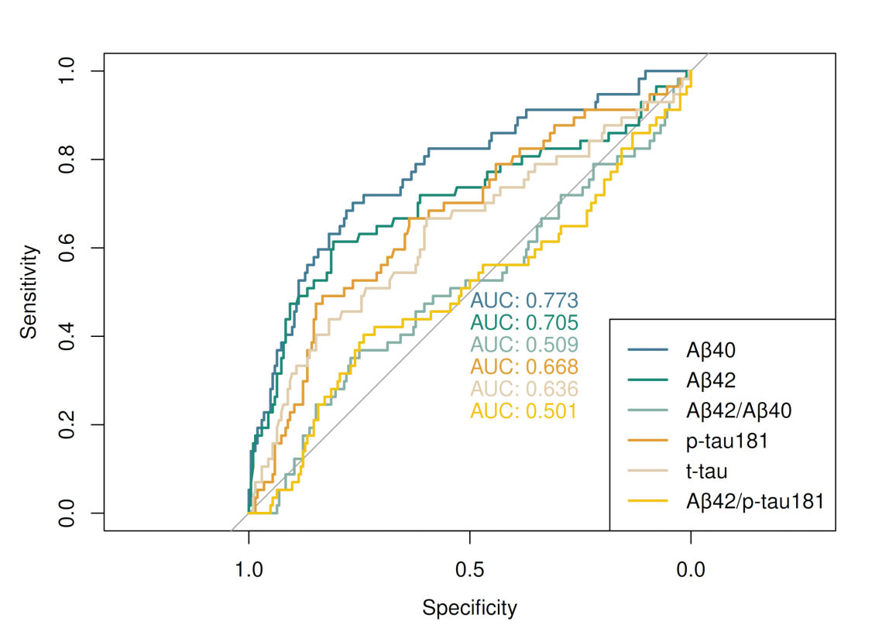
Individual CSF biomarkers ROC curves (colors) and area under the curve values.

FIGURE S6. CAA discriminatory power of amyloid CSF biomarkers in subjects with AD
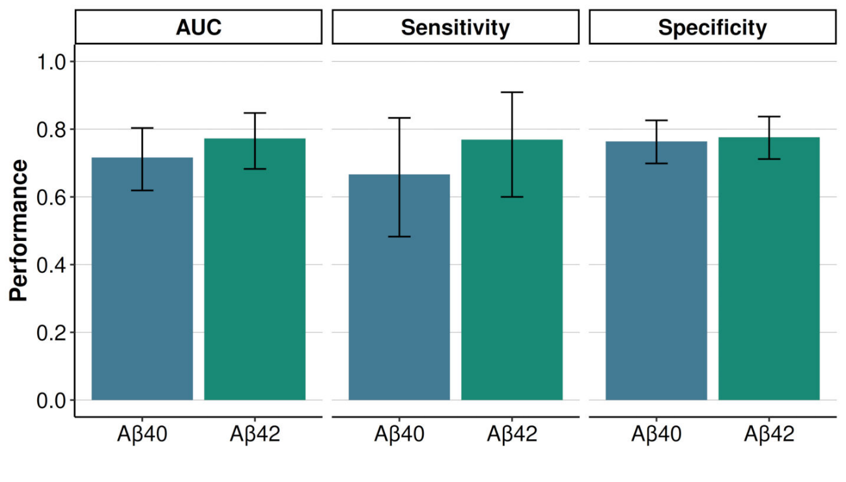
In this sensitivity analysis, we considered only subjects with AD, Bar plots represent the performance of these cutoffs in discriminating CAA in subjects with AD, assessed by AUC, sensitivity, and specificity. Confidence intervals were obtained through bootstrapping (10,0000 resampled sets). Colours represent different biomarkers.

FIGURE S7. Association between CSF biomarkers and CAA cerebrovascular burden (fully adjusted model)
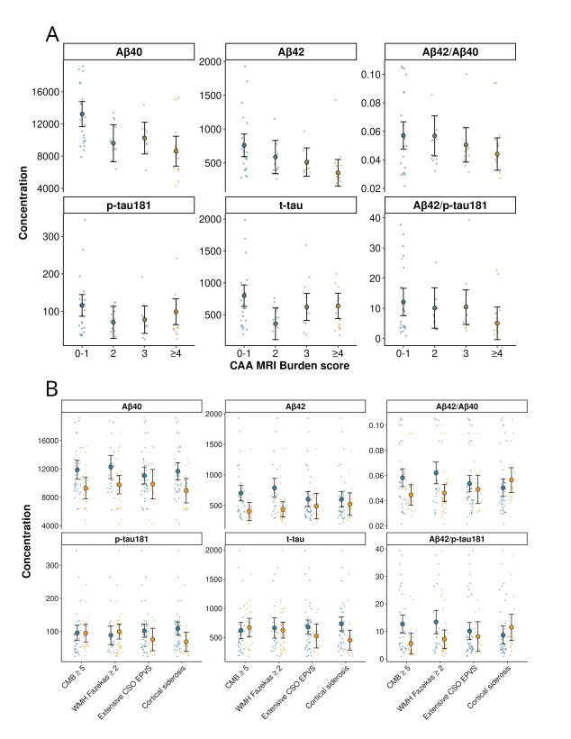
Panel A displays the marginal means and 95% confidence intervals from ANCOVA models comparing CSF biomarkers across groups, adjusted for age, sex, education and APOE ε4. Colours are scaled according to the CAA burden score (X-axis), with blue indicating lower burden and orange indicating higher burden. Panel B extends this analysis to individual CAA-related MRI markers, where colours denote the presence (orange) or absence (blue) of each MRI marker. In both cases asterisks indicate a p-value < 0.05/6, denoting global differences between groups.

Supplementary Tables

TABLE S1. ANCOVA models comparing CSF biomarkers across diagnostic groups
 |  | Model 1 |  | Model 2
Biomarker | Group | Adjusted mean (95% CI) | p for trend | Adjusted mean (95% CI) | p for trend
Aβ40 | HC | 14217.51 (13020.76;15414.26) | <0.0001 | 14436.42 (13109.68;15763.16) | <0.0001
Aβ40 | CAA-nonAD | 10164.92 (8812.7;11517.13) | <0.0001 | 10276.79 (8802.58;11750.99) | <0.0001
Aβ40 | CAA-AD | 11119.02 (9838.03;12400.01) | <0.0001 | 11109.37 (9782.7;12436.04) | <0.0001
Aβ40 | AD | 14217.04 (13661.49;14772.6) | <0.0001 | 13773.42 (13103.57;14443.26) | <0.0001
Aβ42 | HC | 1313.23 (1226.92;1399.54) | <0.0001 | 1293.61 (1190.94;1396.28) | <0.0001
Aβ42 | CAA-nonAD | 736.05 (638.53;833.57) | <0.0001 | 734.74 (620.66;848.83) | <0.0001
Aβ42 | CAA-AD | 431.22 (338.84;523.6) | <0.0001 | 442.65 (339.99;545.32) | <0.0001
Aβ42 | AD | 605.26 (565.19;645.32) | <0.0001 | 604.06 (552.22;655.89) | <0.0001
Aβ42/Aβ40 | HC | 0.09 (0.09;0.1) | <0.0001 | 0.09 (0.09;0.1) | <0.0001
Aβ42/Aβ40 | CAA-nonAD | 0.07 (0.06;0.07) | <0.0001 | 0.07 (0.06;0.07) | <0.0001
Aβ42/Aβ40 | CAA-AD | 0.04 (0.03;0.04) | <0.0001 | 0.04 (0.04;0.05) | <0.0001
Aβ42/Aβ40 | AD | 0.04 (0.04;0.05) | <0.0001 | 0.04 (0.04;0.05) | <0.0001
p-tau181 | HC | 45.75 (29.98;61.53) | <0.0001 | 47.9 (30.26;65.54) | <0.0001
p-tau181 | CAA-nonAD | 46.94 (29.11;64.76) | <0.0001 | 48.31 (28.71;67.92) | <0.0001
p-tau181 | CAA-AD | 131.21 (114.33;148.09) | <0.0001 | 132.64 (115;150.28) | <0.0001
p-tau181 | AD | 132.86 (125.54;140.18) | <0.0001 | 130.59 (121.68;139.5) | <0.0001
t-tau | HC | 332.92 (234.37;431.46) | <0.0001 | 349.36 (238.56;460.16) | <0.0001
t-tau | CAA-nonAD | 372.18 (260.83;483.52) | <0.0001 | 389.44 (266.33;512.55) | <0.0001
t-tau | CAA-AD | 834.14 (728.66;939.63) | <0.0001 | 842.95 (732.16;953.74) | <0.0001
t-tau | AD | 807.73 (761.98;853.48) | <0.0001 | 791.76 (735.82;847.7) | <0.0001
Aβ42/p-tau181 | HC | 30.54 (28.6;32.48) | <0.0001 | 29.9 (27.53;32.27) | <0.0001
Aβ42/p-tau181 | CAA-nonAD | 16.4 (14.2;18.59) | <0.0001 | 16.35 (13.72;18.98) | <0.0001
Aβ42/p-tau181 | CAA-AD | 3.88 (1.8;5.95) | <0.0001 | 4.13 (1.76;6.5) | <0.0001
Aβ42/p-tau181 | AD | 5.15 (4.25;6.05) | <0.0001 | 5.46 (4.27;6.66) | <0.0001

We fitted separate models for each biomarker, with biomarker concentration as the dependent variable and diagnostic group (HC, CAA-nonAD, CAA-AD, AD) as the main predictor. Model 1 was adjusted for age and sex, while Model 2 included additional adjustments for education and APOE ε4 status. Reported values represent adjusted marginal means with 95% confidence intervals. Significance levels reflect overall group differences.

TABLE S2. Association between clinical variables and CSF biomarker principal components
Variable | PC 1 |  | PC 2
Variable | Statistic | p-value | Statistic | p-value | Test Type
Age | 0.01 | 0.81174 | -0.06 | 0.36891 | Correlation Spearman
Sex | 1.23 | 0.26826 | 2.01 | 0.15602 | U Mann Whitney
Education | 0.17 | 0.00893 | 0.01 | 0.91029 | Correlation Spearman
Ethnicity | 0.17 | 0.68082 | 0.12 | 0.72537 | Kruskal-Wallis Test
Hypertension | 1.12 | 0.28898 | 1.97 | 0.16035 | U Mann Whitney
Diabetes | 0 | 0.9934 | 1.41 | 0.23522 | U Mann Whitney
Dyslipidemia | 2.29 | 0.13028 | 2.74 | 0.09768 | U Mann Whitney
Obesity | 0.97 | 0.32414 | 0.15 | 0.70139 | U Mann Whitney
Previous ischemic cardiopathy | 0.51 | 0.4734 | 0.14 | 0.70506 | U Mann Whitney
Use of antiplatelet drugs | 1.19 | 0.27614 | 0.4 | 0.52635 | U Mann Whitney
APOE ε2 | 1.64 | 0.19977 | 1.08 | 0.29952 | U Mann Whitney
APOE ε4 | 30.45 | <0.00001 | 0.93 | 0.33365 | U Mann Whitney
For each principal component (PC) derived from CSF biomarkers, we assessed associations with key demographic and clinical variables. Depending on the variable type, we applied Spearman rank correlation, Mann–Whitney U, or Kruskal–Wallis tests. The table presents corresponding p-values and test statistics (Spearman’s ρ or χ²).

TABLE S3. ANCOVA models comparing CSF biomarkers across CAA burden groups
 |  | Model 1 |  | Model 2
Biomarker | MRI Burden Score | Adjusted mean (95% CI) | p trend | Adjusted mean (95% CI) | p trend
Aβ40 | 0-1 | 12681.1 (11317.54;14044.66) | 0.0026 | 13218.64 (11654.2;14783.09) | 0.00245
Aβ40 | 2 | 10287.38 (8364.61;12210.14) | 0.0026 | 9600.21 (7296.19;11904.22) | 0.00245
Aβ40 | 3 | 10358.23 (8471.98;12244.49) | 0.0026 | 10236.72 (8268.65;12204.79) | 0.00245
Aβ40 | ≥4 | 8377.08 (6675.02;10079.13) | 0.0026 | 8611.32 (6753.81;10468.84) | 0.00245
Aβ42 | 0-1 | 758.12 (602.63;913.6) | 0.03607 | 760.87 (594.48;927.26) | 0.02204
Aβ42 | 2 | 526.21 (306.96;745.47) | 0.03607 | 587.47 (342.42;832.52) | 0.02204
Aβ42 | 3 | 496.48 (281.39;711.57) | 0.03607 | 513.08 (303.77;722.4) | 0.02204
Aβ42 | ≥4 | 409.65 (215.56;603.74) | 0.03607 | 354.12 (156.56;551.68) | 0.02204
Aβ42/Aβ40 | 0-1 | 0.06 (0.05;0.07) | 0.46287 | 0.06 (0.05;0.07) | 0.30777
Aβ42/Aβ40 | 2 | 0.05 (0.04;0.06) | 0.46287 | 0.06 (0.04;0.07) | 0.30777
Aβ42/Aβ40 | 3 | 0.05 (0.03;0.06) | 0.46287 | 0.05 (0.04;0.06) | 0.30777
Aβ42/Aβ40 | ≥4 | 0.05 (0.04;0.06) | 0.46287 | 0.04 (0.03;0.06) | 0.30777
p-tau181 | 0-1 | 104.96 (77.65;132.26) | 0.69378 | 115.83 (86.79;144.86) | 0.27425
p-tau181 | 2 | 85.63 (47.12;124.13) | 0.69378 | 70.51 (27.75;113.26) | 0.27425
p-tau181 | 3 | 81.3 (43.53;119.08) | 0.69378 | 77.71 (41.18;114.23) | 0.27425
p-tau181 | ≥4 | 85.85 (51.76;119.93) | 0.69378 | 98.85 (64.37;133.32) | 0.27425
t-tau | 0-1 | 706.97 (531.92;882.02) | 0.47536 | 798.68 (630.4;966.96) | 0.0516
t-tau | 2 | 506.03 (259.19;752.87) | 0.47536 | 357.69 (109.85;605.52) | 0.0516
t-tau | 3 | 655.79 (413.64;897.94) | 0.47536 | 622.92 (411.22;834.62) | 0.0516
t-tau | ≥4 | 538.55 (320.05;757.06) | 0.47536 | 638.17 (438.36;837.98) | 0.0516
Aβ42/p-tau181 | 0-1 | 12.66 (8.25;17.07) | 0.37919 | 12.11 (7.57;16.65) | 0.24818
Aβ42/p-tau181 | 2 | 8.06 (1.84;14.28) | 0.37919 | 10.12 (3.43;16.81) | 0.24818
Aβ42/p-tau181 | 3 | 9.77 (3.67;15.88) | 0.37919 | 10.4 (4.68;16.11) | 0.24818
Aβ42/p-tau181 | ≥4 | 6.88 (1.37;12.38) | 0.37919 | 5.04 (-0.36;10.43) | 0.24818

We fitted separate models for each biomarker, with biomarker concentration as the dependent variable and CAA MRI burden groups (0-1 marker/s, 2 markers, 3 markers, ≥4 markers) as the main predictor. Model 1 was adjusted for age and sex, while Model 2 included additional adjustments for education and APOE ε4 status. Reported values represent adjusted marginal means with 95% confidence intervals. Significance levels reflect overall group differences, and we considered as significant those p-values < 0.05/6 (Bonferroni adjustment).

TABLE S4. ANCOVA models comparing CSF biomarkers by presence of individual CAA MRI markers
 |  |  | Model 1 |  | Model 2
MRI marker | Biomarker | Group | Adjusted mean (95% CI) | p-value | Adjusted mean (95% CI) | p-value
Lobar CMBs ≥5 | Aβ40 | No | 11755.74 (10610.75;12900.74) | 0.00747 | 11891.34 (10586.2;13196.49) | 0.01262
Lobar CMBs ≥5 | Aβ40 | Yes | 9207.92 (7819.04;10596.8) | 0.00747 | 9289.3 (7788;10790.59) | 0.01262
Lobar CMBs ≥5 | Aβ42 | No | 693.68 (570.75;816.62) | 0.00562 | 702.62 (574.14;831.11) | 0.00407
Lobar CMBs ≥5 | Aβ42 | Yes | 409.81 (260.68;558.93) | 0.00562 | 404.11 (256.32;551.9) | 0.00407
Lobar CMBs ≥5 | Aβ42/Aβ40 | No | 0.06 (0.05;0.07) | 0.04197 | 0.06 (0.05;0.07) | 0.01491
Lobar CMBs ≥5 | Aβ42/Aβ40 | Yes | 0.05 (0.04;0.05) | 0.04197 | 0.04 (0.04;0.05) | 0.01491
Lobar CMBs ≥5 | p-tau181 | No | 92.36 (70.68;114.04) | 0.96483 | 95.67 (72.65;118.7) | 0.96037
Lobar CMBs ≥5 | p-tau181 | Yes | 91.59 (65.29;117.89) | 0.96483 | 94.79 (68.3;121.28) | 0.96037
Lobar CMBs ≥5 | t-tau | No | 597.3 (457.15;737.46) | 0.66265 | 621.31 (482.1;760.51) | 0.65584
Lobar CMBs ≥5 | t-tau | Yes | 646.48 (476.48;816.49) | 0.66265 | 669.23 (509.1;829.36) | 0.65584
Lobar CMBs ≥5 | Aβ42/p-tau181 | No | 12.54 (9.17;15.91) | 0.01604 | 12.66 (9.32;16) | 0.00814
Lobar CMBs ≥5 | Aβ42/p-tau181 | Yes | 5.84 (1.75;9.92) | 0.01604 | 5.56 (1.72;9.41) | 0.00814
Lobar CMBs ≥5 | Aβ42/p-tau181 | Yes | 8.29 (4.93;11.65) | 0.01604 | 7.14 (3.78;10.5) | 0.00814
cSS | Aβ40 | No | 11500.08 (10435.26;12564.9) | 0.01267 | 11679.29 (10476.65;12881.93) | 0.0128
cSS | Aβ40 | Yes | 9014.23 (7430.16;10598.3) | 0.01267 | 8942.18 (7224.21;10660.15) | 0.0128
cSS | Aβ42 | No | 614.78 (494.2;735.37) | 0.28707 | 599.88 (470.72;729.05) | 0.48999
cSS | Aβ42 | Yes | 497.47 (318.09;676.86) | 0.28707 | 520.97 (336.46;705.48) | 0.48999
cSS | Aβ42/Aβ40 | No | 0.05 (0.04;0.06) | 0.79855 | 0.05 (0.04;0.06) | 0.3165
cSS | Aβ42/Aβ40 | Yes | 0.05 (0.04;0.07) | 0.79855 | 0.06 (0.05;0.07) | 0.3165
cSS | p-tau181 | No | 101.9 (82.48;121.31) | 0.08141 | 108.6 (88.5;128.7) | 0.02865
cSS | p-tau181 | Yes | 70.7 (41.82;99.58) | 0.08141 | 68.7 (39.99;97.42) | 0.02865
cSS | t-tau | No | 681.25 (555.54;806.97) | 0.08109 | 735.03 (615.54;854.51) | 0.01083
cSS | t-tau | Yes | 479.01 (291.99;666.03) | 0.08109 | 456.2 (285.51;626.88) | 0.01083
cSS | Aβ42/p-tau181 | No | 9.42 (6.15;12.7) | 0.68773 | 8.65 (5.36;11.95) | 0.33582
cSS | Aβ42/p-tau181 | Yes | 10.62 (5.75;15.49) | 0.68773 | 11.47 (6.76;16.17) | 0.33582
CSO severe PVS | Aβ40 | No | 10969.11 (9911.54;12026.69) | 0.33666 | 11079.04 (9879.25;12278.83) | 0.31227
CSO severe PVS | Aβ40 | Yes | 9938.53 (8088.29;11788.77) | 0.33666 | 9850.77 (7773.33;11928.21) | 0.31227
CSO severe PVS | Aβ42 | No | 597.25 (482.65;711.86) | 0.4948 | 602.94 (481.92;723.96) | 0.34622
CSO severe PVS | Aβ42 | Yes | 518.07 (317.57;718.57) | 0.4948 | 487.54 (277.99;697.08) | 0.34622
CSO severe PVS | Aβ42/Aβ40 | No | 0.05 (0.05;0.06) | 0.7072 | 0.05 (0.05;0.06) | 0.49098
CSO severe PVS | Aβ42/Aβ40 | Yes | 0.05 (0.04;0.06) | 0.7072 | 0.05 (0.04;0.06) | 0.49098
CSO severe PVS | p-tau181 | No | 98.52 (79.99;117.04) | 0.16421 | 102 (82.43;121.58) | 0.18543
CSO severe PVS | p-tau181 | Yes | 72.25 (39.84;104.66) | 0.16421 | 75.63 (41.73;109.53) | 0.18543
CSO severe PVS | t-tau | No | 659.42 (539.45;779.39) | 0.16307 | 681.19 (562.4;799.98) | 0.2027
CSO severe PVS | t-tau | Yes | 488.87 (278.98;698.76) | 0.16307 | 527.35 (321.66;733.04) | 0.2027
CSO severe PVS | Aβ42/p-tau181 | No | 10.05 (6.95;13.14) | 0.74797 | 10.1 (6.98;13.22) | 0.52832
CSO severe PVS | Aβ42/p-tau181 | Yes | 9.04 (3.63;14.46) | 0.74797 | 8.11 (2.71;13.51) | 0.52832
WMHs Fazekas ≥2 | Aβ40 | No | 11919.01 (10489.43;13348.59) | 0.03572 | 12274.96 (10630.32;13919.61) | 0.02573
WMHs Fazekas ≥2 | Aβ40 | Yes | 9960.48 (8828.42;11092.55) | 0.03572 | 9794.9 (8495.22;11094.57) | 0.02573
WMHs Fazekas ≥2 | Aβ42 | No | 735.91 (584.96;886.86) | 0.00975 | 786.89 (631.05;942.73) | 0.00126
WMHs Fazekas ≥2 | Aβ42 | Yes | 478.59 (359.06;598.13) | 0.00975 | 436.19 (313.04;559.34) | 0.00126
WMHs Fazekas ≥2 | Aβ42/Aβ40 | No | 0.06 (0.05;0.07) | 0.08425 | 0.06 (0.05;0.07) | 0.00699
WMHs Fazekas ≥2 | Aβ42/Aβ40 | Yes | 0.05 (0.04;0.06) | 0.08425 | 0.05 (0.04;0.05) | 0.00699
WMHs Fazekas ≥2 | p-tau181 | No | 88.52 (62.18;114.86) | 0.73318 | 88.35 (59.85;116.84) | 0.543
WMHs Fazekas ≥2 | p-tau181 | Yes | 94.26 (73.4;115.12) | 0.73318 | 99.76 (77.25;122.28) | 0.543
WMHs Fazekas ≥2 | t-tau | No | 640.7 (470.12;811.29) | 0.72792 | 664.41 (491.24;837.57) | 0.74669
WMHs Fazekas ≥2 | t-tau | Yes | 602.78 (467.69;737.86) | 0.72792 | 627.62 (490.78;764.46) | 0.74669
WMHs Fazekas ≥2 | Aβ42/p-tau181 | No | 12.21 (7.97;16.46) | 0.15176 | 13.4 (9.14;17.65) | 0.02947
WMHs Fazekas ≥2 | Aβ42/p-tau181 | Yes | 8.29 (4.93;11.65) | 0.15176 | 7.14 (3.78;10.5) | 0.02947

We fitted separate models for each biomarker, with biomarker concentration as the dependent variable and individual MRI markers as the predictors of interest. Model 1 was adjusted for age and sex, while Model 2 included additional adjustments for education and APOE ε4 status. Reported values represent adjusted marginal means with 95% confidence intervals. Significance levels reflect overall group differences, and we considered as significant those p-values < 0.05/6 (Bonferroni adjustment).

References
1. Puig-Pijoan A, García-Escobar G, Fernández-Lebrero A, et al. The CORCOBIA study: Cut-off points of Alzheimer’s disease CSF biomarkers in a clinical cohort. Neurol Engl Ed. 2024;39(9):756-765. doi:10.1016/j.nrleng.2022.05.002
2. Guía oficial de práctica clínica en demencia. Luzán 5 Health Consulting S.A. ; Ediciones SEN; 2018.
3. Charidimou A, Boulouis G, Frosch MP, et al. The Boston criteria version 2.0 for cerebral amyloid angiopathy: a multicentre, retrospective, MRI–neuropathology diagnostic accuracy study. Lancet Neurol. 2022;21(8):714-725. doi:10.1016/S1474-4422(22)00208-3
4. Albert MS, DeKosky ST, Dickson D, et al. The diagnosis of mild cognitive impairment due to Alzheimer’s disease: Recommendations from the National Institute on Aging‐Alzheimer’s Association workgroups on diagnostic guidelines for Alzheimer’s disease. Alzheimers Dement. 2011;7(3):270-279. doi:10.1016/j.jalz.2011.03.008
5. McKhann GM, Knopman DS, Chertkow H, et al. The diagnosis of dementia due to Alzheimer’s disease: Recommendations from the National Institute on Aging‐Alzheimer’s Association workgroups on diagnostic guidelines for Alzheimer’s disease. Alzheimers Dement. 2011;7(3):263-269. doi:10.1016/j.jalz.2011.03.005
6. Folstein MF, Folstein SE, McHugh PR. “Mini-mental state.” J Psychiatr Res. 1975;12(3):189-198. doi:10.1016/0022-3956(75)90026-6
7. Buschke H, Kuslansky G, Katz M, et al. Screening for dementia with the Memory Impairment Screen. Neurology. 1999;52(2):231-231. doi:10.1212/WNL.52.2.231
8. Peña-Casanova J. Test Barcelona Revisado: programa integrado de exploración neuropsicológica : TBR. 2a ed. Masson; 2005.
9. Buschke H. Cued recall in Amnesia. J Clin Neuropsychol. 1984;6(4):433-440. doi:10.1080/01688638408401233
10. Roth C. Boston Naming Test. In: Kreutzer JS, DeLuca J, Caplan B, eds. Encyclopedia of Clinical Neuropsychology. Springer New York; 2011:430-433. doi:10.1007/978-0-387-79948-3_869
11. Reed JC, Reed HBC. The Halstead—Reitan Neuropsychological Battery. In: Goldstein G, Incagnoli TM, eds. Contemporary Approaches to Neuropsychological Assessment. Critical Issues in Neuropsychology. Springer US; 1997:93-129. doi:10.1007/978-1-4757-9820-3_4
12. Blessed G, Tomlinson BE, Roth M. The Association Between Quantitative Measures of Dementia and of Senile Change in the Cerebral Grey Matter of Elderly Subjects. Br J Psychiatry. 1968;114(512):797-811. doi:10.1192/bjp.114.512.797
13. Galasko D, Bennett D, Sano M, et al. An Inventory to Assess Activities of Daily Living for Clinical Trials in Alzheimerʼs Disease: Alzheimer Dis Assoc Disord. 1997;11:33-39. doi:10.1097/00002093-199700112-00005
14. The Global Deterioration Scale for assessment of primary degenerative dementia. Am J Psychiatry. 1982;139(9):1136-1139. doi:10.1176/ajp.139.9.1136
15. Morris JC. The Clinical Dementia Rating (CDR): Current version and scoring rules. Neurology. 1993;43(11):2412. doi:10.1212/WNL.43.11.2412-a
16. Gobom J, Parnetti L, Rosa-Neto P, et al. Validation of the LUMIPULSE automated immunoassay for the measurement of core AD biomarkers in cerebrospinal fluid. Clin Chem Lab Med CCLM. 2022;60(2):207-219. doi:10.1515/cclm-2021-0651
17. Mattsson N, Rosén E, Hansson O, et al. Age and diagnostic performance of Alzheimer disease CSF biomarkers. Neurology. 2012;78(7):468-476. doi:10.1212/WNL.0b013e3182477eed
18. for the Women’s Brain Project and the Alzheimer Precision Medicine Initiative, Ferretti MT, Iulita MF, et al. Sex differences in Alzheimer disease — the gateway to precision medicine. Nat Rev Neurol. 2018;14(8):457-469. doi:10.1038/s41582-018-0032-9
19. Lee BN, Wang J, Hall MA, Kim D, Stites SD, Shen L. Sex modifies effects of imaging and CSF biomarkers on cognitive and functional outcomes: a study of Alzheimer’s disease. Neurobiol Aging. 2024;133:67-77. doi:10.1016/j.neurobiolaging.2023.10.002
20. Charidimou A, Martinez-Ramirez S, Reijmer YD, et al. Total Magnetic Resonance Imaging Burden of Small Vessel Disease in Cerebral Amyloid Angiopathy: An Imaging-Pathologic Study of Concept Validation. JAMA Neurol. 2016;73(8):994. doi:10.1001/jamaneurol.2016.0832
21. Boulouis G, Charidimou A, Jessel MJ, et al. Small vessel disease burden in cerebral amyloid angiopathy without symptomatic hemorrhage. Neurology. 2017;88(9):878-884. doi:10.1212/WNL.0000000000003655

