A Randomized, Controlled Trial of the Novel Kv7 Channel Opener Azetukalner in Individuals with Major Depressive Disorder and Anhedonia: Neural Response to Reward, Clinical Outcomes, and Safety

Supplemental Material

- Supplemental Methods
- Supplemental Tables and Figures
- Supplemental Methods

Incentive Flanker task description
The IFT (Figure 1A) is a modified version of the Monetary Incentive Delay (MID) task that includes a longer mean cue time, jittered cue time, catch trials and a flanker challenge that all facilitate modeling of reward anticipation during the cue phase and reward outcome after the flanker phase. After the cue phase at the beginning of the task, participants were to respond correctly to the target letters S/K and H/C located in the center of five-letter string by pressing a response button with either their right index or middle finger. The response period duration varied by participant and was based on a titration process during a practice session, which adjusts the difficulty of the task to keep accuracy ~60% for each trial. This approach ensures sufficient variance in reaction time and enough correct/incorrect trial types to model. The cue types presented at the beginning of each trial were shown for 2000 ms. – 6000 ms. and consisted of +50 cent (gain cue), -50 cent (loss cue) and 0 cent (neutral cue). A correct response in a gain trial was rewarded with 50 cent (or not receiving 50 cent when responded incorrectly), in a loss trial a correct response resulted in not losing 50 ct (but losing 50 cent when responded incorrectly), while no money was at stake during the neutral trials. After 67% of trials, the flanker challenge started where participants responded as quickly as possible to the letter, followed by the feedback phase where participants were shown for 2000 ms. whether they have responded correctly, incorrectly, or too slowly. After a subsequent inter trial interval during which a fixation cross was shown for 2000 ms. – 6000 ms. In 33% of trials, however, a blank screen was shown for 2000 ms. indicating a “catch” trial, which reduces collinearity between cue and feedback phase and improves model parameter estimation. In total there were 4 blocks with 40 trials for each cue type, resulting in a total of 120 trials per block. The duration of one block was ~ 6 minutes. At the end of each block participants were presented with the total amount of money they collected so far during the task.
Imaging Acquisition and Processing
All IFT fMRI data were preprocessed using multi-echo independent component analysis (ME-ICA), which includes slice-time correction, motion and physiological artifact removal. Thereto, the data was decomposed into independent components, which were analyzed to investigate whether their time course scaled with signal change dependent on TE, which indicates a BOLD-like component. Component time courses not dependent on TE- related signal change were considered non-BOLD components and removed [add Kundu et a l]. Afterwards, the images were normalized to MNI space and smoothed with a 5mm FWHM Gaussian kernel.
The IFT subject level models were created by entering all runs into the GLM. We included onset regressors for cue type (gain, loss, neutral), congruency for the flanker challenge (congruent, incongruent) and feedback (positive, negative, neutral) at the end of a trial. The duration of the cue presentation varied between two and six seconds and was entered for each trial, while flanker and feedback were modeled as events, respectively. The main contrast of interest that reflects reward anticipation was computed by subtracting the estimated parameters for the neutral condition from the parameters of the gain condition. The resulting contrast estimates were then extracted from the VS region of interest using an anatomical mask from the Harvard-Oxford atlas. The extracted data was then statistically analyzed.
Sample Size Calculation
Sample size calculations were based on estimates from the ezogabine trial (15). The estimated mean difference in bilateral VS activation from baseline to week 5 was 0.323 in the ezogabine group and –0.14 in the placebo group. Using a linear mixed-effects model and assuming the variance of the random intercept was 0.14 and residual variance was 0.36, a total of 50 participants (25 per group) would provide the trial with at least 80% power to detect a difference of 0.4 to 0.6 in bilateral VS activation from baseline to week 8 between azetukalner and placebo at a two-sided significance level of 0.10. To account for 20% study dropout, the sample size was increased to 60 participants (30 per group).
Adverse Events of Special Interest
Adverse events were reviewed by a study psychiatrist at each study visit through week 12 with pre-defined adverse events of special interest (AESI) focused on disturbances in thinking and perception, bladder and urethral symptoms, cardiovascular changes and ophthalmologic changes. Suicidal ideation and behavior were evaluated by a trained rater using the Columbia- Suicide Severity Rating Scale (C-SSRS) at baseline and weeks 1, 2, 4, 6, 8, and 12 (13). A C-SSRS score greater than 2 necessitated a safety review. Trained raters also administered the 4-item positive symptom subscale of the Brief Psychiatric Rating Scale (BPRS-4) at these timepoints to assess for acute behavioral changes indicative of psychosis (14). Participants completed The American Urological Association Symptom Score Questionnaire (AUA) to urinary retention symptoms at baseline and weeks 4, 8, and 12. An AUA score greater than 7 increased from baseline led to a safety review and was considered an AESI. An electrocardiogram was performed at screening and weeks 2, 8, and 12 to assess cardiovascular changes. Participants underwent a dilated fundoscopic eye examination at screening and week 12 to assess retinal changes.
Response and remission rates:
Response to treatment was calculated as the percentage of participants with a reduction of at least 50% in MADRS score from baseline to week 8. Remission rate was computed as the percentage of participants who achieved less than 10 points on the MADRS at week 8. Participants with missing values on the MADRS at week 8 were considered failures for response and remission.
Researchers interested in obtaining the full study protocol, statistical analysis plan, and/or requesting all study data should contact Dr. James Murrough.

- Supplemental Tables and Figures
Figure S1: Consort Diagram

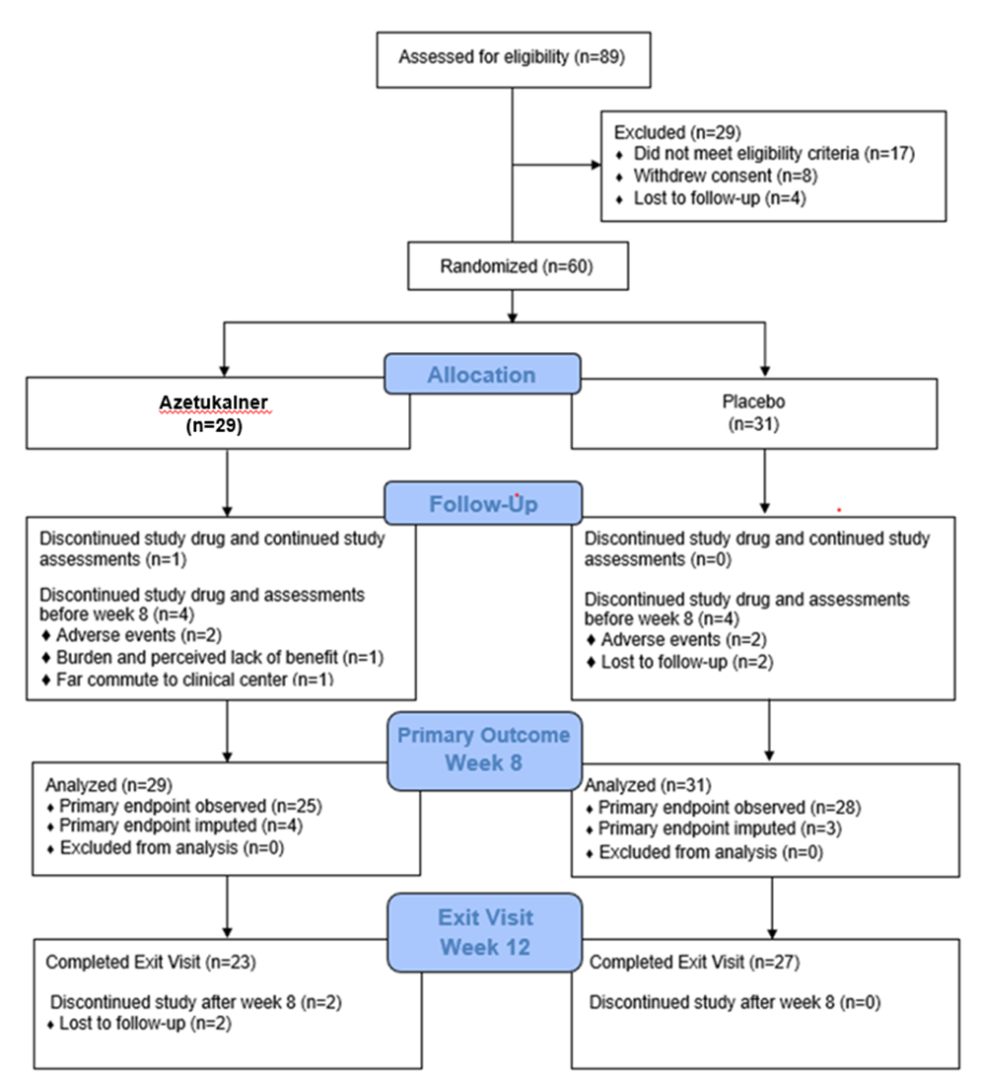

Table S1: Complete List of Adverse Events
 | Azetukalner  (N=29) |  | Placebo  (N=30)
 | N | % | N | %
Any adverse eventª | 27 | 93.1 | 25 | 83.3
Dizziness | 11 | 37.9 | 3 | 10.0
Incoordination | 6 | 20.7 | 1 | 3.3
Confusion | 6 | 20.7 | 0 | 0.0
Drowsiness | 4 | 13.8 | 4 | 13.3
Fatigue | 4 | 13.8 | 3 | 10.0
Visual hallucinations | 4 | 13.8 | 0 | 0.0
Headache | 3 | 10.3 | 6 | 20.0
Blurred vision | 3 | 10.3 | 0 | 0.0
Brain fog | 3 | 10.3 | 0 | 0.0
Eye floaters | 3 | 10.3 | 0 | 0.0
Impairment of attention | 3 | 10.3 | 0 | 0.0
Memory impaired | 3 | 10.3 | 0 | 0.0
Word finding difficulty | 3 | 10.3 | 0 | 0.0
Nausea | 2 | 6.9 | 3 | 10.0
Urinary urgency | 2 | 6.9 | 2 | 6.7
Dry mouth | 2 | 6.9 | 1 | 3.3
Groggy | 2 | 6.9 | 1 | 3.3
Sinus infection | 2 | 6.9 | 0 | 0.0
Thinking disturbances | 2 | 6.9 | 0 | 0.0
Tingling | 2 | 6.9 | 0 | 0.0
Tremor | 2 | 6.9 | 0 | 0.0
Urinary tract infection | 2 | 6.9 | 0 | 0.0
Back pain | 1 | 3.4 | 3 | 10.0
Upper respiratory tract infection | 1 | 3.4 | 3 | 10.0
Anxiety | 1 | 3.4 | 1 | 3.3
Stomach pain | 1 | 3.4 | 1 | 3.3
Arthralgia | 1 | 3.4 | 0 | 0.0
Blepharitis | 1 | 3.4 | 0 | 0.0
Concentration impaired | 1 | 3.4 | 0 | 0.0
Constipation | 1 | 3.4 | 0 | 0.0
Coronavirus infection | 1 | 3.4 | 0 | 0.0
Fainting | 1 | 3.4 | 0 | 0.0
Fall | 1 | 3.4 | 0 | 0.0
Fine motor skill dysfunction | 1 | 3.4 | 0 | 0.0
Hives | 1 | 3.4 | 0 | 0.0
Libido decreased | 1 | 3.4 | 0 | 0.0
Light sensitivity to eye | 1 | 3.4 | 0 | 0.0
Lightheadedness | 1 | 3.4 | 0 | 0.0
Panic attack | 1 | 3.4 | 0 | 0.0
Perceptual disturbance | 1 | 3.4 | 0 | 0.0
Postnasal drip | 1 | 3.4 | 0 | 0.0
Reflux gastritis | 1 | 3.4 | 0 | 0.0
Self-injurious ideation | 1 | 3.4 | 0 | 0.0
Stools watery | 1 | 3.4 | 0 | 0.0
Swelling of feet | 1 | 3.4 | 0 | 0.0
Tachycardia | 1 | 3.4 | 0 | 0.0
Transient aphasia | 1 | 3.4 | 0 | 0.0
Twitching | 1 | 3.4 | 0 | 0.0
Urinary hesitation | 1 | 3.4 | 0 | 0.0
Urinary retention | 1 | 3.4 | 0 | 0.0
Urinary straining | 1 | 3.4 | 0 | 0.0
Vaginal discharge abnormality | 1 | 3.4 | 0 | 0.0
Visual phenomena | 1 | 3.4 | 0 | 0.0
Weak urinary stream | 1 | 3.4 | 0 | 0.0
Viral syndrome | 0 | 0.0 | 2 | 6.7
Alanine aminotransferase increased | 0 | 0.0 | 1 | 3.3
Amaurosis fugax | 0 | 0.0 | 1 | 3.3
Anosmia | 0 | 0.0 | 1 | 3.3
Asthenia | 0 | 0.0 | 1 | 3.3
Bruxism | 0 | 0.0 | 1 | 3.3
Chest discomfort | 0 | 0.0 | 1 | 3.3
Diarrhea | 0 | 0.0 | 1 | 3.3
Diverticulitis | 0 | 0.0 | 1 | 3.3
Ear feels clogged | 0 | 0.0 | 1 | 3.3
Early morning awakening | 0 | 0.0 | 1 | 3.3
Eczema facial | 0 | 0.0 | 1 | 3.3
Fever | 0 | 0.0 | 1 | 3.3
Folliculitis decalvans | 0 | 0.0 | 1 | 3.3
Hot flushes | 0 | 0.0 | 1 | 3.3
Insomnia exacerbated | 0 | 0.0 | 1 | 3.3
Painful urination | 0 | 0.0 | 1 | 3.3
Shoulder pain | 0 | 0.0 | 1 | 3.3
Throat infection | 0 | 0.0 | 1 | 3.3
Urinary frequency | 0 | 0.0 | 1 | 3.3
Vomiting | 0 | 0.0 | 1 | 3.3

ª Data for adverse events from randomization through 12 weeks are shown. Adverse events were collected using MedDRA-preferred terms. Safety was evaluated in the safety population and included all randomized participants who received at least one dose of azetukalner or placebo.
Table S2: Linear Mixed-Effects Model Estimates for Primary Endpoint ^{a,b}
 | Azetukalner | Placebo | Azetukalner – Placebo
 | Predicted Mean (SE) | Predicted Mean (SE) | Difference  (90% CI)
Baseline | 0.13 (0.10) | 0.12 (0.10) | 0.01 (-0.22, 0.24)
Week 8 | -0.11 (0.10) | 0.04 (0.10) | -0.15 (-0.38, 0.08)

ª CI denotes confidence interval, SE standard error.
^{b} Estimates are based on pooled estimates from multiply imputed datasets.

Table S3: Linear Mixed-Effects Model Estimates for Secondary Endpoints^{a, b}

 | Week 0 | Week 2 | Week 4 | Week 6 | Week 8
MADRS Predicted Mean (SE)
Azetukalner | 28.55 (1.70) | 20.15 (1.72) | 16.06 (1.74) | 15.02 (1.77) | 15.54 (1.77)
Placebo | 27.87 (1.65) | 22.05 (1.66) | 19.23 (1.70) | 19.37 (1.70) | 16.86 (1.71)
Difference (90% CI) | 0.68  (-3.24, 4.60) | -1.90  (-5.86, 2.06) | -3.17  (-7.19, 0.84) | -4.35  (-8.40, -0.30) | -1.32  (-5.39, 2.75)
SHAPS Predicted Mean (SE)
Azetukalner | 32.10 (1.32) | 28.93 (1.33) | 26.93 (1.35) | 28.13 (1.37) | 26.17 (1.37)
Placebo | 32.87 (1.28) | 30.86 (1.29) | 31.43 (1.31) | 31.22 (1.31) | 28.63 (1.33)
Difference (90% CI) | -0.77  (-3.80, 2.27) | -1.93  (-5.00, 1.14) | -4.50  (-7.62, -1.39) | -3.09  (-6.23, 0.05) | -2.46  (-5.62, 0.69)

ª CI denotes confidence interval, MADRS Montgomery–Åsberg Depression Rating Scale, SE standard error, SHAPS Snaith-Hamilton Pleasure Scale.
^{b} Scores on the MADRS range from 0 to 60 with higher scores indicating greater severity of depression. Scores on the SHAPS range from 14 to 56 with higher scores indicating greater level of anhedonia.

Table S4: Response and Remission Rates Post-Baseline Based on the MADRSª

 | Response^{b} |  | Remission^{c}
 | Azetukalner | Placebo | Azetukalner | Placebo
Week 2 | 7/29 = 0.24 | 6/31 = 0.19 | 5/29 = 0.17 | 4/31 = 0.13
Week 4 | 11/29 = 0.38 | 9/31 = 0.29 | 8/29 = 0.28 | 5/31 = 0.16
Week 6 | 13/29 = 0.45 | 7/31 = 0.23 | 10/29 = 0.34 | 6/31 = 0.19
Week 8 | 11/29 = 0.38 | 11/31 = 0.35 | 9/29 = 0.31 | 8/31 = 0.26

ª MADRS denotes Montgomery–Asberg Depression Rating Scale.
^{b} Response was defined as reduction of ≥50% in the MADRS score from baseline.
^{c} Remission was defined as a score < 10 on the MADRS.

Table S5: Linear Mixed-Effects Model Estimates for Exploratory Endpoints^{a, b}

 | Week 0 | Week 2 | Week 4 | Week 6 | Week 8
QIDS-SR Predicted Mean (SE)
Azetukalner | 12.76 (0.81) | 9.84 (0.82) | 9.01 (0.83) | 8.37 (0.85) | 7.97 (0.85)
Placebo | 14.26 (0.79) | 9.63 (0.79) | 8.73 (0.81) | 8.69 (0.81) | 7.65 (0.82)
Difference (90% CI) | -1.50  (-3.37, 0.37) | 0.21  (-1.68, 2.10) | 0.28  (-1.64, 2.20) | -0.32  (-2.27, 1.62) | 0.32  (-1.63, 2.27)
TEPS-AP Predicted Mean (SE)
Azetukalner | 34.48 (1.56) | 35.41 (1.57) | 37.55 (1.58) | 37.90 (1.60) | 39.10 (1.60)
Placebo | 32.10 (1.51) | 31.70 (1.52) | 32.71 (1.54) | 32.17 (1.54) | 32.75 (1.55)
Difference (90% CI) | 2.39  (-1.20, 5.97) | 3.71  (0.10, 7.32) | 4.84  (1.19, 8.49) | 5.72  (2.05, 9.40) | 6.35  (2.66, 10.03)
TEPS-CP Predicted Mean (SE)
Azetukalner | 29.00 (1.53) | 29.34 (1.53) | 29.76 (1.54) | 30.89 (1.55) | 32.05 (1.55)
Placebo | 29.90 (1.48) | 29.80 (1.48) | 30.05 (1.49) | 29.69 (1.49) | 30.52 (1.50)
Difference (90% CI) | -0.90  (-4.41, 2.61) | -0.46  (-3.99, 3.07) | -0.29  (-3.84, 3.25) | 1.20  (-2.36, 4.76) | 1.53  (-2.03, 5.10)
CGI-S Predicted Mean (SE)
Azetukalner | 4.41 (0.19) | 3.74 (0.19) | 3.39 (0.20) | 3.11 (0.20) | 3.11 (0.20)
Placebo | 4.65 (0.19) | 4.21 (0.19) | 3.80 (0.19) | 3.62 (0.19) | 3.33 (0.19)
Difference (90% CI) | -0.23  (-0.67, 0.21) | -0.46  (-0.91, -0.02) | -0.41  (-0.87, 0.04) | -0.51  (-0.97, -0.05) | -0.23  (-0.69, 0.23)
CGI-I Predicted Mean (SE)
Azetukalner | 4.14 (0.19) | 3.14 (0.20) | 2.69 (0.20) | 2.48 (0.20) | 2.44 (0.20)
Placebo | 4.10 (0.19) | 3.40 (0.19) | 3.25 (0.19) | 2.96 (0.19) | 2.75 (0.20)
Difference (90% CI) | 0.04  (-0.40, 0.48) | -0.26  (-0.71, 0.19) | -0.56  (-1.02, -0.10) | -0.48  (-0.95, -0.02) | -0.31  (-0.78, 0.16)

ª CI denotes confidence interval, CGI-I Clinical Global Impressions Improvement Scale, CGI-S Clinical Global Impressions Severity Scale, QIDS-SR, SE standard error, TEPS-AP Temporal Experience of Pleasure Scale Anticipatory Pleasure, TEPS-CP Temporal Experience of Pleasure Scale Consummatory Pleasure.
^{b} Scores on the QIDS-SR range from 0 to 27 with higher scores indicating greater severity of depression. Scores on the TEPS-AP range from 10 to 60 and scores on the TEPS-CP range from 8 to 48 with higher scores indicating greater level of anhedonia on both scales. Scores on the CGI-S range from 1 (Normal; not at all ill) to 7 (Among the most extremely ill patients). Scores on the CGI-I range from 1 (Very much improved) to 7 (Very much worse).

