Table S1 Hazard ratios and their p-values for well-defined biological states and processes in LGG and GBM sorted by HR(LGG).
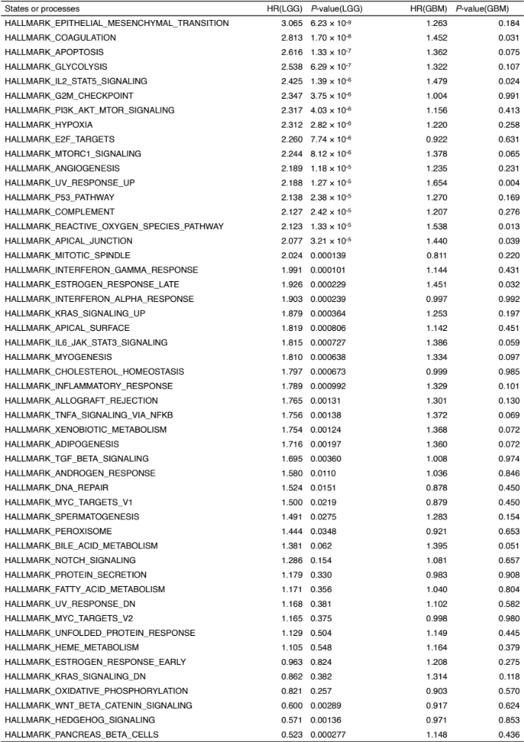
Table S2 Results of Welch's t-test for differences in the activity of each state or process between High-CTL and Low-CTL groups on LGG and GBM sorted by t-Statistic(LGG).
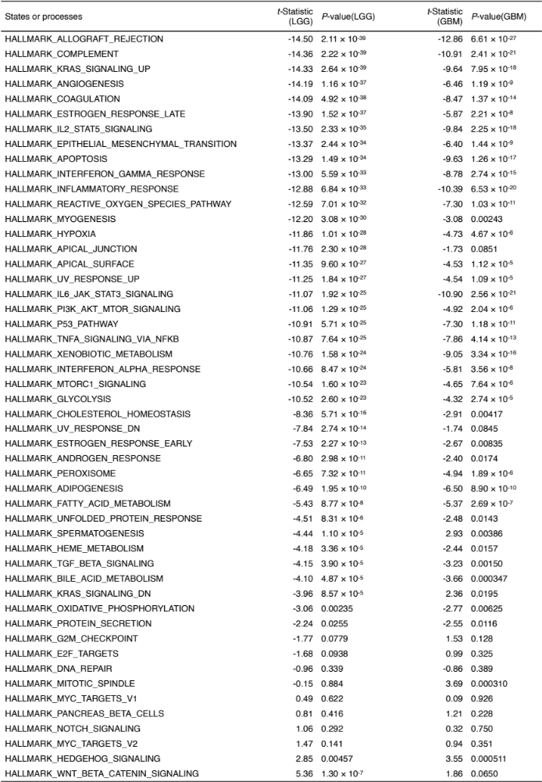
Table S3 Hazard ratios and their p-values for well-defined biological states and processes in UVM and SKCM sorted by HR(UVM).
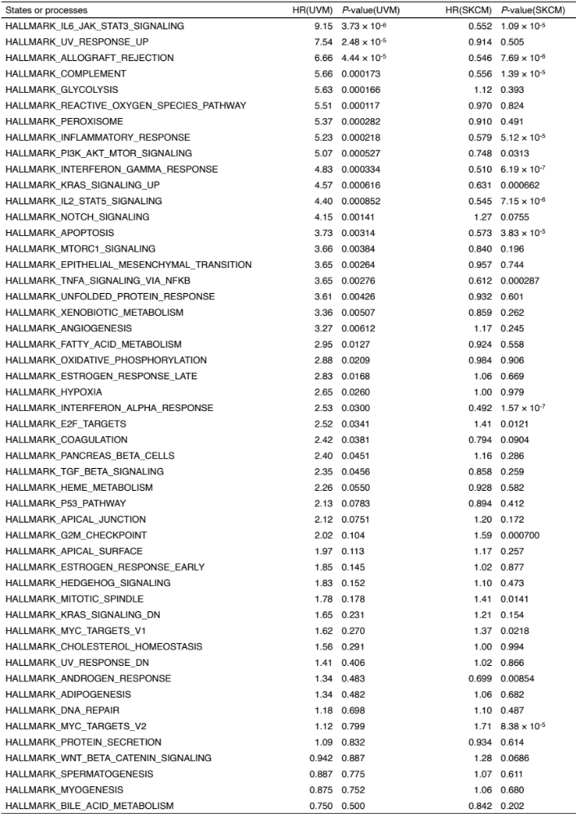
Table S4 Results of Welch's t-test for differences in the activity of each state or process between High-CTL and Low-CTL groups on UVM and SKCM sorted by t-Statistic(UVM).
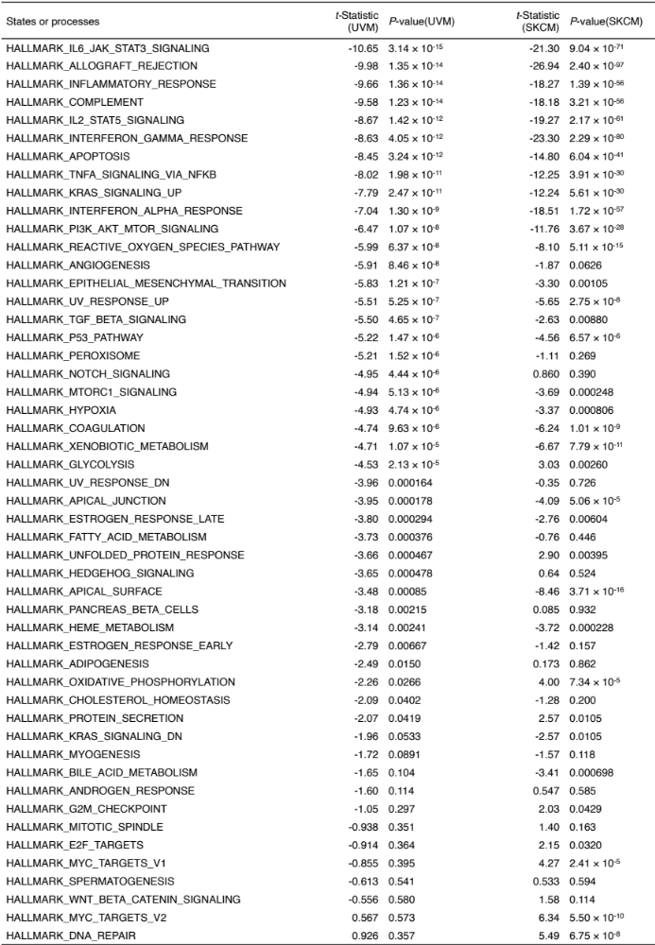
Table S5 Hazard ratios and their p-values for chemokines in UVM and SKCM sorted by HR(UVM).
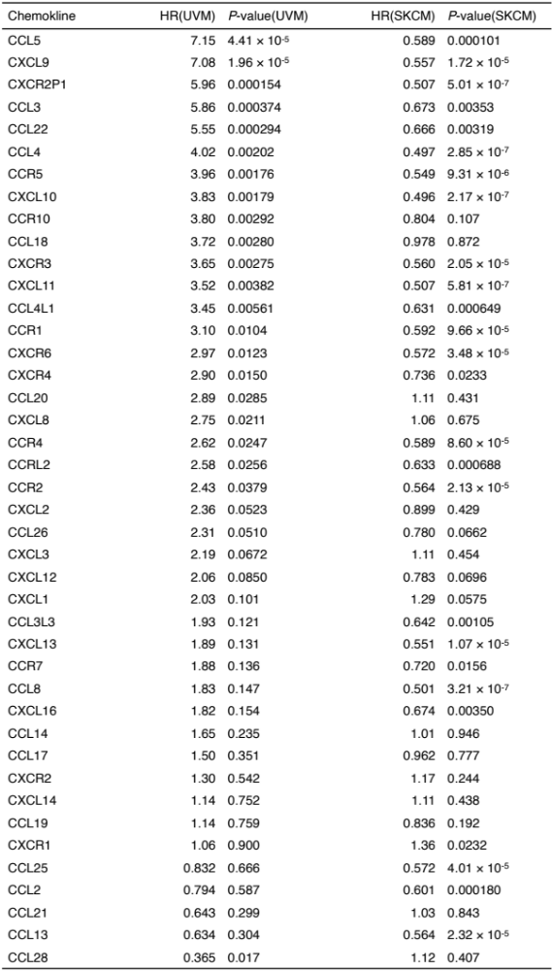

Table S6 Hazard ratios and their p-values for chemokines in LGG and GBM sorted by HR(LGG).
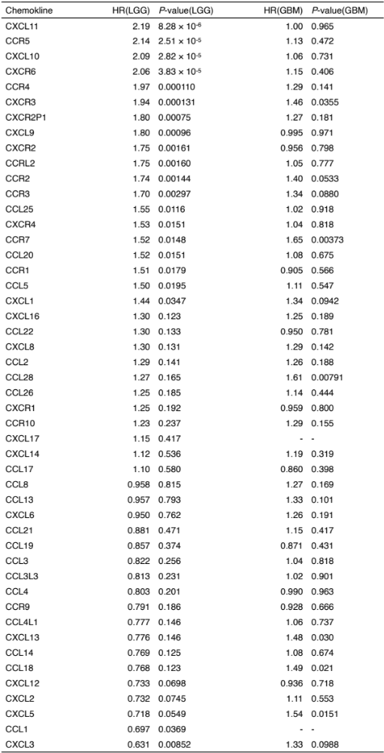

Table S7 Correlations of chemokines expression and the CTL level in UVM and LGG sorted by Pearson’s r(LGG).
