Graphical Abstract Summary:
This study demonstrates the synthesis of sodium silicate from Malaysian rice husk ash (RHA), employed directly as an untreated biochar-type residue, under controlled hydrothermal conditions for use in alkali-activated slag mortars. Using NaOH solutions of 10 M, 12 M, and 14 M at moderate temperatures (40–100 °C), sodium silicate was successfully produced and applied as a single-step activator for ground granulated blast furnace slag. The resulting mortars were benchmarked against OPC and commercial sodium silicate systems and comprehensively evaluated for mechanical and durability performance. Mortars synthesised at 12 M and 14 M under 40–80 °C achieved superior compressive strength (up to 76.8 MPa), reduced porosity, lower water absorption, and enhanced microstructural integrity. These findings highlight the dual significance of RHA as both a silica-rich precursor and a biochar-type material, reinforcing its role in waste-to-resource strategies and validating RHA-derived activators as a technically feasible, low-carbon alternative for sustainable construction.
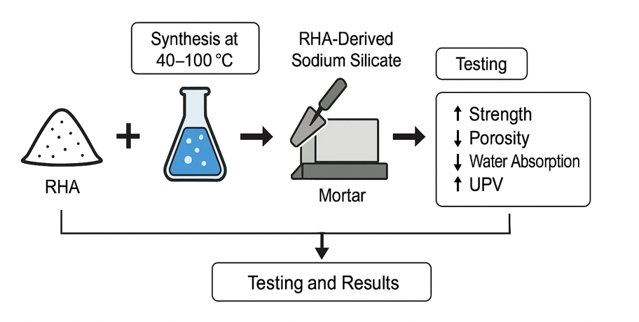

Table of Contents

1.0 Introduction 4
2.0 Materials and Methodology 7
2.1 Materials 7
2.2 Methodology 9
2.2.1 Rha-Synthesised Na₂SiO₃ 9
Method for Development of Mixes 10
2.2.2 Nomenclature 10
2.2.3 Mix Design 10
2.2.4 Mixing Procedures 11
2.2.5 Casting, Compaction, Demoulding and Curing of Specimens 12
3.0 Testing Procedures 12
3.1 Compressive and flexural Strength Test 13
3.2 Water Absorption Test 13
3.3 Porosity 14
3.4 Air Permeability 14
3.5 Ultrasonic Pulse Velocity (UPV) 14
3.6 Testing Methods Summary 15
4.0 Results and Discussion 15
4.1 Ultrasonic Pulse Velocity 16
4.2 Mechanical Properties 17
4.2.1 Compressive Strength 17
4.2.2 Flexural Strength 19
4.3 Transport Mechanism 20
4.3.1 Porosity 20
4.3.2 Water Absorption 22
4.3.3 Air Permeability 23
4.4 Characterisation of Na₂SiO₃-SiO₂/Na₂O ratio 25
4.4.1 Effect of Synthesis Conditions on Oxide Content 26
4.4.2 Correlation Between SiO₂ Content and Compressive Strength 27
4.4.3 Optimal Na₂O/SiO₂ Ratio for Mechanical Properties 29
4.5 Statistical Analysis (ANOVA) 30
4.5.1 Effect of Synthesis Temperature on the Compressive Strength of Mortar 30
4.5.2 Effect of NaOH Concentration on the Compressive Strength of Mortar 31
4.5.3 Effect of Synthesis Temperature on the Flexural Strength of Mortar 33
4.5.4 Effect of NaOH Concentration on the Flexural Strength of Mortar 35
5.0 Conclusion 36

