Supporting Information
A mitochondria-targeted nanozyme for myocardial ischemia/reperfusion injury with synergistic antioxidant and anti-inflammatory properties
Congcong Li^{a, d}, Zhengfeng Zhang^{d}, Chao Luo^{a, d}, Wanqi Lan^{a, d}, Chen Liu^{e}, Wu Liu^{a, d}, Haiyan Xiang ª, Juesheng Yang ª, Yanhua Tang ^{a, d, *}, Xiaolei Wang^{b, c, *}

ª Department of Cardiovascular Surgery, The Second Affiliated Hospital, Jiangxi Medical College, Nanchang University, Nanchang 330008, China.
^{b} The National Engineering Research Center for Bioengineering Drugs and the Technologies, Institute of Translational Medicine, Nanchang University, Nanchang 330088, China.
^{c} School of Chemistry and Chemical Engineering, Nanchang University, Nanchang 330088, China.
^{d} The Second Clinical Medical College of Nanchang University, Nanchang 330008, China.
^{e} Department of Ultrasound, The Second Affiliated Hospital, Jiangxi Medical College, Nanchang University, Nanchang 330008, China.

* Corresponding authors: Yanhua Tang, tyh6565@163.com; Xiaolei Wang, wangxiaolei@ncu.edu.cn.

Supplementary figures
Figure S1. SEM images of (a) MOF, (b) VB@MOF, and (c) VB@MOF/TA.

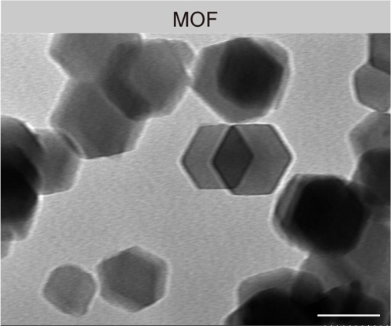

Figure S2. TEM image of MOF. Scale bar: 50 nm.

Figure S3. The hydrated particle size of (a) MOF, (b) VB@MOF, and (c) VB@MOF/TA determined by dynamic light scattering (DLS) assay.

Figure S4. XPS C 1s spectrum of MOF.

Figure S5. Representative digital photographs of ABTS•⁺ solutions (a) and DPPH• solutions (b) exposure to different concentrations of VB@MOF/TA. Scale bar: 5 mm.

Figure S6. POD-like activity of VB@MOF/TA. (a) UV-Vis spectrums of TMB exposure to different concentrations of VB@MOF/TA. (b) The color changes at different concentrations of VB@MOF/TA, scale bar: 5 mm.

Figure S7. Representative digital photographs of •OH solutions exposure to different concentrations of VB@MOF/TA, scale bar: 5 mm.
Figure S8. Hemolysis ratios (down) and optical photographs (upper) of erythrocytes incubated with different concentrations of MOF (a), VB@MOF (b), and VB@MOF/TA (c) for 20 min. Data are presented as the mean ± standard deviation (n = 3).
Figure S9. The cytotoxicity of the MOF, VB@MOF, and VB@MOF/TA. (a-c) The cytotoxicity of H9C2 cells cultured with different concentrations of MOF (a), VB@MOF (b), and VB@MOF/TA (c) for 24 h, 48 h, and 72 h. (d-e) The cytotoxicity of RAW 264.7 macrophages cultured with different concentrations of MOF (d), VB@MOF (e), and VB@MOF/TA (f) for 24 h, 48 h, and 72 h. (g-i) The cytotoxicity of HUVECs cultured with different concentrations of MOF (g), VB@MOF (h), and VB@MOF/TA (i) for 24 h, 48 h, and 72 h. Cell viability was obtained using the CCK-8 kit. Data are presented as the mean ± standard deviation (n ≥ 3).

Figure S10. (a) Representative confocal fluorescence images of H9C2 cells treated with RhB@MOF/TA (red) at various times (0, 1, 4, 8, and 12 h), scale bar: 10 µm. (b) Mean fluorescence intensity (MFI) values are presented as the mean ± standard deviation (n = 5). ns: no significance.

Figure S11. (a) Quantification analysis of the colocalization of the RhB@MOF and RhB@MOF/TA with mitochondria stained with Mito Tracker Green (n = 3, **p = 0.0080). (b) Quantification analysis of the colocalization of the RhB@MOF and RhB@MOF/TA with lysosome stained with Lyso Tracker Green (n = 3, ***p < 0.001). Data are presented as the mean ± standard deviation.

Figure S12. The quantitative analysis of ROS production in H9C2 cells by flow cytometry detection using DCFH-DA (n = 4, ***p _{(Control, OGD/R)} < 0.001, **p _{(OGD/R, VB)} = 0.0033, ***p _{(OGD/R, VB@MOF/TA)} < 0.001, ***p _{(VB, VB@MOF/TA)} < 0.001). Data are presented as the mean ± standard deviation.

Figure S13. (a) Representative fluorescence images of ROS levels in H9C2 cells. The cells were stained with DCFH-DA, scale bar: 100 µm. (b) Quantification analysis of ROS conduction (n = 6, ***p _{(Control, OGD/R)} < 0.001, ***p _{(OGD/R, VB)} < 0.001, ***p _{(OGD/R, VB@MOF/TA)} < 0.001, ***p _{(VB, VB@MOF/TA)} < 0.001). Data are presented as the mean ± standard deviation.

Figure S14. Intracellular ATP levels in H9C2 cells (n = 6, ***p _{(Control, OGD/R)} < 0.001, ***p _{(OGD/R, VB)} < 0.001, ***p _{(OGD/R, VB@MOF/TA)} < 0.001, ***p _{(VB, VB@MOF/TA)} < 0.001). Data are presented as the mean ± standard deviation.

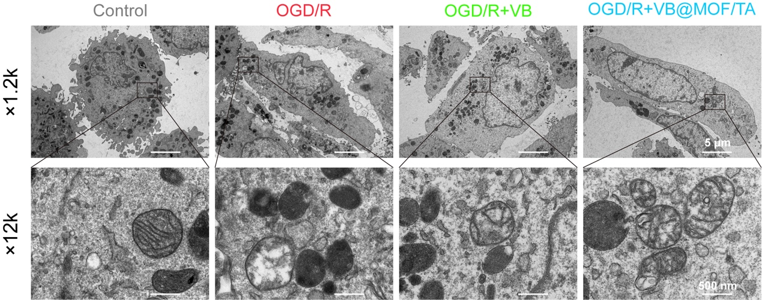
Figure S15. Representative TEM images of mitochondria in H9C2 cells.

Figure S16. Representative live/dead staining fluorescence images of H9C2 cells under various experimental conditions. The cells were stained with Calcein-AM/PI, where green fluorescence indicated living cells and red fluorescence indicated dead cells. Data are presented as mean ± standard deviation (n ≥ 3), scale bar: 100 µm.

Figure S17. Level of TNF-α (a), IL-6 (b), IL-1β (c) and IL-10 (d) released by H9C2 cells assessed by ELISA after OGD/R procedure (n = 6, for TNF-α, ***p _{(Control, OGD/R)} < 0.001, ***p _{(OGD/R, VB)} < 0.001, ***p _{(OGD/R, VB@MOF/TA)} < 0.001, ***p _{(VB,} _{VB@MOF/TA)} < 0.001; for IL-6, ***p _{(Control, OGD/R)} < 0.001, ***p _{(OGD/R, VB)} < 0.001, ***p _{(OGD/R, VB@MOF/TA)} < 0.001, *p _{(VB,} _{VB@MOF/TA)} = 0.0489; for IL-1β, ***p _{(Control, OGD/R)} < 0.001, ***p _{(OGD/R, VB)} < 0.001, ***p _{(OGD/R, VB@MOF/TA)} < 0.001, **p _{(VB,} _{VB@MOF/TA)} = 0.0070; for IL-10, ***p _{(Control, OGD/R)} < 0.001, **p _{(OGD/R, VB)} = 0.0082, ***p _{(OGD/R, VB@MOF/TA)} < 0.001, ***p _{(VB,} _{VB@MOF/TA)} < 0.001. Data are presented as the mean ± standard deviation.

Figure S18. (a) Representative confocal fluorescence images of RAW 264.7 macrophages treated with RhB@MOF/TA (red) at various times (0, 1, 4, 8, and 12 h), scale bar: 10 µm. (b) Mean fluorescence intensity (MFI) values are presented as mean ± standard deviation (n = 4). ns: no significance.

Figure S19. (a) Representative fluorescence images of ROS production in RAW 264.7 macrophages under different experimental conditions. The cells were stained with DCFH-DA, scale bar: 100 µm. (b) Quantitative analysis of ROS level (n = 6, ***p _{(Control, LPS)} < 0.001, ***p _{(LPS, VB)} < 0.001, ***p _{(LPS, VB@MOF/TA)} < 0.001, ***p _{(VB, VB@MOF/TA)} < 0.001). Data are presented as the mean ± standard deviation.

Figure S20. (a) Quantification analysis of CD86 after different treatments, as determined by immunofluorescence staining (n = 6, ***p _{(Control, LPS)} < 0.001, ***p _{(LPS, VB)} < 0.001, ***p _{(LPS, VB@MOF/TA)} < 0.001, *p _{(VB, VB@MOF/TA)} = 0.0407). (b) Quantification analysis of CD206 expression in RAW 264.7 cells after different treatments, as determined by immunofluorescence staining (n = 6, ^{ns}p _{(Control, LPS)} = 0.3145, ***p _{(LPS, VB)} < 0.001, ***p _{(LPS, VB@MOF/TA)} < 0.001, ***p _{(VB, VB@MOF/TA)} < 0.001). Data are analyzed with One-way ANOVA with Bonferroni post hoc test, and presented with the mean ± standard deviation. ns: no significance.

Figure S21. Representative results and quantification of flow cytometry analysis showed the expression of CD86 and CD206 in RAW264.7 cells under different treatments (for CD86: n = 6, ***p _{(Control, LPS)} < 0.001, ***p _{(LPS, VB)} < 0.001, ***p _{(LPS, VB@MOF/TA)} < 0.001, ***p _{(VB, VB@MOF/TA)} < 0.001; for CD206: n = 6, ^{ns}p _{(Control, LPS)} = 0.1365, ***p _{(LPS, VB)} < 0.001, ***p _{(LPS, VB@MOF/TA)} <0.001, ***p _{(VB, VB@MOF/TA)} < 0.001). Data are analyzed using One-way ANOVA with Bonferroni post hoc test, and represented with the mean ± standard deviation. ns: no significance.
Figure S22. (a) Representative fluorescence images of iNOS and Arg-1 in RAW 264.7 macrophages, scale bar: 50 µm. (b) Quantification of iNOS (n = 6, ***p _{(Control, LPS)} < 0.001, ***p _{(LPS, VB)} < 0.001, ***p _{(LPS, VB@MOF/TA)} < 0.001, **p _{(VB, VB@MOF/TA)} = 0.0011). (c) Quantification of Arg-1 (n = 6, ^{ns}p _{(Control, LPS)} = 0.0928, ***p _{(LPS, VB)} < 0.001, ***p _{(LPS, VB@MOF/TA)} < 0.001, **p _{(VB, VB@MOF/TA)} = 0.0013). Data are analyzed with One-way ANOVA with Bonferroni post hoc test, and presented with the mean ± standard deviation. ns: no significance.

Figure S23. (a) Western blot of iNOS and Arg-1 in RAW 264.7 macrophages. (b) Quantification of iNOS (n = 6, ***p _{(Control, LPS)} < 0.001, ***p _{(LPS, VB)} < 0.001, ***p _{(LPS, VB@MOF/TA)} < 0.001, *p _{(VB, VB@MOF/TA)} = 0.0107). (c) Quantification of Arg-1 (n = 6, *p _{(Control, LPS)} = 0.0206, *p _{(LPS, VB)} = 0.0163, ***p _{(LPS, VB@MOF/TA)} <0.001, **p _{(VB, VB@MOF/TA)} = 0.0043). Data are analyzed using One-way ANOVA with Bonferroni post hoc test, and represented with the mean ± standard deviation. FC, fold-change.
Figure S24. Cardiac function detected by transthoracic echocardiography in cardiac short-axis (comparison between I/R and I/R + VB, EF: ***p _{(1d)} < 0.001, ***p _{(7d)} < 0.001, **p _{(14d)} = 0.0092, ***p _{(28d)} < 0.001, FS: ***p _{(1d)} < 0.001, **p _{(7d)} = 0.0097, ^{ns}p _{(14d)} = 0.2903, *p_{(28d)} = 0.0132; comparison between I/R + VB and I/R + VB@MOF/TA, EF: ###p _{(1d)} < 0.001, ###p _{(7d)} < 0.001, #p _{(14d)} = 0.0111, ^{ns}p _{(28d)} = 0.4714, FS: ###p _{(1d)} < 0.001, ##p _{(7d)} = 0.0062, #p _{(14d)} = 0.0499, #p _{(28d)} = 0.0154). Data are presented with the mean ± standard deviation and analyzed with Two-way ANOVA (n ≥ 3).

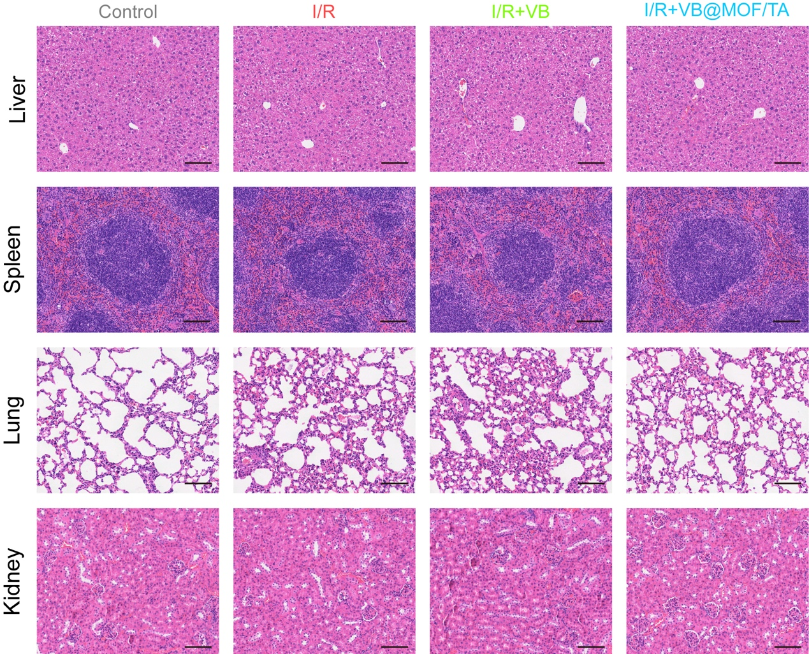
Figure S25. Representative images of hematoxylin-eosin (HE) staining at day 28 post-administration. Scale bar: 100 µm.

Figure S26. Serum biochemistry analysis of liver function and renal function in each group at 28 days post-administration. (a) Alanine aminotransferase (ALT). (b) Aspartate aminotransferase (AST). (c) Creatinine (CRE). (d) Urea nitrogen (UREA). Data are presented as mean ± standard deviation (n = 4). ns: no significance.

Figure S27. Gating strategies of flow cytometry. (a) Gating strategies of intracellular ROS levels. (b) Gating strategies for cellular apoptosis.

TABLES
Table S1. Sum of echocardiography on day 0 and day 1 postoperatively.
Day post-I/R | Index | Long-axis M-mode |  |  |  | Short-axis M-mode
Day post-I/R | Index | Control  (n = 10) | I/R  (n = 10) | VB  (n = 10) | VB@MOF/TA  (n = 10) | Control  (n = 10) | I/R  (n = 10) | VB  (n = 10) | VB@MOF/TA  (n = 10)
0 | EF (%) | 72.41 ± 3.05 | 74.40 ± 5.78 | 71.40 ± 2.00 | 73.51 ± 3.45 | 70.79 ± 2.32 | 73.88 ± 3.05 | 72.98 ± 4.03 | 76.43 ± 5.27
0 | FS (%) | 35.97 ± 2.40 | 37.87 ± 5.15 | 35.07 ± 1.60 | 36.85 ± 2.78 | 34.73 ± 1.85 | 37.25 ± 2.56 | 37.55 ± 4.28 | 39.60 ± 4.95
0 | LVIDd (mm) | 3.45 ± 0.33 | 3.44 ± 0.41 | 3.25 ± 0.59 | 3.32 ± 0.48 | 3.69 ± 0.44 | 3.74 ± 0.41 | 3.56 ± 0.47 | 3.45 ± 0.30
0 | LVIDs (mm) | 2.21 ± 0.22 | 2.14 ± 0.36 | 2.11 ± 0.38 | 2.09 ± 0.31 | 2.41 ± 0.25 | 2.35 ± 0.29 | 2.28 ± 0.34 | 2.08 ± 0.26
1 | EF (%) | 74.23 ± 4.18 | 32.97 ± 4.86 | 46.60 ± 4.33 | 60.47 ± 3.46 | 78.79 ± 4.70 | 32.39 ± 5.68 | 48.40 ± 5.18 | 61.74 ± 3.81
1 | FS (%) | 37.47 ± 3.40 | 13.05 ± 2.23 | 19.66 ± 2.30 | 27.50 ± 2.11 | 41.72 ± 4.68 | 12.86 ± 2.58 | 20.61 ± 2.69 | 28.43 ± 2.49
1 | LVIDd (mm) | 3.21 ± 0.48 | 3.80 ± 0.23 | 3.79 ± 0.37 | 3.65 ± 0.38 | 3.42 ± 0.33 | 4.19 ± 0.30 | 3.84 ± 0.83 | 3.84 ± 0.40
1 | LVIDs (mm) | 2.01 ± 0.35 | 3.30 ± 0.19 | 3.04 ± 0.27 | 2.65 ± 0.29 | 1.99 ± 0.23 | 3.65 ± 0.28 | 3.05 ± 0.72 | 2.65 ± 0.51
Data are presented as mean ± SD. EF, ejection fraction; FS, fractional shortening; LVIDd, Left Ventricular Internal Diameter at End-Diastole; LVDs, Left Ventricular Internal Diameter at End-Systole.

Table S2. Sum of echocardiography on day 7, day 14 and day 28 postoperatively.
Day post-I/R | Index | Long-axis M-mode |  |  |  | Short-axis M-mode
Day post-I/R | Index | Control  (n = 4) | I/R  (n = 4) | VB  (n = 4) | VB@MOF/TA  (n = 4) | Control  (n = 4) | I/R  (n = 4) | VB  (n = 4) | VB@MOF/TA  (n = 4)
7 | EF (%) | 77.88 ± 4.60 | 42.77 ± 1.50 | 57.18 ± 4.63 | 73.65 ± 5.40 | 77.89 ± 4.80 | 39.93 ± 10.38 | 54.72 ± 3.53 | 67.29 ± 2.26
7 | FS (%) | 40.88 ± 4.40 | 17.62 ± 0.74 | 25.61 ± 2.74 | 28.97 ± 3.78 | 40.86 ± 4.52 | 16.52 ± 5.08 | 24.13 ± 2.01 | 32.08 ± 1.60
7 | LVIDd (mm) | 3.74 ± 0.39 | 3.57 ± 0.21 | 3.92 ± 0.41 | 3.62 ± 0.24 | 3.19 ± 0.35 | 4.16 ± 0.21 | 3.94 ± 0.40 | 3.51 ± 0.10
7 | LVIDs (mm) | 2.22 ± 0.37 | 2.94 ± 0.18 | 2.92 ± 0.38 | 2.57 ± 0.26 | 2.14 ± 0.15 | 3.47 ± 0.16 | 3.00 ± 0.36 | 2.38 ± 0.10
14 | EF (%) | 73.64 ± 5.40 | 42.12 ± 5.65 | 53.48 ± 2.70 | 60.47 ± 6.04 | 72.94 ± 6.73 | 43.86 ± 2.59 | 54.01 ± 2.35 | 63.96 ± 2.92
14 | FS (%) | 37.06 ± 4.67 | 17.39 ± 2.80 | 23.36 ± 1.47 | 27.85 ± 3.79 | 36.03 ± 4.17 | 19.43 ± 2.91 | 23.65 ± 1.40 | 29.86 ± 1.97
14 | LVIDd (mm) | 3.21 ± 0.26 | 3.80 ± 0.38 | 3.75 ± 0.49 | 3.94 ± 0.41 | 3.14 ± 0.39 | 4.06 ± 0.49 | 3.71 ± 0.30 | 3.82 ± 0.25
14 | LVIDs (mm) | 2.01 ± 0.02 | 3.14 ± 0.35 | 2.88 ± 0.41 | 2.85 ± 0.45 | 2.01 ± 0.34 | 3.32 ± 0.44 | 2.83 ± 0.19 | 2.68 ± 0.19
28 | EF (%) | 79.20 ± 4.70 | 42.81 ± 3.30 | 58.40 ± 2.15 | 66.11 ± 2.03 | 80.04 ± 3.69 | 46.21 ± 5.22 | 56.48 ± 3.87 | 65.06 ± 2.54
28 | FS (%) | 42.08 ± 4.79 | 17.69 ± 1.67 | 26.25 ± 1.26 | 31.35 ± 1.40 | 43.71 ± 3.73 | 19.47 ± 2.70 | 26.83 ± 1.95 | 34.07 ± 3.60
28 | LVIDd (mm) | 3.44 ± 0.62 | 3.77 ± 0.34 | 3.73 ± 0.27 | 3.90 ± 0.20 | 3.13 ± 0.14 | 3.91 ± 0.15 | 3.50 ± 0.43 | 3.34 ± 0.28
28 | LVIDs (mm) | 2.00 ± 0.42 | 3.10 ± 0.27 | 2.76 ± 0.25 | 2.68 ± 0.16 | 1.67 ± 0.14 | 3.09 ± 0.10 | 2.62 ± 0.36 | 2.62 ± 0.30
Data are presented as mean ± SD. EF, ejection fraction; FS, fractional shortening; LVIDd, Left Ventricular Internal Diameter at End-Diastole; LVDs, Left Ventricular Internal Diameter at End-Systole.

