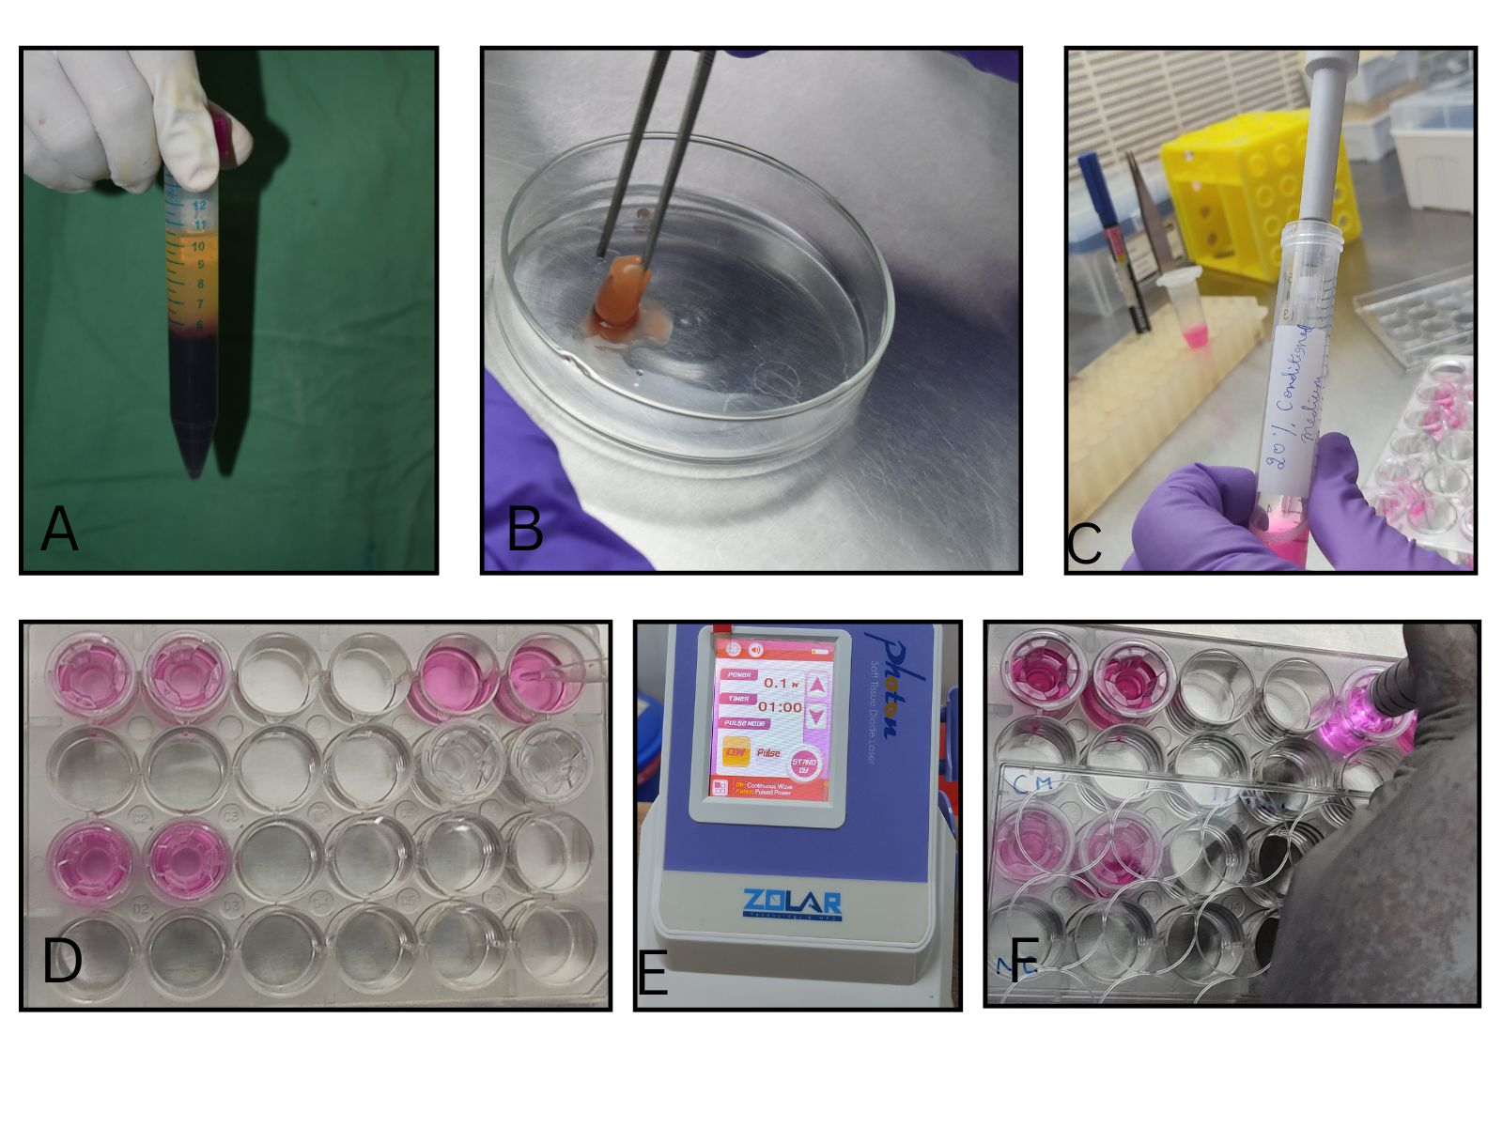
Fig 1: A: L-PRF obtained after centrifugation B: L-PRF transferred to well plate for conditioned media preparation C: Prepared 20% conditioned media D: Addition of conditioned media to lower compartment of wells E: Laser parameters F: Diode laser irradiation
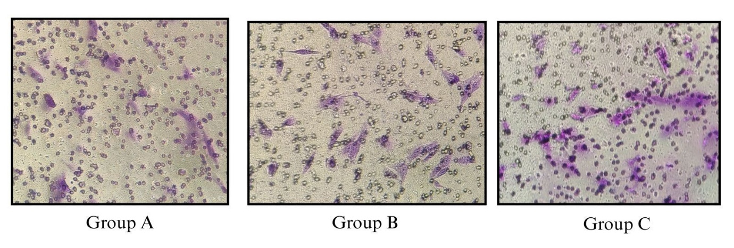
Figure 2: Migrated osteoblasts stained using Crystal violet

