Supplementary Material

Amorphous Aluminum Oxide Clusters Regulating Oxygen Reduction for Photocatalytic H₂O₂ Production over Carbon Nitride

Hiba Elmansouraª, Donghui Wangª, Ganglu Taojinª, Feng Chen^{a,}*

ª Key Laboratory for Advanced Materials and Institute of Fine Chemicals, School of Chemistry and Molecular Engineering, East China University of Science and Technology, 130 Meilong Road, Shanghai 200237, P.R. China.
Dr. Hiba Elmansoura, E-mail: hebaabdallah3@gmail.com
Dr. Donghui Wang, E-mail: dhwang_sl@163.com
Dr. Ganglu Taojin, E-mail: archer2000y@126.com
* Corresponding authors: Prof. Dr. Feng Chen, E-mail: fengchen@ecust.edu.cn, Tel: +86-21-6425 3056.

Experimental section

Materials
A Nafion solution (5 wt%), Na₂SO₄, LiCl, Al(OH)₃, ethanol, and melamine were purchased from the China National Pharmaceutical Group Chemical Reagent Co., Ltd. and were used without further purification. All aqueous solutions used in the experiments were prepared using ultrapure water.

Sample characterization
Powder X-ray diffraction (XRD) patterns were collected using a Rigaku Ultima IV diffractometer equipped with a Cu-Kα source. The lattice patterns and morphology of the samples were observed using a transmission electron microscope (TEM) (JEOL, JEM-2100) and a scanning electron microscope (SEM) (GeminiSEM 500). Fourier-transform infrared (FTIR) spectra were recorded on a Nicolet 380 infrared spectrometer in the range of 4000-400 cm⁻¹. The contents of Al and Li were detected using inductively coupled plasma atomic emission spectrometry (ICP-AES) (Agilent 725). Elemental composition was analyzed using energy-dispersive X-ray spectroscopy (EDS) (Tecnai G2 F20 S-TWIN). The absorbance of I₃⁻ solution was measured using a Shimadzu ultraviolet-visible spectrophotometer (UV-2600) and diffuse reflectance spectroscopy (DRS) was performed in the range of 200 to 800 nm with BaSO₄ as the reference. X-ray photoelectron spectroscopy (XPS) was conducted using a Thermo Fisher ESCALAB 250Xi instrument with Al Kα excitation source, and internal calibration was performed using the C1s binding energy (BE) from carbon contaminants at 284.8 eV. Photoluminescence (PL) and transient PL were monitored using a fluorescence spectrometer (Edinburgh Instruments FLS980) with an excitation wavelength of 360 nm. Electron paramagnetic resonance (EPR) measurements were carried out on an EPR spectrometer (Bruker BioSpin GmbH) using DMPO as a free radical capture reagent to detect superoxide radicals.

Photocatalytic performance measurement
The catalyst (10 mg) was placed in a 30 mL quartz tube, and a 10% ethanol solution (3 mL ethanol and 27 mL deionized water) was added to disperse the catalyst thoroughly through 5 minutes of ultrasonication. Subsequently, the solution was saturated with O₂ under dark conditions by continuously injecting O₂ into the solution for 30 minutes. After 30 minutes, the O₂ flow rate was controlled at 50 ml min ⁻¹, and the reaction solution was illuminated under white light LED for the photocatalytic test. The average light intensity was 95 mW cm ⁻². Throughout the photocatalytic process, magnetic stirring was used at a controlled speed of 1200 rpm. Every 20 minutes, 1.5 ml of reaction solution was extracted, and after centrifugal filtration, the photocatalyst was removed.
To investigate the influence of different sacrificial agents on H₂O₂ generation activity under the same conditions, both BQ and AgNO₃ were added to the reaction system at a concentration of 10 mM. To explore the impact of different atmospheres (N₂, O₂, or air) on photocatalytic H₂O₂ generation activity, N₂ was continuously injected into the reaction solution for 30 minutes under dark conditions to ensure the absence of residual O₂. Subsequently, photocatalytic testing was conducted under continuous N₂ flow conditions. Additionally, the decomposition rate of H₂O₂ by different samples was tested in a 0.1 M H₂O₂ solution. The amount of H₂O₂ was determined using the iodine titration method. A solution of 1 ml 0.4 mol L -1 potassium iodide (KI) and 1 ml 0.1 mol L⁻¹ potassium hydrogen phthalate (C₈H₅KO₄) was added to 1 ml of the H₂O₂ sample solution, and the solution was allowed to stand for 30 minutes. H₂O₂ reacted with I- under acidic conditions to form I₃⁻ (H₂O₂ + 3I⁻ + 2H⁺ → I₃⁻ + 2H₂O), which exhibited strong absorption at around 350 nm.^{[1]} The content of I₃⁻ was determined by measuring the absorbance at 350 nm using ultraviolet-visible spectrophotometry. This allowed for the calculation of the total amount of H₂O₂ generated during the reaction. Supplementary Figure S1 shows the standard curve for H₂O₂.

Apparent quantum yield measurement
The apparent quantum yield (AQY) for H₂O₂ production on CCN-Al was tested using monochromatic LED light sources with wavelengths of 395 nm, 420 nm, 455 nm, and 470 nm. The concentration of photocatalyst in the reaction solution was 0.67 g L⁻¹. The irradiation area was controlled at 19 cm², and the average light intensity was measured using a light power meter. The AQY was calculated using the following formula:
Eq. (3): $η= \frac{Ne }{Np}×100\%=\frac{2 × M ×{ N}_{A} × h × c}{S × P × t × λ }× 100\%$
Where, M represents the number of H₂O₂ molecules produced (mol), NA is Avogadro's constant, h is Planck's constant, c is the speed of light, S is the irradiation area, P is the irradiation light intensity, t is the duration of the light reaction (s), and λ is the wavelength of the incident monochromatic light (m).

(Photo)electrochemical measurement
Transient photocurrent (I-T) and electrochemical impedance spectroscopy (EIS) measurements were conducted on a CHI760E electrochemical workstation (Shanghai CH Instruments Co., Ltd.) equipped with a standard three-electrode system. Ag/AgCl electrode (saturated KCl), platinum foil electrode, and indium tin oxide (ITO) glass electrode (1×2 cm) were used as reference electrode, counter electrode, and working electrode, respectively. The preparation process of the working electrode is as follows: 2 mg of the prepared catalyst was dispersed in a mixture solution of ethanol (95 μL), water (95 μL), and Nafion (10 μL) by ultrasonication. Then, 100 μL of the suspension was drop-casted onto the ITO electrode, controlling the electrode area to be 1 cm2. After natural cooling, the electrode was dried under an infrared lamp for 5 minutes. A xenon lamp (300 W) was used as the light source, and NaSO₄ (0.50 M) was used as the electrolyte. Under open-circuit voltage, photocurrent was collected every 20 seconds. Electrochemical impedance spectroscopy was performed at a DC voltage of -1 V (vs. Ag/AgCl), with an AC voltage amplitude of 5 mV and a frequency range from 100 kHz to 0.1 Hz.
The transfer electron number (n) and H₂O₂ selectivity of the samples in the ORR reaction were measured using a rotating ring-disk electrode (RRDE) setup.^{[2]} The electrochemical measurements were conducted in a three-electrode system with RRDE as the working electrode, Ag/AgCl as the reference electrode, and a platinum ring as the counter electrode. A 0.1 M KOH solution saturated with O₂ was used as the electrolyte. The RRDE rotation speed was set to 1600 rpm, and the potential range was set from -1.0 to 0.2 V (vs. Ag/AgCl) with a scan rate of 5 mV/s. Prior to electrochemical performance testing, the working electrode was cyclic voltammetry (CV) scanned in O₂-saturated KOH electrolyte (0.1 mol/L) at a scan rate of 50 mV/s until the curve stabilized. The catalyst ink on the RRDE working electrode was prepared as follows: 5 mg of the sample was mixed with 0.5 mL ethanol, 0.5 mL water, and 50 μL Nafion, and the mixture was ultrasonicated for 20 minutes for even dispersion. Then, 10 μL of the uniformly dispersed sample was drop-casted onto a clean glassy carbon electrode and allowed to naturally dry before testing.
The number of transferred electrons was calculated according to Equation (1):
Eq. (1): $n = 4×\frac{Id}{Id+Ir/N}$
The selectivity was determined by Equation (2):
Eq. (2): %(H₂O₂) = $200×\frac{Ir/N}{Id+Ir/N}$
Where Id is the disk current, Ir is the ring current, and N is the collection efficiency (0.37).

Theoretical calculations
First-principles DFT calculations were performed using the Vienna ab initio simulation package (VASP) ^{[3-5]} and the projector augmented wave (PAW) method ^{[6]}. The exchange- correlation effects were treated in generalized gradient approxi- mation (GGA) with the Perdew-Burke-Ernzerhof (PBE) potential ^{[7]}. The kinetic energy cutoff was chosen to be 500 eV. Brillouin zone integration was sampled with 2$×$2$×$1 Gamma K-points for bulk and surface calculation. The electronic energy was considered self-consistent when the energy change was smaller than 10⁻⁵ eV. A geometry optimization was considered convergent when the force change was smaller than 0.02 eV/Å. Grimme’s DFT-D3 methodology was used to describe the dispersion interactions^{[8]}.
The CCN single-layer unit cells were placed into a vacuum at a depth of 15 Å, and the Brillouin zone was sampled using a 4×4×1 gamma k-point grid. Slab model was constructed in a 2 x 2 supercell, with a vacuum layer of 20 Ǻ in the z direction to avoid the interaction between layers. In order to simulate amorphous Al₂O₃ clusters, we used the research published as a reference^{[9]}, constructed (Al₂O₃)₂ clusters, optimized the structure, and placed them on the CCN single-layer model to study the relevant properties. The (Al₂O₃)₂/CCN model was sampled in Brillouin using a 2×2×1 Gamma k-point grid. During structural optimization, all atoms are allowed to relax. To compare the degree of charge transfer, Bader charge analysis and differential charge density analysis were performed.
The adsorption energy (E_{ads}) was defined as:
$$E_{ads}= E_{ad/sub}+E_{ad}-E_{sub}$$
where E_{ad/sub}, E_{ad}, and E_{sub} are the total energies of the optimized adsorbate/substrate system, the adsorbate in the gas phase, and the clean substrate, respectively. The Brillouin zone was sampled using a 1×1×1 Gamma point grid for optimization of gas molecules.
The free energy (G) for elemental reaction step were calculated as:
$$G=E+ZPE-TS+H(T)$$
where E is the total energy calculated by DFT, ZPE is the zero point energy, T is the temperature (298.15 K), S represents the entropy, and H(T) means enthalpy. The zero energy and entropy of the adsorbed substance are calculated based on the frequency of vibration. The free energy of H₂O and H₂ is calculated from the gas phase H₂O at 0.035 bar and H₂ at 298.15 K at 1 bar. The free energy of O₂ is calculated using the equation G(O₂) = G(H₂O) - 2G(H₂) + 4.92eV.
The 2e⁻ ORR path can be written as:
$$*+O_{2} +H^{+}+e^{-}→ *OOH$$
$$*OOH+H^{+}+e^{-} → H_{2}O_{2}+*$$
The 4e⁻ ORR path can be written as:
$$*+O_{2} +H^{+}+e^{-}→ *OOH$$
$$*OOH+H^{+}+e^{-} → H_{2}O+*O$$
$$*O+H^{+}+e^{-}→*OH$$
$$*OH+H^{+}+e^{-}→H_{2}O+*$$
where an asterisk (*) indicates the active site of the catalyst.
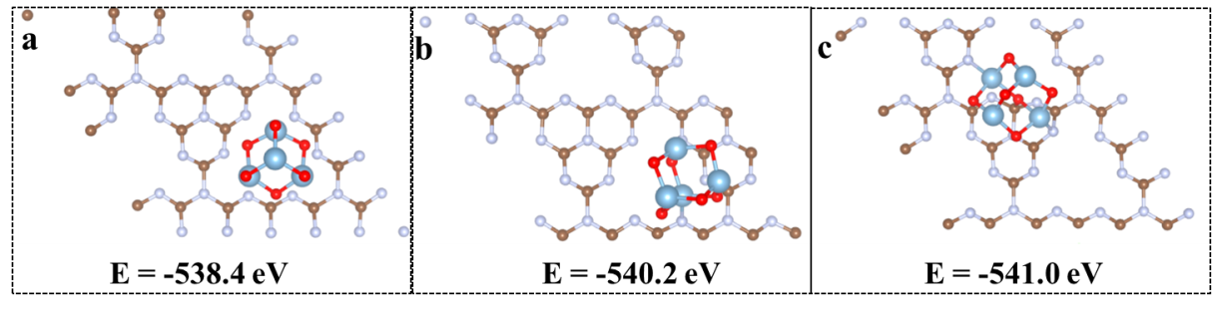
Fig. S1 The top views of the optimal structure with (Al₂O₃)₂ on different site of CCN.
The structure of three CCN-Al models with Al₂O₃ load at different positions of CCN is optimized. The results showed that when Al₂O₃ was loaded on the heptazine backbone, the energy of the system was the lowest. Subsequent calculations are based on the model shown in Figure S1c.

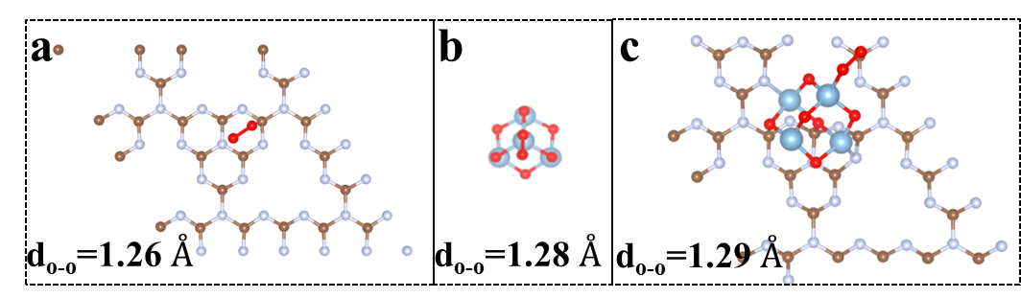
Fig. S2 O-O length of oxygen adsorbed on CCN, Al₂O₃ and CCN-Al.
The adsorption models of oxygen on CN, Al₂O₃ and CCN-Al were optimized. The results show that the bond lengths of O-O are 1.26 Ǻ, 1.28 Ǻ and 1.29 Ǻ, respectively.

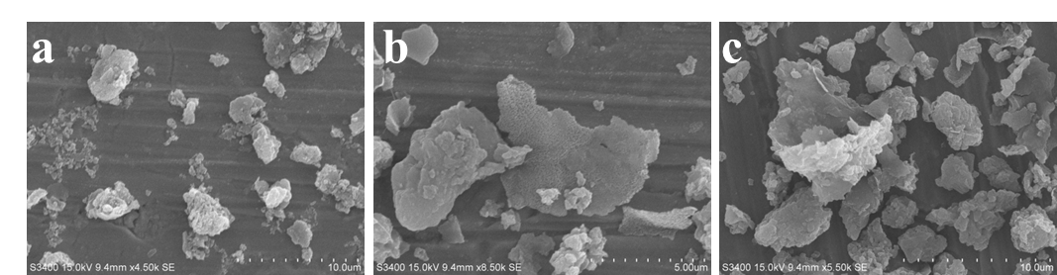
Fig. S3 The SEM images of samples. (a) CN. (b) CCN. (c) CCN-Al-2.

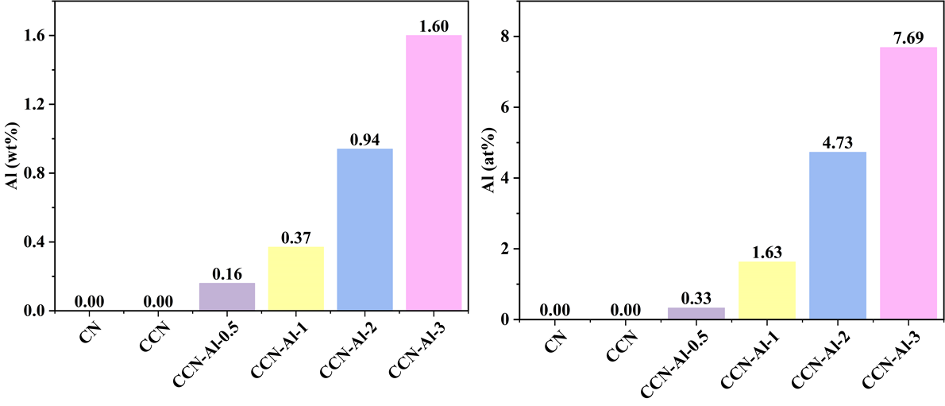
Fig. S4 The mass proportion or atomic proportion of Al in the all samples obtained by (a) ICP-AES, (b) XPS.

Fig. S5 The spectrum of the white light LED source.

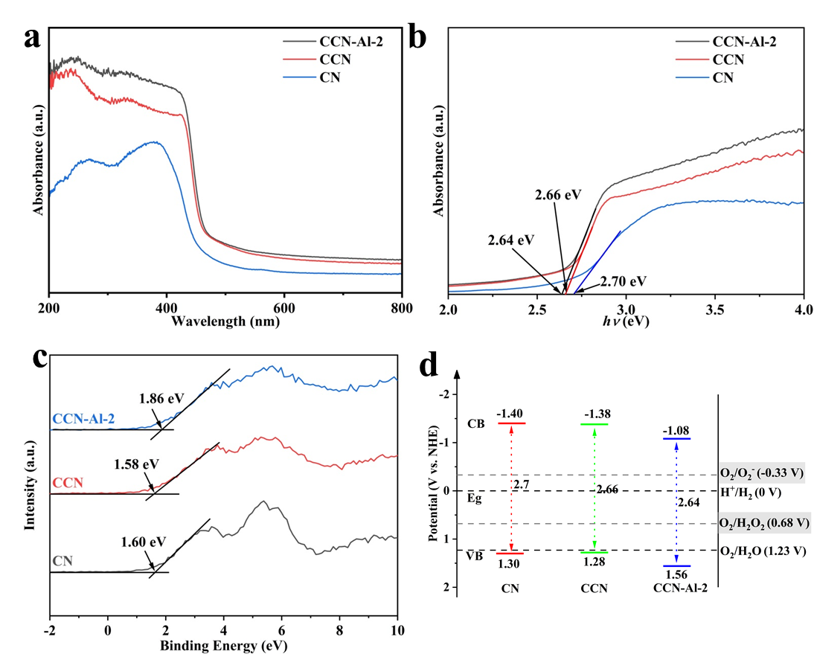
Fig. S6 UV-vis DRS spectra (a) and (b) corresponding plots of transformed Kubelka-Munk function versus photo energy of CN, CCN and CCN-Al-2; (c) The valence band XPS spectra and (d) estimated band structure of CN, CCN and CCN-Al-2.
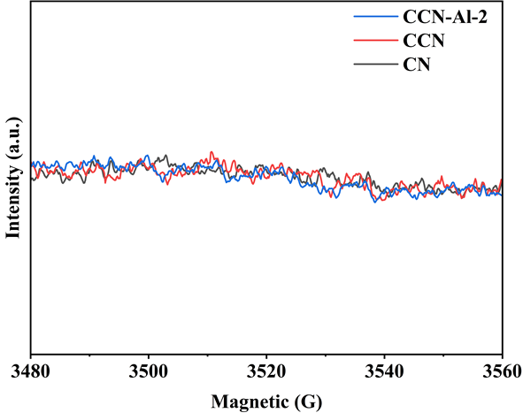
Fig. S7 Electron paramagnetic resonance (EPR) signal of DMPO-•O₂⁻ over CN, CCN and CCN-Al-2 under dark.

Table S1 Comparison of photocatalytic H₂O₂ production.
Samples | Reaction conditions | Light source | H₂O₂ yields  (mmol/g/h) | AQY | Ref
CCN-Al-2 | 10 % EtOH | white LEDs | 50.20 | 21.6  (420 nm) | Our work
BPMC-Vs | 10 % IPA | λ≥400 nm | 3.17 | 4.2  (420 nm) | [10]
Cv@g-C₃N₄ | 10 % EtOH | λ≥420 nm | 18.20 | 9.6  (420 nm) | [11]
Nv-C≡N-CN | 10 % IPA | λ≥420 nm | 3.10 | 22.1  (420 nm) | [12]
CN-KCl/KI | 10 % IPA | λ≥400 nm | 13.10 | 13.7  (420nm) | [13]
ATC-CNK | 5% EtOH | solar simulator | 26.70 | 20.5  (420 nm) | [14]
DC3N4/DC3N5 | 10% IPA | λ≥400 nm | 7.64 | 7.4  (420 nm) | [15]
ZIS/CN | 10 % IPA | solar simulator | 2.13 | 9.8  (420 nm) | [16]
CCN-550 | 1 % BA | λ≥420 nm | 5.84 | 11.57  (420 nm) | [17]
Ni/OtCN | 10 % EtOH | λ>420 nm | 2.46 | 14.9  (420 nm) | [18]
Na-PCN | 10 % IPA | λ>420 nm | 16.0 | 22.3  (420nm) | [19]

Table S2 Fitting parameters of time-resolved PL spectra of CN, CCN and CCN-Al-2.
Samples | A₁ | τ₁/ns | A₂ | τ₂/ns | Τ_{ave}/ns
CN | 3759.71 | 1.83 | 1184.17 | 6.60 | 4.36
CCN | 3910.81 | 0.62 | 569.14 | 3.10 | 1.79
CCN-Al-2 | 4098.18 | 0.56 | 510.43 | 3.41 | 1.66

A tri-exponential function fitting was employed to analyze the PL decay curves, τ_{ave} is the the
average PL lifetime, τi is the estimated lifetime value and Ai is the corresponding amplitude.
$$τ_{ave}= \frac{A_{1}{{*τ}_{1}}^{2}+A_{2}*{τ_{2}}^{2}}{A_{1}*τ_{1}+A_{2}*τ_{2}}$$

References
[1] H. Zhao, Q. Jin, M.A. Khan, S. Larter, S. Siahrostami, M.G. Kibria, J. Hu, Rational design of carbon nitride for remarkable photocatalytic H2O2 production, Chem Catal. 2(7) (2022) 1720-1733. https://doi.org/10.1016/j.checat.2022.04.015.
[2] P. Zhang, Y. Tong, Y. Liu, J.J.M. Vequizo, H. Sun, C. Yang, A. Yamakata, F. Fan, W. Lin, X. Wang, W. Choi, Heteroatom Dopants Promote Two-Electron O2 Reduction for Photocatalytic Production of H2O2 on Polymeric Carbon Nitride, Angew. Chem. Int. Ed. 59(37) (2020) 16209-16217. https://doi.org/10.1002/anie.202006747.
[3] G. Kresse, J. Furthmüller, Efficiency of ab-initio total energy calculations for metals and semiconductors using a plane-wave basis set, Comput. Mater. Sci 6(1) (1996) 15-50. https://doi.org/https://doi.org/10.1016/0927-0256(96)00008-0.
[4] G. Kresse, J. Hafner, Ab initio molecular dynamics for liquid metals, Physical review B 47(1) (1993) 558.
[5] G. Kresse, J. Hafner, Ab initio molecular-dynamics simulation of the liquid-metalamorphous-semiconductor transition in germanium, Physical Review B 49(20) (1994) 14251-14269. https://doi.org/10.1103/PhysRevB.49.14251.
[6] G. Kresse, From ultrasoft pseudopotentials to the projector augmented-wave method, Physical Review B - Condensed Matter and Materials Physics 59(3) (1999) 1758-1775. https://doi.org/10.1103/PhysRevB.59.1758.
[7] J.P. Perdew, K. Burke, M. Ernzerhof, Generalized gradient approximation made simple, Phys. Rev. Lett. 77(18) (1996) 3865.
[8] S. Grimme, J. Antony, S. Ehrlich, H. Krieg, A consistent and accurate ab initio parametrization of density functional dispersion correction (DFT-D) for the 94 elements H-Pu, The Journal of chemical physics 132(15) (2010) 154104.
[9] S. Yuan, H. Zhang, Y. Wang, Y. Ma, S. Yuan, Atomistic insights into heterogeneous reaction of hydrogen peroxide on alumina particles: Combining DFT calculation and ReaxFF molecular dynamics simulations, Colloids Surf., A 626 (2021) 127064. https://doi.org/10.1016/j.colsurfa.2021.127064.
[10] W. Zeng, Y. Dong, X. Ye, Y. Zhao, Z. Zhang, T. Zhang, L. Zhang, J. Chen, X. Guan, Modulating Local Proton Coverage and *OOH Generation via Coupled Multiple Sites for Enhanced Photocatalytic H2O2 Production, ACS Catal. 15(8) (2025) 6036-6045. https://doi.org/10.1021/acscatal.5c01205.
[11] L. Chen, C. Chen, Z. Yang, S. Li, C. Chu, B. Chen, Simultaneously Tuning Band Structure and Oxygen Reduction Pathway toward High-Efficient Photocatalytic Hydrogen Peroxide Production Using Cyano‐Rich Graphitic Carbon Nitride, Adv. Funct. Mater. 31(46) (2021) 2105731. https://doi.org/10.1002/adfm.202105731.
[12] X. Zhang, P. Ma, C. Wang, L. Gan, X. Chen, P. Zhang, Y. Wang, H. Li, L. Wang, X. Zhou, K. Zheng, Unraveling the dual defect sites in graphite carbon nitride for ultra-high photocatalytic H2O2 evolution, Energy Environ. Sci. 15(2) (2022) 830-842. https://doi.org/10.1039/d1ee02369a.
[13] L.L. Liu, F. Chen, J.H. Wu, J.J. Chen, H.Q. Yu, Synergy of crystallinity modulation and intercalation engineering in carbon nitride for boosted H2O2 photosynthesis, Proc Natl Acad Sci U S A 120(6) (2023) e2215305120. https://doi.org/10.1073/pnas.2215305120.
[14] Z. Yang, L. Li, S. Zeng, J. Cui, K. Wang, C. Hu, Y. Zhao, Nanoarchitecture Manipulation by Polycondensation on KCl Crystals toward Crystalline Lamellar Carbon Nitride for Efficient H2O2 Photoproduction, ACS Appl. Mater. Interfaces 15(6) (2023) 8232-8240. https://doi.org/10.1021/acsami.2c22366.
[15] W. Gan, R. Chen, N. Chen, J. Guo, H. Niu, L. Zhang, G. Wang, Z. Sun, W. Liu, X. Fu, Dual defect sites in S-scheme C3N4/C3N5 homojunction for synergistically boost photosynthesis hydrogen peroxide, Chem. Eng. J. 519 (2025) 165557. https://doi.org/https://doi.org/10.1016/j.cej.2025.165557.
[16] Y. Shao, J. Hu, T. Yang, X. Yang, J. Qu, Q. Xu, C.M. Li, Significantly enhanced photocatalytic in-situ H2O2 production and consumption activities for efficient sterilization by ZnIn2S4/g-C3N4 heterojunction, Carbon 190 (2022) 337-347. https://doi.org/10.1016/j.carbon.2022.01.019.
[17] J.J. Foo, S.-F. Ng, S.H. Kok, X. Zeng, L.-L. Tan, W.-J. Ong, Synergistic potassium intercalation and cyano group modification on crystalline carbon nitride homojunction towards dual-functional photoredox coupling of H2O2 and benzaldehyde production, Chem. Eng. J. 505 (2025) 158992. https://doi.org/https://doi.org/10.1016/j.cej.2024.158992.
[18] R. Du, K. Xiao, B. Li, X. Han, C. Zhang, X. Wang, Y. Zuo, P. Guardia, J. Li, J. Chen, J. Arbiol, A. Cabot, Controlled oxygen doping in highly dispersed Ni-loaded g-C3N4 nanotubes for efficient photocatalytic H2O2 production, Chem. Eng. J. 441 (2022) 135999. https://doi.org/10.1016/j.cej.2022.135999.
[19] L. Jian, Y. Dong, H. Zhao, C. Pan, G. Wang, Y. Zhu, Highly crystalline carbon nitrogen polymer with a strong built-in electric fields for ultra-high photocatalytic H2O2 production, Appl. Catal., B 342 (2024) 123340. https://doi.org/https://doi.org/10.1016/j.apcatb.2023.123340.

