Figure S1 ¹H NMR spectrum of LPSF FT-2
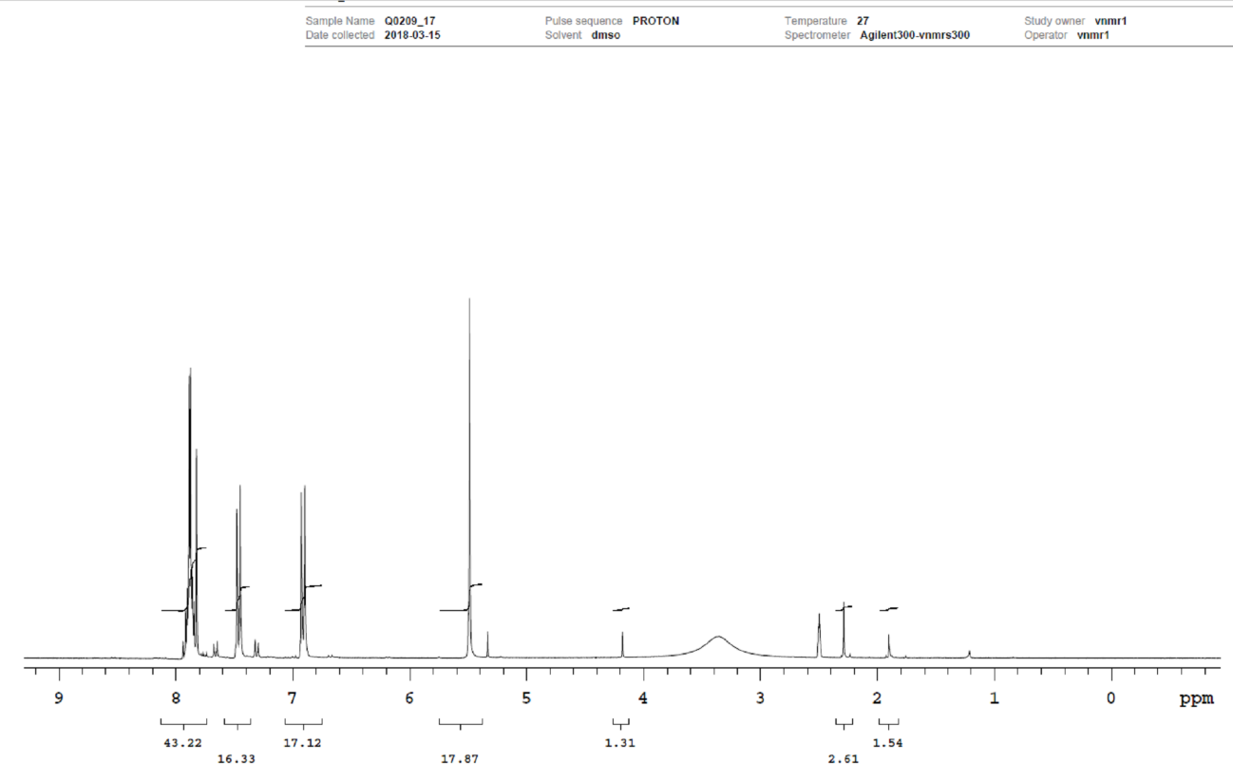

Figure S2 ¹³C NMR spectrum of LPSF FT-2
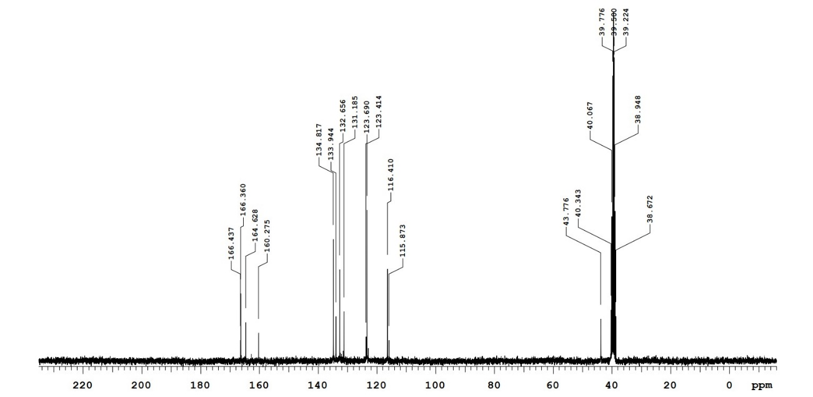

Figure S3 Maldi-Tof Mass Spectrum of LPSF FT-2 Compound
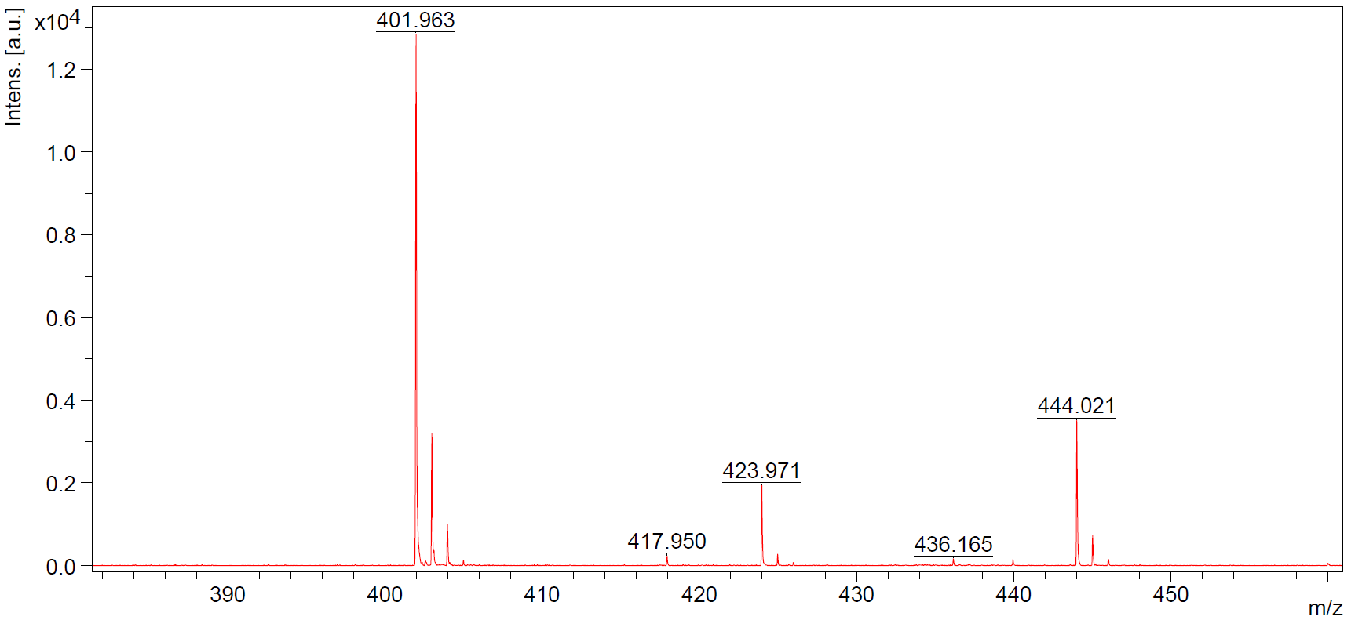

Figure S4 ¹H NMR spectrum of LPSF FT-3
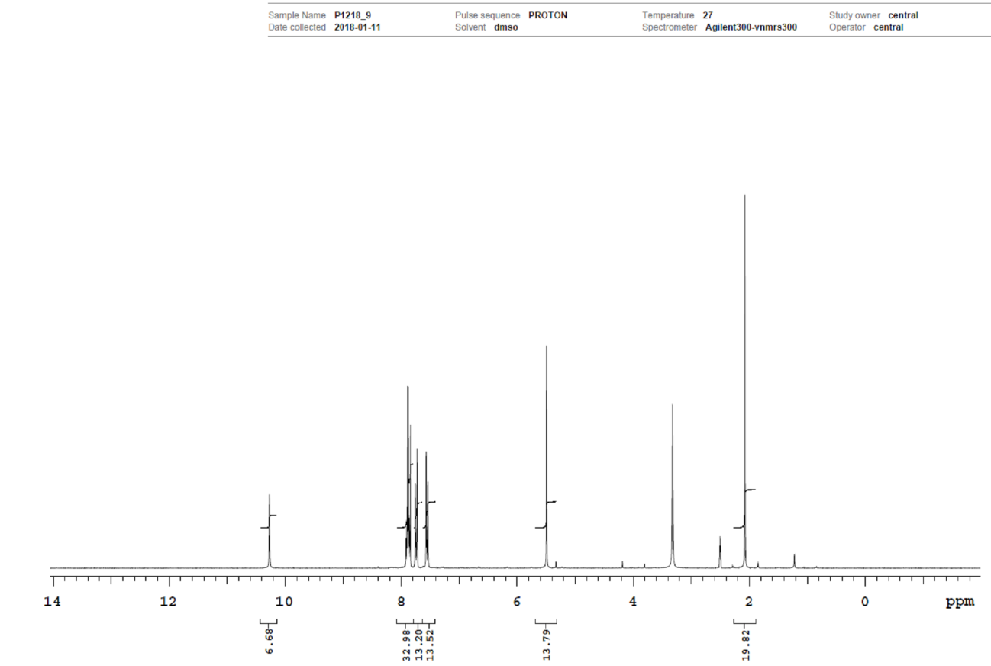

Figure S5 ¹³C NMR spectrum of LPSF FT-3
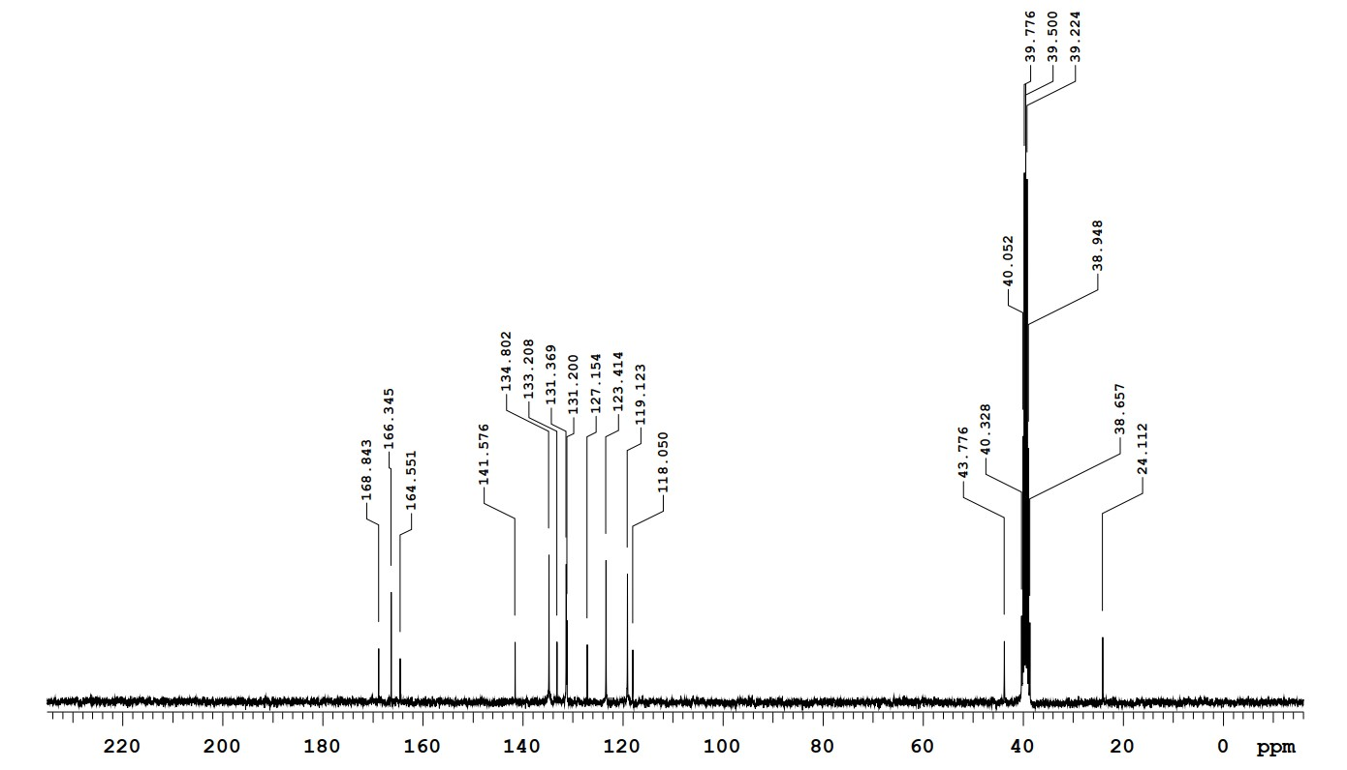

Figure S6 Maldi-Tof Mass Spectrum of LPSF FT-3 Compound
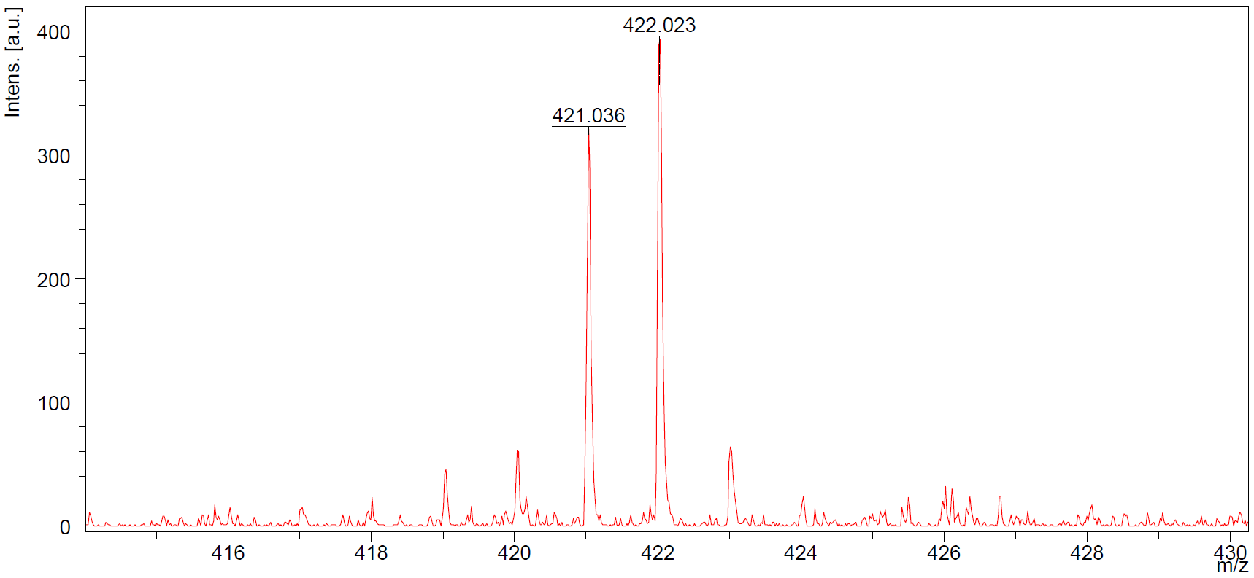

Figure S7 ¹H NMR spectrum of LPSF FT-4
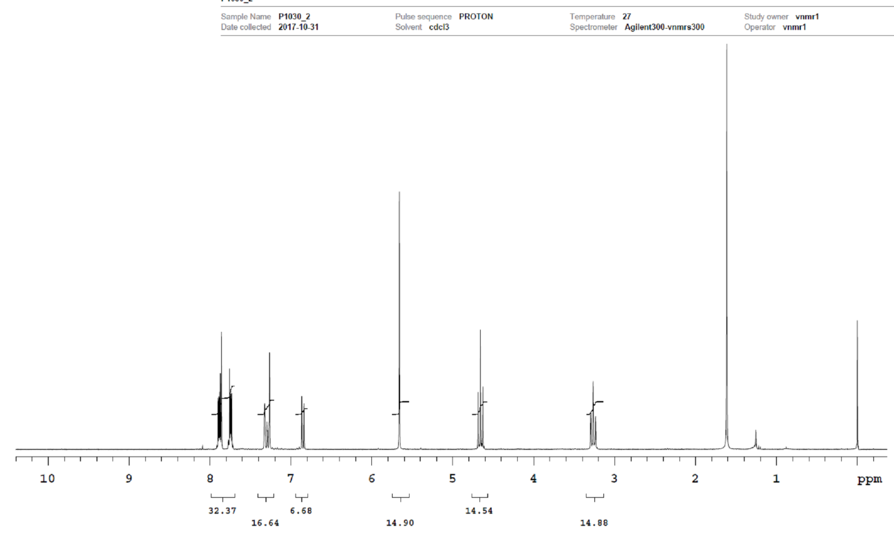

Figure S8 ¹³C NMR spectrum of LPSF FT-4
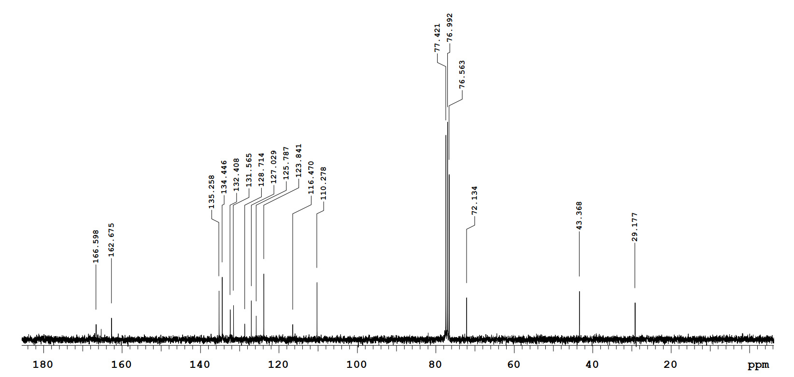

Figure S9 Maldi-Tof Mass Spectrum of LPSF FT-4 Compound
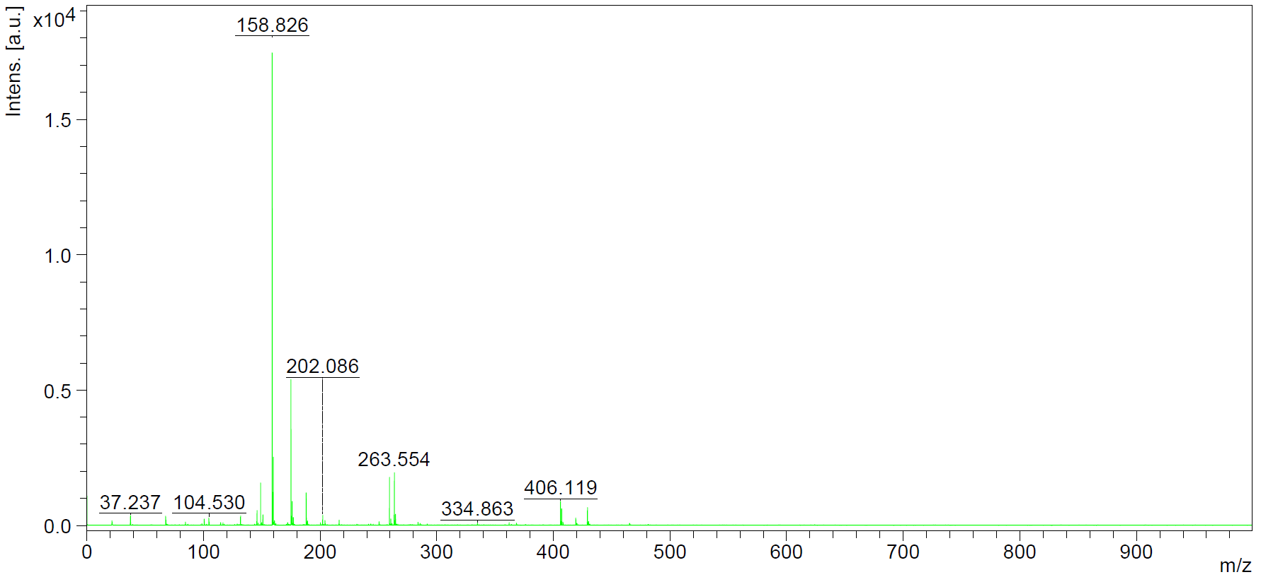

Figure S10 ¹H NMR spectrum of LPSF FT-6
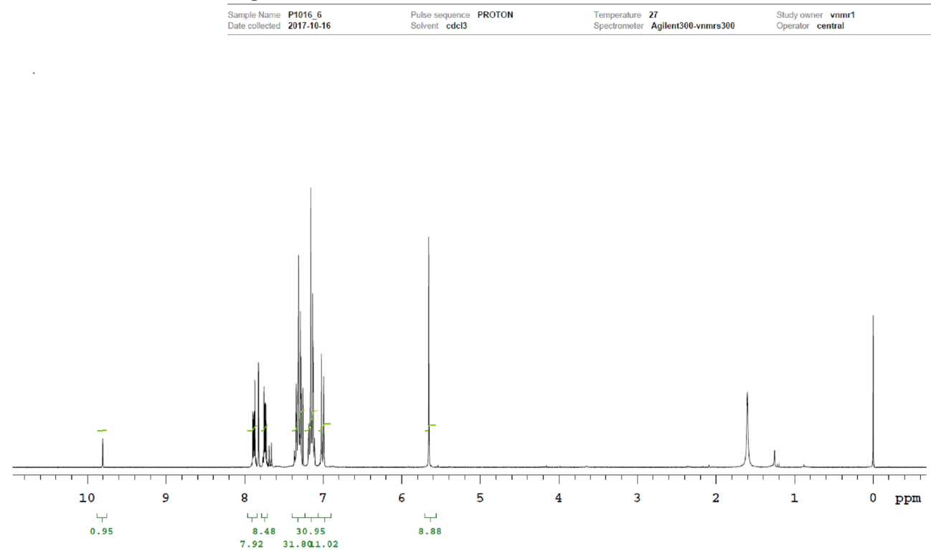
Figure S11 ¹³C NMR spectrum of LPSF FT-6
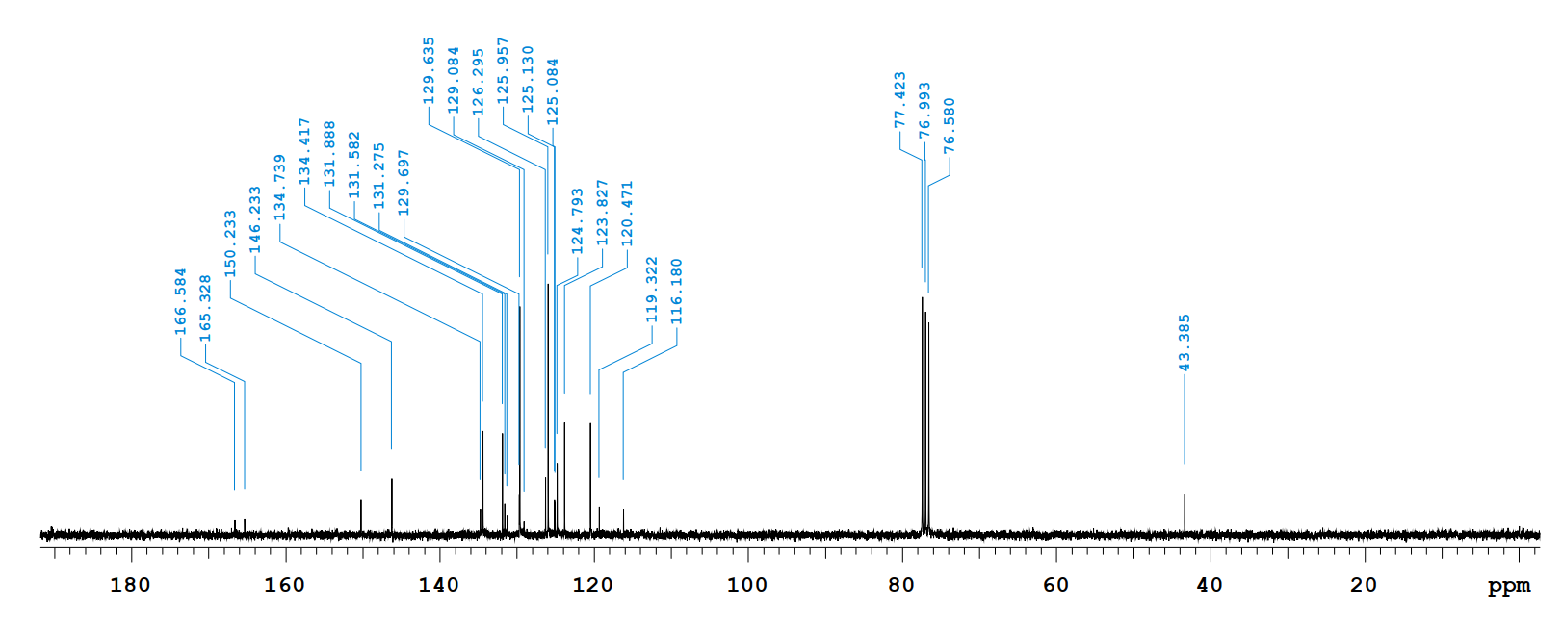

Figure S12 Maldi-Tof Mass Spectrum of LPSF FT-6 Compound
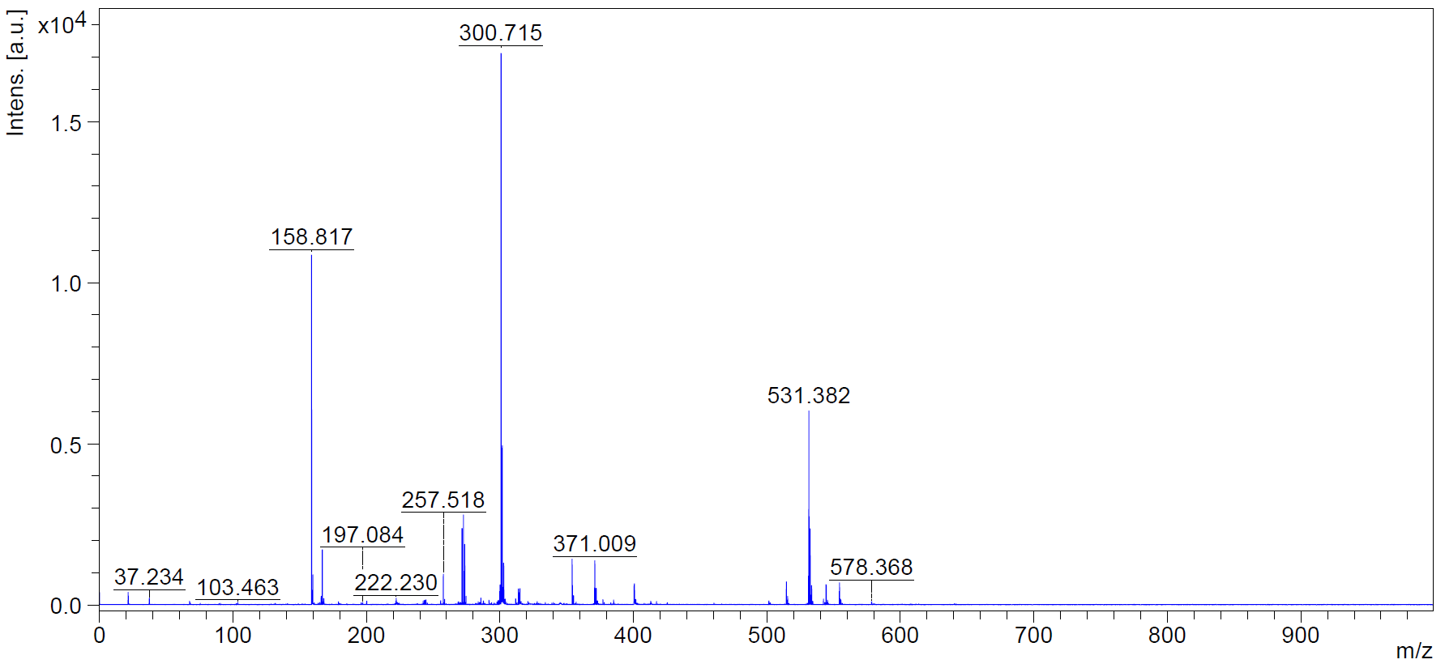

Figure S13 ¹H NMR spectrum of LPSF FT-7
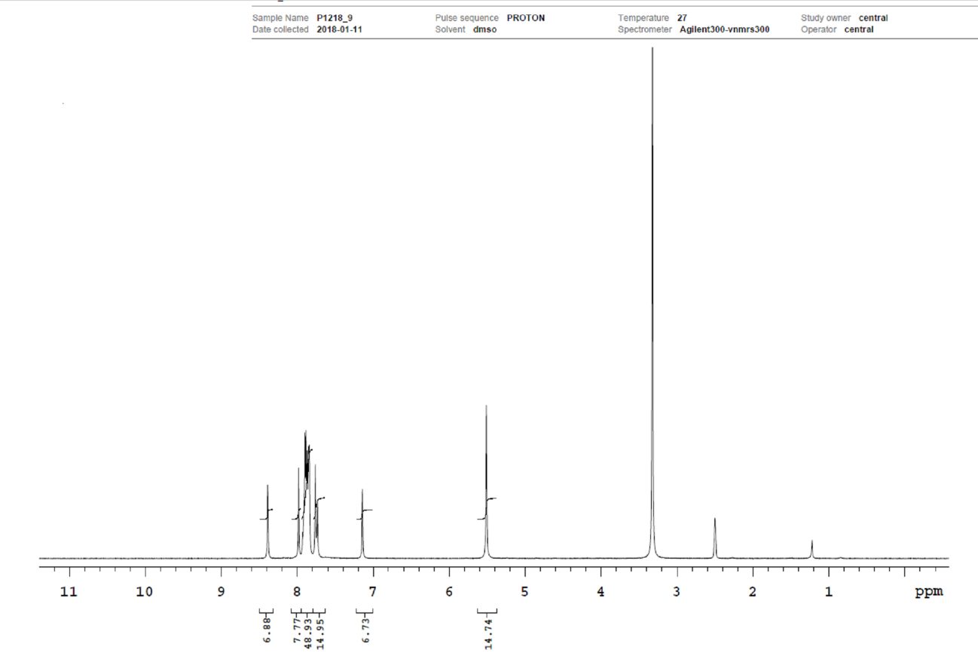
Figure S14 ¹³C NMR spectrum of LPSF FT-7
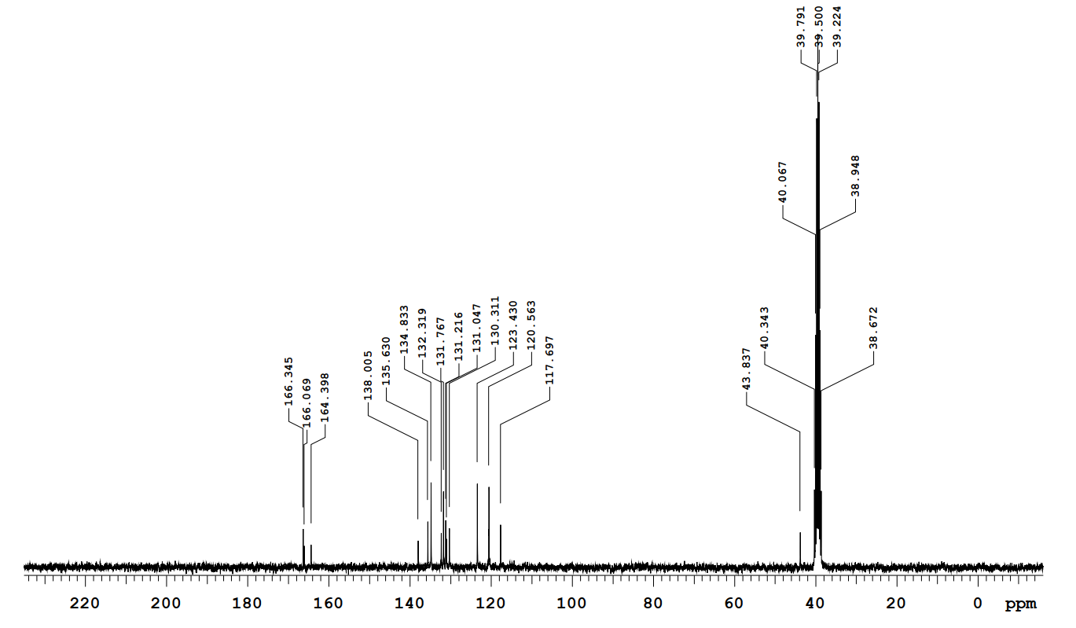

Figure S15 Maldi-Tof Mass Spectrum of LPSF FT-7 Compound
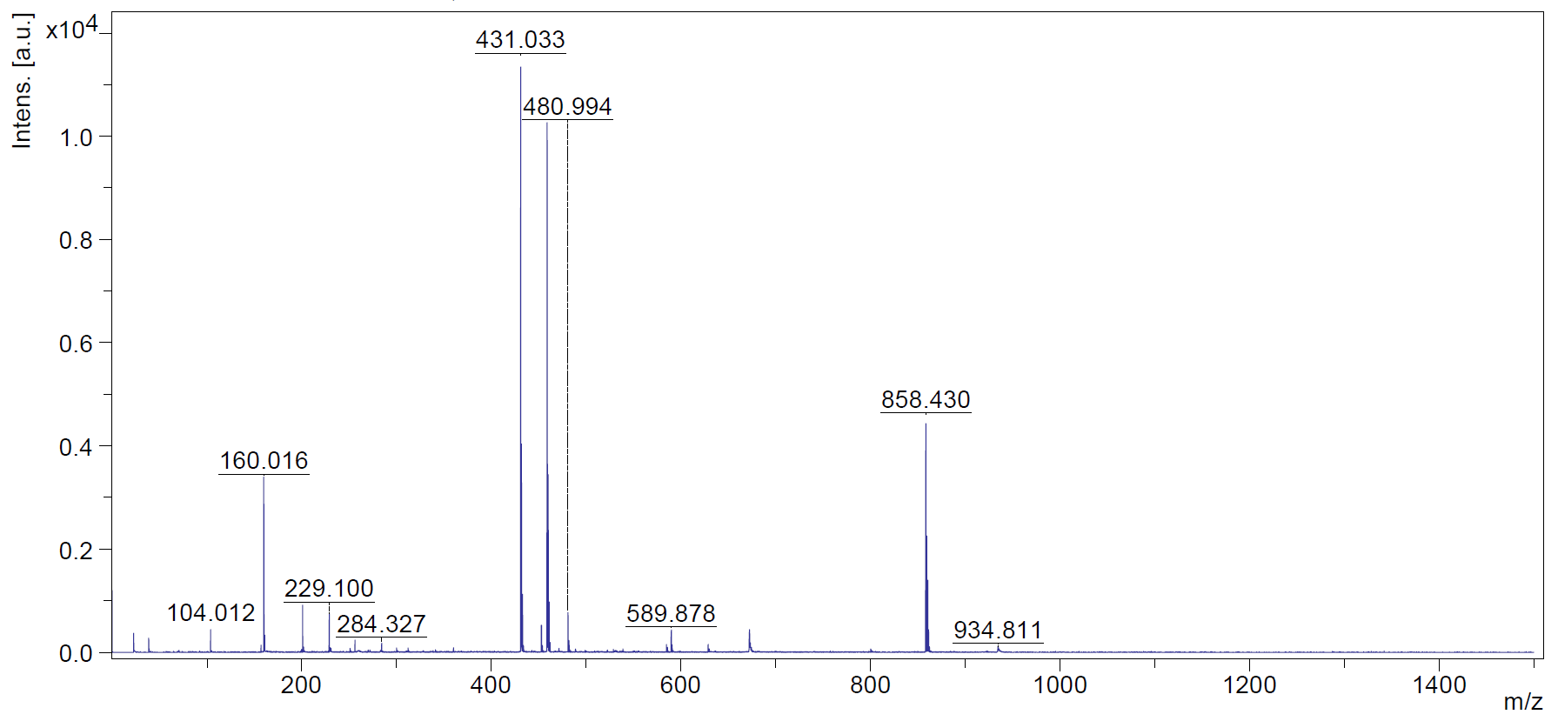
Figure S16 ¹H NMR spectrum of LPSF FT-8
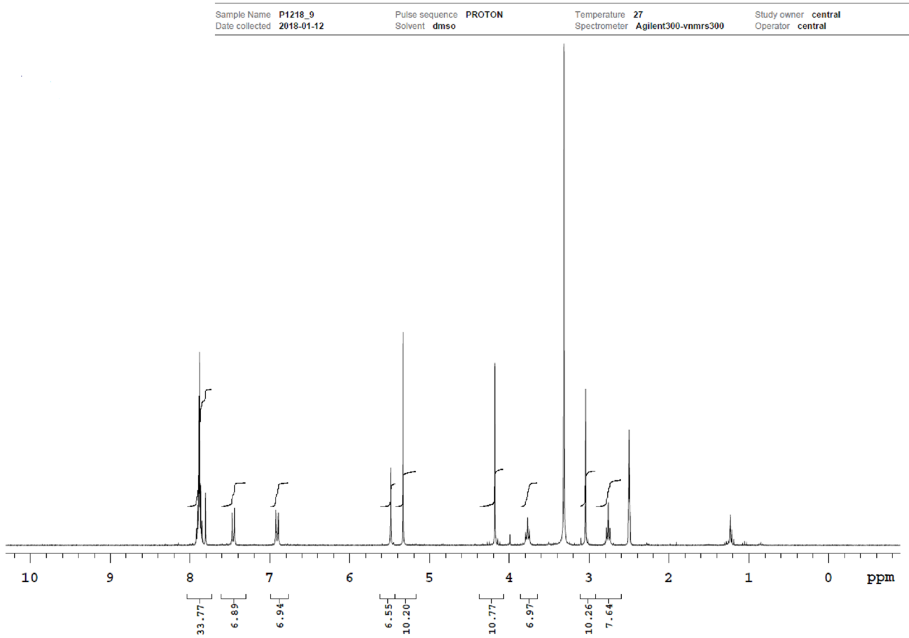

Figure S17 ¹³C NMR spectrum of LPSF FT-8
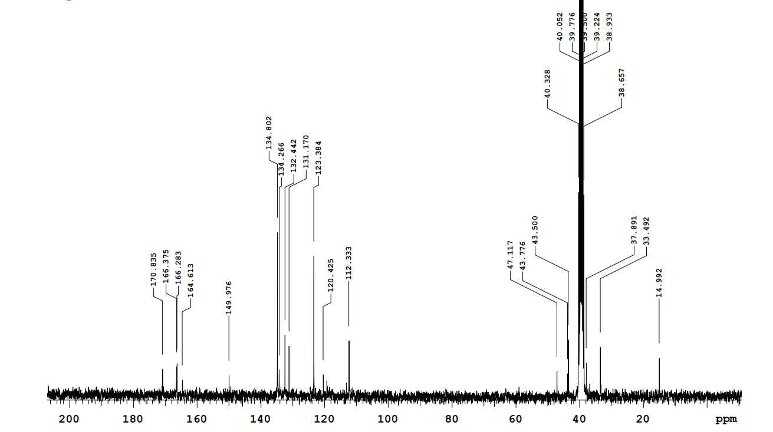

Figure S18 Maldi-Tof Mass Spectrum of LPSF FT-8 Compound
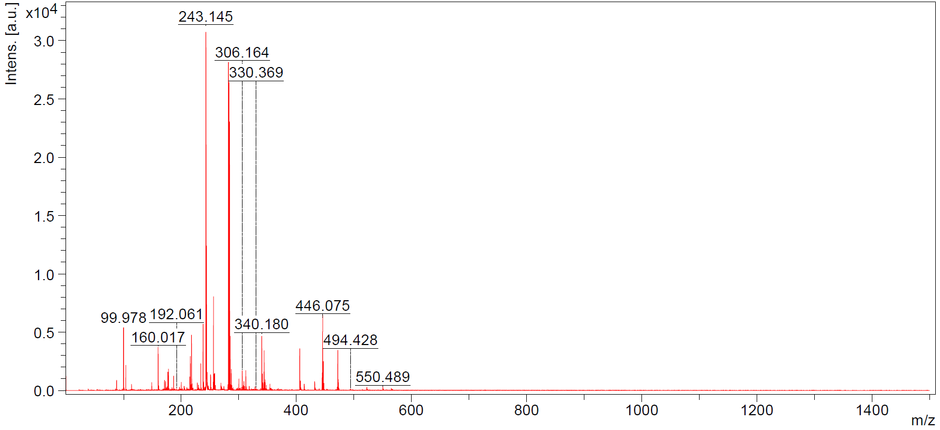

Figure S19 ¹H NMR spectrum of LPSF FT-9
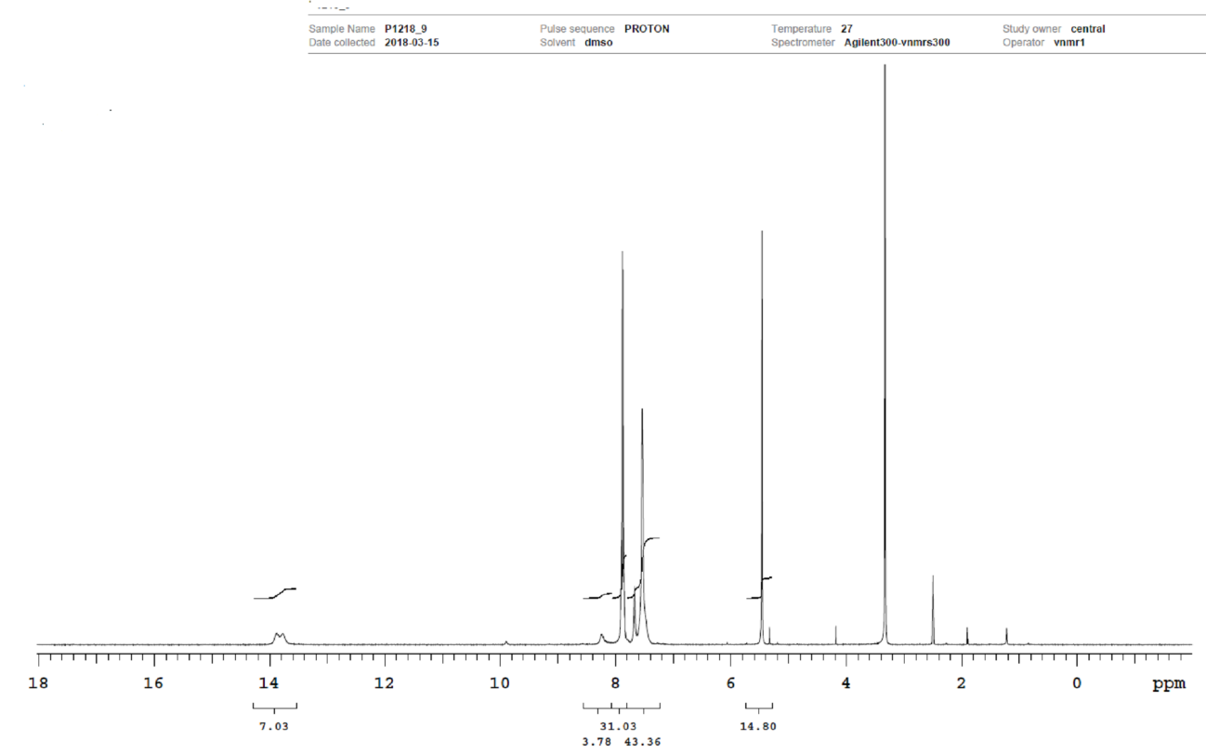

Figure S20 ¹³C NMR spectrum of LPSF FT-9
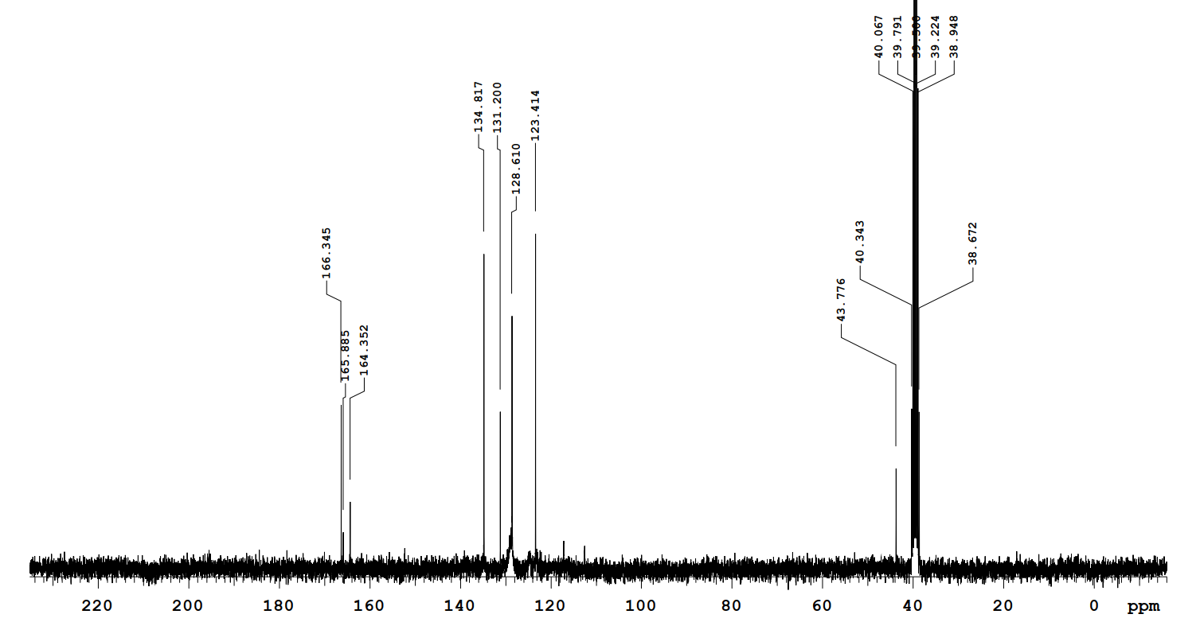

Figure S21 Maldi-Tof Mass Spectrum of LPSF FT-9 Compound
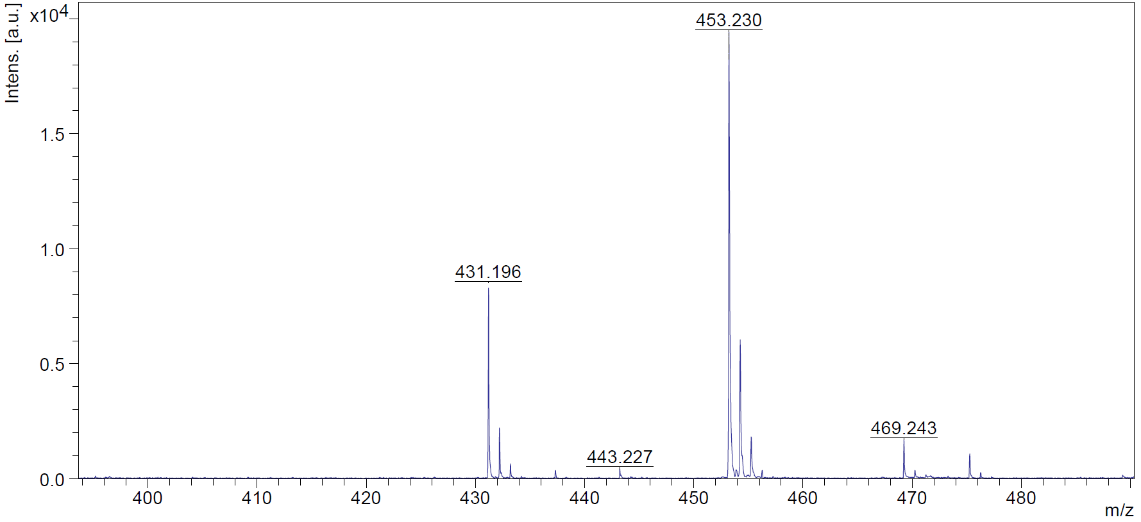

Figure S22 ¹H NMR spectrum of LPSF FT-12
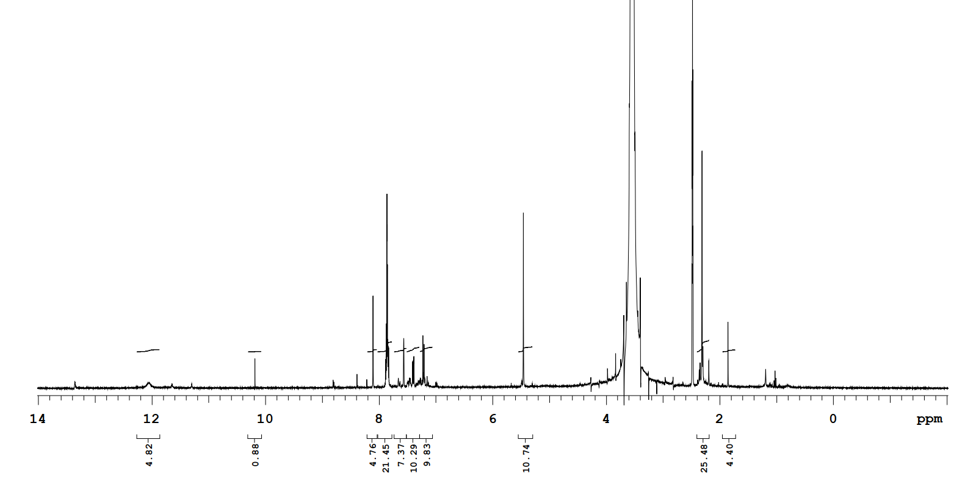

Figure S23 ¹³C NMR spectrum of LPSF FT-12
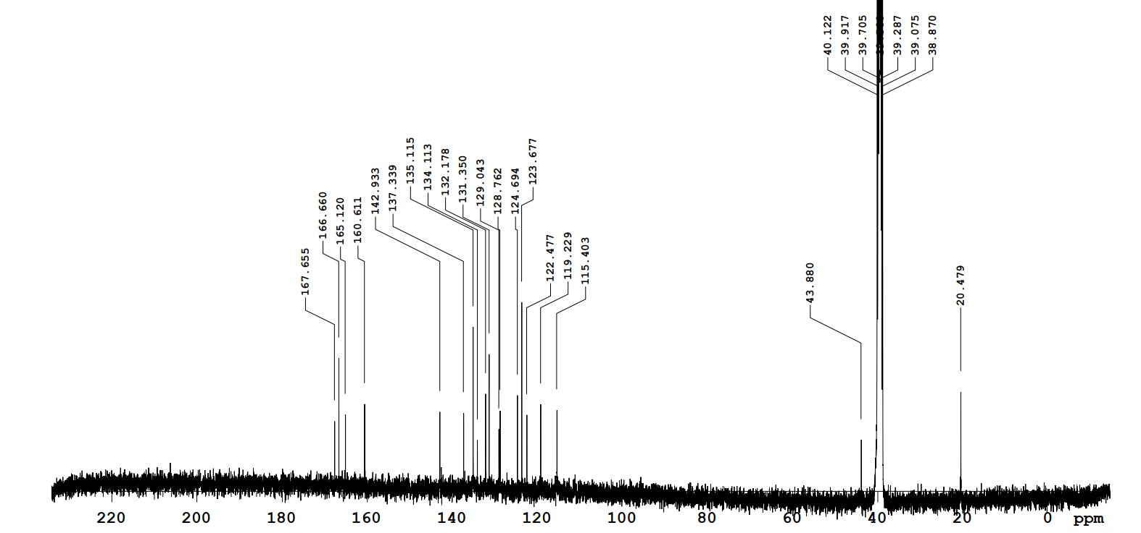

Figure S24 Mass Spectrum of LPSF FT-12 Compound

Figure S25 ¹H NMR spectrum of LPSF FT-15
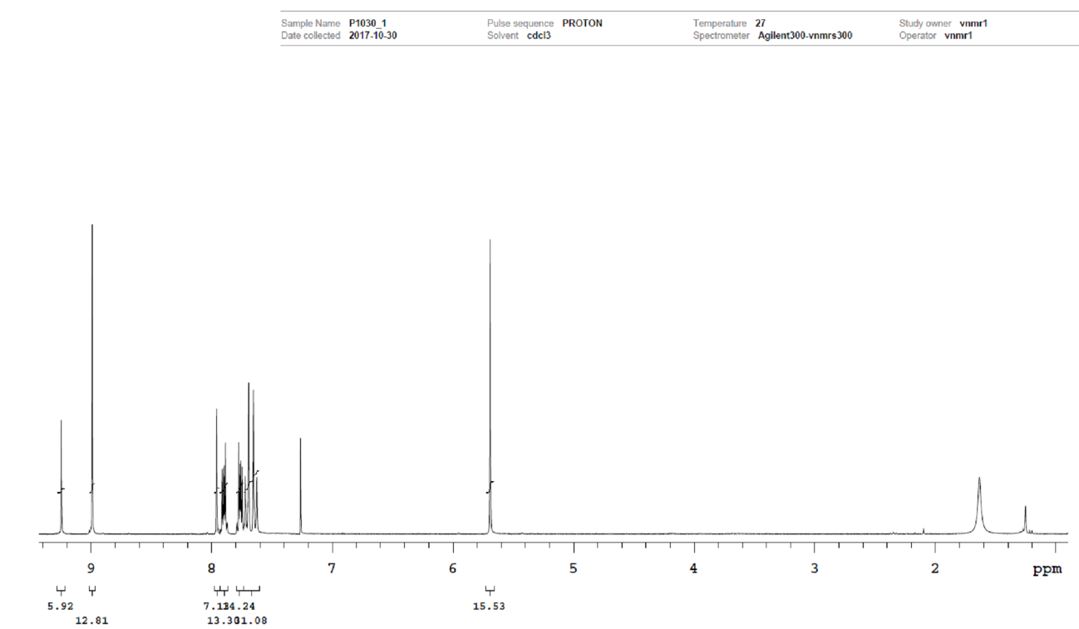

Figure S26 ¹³C NMR spectrum of LPSF FT-15
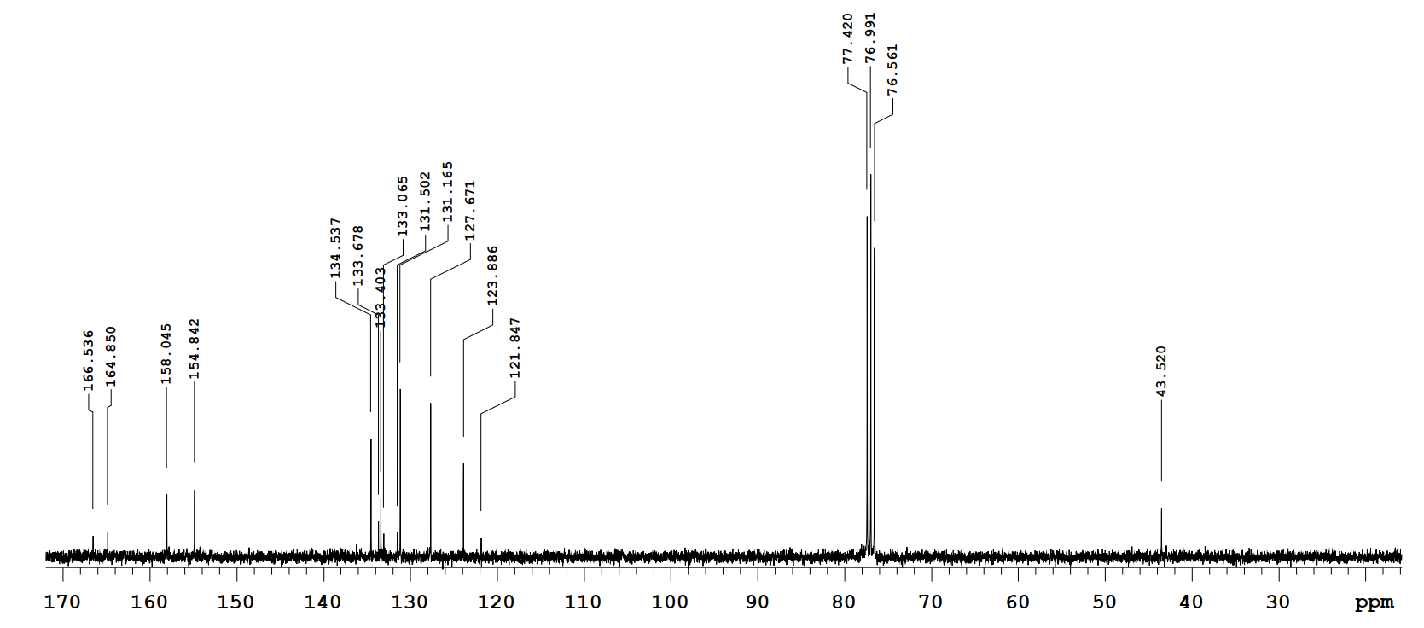

Figure S27 Maldi-Tof Mass Spectrum of LPSF FT-15 Compound

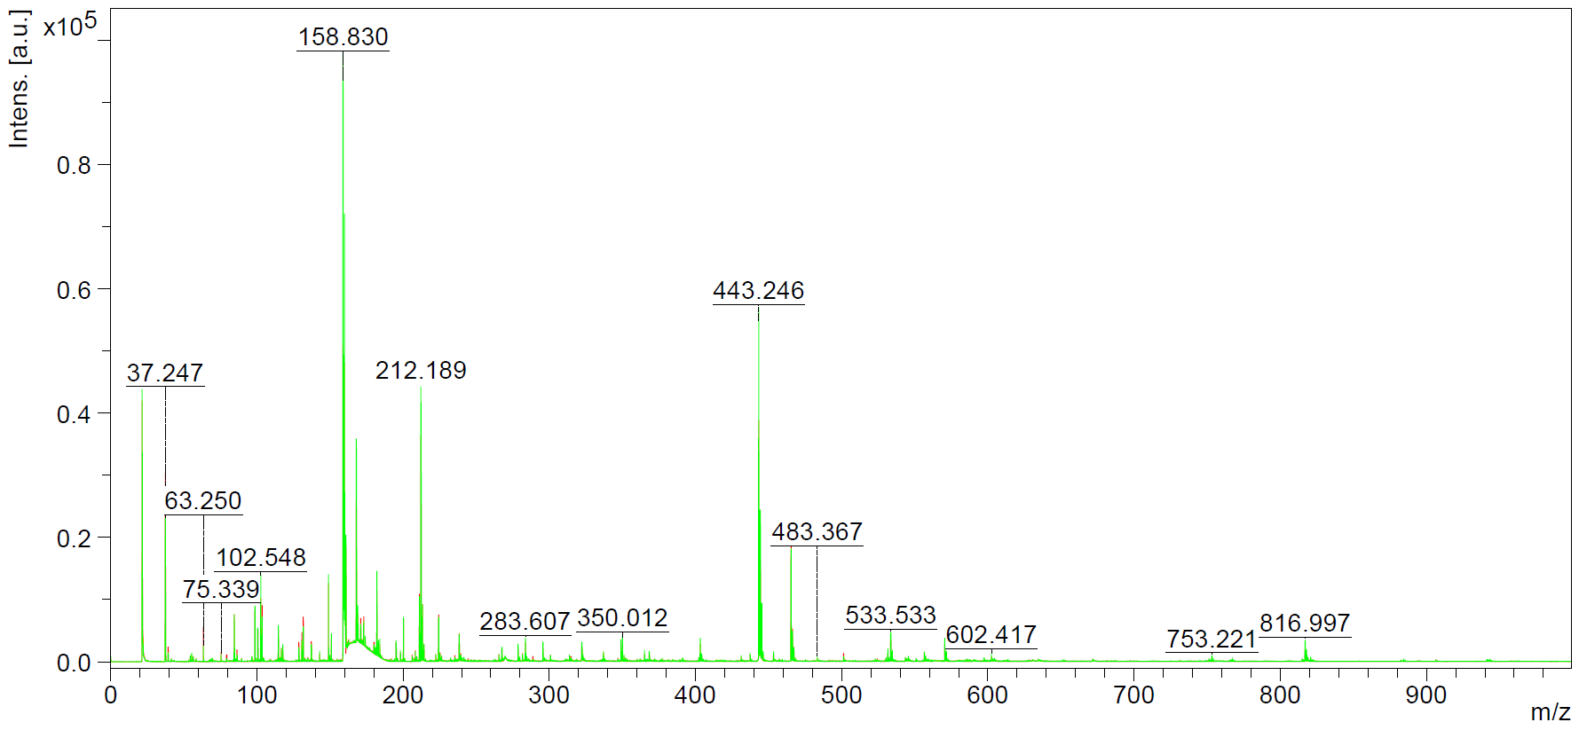

Figure S28 ¹H NMR spectrum of LPSF FT-18
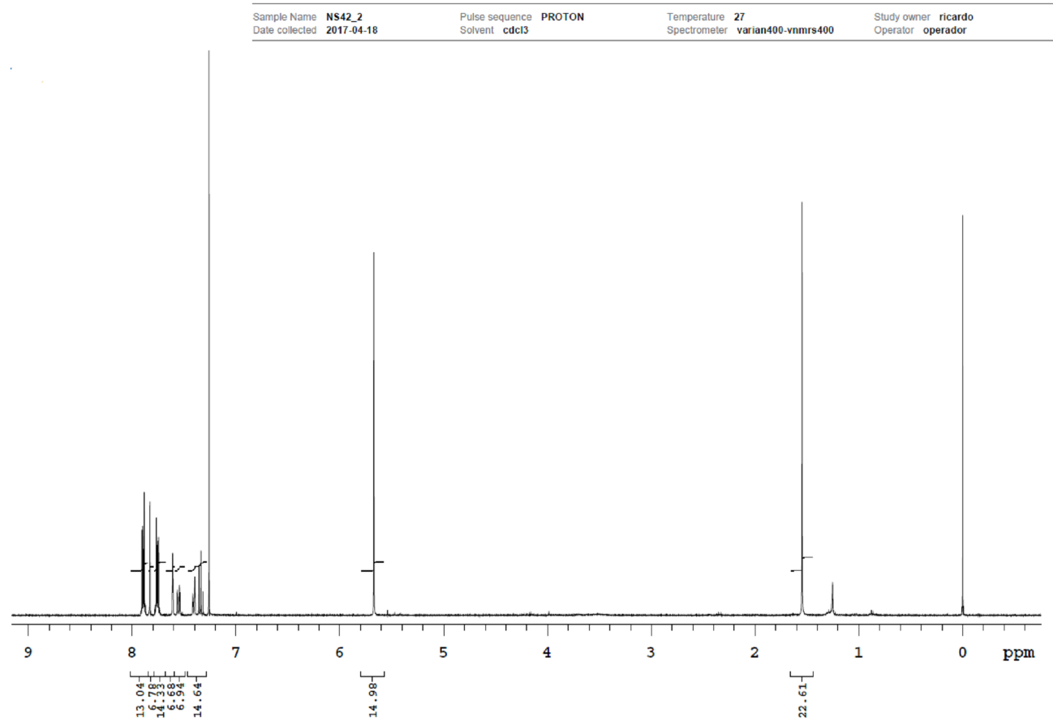

Figure S29 ¹³C NMR spectrum of LPSF FT-18
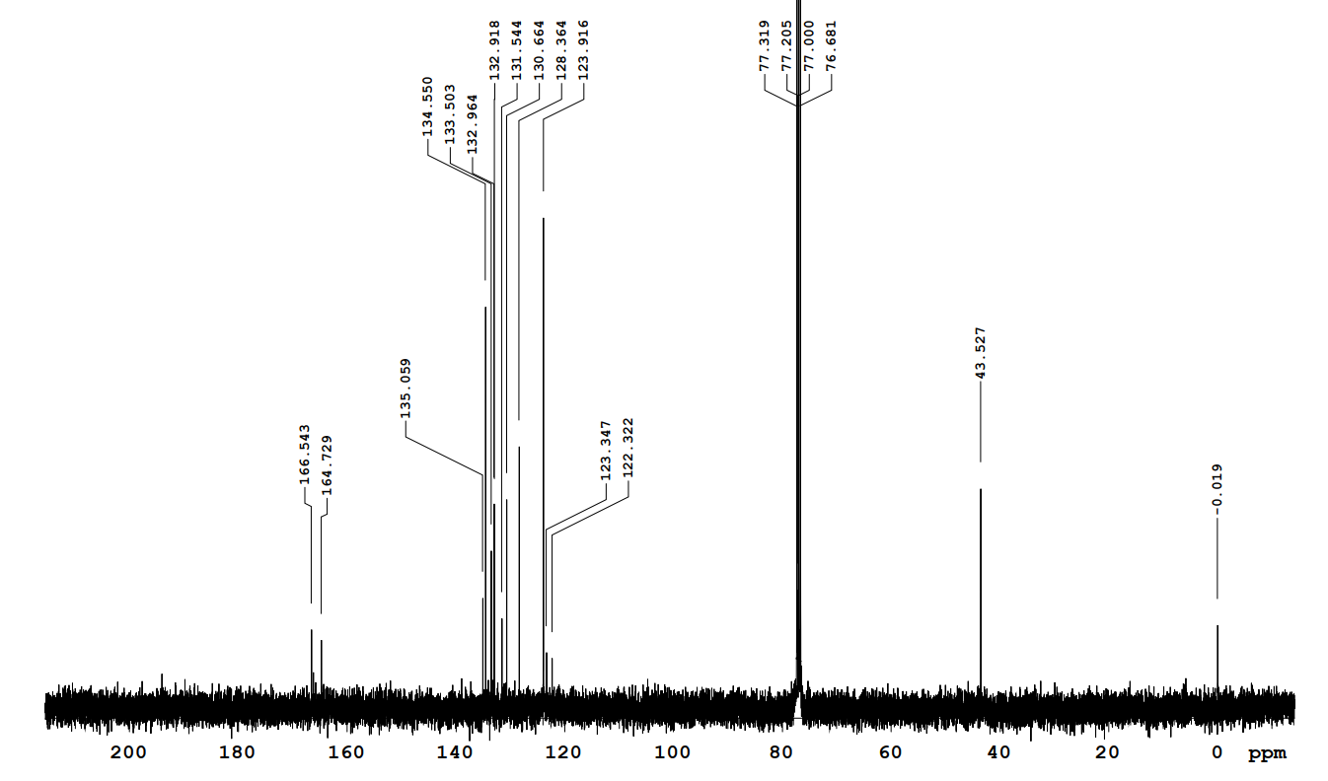

Figure S30 Maldi-Tof Mass Spectrum of LPSF FT-18 Compound
