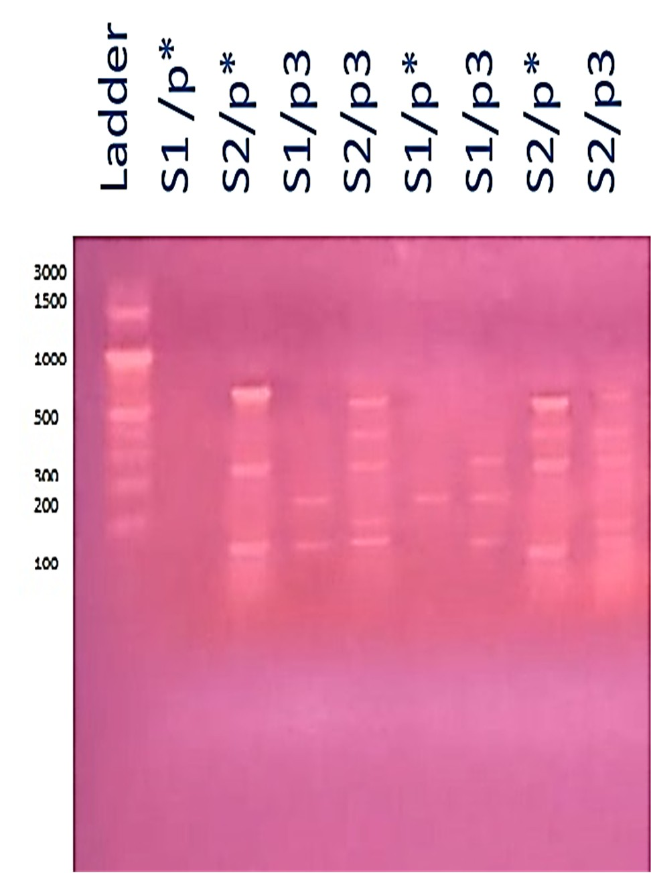

Supplementary Figure 1S: Random polymorphic DNA polymerase chain reaction (RAPD-PCR) patterns of 8 C. alexandrinus (S1) isolated from soil and C. brevis (S2) isolated from wood.

