Appendices

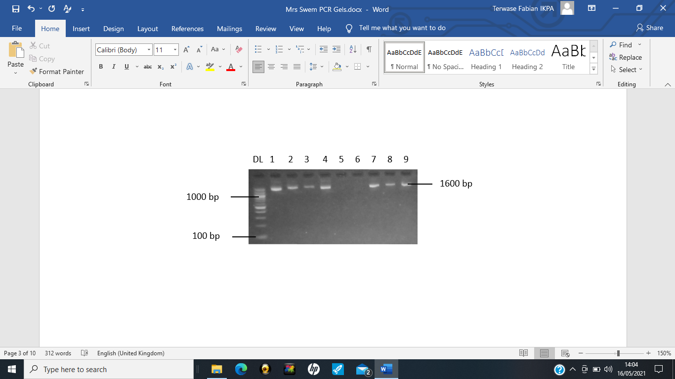
Plate 1: Agarose gel showing 1600 bp fragment of malaria species from primary reaction of rPLU1 and rPLU5 primers. DL = 100 bp DNA ladder, lanes 1, 2, 3, 4, 7, 8 and 9 = positive samples.

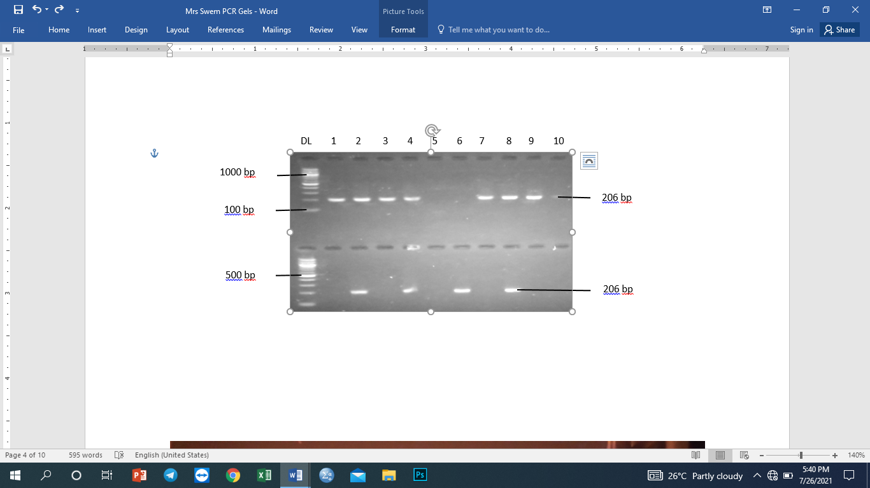
Plate 2: Agarose gel showing 206 bp fragment of P. falciparum from secondary reaction of rFAL1 and rFAL2 primers. DL=100 bp DNA ladder, lanes 1, 2, 3, 4, 7, 8, 9 = positive samples; lanes 5, 6, and 10 = negative samples.

Plate 3: 100 bp DNA ladder, lanes 1, 2. 3, 4, 7, 8 and 9 = positive samples. Lower gel:
lanes 2, 4, 6, and 8 = positive samples; bringing all positive samples to eleven
(11).

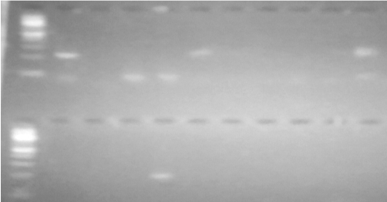
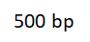
K1 clone
100 bp

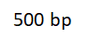
100 bp
MAD 20 clone

Plate 4: Agarose gel of variable sizes of P. falciparum msp-1 parasite
clones from secondary reactions of msp-1, M1-KF and M1-
KR primers showing K1 parasite clones (Upper gel) and MSP-1
M1-MF and M1-MR primers showing a single MAD20 parasite
clone at lane 4 (lower gel). DL=100 bp DNA ladder.

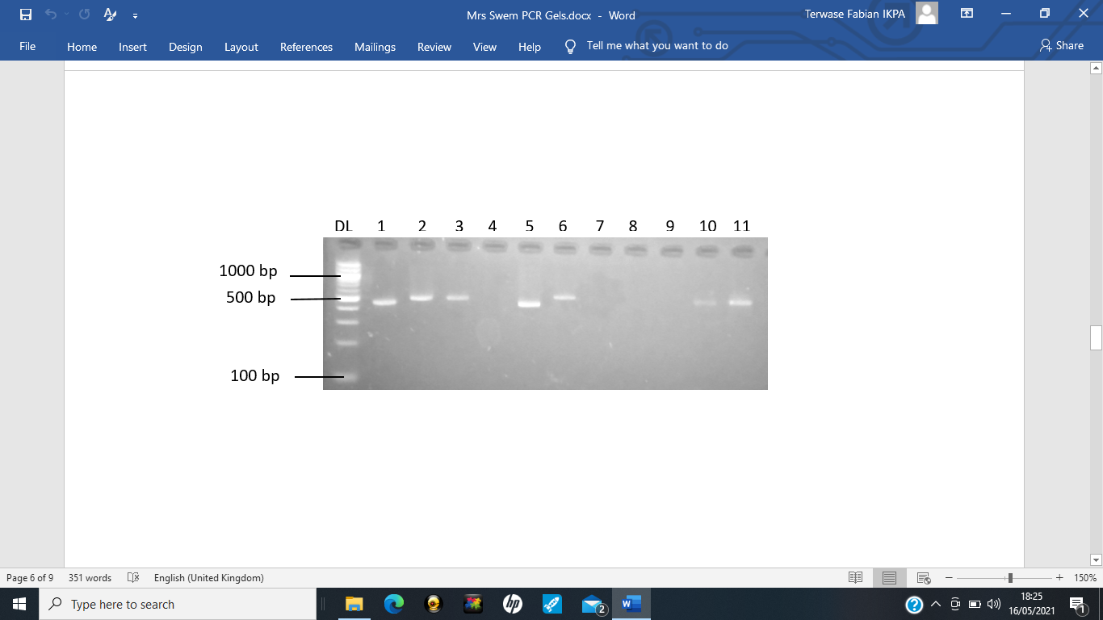
Plate 5: Agarose gel of variable sizes of P. falciparum 3D7 parasite clones from
secondary reaction of MSP-2 M2-ICF and M2-ICR primers

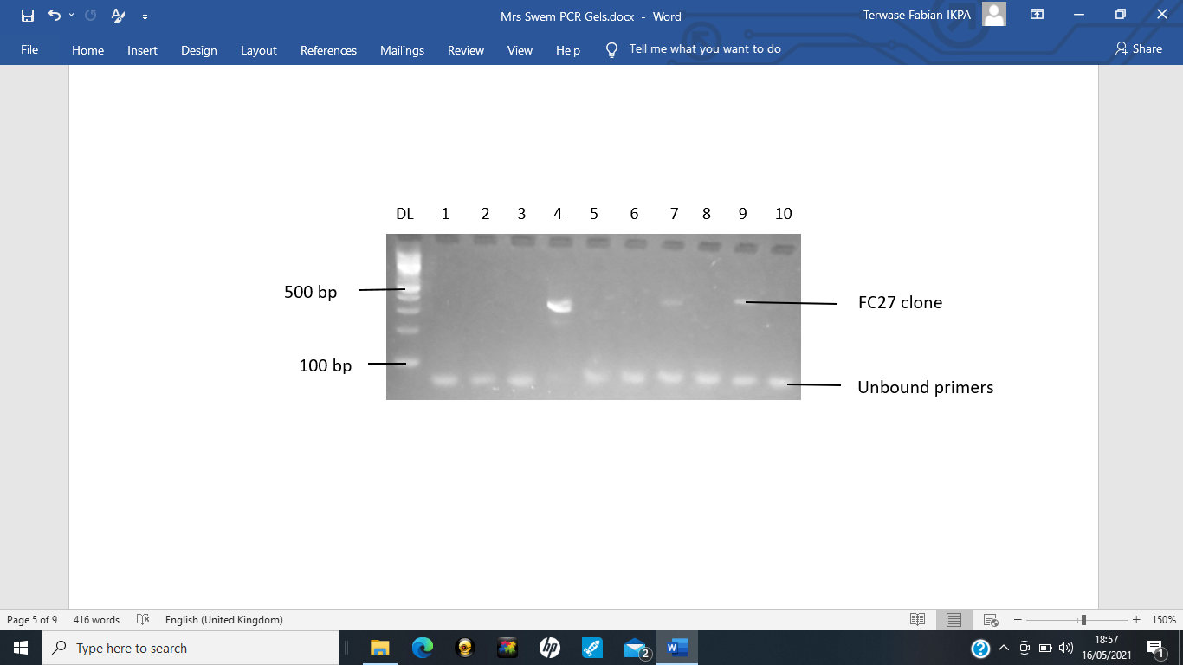

Plate 6: Agarose gel of variable sizes of P. falciparum FC27 parasite clones from
secondary reaction of MSP-2 M2-FCF and M2-FCR primers.

