Supplementary Results: Figures S5 and S6.

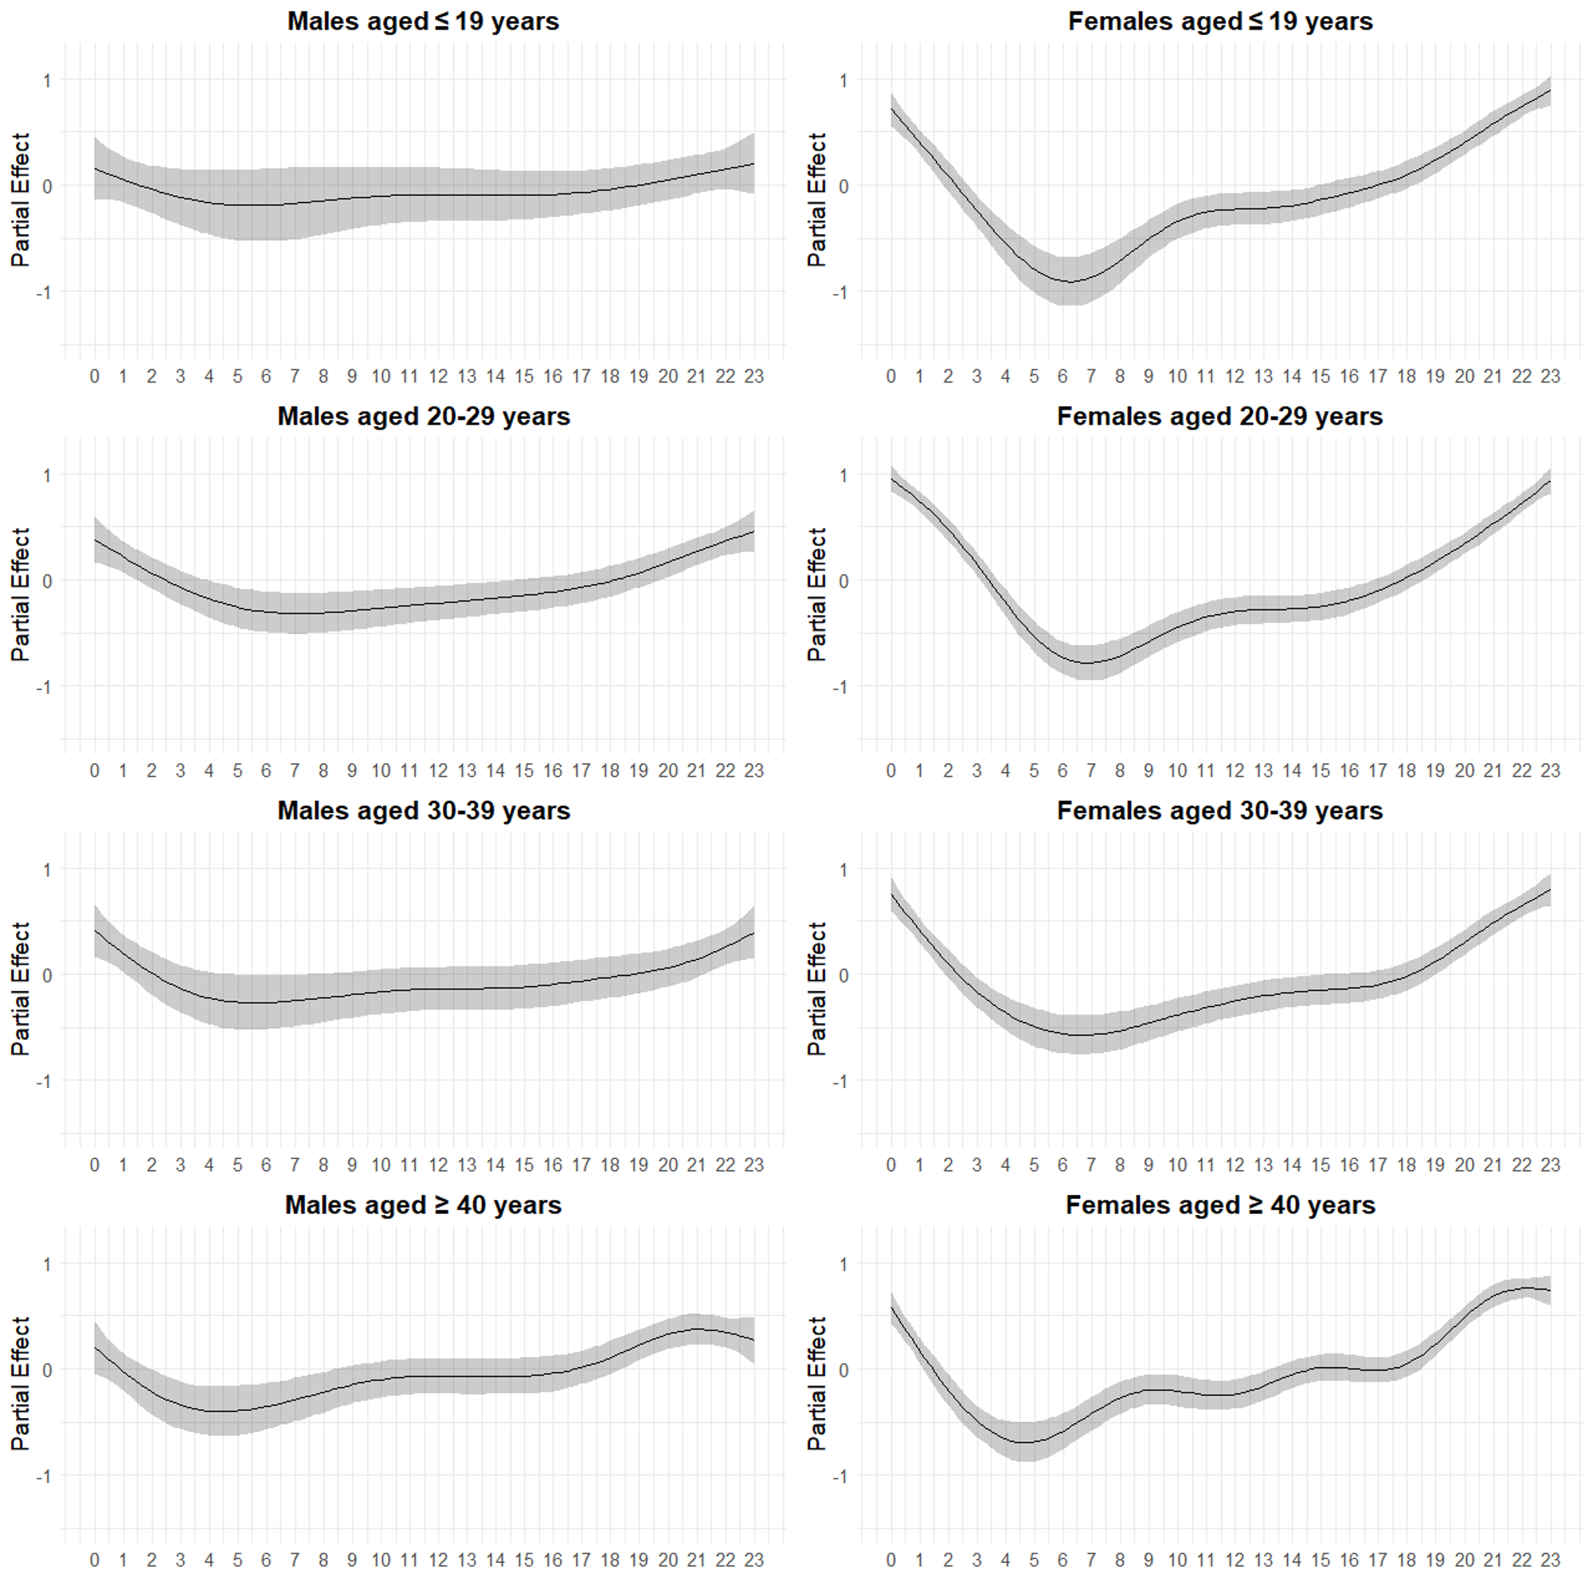
Figure S5. Partial effect plots for time-of-day (hour) on posting frequency in the NHK forum by gender and age group (≤19, 20s, 30s, ≥40), 1 February 2020 – 31 January 2023, 2025. Plots display GAM spline terms, illustrating relative hourly effects.

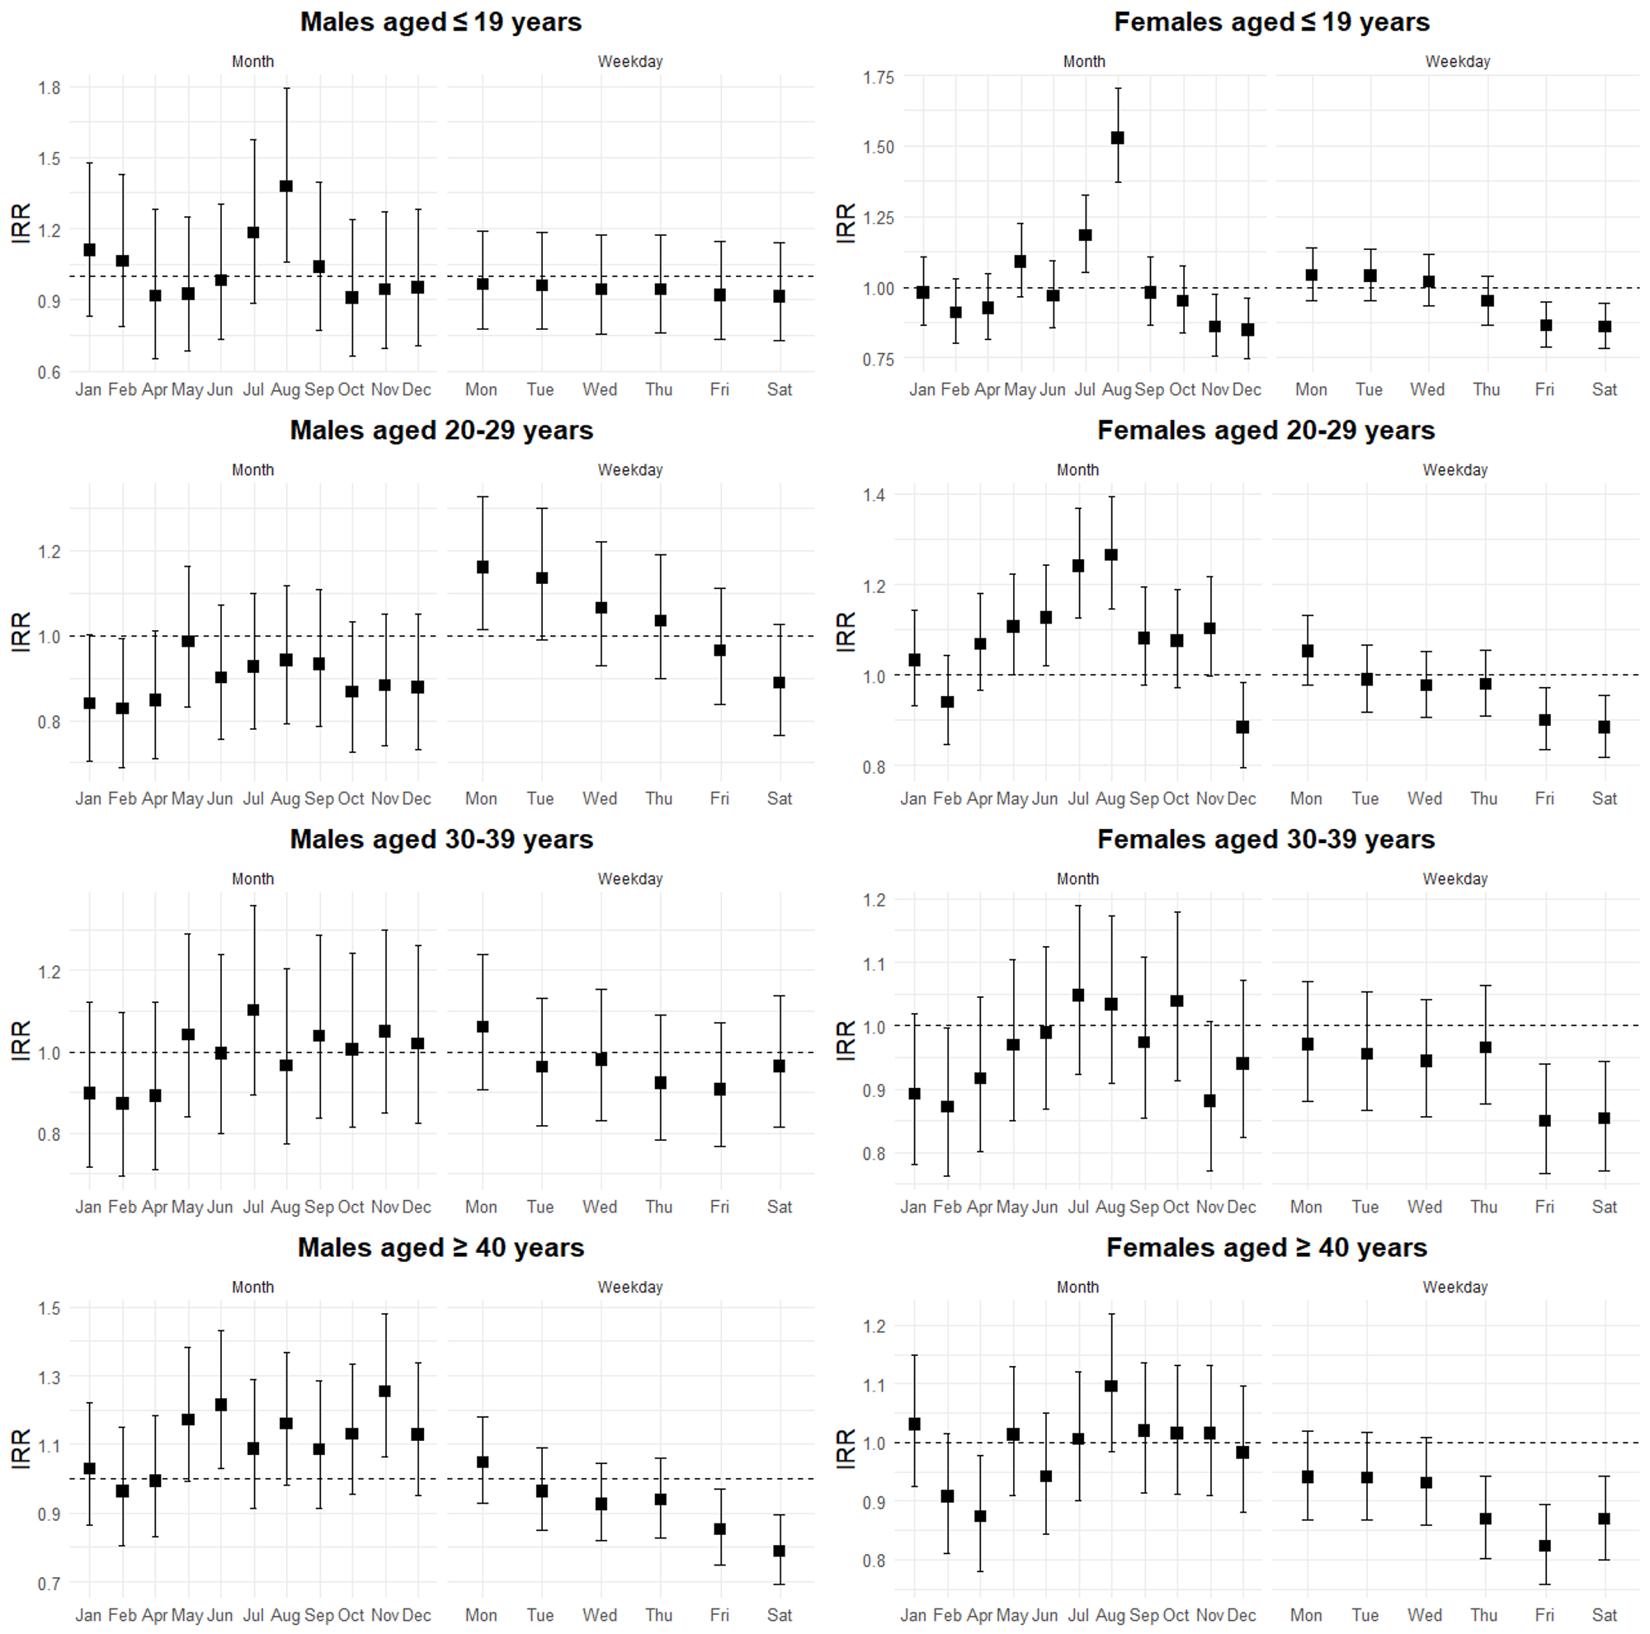
Figure S6. Monthly and weekday effects on posting frequency by gender and age group, 1 February 2020 – 31 January 2023. March served as the reference month, and Sunday as the reference day. Results are presented as incidence rate ratios (IRRs).

