Supplementary Results: Figures S1-2.

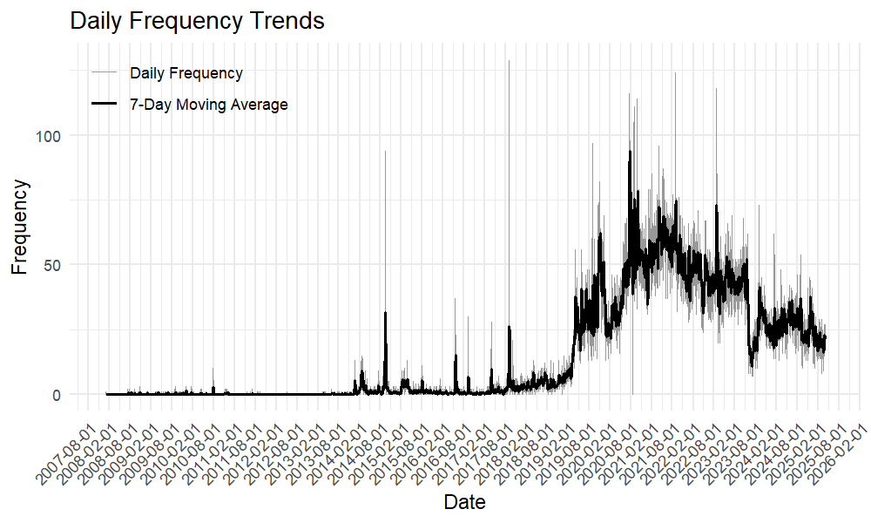
Figure S1. Daily (grey line) and 7-day moving average (black line) number of postings on the NHK forum from 1 January 2008 to 31 March 2025.

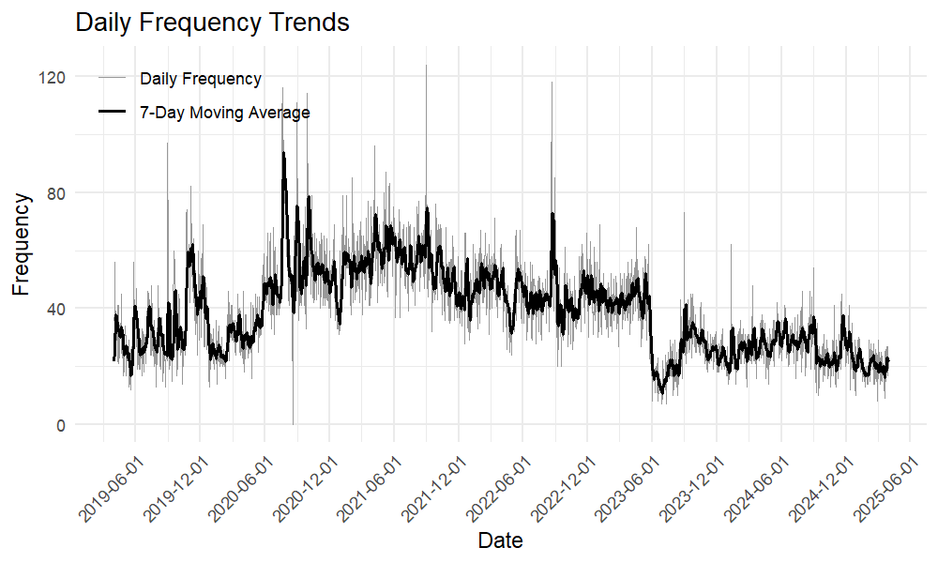 Figure S2. Daily (grey line) and 7-day moving average (black line) number of postings on the NHK forum from 1 April 2019 to 31 March 2025.

