Additional file 3. Determination of Equation for Estimated Maximal Oxygen Uptake Based on 10-m Shuttle Run Test in adults.

Context. The 20-m shuttle run test (SRT) is a common undirect method to estimate individual cardiorespiratory fitness [1]. In this test, participants run back and forth between two lines placed 20 meters apart gradually increasing their speed. The highest speed achieved during the test is used to predict the maximal oxygen uptake (VO_{2max}) [1, 2]. Léger and Lambert [2], who developed this 20m-SRT, used the following regression model to estimate individuals’ VO₂max = 5.857 * 20m-SRT speed - 19.458. It is important to note that the 20m-SRT was initially designed to assess the aerobic fitness of athletes, and may therefore be less suitable for others individuals notably those with low fitness levels. Thus, previous researches proposed various adaptation of the SRT by reducing the distance (e.g., using 10 or 15m) and/or decreasing initial speed level [3, 4]. To adequately estimate individuals’ VO₂_{max} using the modified version of the test, it is necessary to adapt the original prediction equation. In the present study, we employed a 10-meter shuttle run test (10m-SRT), starting at a speed of 6.5 km/h. To determine a new regression equation that accurately estimates VO₂_{max} for individuals performing this modified protocol, the following procedure was implemented.

Methods. For this, we recruited 15 additional participants with similar characteristics of our study population (6 men, 9 women; average age: 25.6 ± 2.1 years). They performed a 10m-SRT, where the running speed started at 6.5 km/h and increased by 0.5 km/h every minute, guided by an audio signal (Pack Sportbeeper Pro, CE, France). The test ended when the participant could no longer maintain the required speed, which indicated their 10m SRT speed. During the 10m-SRT, heart rate (Polar A200 device connected to a Polar H7 chest strap sensor), ventilation (VE), oxygen consumption (VO₂), and carbon dioxide production (VCO₂) were continuously measured using a gas analyzer (MetaMax 3b, Cortex Biophysik, Leipzig, Germany).

Data analyzes. From the data recorded by the gas analyzer during the running test, we determined the maximal VO₂ value recorded during the test (VO_{2peak}) for each participant. Subsequently, the average VO_{2max} was calculated by averaging the VO₂ values measured during the 15 seconds before and after the VO_{2peak}. We then established the regression equation using the measured VO_{2max} during the test and the corresponding 10m-SRT speed. Thus, VO_{2max} = 8.0574 * 10m-SRT speed - 32.64 (Fig 1).
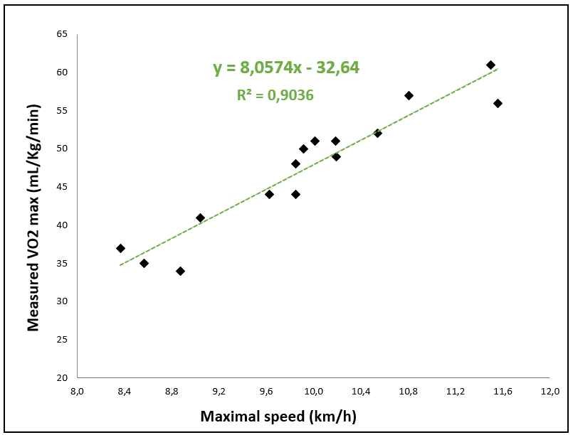
Fig 1. The relationship between the maximum speed attained in the 10-meter shuttle run test and measured VO_{2max}.

REFERENCES
1. Mayorga-Vega D, Aguilar-Soto P, Viciana J. Criterion-Related Validity of the 20-M Shuttle Run Test for Estimating Cardiorespiratory Fitness: A Meta-Analysis. J Sports Sci Med. 2015;14:536–47.
2. Léger LA, Lambert J. A maximal multistage 20-m shuttle run test to predict VO2 max. Eur J Appl Physiol. 1982;49:1–12.
3. Cho H-L, Park H-Y, Nam S-S. Development of multistage 10-m shuttle run test for VO2max estimation in healthy adults. 2022. https://www.jomh.org/articles/10.31083/jomh.2021.066. Accessed 19 Mar 2025.
4. Magee MK, White JB, Merrigan JJ, Jones MT. Does the Multistage 20-m Shuttle Run Test Accurately Predict VO2max in NCAA Division I Women Collegiate Field Hockey Athletes? Sports. 2021;9:75.

